Supplementary Information

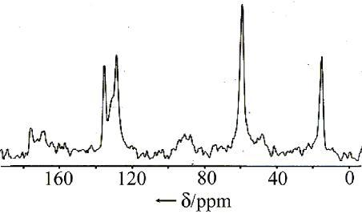

Figure 1. The CP/MAS ¹³C NMR of the SiO₂(9.7) modified by phenyl groups.
Figure 2. The FT-IR spectra of heterogeneous Mn(salen) catalyst immobilized by phenyl sulfonic group. a) Ph/SiO₂(9.7), b) PhSO₃Na/SiO₂(9.7), c) Mn(salen-a)/SiO₂(9.7).
Figure 3. The UV-Vis spectra of heterogeneous Mn(salen) catalysts
a) Mn(salen-a)Cl, b) PhSO₃Na/SBA(7.6), c) Mn(salen-a)/SBA(7.6).
Figure 4. The pXRD spectra of heterogeneous Mn(salen) catalysts immobilized onto mesoporous materials. a) SBA-15(7.6), b) Ph /SBA(7.6), c) Mn(salen-a)/SBA(7.6).

