Supporting Information

-------------------------------------------------------------------------------------------
Microflow Electroorganic Synthesis without Supporting Electrolyte

Roberto Horcajada, Masayuki Okajima, Seiji Suga, and Jun-ichi Yoshida*

Department of Synthetic Chemistry and Biological Chemistry, Graduate School of Engineering, Kyoto University, Nishikyo-ku, Kyoto 615-8510.. Fax: +81-75-383-2727; Tel:+81-75-383-2726; E-mail:yoshida@sbchem.kyoto-u.ac.jp

----------------------------------------------------------------------------------------------------------

General Remarks. GC analysis was performed on a gas chromatograph (SHIMADZU GC-14B) equipped with a flame ionization detector using a fused-silica capillary. ¹H and ¹³C NMR spectra were recorded in CDCl₃ on Varian Gemini 2000, Varian MERCURYplus-400 with Me₄Si as an internal standard, unless otherwise noted. NMR spectra of the carbamates were usually very broad and sometimes separated into two signals due to their rotamers. Thin-layer chromatography (TLC) was carried out by using Merck precoated silica gel F₂₅₄ plates (thickness 0.25 mm).

Materials. Methanol was obtained commercially and dried over molecular sieves 3A and distilled before electrolysis. Water content in methanol was less than 70 ppm, as judged by Karl Fischer titration.

p-Methoxytoluene (Wako Inc.) and acenaphthylene (TCI) were purchased and used as received. N-Methoxycarbonyl pyrrolidine, however, was made by the procedure described by Shono and co-workers.

Electrochemical Microflow Reactor (Fig. 1). A microflow electrochemical reactor shown in Figure 1, which was composed of diflone and stainless steel bodies by a mechanical manufacturing technique, was used. The two-compartment cell was divided by a diaphragm (diameter: 20 mm) of PTFE membrane (ADVANTEC T300A, thickness: 75 μm, pore size: 3 μm). For comparison, PTFE membranes of different pore sizes were also used (ADVANTEC T010A, thickness: 70 μm, pore size: 0.1 μm). Each compartment was filled with carbon felt electrode made of carbon fibers (Nippon Carbon JF-20-P7, 6 mm x 6 mm, dried at 250 ºC/1 mmHg for 2 h before use).

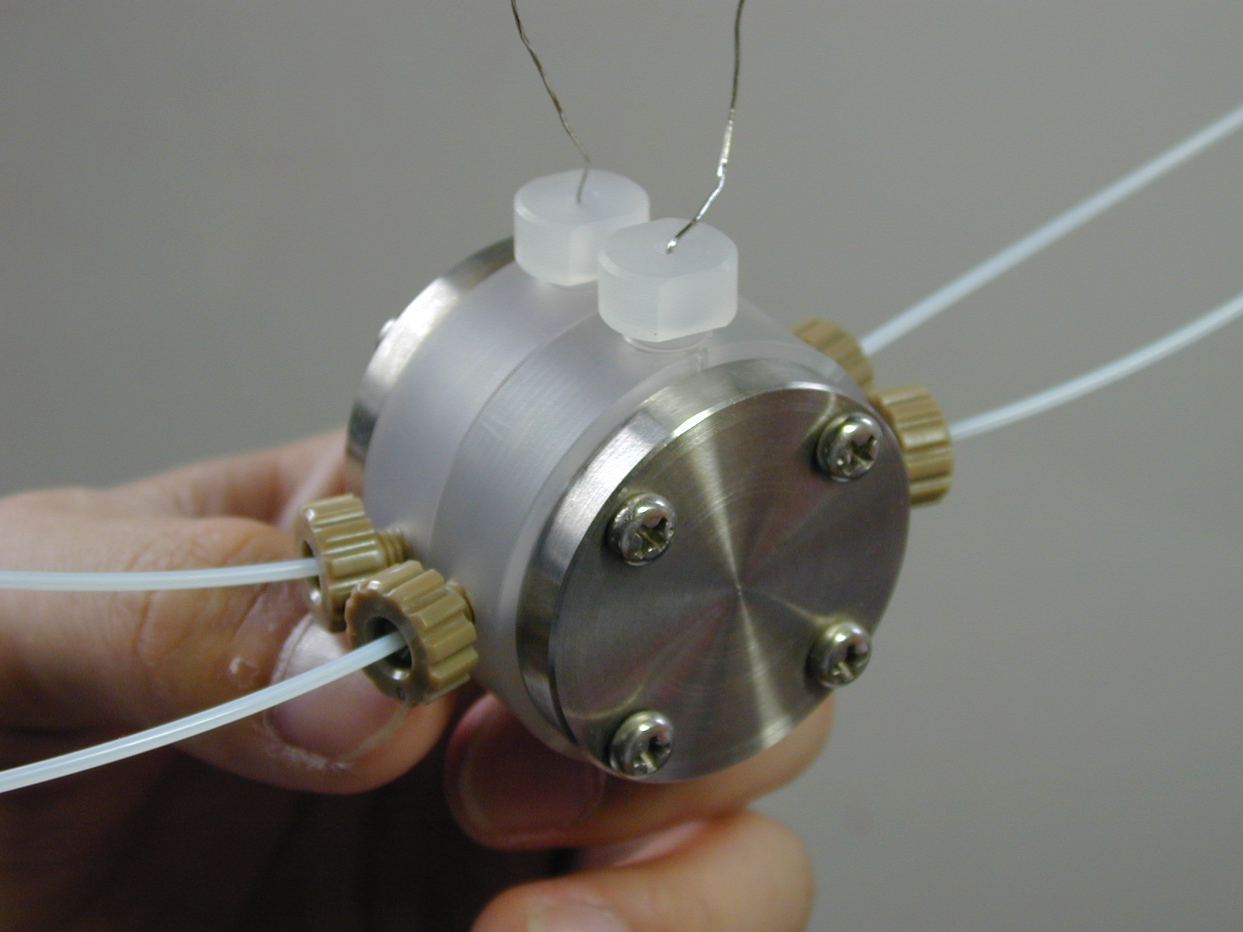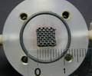
a b c
Fig. 1. Microflow electrochemical cell. a. exterior look of the reactor. b. inside the reactor. c. diagram of the system.

Typical Procedure for Microflow Electroorganic Synthesis without Supporting Electrolyte. Oxidation of p-Methoxytoluene (1). Before the electrolysis, a solution of trifluoromethanesulfonic acid in methanol (0.125 M, 0.5 mL) was introduced at the inlet to fill the anodic and cathodic chamber with the acidic solution. After that, a 0.05 M solution of 1 (31 mg, 0.25 mmol) in methanol (5 mL) was fed into the inlet of the anodic compartment (flow rate: 2 mL/h). The electrolysis was carried out under constant current condition (11 mA, 4.0 F/mol and 22 mA, 8.0 F/mol based on the starting material (1)) at room temperature (cooled in a water bath). The outlet solution was discarded until the neutral pH and the aliquots (1 mL) of the outlet solution were collected and analyzed by GC to determine the amount of the product p-methoxybenzaldehyde dimetylacetal (2) obtained.

The authentic samples of the acetal 2 were synthesized by the following procedure: p-methoxybenzaldehyde (2.04 g, 16 mmol) was dissolved in dry methanol (30 mL) under an argon atmosphere. TiCl₄ (28 mg, 0.15 mmol) was added at 0 ºC and the mixture was stirred for 15 minutes. After that time, Triethylamine (1.82 g, 18 mmol) was added at the same temperature with stirring. After 30 minutes, water (20 mL) was added and the organic material was extracted with diethyl ether (3x50 mL). After evaporation of the ether, p-methoxybenzaldehyde dimethylacetal was obtained by flash chromatography on neutral aluminum oxide (10% CH₂Cl₂/Hexane) follow by ball to ball distillation as a colorless liquid. (2.1 g, 62%). ¹H-NMR (CDCl₃, 400 MHz, δ/ppm): 3.29 (6H, s, OMe), 3.76 (3H, s, OMe), 5.32 (1H, s, CH), 6.86 (2H, d, J = 8.8 Hz, Ar), 7.34 (2H, d, J = 8.8 Hz, Ar); ¹³C-NMR (CDCl₃, 100 MHz, δ/ppm): 52.63 (OMe), 55.27 (OMe), 103.04 (CH acetal), 113.47 (Ar^{C}), 127.88 (Ar^{B}), 131.84 (Ar^{A}), 159.45 (Ar^{D}).

(2)

Oxidation of N-Methoxycarbonyl Pyrrolidine (3). The 0.05 M solution of the compound 3 (32 mg, 0.25 mmol) in methanol (5 mL) was used for the electrochemical methoxylation. The electrolysis was carried out at room temperature at a constant current (11 mA, 4.0 F/mol and 22 mA, 8.0 F/mol based on the starting material). The 1 mL aliquots was also analyzed by GC to determine the amount of N-methoxycarbonyl-2-methoxypyrrolidine (4) and N-methoxycarbonyl-2,5-dimethoxy- pyrrolidine (5) obtained.

The authentic samples of compounds 4 and 5 were obtained by the procedures described by Shono and co-workers.^{1,}

Oxidation of Acenaphthylene (6). 0.05 M solution of the title compound 6 (38 mg, 0.25 mmol) in methanol (5 mL) was used for the electrochemical methoxylation. The electrolysis was carried out at 50 ºC at a constant current (11 mA, 4.0 F/mol based on the starting material). The 1 mL aliquots was collected in the presence of triethyl amine (4 mg per aliquot) and analyzed by GC to determine the amount of the product 1,2-dimethoxyacenaphthene (7) obtained.

The authentic samples of 1,2-dimethoxyacenaphthene (7) was obtained by electrochemical methoxylation of the starting material in an undivided H-cell (20 ml) without cooling system. The supporting electrolyte solution was produced by adding by 0.4 g of Na in 20 mL of dry methanol and it was equally distributed in both compartments of the electrochemical cell. 6 (0.2g, 1.32 mmol) was added to the anodic compartment. The electrolysis was carried out with two platinum electrodes under a constant current of 150 mA. During electrolysis the temperature inside the electrochemical cell raised from 22 to 49 ºC. After 3 F/mol consumed, the solvent was evaporated and the organic material was extracted with diethyl ether (3x30 mL). After evaporation of ether, the desired product (7) was obtained after flash chromatography (5% ethyl acetate/ hexane) as red oil (68 mg, 24%) which contained a mixture of the cis and trans product. ¹H- and ¹³C-NMR was in accordance with the reported data.

T. Shono, Y. Matsumura and K. Tsubata. Org. Syn. Col., 1990, 7, 307.
A. Derici, N. Pastori and O. Porta. Tet., 1998, 54, 15679.
T. Shono, H. Hamaguchi and Y. Matsumura. J. Am. Chem. Soc., 1975, 97, 4262. T. Shono, Y. Matsumura, K. Tsubata, Y. Sugihara, S. Yamana, T. Kanazawa and T. Aoki, J. Am. Chem. Soc., 1982, 104, 6697.
Y. N. Ogibin, A. I. Ilovaiski and G. I. Nikishin. Electrochim. Acta, 1997, 42, 1933.

