Electronic Supplementary Information

X-ray structures of 5b and 5d

The common central unit of the conjugated oligomers is held in good planarity by strong H···F and S···F non-covalent contacts. For compound 5b (SI Fig 1) the H···F distances are 2.163 and 2.269 Å, whilst those for S···F are 2.707 and 2.721 Å (sum of the van der Waals radii: H + F = 2.67 Å, S + F = 3.27 Å). The minimum/maximum torsion angles between the benzene and adjacent thiophene rings are 0.52°/4.22°, respectively. The molecules pack into sheets in which the molecules are assembled in a ‘T-shape’. This arrangement is enforced by intermolecular contacts between hydrogens at the 5-positions of the terminal thiophene rings and the fluorine substituents on the benzene ring (H8···F3 = 2.420 Å, H28···F1 = 2.396 Å; see SI Fig 2). There are three weak π-π interactions in the structure of 5b, namely, an overlap between terminal thiophene units and the central tetrafluorobenzene ring and also interactions between related thiophene units bearing S3 atoms. The distances between ring centroids are in the range 3.626 – 3.896 Å.

The asymmetric unit of compound 5d features an inversion centre within the tetrafluorophenylene ring. In the asymmetric unit, one hexyl chain is perpendicular and the other is in the plane of the conjugated unit; there is also some disorder within the alkyl chains. The intramolecular H···F and S···F contacts are 2.210 Å and 2.704 Å and the maximum torsion angle between the thiophene and benzene ring is 1.99°. Compound 5d is more co-planar throughout the chain than 5b, with maximum torsion angles between adjacent thiophene rings at 4.08° for the former and 7.05° for 5b. In addition to the strong intramolecular contacts, oligomer 5d forms chains of molecules (Fig 1 in manuscript) through intermolecular S···S contacts (3.408 Å, van der Waals radii for S + S = 3.60 Å). The molecules are arranged in sheets in which parallel chains are insulated by the alkyl groups. In the third dimension (SI Fig 3), the pseudo-chains form slipped stacks; the mean co-facial distance between the chains is 3.557 Å. Within each stack, the hexyl substituents perpendicular to the pentaaryl unit are held in place by intermolecular H···F contacts with tetrafluorobenzene rings on adjacent molecules (H22···F3 = 2.588 Å, H20···F2 = 2.609 Å). The interactions described above give the material a unique 2-dimensional assembly of intermolecular contacts.

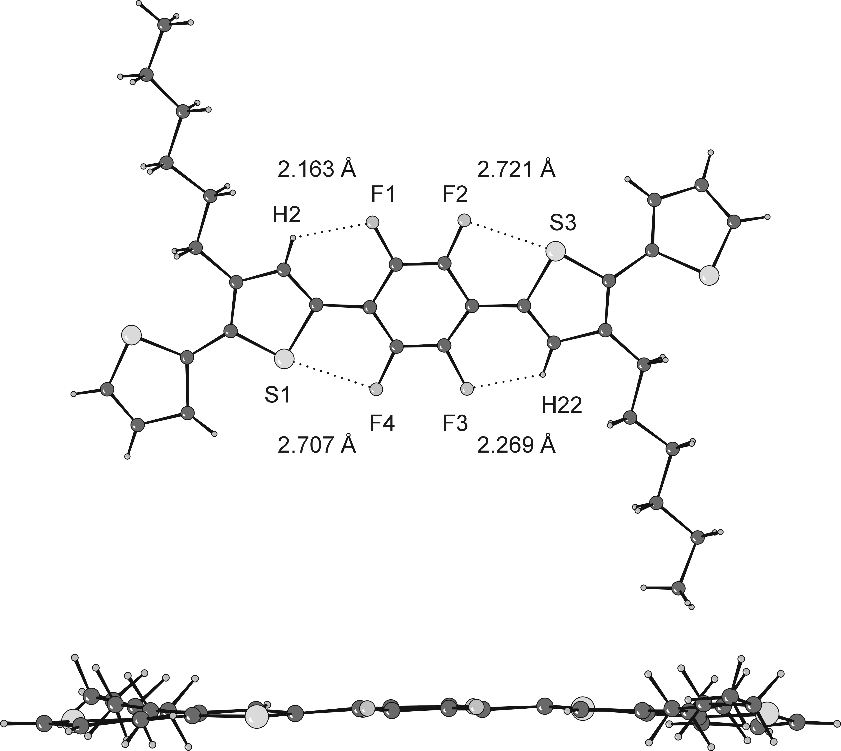

SI Fig 1 X-ray crystal structure of compound 5b, showing relevant intramolecular contacts and a ‘side-on’ view of the molecule.

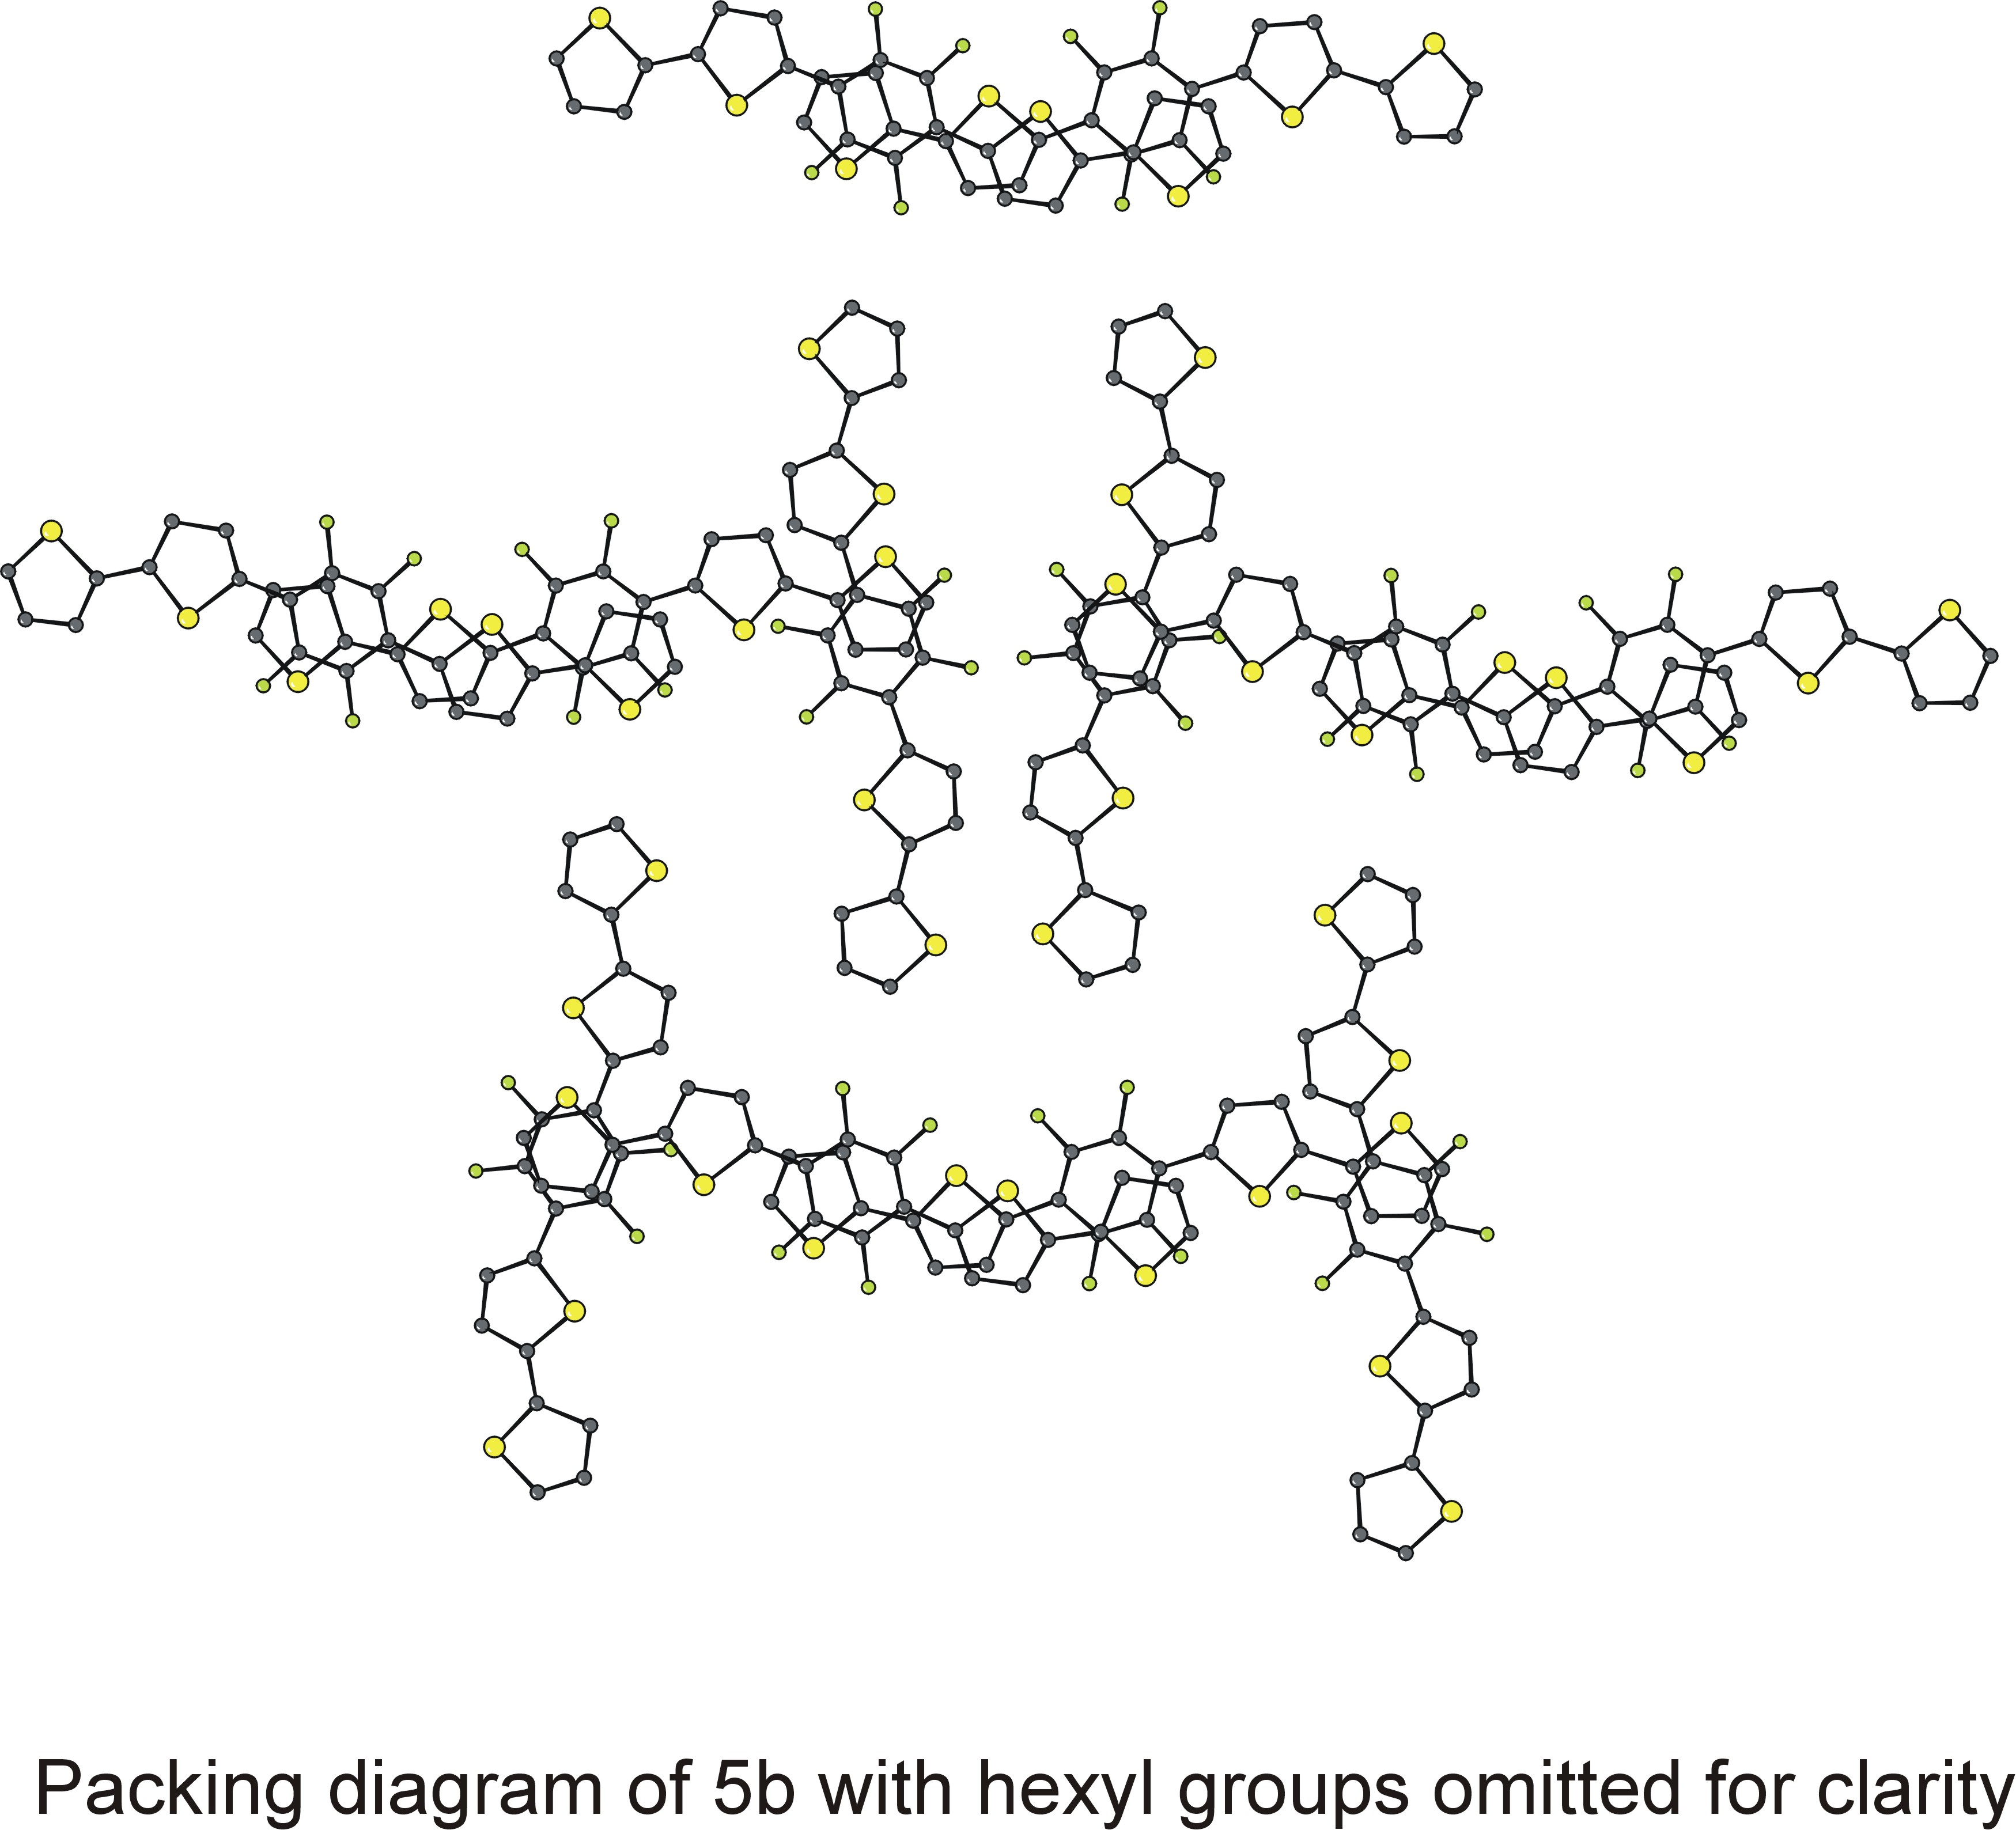

SI Fig 2
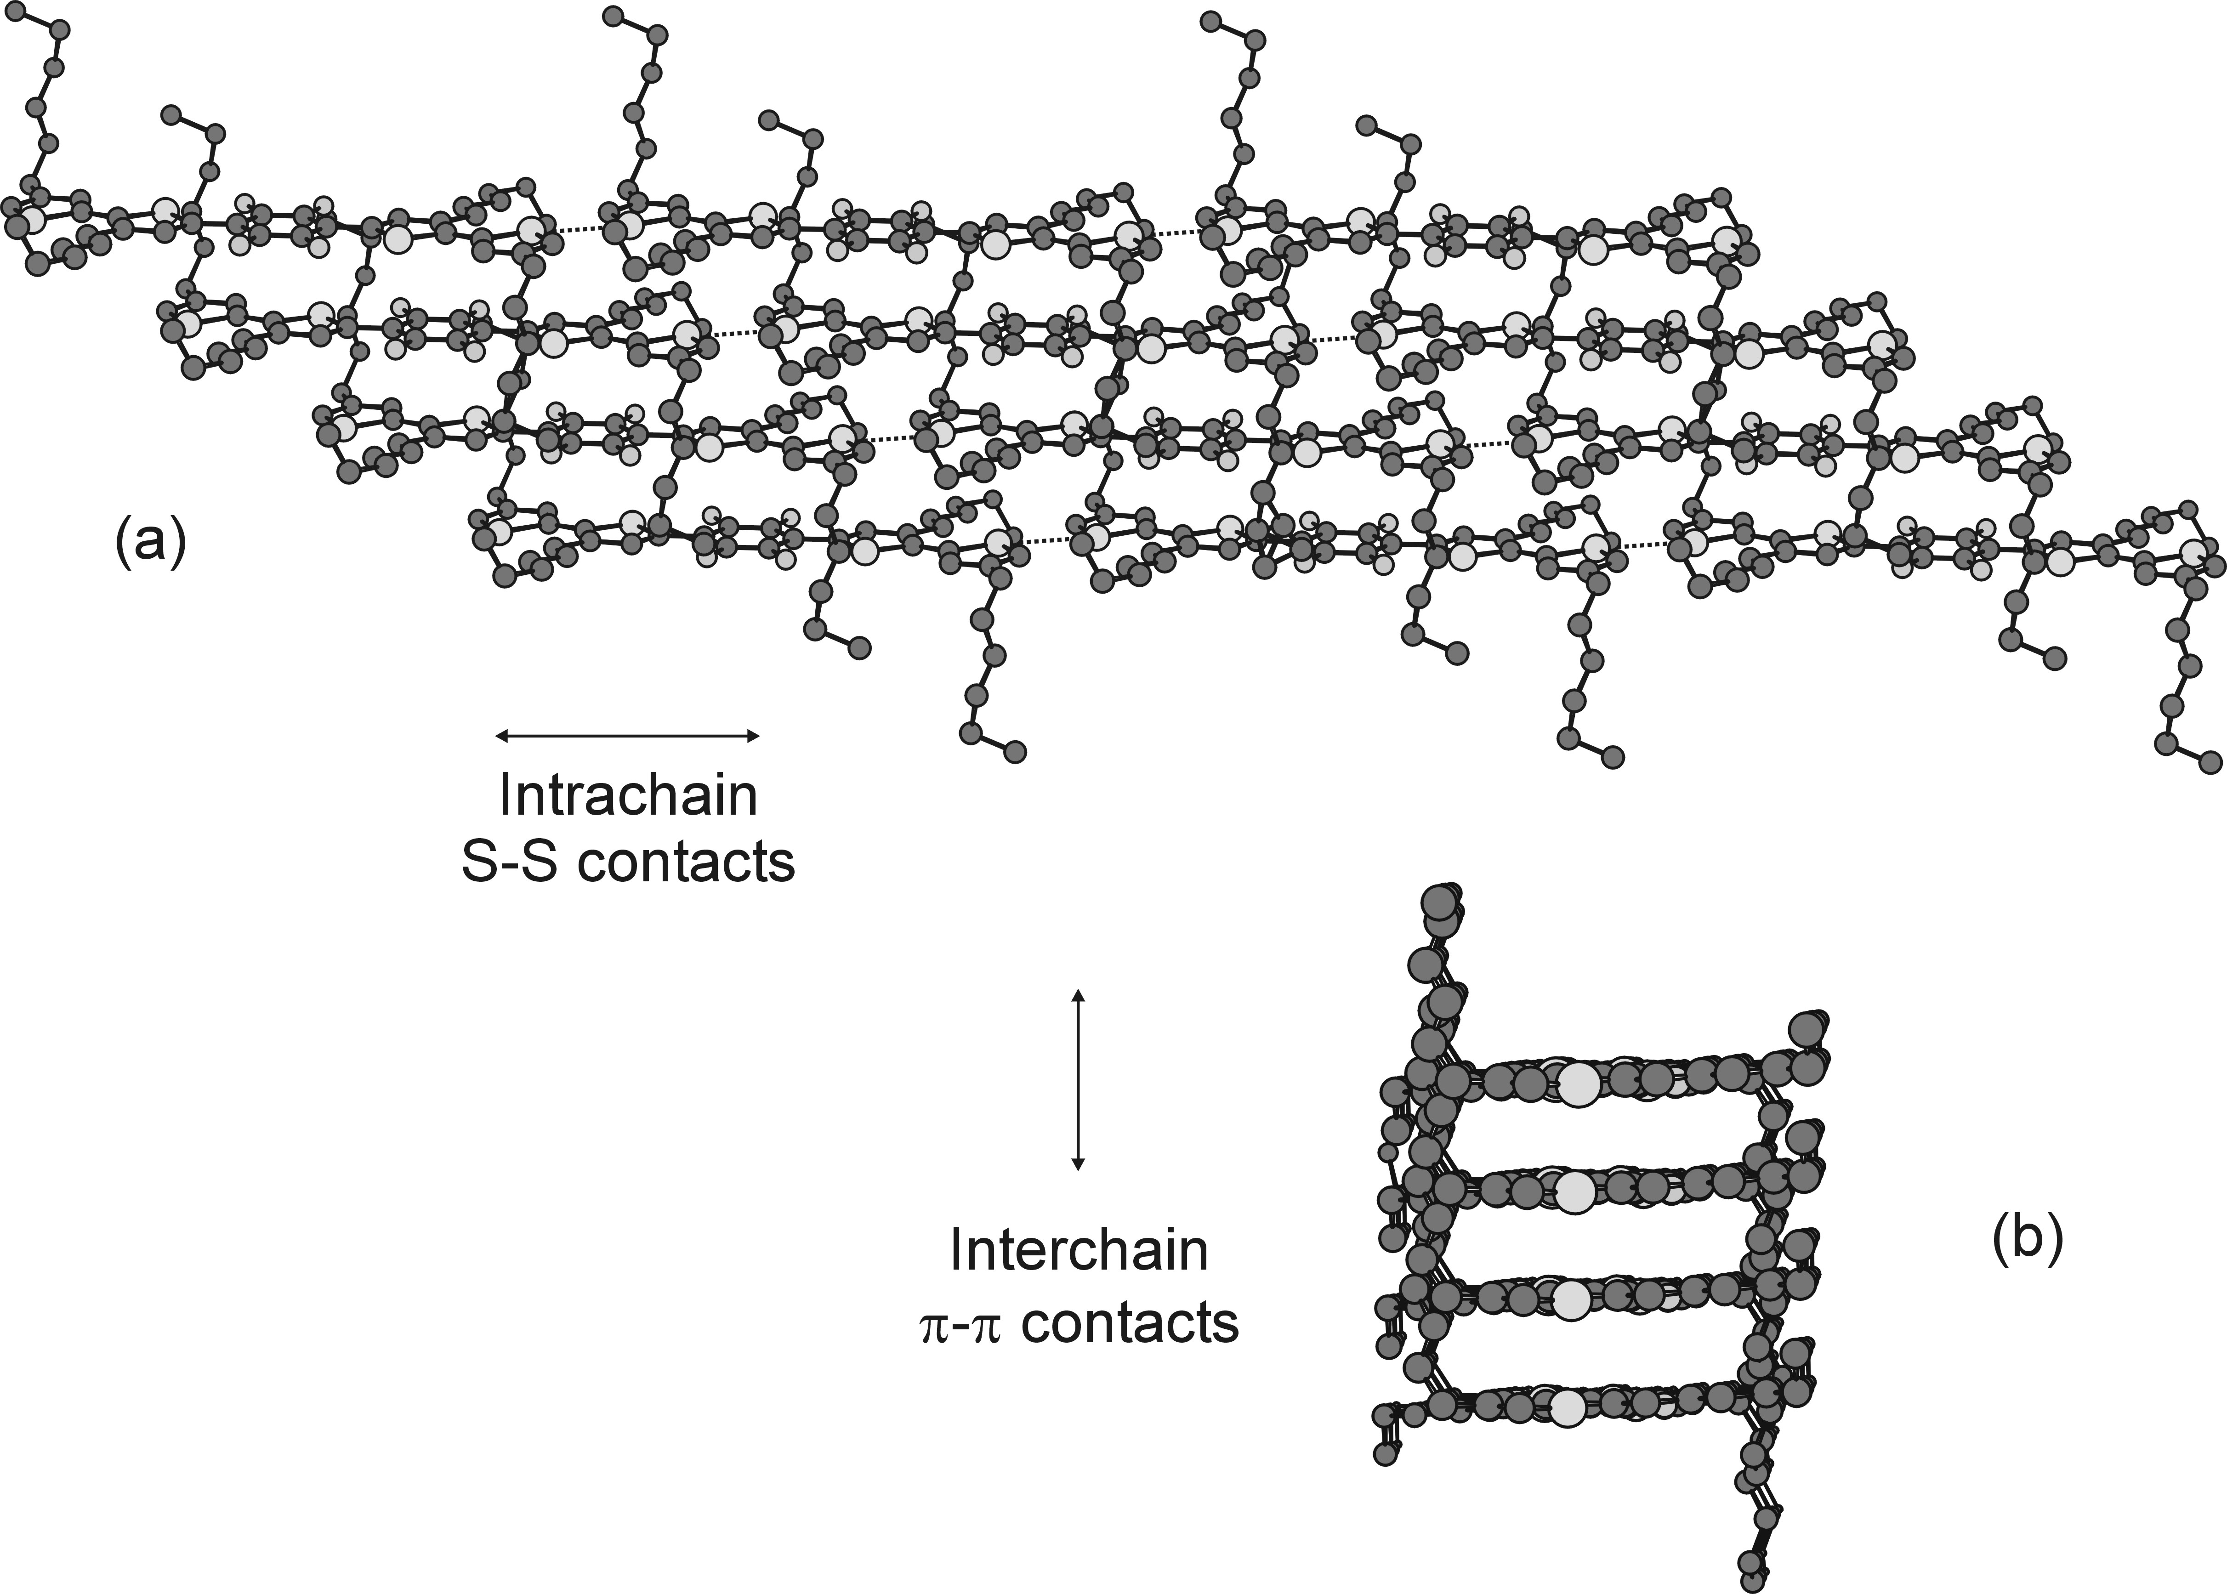

SI Fig 3 Compound 5d : assembly of chains and their ability to form 2-dimensional stacks through (a) intrachain and (b) intrastack contacts.

UV-vis absorption data

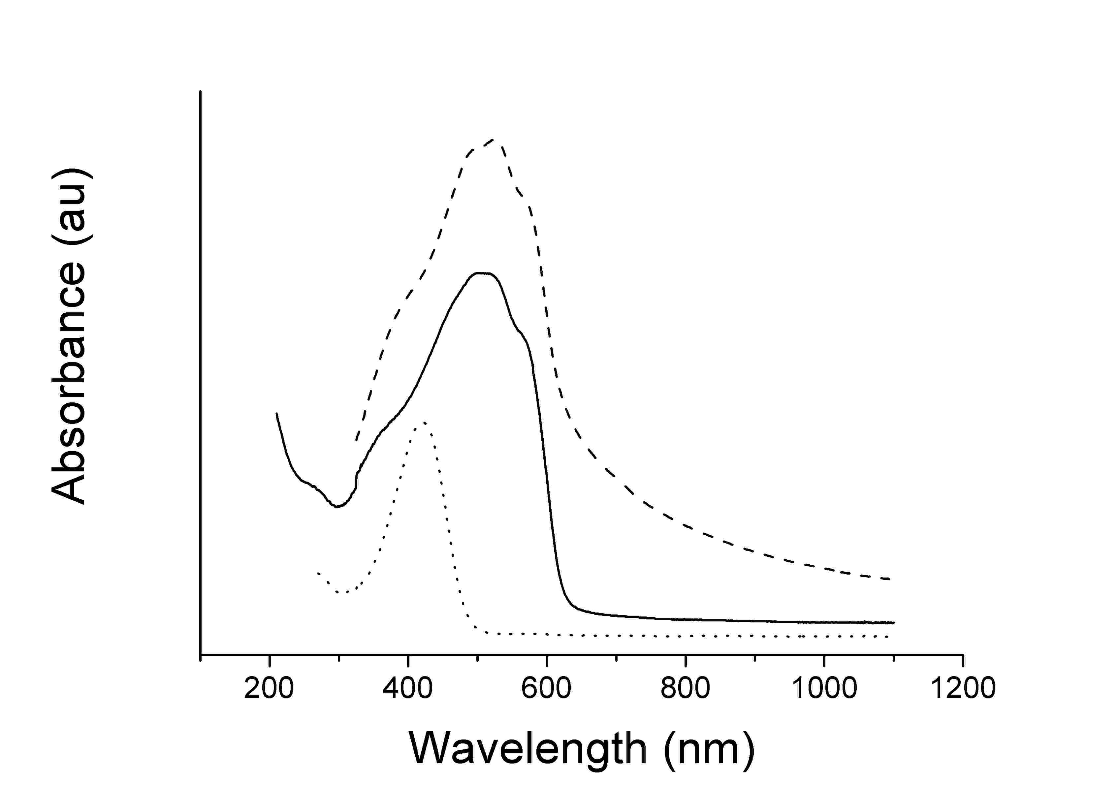
SI Fig 4 Absorption spectra of poly(5d) on ITO glass (—), 9 in chloroform (·····) and 9 on quartz (---).

Experimental conditions

X-ray crystallography

Data were collected at 120K on a Nonius KappaCCD area detector situated at the window of a rotating anode (λMo-k_{α} = 0.71073 Å). The structures were solved by direct methods, SHELXS-97, and refined using SHELXL-97. Hydrogen atoms were included in the refinement, but thermal parameters and geometry were constrained to ride on the atom to which they are bonded. The data were corrected for absorption effects using SORTAV.
5b C₃₄H₃₄F₄S₄, Tetragonal, P4₁2₁2, a = 20.5113(12), c = 14.2496(11) Å, volume = 5995(7) Å³, Z = 8, D_{c} = 1.433 Mg/m³, μ = 0.366 mm⁻¹, θ_{max} = 27.98°, 59088 measured, 6585 unique (R_{int} = 0.2283) and 4093 (I>2σ(I)) reflections, R1 (obs) = 0.1388 and wR2 (all data) = 0.3407, ρ_{max}/ρ_{min} = 0.734/-0.828 eÅ⁻³. 5d C₄₆H₅₈F₄S₄, Triclinic, P-1, a = 6.1497(2), b = 11.3722(8), c = 15.4457(10) Å, α = 91.678(3), β = 11.3722(8), γ = 102.556(4) °, volume = 1043.26(11) Å³, Z = 1, D_{c} = 1.297 Mg/m³, μ = 0.278 mm⁻¹, θ_{max} = 27.50°, 13381 measured, 4477 unique (R_{int} = 0.1914) and 3138 (I>2σ(I)) reflections, R1 (obs) = 0.0839 and wR2 (all data) = 0.2350, ρ_{max}/ρ_{min} = 0.919/-1.500 eÅ⁻³.
Full supplementary data have been deposited with the Cambridge Crystallographic Data Centre with deposition codes CCDC245178 and CCDC245177 for compounds 5b and 5d respectively .

The data quality for 5b is somewhat poor, with high r factors and irregular thermal parameters. Precession photographs on the H0L and HK0 planes show anomalous diffraction between reflections, indicating that there are stacking faults.

Compound 5d has a large residual electron density hole (-1.50 eÅ⁻³), which is situated 0.73 Å from S2.

Cyclic voltammetry

The polymer was grown from a CH₂Cl₂ solution (10⁻³ M substrate, 0.1 M tetrabutylammonium hexafluorophosphate), on ITO glass by repetitive cycling over the range 0.0 – +1.3 V and dedoped by cycling over the range -0.1 - +0.3 V for several hours in a monomer-free solution.

Device fabrication

Organic field-effect transistors were fabricated on highly doped silicon substrates with silicon oxide (SiO₂) insulating layer, where the substrate served as a common gate electrode. Source-drain gold electrodes were photolithographically defined on the SiO₂ layer. Prior to organic semiconductor deposition, FET substrates were treated with a silylating agent hexamethyldisilazane (HMDS). Polymer films were spin-coated from 0.5 wt% chloroform solution on FET substrates and then annealed at 150ºC. The electrical characterization of the transistor devices was carried out in a dry nitrogen atmosphere using Agilent 4155C Semiconductor Parameter Analyser.

