Supporting Information

for the manuscript


Dibenzo[a,d]cycloheptenyl Dibenzophosphole Palladium Dichoride: Synthesis, X-Ray-Crystal Structure and Application in the Suzuki-Myaura Coupling

by

Claire Thoumazet, ª Louis Ricard, ª Hansjörg Grützmacher,^{b} and Pascal Le Floch,*ª

ª Laboratoire “Hétéroéléments et Coordination”, UMR CNRS 7653, Departement de Chimie, Ecole Polytechnique, 91128 Palaiseau cedex, France. Fax: (+33).1.69.33.39.90; Tel: (+33).1.69.33.45.70; E-mail: lefloch@poly.polytechnique.fr.
^{b} Department of Chemistry and Applied Biology (D-CHAB), ETH Hönggerberg, Wolfgang-Pauli Str. 8093 Zürich, Switzerland. Fax: (+41).1.633.10.32.; Tel: : (+41).1.632.28.55.; E-mail: gruetzmacher@inorg.chem.eth.ch

Content

1°) General considerations.
2°) Syntheses and characterizations of P-H phosphole 1 and complex 3.
3°) General procedure for catalytic reactions.
4°) X-ray crystal structures of 2 and 3.

1°) General considerations.

All reactions were routinely performed under an inert atmosphere of argon or nitrogen by using Schlenk and glove-box techniques and dry deoxygenated solvents. Dry THF, ether and hexanes were obtained by distillation from Na/benzophenone. Dry dichloromethane was distilled on P₂O₅, dry toluene on Na and dry acetonitrile on CaH₂. Nuclear magnetic resonance spectra were recorded on a Bruker AC-300 SY spectrometer operating at 300.0 MHz for ¹H, 75.5 MHz for ¹³C and 121.5 MHz for ³¹P. Solvent peaks are used as internal reference relative to Me₄Si for ¹H and ¹³C chemical shifts (ppm); ³¹P chemical shifts are relative to a 85% H₃PO₄ external reference. Coupling constants are given in Hertz. The following abbreviations are used: s, singlet; d, doublet; t, triplet; m, multiplet; v, virtual. Mass spectra were obtained at 70 eV with a HP 5989B spectrometer coupled to a HP 5980 chromatograph by the direct inlet method. Elemental analyses were performed by the "Service d'analyse du CNRS", at Gif sur Yvette, France. [Pd(COD)Cl2]^{[1]}, P-phenyl-dibenzophosphole^{[2]}, and dibenzo[a,d]cyclohepten-5-yl chloride^{[3]} were prepared according to literature procedures. All other reagents and chemicals were obtained commercially and used as received.

2°) Syntheses and characterizations of P-H phosphole 1 and complex 3.

Synthesis of P-H dibenzophosphole 1:^{[4]} a solution of P-phenyl-dibenzophospholide anion was prepared from lithium (50 mmol, 0.35 g) and P-phenyl-dibenzophosphole (3.84 mmol, 1g) in THF (5mL). The solution turned brown and the progress of the reaction was followed by NMR. After completion (~ 3 hours), the excess of lithium was removed and a solution of HCl in ether 1M was added (1eq, 3.85 mL). The solution became colorless. The solvent was evaporated and the product was extracted in hexanes to remove traces of oxide. After evaporation of the solvent, the P-H-dibenzophosphole 1, very air and moisture sensitive, was obtained as a white solid (0.56 g, 80 %). ³¹P NMR (121.5 MHz, THF, 25°C) = δ -68.

Synthesis of complex 3: to a solution of ligand 2 (0.5 mmol, 200 mg) in dichloromethane (5 mL) was added [Pd(COD)Cl₂] (1 eq, 152 mg). The solution turned yellow and the formation of complex 3 was determined by ³¹P NMR. After stirring 10 minutes at room temperature, the solvent was removed and complex 3 was filtrated in THF to yield a yellow solid (250 mg, 95%). Crystallization was achieved from hot dichloromethane. ³¹P NMR (121.5 MHz, CD₂Cl₂, 25°C): δ 98. ¹H NMR (300 MHz, CD₂Cl₂, 25°C, TMS ): δ 4.49 (d, J_{PH} = 15.6 Hz, 1H, H₁₃), 6.23 (dvd, AA’XX’, Σ J = 16.7 Hz, 2H, H₅-H₈), 7.06 (dvdd, AA’XX’, Σ J = 10.0 Hz, 2H, H₁₅-H₂₆), 7.15 (dvdt, AA’XX’, Σ J = 20.2 Hz, 2H, H₃-H₁₀), 7.35 (s, 2H, H₂₀-H₂₁), 7.54 (m, 6H, H₁₇-H₂₄, H₁₆-H₂₅ and H₄-H₉), 7.85 (m, 4H, H₁₈-H₂₃ and H₂-H₁₁); ¹³C NMR (75.5 MHz, CD₂Cl₂, 25°C) δ 53.3 (C₁₃), 100.6 (s, C₂₀-C₂₁), 122.0 (d, J_{PC} = 6.5 Hz, C₂-C₁₁), 129.3 (d, J_{PC} = 11.0 Hz, C₃-C₁₀), 129.7 (d, J_{PC} = 1.3 Hz C₁₆-C₂₅), 130.1 (d, J_{PC} = 6.6 Hz, C₁₅-C₂₆), 130.5 (d, J_{PC} = 12.3 Hz, C₅-C₈), 131.6 (s, C₁₇-C₂₄), 131.8 (d, J_{PC} = 1.0 Hz, C₁₈-C₂₃), 133.3 (d, J_{PC} = 7.8 Hz, C₁₉-C₂₂), 133.7 (d, J_{PC} = 2.4 Hz, C₄-C₉), 135.5 (d, J_{PC} = 3.0 Hz, C₁₄-C₂₇), 143.0 (d, J_{PC} = 10.6 Hz, C₁-C₁₂), missing signal C₆-C₇.

3°) General procedure for catalytic reactions.

Method A: preparation of the catalyst was achieved by dilution of 3 (3 mg, 0.0056 mmol) in dichloromethane (30 mL) at room temperature under inert atmosphere. 22 μL (0.0001%) of the solution was taken with a syringe, poured into a Schlenck tube, and the solvent was evaporated. The Schlenk tube was then filled with phenylboronic acid (6 mmol, 731.6 mg), K₂CO₃ (8 mmol, 1.1 g) and the halogenoarene (4 mmol) in toluene (6 mL). The mixture was heated at 100 °C. The progress of the reaction was monitored by GC. When the reaction reached completion, a small amount of silica gel was added and the solvent was evaporated in vacuo. The product was then isolated by column chromatography on silica gel (petroleum ether) and characterized by comparison with literature.
Table 1:
Entry Substrate | mol% 3 | t(h) | T(°C) | GC(%)ª | Yield(%)^{b} | TON
1 bromobenzene | 0.0001 | 14 | 100 | 99.9 | 96 | 9.9 10⁵
2 bromobenzene | 0.0005 | 2 | 100 | 94.5 | 93 | 1.9 10⁵
3 bromobenzene | 0.00001 | 21 | 100 | 8.3 | 7 | 8.3 10⁵
4 4-bromotoluene | 0.0001 | 14 | 100 | 81 | 76 | 8.1 10⁵
5 4-bromoanisole | 0.0001 | 14 | 100 | 39 | 38 | 3.9 10⁵
6 4-bromoacetophenone | 0.0001 | 14 | 100 | 63 | 61 | 6.3 10⁵
ªBased on GC analysis with external standards ^{b}Isolated yields by column chromatography; products fully characterized by NMR and MS by comparison with literature data

Bromobenzene (table 1, entry 1-3)^{[5]}: the procedure afforded 592 mg (96%) of the title compound.
4-bromotoluene (table 1, entry 4)^{[5]}: the procedure afforded 514 mg (76%) of the title compound.
4-bromoanisole (table 1, entry 5)^{[5]}: the procedure afforded 281 mg (38%) of the title compound.
4-bromoacetophenone (table 1, entry 6)^{[6]}: the procedure afforded 481 mg (61%) of the title compound.

Method B: the catalyst 3 (5.5 mg, 1%), phenylboronic acid (1.4 mmol, 170.7 mg), KO^{t}Bu (1.5 mmol, 168.3 mg) and the chlorobenzene (1 mmol, 102μL) were mixed in iPrOH (1.5 mL). The mixture was stirred at ambiant temperature and the progress of the reaction was monitored by GC. Purification was carried out as above.
Table 2:
Entry Substrate | mol% 3 | t(h) | T(°C) | GC(%)ª | Yield(%)^{b} | Benzene GC (%)ª | TON
1 chlorobenzene | 2 | 96 | RT | 32.4 | 31 | 47.6 | 16.2
2 chlorobenzene | 1 | 16 | 50 | 14.6 | 13 | 55.7 | 14.6
3 bromobenzene | 1 | 2 | RT | 81.6 | 81 | 7.5 | 81
4 bromobenzene | 0.1 | 2 | RT | 62.2 | 61.5 | - | 615
5 bromobenzene | 0.1 | 3 | RT | 77.6 | 76 | 1.2 | 776
6 bromobenzene | 0.01 | 12 | 60 | 91.3 | 90 | 5.5 | 9130
ªBased on GC analysis with external standards ^{b}Isolated yields by column chromatography; products fully characterized by NMR and MS by comparison with literature data.

4°) X-ray crystal structures of 2 and 3.

X-ray structure data : Nonius KappaCCD diffractometer, φand ωscans, MoKαradiation (λ = 0.71073Å), graphite monochromator, T = 150K, structure solution with SIR97^{[7]}, refinement against F² in SHELXL97^{[8]} with anisotropic thermal parameters for all non-hydrogen atoms, calculated hydrogen positions with riding isotropic thermal parameters.

Crystal data for 2 (C₂₇H₁₉P): colorless plate, 0.18x0.16x0.12 mm; monoclinic, P2₁/c, a = 10.4290(10) , b = 10.1650(10) , c = 18.9660(10) (Å), β= 101.6900(10) , V = 1968.9(3) Å³, Z = 4 , d = 1.263 g.cm⁻³, μ= 0.149 cm⁻¹, F(000) = 784 , θmax = 30.02 °, HKL ranges: -14 14 ; -12 14 ; -26 26, 9121 data collected, 5724 unique data (Rint = 0.0184 ), 4173 data with I > 2σ(I), 254 parameters refined, GoF(F²) = 1.096, final R indices (R1 = Σ||F_{o}| - |Fc||/Σ|Fo|, wR2 = [Σw(F_{o}²- F_{c}²)²/Σw(F_{o}²)²]^{1/2}): R1 = 0.0526, wR2 = 0.1697, max/min residual electron density 1.667(0.057) / -0.383(0.057) eA⁻³.
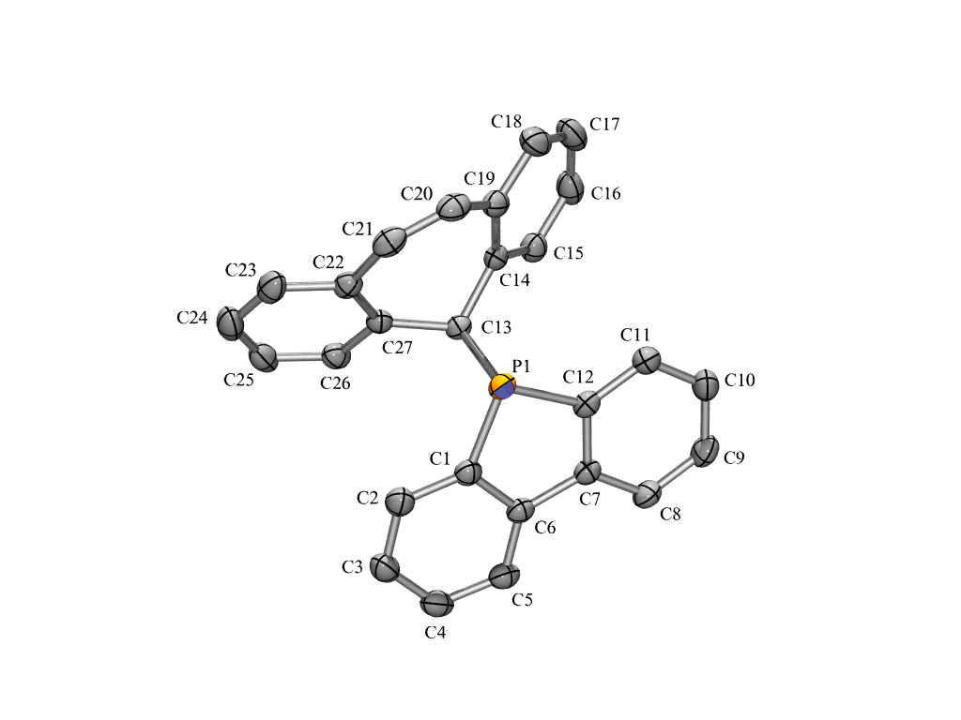
Crystal data for 3 (C₂₇H₁₉Cl₂PPd,2(CH₂Cl₂)): yellow plate, 0.22x0.22x0.16 mm; orthorhombic, P2₁2₁2₁, a = 10.3990(10), b = 15.8850(10), c = 17.0640(10) Å, V = 2818.8(4) Å³, Z = 4 , d = 1.700 g.cm⁻³ , μ= 1.304 cm⁻¹, F(000) = 1440, θmax = 30.03 °, HKL ranges: -14 14 ; -22 22 ; -23 24, 8152 data collected, 8152 unique data (Rint = 0.0000 ), 6850 data with I > 2σ(I), 353 parameters refined, GoF(F²) = 1.017, final R indices (R1 = Σ||F_{o}| - |Fc||/Σ|Fo|, wR2 = [Σw(F_{o}²- F_{c}²)²/Σw(F_{o}²)²]^{1/2}): R1 = 0.0356, wR2 = 0.0858, max/min residual electron density 0.906(0.088) / -0.826(0.088) eA⁻³.

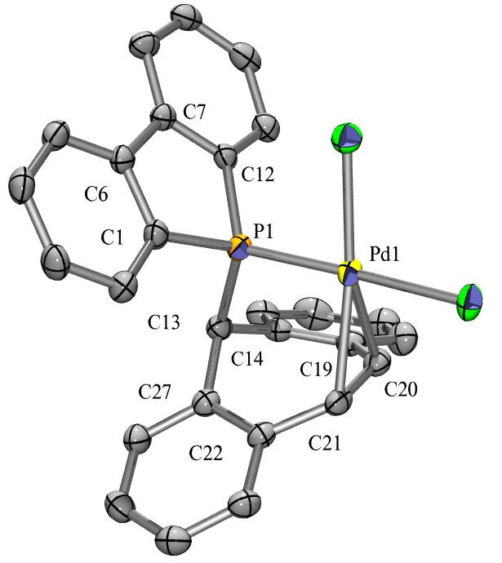

Crystallographic data for the structures reported in this paper have been deposited with the Cambridge Crystallographic Data Center as supplementary publications no. CCDC 256941 and CCDC 256942. Copies of the data can be obtained free of charge on application to CCDC, 12 Union Road, Cambridge CB21EZ, UK (fax (+44)1223-336-033 ; e-mail : deposit@ccdc.cam.ac.uk).

References:
[1] D. Drew, J. R. Doyle, in Inorganic Syntheses, Vol. 28 (Ed.: R. J. Angelici), 1990, pp. 348.
[2] S. Affandi, R. L. Green, B. T. Hsieh, M. S. Holt, J. H. Nelson, Synth. React. Inorg. Met.-Org. Chem. 1987, 17, 307.
[3] J. Thomaier, S. Boulmaâz, H. Schönberg, H. Rüegger, A. Currao, H. Grützmacher, H. Hillebrecht, H. Pritzkow, New J. Chem. 1998, 947.
[4] E. H. Braye, I. Caplier, R. Saussez, Tetrahedron 1971, 27, 5523.
[5] M. S. C. Rao, G. S. K. Rao, Synthesis 1987, 231.
[6] I. Barba, R. Chinchilla, C. Gómez, Tetrahedron 1990, 46, 7813.
[7] A. Altomare, M. C. Burla, M. Camalli, G. Cascarano, C. Giacovazzo, A. Guagliardi, A. G. G. Moliterni, G. Polidori, R. Spagna, SIR97, an integrated package of computer programs for the solution and refinement of crystal structures using single crystal data.
[8] G. M. Sheldrick, SHELXL-97, Universität Göttingen, Göttingen, Germany, 1997.

