Electronic Supplementary Information for

Anisotropic assembly of gold nanorods assisted by selective ion recognition of surface-anchored crown ether derivatives
(NTT Basic Research Labs)
Hiroshi Nakashima, Kazuaki Furukawa, Yoshiaki Kashimura and Keiichi Torimitsu

1. Synthesis of gold nanorods (NRs). The gold NRs were prepared by a combination of the chemical reduction of HAuCl₄ and a subsequent photochemical reaction.^{S1} 65 μL of acetone, 45 μL of cyclohexane, and 100 μL of silver nitrate solution (10 mM) were added to 3 mL of the reaction solution containing cetyltrimethylammonium bromide (CTAB) (80 mM) and hydrogen tetrachloroaurate (III) tetrahydrate (2 mM). Next, 200 μL of ascorbic acid solution (40 mM) was added to the reaction solution, which instantaneously changed the reaction solution from pale yellow to colourless. Subsequently, an aliquot of the reaction solution was placed in a quartz cell (optical path length: 1 cm), and the cell was then irradiated with ultraviolet (UV) light from an UV light source (Hoya-Schott, HLS100UM) through a bandpass filter (Sigma UTVAF-50S-33U) with moderate stirring. After irradiation for 10 minutes, a dark-brown, crude gold NR solution was produced. The obtained gold NRs were purified by centrifuging 1.5 mL of the NR solution in a tube for 15 minutes at 10000 rpm and 10 ˚C to precipitate the solid, and then the supernatant was removed. The residue was redispersed in 1.5 mL of DI water. This purification process was repeated twice to eliminate excess CTAB.
The obtained gold NRs were fairly uniform in shape (rod length: 40-45 nm, rod width: 10-15 nm, average aspect ratio: 3.9) and exhibited two plasmon absorption maxima around 700 and 520 nm, corresponding to a longitudinal mode and a transverse mode, respectively.

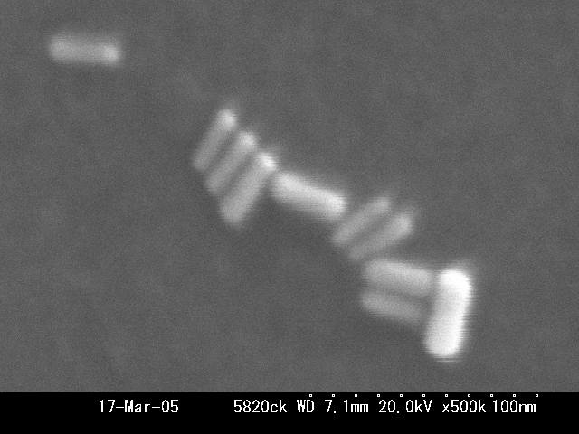
Fig. S1. SEM image of obtained gold nanorods. Scale bar: 50 nm.
Fig. S2. Absorption spectrum of obtained gold nanorods in water.

2. Synthesis of thiol-modified crown ether derivatives. All reactions were conducted in an argon atmosphere. The thiol-modified crown ether derivatives were synthesized according to a previously reported method.^{S2}

2-1. 2-[(6-Bromohexyl)oxy]methyl-12-crown-4 (1). A suspension of 2-(hydroxymethyl)-12- crown-4 (1.00 g, 4.85 mmol) and sodium hydride (60% dispersion in mineral oil; 0.50 g, 12.5 mmol) in DMF (10 mL) was stirred at room temperature. After 30 min, 1,6-dibromohexane (5.92 g, 24.3 mmol) was added, and the reaction mixture was stirred overnight. Subsequently, the reaction was quenched with methanol, and the solvent was evaporated under reduced pressure. The residue was taken up in CH₂Cl₂ (100 mL) and washed with water (3 × 100 mL). The mixture was dried over MgSO₄, and then the solution was filtered and evaporated. The residue was purified by column chromatography (SiO₂, hexane/EtOAc 1:1) to yield 1 as a colourless oil (1.50 g, 83.7%): ¹H NMR (δ = ppm; 300 MHz; CDCl₃; Me₄Si) 1.29-1.48 (m, 4H), 1.50-1.64 (m, 2H), 1.79 (t, 2H), 3.31-3.48 (m, 7H), 3.57-3.82 (m, 14H); ¹³C NMR (δ = ppm; 75.43 MHz; CDCl₃; Me₄Si) 25.29, 27.95, 29.40, 32.69, 33.88, 70.16, 70.34, 70.64, 70.86, 70.92, 71.47, 71.76, 78.57.

2-2. 2-[(6-Mercaptohexyl)oxy]methyl-12-crown-4 (2). A solution of 1 (1.00 g, 2.71 mmol) and thiourea (1.00 g, 13.8 mmol) in ethanol (62.5 mL) was heated under reflux overnight. The solvent was evaporated under reduced pressure. Potassium hydroxide (1.00 g, 17.5 mmol) in water was added to the residue, and the reaction mixture was heated under reflux for 2 h. After acidifying the mixture with 1 M HCl, CH₂Cl₂ (100 mL) was added and the organic layer was washed with water (3 × 100 mL). The mixture was dried over MgSO₄, and then the solution was filtered and evaporated. The residue was purified by column chromatography (SiO₂, hexane/EtOAc 1:3) to yield 2 as a colourless oil (0.35 g, 40.2%): ¹H NMR (δ = ppm; 300 MHz; CDCl₃; Me₄Si) 1.29-1.46 (m, 4H), 1.50-1.70 (m, 5H), 2.51 (q, 2H), 3.35-3.55 (m, 5H), 3.60-3.90 (m, 14H); ¹³C NMR (δ = ppm; 75.43 MHz; CDCl₃; Me₄Si) 24.56, 25.59, 28.16, 29.50, 33.95, 70.27, 70.42, 70.73, 70.90, 71.00, 71.52, 71.85, 78.69; EI MS m/z 322 (calcd. for C₁₅H₃₀O₅S₁ 322.4); IR (cm⁻¹, neat, KBr) 2931, 2858 (C-H), 2555 (S-H), 1131 (C-O) cm⁻¹.

2-3. 2-[(6-Mercaptohexyl)oxy]methyl-15-crown-5 (3). This compound was synthesized from 2-(hydroxymethyl)-15-crown-5 by alkylation with 1,6-dibromohexane (analogous to the synthesis of 1), followed by conversion of the bromide into thiol (analogous to the synthesis of 2). The crude product was purified by column chromatography (SiO₂, hexane/EtOAc 1:3) to give 3 as a colourless oil (18.6% from 2-(hydroxymethyl)-15-crown-5): ¹H NMR (δ = ppm; 300 MHz; CDCl₃; Me₄Si) 1.30-1.45 (m, 5H), 1.53-1.72 (m, 4H), 2.51 (q, 2H), 3.42-3.49 (m, 5H), 3.57-3.88 (m, 18H); ¹³C NMR (δ = ppm; 75.43 MHz; CDCl₃; Me₄Si) 24.56, 25.58, 28.15, 29.49, 33.95, 70.25, 70.54, 70.58, 70.77, 70.92, 71.04, 71.05, 71.43, 71.58, 78.72; EI MS m/z 366 (calcd. for C₁₇H₃₄O₆S₁ 366.5); IR (cm⁻¹, neat, KBr) 2929, 2860 (C-H), 2555 (S-H), 1118 (C-O) cm⁻¹.

3. Control experiments: Absorption spectra of non-functionalised gold NRs and spherical gold nanoparticles (no crown ethers) on addition of NaCl solution.
(A)
(B)
Fig. S3. Absorption spectral change of (A) gold nanorods (rod length: 40-45 nm, rod width: 10-15 nm, average aspect ratio: 3.9) and (B) spherical gold nanoparticles (particle size: 20-30 nm) with no surface crown ethers on addition of 5, 10, 20, 30 μL of NaCl solution (1 mM) as control experiments.

4. End-to-end assembly of a complex of gold NRs with crown ether derivatives induced by the ion recognition process.
We successfully visualized the anisotropic end-to-end assembly of a number of crown ether functionalised gold NRs by the ion recognition process on a silicon substrate by SEM.
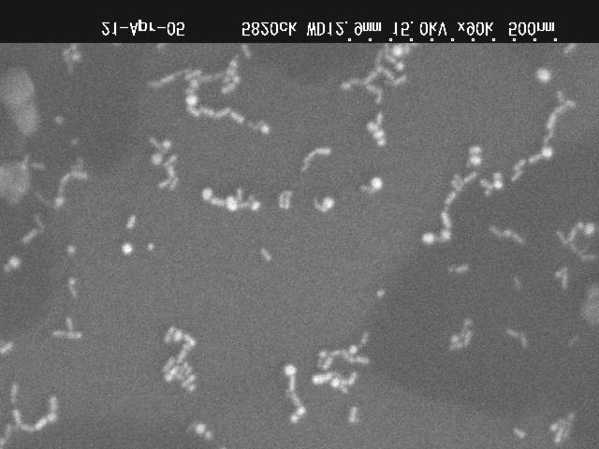
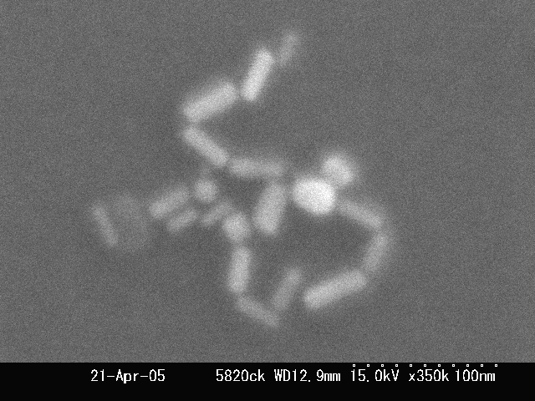
Fig. S4. SEM image of the end-to-end assembled gold nanorods induced by the formation of sandwich complex of surface-anchored 15-crown- 5-SH with K⁺. Scale bar: 100 nm.

5. Differences in the absorption maximum shift of the longitudinal mode of gold NR complex on the addition of 12-crown-4-SH/Na⁺ (Fig.2(A)) and 15-crown-5-SH/K⁺ (Fig.1(B)).
In Fig.2(A), the 12-crown-4-SH/Na⁺ system did not show a distinct red shift of the absorption maximum compared with Fig.1(B) (15-crown-5-SH/K⁺ system). However, the absorption maximum of the longitudinal mode in Fig.2(A)did not decrease monotonically but maintained a certain maximum wavelength (ca. 695 nm) because of the concentration of [Na⁺] = 3 ×10⁻⁵ [M]. The difference between Fig.1(B) and Fig.2(A) may depend on the number of oxygen atoms in the crown cavity. The 12-crown-4 has only four oxygen atoms in the cavity and thus the binding force of 12-crown-4 against cations is weaker than that of 15-crown-5 (containing five oxygen atoms). This is attributed to the unstable and flexible end-to-end gold nanorod connection in the 12-crown-4-SH/Na⁺ system, which is the reason for there being no noticeable red shift of the absorption peaks.
Fig. S5. Absorption peak wavelength at λ_{max} of the longitudinal mode of gold nanorods with 12-crown-4-SH as a function of Na⁺ concentration.

6. Method for synthesising the gold NR complex with crown ether derivatives.
The experimental method in which the crown ethers should initially attach to the gold nanorod surfaces and then metal ions should be added into the nanorod complex solution is considered to be the standard approach. Although we initially tried this approach, the synthesised crown ethers did not dissolve in water, but only dissolved in organic solvents such as hexane and tetrahydrofuran. The gold nanorods aggregated and precipitated easily in the organic solvents, since CTAB was removed from the gold nanorod surfaces in the organic solvents and thus the nanorods could not maintain a stable dispersion. (We also tried using DMSO, alcohol and acetone, which are compatible with water, but this approach also failed.) However, when we used aqueous NaCl solution or KCl solution, the crown ethers were dispersed in water, since oxygen atoms in the crown cavity might contain a negative charge induced by cations (positive charge) in the water. Therefore, on this occasion we employed the experimental method described above. We only changed the amounts of the solution including the crown ethers and cations that we added to the gold nanorod solution (the ratio of [crown]/[metal] was fixed at 1). The ratio change of [crown]/[metal] in nanorod solution is crucial in terms of the plasmonic nanosensor sensitivity, however here we did not investigate [crown]/[metal] due to the many and complicated parameters. This subject is our next essential work.

References
S1. (a) F. Kim, J. H. Song and P. Yang, J. Am. Chem. Soc., 2002, 124, 14316. (b) Y. Niidome, K. Nishioka, H. Kawasaki and S. Yamada, Chem. Commun., 2003, 2376.
S2. Flink, B. A. Boukamp, A. Berg, F. C. J. M. Veggel and D. N. Reinhoudt, J. Am. Chem. Soc., 1998, 120, 4652.

