Supporting Information

Trityl-nitroxide biradicals as unique molecular probes for the simultaneous measurement of redox status and oxygenation
Yangping Liu,† Frederick A. Villamena,†,‡ Antal Rockenbauer§ and Jay L. Zweier†,*
†Center for Biomedical EPR Spectroscopy and Imaging, The Davis Heart and Lung Research Institute, the Division of Cardiovascular Medicine, Department of Internal Medicine and ‡Department of Pharmacology, College of Medicine, The Ohio State University, Columbus, OH, 43210, USA, §Chemical Research Center, Institute of Structural Chemistry, P.O. Box 17, H-1525 Budapest, Hungary.
* Email: Jay.Zweier@osumc.edu

Supplementary Materials Table of Contents

I. EPR Spectroscopy | S2
II. Determination of J-coupling values of biradicals | S2
III. Reaction of biradicals with ascorbic acid detected by EPR spectroscopy | S3-5
IV. Reaction of biradicals with ascorbic acid detected by UV-vis spectroscopy | S6
V. Kinectic study of biradicals with ascorbic acid detected by EPR spectroscopy | S7-10
VI. Oxygen sensitivity | S11
VII. Spin density distribution on the basis of theoretical calculation at the B3LYP/6-31+G(d,p)//HF/3-21G(d) level of theory | S12-19
VIII. Synthesis | S20-22

I. EPR spectroscopy
EPR spectra were recorded at room temperature using Bruker EMX X-band spectrometer with high sensitivity resonator. The following acquisition parameters were used in the data acquisition: modulation frequency, 100 kHz; microwave frequency, 9.85 GHz; modulation amplitude, 0.03-0.2 G; time constant, 10-41 ms; scan time, 10-42 s; and microwave power, 1-5 mW.
II. Determination of J-coupling values of biradicals
In order to determine the J values and the confidence intervals, a complete parameter adjustment we carried out using an EPR simulation program (Rockenbauer, A. and Korecz, L. (1996) Automatic computer simulations of ESR spectra. Appl. Magn. Reson. 10, 29-43). The following parameters were optimized: g₁, g₂, A_{N}, the relaxation or line width variation parameters: α, β, and γ, and J. This method gave the optimum J values of J = 300 G and 52.5 G for TN1 and TN2, respectively. Thereafter, we systematically changed the J value, and then fixing this value again with reoptimization of the other six parameters and the least square errors were determined in all cases. When J was changed the least square error increased. The noise level of the spectra was also determined as well as for the J' and J", where we found that the least square error was larger than the optimum value by the amount of the noise level.
Then J' and J" can be considered as the limits of the confidence interval:
TN1: J' = 160 G, J" is infinite;
TN2: J' = 52.3 and J" = 52.8 G.
Consequently the error bracket is ± 0.3 G for TN2, while for TN1 only we can state the correct J should be larger than 160 G, but the upper limit cannot be determined.
III. Reaction of biradicals with ascorbic acid detected by EPR spectroscopy

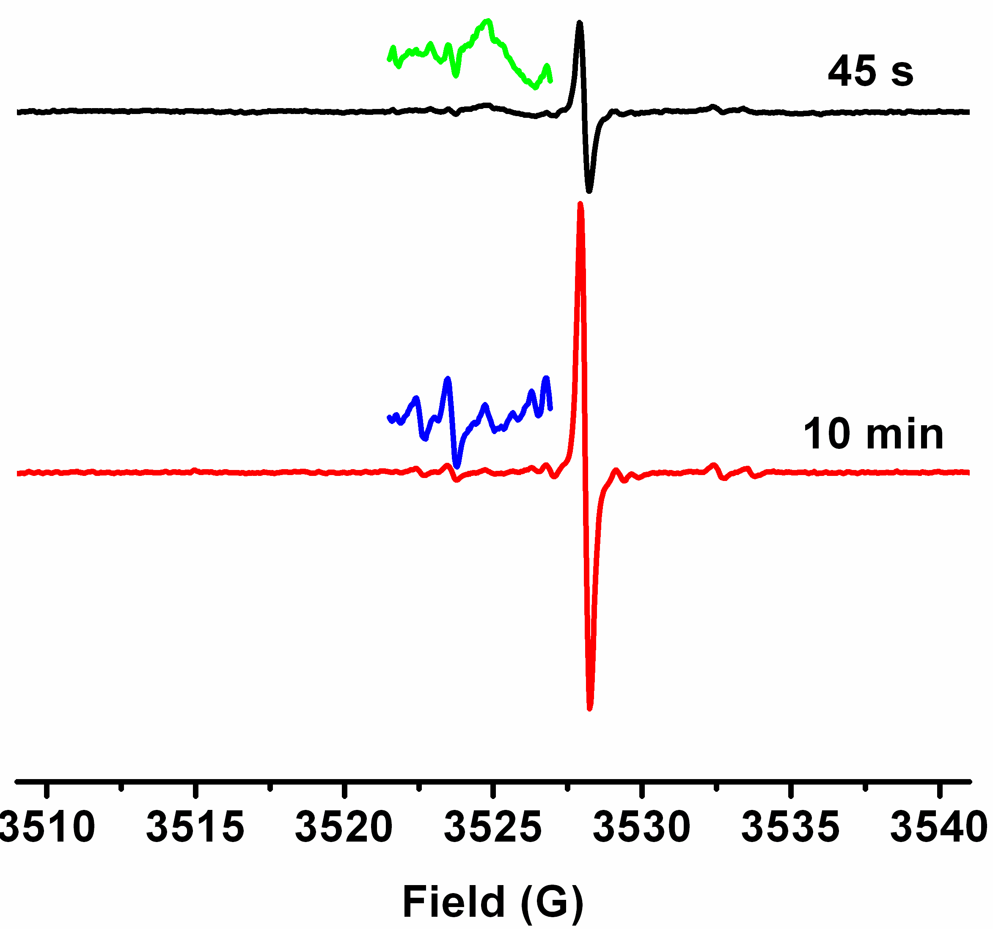
Figure S1. EPR spectra obtained by reaction of TN2 (10 μM) with ascorbic acid (400 μM) in PBS (50 mM, pH 7.4) after 45s and 10 min. Spectra were recorded with 5 mW microwave power and 0.2 G modulation amplitude.

Figure S2. The partially overlapping triplet EPR signal obtained by reaction of TN1 (10 μM) with Ascorbic acid (400 μM) in PBS (50 mM, pH 7.4) after 20 min. Spectra were recorded with 5 mW microwave power and 0.05 G modulation amplitude.

Figure S3. The singlet EPR signal obtained by reaction of TN2 (10 μM) with Ascorbic acid (400 μM) in PBS (50 mM, pH 7.4) after 20 min. Spectra were recorded with 5 mW microwave power and 0.05 G modulation amplitude.

Figure S4. Experimental and Simulated EPR spectra of the trityl-hydroxylamine TN1-H. In the computer simulation, ¹³C hyperfine splittings from three aromatic groups were considered.

IV. Reaction of biradicals with ascorbic acid detected by UV-vis spectroscopy
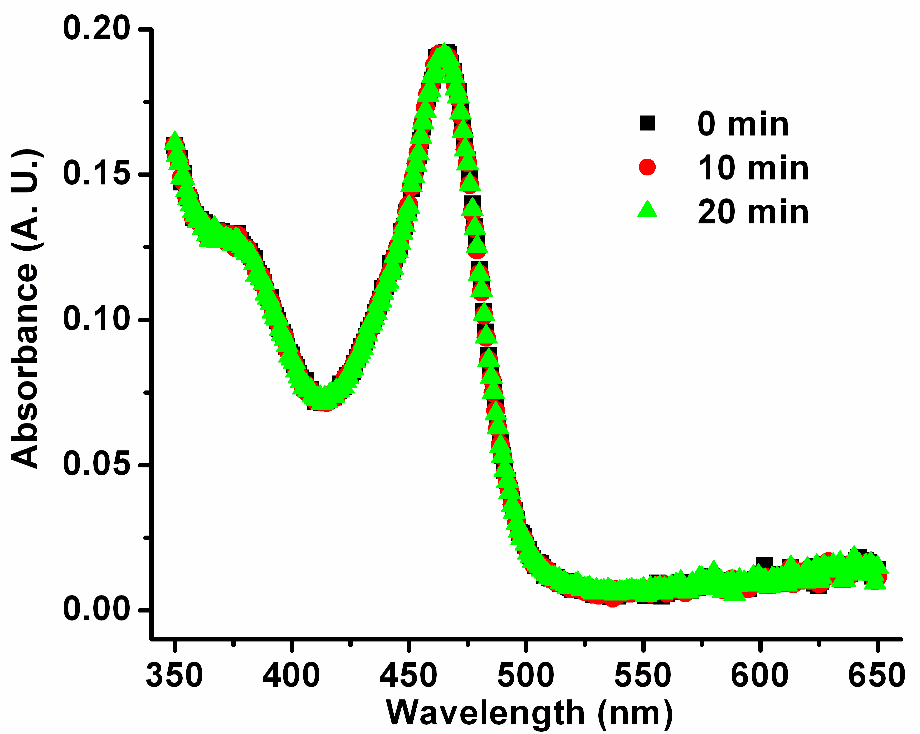

Figure S5. UV-vis spectra of 10 μM TN1 incubated with ascorbic acid (400 μM) over a period of 0-20 min in PBS (50 mM, pH 7.4).

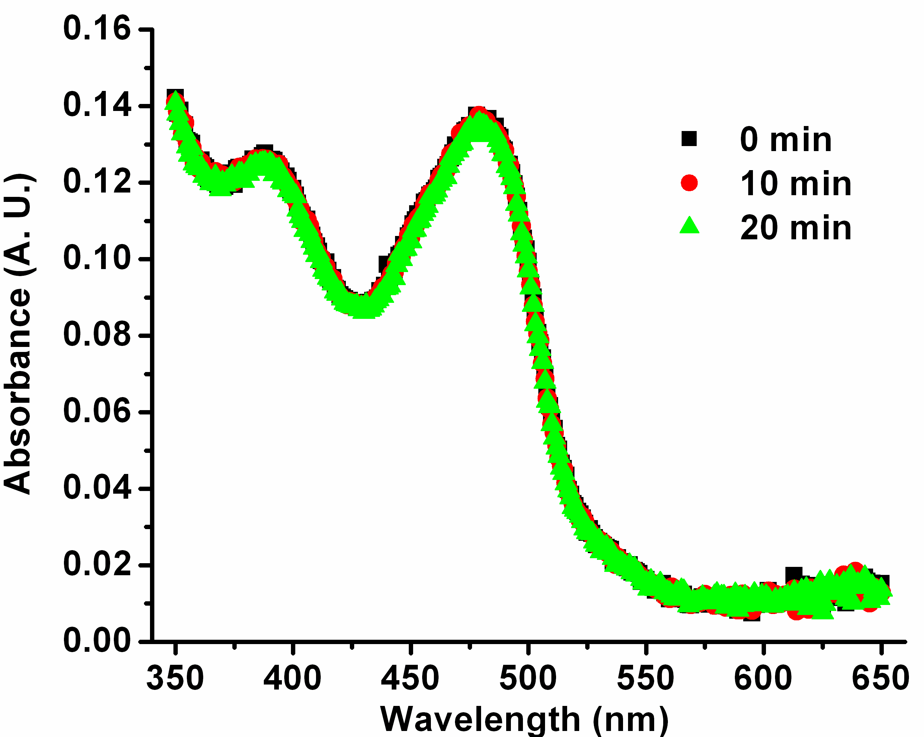

Figure S6. UV-vis spectra of 10 μM TN2 incubated with ascorbic acid (400 μM) over a period of 0-20 min in PBS (50 mM, pH 7.4).
V. Kinectic study of biradicals with ascorbic acid detected by EPR spectroscopy.
Various concentrations of ascorbic acid (50, 100, 200 and 400 μM) were added to the solution of TN1 or TN2 (10 μM) in PBS (50 mM, pH 7.4). Incremental EPR spectra were recorded 45 s after mixing and this point was considered to be t = 0 in Figure S7, S8, S10 and S11. The concentration of trityl-hydroxylamines, TN1-H or TN2-H, at each time point was obtained by comparing their double integrated signal intensities relative to CT03 as standard. Since the ascorbic acid concentration (50, 100, 200 and 400 μM) used was in greater excess than the biradical concentration (10 μM), the reaction kinetics of the biradical with ascorbic acid is a pseudo first-order reaction. The rate laws for this reaction are shown below:
$$\begin{aligned}−\frac{d\left[\text{TN}\right]}{\text{dt}}=k_{2}[\text{Asc}][\text{TN}] \\ \left[\text{TN}\right]={\left[\text{TN}\right]}_{0}−\left[\text{TNH}\right] \\ k_{\text{obs}}=k_{2}[\text{Asc}] \\ −\frac{d\left({\left[\text{TN}\right]}_{0}−[\text{TNH}]\right)}{\text{dt}}=k_{2}[\text{Asc}]\left({\left[\text{TN}\right]}_{0}−[\text{TNH}]\right)=k_{\text{obs}}\left({\left[\text{TN}\right]}_{0}−[\text{TNH}]\right) \\ \int{\frac{d\left({\left[\text{TN}\right]}_{0}−[\text{TNH}]\right)}{\text{dt}}=\int{−k_{\text{obs}}\left({\left[\text{TN}\right]}_{0}−[\text{TNH}]\right)}} \\ \text{ln}\left(\frac{{\left[\text{TN}\right]}_{0}−[\text{TNH}]}{{\left[\text{TN}\right]}_{0}}\right)=−k_{\text{obs}}t\end{aligned}$$
where [TN] is the concentration of biradical; k₂ is the second-order rate constant; [Asc] is the ascorbic acid concentration used; [TN]₀ is the initial concentration of biradical; [TNH] is the concentration of the trityl-hydroxylamine. The approximated second order rate constant k₂ was finally calculated from the slope of the plot of k_{obs} versus [Asc]. The standard deviation for k₂ was obtained from the various points shown in plots S9 and S12.

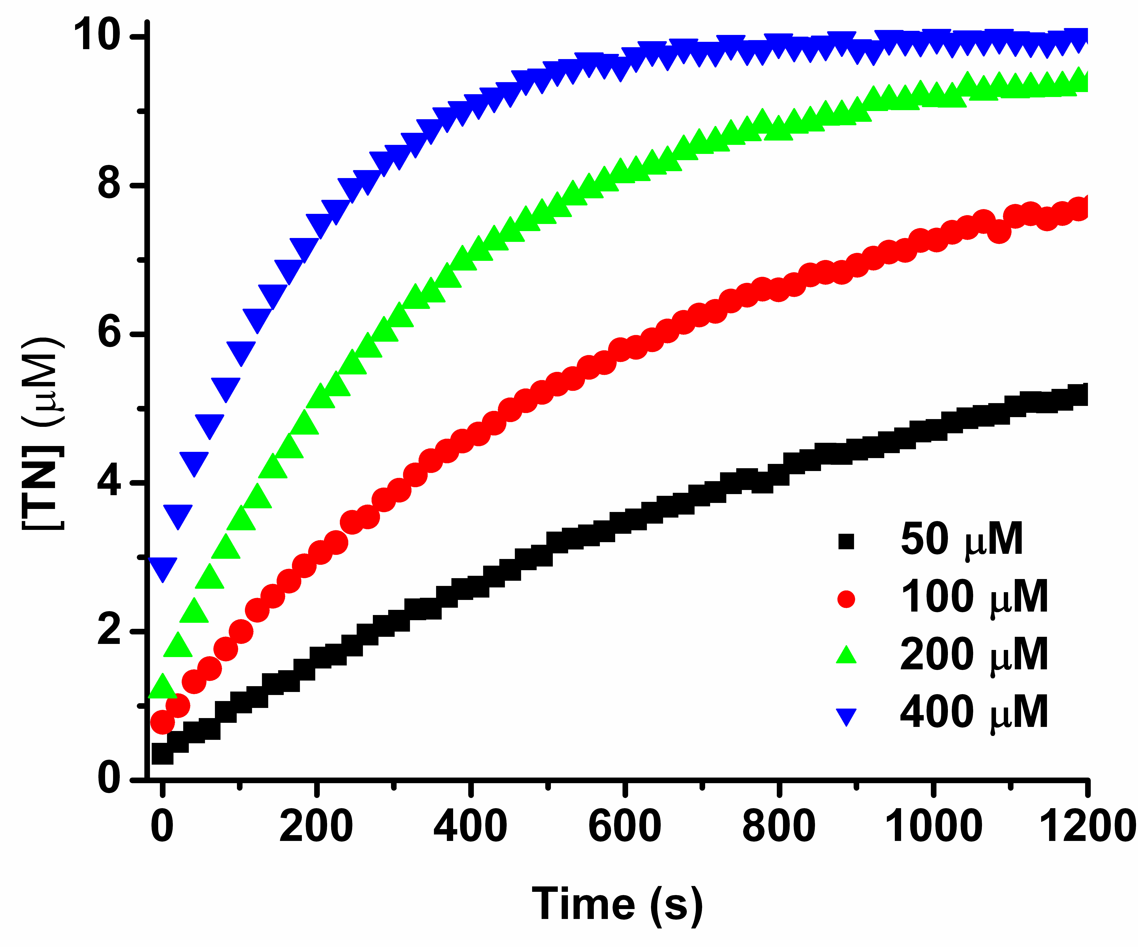

Figure S7. Trityl signal formation in the reaction of TN1 (10 μM) with various concentrations of ascorbic acid in PBS (50 mM, pH 7.4).

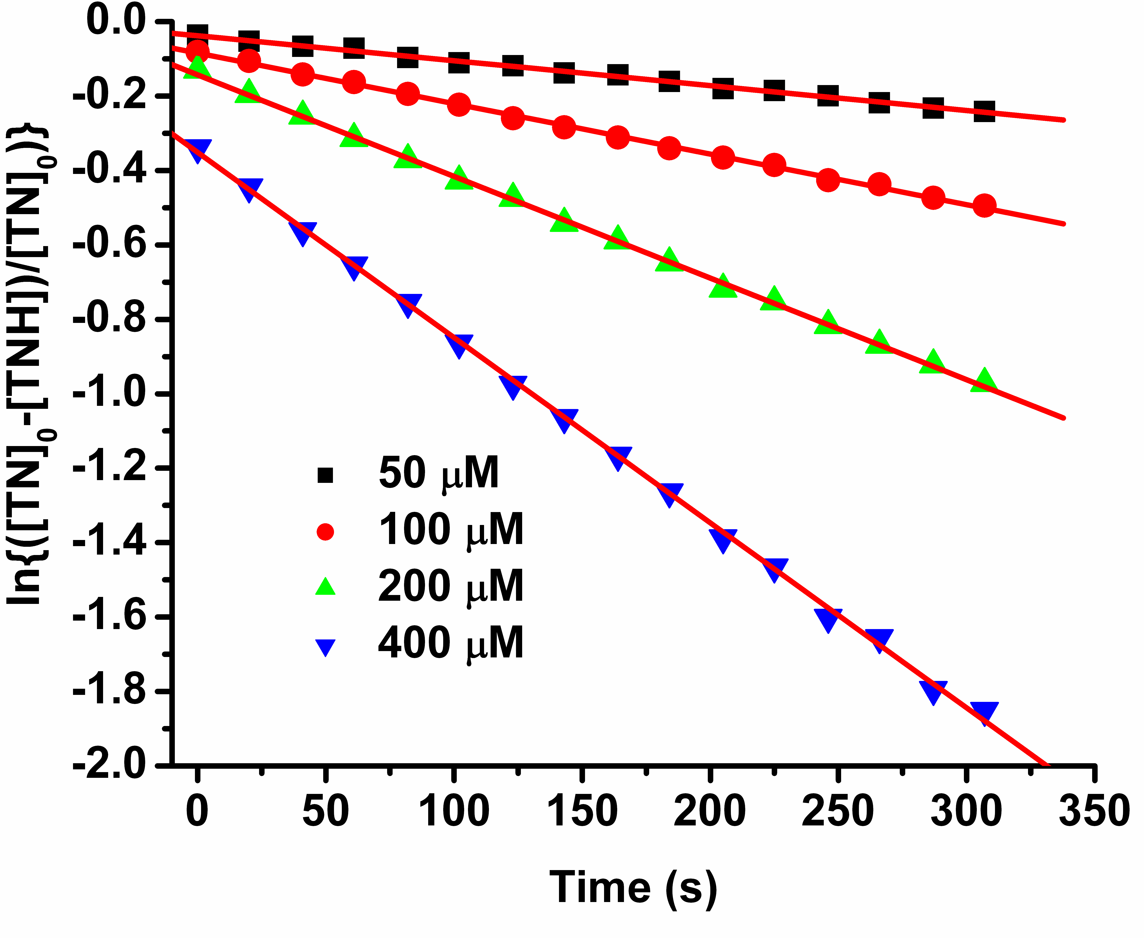
Figure S8. Plot of ln{([TN]₀-[TNH])/[TN]₀} vs t for TN1

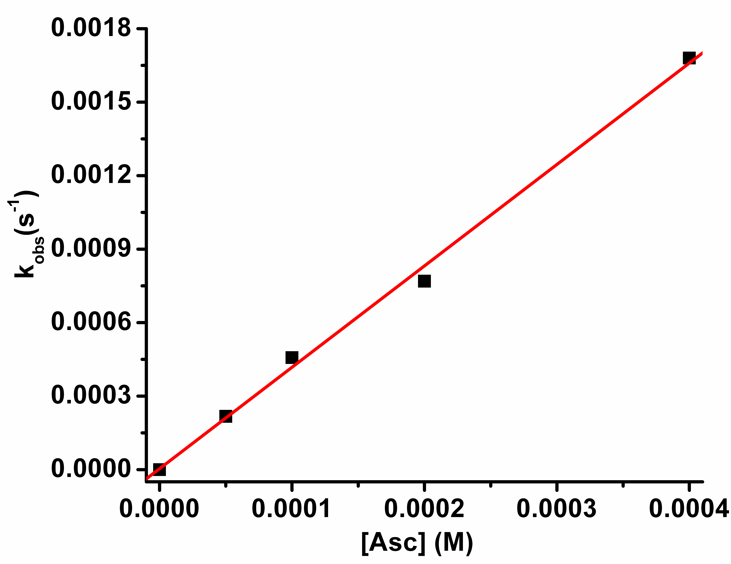
Figure S9. Plot of k_{obs} vs [Asc] for TN1

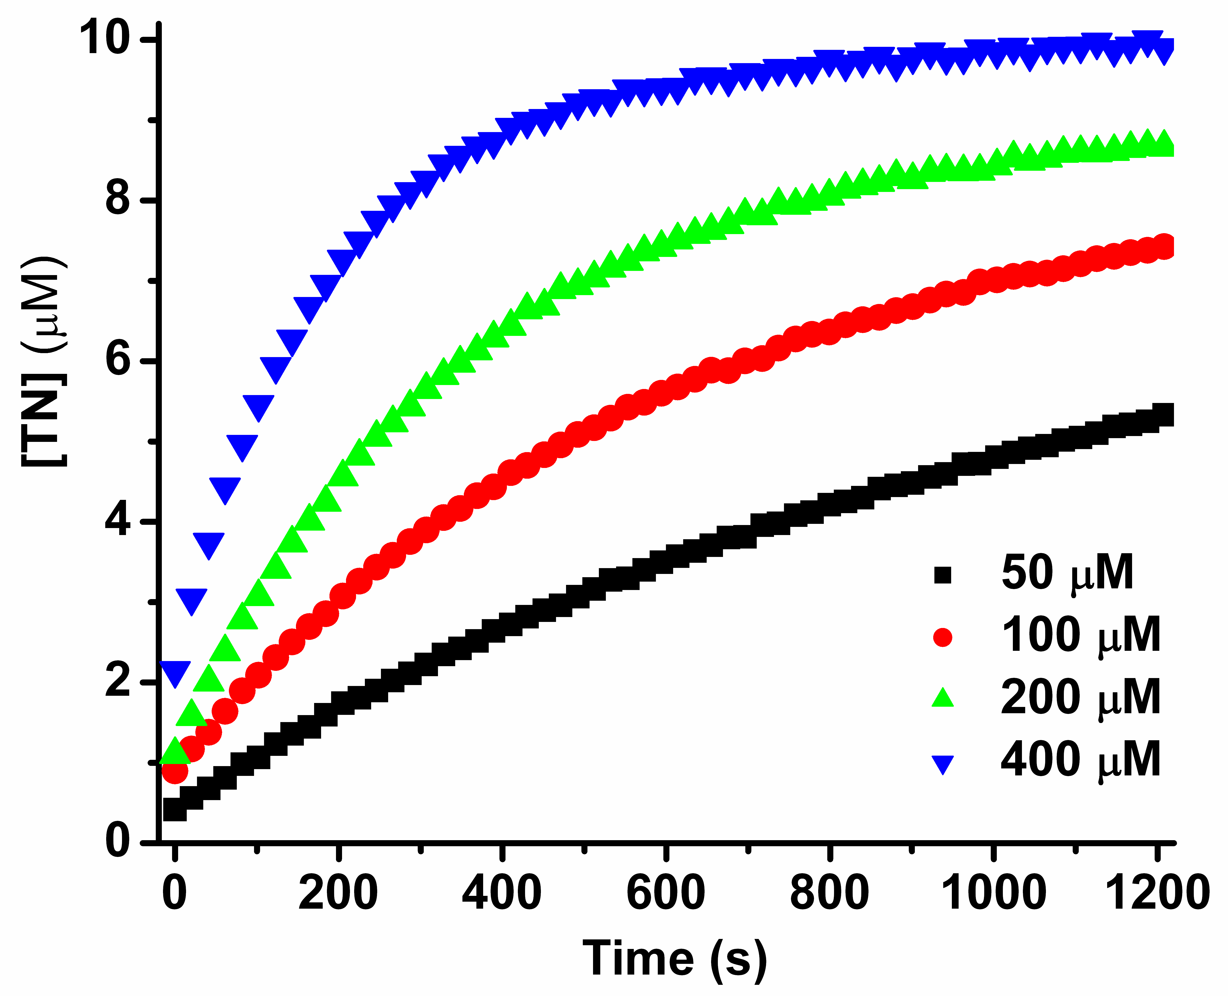

Figure S10. Trityl signal formation in the reaction of TN2 with various concentrations of ascorbic acid in PBS (50 mM, pH 7.4).
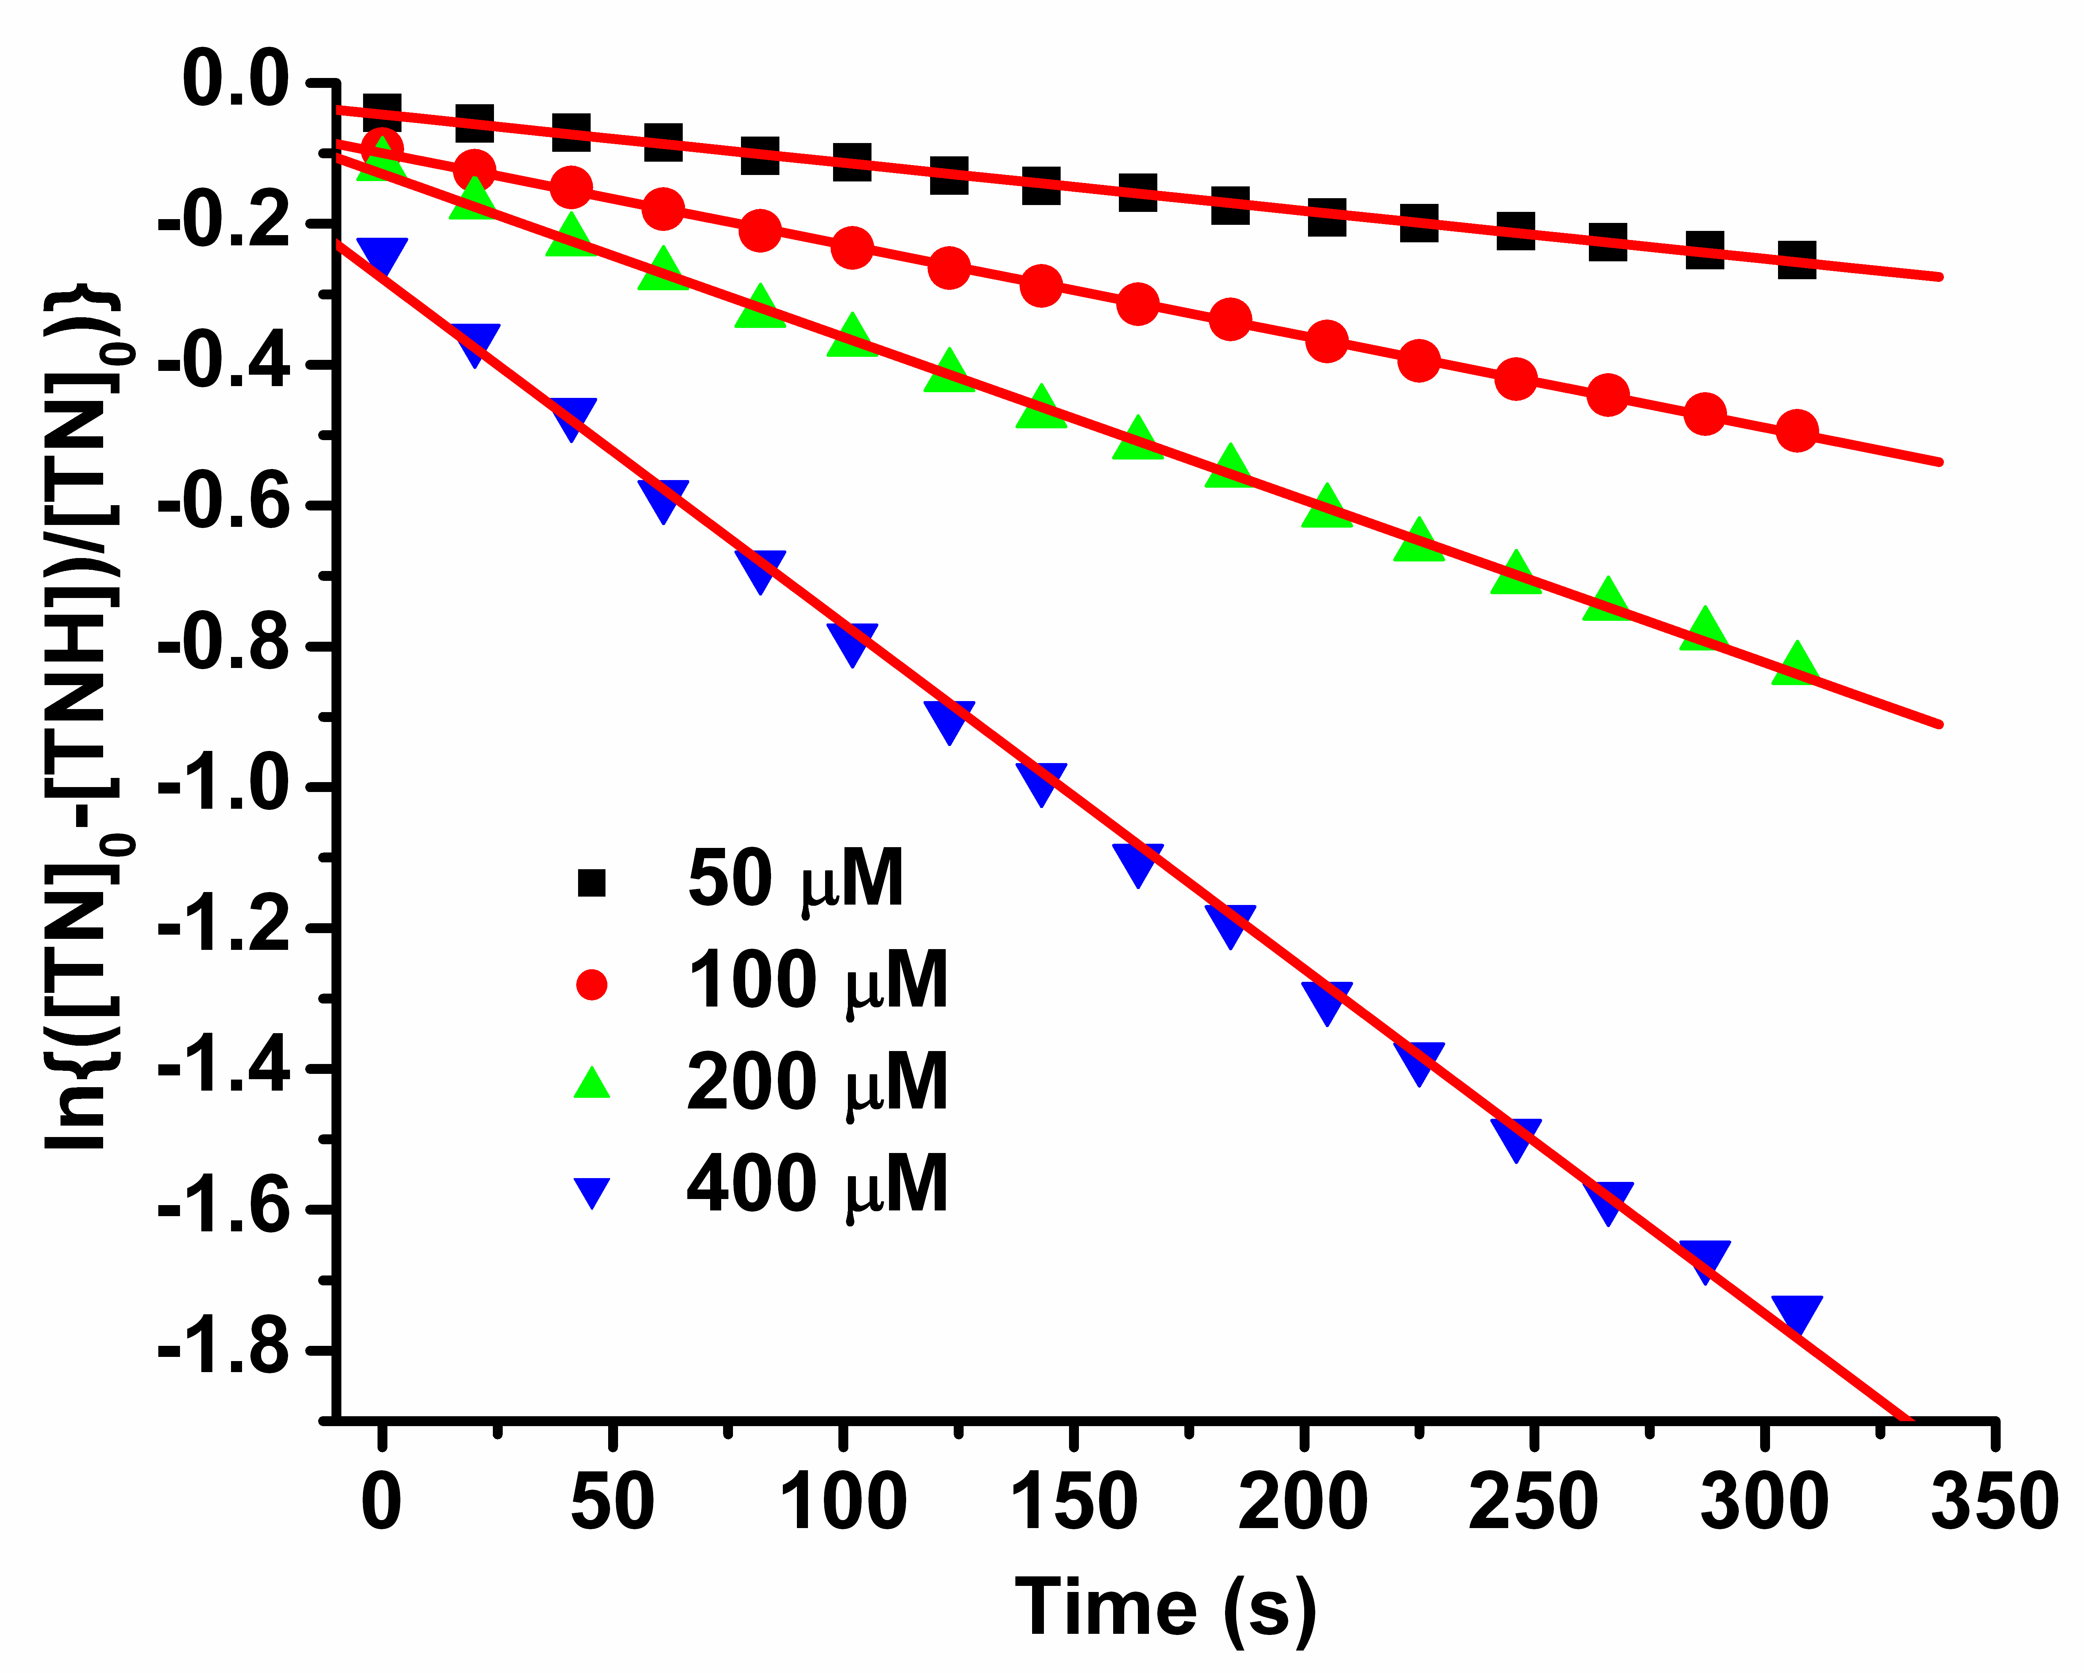

Figure S11. Plot of ln{([TN]₀-[TNH])/[TN]₀} vs t for TN2

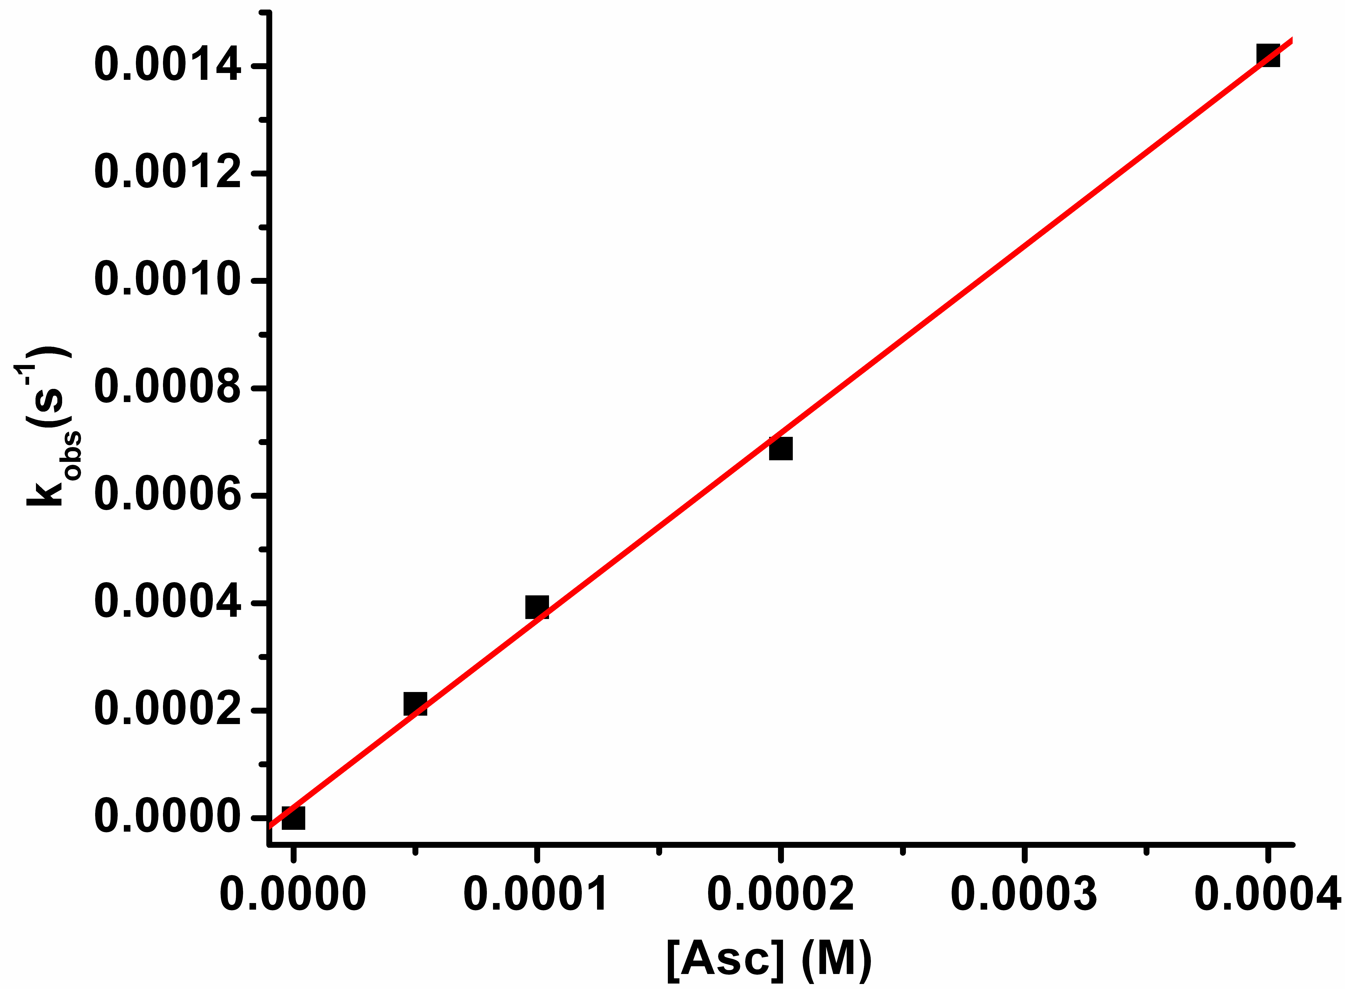

Figure S12. Plot of k_{obs} vs [Asc] for TN2

VI. Oxygen sensitivity
In order to measure oxygen sensitivity of the trityl-hydroxylamine TN1-H and TN2-H, ascorbic acid (2 mM) was added to a solution of biradicals (100 μM) in PBS buffer. After 10 min, the solution was transferred into a gas-permeable Teflon tube (i.d. = 0.8 mm) and was sealed at both ends. The sealed sample was placed inside a quartz EPR tube with open ends. Nitrogen or N₂/O₂ gas mixture with varying concentrations of O₂ was allowed to bleed into the EPR tube and after about 4 min, was changed into another gas mixture. EPR spectra were recorded using a model of incremental sweep. According to the resulting spectra, the peak-peak linewidth and the spectral ratio (I_{in}/I_{out}) were calculated.

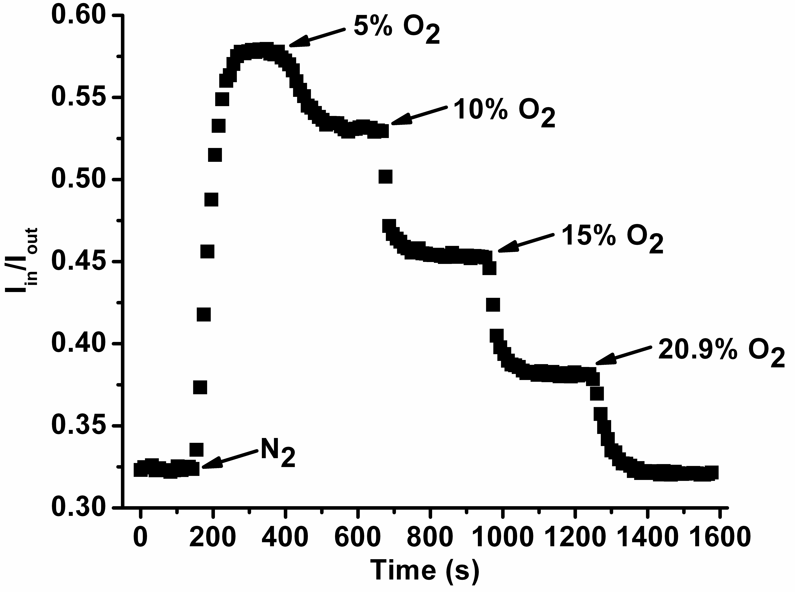
Figure S13. Plot of the spectral ratio (I_{in}/I_{out}) as a function of time.

VII. Spin density distribution on the basis of theoretical calculation at the B3LYP/6-31+G(d,p)//HF/3-21G(d) level of theory
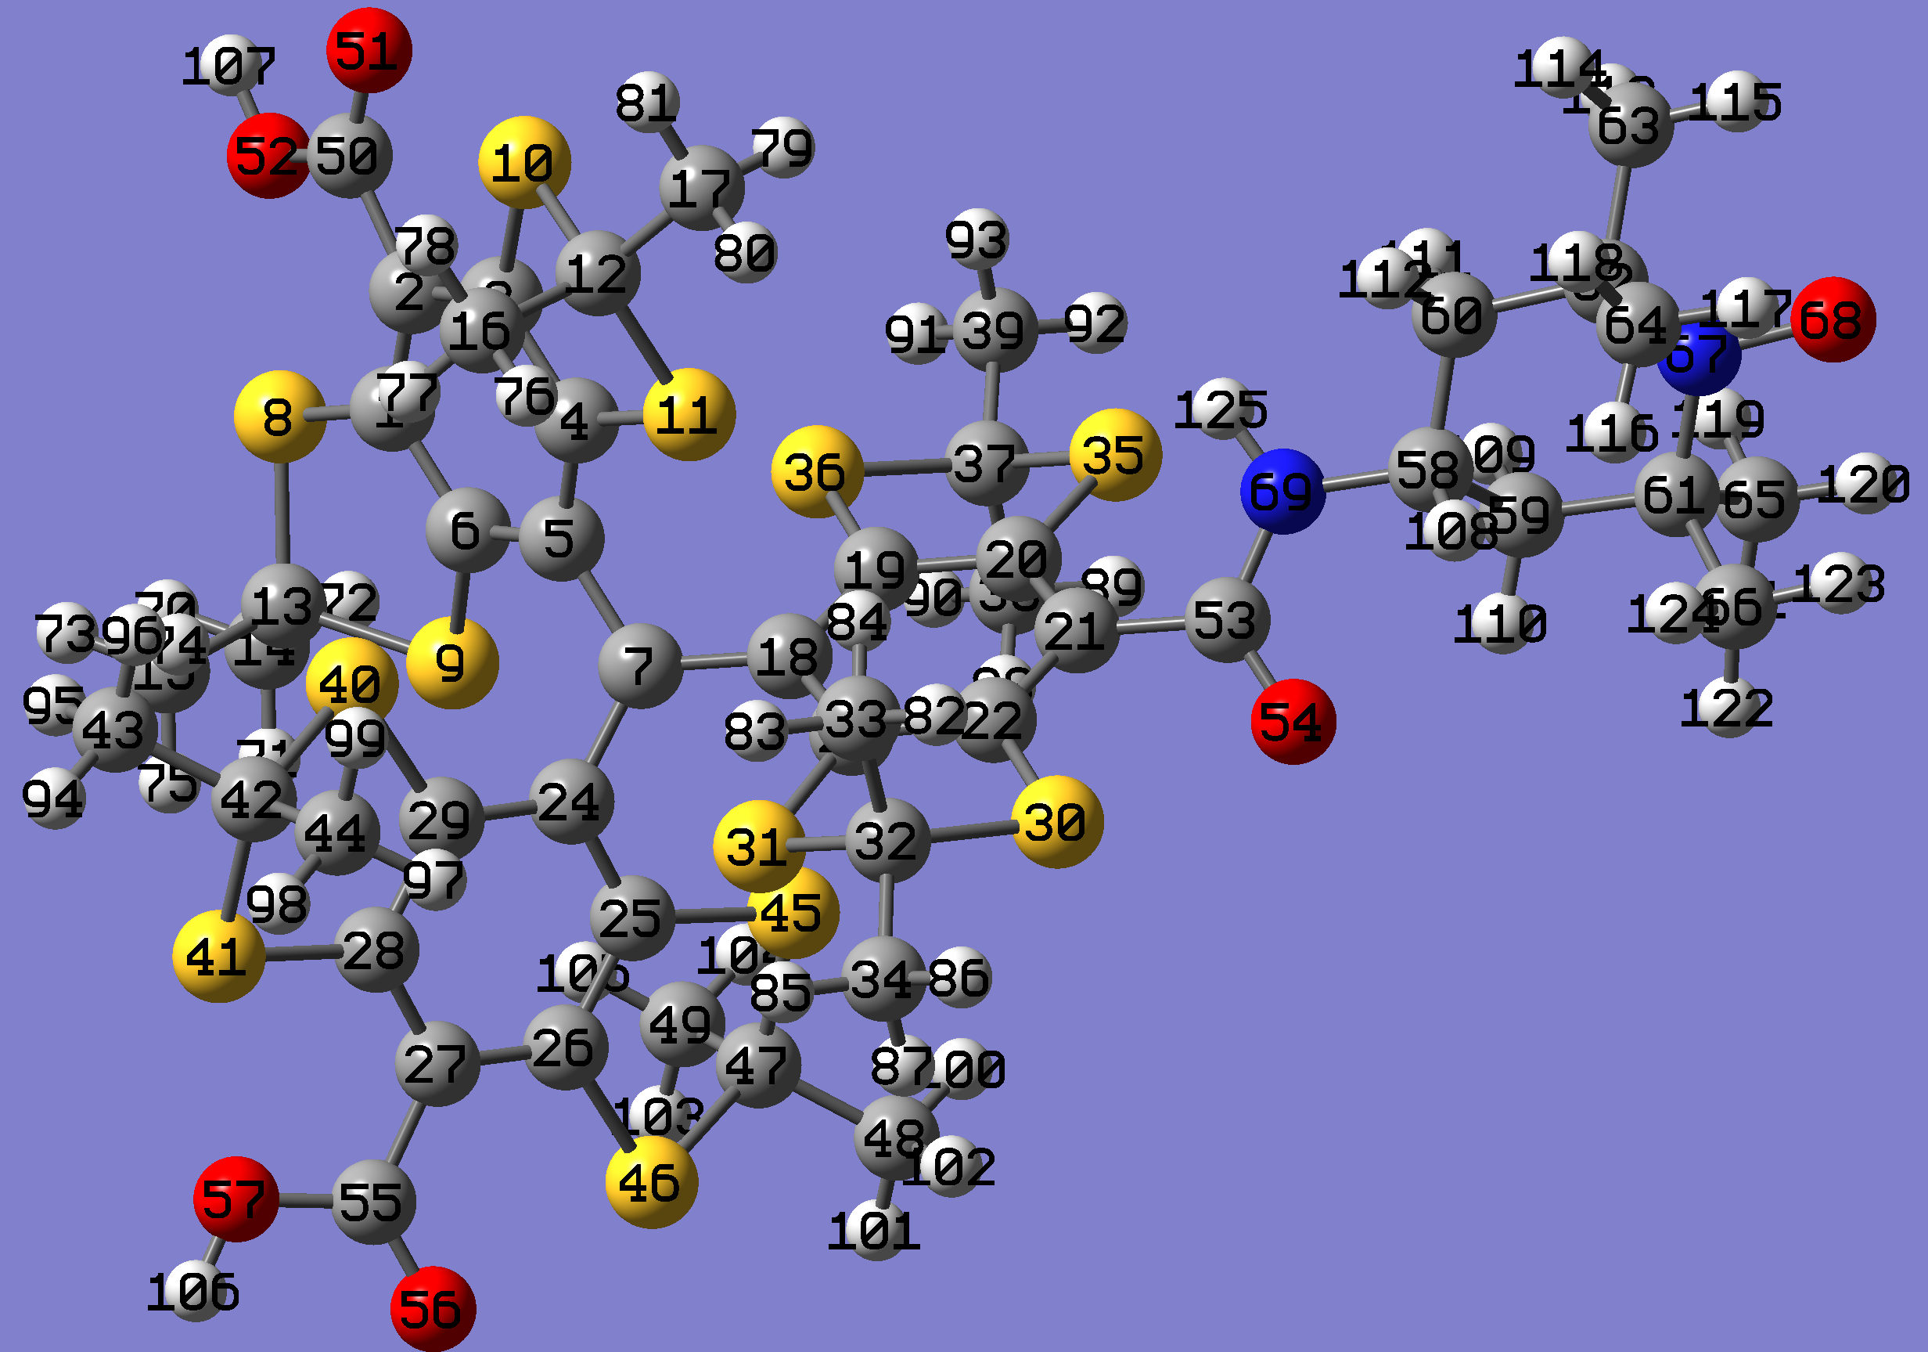
Figure S14. Optimized structure of TN1

Table S1. Charge and spin density distribution of TN1.
atom | atom # | charge | spin density
C | 1 | -0.13266 | -0.02788
C | 2 | -0.2045 | 0.0638
C | 3 | -0.155 | -0.0286
C | 4 | 3.05239 | 0.0793
C | 5 | -0.11438 | -0.06782
C | 6 | -0.20304 | 0.0746
C | 7 | 0.10285 | 0.61417
S | 8 | 0.38701 | -0.00373
S | 9 | 0.36374 | 0.0163
S | 10 | 0.40825 | -0.00217
S | 11 | 0.35359 | 0.00711
C | 12 | -0.39471 | -0.00039
C | 13 | -0.39291 | -0.00075
C | 14 | -0.69693 | 1E-05
C | 15 | -0.70118 | 0.00042
C | 16 | -0.69857 | 0.00019
C | 17 | -0.69655 | -1E-05
C | 18 | -0.12757 | -0.07175
C | 19 | -0.18818 | 0.08264
C | 20 | -0.18164 | -0.03282
C | 21 | -0.15066 | 0.07694
C | 22 | -0.14972 | -0.0316
C | 23 | -0.18436 | 0.09012
C | 24 | -0.10077 | -0.06901
C | 25 | -0.19615 | 0.08081
C | 26 | -0.13382 | -0.02702
C | 27 | -0.20265 | 0.06347
C | 28 | -0.16226 | -0.0278
C | 29 | -0.19398 | 0.07722
S | 30 | 0.39094 | -0.00328
S | 31 | 0.35382 | 0.01118
C | 32 | -0.39023 | -0.00027
C | 33 | -0.69906 | 0.0002
C | 34 | -0.69778 | -4E-05
S | 35 | 0.31822 | -0.0036
S | 36 | 0.36019 | 0.00697
C | 37 | -0.37286 | 0.0002
C | 38 | -0.70005 | 1E-05
C | 39 | -0.69805 | -1E-05
S | 40 | 0.34672 | 0.00682
S | 41 | 0.37816 | -0.0027
C | 42 | -0.38762 | -0.0002
C | 43 | -0.69694 | -2E-05
C | 44 | -0.69946 | 0.00012
S | 45 | 0.35235 | 0.00811
S | 46 | 0.40121 | -0.00181
C | 47 | -0.39244 | -0.00038
C | 48 | -0.69768 | -4E-05
C | 49 | -0.69901 | 0.00031
C | 50 | 0.80283 | -0.00043
O | 51 | -0.59479 | 0.01609
O | 52 | -0.72674 | 0.00202
C | 53 | 0.68434 | -0.00268
O | 54 | -0.6214 | 0.00892
C | 55 | 0.80604 | -0.00046
O | 56 | -0.58995 | 0.01451
O | 57 | -0.72735 | 0.00183
C | 58 | -0.08201 | 1E-05
C | 59 | -0.47339 | 0.00127
C | 60 | -0.47382 | 0.00102
C | 61 | 0.09457 | -0.01573
C | 62 | 0.09761 | -0.01599
C | 63 | -0.6845 | 0.00878
C | 64 | -0.69278 | 0.0268
C | 65 | -0.68373 | 0.00869
C | 66 | -0.69181 | 0.02685
N | 67 | -0.03971 | 0.42865
O | 68 | -0.42358 | 0.536
N | 69 | -0.64929 | 0.00325
H | 70 | 0.25179 | -1E-05
H | 71 | 0.25136 | 0
H | 72 | 0.25947 | -1E-05
H | 73 | 0.24437 | -1E-05
H | 74 | 0.25954 | -2E-05
H | 75 | 0.24822 | -1E-04
H | 76 | 0.24357 | -9E-05
H | 77 | 0.25393 | -1E-05
H | 78 | 0.24616 | 0.0001
H | 79 | 0.26007 | -1E-05
H | 80 | 0.24824 | 0
H | 81 | 0.25231 | -5E-05
H | 82 | 0.24587 | 0.00015
H | 83 | 0.24335 | -7E-05
H | 84 | 0.25318 | -2E-05
H | 85 | 0.2484 | 0
H | 86 | 0.25178 | -6E-05
H | 87 | 0.26389 | -1E-05
H | 88 | 0.25765 | -1E-05
H | 89 | 0.24575 | 0.00013
H | 90 | 0.24915 | -3E-05
H | 91 | 0.25429 | 1E-05
H | 92 | 0.25115 | -5E-05
H | 93 | 0.26205 | -1E-05
H | 94 | 0.25176 | -4E-05
H | 95 | 0.25985 | -1E-05
H | 96 | 0.2508 | 0
H | 97 | 0.2569 | -2E-05
H | 98 | 0.24538 | 1E-04
H | 99 | 0.24524 | -6E-05
H | 100 | 0.24911 | -1E-05
H | 101 | 0.25184 | -6E-05
H | 102 | 0.26406 | 0
H | 103 | 0.24643 | 7E-05
H | 104 | 0.24506 | -8E-05
H | 105 | 0.25336 | 0
H | 106 | 0.53181 | -5E-05
H | 107 | 0.5332 | -0.00016
H | 108 | 0.26267 | 3E-05
H | 109 | 0.24603 | 5E-05
H | 110 | 0.27444 | -0.00066
H | 111 | 0.24639 | 0.00011
H | 112 | 0.25645 | -0.00065
H | 113 | 0.24395 | 0.00013
H | 114 | 0.23756 | -0.00104
H | 115 | 0.26939 | -0.00039
H | 116 | 0.23589 | -0.00083
H | 117 | 0.26499 | -0.00101
H | 118 | 0.24213 | 0.00063
H | 119 | 0.24257 | 0.00013
H | 120 | 0.26671 | -0.00037
H | 121 | 0.24035 | -0.00103
H | 122 | 0.24791 | 0.00063
H | 123 | 0.26078 | -0.00106
H | 124 | 0.2356 | -0.00084
H | 125 | 0.43556 | -8E-05

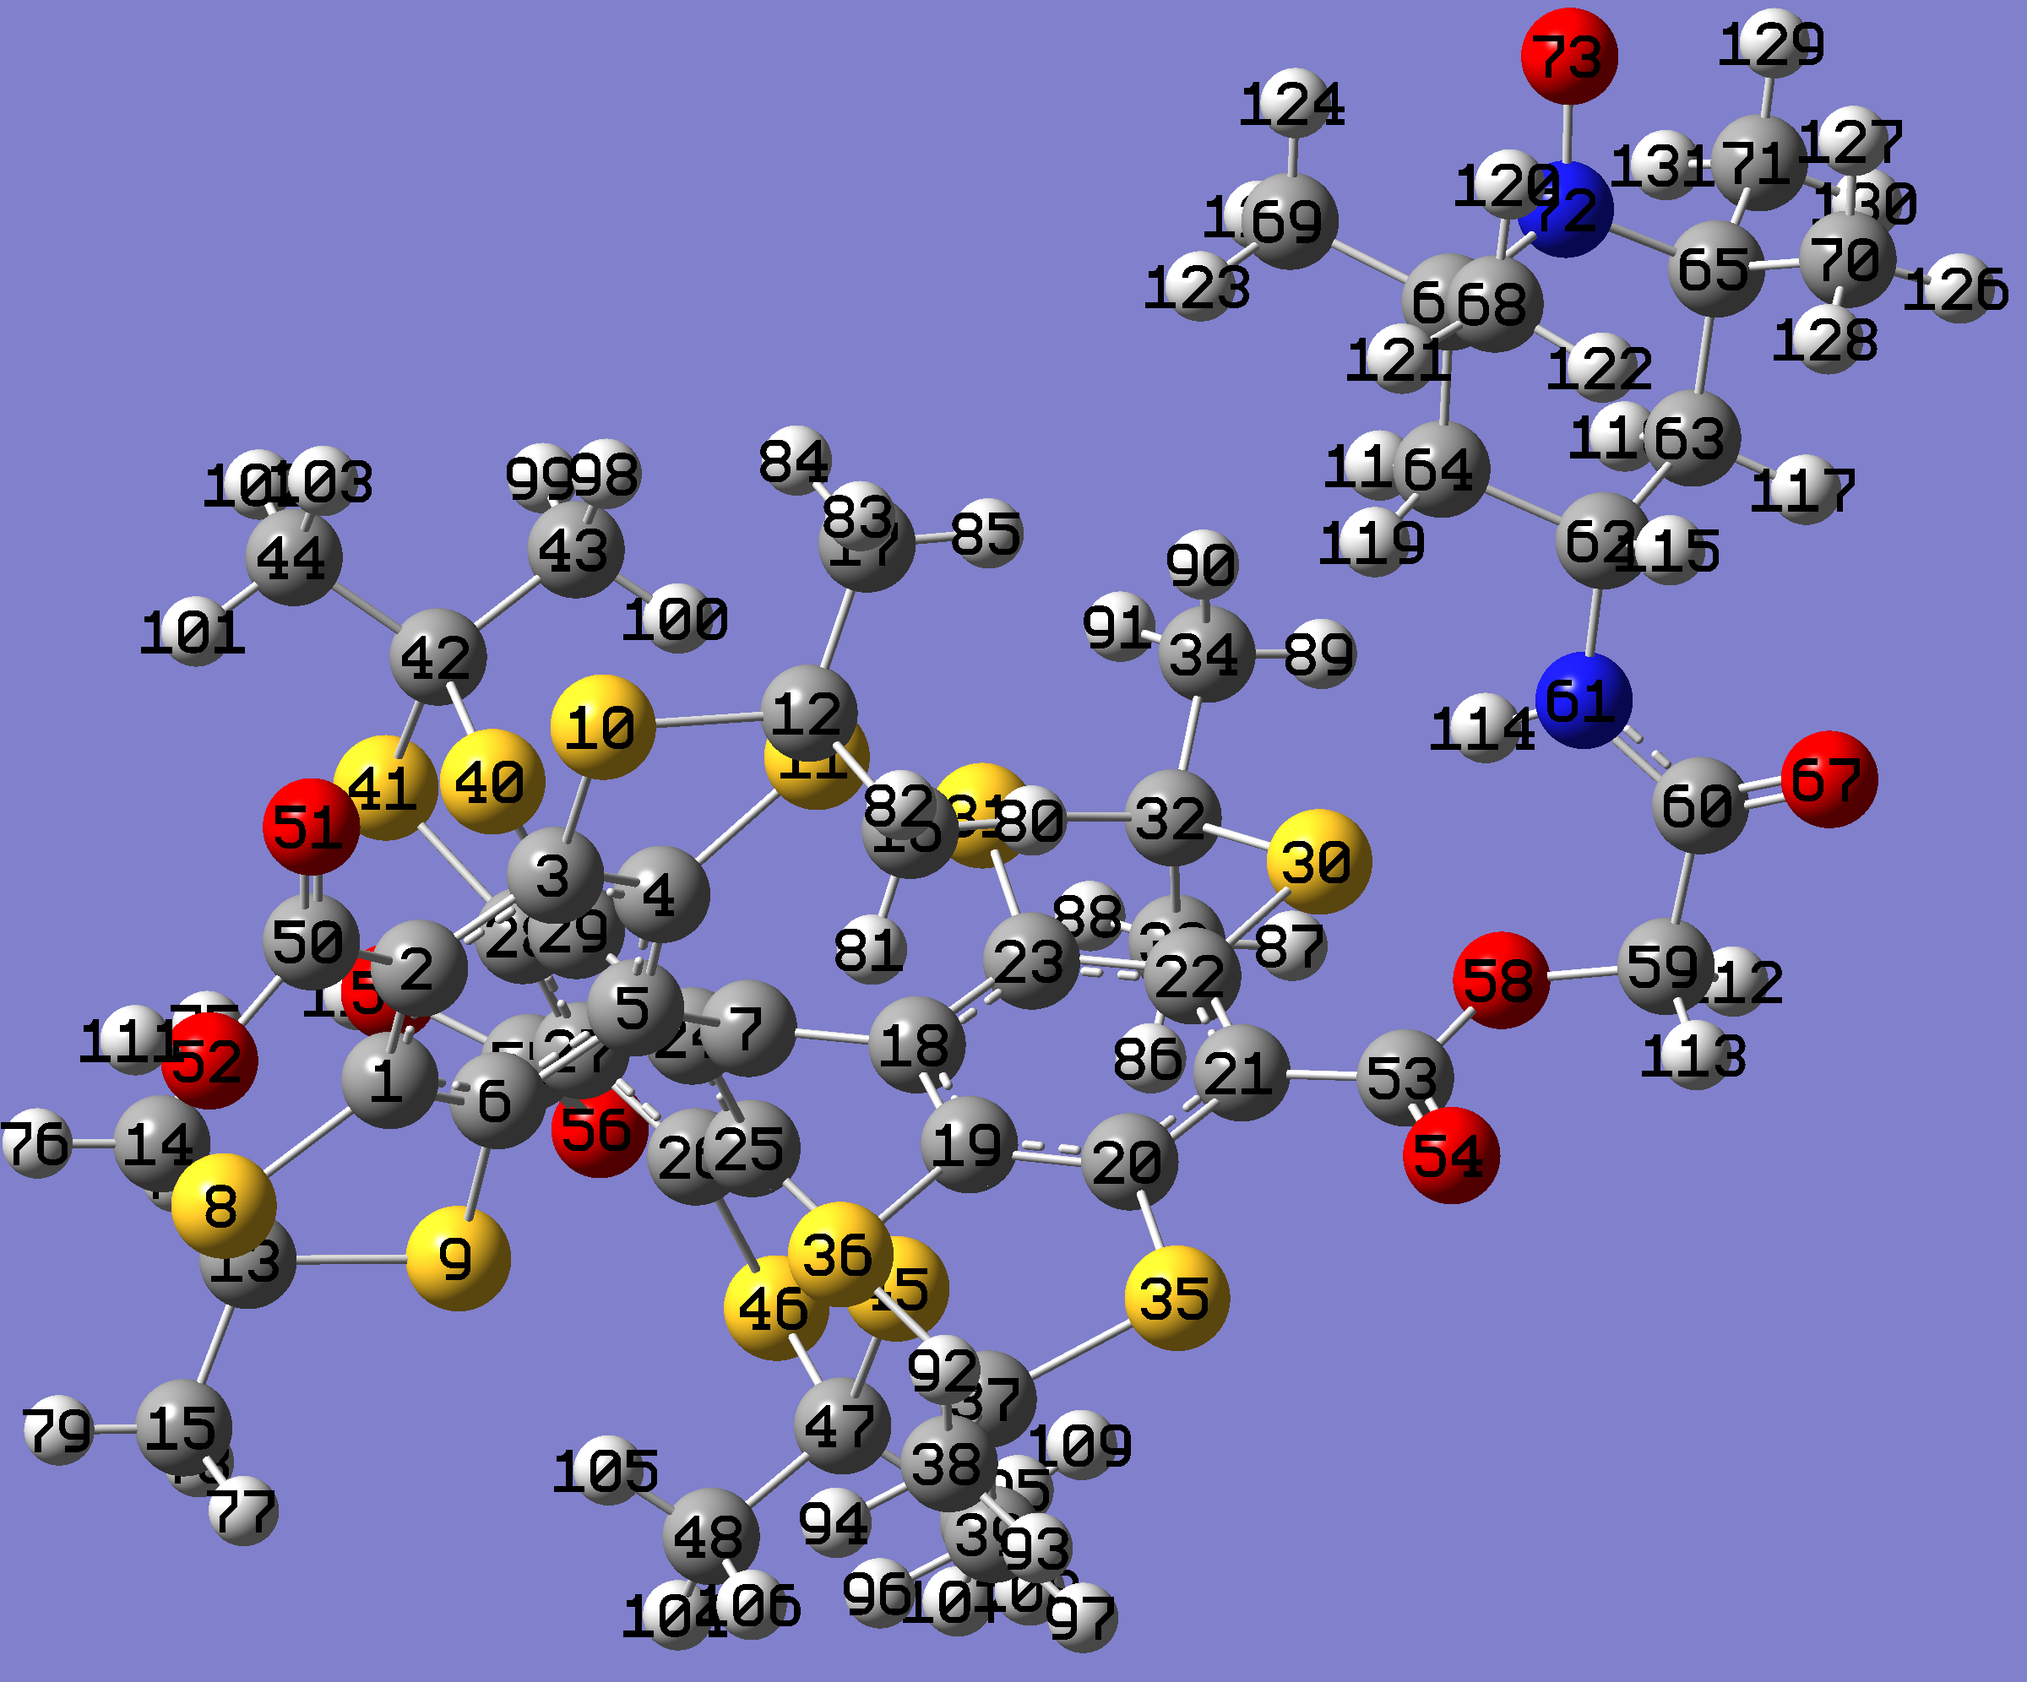
Figure S15. Optimized structure of TN2.

Table S2. Charge and spin density distribution of TN2
 |  | charge | spin density
C | 1 | -0.13569 | -0.02697
C | 2 | -0.20075 | 0.06267
C | 3 | -0.15708 | -0.026
C | 4 | -0.19538 | 0.07226
C | 5 | -0.11752 | -0.06446
C | 6 | -0.20126 | 0.07178
C | 7 | 0.09813 | 0.62277
S | 8 | 0.38435 | -0.00333
S | 9 | 0.36088 | 0.01598
S | 10 | 0.40803 | -0.00309
S | 11 | 0.36324 | 0.01712
C | 12 | -0.39075 | -0.00077
C | 13 | -0.39071 | -0.00083
C | 14 | -0.70161 | 0.00029
C | 15 | -0.6974 | 0
C | 16 | -0.70127 | 0.00035
C | 17 | -0.6963 | 0
C | 18 | -0.10162 | -0.06918
C | 19 | -0.19472 | 0.08094
C | 20 | -0.15442 | -0.02784
C | 21 | -0.20137 | 0.06417
C | 22 | -0.127 | -0.02892
C | 23 | -0.20684 | 0.07312
C | 24 | -0.09057 | -0.06959
C | 25 | -0.18916 | 0.0791
C | 26 | -0.16867 | -0.02657
C | 27 | -0.19918 | 0.06232
C | 28 | -0.13871 | -0.02727
C | 29 | -0.20173 | 0.07673
S | 30 | 0.36211 | -0.00361
S | 31 | 0.36119 | 0.01593
C | 32 | -0.38898 | -0.00086
C | 33 | -0.70161 | 0.00041
C | 34 | -0.69679 | 3E-05
S | 35 | 0.40791 | -0.00191
S | 36 | 0.35874 | 0.00754
C | 37 | -0.39221 | -0.00031
C | 38 | -0.6973 | -2E-05
C | 39 | -0.69941 | 0.00023
S | 40 | 0.35076 | 0.00616
S | 41 | 0.37591 | -0.00259
C | 42 | -0.38783 | -0.00021
C | 43 | -0.69976 | 0.0002
C | 44 | -0.69767 | -3E-05
S | 45 | 0.34367 | 0.00793
S | 46 | 0.39824 | -0.0019
C | 47 | -0.38959 | -0.00031
C | 48 | -0.69934 | 0.00032
C | 49 | -0.69737 | -3E-05
C | 50 | 0.80643 | 9E-05
O | 51 | -0.58984 | 0.01464
O | 52 | -0.72555 | 0.00185
C | 53 | 0.81376 | -0.00088
O | 54 | -0.58915 | 0.01531
C | 55 | 0.80637 | -0.00059
O | 56 | -0.59118 | 0.01398
O | 57 | -0.72613 | 0.00181
O | 58 | -0.57905 | 0.00251
C | 59 | -0.19233 | -0.00021
C | 60 | 0.65547 | 0.00019
N | 61 | -0.65663 | 0.00019
C | 62 | -0.08384 | -6E-05
C | 63 | -0.47241 | 0.00103
C | 64 | -0.47258 | 0.00104
C | 65 | 0.09436 | -0.01568
C | 66 | 0.0968 | -0.01576
O | 67 | -0.6429 | 0.0001
C | 68 | -0.69258 | 0.02678
C | 69 | -0.68341 | 0.00863
C | 70 | -0.69186 | 0.02684
C | 71 | -0.68379 | 0.00855
N | 72 | -0.03964 | 0.42792
O | 73 | -0.42336 | 0.5366
H | 74 | 0.24848 | -8E-05
H | 75 | 0.2597 | -2E-05
H | 76 | 0.24512 | 0
H | 77 | 0.25976 | 0
H | 78 | 0.25146 | 0
H | 79 | 0.25243 | -1E-05
H | 80 | 0.24558 | -8E-05
H | 81 | 0.25932 | -2E-05
H | 82 | 0.24725 | -1E-05
H | 83 | 0.25394 | 0
H | 84 | 0.26121 | -1E-05
H | 85 | 0.24592 | 0
H | 86 | 0.26024 | -2E-05
H | 87 | 0.24507 | -1E-05
H | 88 | 0.25113 | -9E-05
H | 89 | 0.25252 | 0
H | 90 | 0.25771 | -1E-05
H | 91 | 0.25362 | 0
H | 92 | 0.26006 | 0
H | 93 | 0.25284 | -4E-05
H | 94 | 0.25172 | 0
H | 95 | 0.25363 | -1E-05
H | 96 | 0.24664 | -8E-05
H | 97 | 0.24686 | 1E-04
H | 98 | 0.24978 | -6E-05
H | 99 | 0.24583 | 7E-05
H | 100 | 0.25349 | 1E-05
H | 101 | 0.25969 | -1E-05
H | 102 | 0.2516 | -4E-05
H | 103 | 0.2542 | 0
H | 104 | 0.24726 | 8E-05
H | 105 | 0.25422 | 0
H | 106 | 0.24611 | -7E-05
H | 107 | 0.2535 | -6E-05
H | 108 | 0.25046 | 0
H | 109 | 0.25952 | 0
H | 110 | 0.53207 | -5E-05
H | 111 | 0.53282 | -8E-05
H | 112 | 0.2601 | 0.00014
H | 113 | 0.27515 | -1E-05
H | 114 | 0.44208 | 0
H | 115 | 0.26531 | 3E-05
H | 116 | 0.24169 | 7E-05
H | 117 | 0.27198 | -0.00066
H | 118 | 0.24491 | 0.00011
H | 119 | 0.25782 | -0.00066
H | 120 | 0.26481 | -0.00101
H | 121 | 0.24213 | 0.00065
H | 122 | 0.23623 | -0.00083
H | 123 | 0.23491 | -0.00105
H | 124 | 0.26949 | -0.00039
H | 125 | 0.24413 | 0.00013
H | 126 | 0.24753 | 0.00065
H | 127 | 0.26127 | -0.00105
H | 128 | 0.2361 | -0.00084
H | 129 | 0.26734 | -0.00038
H | 130 | 0.23997 | -0.00103
H | 131 | 0.24195 | 0.00015

VIII. Synthesis
The TAM radical CAT-03 were synthesized according to the previous procedure (Liu, Y. P.; Villamena, F. A.; Sun, J.; Xu, Y.; Dhimitruka, I.; Zweier, J. L. J. Org. Chem. 2008, 73, 1490).
TN1
To the solution of CAT-03 (120 mg, 0.12 mmol), 4-amino-TEMPO (21 mg, 0.12 mmol), HOBt (24 mg, 0.18 mmol) and Et₃N (50 μL) in dry DMF (10 ml) was added BOP (80 mg, 0.18 mmol). The reaction mixture was stirred under N₂ at room temperature for 18 h. Solvent was removed under vacuum, and the residue was dissolved in phosphate buffer (0.2 M, pH 7.4) and purified by column chromatography on reverse phase C-18 and water followed by 0-20% acetonitrile in water as eluants to give the biradical as a green solid (118 mg, 86 %). MS (M⁺, m/z): 1152.0817 (measured), 1152.0787 (calculated).

TN2
To the solution of CAT-03 (82 mg, 0.082 mmol) and 4-(2-Bromoacetamido)-TEMPO (29 mg, 0.098 mmol) in DMSO (10 mL) was added solid K₂CO₃ (23 mg, 0.164 mmol). The reaction mixture was stirred for 18 h at room temperature. Then, 50 mL of the citric acid solution (8%, w/v) and 40 mL of ethyl acetate were added and the organic layer was separated. The aqueous solution was extracted with ethyl acetate (2x40 mL). The combined organic solution was washed with saturated NaCl (3x50 mL) and water (1x50 mL), dried over anhydrous Na₂SO₄ and evaporated in vacuo. The residue was dissolved in phosphate buffer (200 mM, pH 7.4) and purified by column chromatography on reverse phase C-18 and water followed by 0-40% acetonitrile in water as eluants to give the compound as a brown solid (38 mg, 38%). MS ([M+H]⁺, m/z): 1211.060 (measured), 1121.092 (calculated).

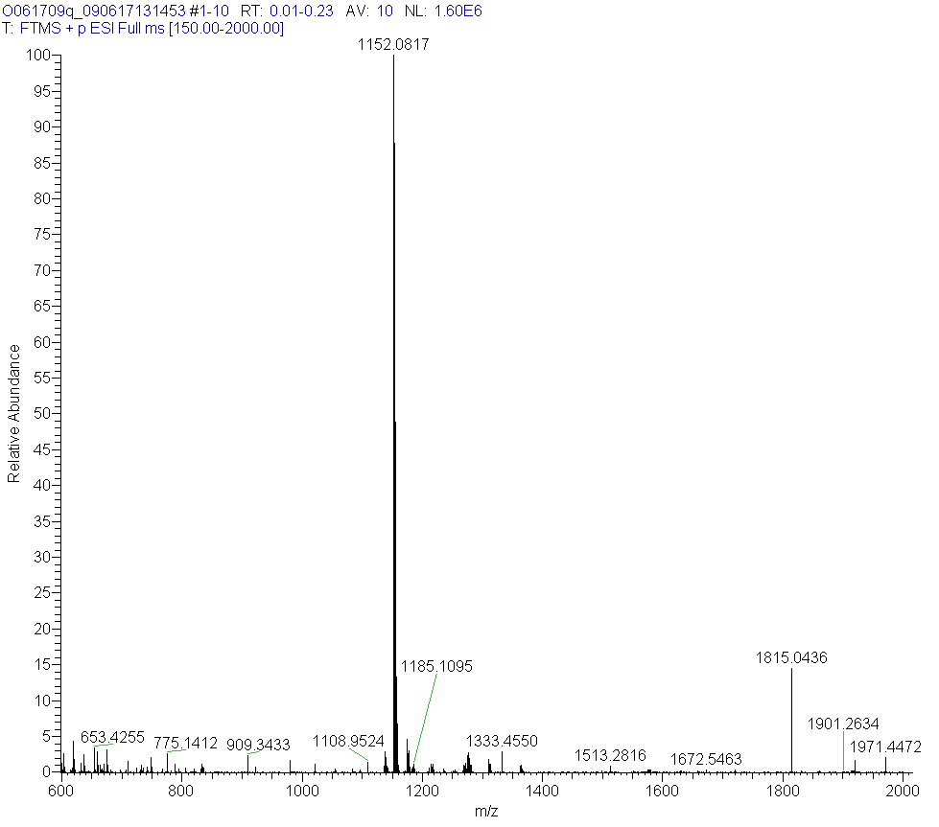
Figure S16. High Resolution Mass Spectrum of TN1.

Figure S17. High Resolution Mass Spectrum of TN2.

