Supporting Information

Panchromatic light harvesting in single wall carbon nanotube hybrids – immobilization of porphyrin-phthalocyanine conjugates
Juergen Bartelmessª, Ana R. M. Soares^{b,c}, M. Victoria Martínez-Díaz ^{c}, Maria G. P. M. S. Neves^{b}, Augusto C. Tomé^{b}, José A. S. Cavaleiro^{b}, Tomás Torres ^{c,d,*} and Dirk M. Guldi^{a,}

Experimental section – Spectroscopic measurements

THF was of spectrophotometric grade (99.5%), DMF was of ACS spectrophotometric grade (99.8%), all were purchased from Sigma-Aldrich. SWNT (HiPCO Batch Nr.: R0510C) were purchased from CNI. The experiments were performed at room temperature and ambient conditions. Steady-state absorption spectra were measured by a Cary5000 (Varian) two beam spectrometer. Emission spectra were recorded by using a FluoroMax-P (HORIBA). Femtosecond transient absorption studies were performed using 387 nm laser pulses with a 150 fs pulse width (1 kHz, 200 nJ), from an amplified Ti:sapphire laser system (SHG, CPA 2001, Clark-MXR Inc.) additional excitation experiments was carried by using 700 nm pulses created by a NOPA (Clark-MXR Inc.). For the detection we used a Helios TAPPS from Ultrafast Inc..

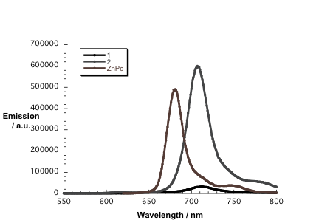
Figure S1: Fluorescence spectra of 1 (black), 2 (grey) upon photoexcitation at the porphyrin Soret band maximum (410 nm – 1; 415 nm 2) and of ZnPc (brown) after excitation at 610 nm. All samples 1.7 x 10⁻⁶ M in a mixture of 25% THF / 75% DMF.
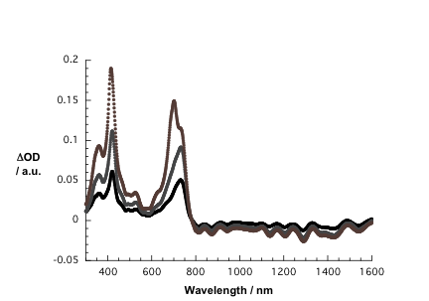
Figure S2: Differential absorption spectra calculated from titration experiments of SWNT suspended in a mixture of 25% THF / 75% DMF with 1. Please compare Figure 1.
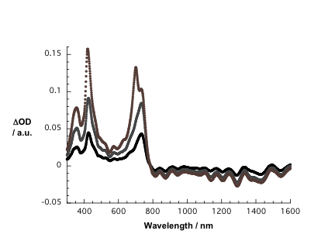
Figure S3: Differential absorption spectra calculated from titration experiments of SWNT suspended in a mixture of 25% THF / 75% DMF with 2. Please compare Figure 2.
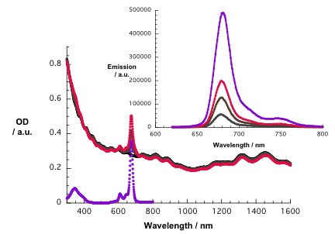
Figure S4: Titration of SWNT suspended in 25% THF / 75% DMF with ZnPc reference. Black – absorption spectrum of pure SWNT, grey – absorption spectrum of 5.8 x 10⁻⁷ M of ZnPc with SWNT, brown – absorption spectrum of 1.1 x 10⁻⁶ M of ZnPc with SWNT, red – absorption spectrum of 1.7 x 10⁻⁶ M of ZnPc with SWNT, purple – absorption spectrum 1.7 x 10⁻⁶ of ZnPc. Inset: corresponding fluorescence spectra after 610 nm excitation.
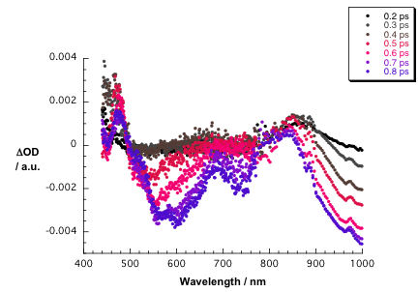
Figure 5 Differential absorption spectra obtained upon femtosecond laser flash photolysis (387 nm) of SWNT / 1 in 25% THF / 75% DMF at room temperature – visible and near-infrared part with time delays between 0.2 and 0.8 ps.

