Electronic Supplementary Information

[2.2]Paracyclophane as a bridging unit in the design of organic dyes for sensitized solar cells

Yuan Jay Chang,ª Motonori Watanabe,^{b} Po-Ting Chou,^{b} and Tahsin J. Chow^{*b}

ªDepartment of Chemistry, National Taiwan University, Taipei 106, Taiwan;
^{b}Institute of Chemistry, Academia Sinica, Taipei 115, Taiwan.

Contents
1. Experimental (CP~CP4) 2-7
2. ¹H and ¹³C NMR spectra 8-19
3. Theoretical calculation 20-22
4. CV spectra 23
5. HOMO-LUMO level 23
6. EIS spectra 24
7. Electron lifetime spectra 25
8. References 26

- Experimental (CP1~CP4)
General Information
All reactions and manipulations were carried out under a nitrogen atmosphere. Solvents were distilled freshly according to standard procedures. ¹H and ¹³C NMR spectra were recorded on Brucker (AV 400/AV 500 MHz) spectrometer in CDCl₃, and DMSO-d₆ as a solvent. Chemical shifts are reported in scale downfield from the peak for tetramethylsilane. Absorption spectra were recorded on a Jasco-550 spectrophotometer. Emission spectra and photoluminescence quantum yield were obtained from a Hitachi F-4500 spectrofluorimeter. The emission spectra in solutions were measured in spectral grade solvent by the 90 degree angle detection, and those of thin film were recorded by front-face detection. The redox potentials were measured by using cyclic voltammetry on CHI 620 analyzer. All measurements were carried out in THF solutions containing 0.1 M tetrabutylammonium hexaflouro-
phosphate (TBAPF₆) as supporting electrolyte at ambient condition after purging 10 minutes with N₂. The conventional three electrode configuration was employed, which consists of a glassy carbon working electrode, a platinum counter electrode, and a Ag/Ag⁺ reference electrode calibrated with ferrocene/ferrocenium (Fc/Fc⁺) as an internal reference. Mass spectra were recorded on a VG70-250S mass spectrometer. Elementary analyses were performed on a Perkin-Elmer 2400 CHN analyzer.
The chemicals, i.e., iron powder, bromine, trans-dichlorobis(triphenylphosphine) palladium (II) (PdCl₂(PPh₃)₂), n-butyllithium (1.6 M in hexane), N,N-dimethylformamide (DMF), tetrahydrofuran (THF), cyanoacetic acid, ammonium acetate, and acetic acid. All chemicals were purchased from ACROS, Merck, Lancaster, TCI, Sigma-Aldrich, separately, and purified before use. Chromatographic separations were carried out by using silica gel from Merk, Kieselgel si 60 (40 - 63 μm).

Scheme S1. Synthetic routes of CP1~CP4. Reagents and conditions: (si) Fe, Br₂, CH₂Cl₂, reflux. (sii) PdCl₂(PPh₃)₂, N-(4-(tributylstannyl)phenyl)-N-phenyl-
benzenamine or N-(4-(5-(tributylstannyl)thiophen-2-yl)phenyl)-N-phenyl-
benzenamine, DMF, 90°C. (siii) (a) PdCl₂(PPh₃)₂, (5-(1,3-dioxolan-2-yl)
thiophen-2-yl)tributylstannane, DMF, 90 °C; (b) AcOH:THF:H₂O (4:2:1), 60°C. (siv) n-BuLi, DMF, THF, -78°C. (sv) cyanoacetic acid, NH₄OAc, AcOH, 90~100 °C.

(1) ¹
The iron powder (270 mg, 4.8 mmol) in dry CH₂Cl₂ (100 mL) was placed in a three-necked flask and was stirred with refulx for 1 hr under a nitrogen atmosphere. Then added [2.2]paracyclophane (20 g, 96.1 mmol) in CH₂Cl₂ (100 mL) and stirred 30 minutes, and bromine solution was added dropwise over 4 hrs. After HBr fumes no longer detected, the mixture was evaporated to get light brown crude solid that were recrystallized (CH₂Cl₂) to give 1 as off-white solid in 36% yield (12.6 g, 34.6 mmol). Spectroscopic data of 1: δ_{H} (400 MHz, CDCl₃) 7.16 (d, 2H, J = 7.6 Hz), 6.53 (s, 2H), 6.46 (d, 2H, J = 7.6 Hz), 3.51 (t, 2H, J = 11.8 Hz), 3.17 (td, 2H, J = 11.6, 4.8 Hz), 2.96 (t, 2H, J = 12.4 Hz), 2.86 (td, 2H, J = 11.6, 4.8 Hz); δ_{C} NMR (100 MHz, CDCl₃) 141.1, 138.5, 137.3, 134.1, 128.2, 126.7, 35.3, 32.84; m/z (FAB) 363.9468 (M⁺, C₁₆H₁₄Br₂ requires 363.9462).

(2-T) ²
To a three-necked flask containing a mixture of 1 (2.0 g, 5.49 mmol), PdCl₂(PPh₃)₂ (116 mg, 0.16 mmol), and N-(4-(tributylstannyl)phenyl)-N-phenylbenzenamine (2.94 g, 5.47 mmol) in DMF (20 mL). The reaction mixture was stirred at 90 °C for 12 h. After cooling, the reaction was quenched by adding MeOH and KF_{(aq)} (saturated 15 mL). The mixture was extracted with CH₂Cl₂ and the organic layer dried over anhydrous MgSO₄. Evaporation of the solvent gave the crude, which was purified by silica gel with dichloromethane/hexane (1/9) as eluent. White powder of 2-T was obtained in 35% yield (1.01 g, 1.91 mmol). δ_{H} (400 MHz, CDCl₃) 7.32 (t, 6H, J = 8.0 Hz), 7.12-7.21 (m, 7H), 7.08 (t, 2H, J = 7.2 Hz), 6.65 (s, 1H), 6.62 (d, 1H, J = 8.4 Hz), 6.57 (d, 2H, J = 7.6 Hz), 6.50 (d, 1H, J = 7.6 Hz), 3.45-3.58 (m, 2H), 3.22-3.30 (m, 1H), 2.79-3.08 (m, 5H); δ_{C} NMR (100 MHz, CDCl₃) 147.6, 146.7, 141.9, 141.8, 139.3, 138.8, 137.3, 136.4, 135.1, 135.0, 134.0, 131.9, 130.4, 129.3, 128.9, 128.1, 126.4, 124.6, 123.2, 123.0, 35.6, 34.4, 33.7, 33.2; m/z (FAB) 529.1395 (M⁺, C₃₄H₂₈NBr requires 529.1405).

(2-TS)
Compound 2-TS was synthesized according to the same procedure as that of 2-T, giving yellow solid of 2-TS in 35% yield. δ_{H} (400 MHz, CDCl₃) 7.63 (dt, 2H, J = 8.4, 3.2 Hz), 7.31-7.37 (m, 5H), 7.17-7.23 (m, 6H), 7.10-7.14 (m, 3H), 6.62-6.87 (m, 3H), 6.31-6.60 (m, 3H), 3.57-3.90 (m, 2H), 2.88-3.51 (m, 6H); δ_{C} (100 MHz, CDCl₃) 147.5, 147.3, 144.0, 142.6, 141.6, 139.7, 138.7, 137.2, 136.9, 135.2, 134.1, 133.2, 129.3, 129.1, 128.7, 128.4, 127.1, 126.5, 126.4, 124.5, 124.4, 123.9, 123.8, 123.1, 123.0, 122.8, 122.7, 35.4, 34.2, 34.1, 33.1; m/z (FAB) 611.1279 (M⁺, C₃₈H₃₀NSBr requires 611.1282).

(2-C6TS)
Compound 2-C6TS was synthesized according to the same procedure as that of 2-T, giving yellow solid of 2-C6TS in 32% yield. δ_{H} (400 MHz, CDCl₃) 7.51 (d, 2H, J = 7.6 Hz), 6.99-7.23 (m, 8H), 6.88 (d, 4H, J = 8.4 Hz), 6.81 (dd, 2H, J = 7.8, 1.6 Hz), 6.53-6.64 (m, 4H), 3.98 (t, 2H, J = 6 .4 Hz), 3.79-3.86 (m, 1H), 3.52-3.58 (m, 1H), 3.21-3.28 (m, 1H), 2.89-3.08 (m, 5H), 1.79-1.86 (m, 4H), 1.47-1.53 (m, 4H), 1.37-1.41 (m, 8H), 0.96 (t, 6H, J = 7.2 Hz); δ_{C} (100 MHz, CDCl₃) 155.6, 148.3, 144.5, 141.9, 141.6, 140.4, 139.8, 139.7, 139.4, 138.7, 137.2, 137.0, 136.8, 135.3, 135.1, 134.6, 134.1, 133.6, 133.2, 132.2, 129.2, 128.6, 127.6, 127.1, 126.6, 126.5, 126.2, 122.2, 120.6, 115.3, 35.4, 34.2, 34.1, 33.1, 31.6, 29.3, 25.8, 22.6, 14.0; m/z (FAB) 811.3064 (M⁺, C₅₀H₅₄NO₂SBr requires 811.3059).

(3-T)
A mixture of 2T (1.0 g, 1.89 mmol), PdCl₂(PPh₃)₂ (40 mg, 0.06 mmol), and 2-(1,3-dioxolaneyl)-5-(tributylstannaneyl)thiophene (1.68 g, 3.78 mmol) in DMF (20 mL). The reaction mixture was stirred at 90 °C for 12 h. After cooling, the reaction was quenched by adding MeOH and KF_{(aq)} (saturated 15 mL). The mixture was extracted with CH₂Cl₂ and the organic layer dried over anhydrous MgSO₄. Evaporation of the solvent gave the crude, which added a solution of acetic acid/ THF/H₂O (4/2/1). The mixture was stirred with a magnetic bar for 6 hours at 60 Celsius degree, then was quenched by adding water and extracted with dichloromethane. The organic layer was dried over anhydrous MgSO₄ and evaporated under vacuum. The products were purified by silica gel column chromatograph eluted with dichloromethane/hexane (1/1). Yellow solid of 3T was obtained in 35% yield (371 mg, 0.66 mmol). Spectroscopic data of 3T: δ_{H} (400 MHz, CDCl₃) 9.79 (s, 1H), 7.82 (d, 1H, J = 4.0 Hz), 7.36 (t, 3H, J = 8.0 Hz), 7.31 (d, 3H, J = 7.6 Hz), 7.18-7.24 (m, 7H), 7.08 (t, 2H, J = 7.2 Hz), 6.61-6.74 (m, 6H), 3.68-3.74 (m, 1H), 3.50-3.57 (m, 1H), 2.86-3.08 (m, 1H); δ_{C} ( 100 MHz, CDCl₃) 182.8, 154.4, 147.6, 146.8, 143.0, 141.9, 140.8, 139.3, 137.6, 137.0, 136.7, 135.2, 135.1, 134.8, 133.7, 133.5, 132.1, 131.0, 130.3, 129.3, 128.7, 127.2, 124.6, 123.2, 123.0, 34.6, 34.5, 34.1, 33.8; m/z (FAB) 561.2123 (M⁺, C₃₉H₃₁NOS requires 561.2126).

(3-TS)
Compound 3TS was synthesized according to the same procedure as that of 3T, giving yellow solids of 3TS in 43% yield. δ_{H} (400 MHz, CDCl₃) 9.97 (s, 1H), 7.82 (d, 1H, J = 4.0 Hz), 7.59 (d, 2H, J = 8.4 Hz), 7.28-7.33 (m, 5H), 7.23 (d, 1H, J = 4.0 Hz), 7.06-7.18 (m, 9H), 6.91 (d, 1H, J = 8.0 Hz), 6.61-6.73 (m, 5H), 3.84-3.90 (m, 1H), 3.67-3.674 (m, 1H), 2.90-3.09 (m, 6H); δ_{C} (100 MHz, CDCl₃) 182.8, 154.3, 147.5, 147.3, 144.1, 143.0, 142.5, 140.6, 139.8, 137.6, 137.1, 137.0, 135.2, 135.1, 134.9, 133.8, 133.5, 133.3, 131.1, 129.3, 128.4, 127.2, 127.1, 126.4, 124.5, 123.8, 123.1, 122.8, 34.6, 34.4, 34.2, 33.9; m/z (FAB) 643.2001 (M⁺, C₄₃H₃₃NOS₂ requires 643.2004).

(3-C6TS)
Compound 3-C6TS was synthesized according to the same procedure as that of 3T, giving yellow solid of 3-C6TS in 30% yield. δ_{H} (400 MHz, CDCl₃) 9.96 (s, 1H), 7.50 (d, 2H, J = 8.4 Hz), 7.23 (d, 2H, J = 3.6 Hz), 7.07-7.10 (m, 4H), 6.98 (d, 2H, J = 8.0 Hz), 6.90 (dd, 1H, J = 7.8, 1.6 Hz), 6.86 (d, 4H, J = 9.2 Hz), 6.59-6.72 (m, 6H), 3.96 (t, 4H, J = 6.4 Hz), 3.83-3.89 (m, 1H), 3.66-3.72 (m, 1H), 2.87-3.09 (m, 6H), 1.77-1.82 (m, 4H), 1.47-1.51 (m, 4H), 1.35-1.39 (m, 8H), 0.94 (t, 6H, J = 6.8 Hz); δ_{C} (100 MHz, CDCl₃) 182.8, 155.5, 154.4, 148.3, 143.0, 140.6, 140.4, 139.7, 137.6, 137.0, 135.2, 134.9, 133.8, 133.4, 133.2, 131.1, 129.2, 127.2, 127.0, 126.6, 126.2, 122.2, 120.5, 115.3, 68.3, 34.4, 34.2, 33.9, 31.6, 29.7, 29.3, 25.7, 22.6; m/z (FAB) 843.3769 (M⁺, C₅₅H₅₇NO₃S₂ requires 843.3780).

(4-TS)
To a solution of 2-TS (2.0 g, 3.27 mmol) in THF at -78 °C was added dropwise n-BuLi (3.10 mL, 4.90 mmol, 1.6 M in hexane). The mixture was stirred for 1 h, then to it was added DMF (0.4 mL, 4.9 mmol). The reaction was stirred with a magnetic bar for 6 h, then was quenched by adding water and extracted with ethyl acetate. The organic layer was dried over anhydrous MgSO₄ and evaporated under vacuum. The products were purified by silica gel column chromatograph eluted with dichloromethane/hexane (1/1). Yellow solid of 4-TS was obtained in 62% yield (1.14 g, 2.02 mmol). Spectroscopic data of 4-TS: δ_{H} (400 MHz, CDCl₃) 10.0 (s, 1H), 7.59 (d, 2H, J = 8.4 Hz), 7.28-7.34 (m, 5H), 7.03-7.19 (m, 10H), 6.68 (d, 1H, J = 7.6 Hz), 6.67 (d, 1H, J = 1.6 Hz), 6.54 (d, 1H, J = 8.0 Hz), 6.42 (dd, 1H, J = 7.6, 1.6 Hz), 4.15-4.21 (m, 1H), 3.80-3.85 (m, 1H), 3.22-3.28 (m, 1H), 2.99-3.14 (m, 5H); δ_{C} (100 MHz, CDCl₃) 192.0, 147.5, 147.4, 144.3, 143.1, 142.3, 140.6, 140.0, 137.2, 136.6, 136.5, 135.3, 135.1, 135.0, 132.9, 131.5, 129.3, 128.3, 127.3, 126.4, 124.5, 123.8, 123.1, 122.9, 34.7, 34.2, 33.9, 33.1; m/z (FAB) 562.2205 ((M+H)⁺, C₃₉H₃₁ONS requires 562.2214).

(CP1) ³
A mixture of 3T (1.0 g, 1.78 mmol), cyanoacetic acid (182 mg, 2.14 mmol), and ammonium acetate (35 mg, 0.45 mmol) in acetic acid was placed in a three-necked flask under a nitrogen atmosphere and was stirred at 100 °C for 12 h. After cooling, the reaction was quenched by adding water, then was extracted with CH₂Cl₂. The organic layer was dried over anhydrous MgSO₄ and evaporated under vacuum. The products were purified by silica gel column chromatograph eluted with CH₂Cl₂/acetic acid (19/1). The deeply red solid was isolated in 70% yield (782 mg, 1.24 mmol). Spectroscopic data of CP1: δ_{H} (400 MHz, DMSO-d₆) 8.55 (s, 1H), 8.09 (d, 1H, J = 4.0 Hz), 7.52 (d, 1H, J = 4.0 Hz), 7.44 (d, 2H, J = 8.4 Hz), 7.37 (d, 2H, J = 7.6 Hz), 7.35 (d, 2H, J = 8.0 Hz), 7.08-7.12 (m, 1H), 6.80 (d, 2H, J = 10.4 Hz), 6.54-6.67 (m, 4H), 3.64 (t, 1H, J = 11.2 Hz), 3.32-3.40 (m, 1H), 2.71-3.10 (m, 6H); δ_{C} NMR (100 MHz, DMSO-d₆) 164.1, 153.5, 147.5, 147.1, 146.5, 141.9, 141.0, 140.8, 139.5, 137.9, 136.9, 135.8, 135.7, 135.2, 135.0, 133.6, 133.5, 133.2, 131.2, 130.9, 130.1, 129.0, 128.2, 124.7, 123.7, 123.1, 117.1, 98.9, 34.4, 34.3, 34.2, 33.7; m/z (FAB) 629.2278 ((M+H)⁺, C₄₂H₃₃N₂O₂S requires 629.2263).

(CP2)
Compound CP2 was synthesized according to the same procedure as that of CP1, giving yellow solid of CP2 in 72% yield. δ_{H} (400 MHz, DMSO-d₆) 8.36 (s, 1H), 7.63 (d, 2H, J = 8.0 Hz), 7.46 (d, 1H, J = 2.4 Hz), 7.32 (d, 5H, J = 7.6 Hz), 7.22 (d, 1H, J = 2.4 Hz), 7.00-7.09 (m, 8H), 6.83 (d, 2H, J = 7.2 Hz), 6.75 (d, 1H, J = 7.6 Hz), 6.69 (s, 1H), 6.60 (d, 1H, J = 7.6 Hz), 6.44 (d, 1H, J = 7.2 Hz), 3.69 (t, 1H, J = 10.0 Hz), 3.48 (t, 1H, J = 10.8 Hz), 2.82-3.14 (m, 6H); δ_{C} (100 MHz, DMSO-d₆) 163.9, 152.6, 147.3, 147.2, 143.8, 143.1, 142.2, 140.6, 139.8, 137.2, 135.5, 135.0, 134.8, 134.3, 133.6, 132.9, 132.2, 131.2, 130.0, 128.2, 128.1, 126.8, 124.6, 124.0, 123.8, 123.7, 116.7, 104.6, 34.5, 34.1, 33.9, 33.1; m/z (FAB) 629.2281 ((M+H)⁺, C₄₂H₃₃N₂O₂S requires 629.2263).

(CP3)
Compound CP3 was synthesized according to a similar procedure as that of CP1, giving yellow solid of CP3 in 65% yield. δ_{H} (400 MHz, DMSO-d₆) 8.54 (s, 1H), 8.08 (d, 1H, J = 3.2 Hz), 7.65 (d, 2H, J = 8.0 Hz), 7.51 (d, 1H, J = 3.2 Hz), 7.48 (d, 1H, J = 3.2 Hz), 7.33 (t, 4H, J = 7.6 Hz), 7.25 (d, 1H, J = 2.8 Hz), 7.01-7.10 (m, 8H), 6.79 (s, 1H), 6.73 (d, 3H, J = 11.6 Hz), 6.64 (d, 1H, J = 8.0 Hz), 6.57 (d, 3H, J = 7.6 Hz), 3.72 (t, 1H, J = 10.6 Hz), 3.63 (d, 1H, J = 10.6 Hz), 2.96-3.07 (m, 4H), 2.76-2.80 (m, 2H); δ_{C} NMR (100 MHz, DMSO-d₆) 164.0, 147.3, 147.2, 143.6, 142.4, 140.6, 140.1, 137.9, 137.3, 135.7, 135.3, 134.9, 133.8, 133.4, 133.2, 130.1, 129.6, 128.3, 128.0, 126.8, 124.6, 124.0, 123.8, 123.7, 34.4, 34.2, 34.1, 29.45; m/z (FAB) 711.2156 ((M+H)⁺, C₄₆H₃₅N₂S₂O₂ requires 711.2140).

(CP4)
Compound CP4 was synthesized according to the same procedure as that of CP1, giving orange solid of CP4 in 62% yield. δ_{H} (400 MHz, CDCl₃) 8.44 (s, 1H), 7.90 (d, 1H, J = 4.0 Hz), 7.50 (d, 2H, J = 8.4 Hz), 7.29 (d, 1H, J = 3.6 Hz), 7.24 (d, 1H, J = 3.2 Hz), 7.07-7.11 (m, 5H), 6.98 (d, 2H, J = 8.0 Hz), 6.91 (dd, 1H, J =8.0, 1.6 Hz), 6.86 (d, 4H, J = 8.8 Hz), 6.77 (d, 1H, J = 3.2 Hz), 6.66-6.69 (m, 4H), 3.95 (t, 4H, J = 6.4 Hz), 3.83-3.88 (m, 1H), 3.70-3.76 (m, 1H), 2.90-3.09 (m, 6H), 1.77-1.82 (m, 4H), 1.47-1.51 (m, 4H), 1.35-1.40 (m, 8H), 0.94 (t, 6H, J = 6.8 Hz); δ_{C} NMR (100 MHz, DMSO-d₆) 167.4, 156.1, 155.5, 148.3, 148.0, 144.5, 141.8, 140.8, 140.5, 139.7, 139.4, 137.8, 137.2, 135.5, 135.2, 134.9, 133.4, 133.2, 131.5, 129.2, 127.8, 127.1, 122.2, 115.7, 96.7, 68.3, 34.5, 34.2, 34.1, 31.6, 29.7, 29.3, 25.7, 22.6, 14.0; m/z (FAB) 911.3922 ((M+H)⁺, C₅₈H₅₈N₂S₂O₄ requires 911.3916).

- ¹H and ¹³C NMR spectra
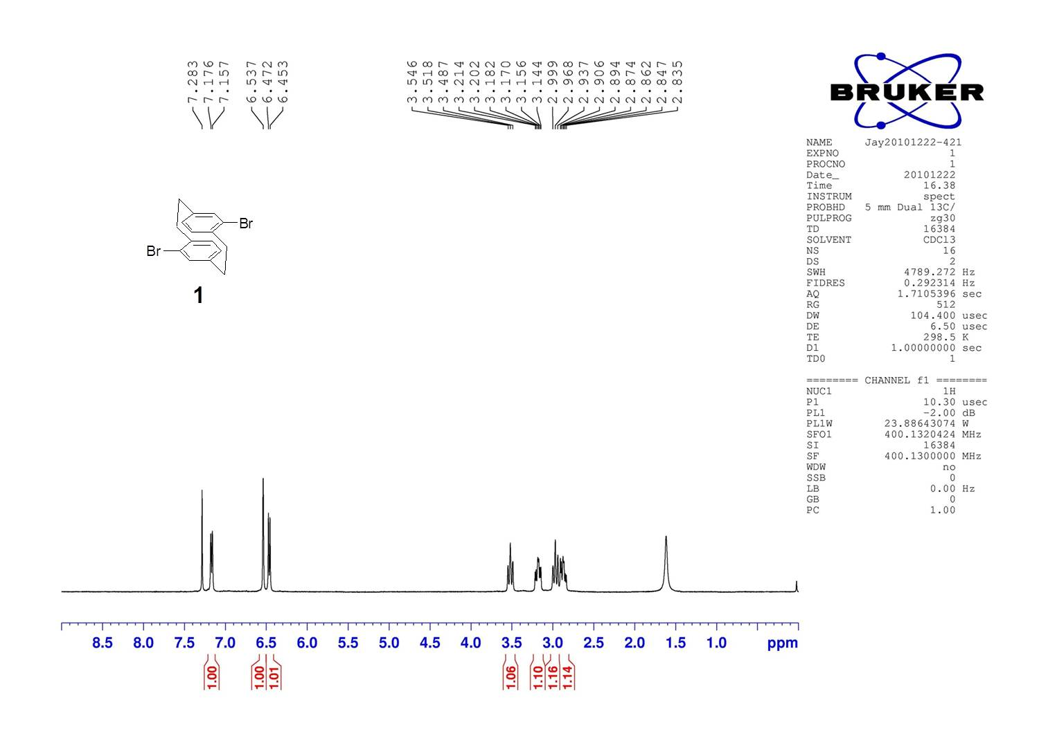

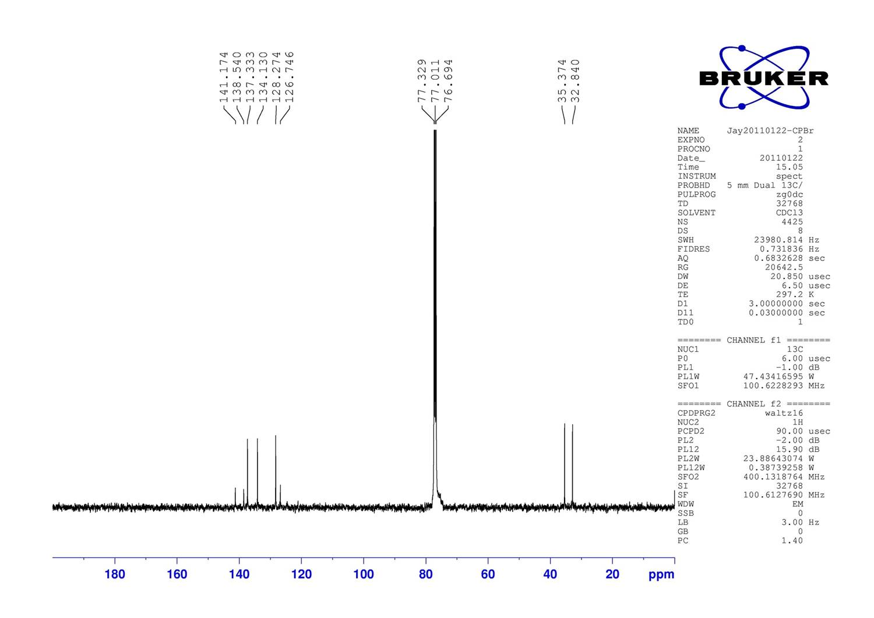

Figure S1: ¹H NMR (upper) and ¹³C NMR (lower) spectra of 1 in CDCl₃.
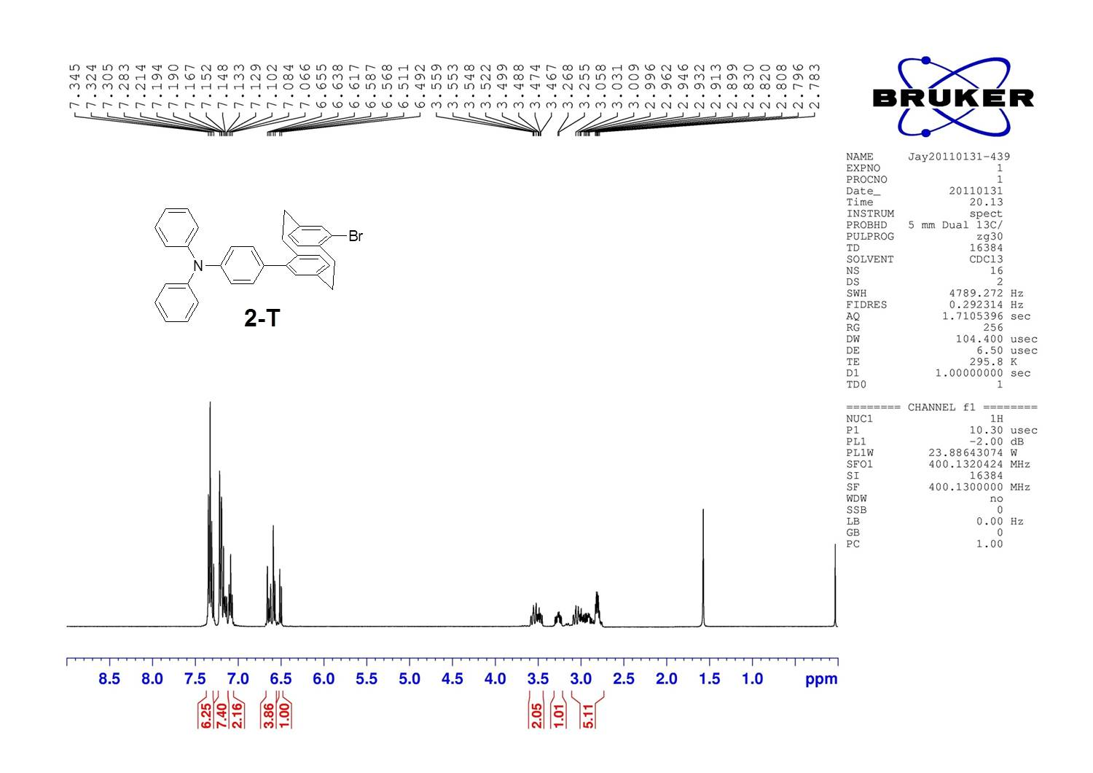

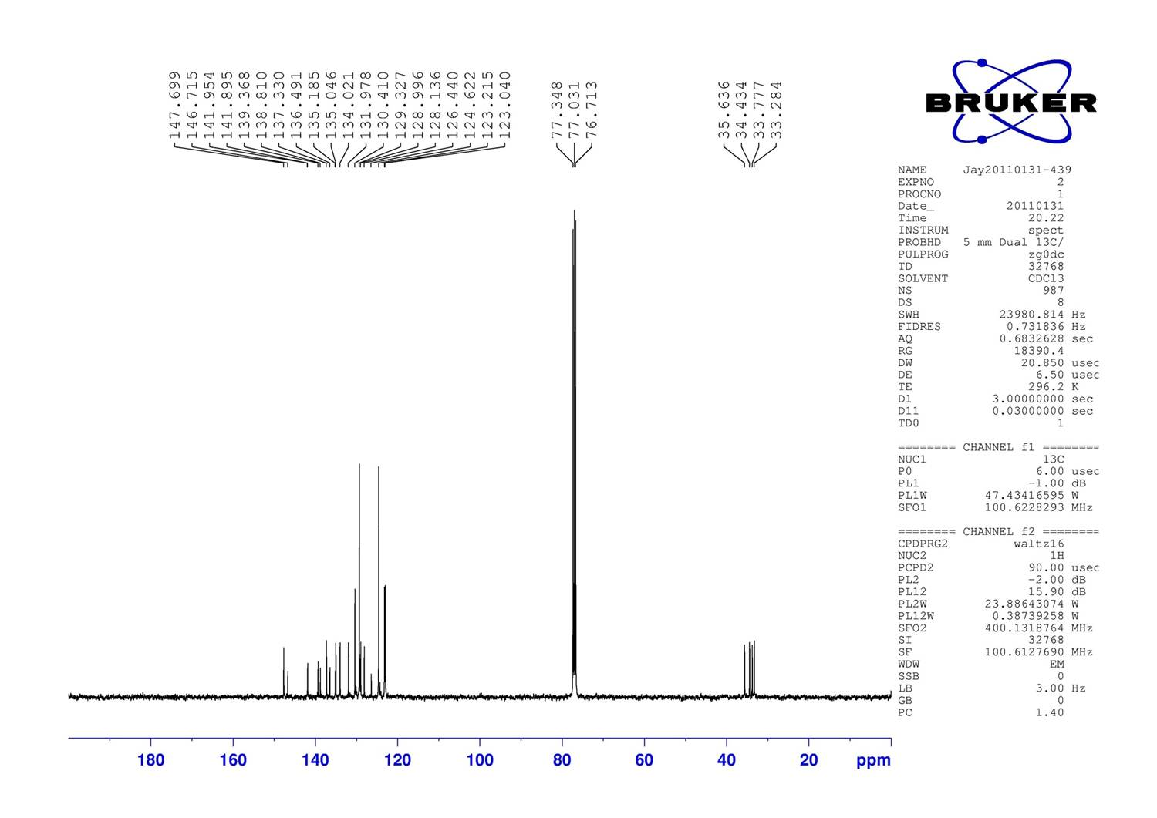

Figure S2: ¹H NMR (upper) and ¹³C NMR (lower) spectra of 2-T in CDCl₃.

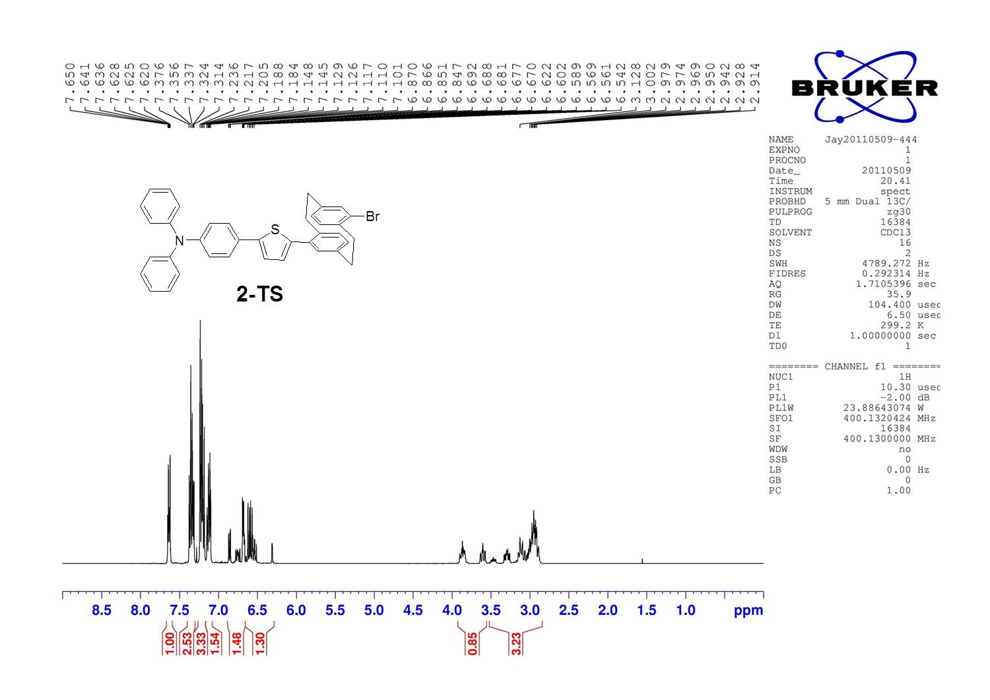

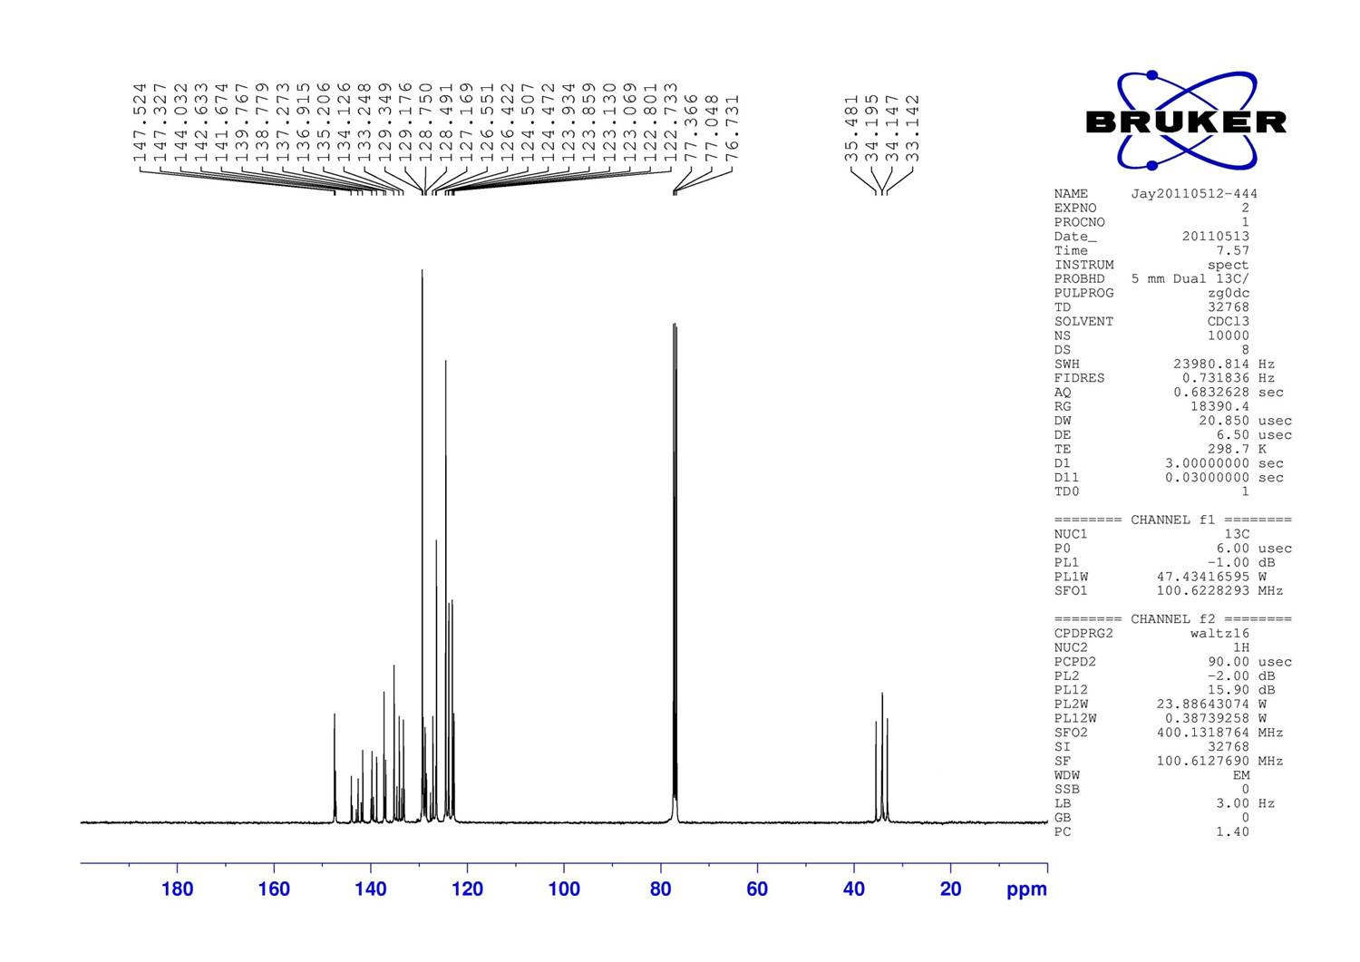

Figure S3: ¹H NMR (upper) and ¹³C NMR (lower) spectra of 2-TS in CDCl₃.

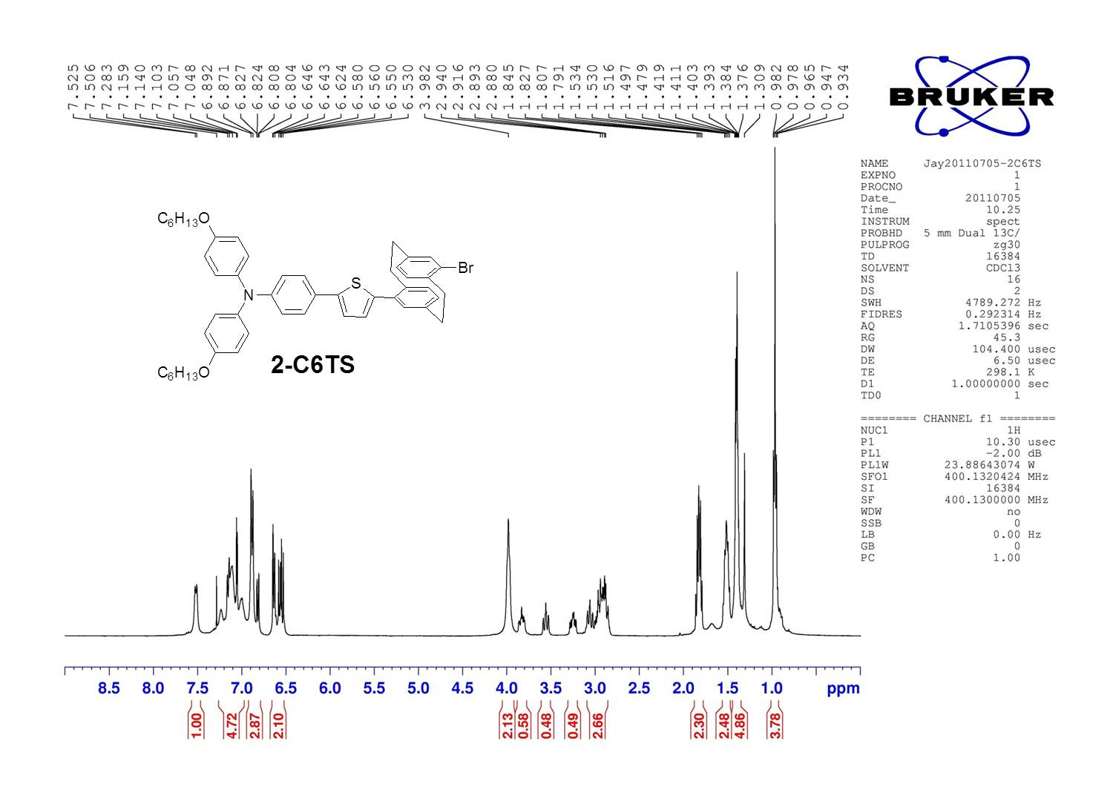

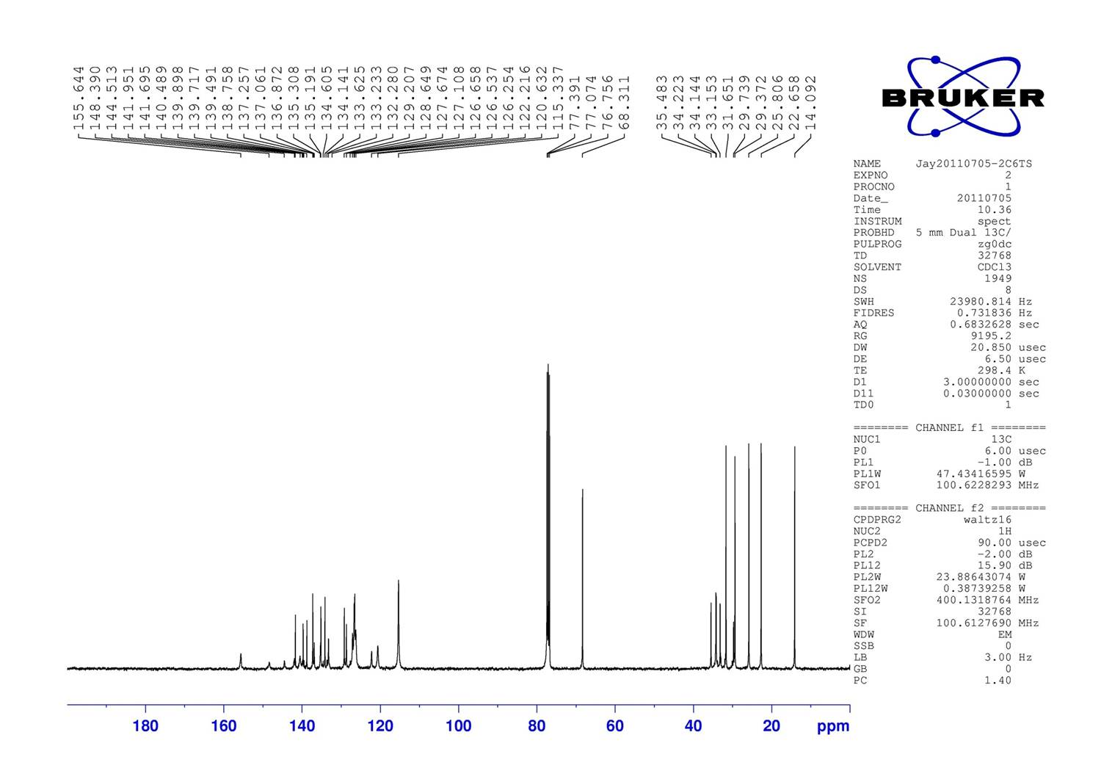

Figure S4: ¹H NMR (upper) and ¹³C NMR (lower) spectra of 2-C6TS in CDCl₃.
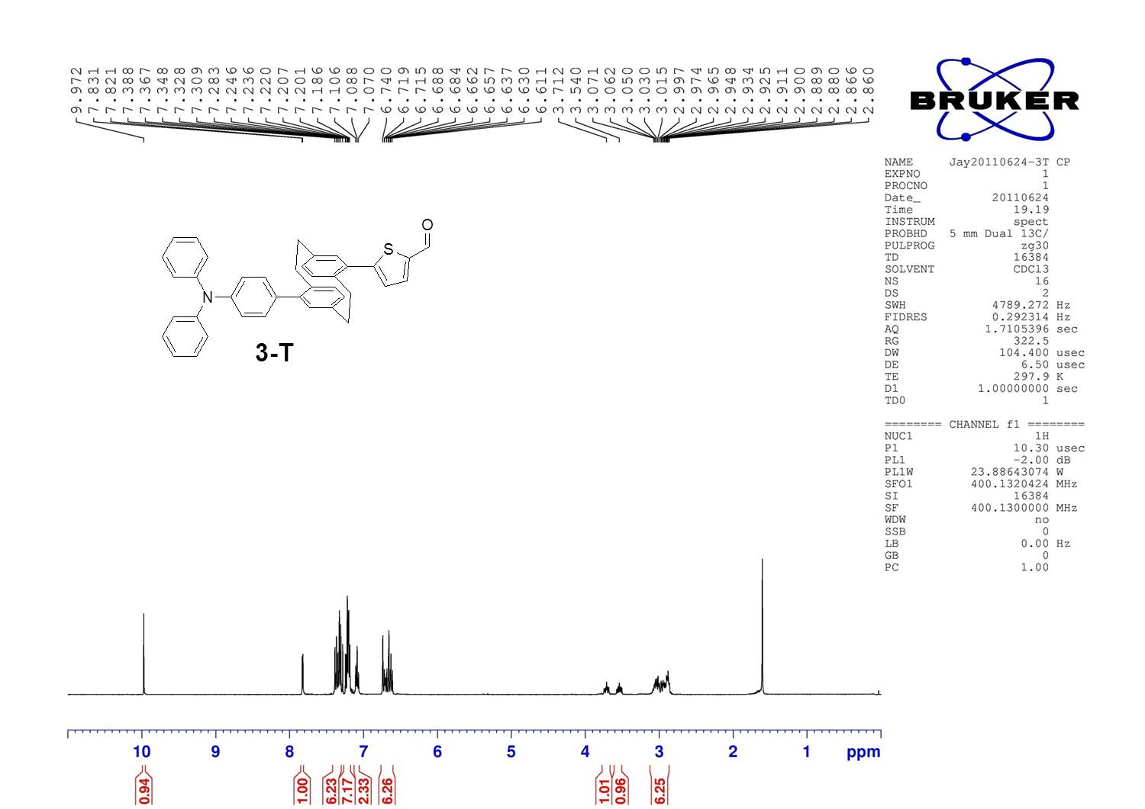

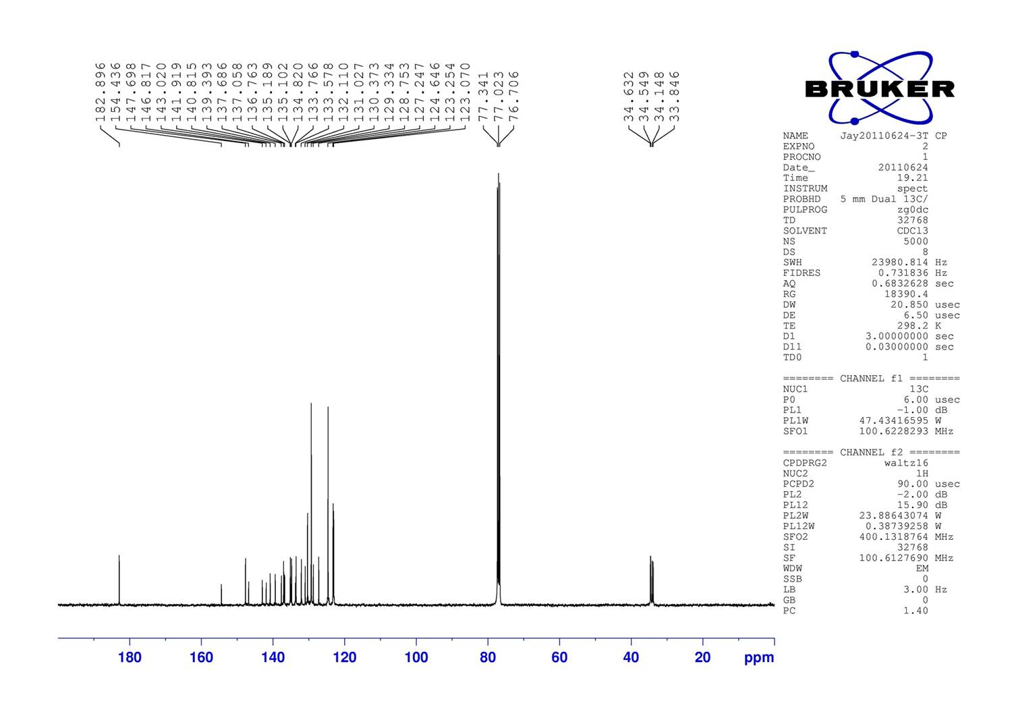

Figure S5: ¹H NMR (upper) and ¹³C NMR (lower) spectra of 3-T in CDCl₃.

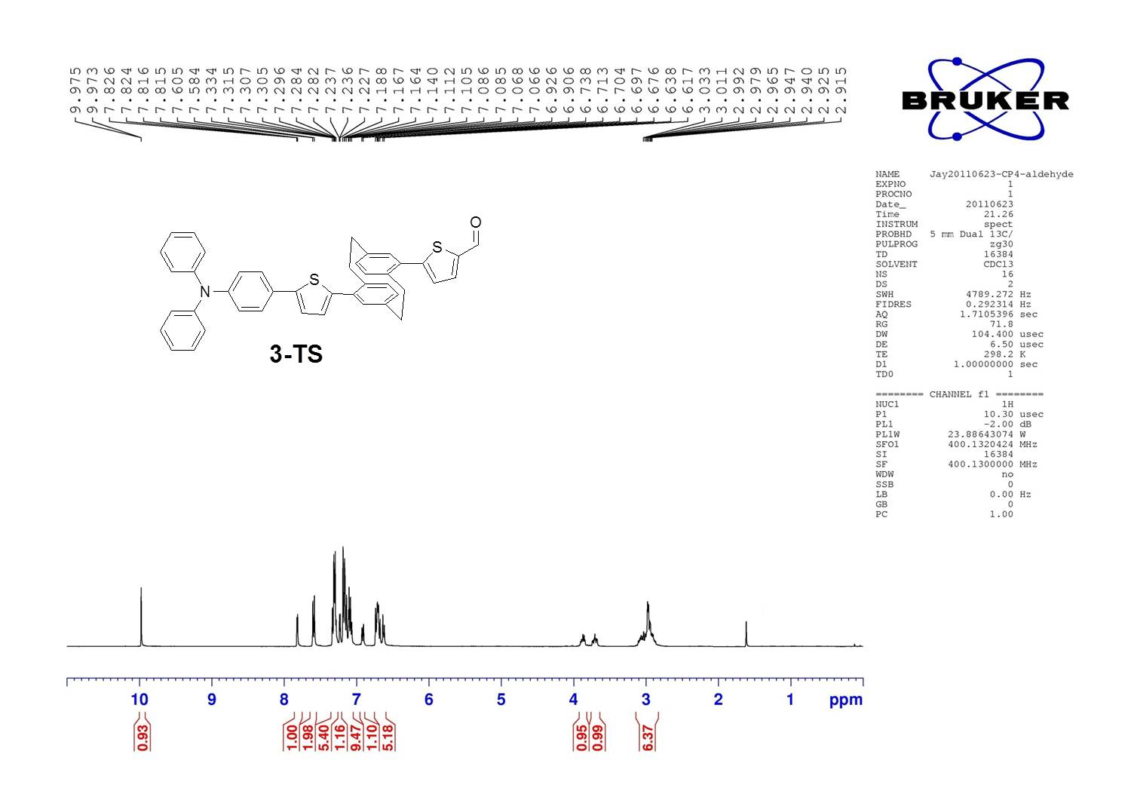

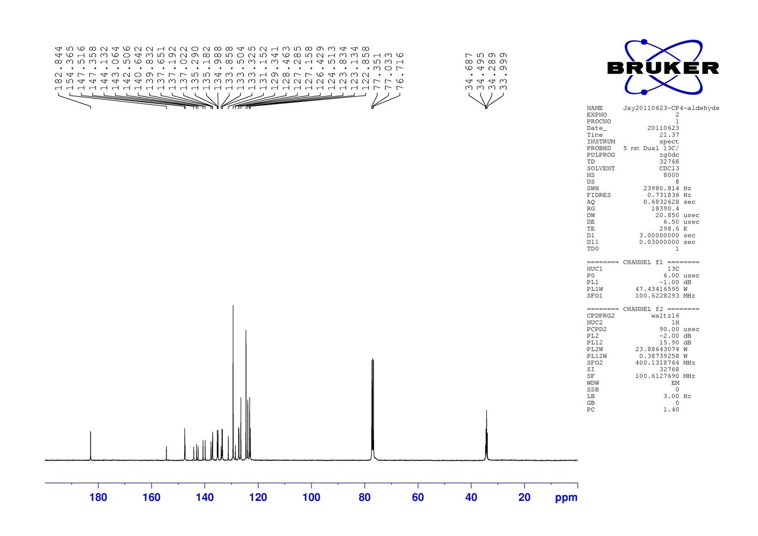

Figure S6: ¹H NMR (upper) and ¹³C NMR (lower) spectra of 3-TS in CDCl₃.

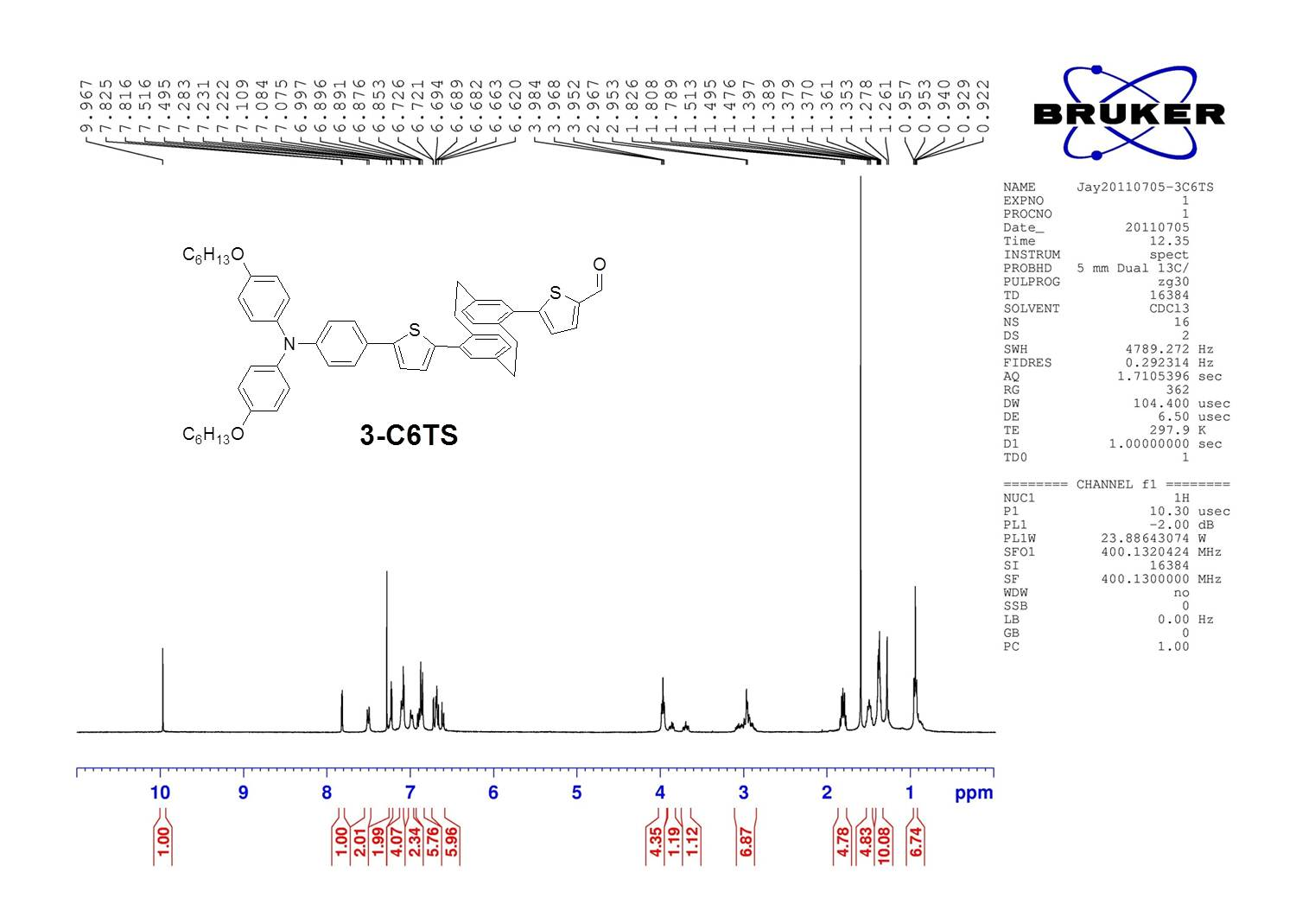

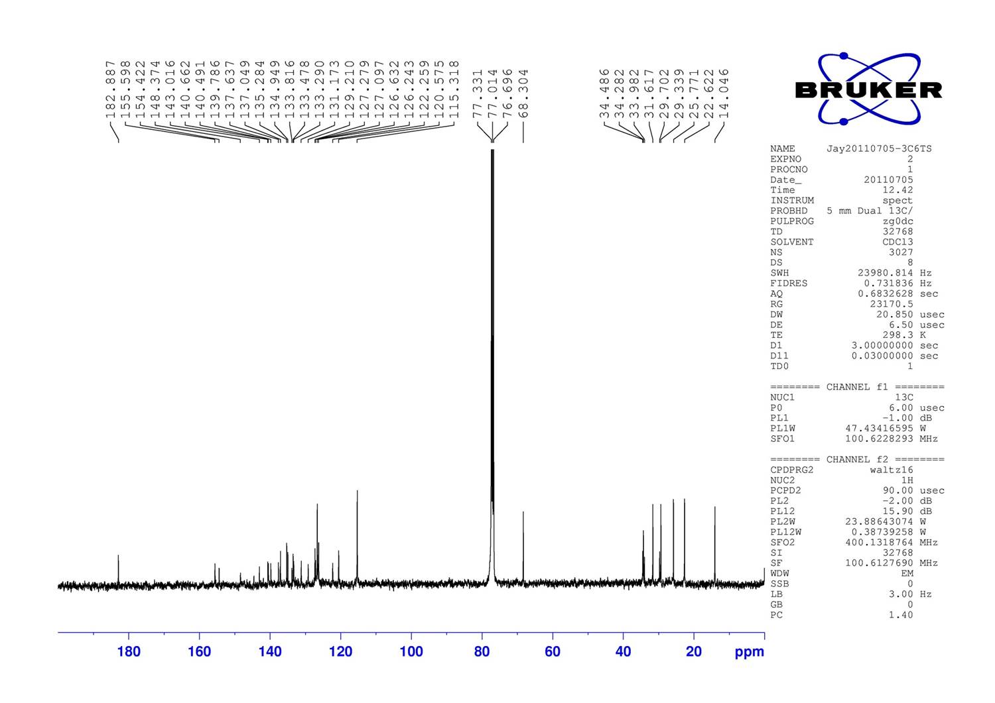

Figure S7: ¹H NMR (upper) and ¹³C NMR (lower) spectra of 3-C6TS in CDCl₃.

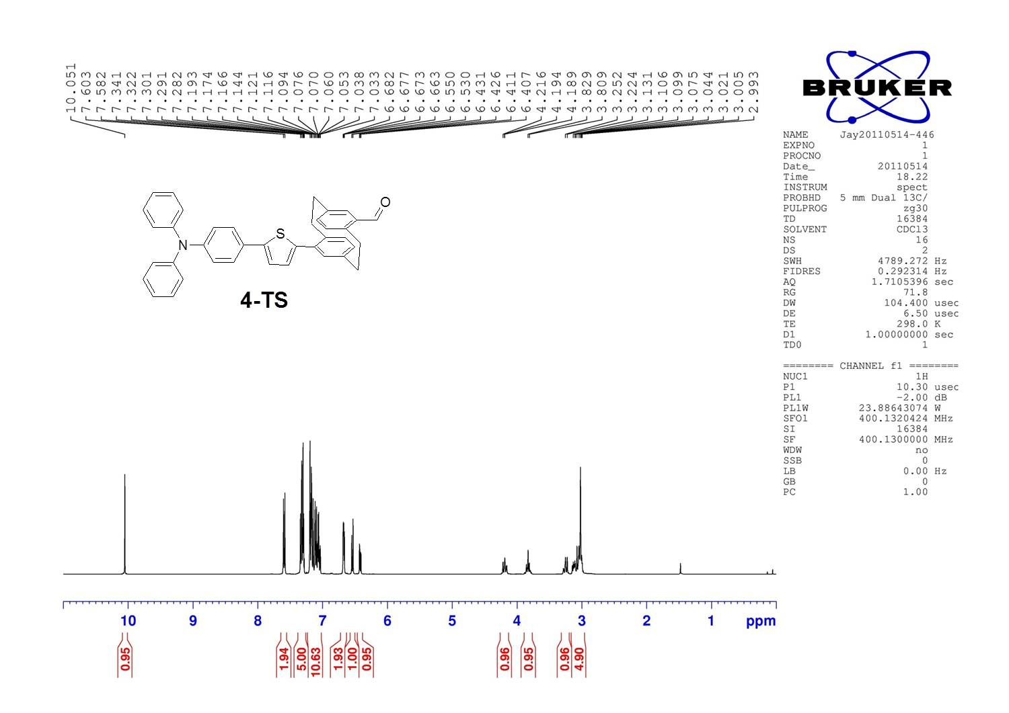

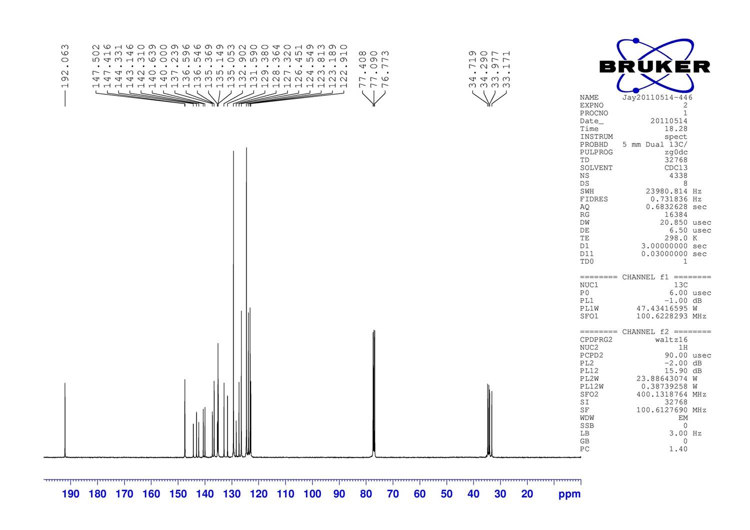

Figure S8: ¹H NMR (upper) and ¹³C NMR (lower) spectra of 4-TS in CDCl₃.
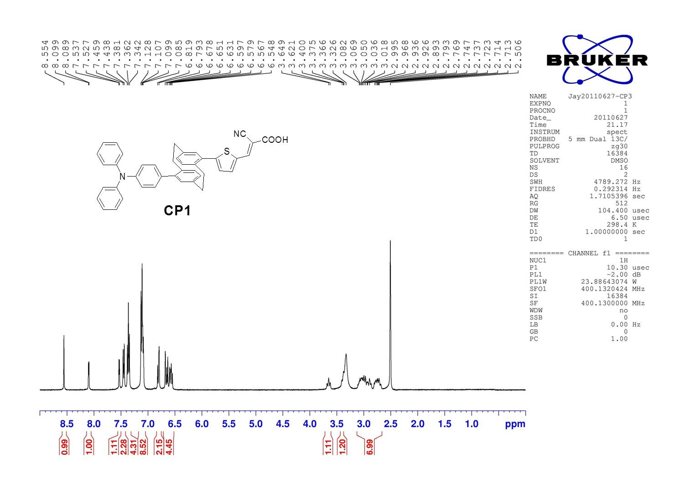

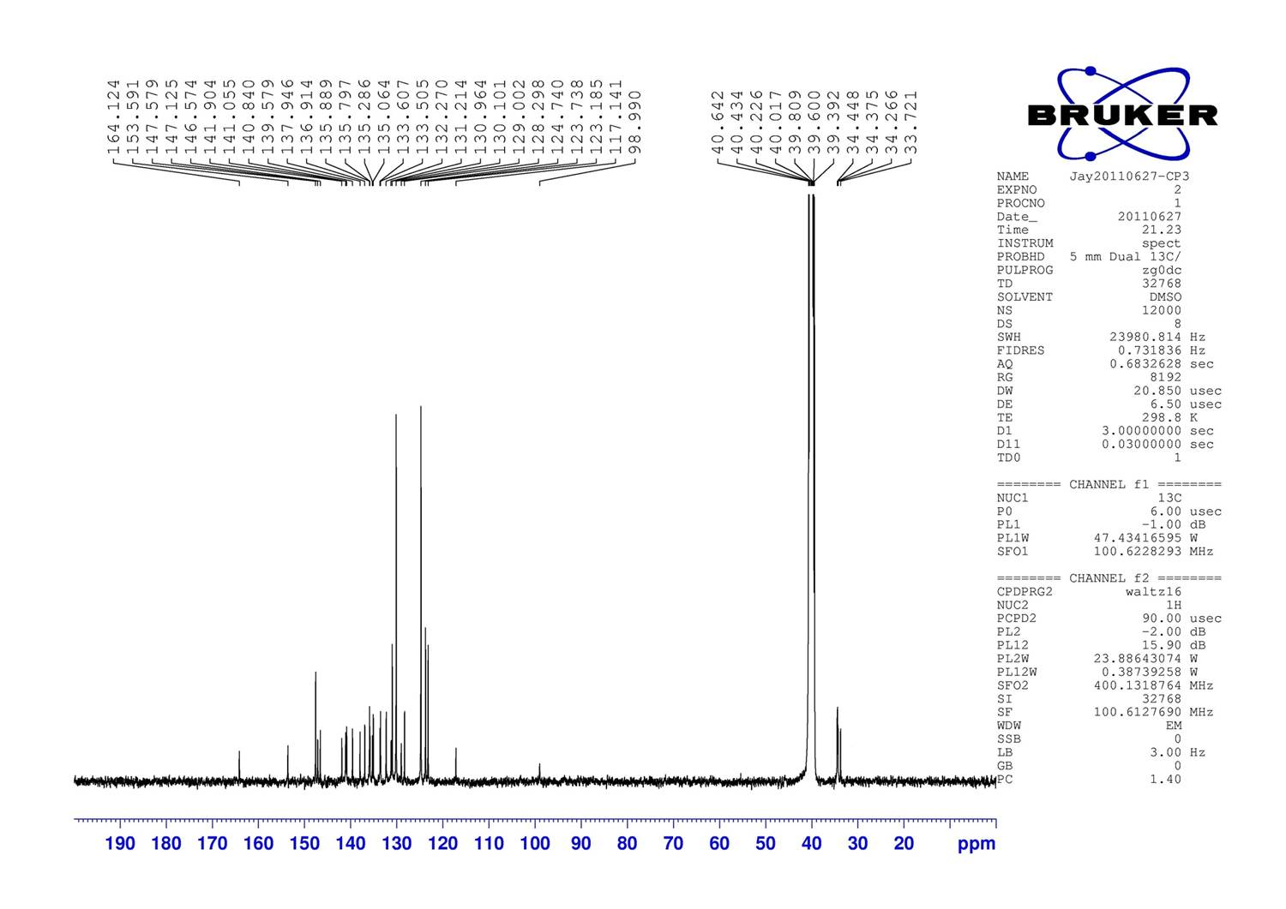

Figure S9: ¹H NMR (upper) and ¹³C NMR (lower) spectra of CP1 in DMSO-d₆.

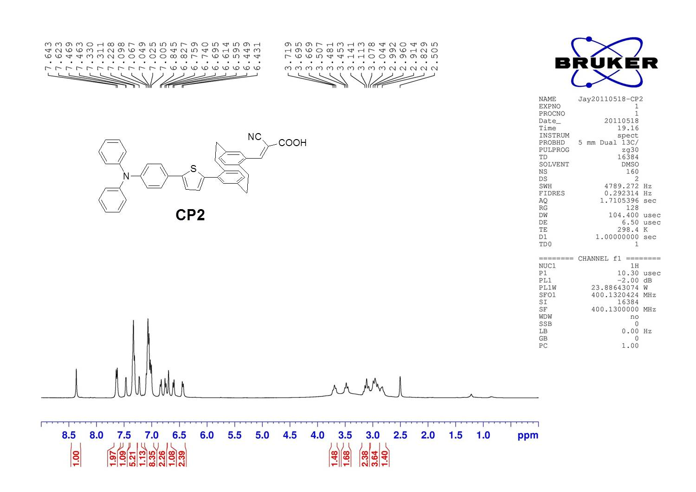

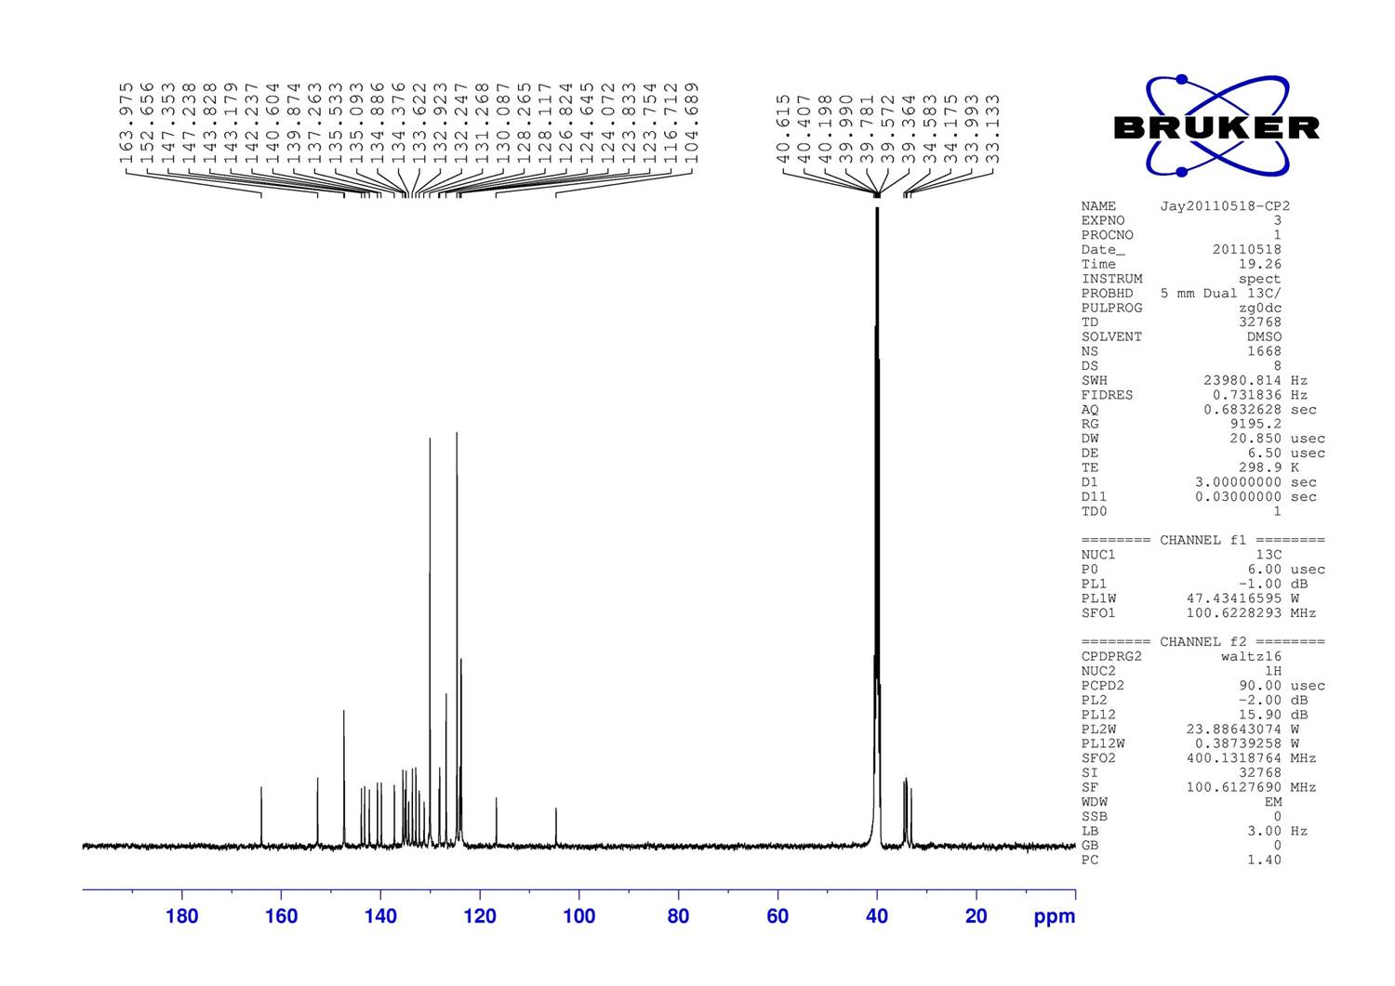

Figure S10: ¹H NMR (upper) and ¹³C NMR (lower) spectra of CP2 in DMSO-d₆.

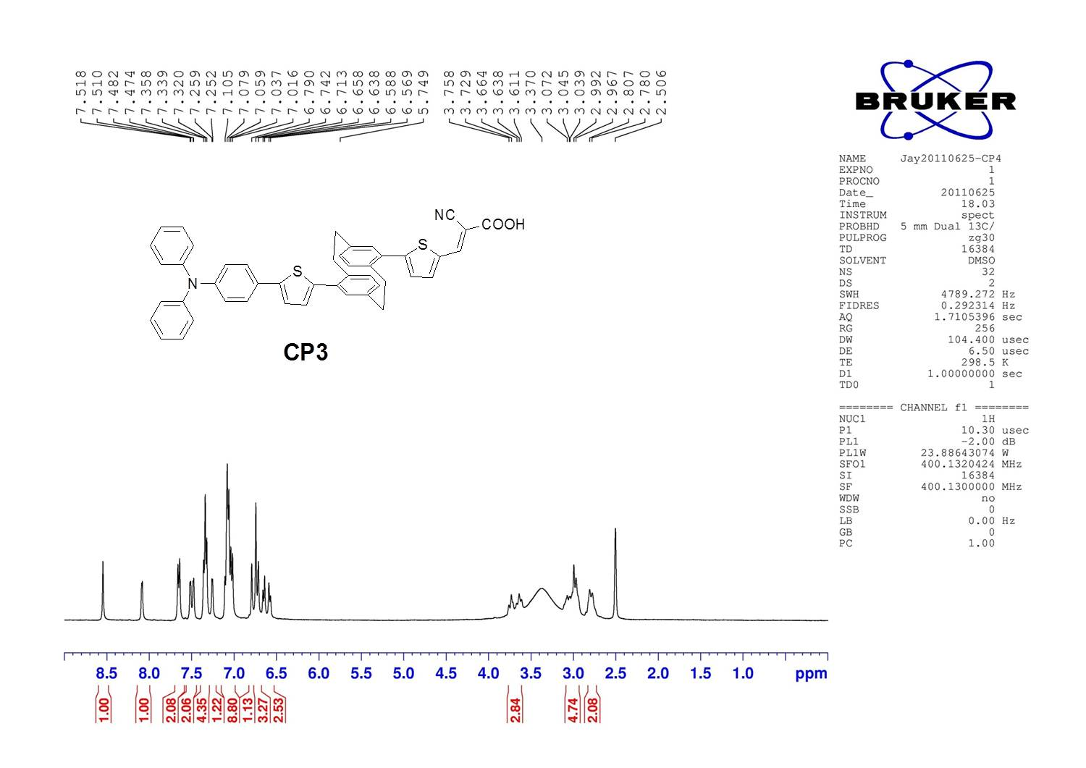

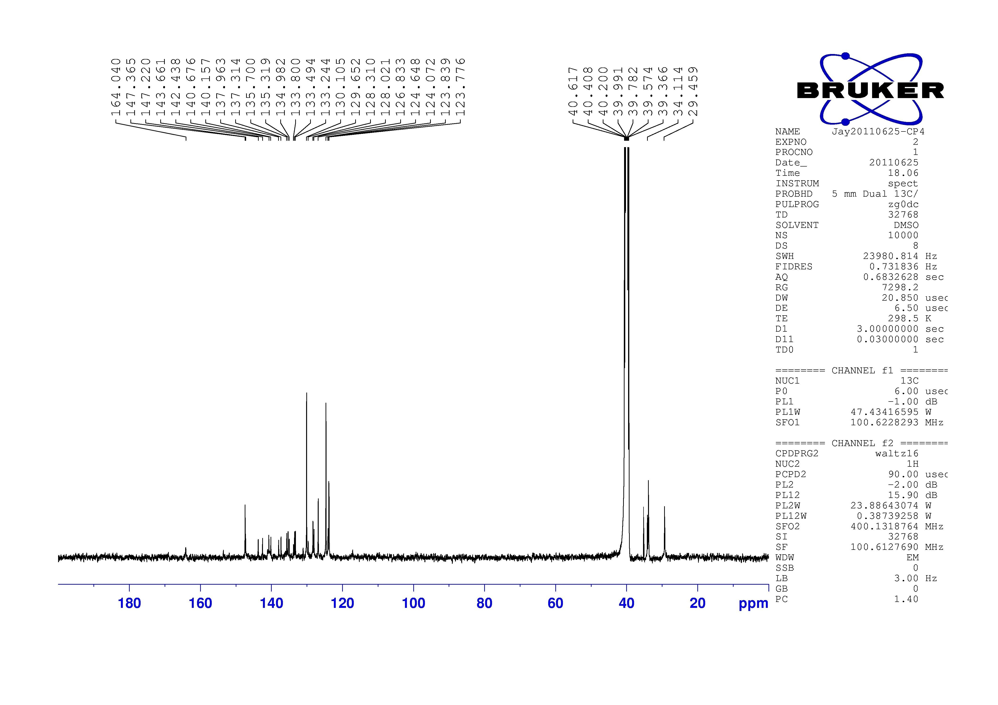

Figure S11: ¹H NMR (upper) and ¹³C NMR (lower) spectra of CP3 in DMSO-d₆.
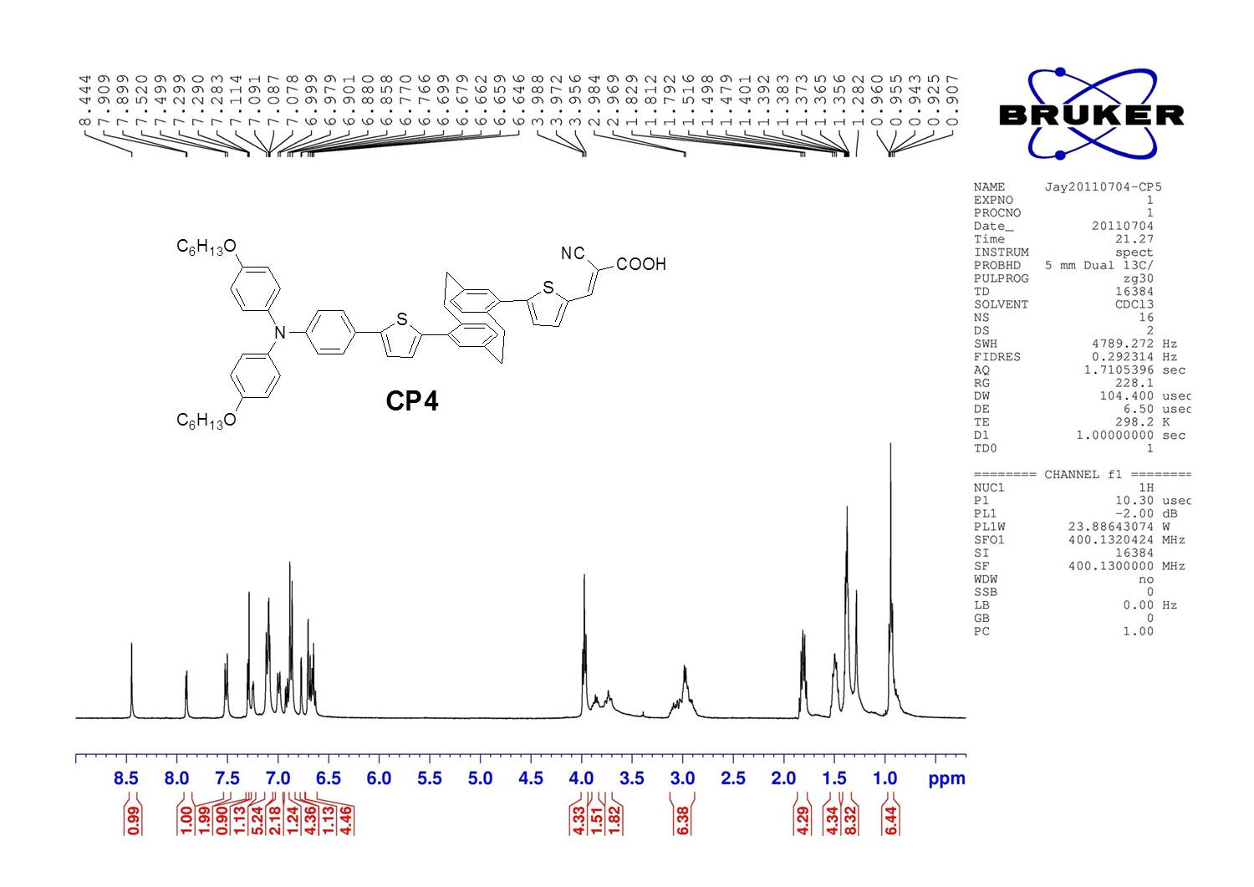

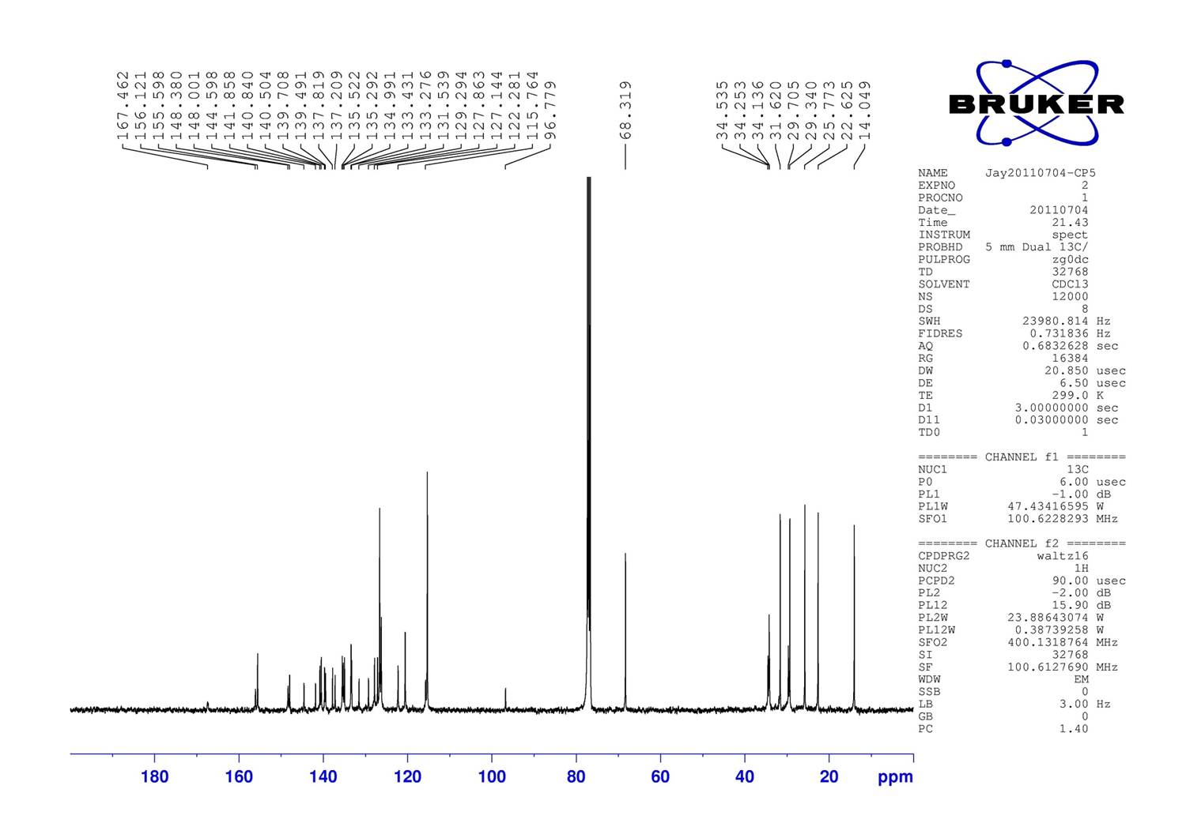

Figure S12: ¹H NMR (upper) and ¹³C NMR (lower) spectra of CP4 in CDCl₃.

- Theoretical calculation

Table S1. Calculated transition (gas phase) and the lowest energy absorption bands by Gaussian09⁴.
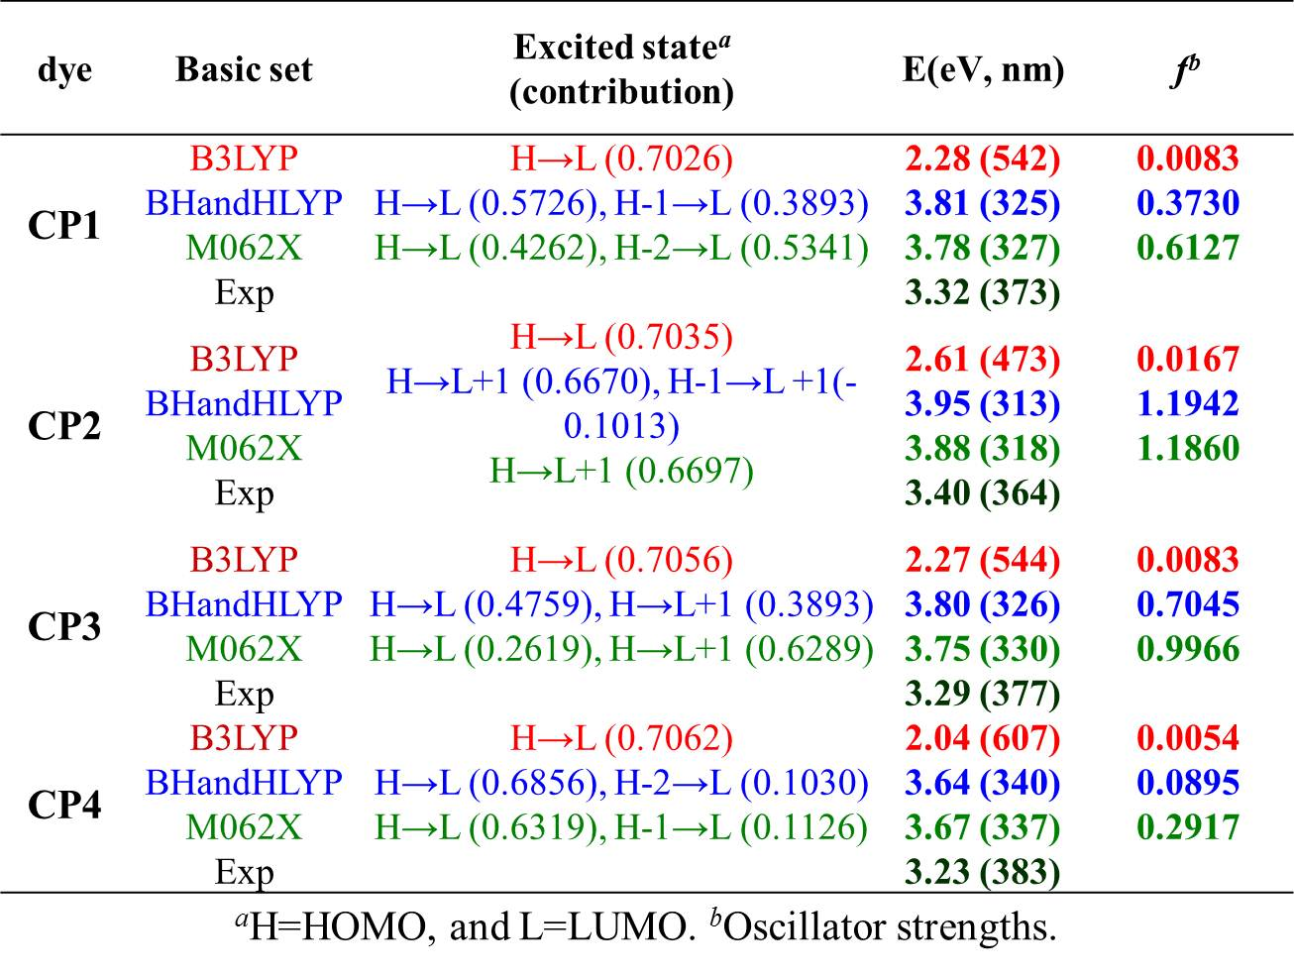

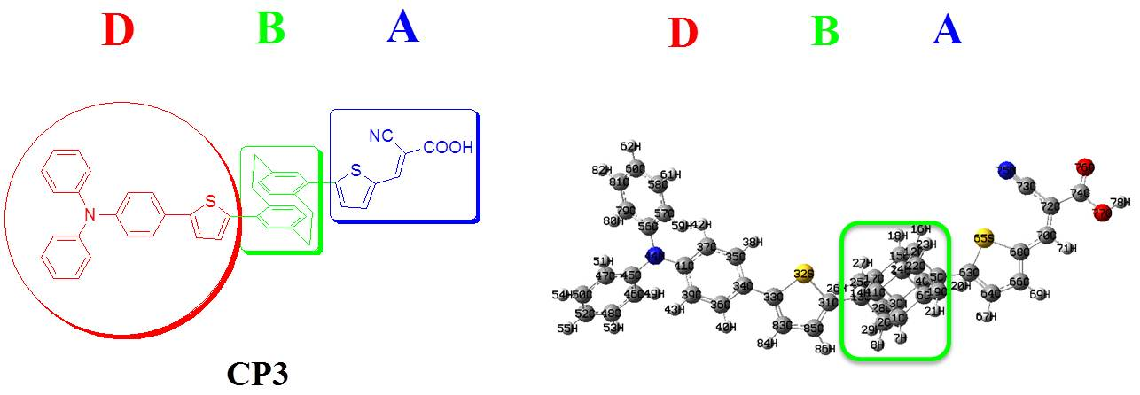

Table S2. Difference of Mulliken charges between ground state (S₀) and excited state (S₁), estimated by time dependent DFT/M062X⁵ model.
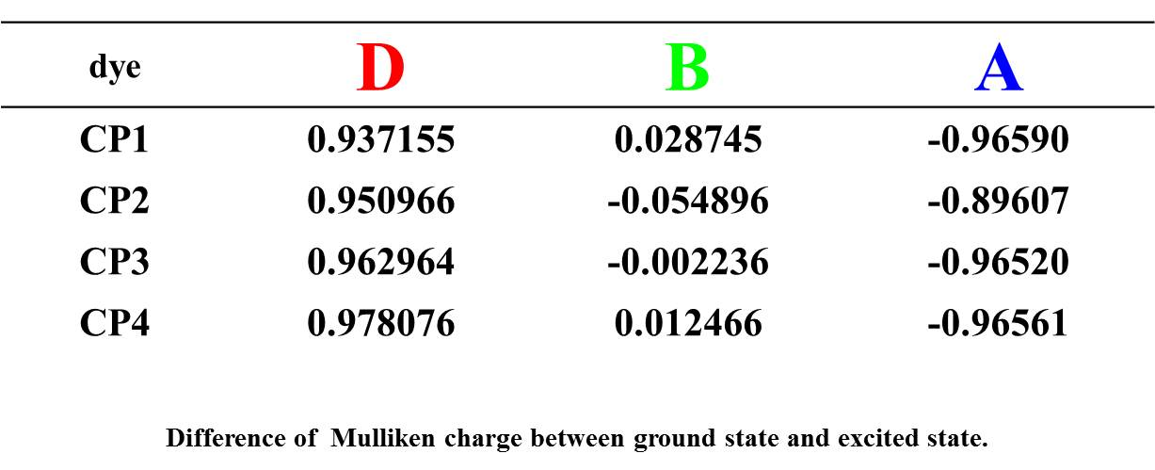

Figure S13. Bar-chart plots on the redistribution of Mulliken charge upon photo-excitation as shown in Table S2.
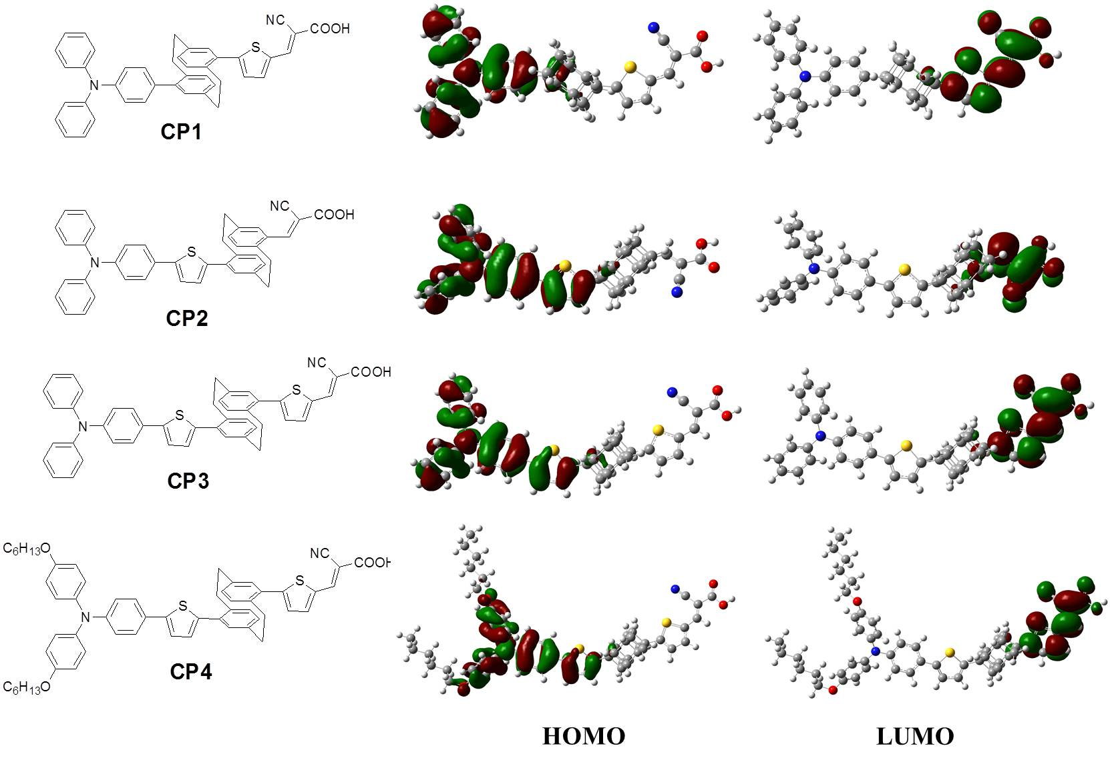
Figure S14. Computed HOMO and LUMO orbitals of CP-series compounds.
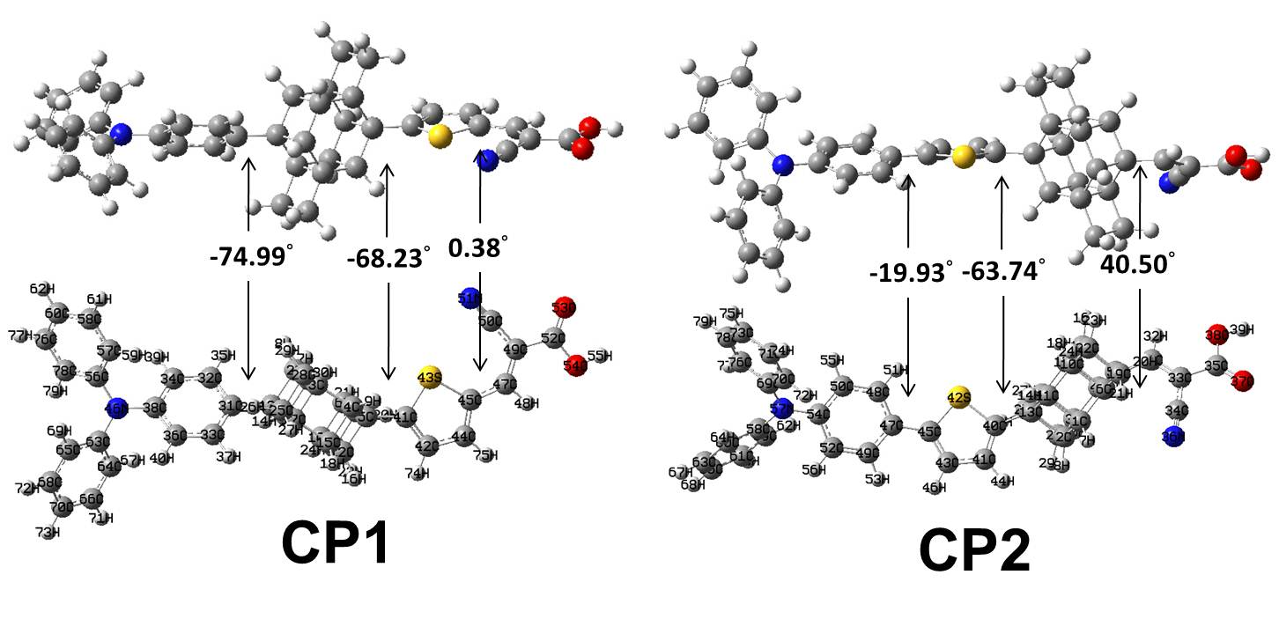
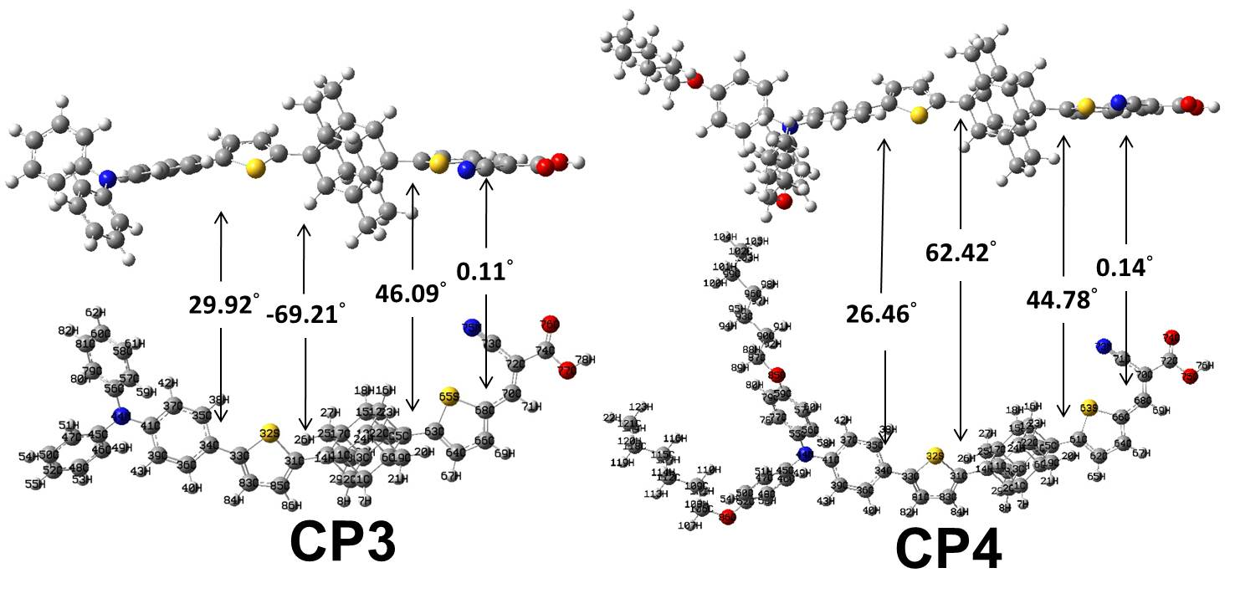
Figure S15. Computed dihedral angles of CP-series.
- CV spectra
Figure S16. CV spectra of organic dyes.

- HOMO-LUMO level
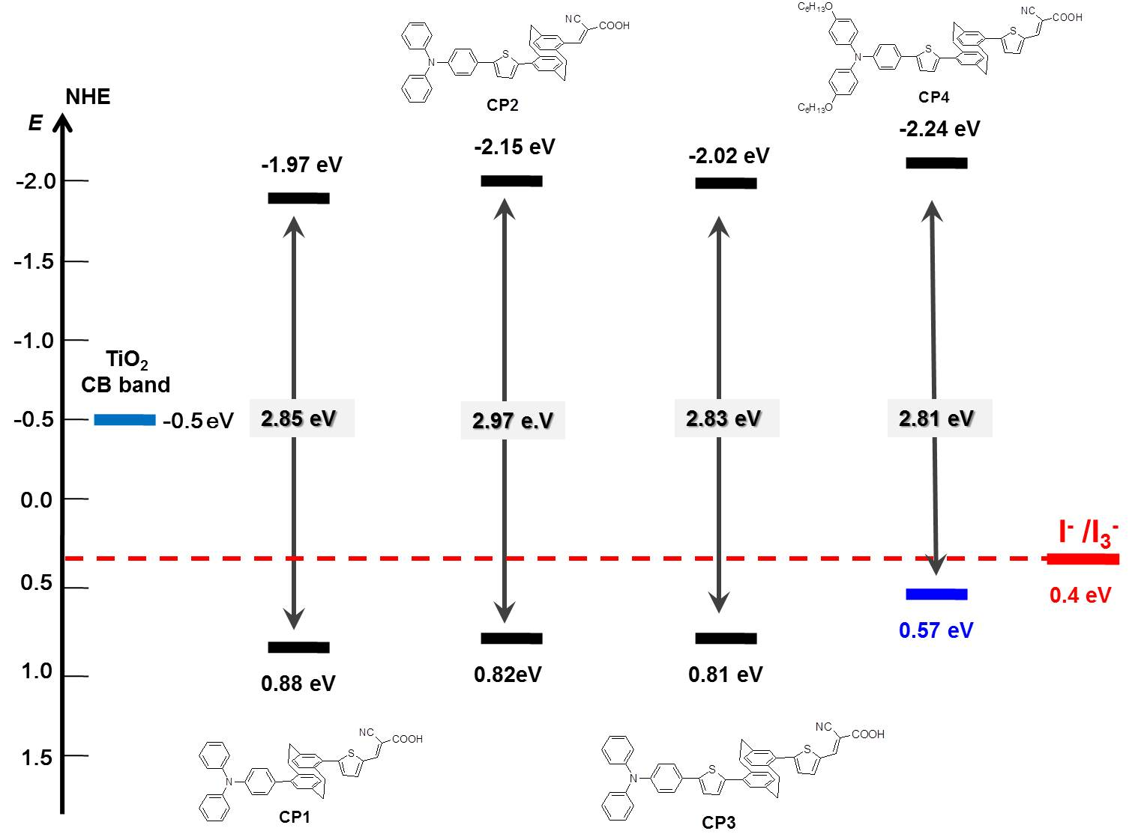

Figure S17. HOMO - LUMO energy levels of CP-series.
- EIS spectra

Figure S18. Impendance spectra of CP-series organic dyes at -0.73 V bais in the dark. (upper) Nyquist plots; (lower) Bode phase plots.

- Electron lifetime spectra

Figure S19. Traces of transient photovoltage decay of device on dyes with LiI (0.5M) electrolyte in acetonitrile.

- References
- (a) H. J. Reich and D. J. Cram, J. Am. Chem. Soc., 1969, 91, 3527. (b) D. C. Braddock, I. D. MacGilp and B. G. Perry, J. Org. Chem., 2002, 67, 8679. (c) H. –F. Chow, K. –H. Low and K. Y. Wong, Synlett, 2005, 14, 2130.
- J. K. Stille, Angew. Chem., Int. Ed., 1986, 25, 508.
- E. Knoevenagel, Angew. Chem., Int. Ed., 1922, 35, 29.
- M. J. Frisch, G. W. Trucks, H. B. Schlegel, G. E. Scuseria, M. A. Robb, J. R. Cheeseman, G. Scalmani, V. Barone, B. Mennucci, G. A. Petersson, H. Nakatsuji, M. Caricato, X. Li, H. P. Hratchian, A. F. Izmaylov, J. Bloino, G. Zheng, J. L. Sonnenberg, M. Hada, M. Ehara, K. Toyota, R. Fukuda, J. Hasegawa, M. Ishida, T. Nakajima, Y. Honda, O. Kitao, H. Nakai, T. Vreven, Jr. J. A. Montgomery, J. E. Peralta, F. Ogliaro, M. Bearpark, J. J. Heyd, E. Brothers, K. N. Kudin, V. N. Staroverov, R. Kobayashi, J. Normand, K. Raghavachari, A. Rendell, J. C. Burant, S. S. Iyengar, J. Tomasi, M. Cossi, N. Rega, J. M. Millam, M. Klene, E. J. Knox, B. Cross, V. Bakken, C. Adamo, J. Jaramillo, R. Gomperts, R. E. Stratmann, O. Yazyev, A. J. Austin, R. Cammi, C. Pomelli, J. W. Ochterski, R. L. Martin, K. Morokuma, V. G. Zakrzewski, G. A. Voth, P. Salvador, J. J. Dannenberg, S. Dapprich, A. D. Daniels, O. Farkas, J. B. Foresman, J. V. Ortiz, J. Cioslowski and D. J. Fox, Gaussian 09 (Revision A.02), Gaussian, Inc., Wallingford CT, (2009).
- Y. Zhao and D. G. Truhlar, Acc. Chem. Res., 2008, 41, 157.

