New Polynuclear U(IV)-U(V) Complexes from U(IV) Mediated Uranyl(V) Disproportionation

Supporting information for the manuscript

Victor Mougel, Jacques Pécaut and Marinella Mazzanti

Laboratoire de Reconnaissance Ionique et Chimie de Coordination, Service de Chimie Inorganique et Biologique (UMR-E 3 CEA-UJF), INAC,
CEA-Grenoble, 38054 GRENOBLE, Cedex 09, France.
*Correspondence to Dr. Marinella Mazzanti
Fax: (+)33(0)438785090 ; E-mail: marinella.mazzanti@cea.fr

General considerations.
All manipulations were carried out under an inert argon atmosphere using Schlenk techniques and an MBraun glovebox equipped with a purifier unit. The water and oxygen level were always kept at less than 1 ppm. The solvents were purchased from Aldrich in their anhydrous form conditioned under argon and were vacuum distilled from K/benzophenone (diisopropylether, hexane and pyridine) or CaH₂ (acetonitrile). Depleted uranium turnings were purchased from the "Société Industrielle du Combustible Nucléaire" of Annecy (France).
FTIR spectra were recorded with a Perkin Elmer Spectrum 100 Series FTIR spectrophotometer.
Elemental analyses were performed under argon by Analytische Laboratorien GMBH at Lindlar, Germany.
¹H NMR spectra were recorded on Varian MERCURY 400 MHz and Bruker 200 MHz and 500 MHz spectrometers. NMR chemical shifts are reported in ppm with solvent as internal reference; the signals were assigned to the corresponding protons using COSY experiments.
The starting materials [(UO₂Py₅)(KI₂Py₂)] ¹, [UI₄(Et₂O)] ², [UI₄(PhCN)₄] ³, [U(salen)Cl₂(THF)₂] ⁴ and [UO₂(salophen-^{t}Bu₂)(py)K] ⁵ were prepared according to literature procedures.

Syntheses.
Synthesis of {[UO₂(Mesaldien)]K}_{n}, 1.
A suspension of MesaldienK₂ (49.6 mg, 0.123 mmol, 1 eq.) in pyridine (2 mL) was added to a suspension of [(UO₂Py₅)(KI₂Py₂)]_{n} (138 mg, 0.123 mmol, 1 eq.) in 1 mL of pyridine resulting in a dark blue solution. After 3h stirring at room temperature, an off-white precipitate of KI formed. The precipitate was filtered out and THF was slowly diffused into the filtrate to yield after two days blue needles suitable for X-Ray single crystal diffraction. The solid was filtered, washed 3 times with 3 ml of cold THF and dried under vacuum to afford 73.5 mg of the 1.0.1 Py (0.116 mmol, 94%).
¹H NMR (MeCN-d₃; 298 K; 200MHz ): δ=-5.45 (s, 3H, -NCH₃); -4.61 (s, 2H,-NCH₂-);-3.70 (s, 2H,-CH₂-); -3.70 (br s, 2H,-CH₂-);0.65 (d, 2H, J³_{H-H} = 8.54 Hz, -CH-_{aromatic}); 1.28 (br. s, 2H,-NCH₂-); 5.02 (t, 2H, J³_{H-H} = 7.32 Hz, -CH-_{aromatic}); 5.31 (d, 2H, J³_{H-H} = 7.21 Hz, -CH-_{aromatic}); 6.13 (t, 2H, J³_{H-H} = 7.32 Hz, -CH-_{aromatic}); 9.46 (s, 2H, -HC=N-).
Elemental analysis (%) calcd for {[UO₂(Mesaldien)]K.0.1 Py }_{n} (C_{19.5}H_{21.5}KN_{3.1}O₄U, M_{r} = 640.42) C 36.57, H 3.38, N 6.78; found C 36.69, H 3.49, N 6.84.

Synthesis of {[UO₂(Mesaldien)(U(Mesaldien)]₂(µ-O)}, 2.
a)To a suspension of [(UO₂Py₅)(KI₂Py₂)]_{n} (92.7 mg, 0.083 mmol, 2 eq.) of pyridine (1 mL), a suspension of MesaldienK₂ (50 mg, 0.124 mmol, 3 eq.) in pyridine (2 mL) was added resulting in a dark blue solution. After 3h stirring at room temperature, a solution of UI₄(Et₂O)₂ (37.1 mg, 0.041 mmol, 1 eq.) in pyridine (1 mL) was added, resulting in a colour change of the solution to dark red. The resulting solution was stirred for 15 minutes, filtered to remove KI, and the filtrate was left standing to afford 2 as red needles which were collected, washed and dried to yield 52.5 mg of 2.2.5 Py (0.0208 mmol and 76%). Evaporation of this solution and re-crystallisation of the residue from Py/hexane afforded 7.2 mg (0.0121 mmol, 88%) of 3.
¹H NMR of 3 (MeCN-d₃; 298 K; 200MHz ): δ=3.20 (s, 3H, -NCH₃); 3.55 (dd, 2H,-NCH₂-); 3.86 (td, 2H,-CH₂-); 4.52 (dd, 2H,-CH₂-); 5.02 (tq, 2H, ,-NCH₂-); 6.73 (t, 2H, J³_{H-H} = 7.01 Hz, -CH-_{aromatic}); 6.99 (d, 2H, J³_{H-H} = 8.24 Hz, -CH-_{aromatic}); 7.56 (d, 2H, J³_{H-H} = 7.62 Hz, -CH-_{aromatic}); 9.49 (s, 2H, -HC=N-).
The low solubility of the isolated complex 2 prevents its NMR characterization.
Elemental analysis (%) calcd for {[UO₂(Mesaldien)(U(Mesaldien)]₂(µ-O).2.5 Py (C_{88.5}H_{96.5}N_{14.5}O₁₃U₄, M_{r} = 2523.19) C 42.13, H 3.86, N 8.05; found C 42.13, H 4.12, N 8.39.

Synthesis of [U(Mesaldien)I₂].MeCN.
A solution of 57.7 mg of UI₄(PhCN)₄ (0.049 mmol) in acetonitrile (1.5 mL) was added to a suspension of 20 mg of saldienK₂ (0.049 mmol) in 1.5 mL of acetonitrile yielding after 5 minutes a dark red solution, that was filtered and set for crystallisation. 28.2 mg of dark red crystals suitable for X-Ray of [U(Mesaldien)I₂].MeCN were collected after one night (0.033 mmol, 67%).
¹HNMR (200 MHz, Py-d5, 298 K): δ = 96.53 (s, 2H), 42.42 (s, 2H), 29.86 (s, 2H), 23.10 (d, 4H), 16.62 (s, 2H), 13.65 (s, 2H), -2.92 (s, 3H) , -29.08 (s, 2H), -40.36 (s, 2H).
Elemental analysis (%) calcd for [U(Mesaldien)I₂].MeCN: C₂₁H₂₄I₂N₄O₂U: C, 29.46; H, 2.83; N, 6.54. Found: C, 29.54; H, 2.81; N, 6.64

Isolation of 4
A dark green solution of [UO₂(salophen-^{t}Bu₂)(py)K] (12.9 mg, 0.0139 mmol, 2 eq.) in pyridine (0.5 mL) was added to a light green solution of [U(salen)Cl₂(THF)₂] (5 mg, 0.0069mmol, 1 eq.) in pyridine (0.5 mL), resulting in an immediate colour change to dark red. Proton NMR of the mother liquor shows the presence of a complicated mixture of uranium(IV)/(V)/(VI) compounds. The solution was stirred over 12h, taken to dryness and the brown solids were dissolved in acetonitrile to yield after 2 days standing dark brown crystals suitable for X-ray diffraction of 4 (4 mg collected).
Crystals of 4 were reproducibly obtained using this procedure.
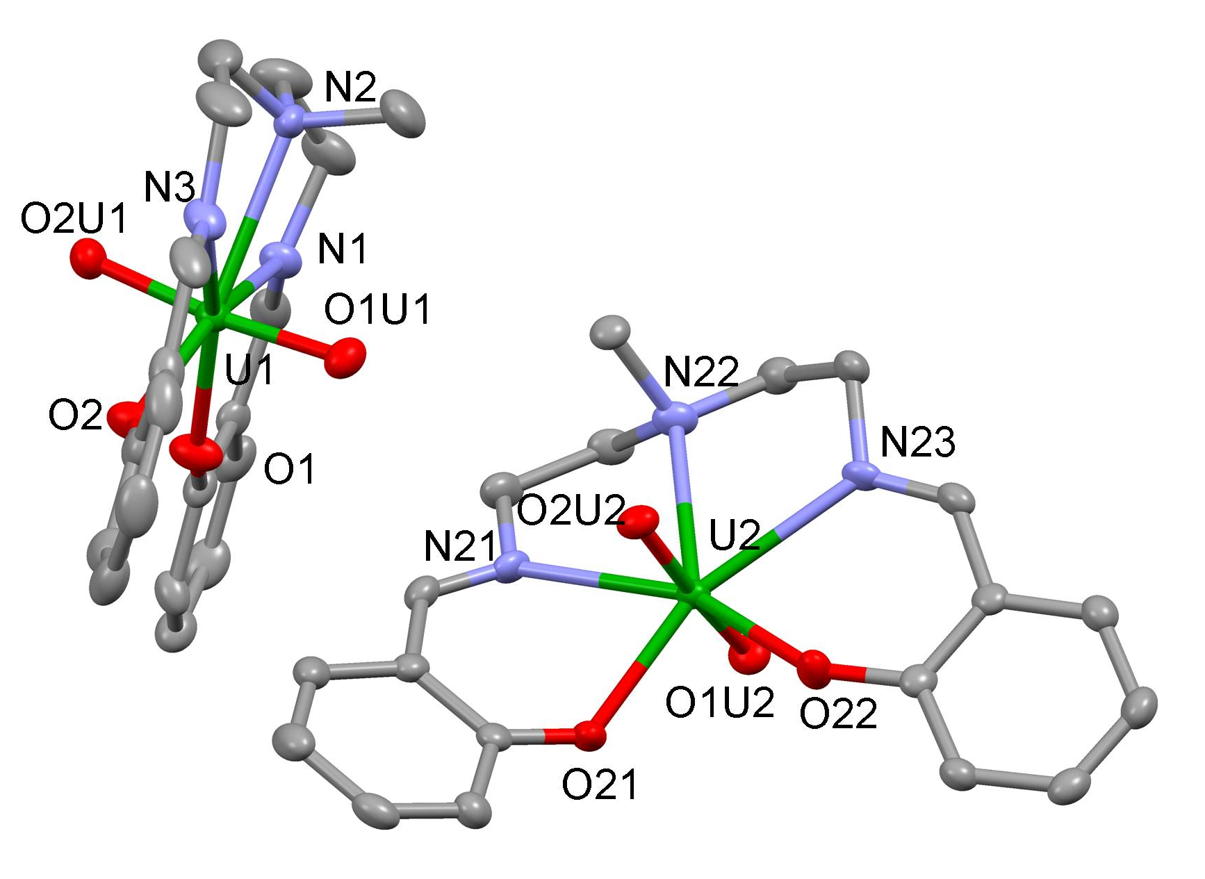
Figure S1. Ellipsoid plot of complex 3. (H and disordered methyl and ethyl groups were omitted for clarity, C are represented in grey, O in red, N in blue and U in green) Selected distance (Å) and angles (deg):U(1)-O(1U1) 1.784(3), U(1)-O(2U1) 1.779(3), U(1)-O(1) 2.218(3), U(1)-O(2) 2.218(3), U(1)-N(3) 2.578(4), U(1)-N(2) 2.609(4), U(1)-N(1) 2.604(4), U(2)-O(2U2) 1.770(3), U(2)-O(1U2) 1.786(3), U(2)-O(21) 2.239(3), U(2)-O(22) 2.221(3), U(2)-N(23) 2.580(4), U(2)-N(22) 2.616(4), U(2)-N(21) 2.561(4) and O(1U1)-U(1)-O(2U1) 173.30(15), O(2U2)-U(2)-O(1U2) 174.13(14).
Description of the structure of 3.
The structure of 3 consists in a typical uranyl(VI) Schiff base complex, with two crystallographically inequivalent uranyl(VI) cations coordinated by the three nitrogen and the two oxygen atoms of the ligand in their equatorial plane, the uranium atoms being at the center of a slightly distorded pentagonal bipyramid. In this complex, the mean value of the U=O bond distances (1.77(1) Å) lie in the range of the values observed for uranyl(VI) complexes.

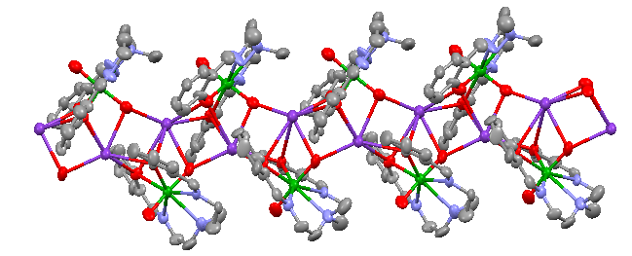
Figure S2. Ellipsoid plot at 50 % probability of the polymeric complex 1 (co-crystallised pyridine molecule and H were omitted for clarity, C are represented in grey, O in red, K in purple, N in blue and U in green). Selected distances (Å) U(1)-O(1U1) 1.862(2), U(1)-O(2U1) 1.79(2), O(1U1)-K(2) 2.632(18), O(1U1)-K(1) 2.804(19).
Figure S3: Proton NMR spectrum of 1 in acetonitrile (1.5 mM, 200 MHz, *: solvent residual peak) 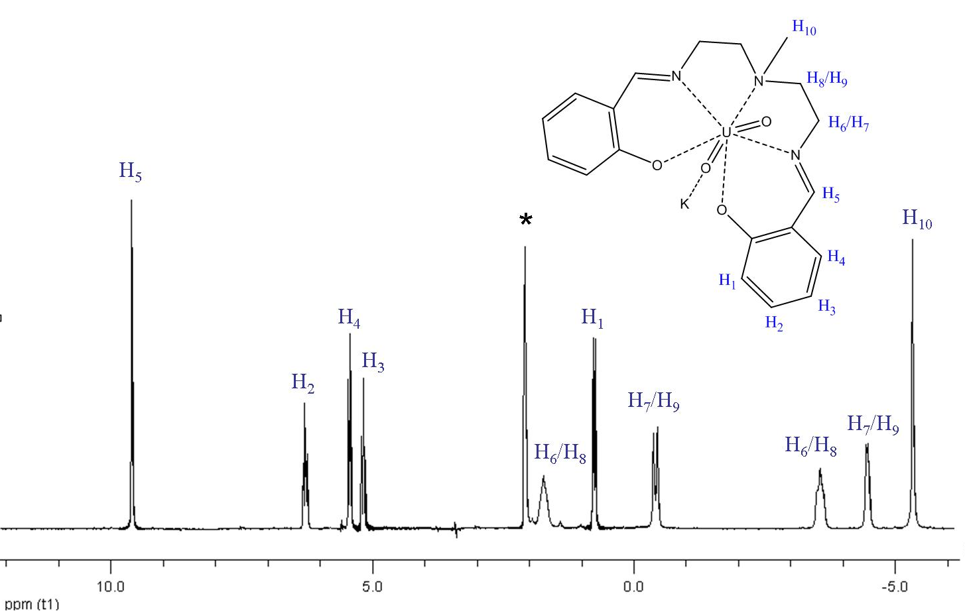

Figure S4: Proton NMR spectrum of 3 in acetonitrile (5 mM, 200 MHz, *: solvent residual peak)
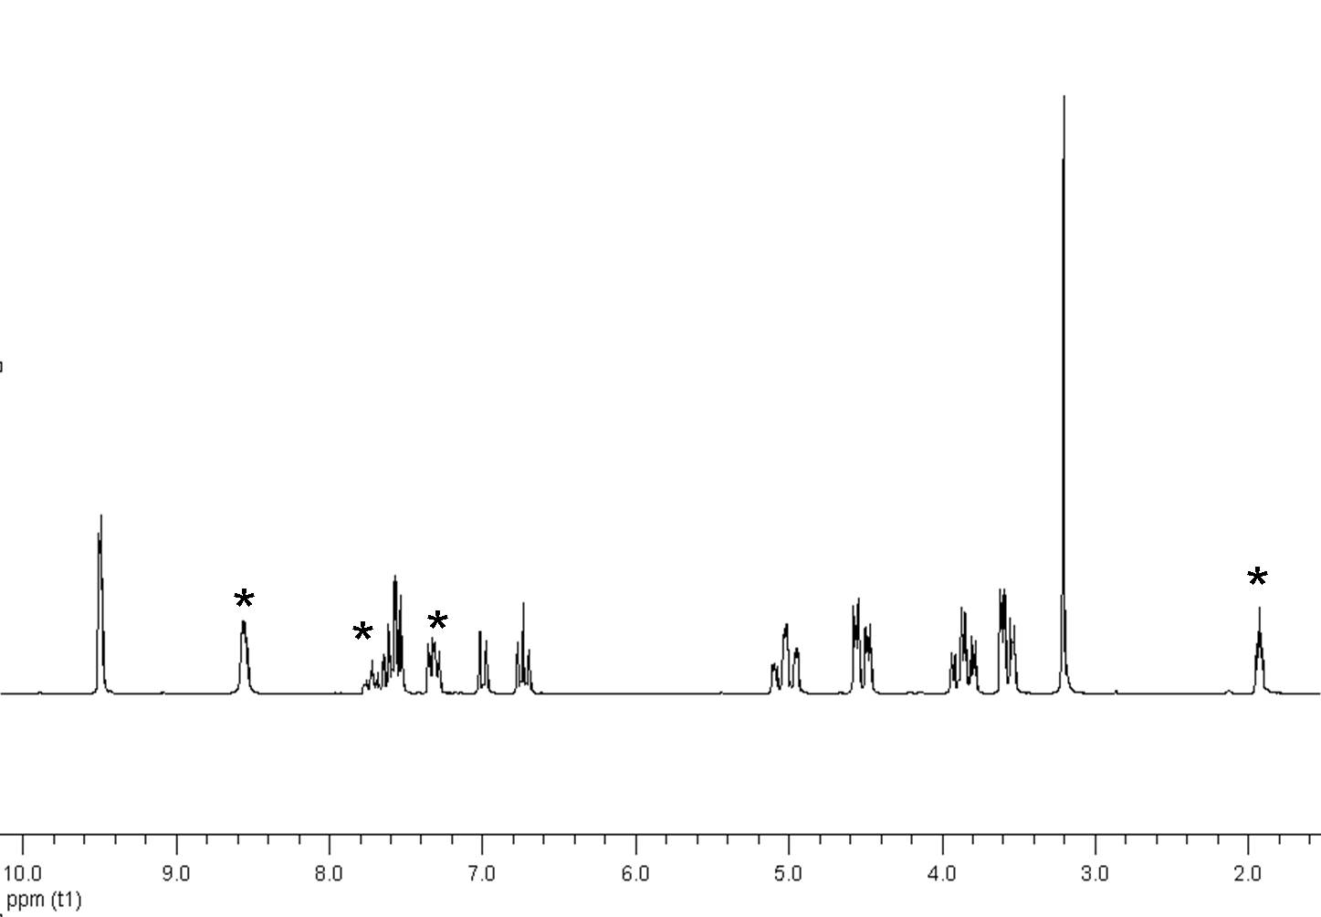
Figure S5: Proton NMR spectrum of the reaction mixture during the course of the synthesis of 4 in acetonitrile (200 MHz, *: solvent residual peak)
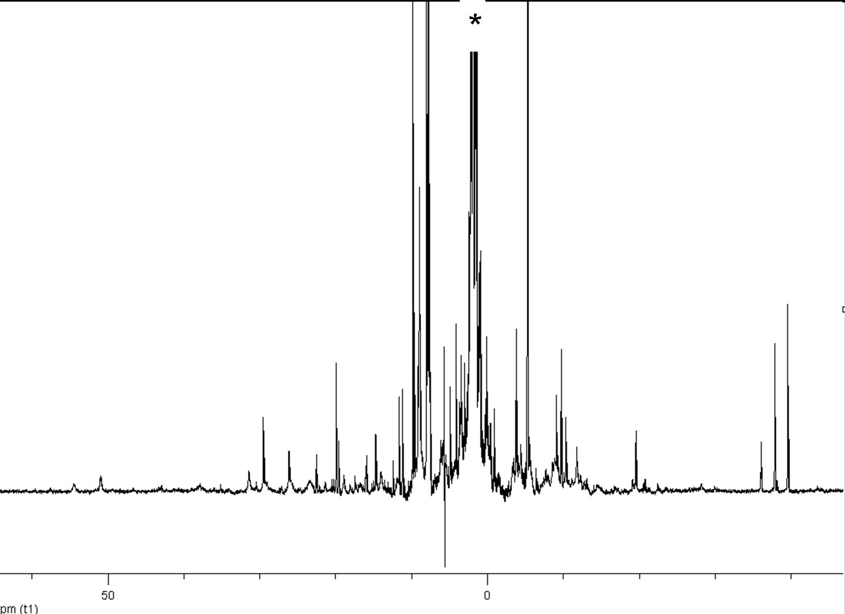
Figure S6: Proton NMR spectrum of the crystals of 4 in acetonitrile (200 MHz, *: solvent residual peak)
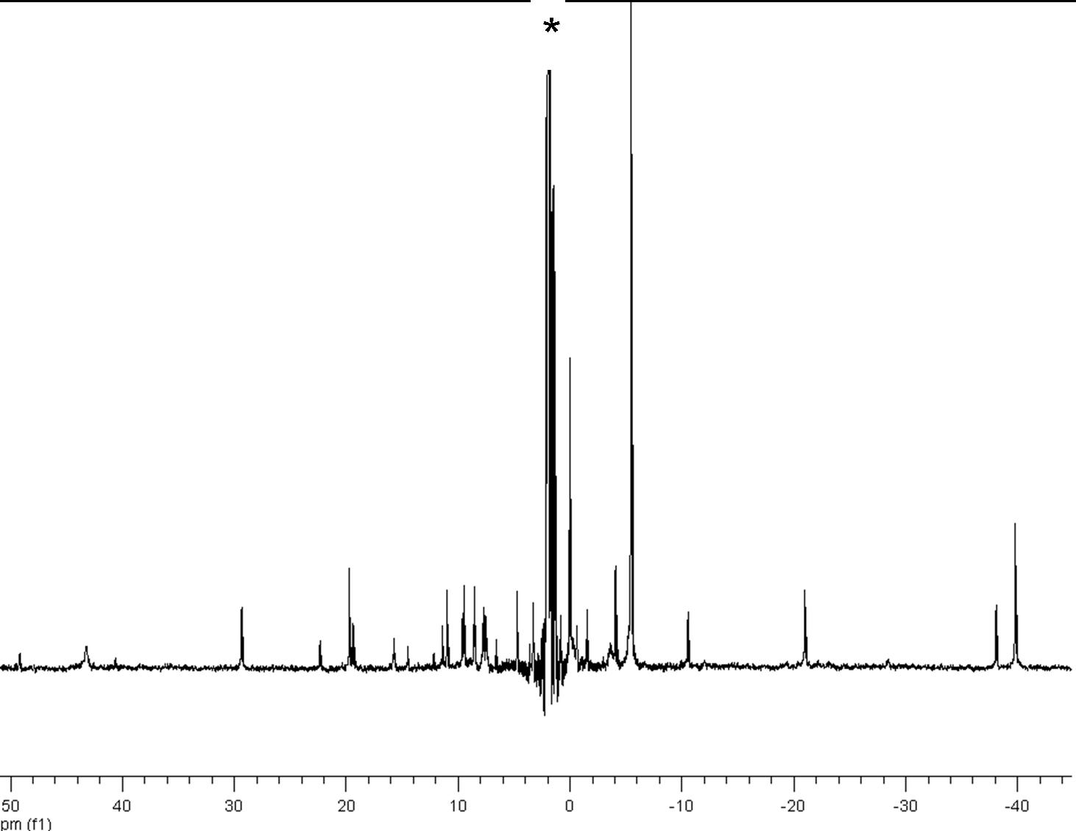
Figure S7. Infrared spectra of 1 (green line), 2 (red line) and [U(Mesaldien)I₂].MeCN (blue line).
The infrared sprectrum of 2 presents a strong band at 530 cm⁻¹ that is not present in the infrared spectra of the starting materials 1 and [U(Mesaldien)I₂] (figure S6). This peak was assigned to the U-O-U stretch, in comparison with the U-O-U vibration reported for the linear chains …O-U-O-U-O… in U₃O₈ .⁶

X-Ray Crystallography.
Diffraction data were taken using a Oxford-Diffraction XCallibur S kappa geometry diffractometer (Mo-Kα radiation, graphite monochromator, λ = 0.71073 Å). To prevent evaporation of co-crystallised solvent molecules the crystals were coated with light hydrocarbon oil and the data were collected at 150 K. The cell parameters were obtained with intensities detected on three batches of 5 frames. The crystal-detector distance was 4.5 cm. The number of settings and frames has been established taking in consideration the Laue symmetry of the cell by CrysAlisPro Oxford-diffraction software ⁷ 206 (for 1), 84 (for 2), 202 (for 3) and 224 (for 4) narrow data were collected for 1° increments in ω with a 300 s exposure time for 1 and 2, 50 s for 3, and 15s for 4. Unique intensities detected on all frames using the Oxford-diffraction Red program were used to refine the values of the cell parameters. The substantial redundancy in data allows empirical absorption correction to be applied using multiple measurements of equivalent reflections with the ABSPACK Oxford-diffraction program. Space groups were determined from systematic absences, and they were confirmed by the successful solution of the structure. The structures were solved by direct methods using the SHELXTL 6.14 package ⁸ and for all structures all atoms except hydrogens were found by difference Fourier syntheses. All non-hydrogen atoms were anisotropically refined on F². Hydrogen atoms were fixed in ideal position. The structure of 1( Rint = 10.18% ) and the structure of 2 (Rint = 10.45% ) are not of perfect quality as a result of their low theta diffraction angle (Theta max = 23.26°deg for 1 and 26.37 deg for 2) probably due to the small crystal size (10 microns on one size). The less than perfect quality of the structure of 4 (Rint = 5.61%, R = 10.40% ) is probably due to the presence of some disorder which it was impossible to model. In this pentanuclear structure, strong sterical effects arise from the 3 central ligands. These 3 ligands are probably disordered in the plane as shown by the ellipsoids shape, but no suitable model was found. Experimental details for X-ray data collections of all complexes are given in Table S1.
Table S1:
 | 1.0.5 Py | 2.4 Py | 3 | 4.4 MeCN
Formula | C_{21.50}H_{23.50}KN_{3.50}O₄U | C₉₆H₁₀₄N₁₆O₁₃U₄ | C₃₈H₄₂N₆O₈U₂ | C₁₂₈H₁₄₇N₁₄O₁₆U₅
Crystal size (mm) | 0.45 x 0.04 x 0.01 | 0.21 x 0.04 x 0.01 | 0.22 x 0.12 x 0.07 | 0.34 x 0.16 x 0.13
cryst syst | Monoclinic | Orthorhombic | Monoclinic | Monoclinic
space group | P 2₁/c | P b c a | P 2₁/c | P 2₁/n
volume (Å³) | 4512.5(14) | 9246.9(13) | 3773.7(2) | 12766.7(8)
a (Å) | 22.925(4) | 27.5621(19) | 16.3093(7) | 16.8481(5)
b (Å) | 14.316(3) | 10.9547(8) | 10.8301(2) | 31.3059(14)
c (Å) | 14.0547(19) | 30.626(3) | 22.1561(6) | 24.9946(10)
α (deg) | 90 | 90 | 90 | 90
β (deg) | 101.946(15) | 90 | 105.356(3) | 104.442(3)
γ (deg) | 90 | 90 | 90 | 90
Z | 8 | 4 | 4 | 4
formula weight (g/mol) | 672.07 | 2642.07 | 4575.62 | 3327.75
density (g cm⁻³) | 1.978 | 1.898 | 2.089 | 1.731
absorption coefficient (mm⁻¹) | 7.412 | 7.056 | 8.632 | 6.387
F(000) | 2560 | 5056 | 2240 | 6404
temp (K) | 150.0(2) | 150.0(2) | 150.0(2) | 150(2)
total no. reflections | 12681 | 14335 | 18306 | 44348
unique reflections [R(int)] | 6438 [0.1018] | 8400 [0.1045] | 11399  [0.0322] | 21558 [0.0561]
Final R indices [I > 2σ(I)] | R1 = 0.0932, wR2 = 0.1986 | R1 = 0.0919, wR2 = 0.1396 | R1 = 0.0377, wR2 = 0.0625 | R1 = 0.1040, wR2 = 0.2542
Largest diff. peak and hole (e.A⁻³) | 1.894 and -1.329 | 2.427 and -1.438 | 1.747 and -1.197 | 3.111 and –3.147
GOF | 0.987 | 1.007 | 0.997 | 1.106

1. L. Natrajan, F. Burdet, J. Pecaut and M. Mazzanti, J. Am. Chem. Soc., 2006, 128, 7152-7153.
2. C. D. Carmichael, N. A. Jones and P. L. Arnold, Inorg. Chem., 2008, 47, 8577-8579.
3. A. E. Enriquez, B. L. Scott and M. P. Neu, Inorg. Chem., 2005, 44, 7403-7413.
4. F. Calderazzo, M. Pasquali and N. Corsi, J. Chem. Soc.-Chem. Commun., 1973, 784-785.
5. G. Nocton, P. Horeglad, V. Vetere, J. Pecaut, L. Dubois, P. Maldivi, N. M. Edelstein and M. Mazzanti, J. Am. Chem. Soc., 2010, 132, 495-508.
6. M. Tsuboi, M. Terada and T. Shimanouchi, J. Chem. Phys., 1962, 36, 1301-1304.
7. Agilent, in CrysAlis PRO., ed. A. technologies, Yarnton, England, 2010.
8. G. M. Sheldrick, ed. BRUKER A. Inc, Madison,Wisconsin, USA, 1997.

