Supporting Information
Self-Assembling DNA-Peptide Hybrids: Morphological Consequences of Oligonucleotide Grafting to a Pathogenic Amyloid Fibrils Forming Dipeptide

Nidhi Gour, Dawid Kedracki, Ilyès Safir, Kien Xuan Ngo, and Corinne Vebert-Nardin*
Department of inorganic and analytical chemistry, University of Geneva-Sciences II; 30, quai Ernest-Ansermet, CH-1211 Geneva 4, Switzerland.
Tel: ++41(0)223796422 Fax: +41(0)223796069
Email: corinne.vebert@unige.ch
General: Dichloromethane extra dry, N,N-dimethylformamide, sodium chloride, triethylamine were purchased from Acros Organics (Geel, Belgium). N,N′-dicyclohexylcarbodiimide, N-hydroxysuccinimide, sodium bicarbonate and dialysis tube (cut-off 2000 M_{w}) were supplied by Sigma Aldrich (Buchs, Swizerland). The ammonia solution 35% was purchased from Fisher Scientific SA (Wohlen, Switzerland). Fmoc-Phe-Phe-OH was provided by Bachem (Bubendorf, Switzerland). 5’-CTCTCTCTCTTT-3’ modified at the 5’ end with a C₆ amino linker and 5’-FITC labelled complementary DNA sequence 5’-AAAGAGAGAGAG-3’ were purchased from Microsynth Laboratory (Balgash, Switzerland). ESI mass spectra were recorded on 11HTS PAL -LC10A-API 150Ex. The analytical HPLC was equipped with a LC-Net II/ADC transmitter, a Jasco UV-2077 detector and a Jasco PU-980 pump.

Synthesis and Characterization:
In brief, the Fmoc protected acid group of Phe-Phe-OH was first activated with N-hydroxysuccinimide by the previously reported methodology¹.The activated ester thus synthesized was then used for coupling to the free 5’-amino group of a 12-mer DNA sequence 5’-CTCTCTCTCTTT-3’ modified at the 5’ end with a C₆ amino linker whereas the 3’ end was still bound to the controlled pore glass (CPG) solid support. Solid phase synthesis was employed to avoid tedious steps of chemistry or purification. Finally the solid support and protecting groups were removed by treatment with liquid ammonia. The resulting compound was characterised by ESI MS and analytical HPLC as reported in previous studies².
Scheme-1: Synthetic route of the FF-nucleotide hybrid (4)
Conjugation of active N-hydroxy-succinimide ester Fmoc Phe-Phe-OH (2) Activation of Fmoc Phe-Phe-OH was done according to a previously reported methodology¹. In a two necked round bottom flask N-hydroxy-succinimide (230 mg, 1.2 eq) and Fmoc Phe-Phe-OH (1 g, 1 eq) was taken and dissolved in (20 mL) dry dichloromethane. It was stirred on ice under nitrogen atmosphere for 10 minutes. N,N'-dicyclohexylcarbodiimide (460 mg, 1.2 eq) was dissolved in dry dichloromethane (5 mL) and added to the reaction mixture. The stirring was continued for 1 h on ice. Then it was stirred at room temperature overnight. The white precipitate of N,N'-dicyclohexylurea was filtered off. The filtrate was washed with 10% sodium bicarbonate yielding a brine solution further dried over anhydrous sodium sulphate. The filtration was followed by solvent evaporation yielding 800 mg of product (52% reaction efficiency). Rf=0.5 (10 % methanol/dichloromethane). ¹H NMR (400 MHz, CDCl₃) δ(ppm) : 7.1-7.34 (m, 12H), 7.41-7.45 (m, 2H), 7.52-7.56 (m, 2H), 7.77-7.79 (m, 2H), 4.9-5.01(m, 2H), 5.3 (m, H), 6.13( brd, H), 4.40-4.42(m, H), 2.82-2.86 (m, 4H), 3.03-3.13(m, H), 3.25-3.31 (m, H), 3.45-3.54(m, 2H) ; ¹³C NMR (100 MHz, CDCl₃, 25ºC, TMS) δ (ppm) 24.85, 25.53, 25.58, 33.74, 37.5, 44.42, 47.09, 49.42, 51.37, 67.14, 81.01, 119.99, 120.01, 127.11, 127.17, 127.49, 127.76, 128.72, 128.80, 129.40, 129.47, 134.32, 141.29,141.30,143.72,167.03,170.31. m/z (ESI-MS) Calculated [M+H]⁺ 632.24; Found 632.26.
Coupling of Fmoc Phe-Phe active ester with a C₆ amino-modified nucleotide sequence bound to the CPG resin (3) Compound 2 (180 mg) was added in a 2mL reactor. Subsequently, 50 mg of solid cpg-resin bound oligonucleotide 5’-CTCTCTCTCTTT-3’ modified at the 5’ end with a C₆ amino linker (1) (50 mg. 2 µM, 1 eq) was added to the reactor. To this, 1.5 mL of dry DCM and 45 µL of triethylamine were added. The reactor was subsequently closed and shaked at room temperatur overnight. The 2 mL reactor is fixed to a filter at the bottom which prevents filtration of the resin out but enabling that of solvents. All residual solution was thus drained from the reactor and the resin washed thoroughly with DCM and DMF and subsequently again with DCM to remove any unreacted peptide and other side products using syringe pressure filtration. Finally the resin was dried in presence of nitrogen and weighed in an eppendorf tube.
Removal of the cpg solid support(4) The oligonucleotide bound to the solid support obtained in step 3 (40 mg) was transferred to an eppendorf tube and subsequently 1 mL of ammonia solution was added to it and the resulting mixture kept in a shaker maintained at 40 ºC for 24 h. The solution was then filtered to remove the resin and the supernatant collected. Subsequently this solution was transferred to a dialysis membrane (2000 M_{w} cut off) to remove salts and protecting groups. The dialysis membrane was slowly stirred against milliQ water for 24h. Subsequently the solution was filtered through 0.45 micron filter membranes and the resulting solution lyophilized. Yield 5 mg (40%). The resulting compound was characterised by ESI MS and analytical HPLC as reported in previous studies.² The lyophilized DNA-dipeptide hybrid was dissolved at a concentration of 1 mg mL⁻¹ and passed through 0.45 micron filters and 200 µL of this solution was analyzed by reverse phase HPLC (C-16 analytical column, flow rate of 0.2 mL min⁻¹ in an isochratic gradient of 30% acetonitrile:water with 0.1% TFA, detection at 260 nm) which evidences the purity of the compound. ESI-MS mass spectra of 4 was taken by dissolving 1 mg of the DNA-dipeptide hybrid in 500 µL water, 490 µL acetonitrile and 10 µL triethylamine. m/z (ESI-MS) M-2H/2= expected: 1992.53. observed:1992.66, M-3H/3=expected:1328.01; observed:1328.47, M-4H/4= expected: 995.76, observed:996.17 ; M-5H/5= expected: 796.41, observed:796.7, M-6H/6+CH3CN⁻=673.46 expected: 673.66.

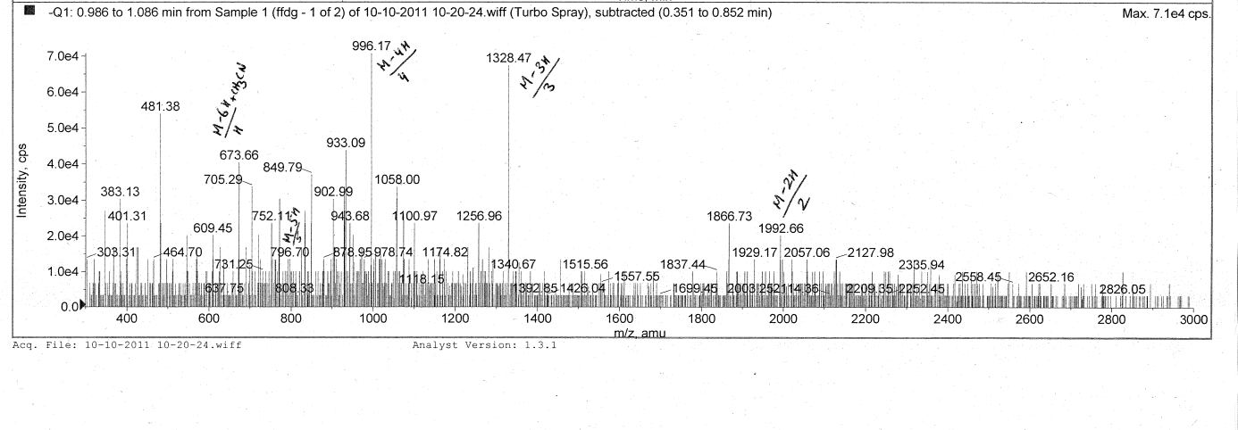
ESI-MS of 4
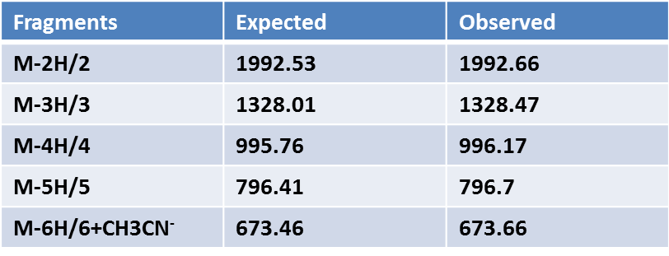

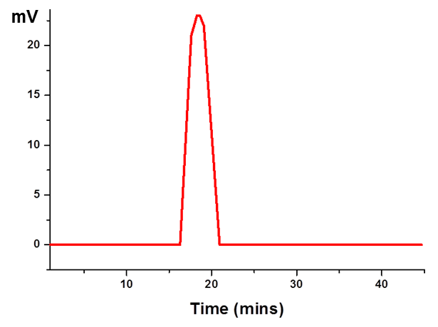
Analytical HPLC of 4
Instrumentation and microscopy techniques
Atomic Force Microscopy (AFM)
4 was dissolved in water at a concentration of 2 mg mL⁻¹ and filtered through 0.45 micron filters. This solution was then incubated for 2 h at 37 °C. 20 µL of this sample was then spread over silicon substrates. All the substrates were cleaned in air plasma (PDC-32G, Harrick, New York) for 20 min and rinsed with a 2 % Helmanex aqueous solution. After rinsing with Milli-Q water and drying with nitrogen, the substrates were heated in an oven at 60 °C for 20 min. AFM images were performed using an MFP-3D microscope (Asylum Research, Santa Barbara, CA). For all measurements, the AFM was equipped with the same cantilever (Pointprobe NSC, MikroMasch, Tallin, Estonia) with an elastic constant of Kc = 4.28 N/m, while the resonant frequency was 137 kHz. The radius of the silicon tip is estimated to less than 10 nm. All images were taken in air at room temperature in the tapping mode. The data acquisition and analysis were operated with the Igor software.
Scanning Electron Microscope (SEM)
Samples for SEM were prepared by the same procedure as for AFM. A 20 μL aliquot of the fresh sample was dried at room temperature on silicon wafers. Dried samples were coated with gold for 20 s in a Jeol JFC-1200 Fine coater. Subsequently, SEM images were acquired on a Jeol 6510LV microscope, equipped with a tungsten filament gun, operating at WD 10.6 mm and 10 kV. Samples to study the effect of urea were made by adding 10 μL of a 100 mM urea aqueous solution to 90 μL of a 1 mM solution of 4. Similarly 10 μL of a 100 mM urea aqueous solution were added to 90 μL of a 1 mM solution of FF.
Transmission Electron Microscope (TEM)
For TEM, 5 µL of fresh sample of a specimen (2mg mL⁻¹) incubated for 2 h in water was placed on a carbon coated 400-mesh copper grid. After sample drying, the sample was imaged without staining directly with a Tecnai G2 electron microscope operating at 120 KV.
Fluorescence microscopy
For encapsulation studies, 2 mg of 4 was co-incubated with a 2 µM sulforhodamine aqueous solution. For release studies, 1N HCl was added to the solution of self-assembled DNA-dipeptide hybrid to reduce the pH from 6.5 to 4.5. Both encapsulation and release of the dye from the spherical structures was examined under a fluorescent microscope (Olympus BX63 microscope system), provisioned with a fluorescence illuminator and a TRTC filter (540/625 nm). For acridine orange binding assays, 10 μM of an acridine orange dye solution was added directly to the DNA-dipeptide hybrid solution (2 mg mL⁻¹ in water) and co-incubated for 1h. 20 μL of this solution was spread on a glass slide, dried at room temperature, and imaged under a fluorescence microscope with a TRTC filter. For hybridization assays a solution of 4 (2 mg mL⁻¹) 100 μL, 2 μL (1 mM stock solution) of FITC labelled complementary DNA sequence 5’-AAAGAGAGAGAG-3’ and 2 μL of a 0.5 M NaCl solution were mixed and incubated at room temperature for 4 h in dark conditions. Thus final molar ratio of FITC complementary DNA to oligonucleotide peptide hybrid was 1:25. 20 μL of this solution was spread on a glass slide, dried at room temperature, and imaged under a fluorescence microscope provisioned with a fluorescence illuminator and a FITC filter (494/521 nm)
Confocal laser scanning microscopy:
10 μM of an acridine orange dye solution was added directly to the DNA-dipeptide hybrid solution (2 mg mL⁻¹ in water) and co-incubated for 1h. 20 μL of this solution was spread on a glass slide, dried at room temperature, and imaged under a Zeiss LSM 700 confocal microscope.

Proposed hypothesis of mechanism of self-assembly of 4 (adapted from ref. 3)

Fig. 1: Diagrammatic representation of the hypothesized structure formation of 4. FF arrange by pi-pi stacking along one direction to give tubular structures^{3.} Due to conjugation with the dinucleotide hydrogen bonding between the nucleobases along the sequence occurs, which results in folding along both the directions favoring the formation of thermodynamically more stable compact spherical morphologies.

Additional Microscopic images:
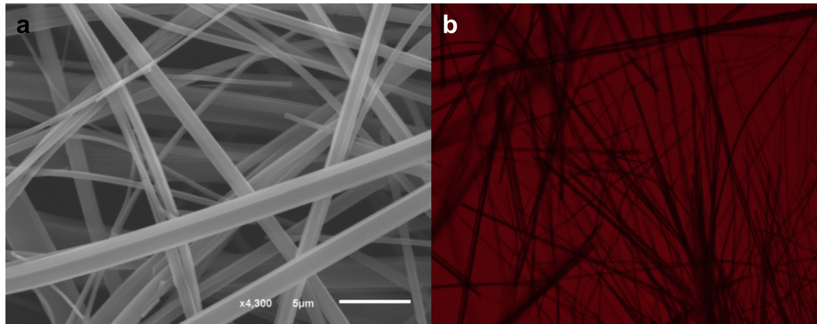

Fig. 2 : Microscopic images of self-assembled F-F fibres (a) by the Scanning Electron Microscopy; (b) and optical Microscopy.
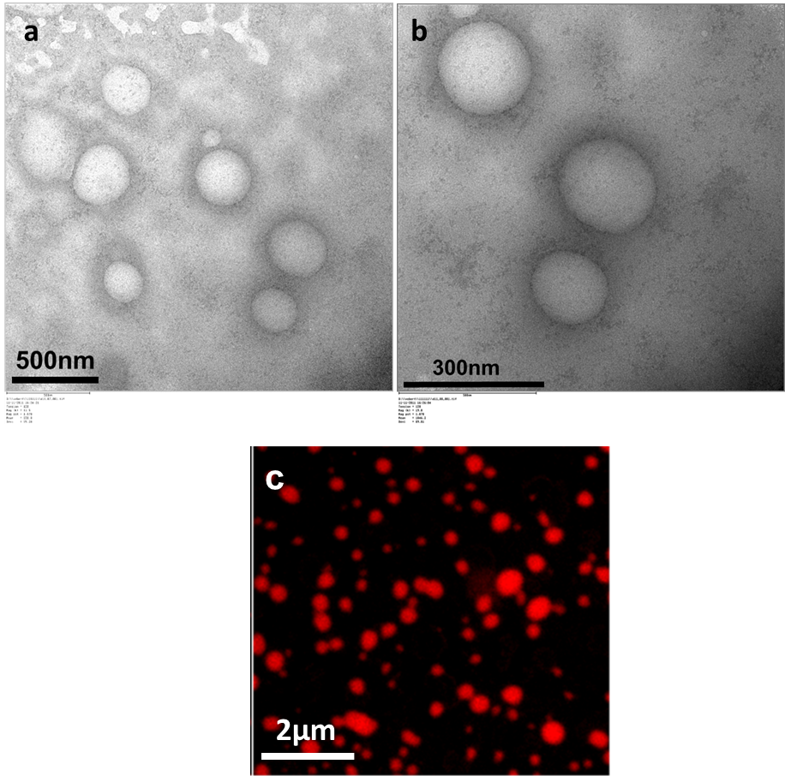

Fig. 3: a) TEM showing the self-assembly of DNA-diipeptide hybrid (4); b) zoomed TEM image; c) Confocal laser scanning microscope image of 4 with acridine orange dye.

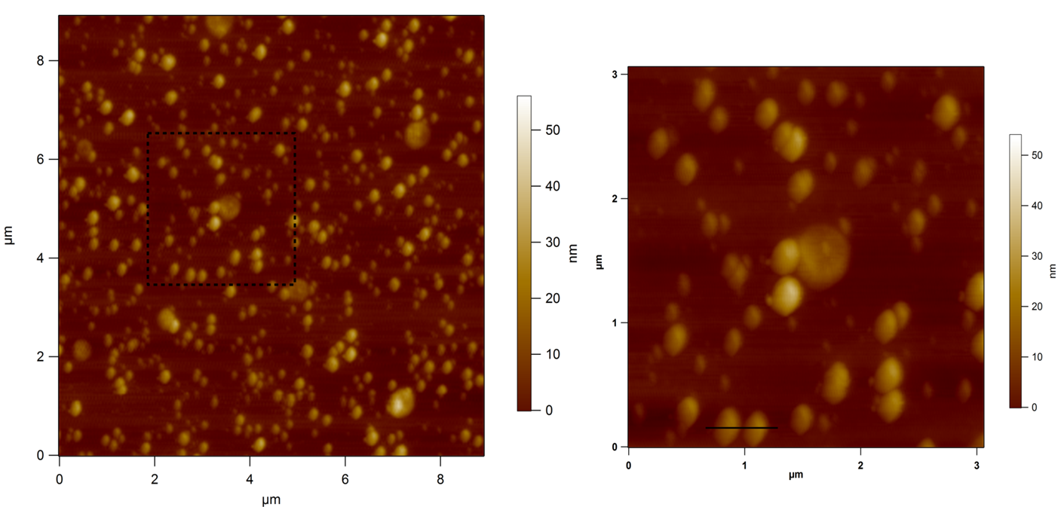

Fig. 3: a) AFM image showing the self-assembly of DNA-dipeptide hybrid (4); b) zoomed AFM image of 4

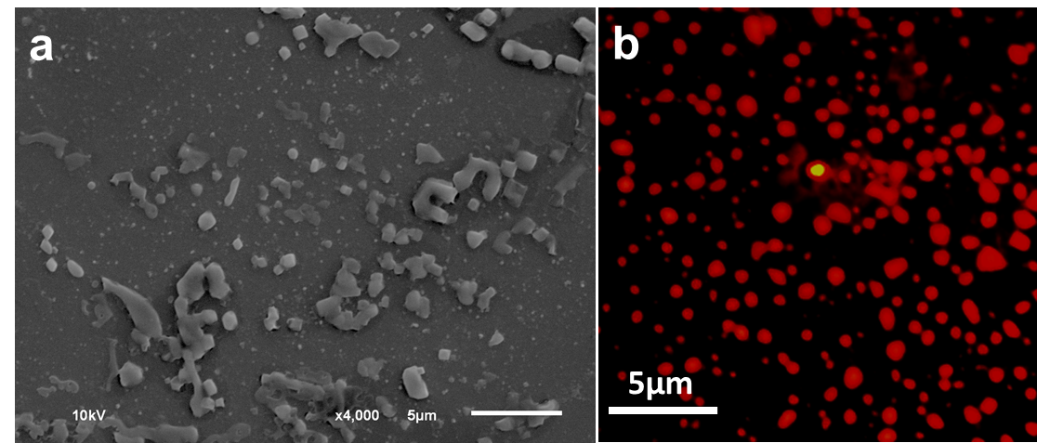
Fig. 4: Microscopic images of DNA-dipeptide hybrid (4) before filtration through 0.45 micron filter : a) SEM image showing the self-assembly of FF-oligonucleotide conjugates (4) before filtration through 0.45 micron filter; b) Fluorescence microscope image of 4 with acridine orange dye.

References:

[1] N. Gour, C. S. Purohit, S. Verma, R. Puri, S. Ganesh, Biochem. Biophys. Res. Commun. 2009, 378, 503-506.
[2] N. Venkatesan, B. H. Kim, Chem. Rev. 2006, 106, 3712-3761
[3] M. Reches, E. Gazit, Nano Lett. 2004, 4, 581-585.

