Supporting Information
A non-nucleoside triphosphate powering kinesin-microtubule motility with photo-tunable velocity

Nishad Perur, Masao Yahara, Takashi Kamei, and Nobuyuki Tamaoki*
Research Institute for Electronic Science, Hokkaido University, N20, W10, Kita-ku, Sapporo, Hokkaido 0010020, Japan.

- Materials
Unless otherwise noted, reagents and solvents were used as received from commercial sources without further purification. Column chromatography was performed on silica gel (60N, spherical, neutral, 40–50 μm; Kanto Chemicals). Ion exchange chromatography was performed using DEAE Sephadex A-25 packing material (GE Healthcare).
- General methods, instrumentation, and measurements
¹H and ¹³C NMR spectra were recorded using an ECX-400 (400 MHz) spectrometer (JEOL). Samples for ¹H NMR spectroscopy were prepared using CDCl₃, CD₃OD, or D₂O as the solvent and tetramethylsilane (TMS) as the internal standard. Samples for ¹³C NMR spectroscopy were prepared using D₂O as the solvent and MeOH as the internal standard. Chemical shift data are given in units of parts per million (ppm) relative to TMS (for ¹H NMR spectra) and MeOH (for ¹³C NMR). Splitting patterns are denoted as s (singlet), d (doublet), t (triplet), m (multiplet), dd (doublet of doublet), or br (broad). Mass spectra were recorded using MALDI-TOF MS (Applied Biosystems Voyager DE Pro) and AccuTOF (JMS-T100LC; JEOL) spectrometers. Absorption spectra were recorded using an Agilent 8453 spectrophotometer. Photoisomerization studies were conducted using a mercury/xenon lamp with suitable filters (366 nm, 436 nm). Microtubule motility assays were performed using an inverted fluorescence optical microscope (Olympus BX50) equipped with a UPlan F1 100x/1.30 oil C1 objective lens (Olympus), appropriate filters [630 nm excitation filter, neutral density filter (ND-25, 25% transmission)], an EBCCD color video camera (Hamamatsu C7190), and an Aquacosmos image processing system (Hamamatsu). Microtubule motility videos were analyzed using ImageJ software. The assay was performed at room temperature (23 °C).
- Synthesis
- Synthesis of NPhAETP.

Synthesis of NPhAETP: a) ethanolamine, DMF, rt, overnight; b) POCl₃, triethylphosphate, NaOH, rt, overnight; c) tributylamine, carbonyldiimidazole, pyrophosphate, dry DMF, Ar atmosphere, rt, overnight.

Compound 1
Ethanolamine (2.4 mL, 39 mmol) was added to a stirred solution of 1-fluoro-2-nitrobenzene (3.0 g, 21.3 mmol) in DMF (15 mL) and then the solution was stirred overnight. The mixture was partitioned between EtOAc and NaCl solution. The organic phase was dried (MgSO₄) and concentrated in a rotary evaporator to obtain pure crystals of the product (3.52 g, 91%). ¹H NMR [CDCl₃ (TMS)]: δ = 1.69 (t, J = 5.3 Hz, 1H), 3.50–3.54 (m, 2H), 3.93–3.97 (m, 2H), 6.68 (t, J = 7.8 Hz, 1H), 6.9 (d, J = 8.6 Hz, 1H), 7.45 (t, J = 7.9 Hz, 1H), 8.19 (d, J = 8.6 Hz, 1H), 8.24 (br, 1H). ESI-MS: m/z 183.58 [M + H]⁺ (calcd. m/z 183.08).

Compound 2
A solution of POCl₃ (2.3 mL, 25 mmol) in triethylphosphate (16 mL) was placed in an ice bath and kept at 0 °C under N₂. The solution was stirred vigorously while compound 1 (3.0 g, 17 mmol) was added slowly in small quantities. The reaction was left overnight at 0 °C. Unreacted POCl₃ was removed through rotary evaporation at 30 °C. While the solution was stirred vigorously at 0 °C, 4 M NaOH (10 mL) was added dropwise to hydrolyze the acid chloride. Cold water (70 mL, 4 °C) was added and then the pH was adjusted to 7.5 using 6 M NaOH. Then, the compound was purified through reverse-phase column chromatography (COSMOSIL C18-OPN; MeOH/H₂O, 1.5:8.5). The purified compound was then applied to a DEAE-Sephadex A-25 column (2.5 × 30 cm, 20 g) and eluted with 0.7 M triethylammonium hydrogencarbonate at 4 °C. The eluted portion was evaporated with EtOH several times to remove triethylammonium hydrogencarbonate. Yield: 0.25 g (5.8%). ¹H NMR [D₂O (TMS)]: δ = 3.69 (t, J = 5.8 Hz, 2H), 4.10–4.17 (m, 2H), 6.76 (t, J = 7.6 Hz, 1H), 7.11 (d, J = 8.8 Hz, 1H), 7.57 (t, J = 7.8 Hz, 1H), 8.16 (d, J = 8.8 Hz, 1H). ESI-MS: m/z 261.47 [M – H]⁺ (calcd. m/z 261.15).

Compound 3.
The triethylammonium salt of compound 3 (0.15 g, 0.57 mmol) was converted to its tributylammonium salt through the addition of tributylamine (0.29 mL, 1.1 mmol) in dry MeOH (2 mL). Triethylamine and MeOH were then removed through rotary evaporation. The tributylammonium salt was dissolved in dry DMF (3 mL). While stirring, a solution of 1,1´-carbonyldiimidazole (90 mg, 0.59 mmol) in dry DMF (0.8 mL) was added under Ar and then the reaction was left for 18 h at room temperature. Excess 1,1´-carbonyldiimidazole was destroyed through the addition of dry MeOH (0.03 mL) and stirring for 1 h. The resulting solution was added dropwise with mixing to a solution of the tributylammonium salt of pyrophosphate [prepared from tetrasodium pyrophosphate (0.62 g, 1.32 mmol) as mentioned in Section (D)] in dry DMF (2.6 mL). After reacting overnight at room temperature, the mixture was cooled to 0 °C in an ice bath. Cold water (3 mL, 4 °C) was added with mixing and then the pH was brought to 7.5 using 1 M NaOH. The mixture partitioned between ether and water; the aqueous phase was evaporated with EtOH at 30 °C and dried. The dried residue was dissolved in 0.1 M triethylammonium hydrogencarbonate and applied to a DEAE-Sephadex A-25 column (2.5 × 30 cm, 20 g) and eluted with a linear gradient (0.1–1.0 M; total volume: 1 L) of triethylammonium hydrogencarbonate at 4 °C. The majority of compound 4 was eluted in the 0.69–0.77 M (10 mL/tube) fractions, as confirmed using ESI MS. These fractions were evaporated with EtOH several times to remove triethylammonium hydrogencarbonate. The product was converted to its sodium salt using 1 M NaI in acetone [see section (E)]. Yield: 50% (0.12 g). ¹H NMR [D₂O (TMS)]: δ = 3.73 (t, J = 5.8 Hz, 2H), 4.21–4.26 (m, 2H), 6.75 (t, J = 7.6 Hz, 1H), 7.17 (d, J = 8.8 Hz, 1H), 7.59 (t, J = 7.8 Hz, 1H), 8.16 (d, J = 8.8 Hz, 1H). ESI-MS: m/z 420.92 [M – H]⁺ (calcd. m/z 420.97).
- Synthesis of NPhAdMTP.

Synthesis of NPhAdMTP: a) ethyl glycolate, reflux, 170 °C, 8 days; b) POCl₃, triethylphosphate, NaOH, rt, overnight; c) tributylamine, carbonyldiimidazole, pyrophosphate, dry DMF, Ar atmosphere, rt, overnight.

Compound 1
A mixture of 2-nitroaniline (14.5 g, 105 mmol) and ethyl glycolate (9.5 mL, 100 mmol) was heated under reflux at 170 °C. After 8 days of continuous stirring, the mixture was partitioned between EtOAc and 2 N HCl. The organic phase was dried (MgSO₄) and concentrated; the residue was purified through column chromatography (SiO₂; CH₂Cl₂/EtOAc, 7:3). Yield: 1.0 g, 5.1%. ¹H NMR [CDCl₃ (TMS)]: δ = 2.96 (s, 1H), 4.33 (d, J = 9.3 Hz, 2H), 7.22 (t, J = 7.9 Hz, 1H), 7.66 (t, J = 7.8 Hz, 1H), 8.21 (d, J = 8.5 Hz, 1H), 8.79 (d, J = 8.6 Hz, 1H). ESI-MS: m/z 196.12 [M + H]⁺ (calcd. m/z 196.05).

Compound 2
A solution of POCl₃ (0.9 mL, 9.8 mmol) in triethylphosphate (5 mL) was placed in an ice bath and kept at 0 °C under N₂. The solution was stirred vigorously while compound 1 (0.59 g, 3.0 mmol) was added slowly in small quantities. The reaction was left to proceed overnight at 0 °C. Unreacted POCl₃ was removed through rotary evaporation at 30 °C. While the resulting solution was stirred vigorously at 0 °C, 4 M NaOH (7 mL) was added dropwise to hydrolyze the acid chloride. Cold water (50 mL, 4 °C) was added and then the pH was adjusted to 7.5 using 6 M NaOH. The solution was applied to a DEAE-Sephadex A-25 column (2.5 × 30 cm, 20 g) and eluted with a linear gradient (0–1.0 M; total volume: 1 L) of triethylammonium hydrogencarbonate at 4 °C. The major fractions of compound 2 were eluted at 0.69–0.75 M (10 mL/tube). The collected fractions were evaporated with EtOH several times to remove triethylammonium hydrogencarbonate. Yield: 0.12 g (14%). ¹H NMR [D₂O (TMS)]: δ = 4.58 (d, J = 7.2 Hz, 2H), 7.17 (t, J = 7.9 Hz, 1H), 7.62 (t, J = 7.8 Hz, 1H), 8.16 (d, J = 8.5 Hz, 1H), 8.76 (d, J = 8.6 Hz, 1H). ESI-MS: m/z 276.52 [M – H]⁺ (calcd. m/z 275.02).

Compound 3
The triethylammonium salt of compound 2 (0.12 g, 0.44 mmol) was converted in its tributylammonium salt through addition of tributylamine (0.2 mL, 0.75 mmol) in dry MeOH (1.3 mL). Triethylamine and MeOH were removed through rotary evaporation and then the tributylammonium salt was dissolved in dry DMF (1 mL). While stirring, a solution of 1,1´-carbonyldiimidazole (0.18 g, 1.1 mmol) in dry DMF (1.4 mL) was added under Ar and then the reaction was left to proceed for 18 h at room temperature. Excess of 1,1´-carbonyldiimidazole was destroyed through the addition of dry MeOH (0.05 mL) and stirring for 1 h. The resulting solution was added dropwise with mixing to a solution of the tributylammonium salt of pyrophosphate [prepared from tetrasodium pyrophosphate (0.53 g, 1.12 mmol) as mentioned in Section (D)] in dry DMF (1.5 mL). After reacting overnight at room temperature, the mixture was cooled to 0 °C in an ice bath. Cold water (2 mL, 4 °C) was added with mixing and then the pH was brought to 7.5 through the addition of 1 M NaOH. The mixture was partitioned between ether and water and then the aqueous phase was evaporated with EtOH at 30 °C and dried. The residue was dissolved in 0.2 M triethylammonium hydrogencarbonate solution and applied to a DEAE-Sephadex A-25 column (2.5 × 30 cm, 20 g) and eluted with a linear gradient (0.2–1.0 M; total volume: 0.8 L) of triethylammonium hydrogencarbonate at 4 °C. The majority of compound 4 was eluted in the 0.69–0.77 M (10 mL/tube) fractions, as confirmed using ESI MS. These fractions were evaporated with EtOH several times to remove triethylammonium hydrogencarbonate. The obtained product was converted to the sodium salt using 1 M NaI in acetone [see section (E)]. Yield: 0.014 g (12%). ¹H NMR [D₂O (TMS)]: δ = 4.68 (d, J = 7.7 Hz, 2H), 7.47 (t, J = 7.9 Hz, 1H), 7.79 (t, J = 7.9 Hz, 1H), 8.04 (d, J = 8.3 Hz, 1H), 8.19 (d, J = 8.5 Hz, 1H). ESI-MS: m/z = 434.89 [M – H]⁺ (calcd. m/z 434.94).
- Synthesis of AzoTP.

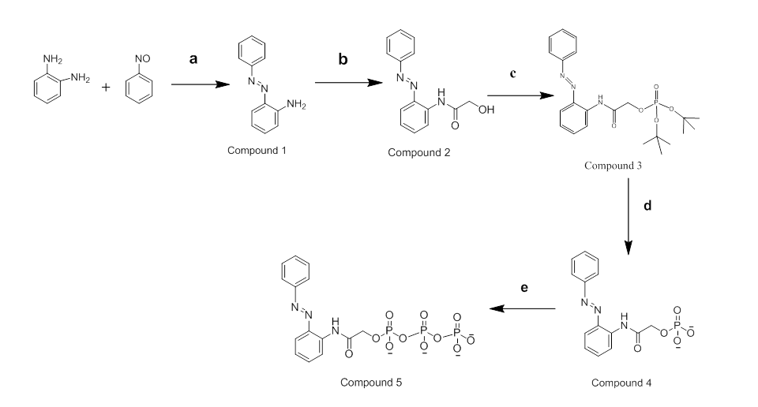
Synthesis of AzoTP: a) AcOH, toluene, N₂ atmosphere, 60 °C, 20 h; b) LiAlH₄, ethyl glycolate, dry THF, Ar atmosphere, rt, 18 h; c) di-tert-butyl N,N-diisopropylphosphoramidite, 1H-tetrazole, dry THF, Ar atmosphere, rt, 7 h; then, mCPBA, 0 °C, 1h; then rt, 40 min; d) trifluoroacetic acid, dry CH₂Cl₂, Ar atmosphere, rt, 6 h; then eluting through DEAE Sephadex A-25 anion exchanger, TEAB; e) tributylamine, carbonyldiimidazole, pyrophosphate, dry DMF, Ar atmosphere, rt, overnight.

Compound 1
A solution of 1,2-phenylenediamine (8.2 g, 75.8 mmol) in toluene (500 mL) was degassed under a stream of N₂ for 20 min and then nitrosobenzene (8.12 g, 75.8 mmol) and acetic acid (4 equiv.) were added under N₂. The mixture was stirred at 60 °C for 24 h and then the solvent was evaporated under reduced pressure. The residue was partitioned between water and CH₂Cl₂. The organic phase was dried (MgSO₄) and concentrated in a rotary evaporator. The residue was purified through column chromatography (SiO₂; hexane/EtOAc, 8:2). Yield: 6.3 g (42%). ¹H NMR [CDCl₃ (TMS)]: δ = 5.9 (br, 2H), 6.77 (d, J = 8.2 Hz, 1H), 6.82 (dd, J = 7.6, 7.6 Hz, 1H), 7.21 (dd, J = 7.6. 7.7 Hz, 1H), 7.41 (t, J = 7.3 Hz, 1H), 7.49 (dd, J = 7.2, 7.7 Hz, 2H), 7.82–7.85 (m, 3H). ESI-MS: m/z = 198.12 [M + H]⁺ (calcd. m/z 198.1).

Compound 2
A solution of compound 1 (5.9 g, 30 mmol) in dry THF (2 mL) was added dropwise to a solution of LiAlH₄ (2 M solution in THF, 3 mL, 6 mmol) with stirring at room temperature under a N₂ atmosphere. After the addition was complete, stirring was maintained for 40 min. Ethyl glycolate (0.57 mL, 6.0 mmol) was added dropwise to the resulting mixture and then stirring was maintained overnight. Then reaction was quenched carefully through successive additions of H₂O (0.3 mL), 10% NaOH (0.3 mL), and H₂O (1 mL). The mixture was partitioned between H₂O and CH₂Cl₂ and the organic phase dried (MgSO₄) and concentrated in a rotary evaporator. The residue was subjected to chromatography (SiO₂; hexane/EtOAc, 6:4). Yield: 1.7 g (22%). ¹H NMR [CDCl₃ (TMS)]: δ = 2.46 (t, J = 5.4 Hz, 1H), 4.35 (d, J = 5.4 Hz, 2H), 7.21 (dd, J = 7.6, 7.8 Hz, 1H), 7.47–7.56 (m, 4H), 7.89 (d, J = 8 Hz, 1H), 7.92 (d, J = 8.4 Hz, 2H), 8.72 (d, J = 8.4 Hz, 1H), 11.0 (br, 1H). ESI-MS: m/z = 278.12 [M + Na]⁺ (calcd. m/z 278.09).

Compound 3
1H-Tetrazole (0.830 g, 12.0 mmol) was added to a solution of compound 2 (1.02 g, 4.00 mmol) and di-tert-butyl N,N-diisopropylphosphoramidite (1.64 mL, 5.20 mmol) in dry THF (20 mL) and then the mixture was stirred for 7 h at room temperature. A solution of m-chloroperoxybenzoic acid (65%, 1.85 g, 6.93 mmol) in dry CH₂Cl₂ (10 mL) was added; the mixture was stirred for 1 h in an ice bath and then for 25 min at room temperature. Saturated aqueous NaHCO₃ (45 mL) was added and the mixture was stirred for a further 40 min. EtOAc (130 mL) was added and then the organic phase was washed with saturated aqueous solutions of NaHCO₃ (twice) and NaCl (once), dried (MgSO₄), concentrated, and dried in vacuum. The residue was purified through column chromatography (SiO₂; hexane/EtOAc, 6:4). Yield: 0.68 g (38%). ¹H NMR [CDCl₃ (TMS)]: δ = 1.46 (s, 18H), 4.60 (d, J = 7.1 Hz, 2H), 7.21 (dd, J = 7.7, 7.8 Hz, 1H), 7.47–7.52 (m, 2H), 7.56 (dd, J = 7.2, 8 Hz, 2H), 7.88 (d, J = 8 Hz, 1H), 8.05 (d, J = 8.5 Hz, 2H), 8.70 (d, J = 8.4 Hz, 1H), 10.73 (br, 1H). ESI-MS: m/z = 448.22 [M + H]⁺ (calcd. m/z 448.20).

Compound 4
Trifluoroacetic acid (1.77 mL) was added to a solution of compound 3 (0.650 g, 1.45 mmol) in dry CH₂Cl₂ (16 mL) and then the mixture was stirred for 6 h at room temperature before the solvent was evaporated. MeOH (30 mL) was added and then the mixture was evaporated; this procedure was repeated three more times to remove CF₃COOH completely, followed by washing with CH₂Cl₂. All solvents were removed using a rotary evaporator and the residue dried under vacuum. Water was added to the residue and the pH adjusted to 7.5 using 1 M NaOH, providing a clear solution. The dissolved product was converted to its triethylammonium salt by eluting through a DEAE Sephadex A-25 column with 0.5 M triethylammonium hydrogencarbonate solution at 4 °C; the eluate was evaporated with EtOH several times to remove triethyl ammonium hydrogencarbonate. Yield: 0.73 g (95%). ¹H NMR [CD₃OD (TMS)]: δ = 4.62 (d, J = 6.6 Hz, 2H), 7.25 (dd, J = 7.7, 7.8 Hz, 1H), 7.50–7.59 (m, 4H), 7.89 (d, J = 8.2 Hz, 1H), 8.07 (d, J = 8.5 Hz, 2H), 8.63 (d, J = 8.4 Hz, 1H). ESI-MS: m/z = 334.06 [M – H]⁺ (calcd. m/z 334.06).

Compound 5
The triethylammonium salt of compound 4 (0.64 g, 1.2 mmol) was converted to its tributylammonium salt through the addition of tributylamine (1 mL, 4 mmol) in dry MeOH (7 mL). Triethylamine and MeOH were removed through rotary evaporation. The tributylammonium salt was dissolved in dry DMF (12 mL). While stirring, a solution of 1,1´-carbonyldiimidazole (1.2 g, 7.5 mmol) in dry DMF (10 mL) was added under Ar and then the reaction was left for 16 h at room temperature. Excess 1,1´-carbonyldiimidazole was destroyed through the addition of dry MeOH (6 mmol, 0.3 mL) and stirring for 1 h. This solution was added dropwise with mixing to a solution of the tributylammonium salt of pyrophosphate [prepared from tetrasodium pyrophosphate (3.5 g, 7.5 mmol) as mentioned in Section (D)] in dry DMF (10 mL). After reacting overnight at room temperature, the mixture was cooled to 0 °C in an ice bath. Cold water (15 mL, 4 °C) was added with mixing and then the pH was brought to 7.5 using 1 M NaOH. The reaction mixture was partitioned between ether and H₂O; the aqueous phase was evaporated with EtOH at 30 °C and dried. The residue was dissolved in 0.2 M triethylammonium hydrogencarbonate and applied to a DEAE-Sephadex A-25 column (2.5 × 30 cm, 20 g) and eluted with a linear gradient (0.2–1.0 M; total volume: 1 L) of triethylammonium hydrogencarbonate at 4 °C. The majority of compound 5 eluted in the 0.67–0.86 M (10 mL/tube) fractions, as confirmed using ESI MS. These fractions were evaporated with EtOH several times to remove triethylammonium hydrogencarbonate. The obtained product was converted to its sodium salt using 1 M NaI in acetone [see section (E)]. The product’s purity was evaluated using thin layer chromatography (silica gel 60 RP-18 F₂₅₄S; MeCN/H₂O, 2:8). Yield: 0.5 g (71%). ¹H NMR [D₂O (TMS)]: δ = 4.71 (d, J = 7.4 Hz, 2H), 7.45 (dd, J = 7.7, 7.8 Hz, 1H), 7.61–7.68 (m, 4H), 7.76 (d, J = 8 Hz, 1H), 7.97–8.02 (m, 3H). ¹³C NMR: δ = 170.80, 170.70, 152.71, 143.51, 134.66, 133.26, 132.74, 130.29, 127.23, 124.33, 123.56, 117.73, 65.41 (the peaks at 170.80 and 170.70 presumably represent the C=O carbon atoms of the amide groups of the isomers having cis and trans orientations around the C–N bond). ESI-MS: m/z = 494.00 [M – H]⁺ (calcd. m/z 494.00).
- Preparation of Tributylammonium pyrophosphate
A solution of tetrasodium pyrophosphate (3.5 g, 7.5 mmol) in water (50 mL) was eluted through a cation exchange resin (BIO-RAD AG 50 W-X8 Resin, 50–100 mesh, hydrogen form) at 4 °C. The eluent with pH of less than 3 (pH paper) was collected directly into a vigorously stirred flask containing tributylamine (2 mL, 8 mmol, 4 °C). The obtained tributylammonium pyrophosphate was dried through repeated rotary evaporation with dry MeOH and then dissolved in dry DMF (10 mL).
- Conversion of triethylammonium salt of triphosphate to sodium salt
The solid triethylammonium salt of compound 5 (ca. 0.6 g) was dissolved in dry MeOH (2 mL). The sodium salt of the product precipitated upon the addition of a solution of NaI in acetone (1 M, 20 mL); it was washed several times with acetone. The residue was freeze-dried and stored at –18 °C.

- Flow cells
Two strips of double-sided adhesive tape were placed on a glass slide, approximately 2 mm apart, and covered with a cover slip (18 × 18 mm), providing a flow cell having a working volume of 3–5 μL. Solutions were pipetted on one side and withdrawn from the other through capillary action, using a Whatman filter paper or a Kimwipe, as described previously.^{1,2}
Fig. S1. Schematic representation of the flow cell (interior volume: ca. 3–5 μL) used for the kinesin-microtubule motility assay.
- Protein purification and preparation
Tubulins were purified from porcine brains through two cycles of polymerization/depolymerization processes in the presence of a high-molarity PIPES buffer.³ Microtubules were polymerized using the purified tubulins and labeled with CF™ 633 succinimidyl ester. The kinesin used in this study was a recombinant kinesin consisting of 573 amino acid residues from the N-terminus of a conventional human kinesin. This recombinant kinesin fused with His-tag in the N-terminus (plasmid: pET 30b) was expressed in E. coli Rossetta (DE3)pLysS and purified through the general method utilizing Ni-NTA-agarose.

- Motility Assay
- Buffers
Kinesin buffer
80 mM PIPES (pH 7.5) + 1 mM EGTA + 2 mM MgSO₄ + 0.5 mg/mL casein.
Microtubule buffer:
80 mM PIPES (pH 7.5) + 1 mM EGTA + 2 mM MgSO₄ + 10 µM taxol + 0.1 mg/mL casein.
Assay buffer
80 mM PIPES (pH 7.5) + 1 mM EGTA + 2 mM MgSO₄ + 0.5 mg/mL casein + 10 µM taxol + Anti-fade reagents (0.14 M β-mercaptoethanol + 20 mM glucose + 20 µg/mL catalase + 0.1 mg/mL glucose oxidase) + AzoTP.
- Procedure
The kinesin solution (diluted with kinesin buffer, ca. 100 μg/mL; 3 μL) was perfused though a flow cell and incubated for 3 min. The microtubule solution (diluted with microtubule buffer, ca. 0.5 μM; 3 μL) was then perfused into the flow cell and incubated for 3 min. The flow cell was rinsed with microtubule buffer (3 μL) to remove unbound microtubules. After 1 min of incubation, motility buffer (3 μL) containing a desired concentration of AzoTP was perfused into the flow cell and the motility of the microtubules was monitored and recorded using fluorescence microscopy. The flow cells that had been irradiated with UV (10 s) or visible (30 s) light were analyzed to determine the gliding motility each time.
- ESI-MASS Spectrum of AzoTP
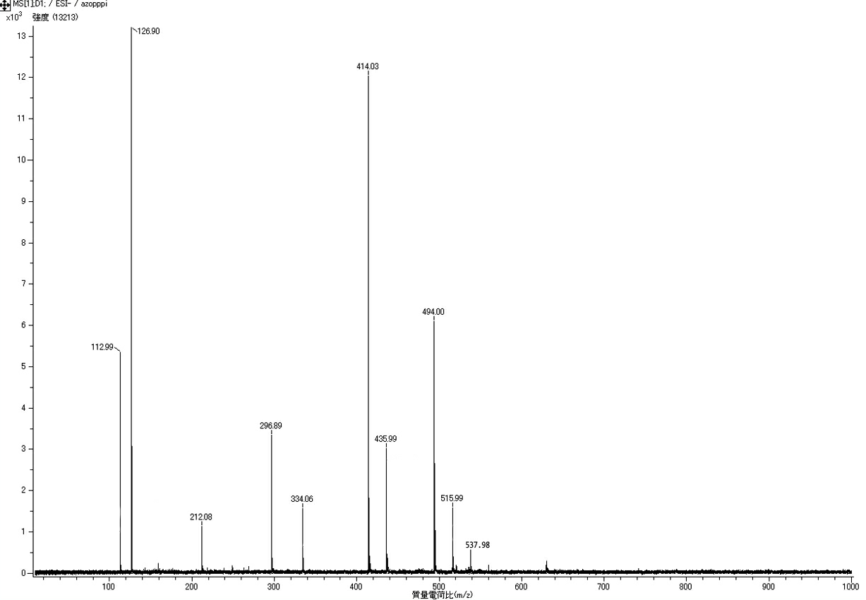
Fig. S2. ESI mass spectrum of AzoTP. The peaks at m/z 537.98, 515.99, and 494.00 can be assigned to the [M – H]⁺ ions of disodium, monosodium, and tetra-protonated AzoTP species, respectively. The peaks at m/z 435.99, 414.03, and 334.06 are fragment peaks of AzoTP having the structures of NaAzoTP – P_{i}, AzoTP – P_{i}, and AzoTP – 2P_{i}, respectively. The structures of the fragments at m/z 296.89, 212.08, 126.90, and 112.99 have not been assigned.
- Absorption Spectra of AzoTP
Fig. S3. Absorption spectra of AzoTP in BRB80 buffer after irradiation for 20 s at 366 nm and then incubation in the dark at 23 °C. The measured molar extinction coefficient for trans-AzoTP at 327 nm was 16,044 M^{–1} cm^{–1}.
- Estimation of cis-to-trans ratio of AzoTP
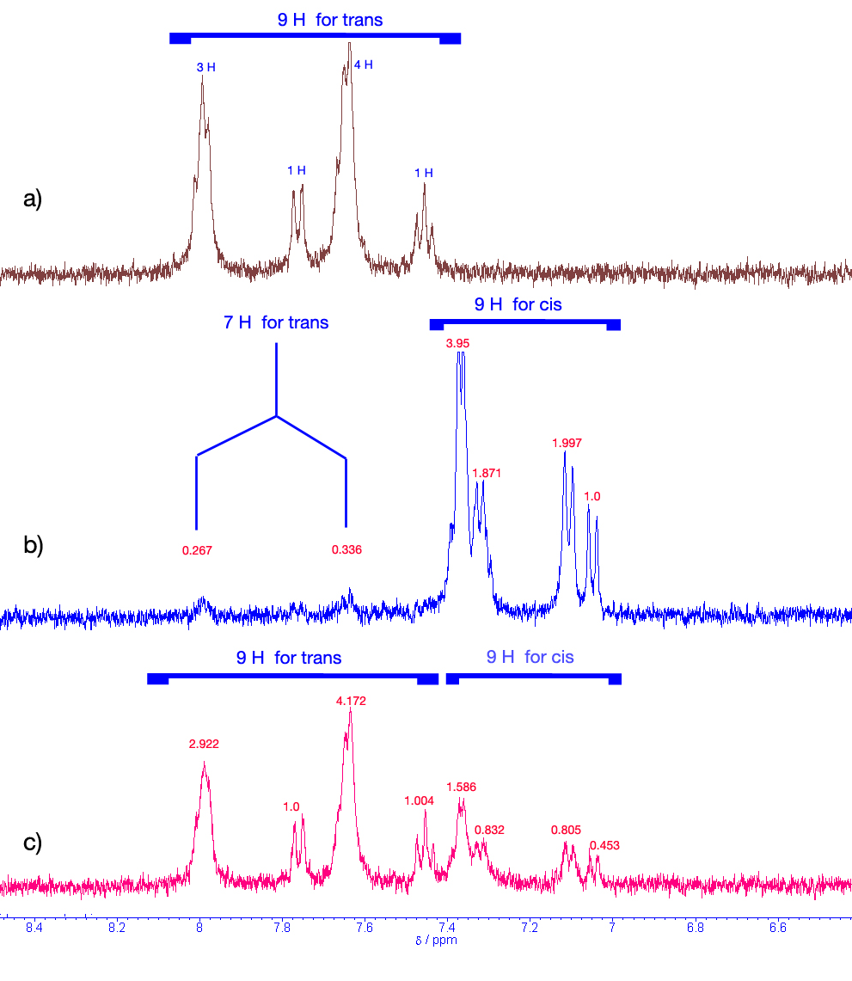
Fig. S4. ¹H NMR spectra (400 MHz, 1D) of AzoTP in D₂O (a) prior to irradiation and (b, c) after irradiation at (b) 366 nm (PSS) and (c) 436 nm (PSS). The signals at 7.45–8.02 ppm correspond to nine aromatic protons of trans-AzoTP; the signals at 7.05–7.39 ppm correspond to nine aromatic protons of cis-AzoTP. The peaks at 7.61–7.68 and 7.97–8.02 ppm, representing seven protons of the trans isomer, and at 7.05–7.39 ppm, representing nine protons of the cis isomer, provided trans-to-cis ratios of 8:92 and 71:29 for the samples in (b) and (c), respectively.

- HPLC profile of AzoTP
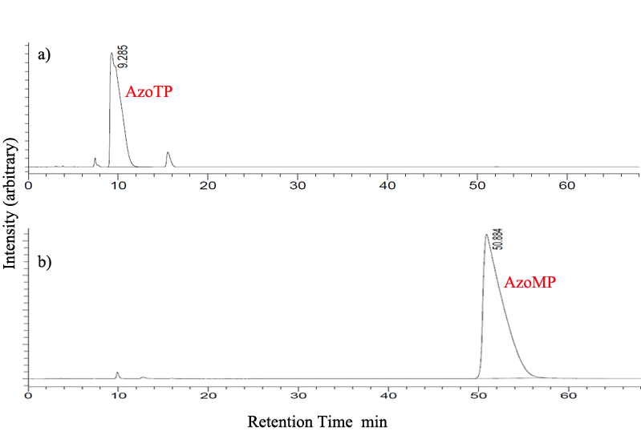
Fig. S5. Reverse-phase HPLC profiles of (a) Azo-triphosphate (AzoTP), (b) Azo-monophosphate (AzoMP) in water. The shoulder near 10 min in the HPLC chromatogram of AzoTP presumably reflects the presence of two isomers having cis and trans orientations around the C–N amide bond. Column: CN-80Ts, 4.6 × 250 mm (TOSOH). Eluent: 20% CH₃CN in aqueous 0.1 M NaH₂PO₄. Monitoring wavelength: λ= 327 nm. Flow rate: 1.0 mL/min at room temperature (23 °C). Injection volume: 50 μL.
- Motility Experiments

Fig. S6: Kinesin-microtubule motility driven by 1 mM ATP as a control experiment with alternating irradiation with UV and visible light. (1) Before irradiation; (2) sample in (1) after UV (366 nm) irradiation for 10 s; (3) sample in (2) after irradiation at 436 nm for 30 s; (4) sample in (3) after UV irradiation for 10 s; (5) sample in (4) after irradiation at 436 nm for 30 s. Error bars: standard deviation for 10 microtubules.

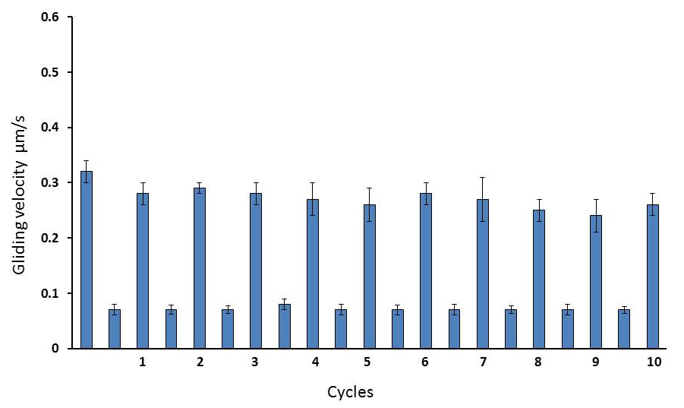
Fig. S7. Repeatability of the photo-controllable change in gliding velocity of AzoTP (3 mM)-driven microtubules through alternating irradiation with UV and visible light over 10 cycles. Error bars: standard deviations for 10 microtubules.
Table S1. Gliding velocities of microtubules in the presence of different concentrations of AzoTP.

Concentration | Gliding Velocity. [Average ± sd (μm/s); n = 10]
 | Before irradiation | After irradiation at 366 nm
0.1 mM | 0.02 ± 0.003 | 0
0.5 mM | 0.09 ± 0.02 | 0.01 ± 0.003
1 mM | 0.16 ± 0.01 | 0.03 ± 0.007
2 mM | 0.26 ± 0.02 | 0.06 ± 0.004
2.5 mM | 0.32 ± 0.02 | 0.07 ± 0.003
3 mM | 0.33 ± 0.02 | 0.07 ± 0.007
3.5 mM | 0.33 ± 0.02 | 0.07 ± 0.02

References
- H. Suzuki, K. Oiwa, A. Yamada, H. Sakakibara, H. Nakayama and S. Mashiko, Jpn. J. Appl. Phys., 1995, 34, 3937–3941.
- J. Howard, A. J. Hunt and S. Baek, Methods Cell Biol., 1993, 39, 137–147.
- M. Castoldi and A. V. Popov, Protein Expression Purif., 2003, 32, 83–88.

