SUPPLEMENTARY INFORMATION

for

N,N’-Dodecamethylene-bis(pyridinium) goes lamellar. Role of C–H…I, C–H…M, and I…I interactions in the crystal structure of its hexaiododipalladate(II) derivative

Francesco Neve* and Alessandra Crispini
Dipartimento di Chimica, Università della Calabria, 87030 Arcavacata di Rende (CS), Italy. Fax: +39 0984 492044; E-mail: f.neve@unical.it

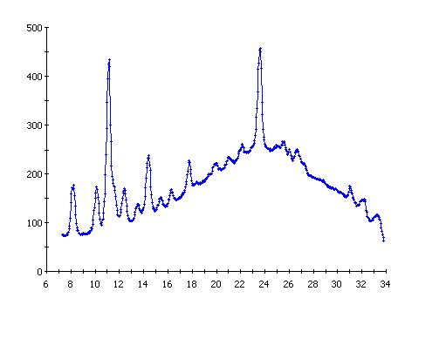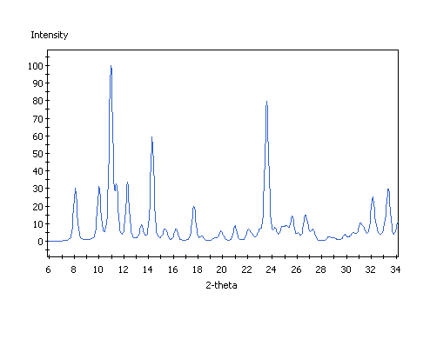
Figure S1. Calculated (lower trace) and experimental (upper trace) X-ray
powder diffraction pattern of [Py-C12-Py][Pd₂I₆].

