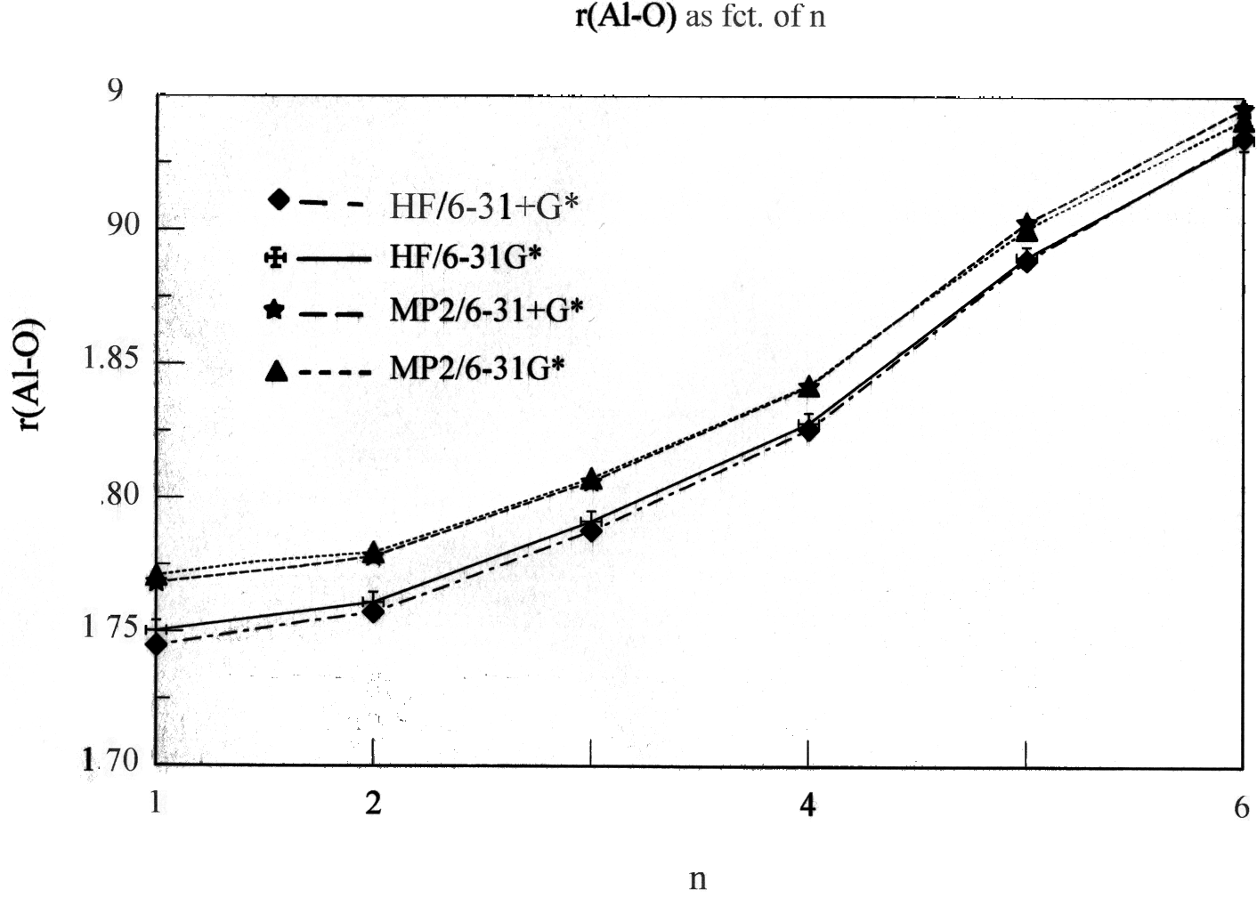
1S) The Al-O bond length, r(Al-O) as a function of the coordination number n for the Al³⁺(OH₂)_{n} cluster (at HF/6-31G*, HF/6-31+G*, MP2/6-31G* and MP2/6-31+G* levels of theory/basis set).

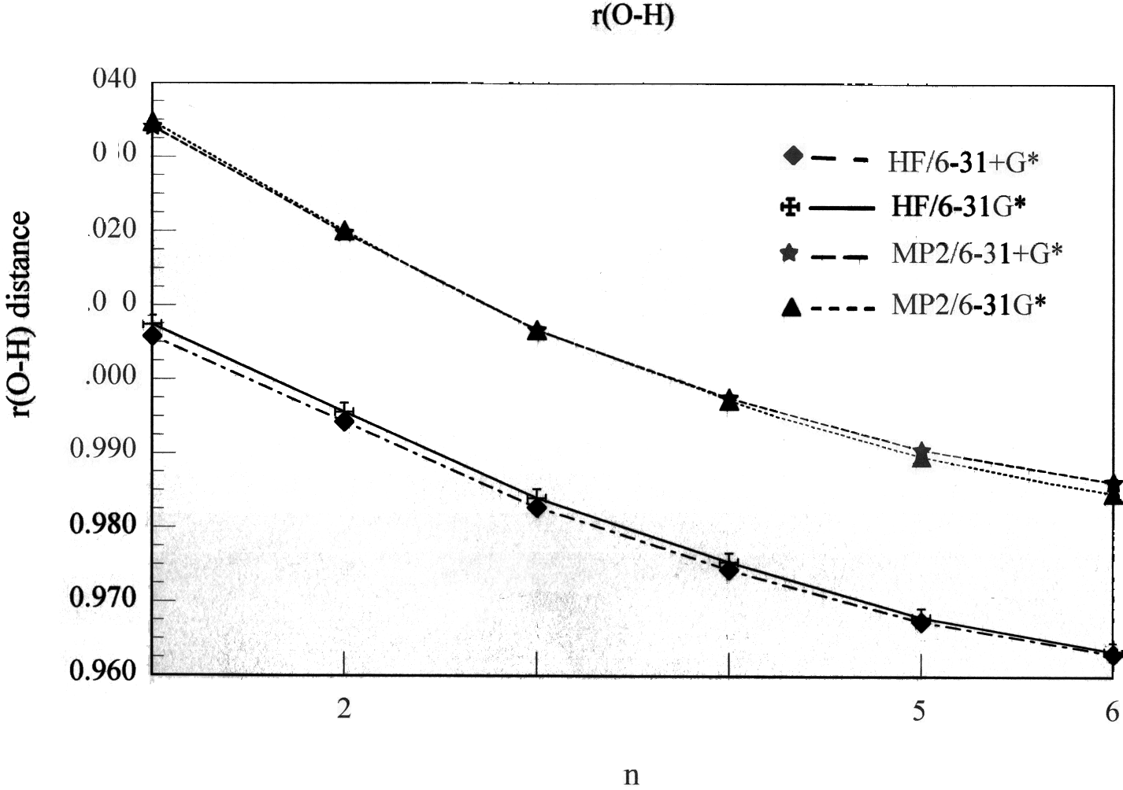
2S) The O-H bond length, r(O-H) of the first-sphere waters as a function of the coordination number n for the Al³⁺(OH₂)_{n} cluster (at HF/6-31G*, HF/6-31+G*, MP2/6-31G* and MP2/6- 31+G* levels of theory/basis set).

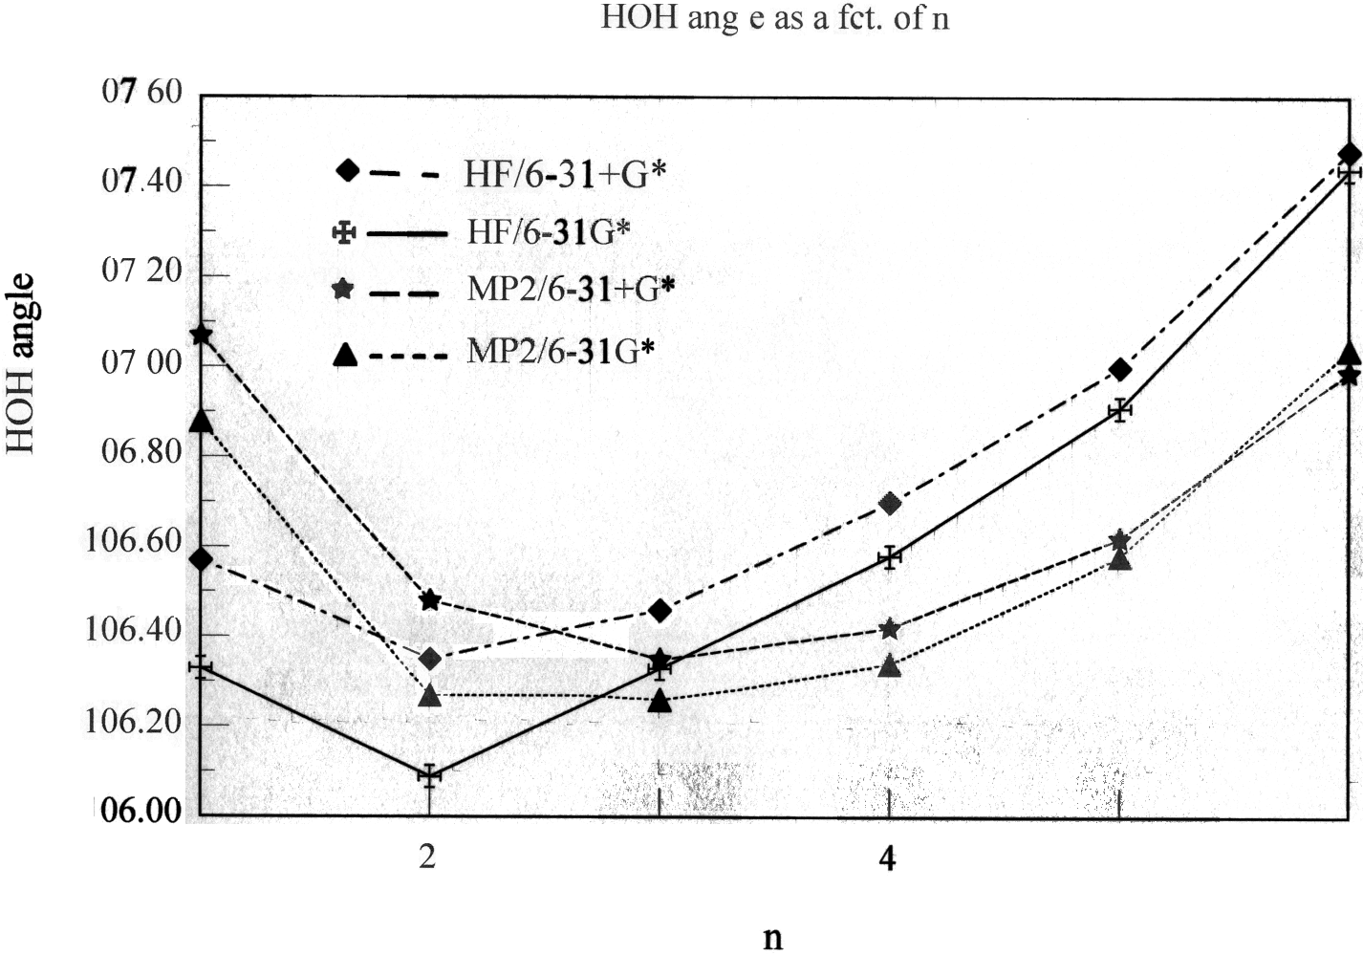
3S) The H-O-H angle of the first-sphere waters in aluminium(III) - water clusters as a function of the coordination number n (at HF/6-31G*, HF/6-31+G*, MP2/6-31G* and MP2/6-31+G* levels of theory/basis set).

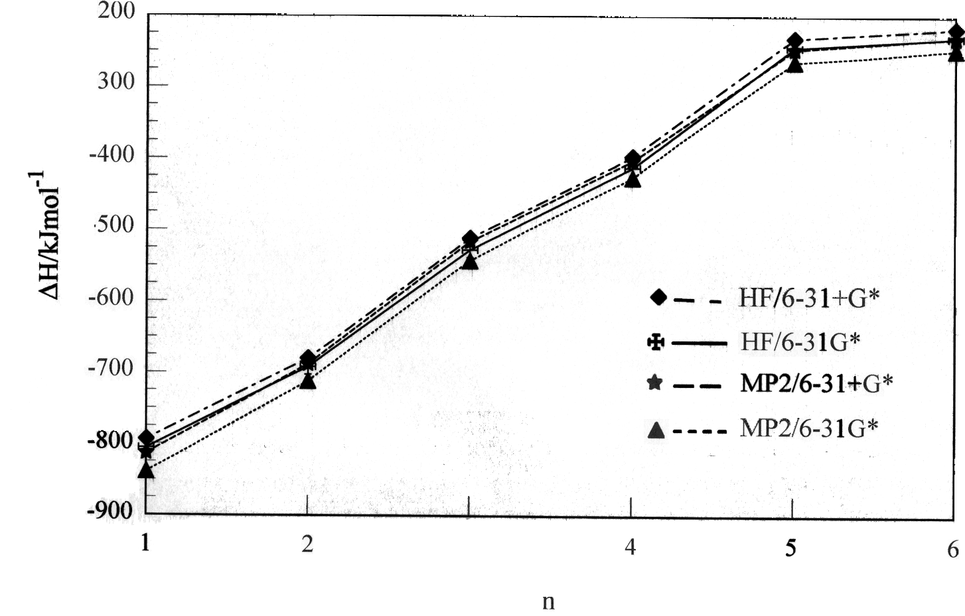
4S) The incremental binding enthalpy (in kJ/mol) as a function of the coordination number, n of the Al³⁺(OH₂)_{n} inner-sphere clusters (at HF/6-31G*, HF/6-31+G*, MP2/6-31G* and MP2/6- 31+G* levels of theory/basis set).

