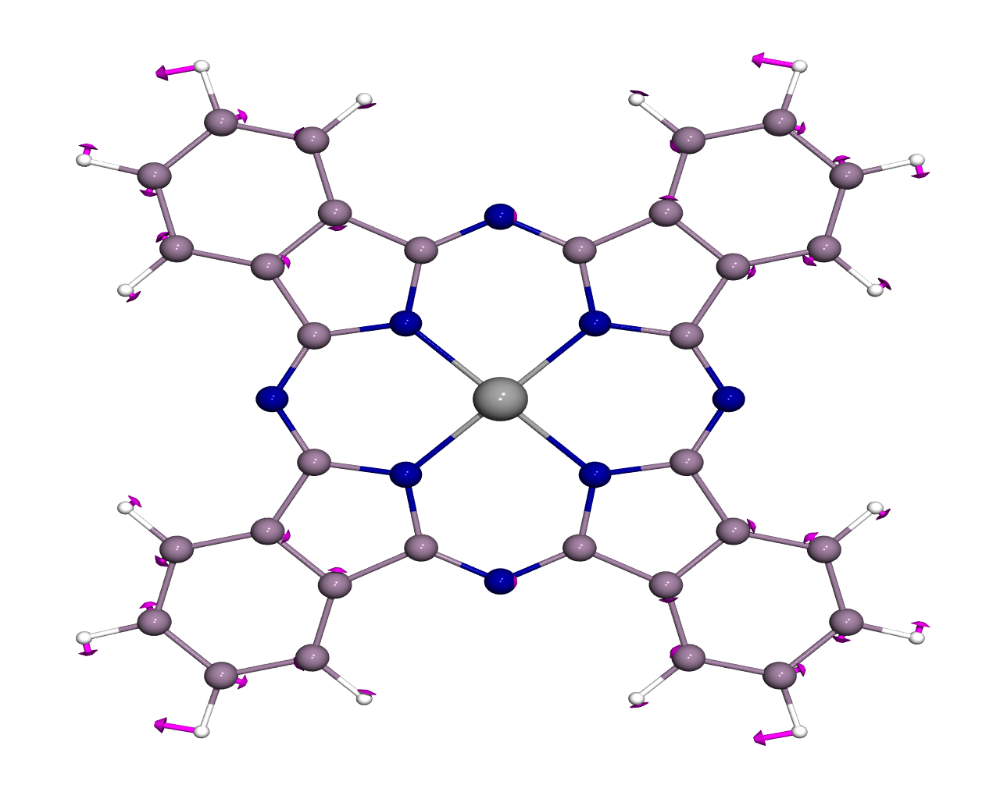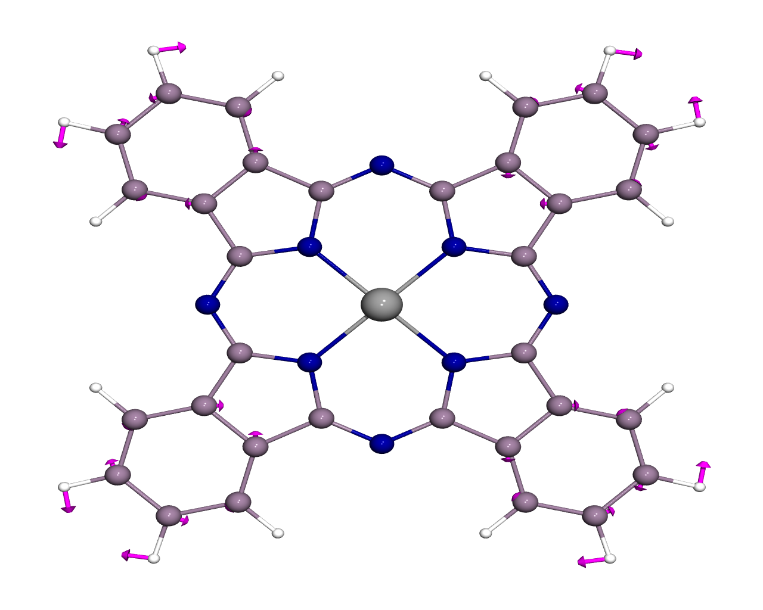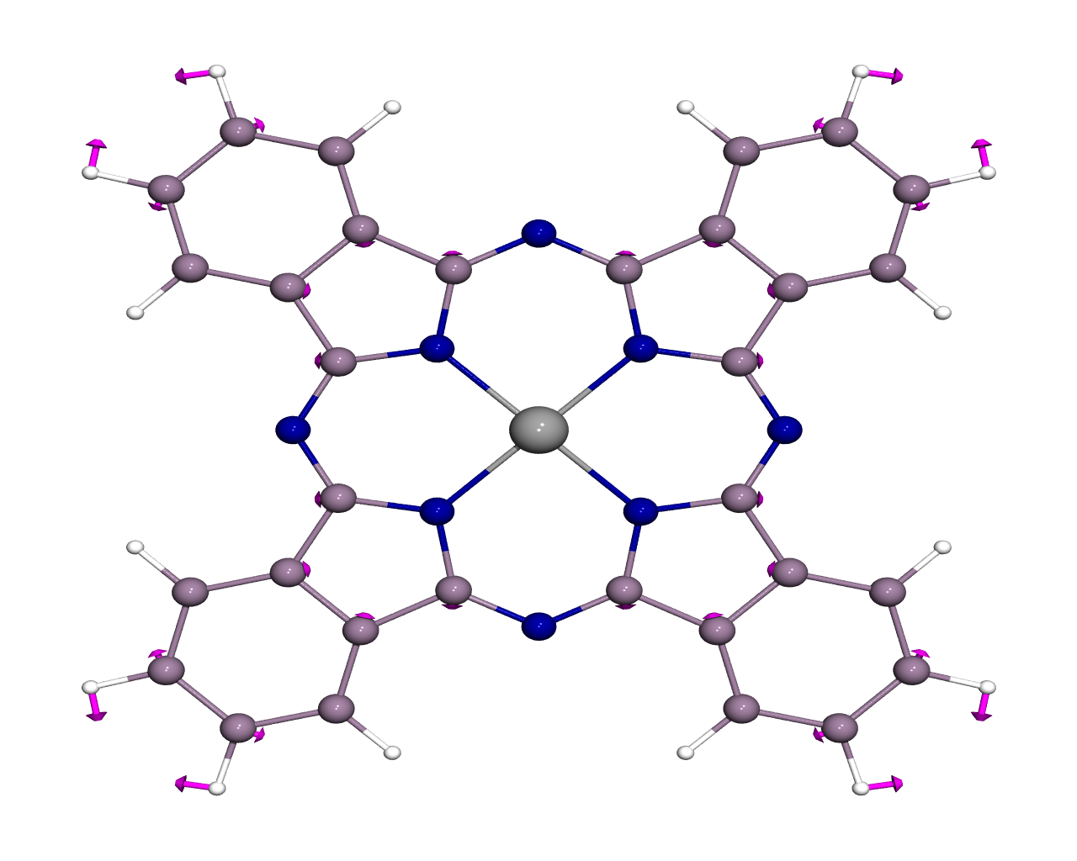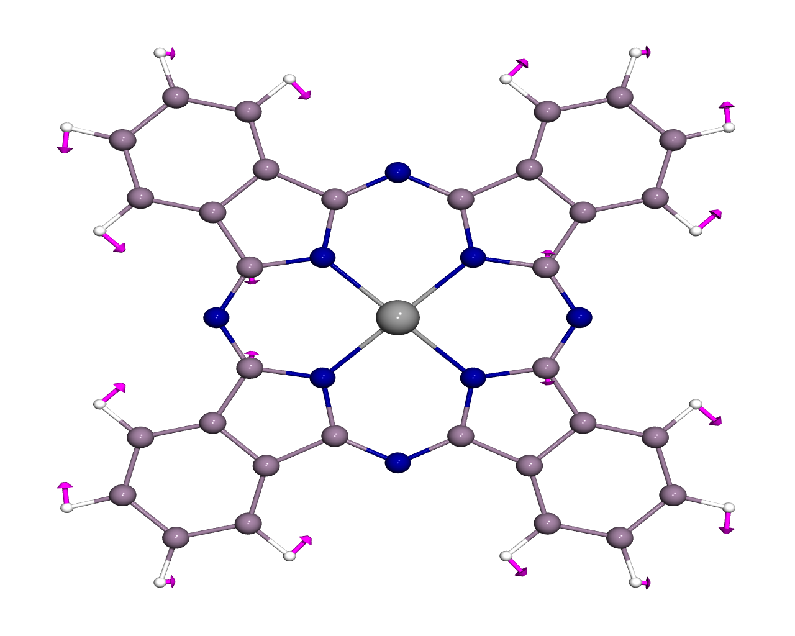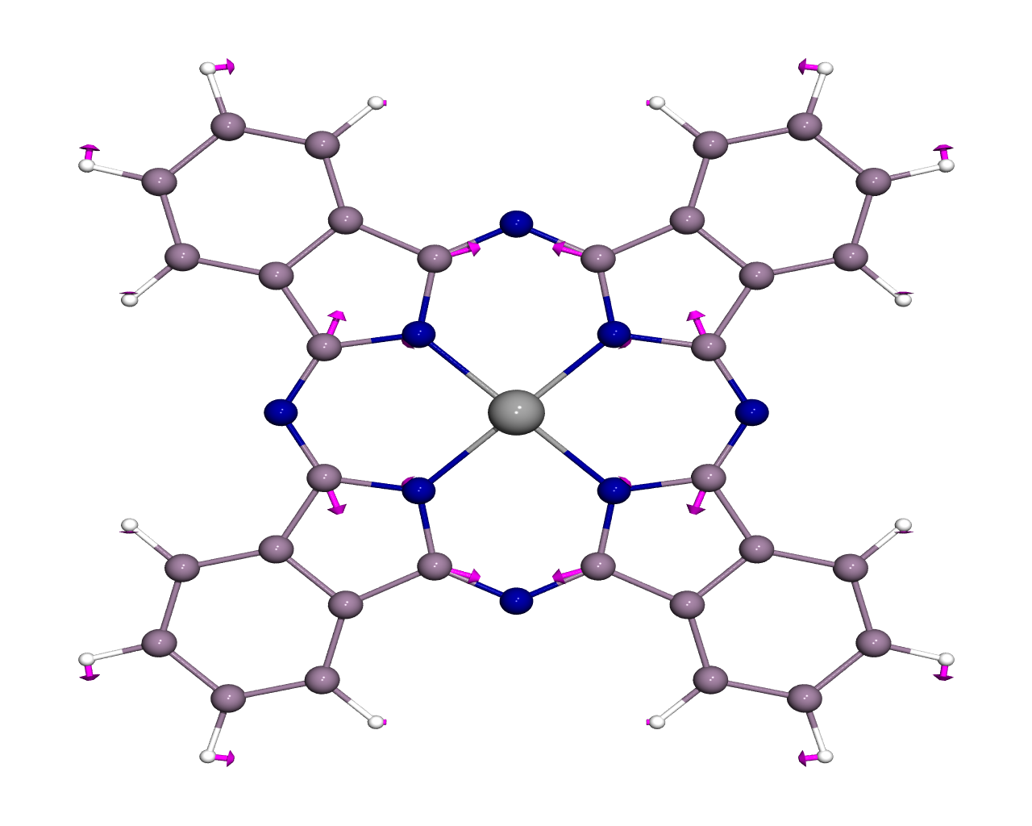
1352 cm⁻¹ 1362 cm⁻¹ 1383 cm⁻¹ 1404 cm⁻¹ 1409 cm⁻¹
E B₁ A₁ E B₂
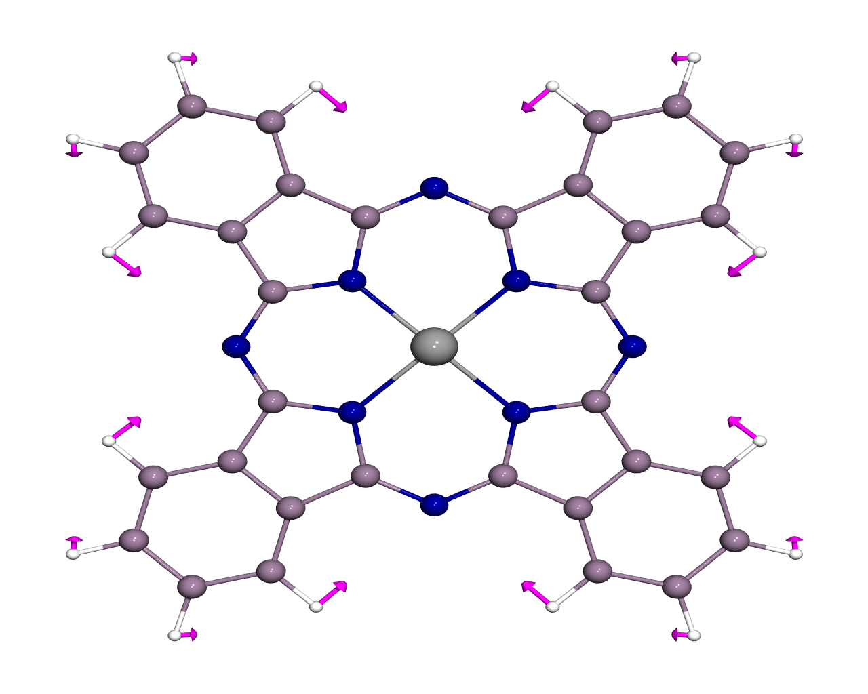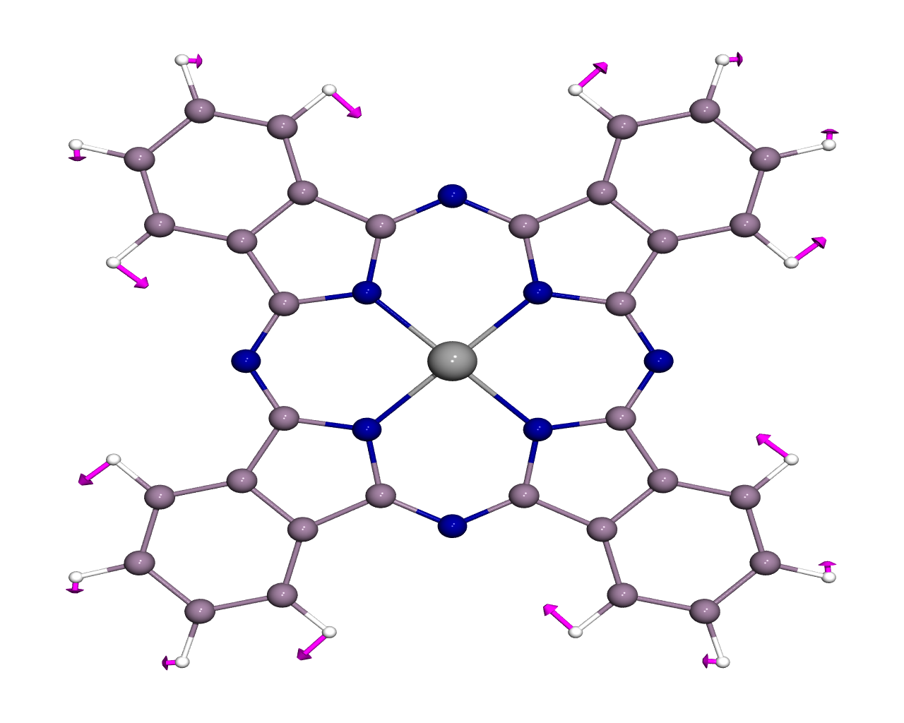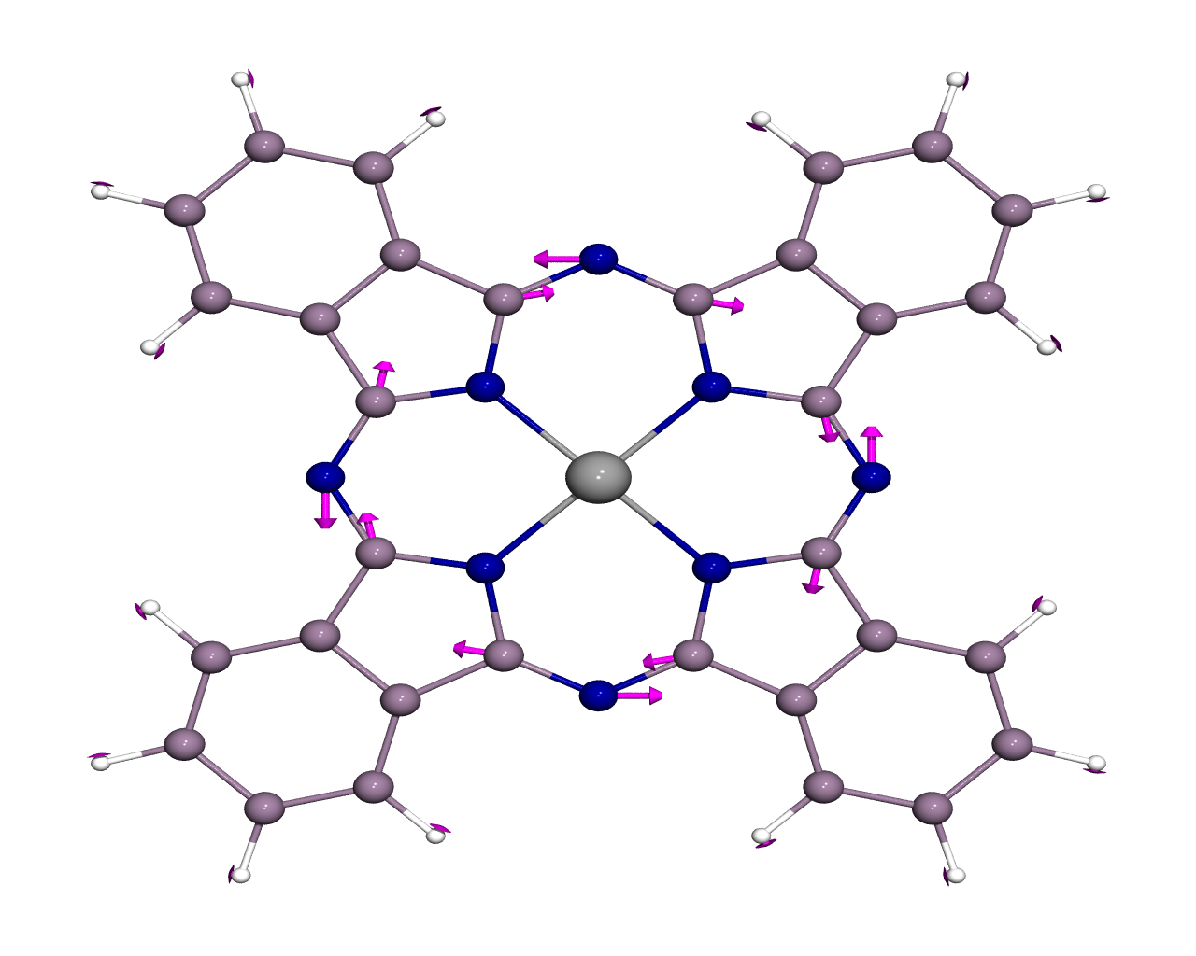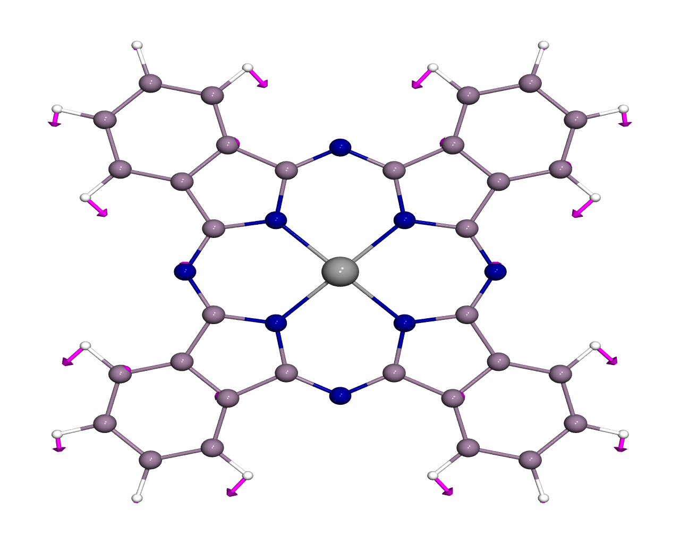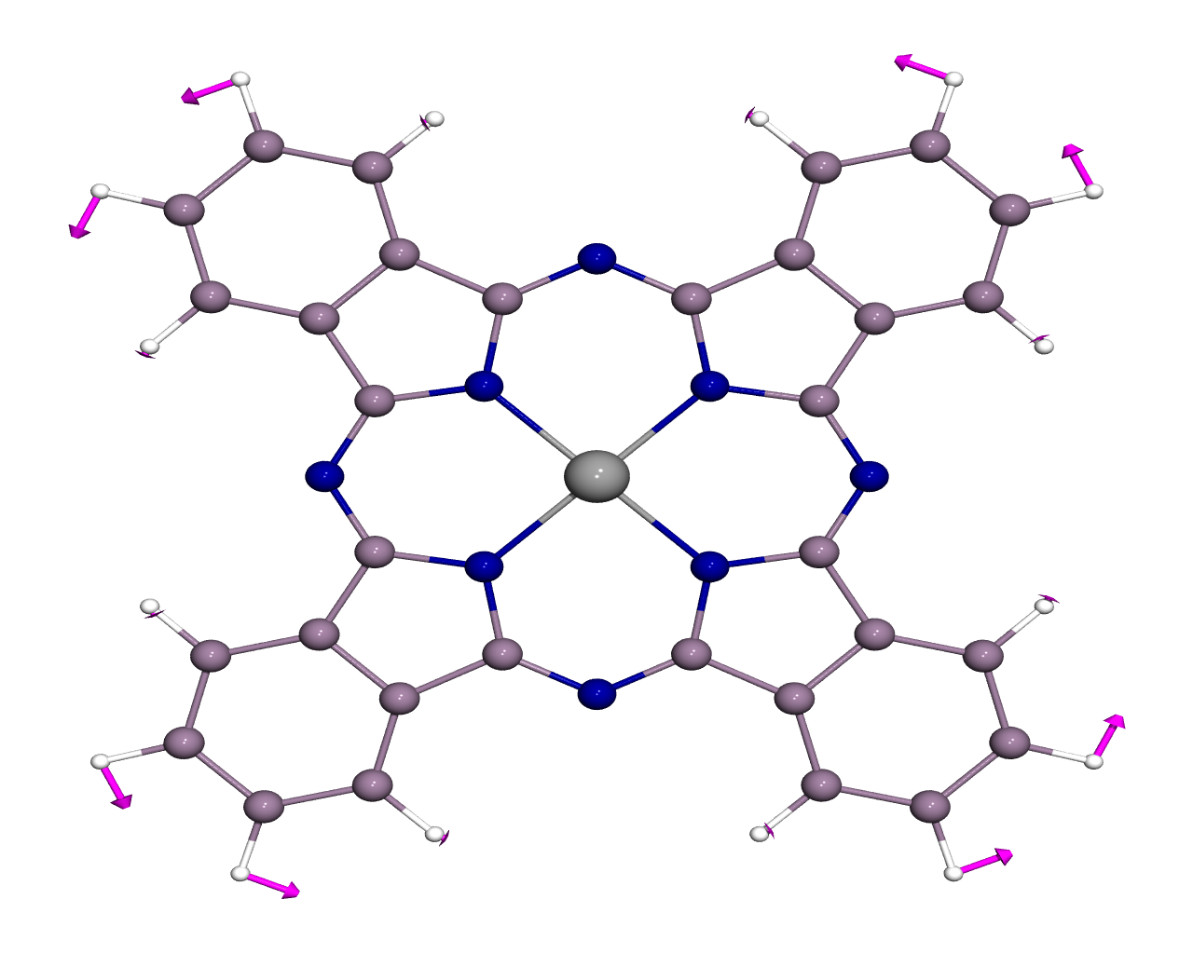
1417 cm⁻¹ 1438 cm⁻¹ 1447 cm⁻¹ 1456 cm⁻¹ 1466 cm⁻¹
A₁ B₁ A₂ E A₂
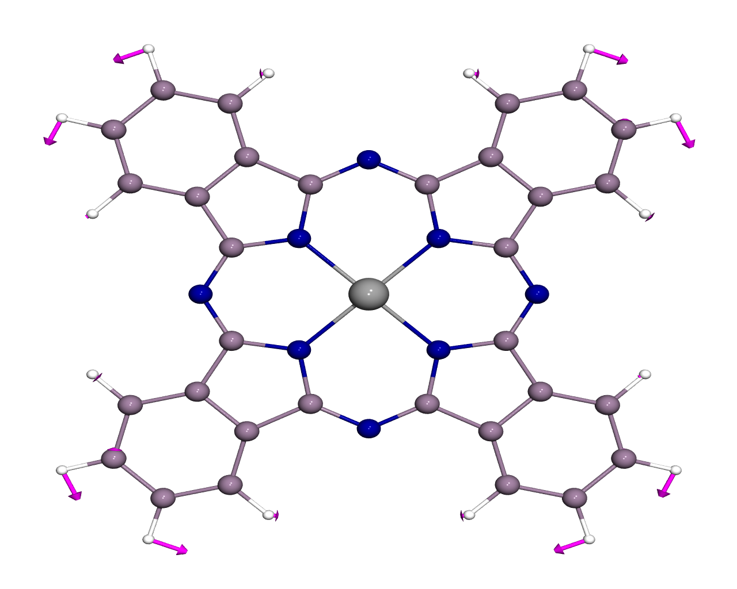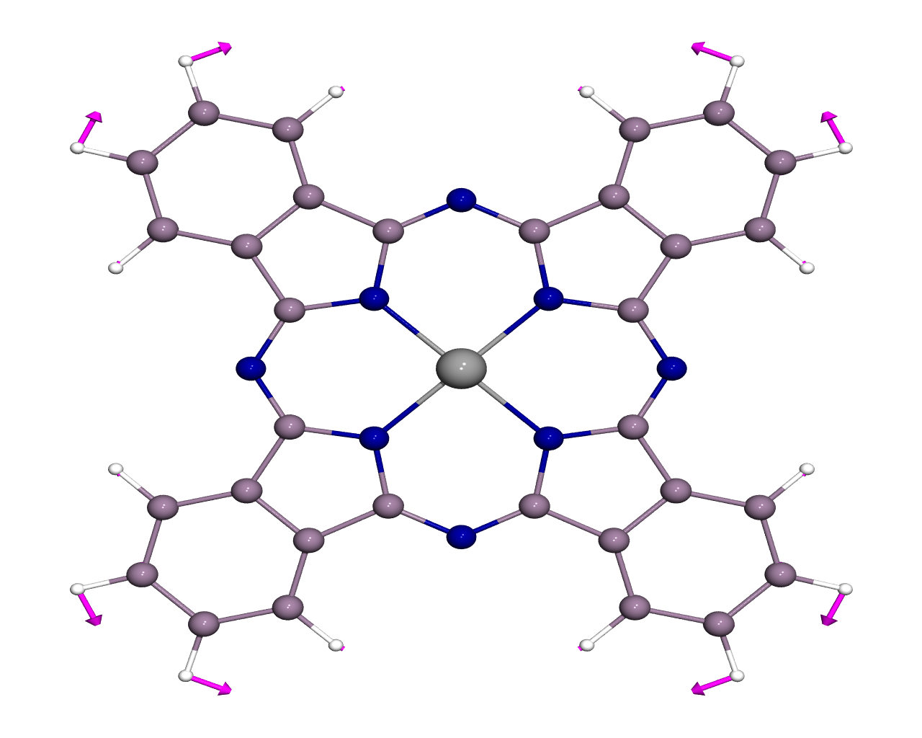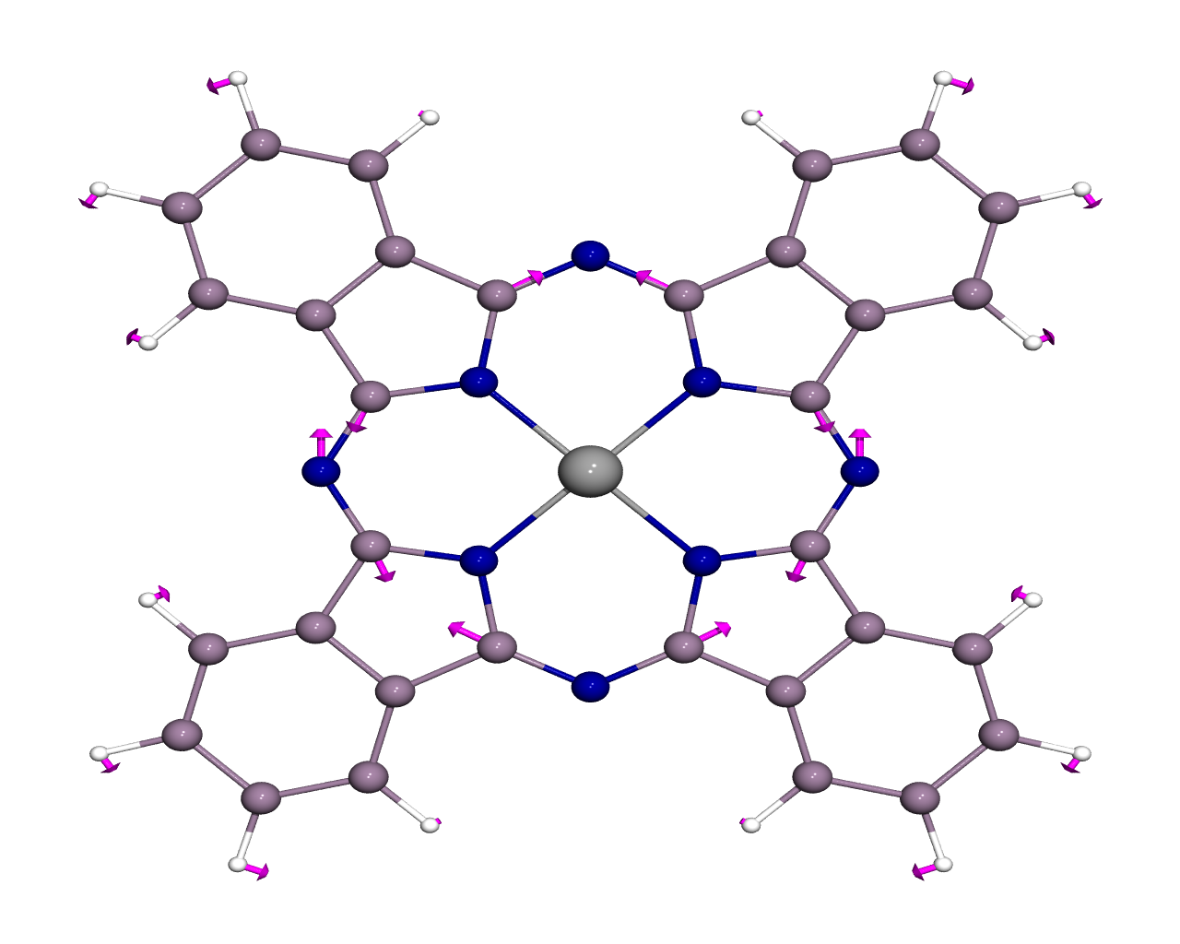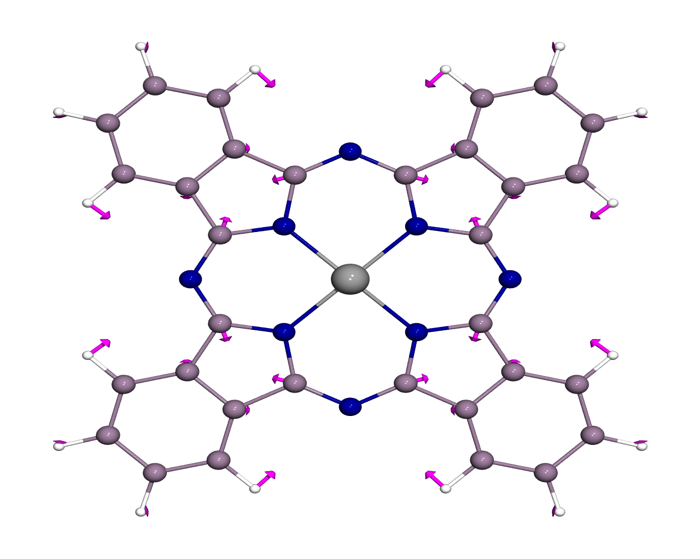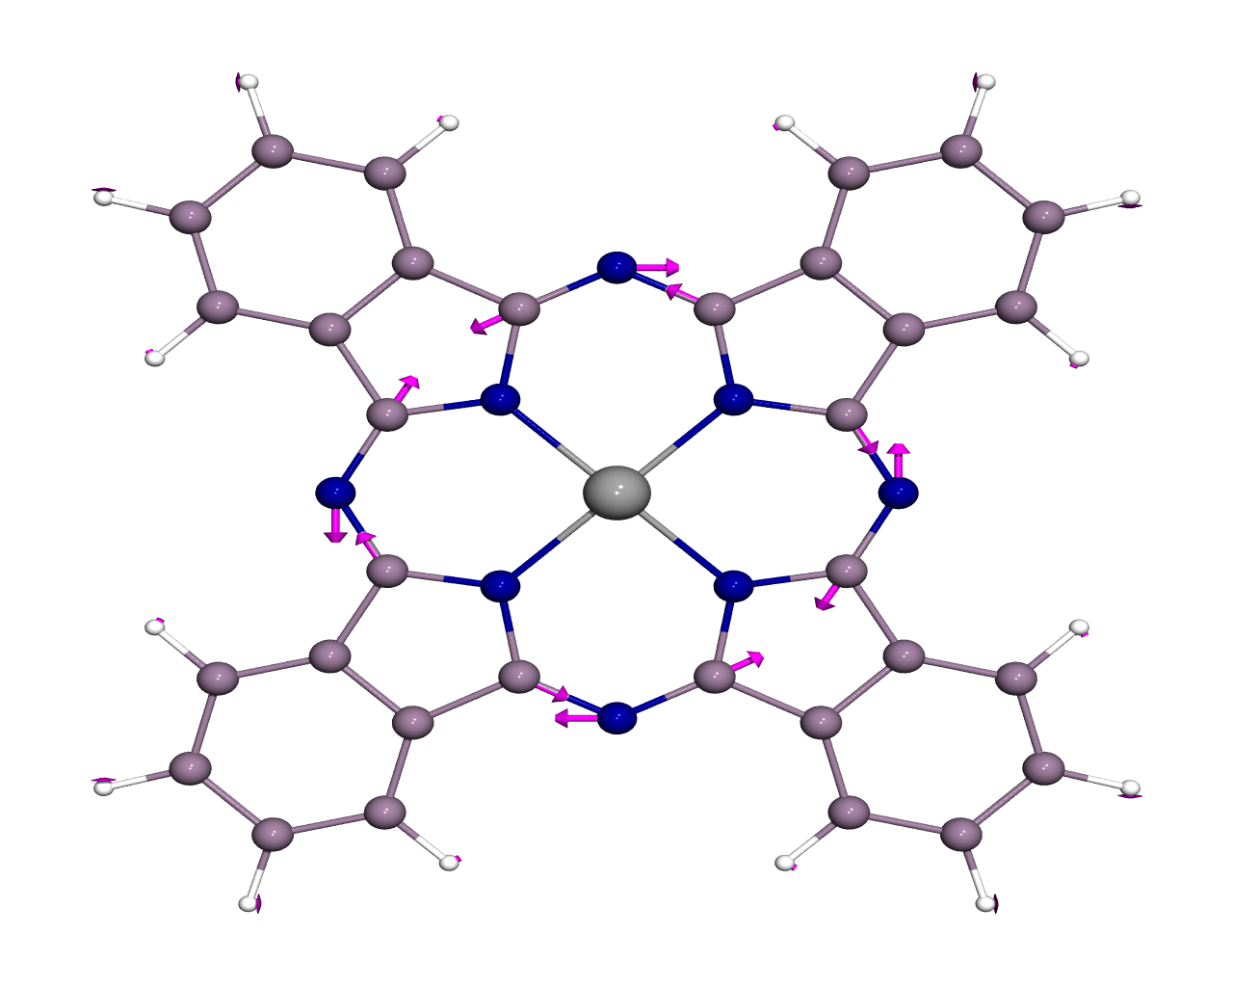
1468 cm⁻¹ 1468 cm⁻¹ 1469 cm⁻¹ 1483 cm⁻¹ 1517 cm⁻¹
E B₂ E A₁ B₁

Figure S1 Vector diagrams for the molecular vibrations of C_{4v} symmetry zinc phthalocyanine in the 1350 – 1550 cm⁻¹ region.

