TABLE S1
Interchange coefficients, dispersive C^{DIS}_{eh,l} and quasichemical C^{QUAC}_{eh,l} (l = 1, Gibbs energy; l = 2, enthalpy; l = 3, heat capacity) for (e,h) contacts between -O- (type e) and -OH (type h) groups in 1-alkanols + monoethers systems⁴⁰ containing homomorphic molecules to the hydroxyether considered.

System | C^{DIS}_{eh,1} | C | C | C | C | C
1-BuOH+1O3ª | 4.8 | 11.0 | 20. | 0.2 | 8.9 | -3.5
1-PeOH+2O3^{b} | 5.1 | 12.0 | 20. | 0.2 | 8.5 | -3.5
1-HxOH+3O3^{c} | 6.7 | 13.0 | 20. | 0.2 | 5.9 | -3.5
1-OcOH+3O4^{d} | 6.7 | 13.0 | 20. | 0.2 | 5.9 | -3.5
1-PeOH+1O4e | 6.1 | 12.0 | 20. | 0.2 | 8.6 | -3.5
1-HxOH+2O4^{f} | 6.3 | 13.0 | 20. | 0.2 | 8.4 | -3.5
1-HpOH+3O4^{g} | 6.7 | 13.0 | 20. | 0.2 | 5.9 | -3.5
1-HxOH+1O5^{h} | 6.1 | 13.0 | 20. | 0.2 | 8.6 | -3.5

ª 1-butanol + methylpropylether (2ME + n-alkanes); ^{b} 1-pentanol + ethylpropylether (2EE + n-alkanes); ^{c} 1-hexanol + dipropylether (2PE + n-alkanes); ^{d} 1-octanol + propylbutylether (2BE + n-alkanes); ^{e} 1-pentanol + methylbutylether (3MP + n-alkanes); ^{f} 1-hexanol + ethylbutylether (3EP + n-alkanes); ^{g} 1-heptanol + propylbutylether (3PP + n-alkanes); ^{h} 1-hexanol + methylpentylether (4MB + n-alkanes).

TABLE S2
Comparison of experimental (exp.) coordinates of azeotropes: temperature (T^{az}); mole fraction (x^{az}₁) and pressure (P^{az}) for alkoxyethanols(1) +
alkanes(2) mixtures with DISQUAC results (calc.) calculated using the coefficients from Table 2.

systemª | T^{az}/K | x^{az}₁ |  | P^{az}/kPa |  | Ref.
 |  | exp. | calc. | exp. | calc.
2ME + n-C₆ | 313.15 | 0.062 | 0.061 | 38.1 | 38.2 | 22
 | 323.15 | 0.070 | 0.69 | 55.7 | 55.9 | 22
2ME + n-C₇ | 323.15 | 0.207 | 0.195 | 22.3 | 22.3 | 22
2ME + C₆H₁₂ | 303.15 | 0.088 | 0.080 | 17.1 | 17.0 | 22
 | 323.15 | 0.107 | 0.095 | 38.4 | 38.3 | 22
2EE + n-C₇ | 303.15 | 0.084 | 0.084 | 8.13 | 8.17 | 21
 | 323.15 | 0.105 | 0.099 | 19.8 | 19.9 | 21
2EE + n-C₈ | 390.20 | 0.376 | 0.355 | 101.3 | 98.7 | 126
2EE + C₆H₁₂ | 303.15 | 0.016 | 0.023 | 16.3 | 16.3 | 21
 | 323.15 | 0.029 | 0.032 | 36.4 | 36.5 | 21

ª for abbreviations, see Table 1
TABLE S3

Excess molar partial enthalpies, H^{E,∞}_{mi} (i =1,2), at 298.15 K for CH₃(CH₂)_{m}O(CH₂)_{p}OH(1) + n-heptane(2) mixtures. Compariosn between
experimental (exp.) data⁸⁷ and DISQUAC (DQ) values calculated using the coefficients from Table 2.

p | m | H^{E,∞}_{m1}/kJ mol |  | H^{E,∞}_{m2}/kJ mol
 |  | exp. | calc. | calc.
2 | 0 | 17.6 | 19.3 | 6.0
 | 1 | 15.5 | 18.6 | 4.3
 | 2 | 15.5 | 8.0 | 3.5
 | 3 | 14.4 | 17.1 | 3.0
 | 11 | 9.6 | 15.3
3 | 0 | 18.1 | 17.7 | 4.0
 | 1 | 17.3 | 17.8 | 3.5
 | 2 | 17.5 | 17 | 3.0
4 | 0 | 21.2 | 17.9 | 3.3

solvent n-dodecane; T = 302.15 K¹³²
TABLE S4
Natural logarithms of the activity coefficients at infinite dilution lnγ∞_{i} in alkoxyethanols(1) + n-alkanes(2) mixtures at various temperatures, T (K). Comparison of experimental results (exp.) with DISQUAC (DQ) values using the coefficients from Table 2.

systemª | T/K | lnγ∞₁ |  | lnγ∞₂ |  | Ref.
 |  | exp. | DQ | exp. | DQ
2ME + n-C₇ | 303.15 | 2.69 | 4.33 | 2.58 | 2.50 | 133
 | 320.15 | 2.10 | 3.87 | 2.40 | 2.37 | 133
 | 340.15 | 2.54 | 3.36 |  | 2.22 | 134
 | 363.15 | 2.30 | 2.81 | 1.47 | 2.06 | 134
2ME + n-C₁₆ | 313.15 | 2.89 | 3.60 | 4.06 | 135
 | 343.15 | 2.16 | 2.82 |  | 3.60 | 135

for abbreviations, see Table 1

REFERENCES
132.- T. Miura, M. Nakamura, Bull. Chem. Soc. Jap., 50 (1977) 2528-2532. 133.- A. Landauer, R.N. Lichtenthaler, J.M. Prausnitz, J. Chem. Eng. Data,
25 (1980) 152-153.
134.- G.M. Lobien, J.M. Prausnitz, Ind. Eng. Chem. Fundamen., 21 (1982)
109-113.
135.- R. Stryjek, M. Luszczyk, M. Fedorko-Antosik, Bull. Acad. Pol. Sci., Ser. Sci. Chim., XXIX (1982) 203-211.
supplementary material 6
FIGURES
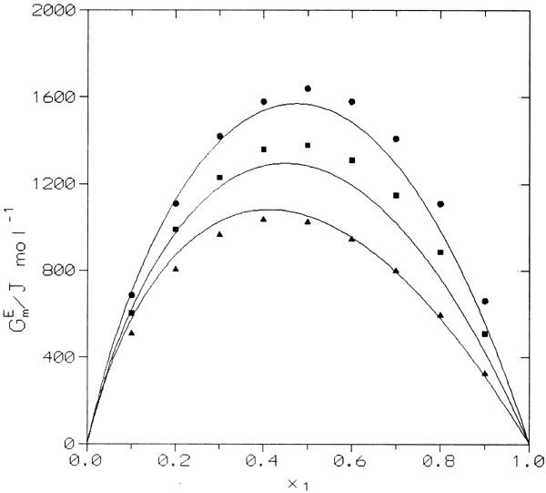
FIG. I G^{E}_{m} of alkoxyethanols(1) + n-alkanes(2) systems. Solid lines,
DISQUAC calculations. Points, experimental results: (○), 2-methoxyethanol(1) + n-heptane(2) at 323.15 K²²; (■), 2-ethoxyethanol(1) + n-heptane(2) at 323.15 K²¹; (▲), 2-butoxyethanol(1) + n-hexane(2) at 303.15 K¹¹⁸.
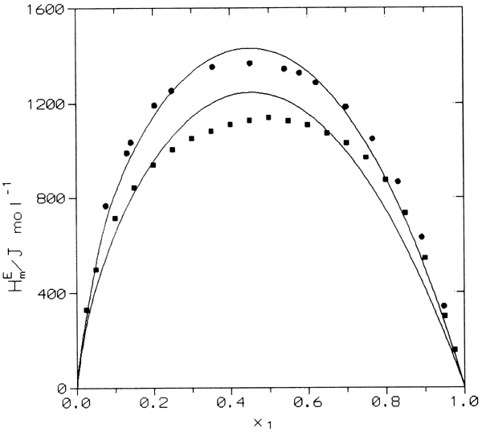
FIG. II H^{E}_{m} of the 2-methoxyethanol(1) + alkanes(2) systems. Solid lines,
DISQUAC calculations. Points, experimental results: (○), n-hexane, T = 323.15 K⁸⁴; (■), cyclohexane, T = 303.15 K¹²⁴.
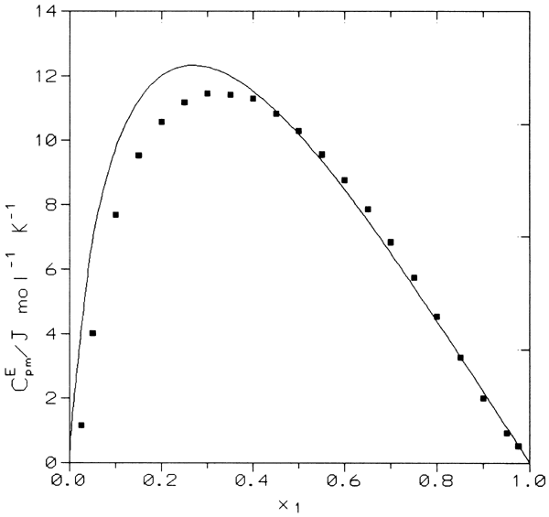
FIG. III CE_{pm} of the 2-propoxyethanol(1) + n-octane(2) system at 298.15 K. Solid line, DISQUAC calculation. Points, experimental results³⁹.

