Supplementary material 3
Internal coordinates employed for normal mode decomposition analysis
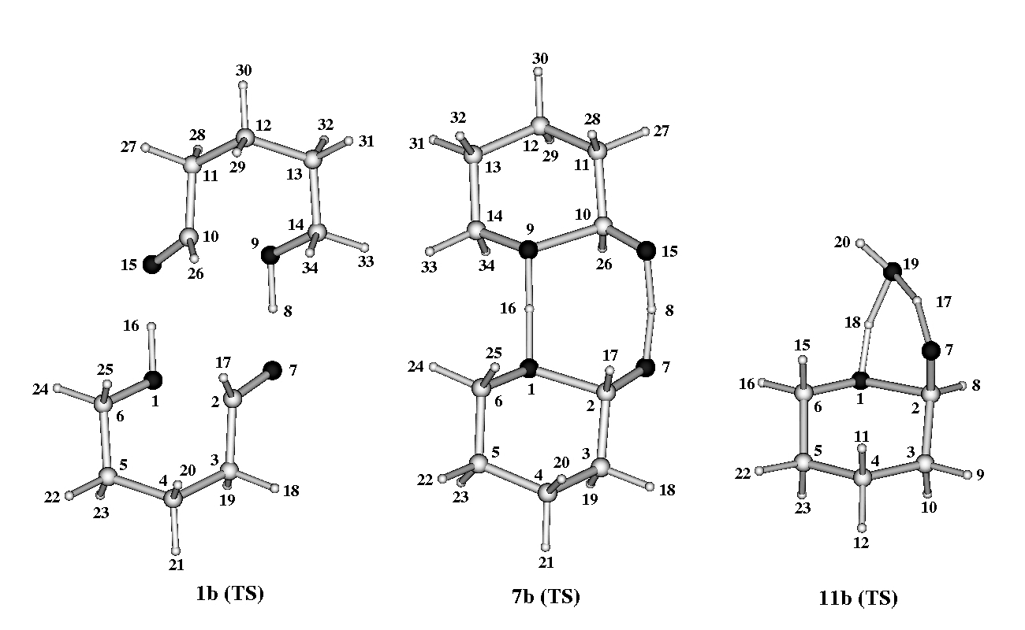
Systems 1-6

distances (n = 36)
r(2-1), r(10-9), r(8-7), r(16-15), r(9-8), r(16-1), r(7-2), r(15-10)
r(3-2), r(4-3), r(5-4), r(6-5), r(6-1),
r(17-2), r(18-3), r(19-3), r(20-4), r(21-4), r(22-5), r(23-5), r(24-6), r(25-6),
r(11-10), r(12-11), r(13-12), r(14-13), r(14-9),
r(26-10), r(27-11), r(28-11), r(29-12), r(30-12), r(31-13), r(32-13), r(33-14), r(34-14),

angles (n = 56)
a(1-6-5), a(2-1-6), a(3-2-1), a(4-3-2), a(5-4-3), a(6-5-4), a(8-7-2), a(16-1-6),
a(7-2-1), a(7-2-3), a(17-2-1), a(17-2-3), a(18-3-2), a(18-3-4), a(19-3-2), a(19-3-4), a(20-4-3),
a(20-4-5), a(21-4-3), a(21-4-5), a(22-5-4), a(22-5-6),
a(23-5-4), a(23-5-6), a(24-6-5), a(24-6-1), a(25-6-5), a(25-6-1),
a(9-14-13), a(10-9-14), a(11-10-9), a(12-11-10), a(13-12-11), a(14-13-12), a(8-9-14), a(16-15-10),
a(15-10-9), a(15-10-11), a(26-10-9), a(26-10-11), a(27-11-10), a(27-11-12), a(28-11-10),
a(28-11-12), a(29-12-11), a(29-12-13), a(30-12-11),
a(30-12-13), a(31-13-12), a(31-13-14), a(32-13-12), a(32-13-14), a(33-14-13), a(33-14-9),
a(34-14-13), a(34-14-9),

torsions (n = 10)
d(1-6-5-4), d(3-2-1-6), d(5-4-3-2),
d(9-14-13-12), d(11-10-9-14), d(13-12-11-10),
d(8-9-14-13), d(16-1-6-5), d(7-8-16-15), d(9-8-16-1).

total coordinates = 102 (3N-6 = 96)

Supplementary material 3 (continued)
Internal coordinates employed for normal mode decomposition analysis

Systems 7-9

distances (n = 36)
r(2-1), r(10-9), r(8-7), r(8-15), r(16-1), r(16-9), r(7-2), r(15-10)
r(3-2), r(4-3), r(5-4), r(6-5), r(6-1),
r(17-2), r(18-3), r(19-3), r(20-4), r(21-4), r(22-5), r(23-5), r(24-6), r(25-6),
r(11-10), r(12-11), r(13-12), r(14-13), r(14-9),
r(26-10), r(27-11), r(28-11), r(29-12), r(30-12), r(31-13), r(32-13), r(33-14), r(34-14),

angles (n = 56)
a(1-6-5), a(2-1-6), a(3-2-1), a(4-3-2), a(5-4-3), a(6-5-4), a(8-7-2), a(16-1-6),
a(7-2-1), a(7-2-3), a(17-2-1), a(17-2-3), a(18-3-2), a(18-3-4), a(19-3-2), a(19-3-4), a(20-4-3),
a(20-4-5), a(21-4-3), a(21-4-5), a(22-5-4), a(22-5-6),
a(23-5-4), a(23-5-6), a(24-6-5), a(24-6-1), a(25-6-5), a(25-6-1),

a(9-14-13), a(10-9-14), a(11-10-9), a(12-11-10), a(13-12-11), a(14-13-12), a(8-15-10), a(16-9-14),
a(15-10-9), a(15-10-11), a(26-10-9), a(26-10-11), a(27-11-10), a(27-11-12), a(28-11-10),
a(28-11-12), a(29-12-11), a(29-12-13), a(30-12-11),
a(30-12-13), a(31-13-12), a(31-13-14), a(32-13-12), a(32-13-14), a(33-14-13), a(33-14-9),
a(34-14-13), a(34-14-9),

torsions (n = 10)
d(1-6-5-4), d(3-2-1-6), d(5-4-3-2),
d(9-14-13-12), d(11-10-9-14), d(13-12-11-10),
d(8-7-2-3), d(8-15-10-11), d(7-8-16-9), d(15-8-16-1).

total coordinates = 102 (3N-6 = 96)

Systems 10-11

distances (n = 21)
r(2-1), r(18-1), r(19-18), r(19-17), r(17-7), r(7-2),
r(20-19), r(3-2), r(4-3), r(5-4), r(6-5), r(6-1),
r(8-2), r(9-3), r(10-3), r(11-4), r(12-4), r(13-5), r(14-5), r(15-6), r(16-6),

angles (n = 33)
a(1-6-5), a(2-1-6), a(3-2-1), a(4-3-2), a(5-4-3), a(6-5-4),
a(7-2-1), a(7-2-3), a(8-2-1), a(8-2-3), a(9-3-2), a(9-3-4), a(10-3-2), a(10-3-4), a(11-4-3),
a(11-4-5), a(12-4-3), a(12-4-5), a(13-5-4), a(13-5-6),
a(14-5-4), a(14-5-6), a(15-6-5), a(15-6-1), a(16-6-5), a(16-6-1),
a(17-7-2), a(19-17-7), a(18-19-17), a(19-18-1), a(20-19-18), a(20-19-17), a(18-1-6),

torsions (n = 5)
d(1-6-5-4), d(3-2-1-6), d(5-4-3-2),
d(18-1-6-5), d(20-19-18-1).

total coordinates = 59 (3N-6 = 54)

