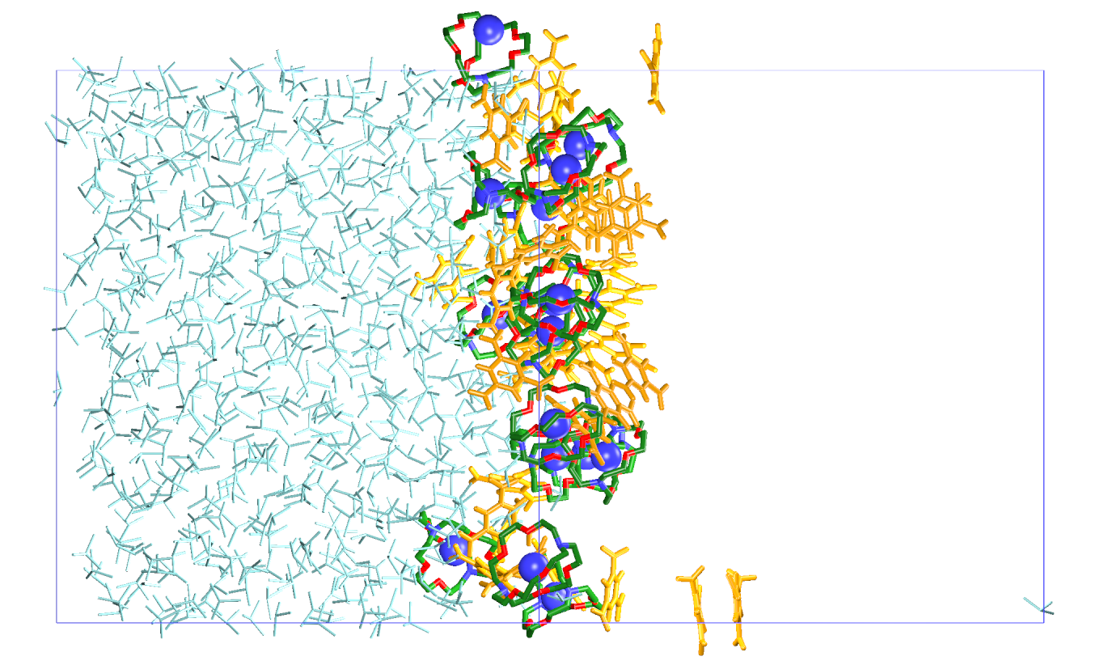 | 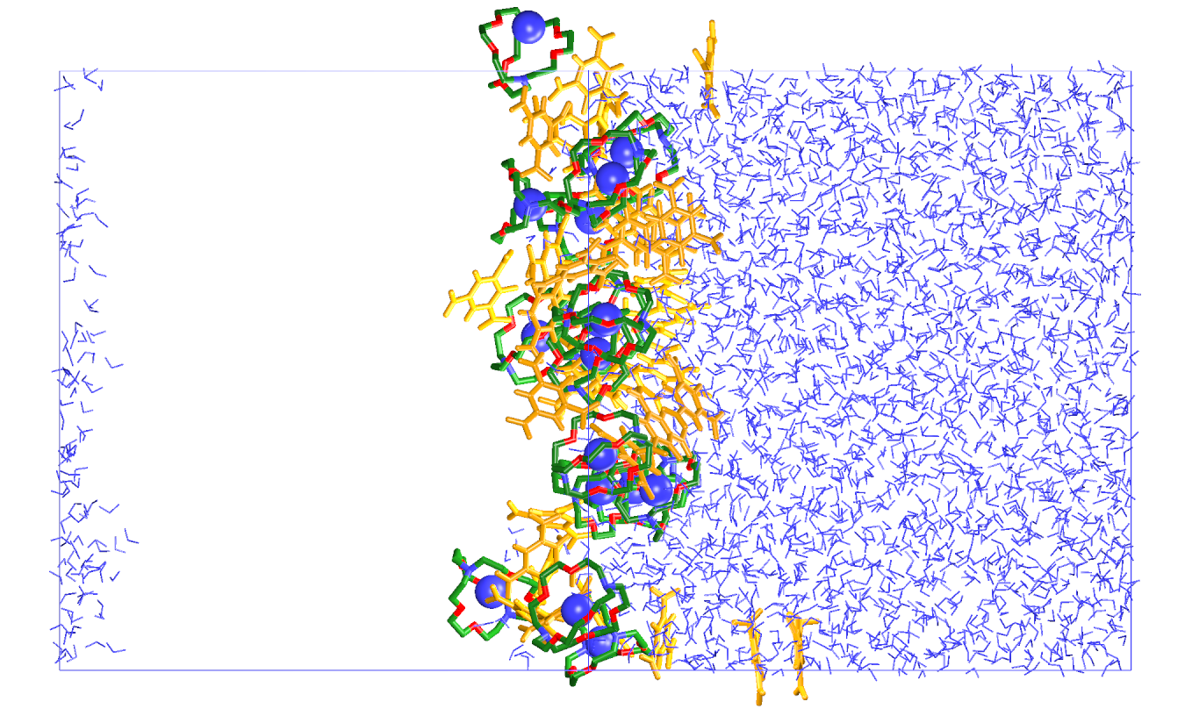 | 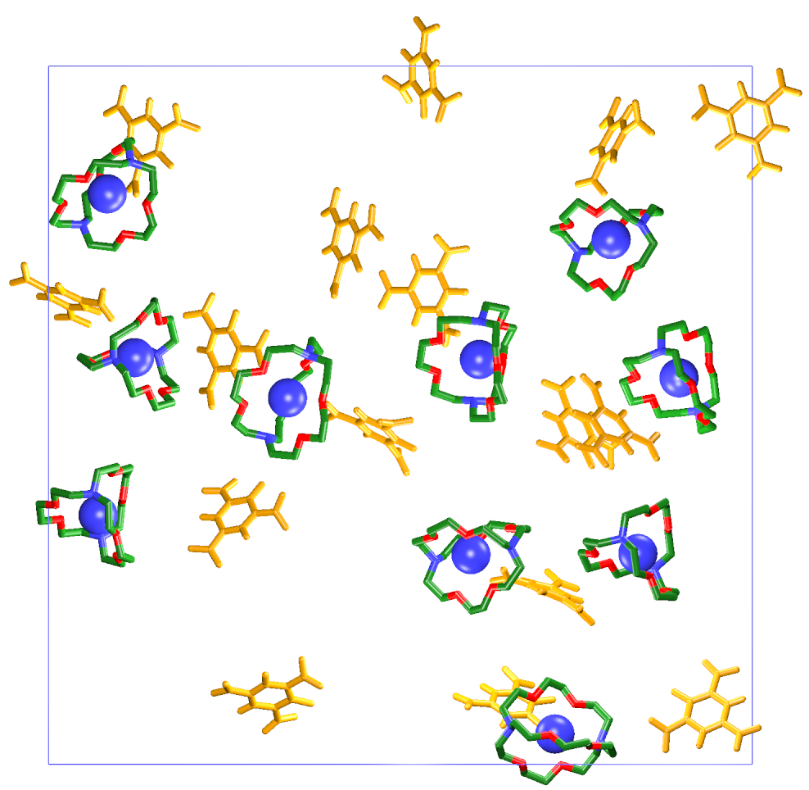
(222.Ba²⁺ ; 2Pic⁻)₁₆ // – 1.3 ns
 | 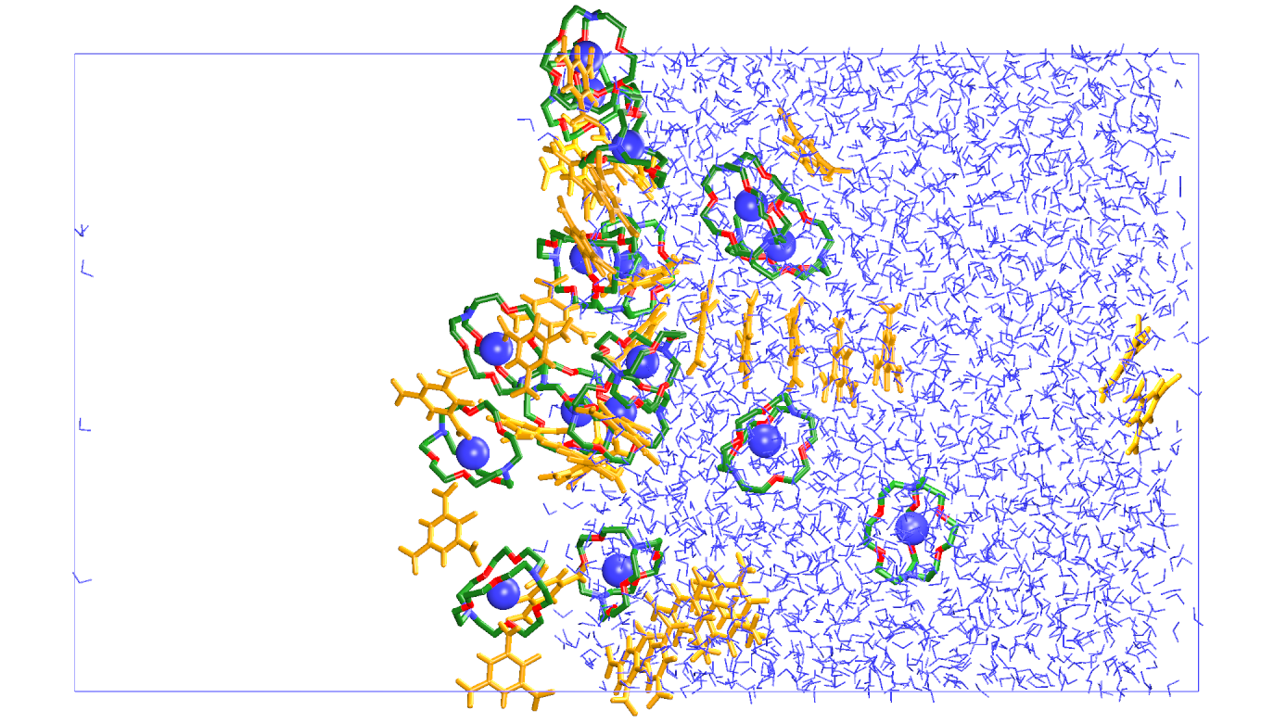 | 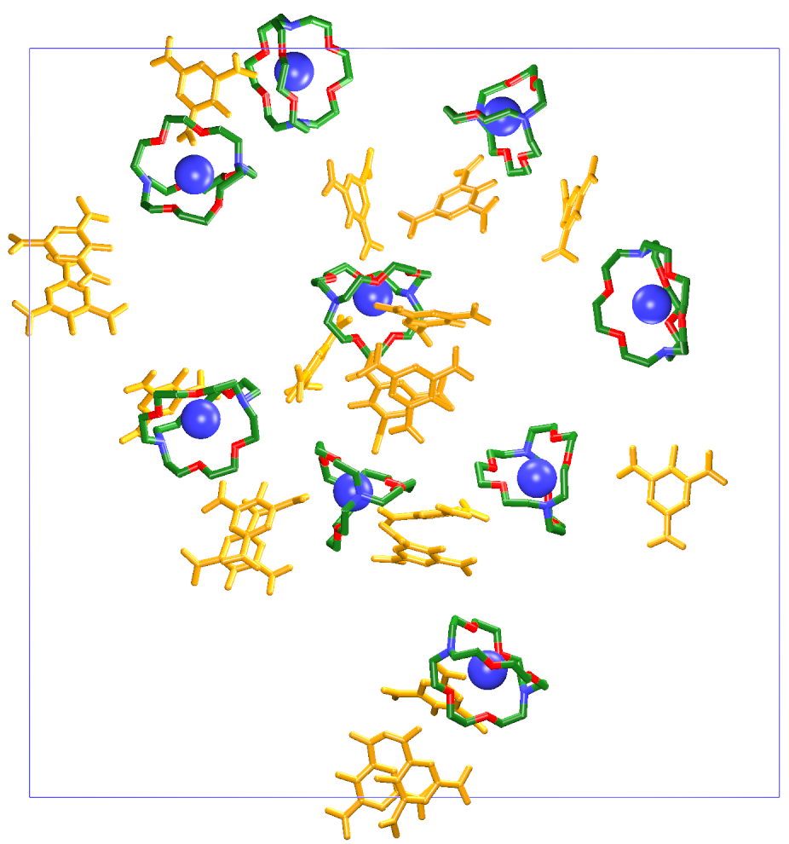
(222.Ba²⁺ ; 2Pic⁻)₁₆ ⊥ – 2.6 ns
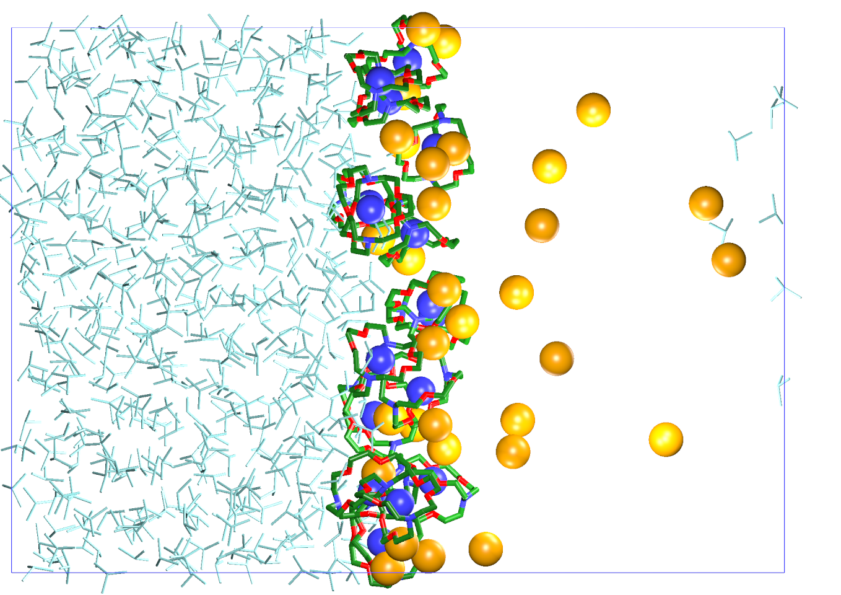 | 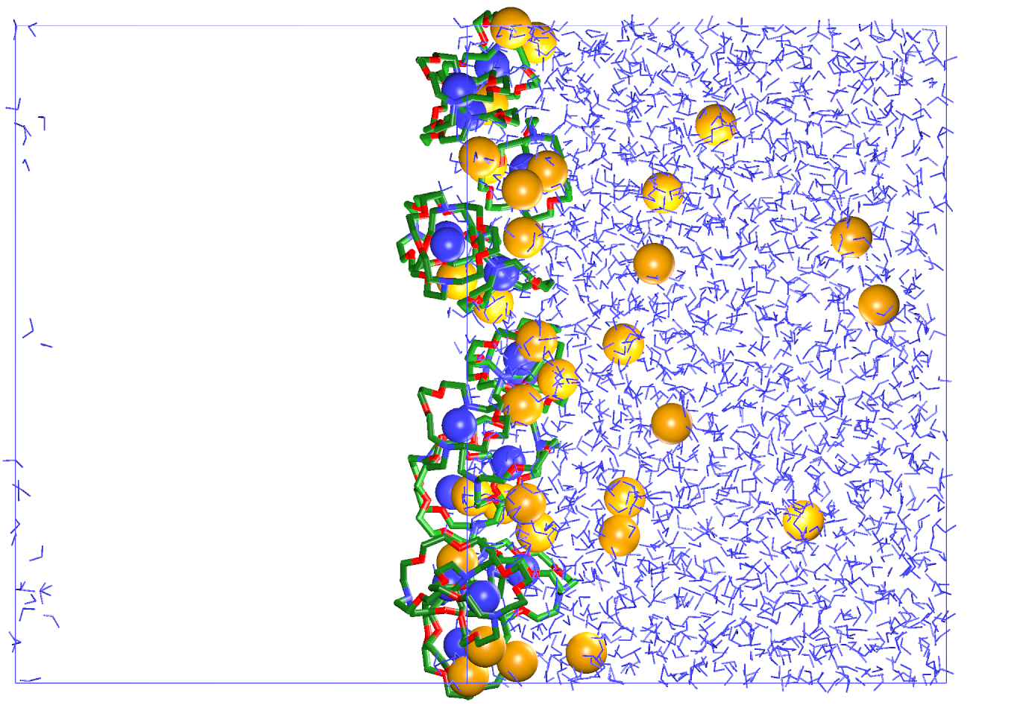 | 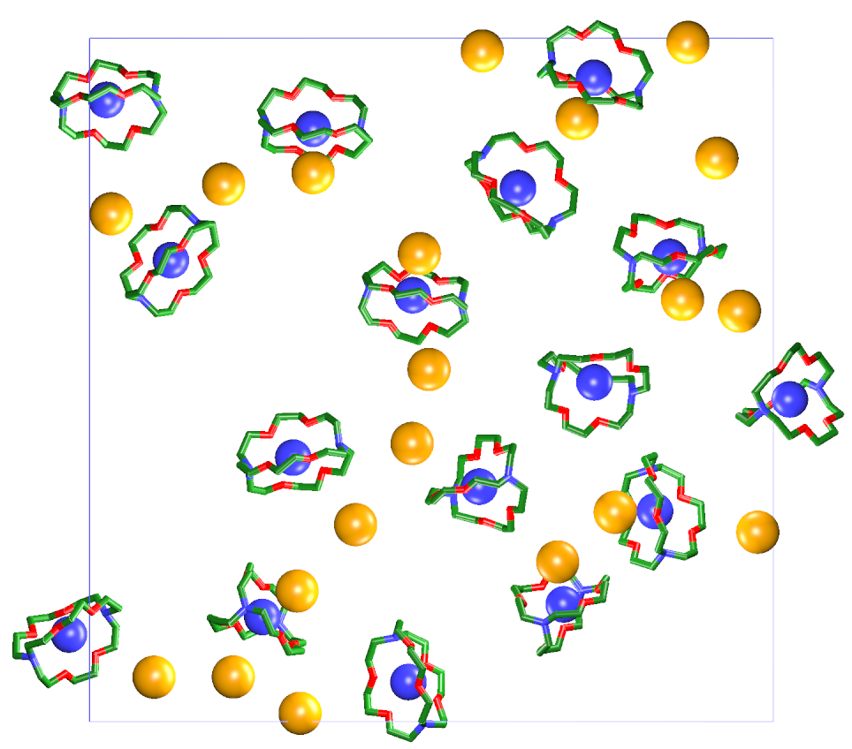
(222.Ba²⁺ ; 2Cl⁻)₁₆ // – 1.1 ns

Figure S5 : The 222.Ba²⁺ cryptates at a water / chloroform interface. See Figure S3 for definitions.

