Molecular Mechanics Modelling of Porphyrins.
Using Artificial Neural Networks to Develop Metal
Parameters for Four-Coordinate
Metalloporphyrins

Helder M. Marques* and Ignacy Cukrowski*

Molecular Sciences Institute, School of Chemistry, University of the Witwatersrand, P.O. Wits, Johannesburg, 2050 South Africa.

E-mail: hmarques@aurum.chem.wits.ac.za; ignacy@aurum.chem.wits.ac.za

SUPPLEMENTARY MATERIAL

Table S1 Additional bond stretching parameters for the MM2 force field for modeling of four-coordinate metalloporphyrins.*

T₁ | T₂ | k_{s} | l_{o} | DIPOLE
c4 | c4 | 4.50 | 1.523 | 0.000
c4 | h | 4.60 | 1.113 | 0.000
cm | h | 4.60 | 1.101 | 0.000
ca | na | 11.09 | 1.380 | 1.260
ca | nb | 11.09 | 1.380 | 1.260
ca | cm | 9.60 | 1.389 | 0.000
ca | cb | 4.80 | 1.439 | 0.000
cb | cb | 10.50 | 1.350 | 0.000
cm | cp | 10.50 | 1.499 | 0.000
cb | c4 | 11.80 | 1.509 | 0.000
cb | h | 4.60 | 1.101 | 0.000
cp | cp | 9.60 | 1.337 | 0.000
cp | h | 4.60 | 1.101 | 0.000
zn | na | 1.30 | 2.000 | 0.000
zn | nb | 1.30 | 2.000 | 0.000
cu | na | 1.89 | 1.920 | 0.000
cu | nb | 1.89 | 1.920 | 0.000
ni | na | 3.01 | 1.869 | 0.000
ni | nb | 3.01 | 1.869 | 0.000
co2 | na | 1.70 | 1.860 | 0.000
co2 | nb | 1.70 | 1.860 | 0.000
pd | na | 3.90 | 1.997 | 0.000
pd | nb | 3.90 | 1.997 | 0.000
cb | br | 2.50 | 1.881 | 1.560
cp | f | 5.40 | 1.320 | 1.480
cb | cl | 3.40 | 1.719 | 1.580
cb | cp | 10.50 | 1.499 | 0.000
c4 | cp | 4.40 | 1.497 | 0.300
c4 | cm | 4.40 | 1.497 | 0.300
c4 | n3 | 5.10 | 1.438 | 0.040
cp | n3 | 6.32 | 1.377 | -0.400
c4 | o3 | 5.36 | 1.402 | 0.440
cp | o3 | 6.00 | 1.355 | 0.001
c4 | f | 5.10 | 1.392 | 1.820
cb | c3 | 9.60 | 1.337 | 0.000
c3 | c3 | 9.60 | 1.337 | 0.000
c3 | h | 4.60 | 1.101 | 0.000
c4 | co | 4.40 | 1.509 | 0.300
o3 | h | 4.60 | 0.942 | -1.115
cm | n2 | 6.32 | 1.377 | -0.400
o1 | n2 | 7.55 | 1.220 | -2.530

*Force constant, k_{s} (mdyn Å⁻¹) for the bond between atoms T₁ and T₂, where l_{o} is the equilibrium (strain-free) bond length (Å), and DIPOLE is the bond dipole moment (D).

Table S2 Additional angle bending parameters for the MM2 force field for modeling of four-coordinate metalloporphyrins.*

T₁ | T₂ | T₃ | k_{b} | θ₀
na | zn | na | 0.200 | 180.0
nb | zn | nb | 0.200 | 180.0
na | zn | nb | 0.200 | 90.0
na | cu | na | 0.200 | 180.0
nb | cu | nb | 0.200 | 180.0
na | cu | nb | 0.200 | 90.0
na | ni | na | 0.200 | 180.0
nb | ni | nb | 0.200 | 180.0
na | ni | nb | 0.200 | 90.0
na | co2 | na | 0.200 | 180.0
nb | co2 | nb | 0.200 | 180.0
na | co2 | nb | 0.200 | 90.0
na | pd | na | 0.200 | 180.0
nb | pd | nb | 0.200 | 180.0
na | pd | nb | 0.200 | 90.0
zn | na | ca | 0.700 | 127.0
zn | nb | ca | 0.700 | 127.0
cu | na | ca | 0.700 | 127.0
cu | nb | ca | 0.700 | 127.0
ni | na | ca | 0.700 | 127.0
ni | nb | ca | 0.700 | 127.0
co2 | na | ca | 0.700 | 127.0
co2 | nb | ca | 0.700 | 127.0
pd | na | ca | 0.700 | 127.0
pd | nb | ca | 0.700 | 127.0
na | ca | cb | 0.300 | 110.0
na | ca | cm | 0.240 | 125.0
ca | cb | cb | 0.470 | 107.0
ca | cm | ca | 0.200 | 125.0
ca | cm | cp | 0.200 | 118.0
ca | cb | h | 0.360 | 120.0
cb | cb | h | 0.360 | 120.0
cm | cp | cp | 0.430 | 120.0
cp | cp | cp | 0.430 | 120.0
cm | cp | h | 0.360 | 120.0
cp | cp | h | 0.360 | 120.0
ca | na | ca | 0.600 | 106.0
cm | ca | cb | 0.400 | 125.0
cm | ca | nb | 0.240 | 125.0
nb | ca | cb | 0.300 | 110.0
ca | nb | ca | 0.600 | 106.0
cp | cp | f | 0.650 | 121.0
c4 | c4 | h | 0.360 | 109.4
h | c4 | h | 0.320 | 109.4
h | c4 | cb | 0.360 | 110.0
c4 | cb | ca | 0.400 | 120.0
c4 | cb | cb | 0.400 | 120.0
cb | c4 | c4 | 0.350 | 112.0
h | cm | ca | 0.200 | 118.0
br | cb | cb | 0.400 | 120.0
br | cb | ca | 0.400 | 120.0
cl | cb | cb | 0.550 | 118.8
cl | cb | ca | 0.550 | 118.8
ca | cb | cp | 0.200 | 120.0
cb | cb | cp | 0.200 | 120.0
cb | cp | cp | 0.430 | 120.0
cp | cp | c4 | 0.550 | 121.4
cp | c4 | h | 0.360 | 109.4
ca | cm | c4 | 0.550 | 121.4
cm | c4 | h | 0.360 | 109.4
cm | c4 | c4 | 0.450 | 109.5
c4 | c4 | c4 | 0.450 | 109.5
h | c4 | n3 | 0.500 | 108.8
cp | n3 | c4 | 0.698 | 107.0
n3 | cp | cp | 0.616 | 123.0
c4 | n3 | c4 | 0.630 | 107.7
cp | cp | o3 | 0.700 | 124.3
o3 | c4 | h | 0.540 | 106.7
cp | o3 | c4 | 0.770 | 110.8
cm | c4 | f | 0.650 | 109.0
f | c4 | c4 | 0.650 | 109.5
f | c4 | f | 1.070 | 107.1
cb | cb | c3 | 0.430 | 120.0
c3 | cb | ca | 0.430 | 120.0
cb | c3 | c3 | 0.430 | 120.0
cb | c3 | c3 | 0.430 | 120.0
cb | c3 | h | 0.360 | 120.0
c3 | c3 | h | 0.360 | 120.0
h | c3 | h | 0.320 | 120.0
c4 | c4 | co | 0.450 | 107.8
co | c4 | h | 0.370 | 107.9
c4 | co | o2 | 0.650 | 107.1
o2 | co | o2 | 0.800 | 122.0
h | o3 | h | 0.400 | 104.5
h | o3 | lp | 0.240 | 101.0
cp | o3 | h | 0.350 | 108.0
cp | c4 | c4 | 0.450 | 109.5
cm | n2 | o1 | 0.800 | 115.0
ca | cm | n2 | 0.600 | 113.5
o1 | n2 | o1 | 0.600 | 128.6

*Angle bending force constant, k_{b} (mdyn Å rad⁻²) for the angle T₁-T₂-T₃, where θ_{o} is the equilibrium (strain-free) bond angle (deg).
Table S3 Additional torsional parameters for the MM2 force field for modeling of four-coordinate metalloporphyrins.*

T₁ | T₂ | T₃ | T₄ | V₁ | V₂ | V₃
ca | na | cu | na | 0.000 | 3.000 | 0.000
ca | na | cu | nb | 0.000 | 3.000 | 0.000
ca | nb | cu | nb | 0.000 | 3.000 | 0.000
ca | nb | cu | na | 0.000 | 3.000 | 0.000
cu | na | ca | cb | 0.000 | 0.250 | 0.000
cu | nb | ca | cb | 0.000 | 0.250 | 0.000
cu | na | ca | cm | 0.000 | 0.240 | 0.000
cu | nb | ca | cm | 0.000 | 0.240 | 0.000
ca | na | ni | na | 0.000 | 3.000 | 0.000
ca | na | ni | nb | 0.000 | 3.000 | 0.000
ca | nb | ni | nb | 0.000 | 3.000 | 0.000
ca | nb | ni | na | 0.000 | 3.000 | 0.000
ca | na | co2 | na | 0.000 | 3.000 | 0.000
ca | na | co2 | nb | 0.000 | 3.000 | 0.000
ca | nb | co2 | nb | 0.000 | 3.000 | 0.000
ca | nb | co2 | na | 0.000 | 3.000 | 0.000
ca | na | zn | na | 0.000 | 3.000 | 0.000
ca | na | zn | nb | 0.000 | 3.000 | 0.000
ca | nb | zn | nb | 0.000 | 3.000 | 0.000
ca | nb | zn | na | 0.000 | 3.000 | 0.000
ca | na | pd | na | 0.000 | 3.000 | 0.000
ca | na | pd | nb | 0.000 | 3.000 | 0.000
ca | nb | pd | nb | 0.000 | 3.000 | 0.000
ca | nb | pd | na | 0.000 | 3.000 | 0.000
ni | na | ca | cb | 0.000 | 0.250 | 0.000
ni | nb | ca | cb | 0.000 | 0.250 | 0.000
ni | na | ca | cm | 0.000 | 0.240 | 0.000
ni | nb | ca | cm | 0.000 | 0.240 | 0.000
co2 | na | ca | cb | 0.000 | 0.250 | 0.000
co2 | nb | ca | cb | 0.000 | 0.250 | 0.000
co2 | na | ca | cm | 0.000 | 0.240 | 0.000
co2 | nb | ca | cm | 0.000 | 0.240 | 0.000
zn | na | ca | cb | 0.000 | 0.250 | 0.000
zn | nb | ca | cb | 0.000 | 0.250 | 0.000
zn | na | ca | cm | 0.000 | 0.240 | 0.000
zn | nb | ca | cm | 0.000 | 0.240 | 0.000
pd | na | ca | cb | 0.000 | 0.250 | 0.000
pd | nb | ca | cb | 0.000 | 0.250 | 0.000
pd | na | ca | cm | 0.000 | 0.240 | 0.000
pd | nb | ca | cm | 0.000 | 0.240 | 0.000
ca | na | ca | cb | 0.000 | 10.000 | 0.000
ca | nb | ca | cb | 0.000 | 10.000 | 0.000
ca | na | ca | cb | 0.000 | 7.200 | 0.000
ca | nb | ca | cb | 0.000 | 7.200 | 0.000
na | ca | cm | h | 0.000 | 3.800 | 0.000
nb | ca | cm | h | 0.000 | 3.800 | 0.000
cb | ca | cm | h | 0.000 | 1.800 | 0.000
na | ca | cm | ca | 0.000 | 0.800 | 0.000
nb | ca | cm | ca | 0.000 | 0.800 | 0.000
cb | ca | cm | ca | -0.170 | 1.950 | 0.000
nb | ca | cm | cp | 0.000 | 0.800 | 0.000
na | ca | cm | cp | 0.000 | 0.800 | 0.000
na | ca | cb | cb | 0.000 | 9.100 | 0.000
nb | ca | cb | cb | 0.000 | 9.100 | 0.000
na | ca | cb | h | 0.000 | 15.000 | 0.000
nb | ca | cb | h | 0.000 | 15.000 | 0.000
ca | cb | cb | ca | 0.000 | 5.600 | 0.000
ca | cb | cb | h | 0.000 | 9.000 | -1.060
cm | ca | cb | cb | 0.000 | 4.000 | 0.000
cm | ca | cb | h | 0.000 | 9.000 | -1.060
cm | ca | cb | c4 | -0.130 | 5.000 | 0.000
ca | cb | cb | c4 | -0.270 | 9.000 | 0.000
nb | ca | cb | c4 | 0.000 | 15.000 | 0.000
na | ca | cb | c4 | 0.000 | 15.000 | 0.000
c4 | cb | cb | c4 | -1.000 | 10.000 | 0.000
h | cb | cb | h | 0.000 | 15.000 | 0.000
c4 | cb | cb | h | 0.000 | 12.500 | 0.000
h | c4 | cb | cb | 0.000 | 0.000 | -0.240
h | c4 | cb | ca | 0.000 | 0.000 | -0.240
c4 | c4 | cb | ca | -0.440 | -0.700 | 0.200
c4 | c4 | cb | cb | -0.440 | -0.700 | 0.200
h | c4 | c4 | cb | 0.000 | 0.000 | -0.240
cp | cp | cp | cp | -0.930 | 5.330 | 0.000
h | cp | cp | h | 0.000 | 10.000 | 0.000
h | cp | cp | cp | 0.000 | 6.000 | -1.060
cm | cp | cp | cp | -0.270 | 10.000 | 0.000
cm | cp | cp | h | 0.000 | 9.000 | -1.060
cb | ca | cm | cp | 0.000 | 2.000 | 0.000
ca | cm | cp | cp | 0.000 | 0.000 | 0.000
ca | na | ca | cm | 0.000 | 8.500 | 0.000
cm | ca | nb | ca | 0.000 | 8.500 | 0.000
cm | ca | na | ca | 0.000 | 8.500 | 0.000
cm | cp | cp | f | 0.000 | 0.000 | 0.000
cp | cp | cp | f | 0.000 | 15.000 | 0.000
f | cp | cp | f | -2.060 | 15.000 | 0.000
h | c4 | c4 | h | 0.000 | 0.000 | 0.237
h | cm | ca | cb | 0.000 | 1.800 | 0.000
h | cm | ca | na | 0.000 | 3.800 | 0.000
h | cm | ca | nb | 0.000 | 3.800 | 0.000
br | cb | cb | br | -1.000 | 10.000 | 0.000
br | cb | ca | cm | -0.130 | 5.000 | 0.000
br | cb | ca | na | 0.000 | 15.000 | 0.000
br | cb | ca | nb | 0.000 | 15.000 | 0.000
br | cb | cb | ca | -0.270 | 9.000 | 0.000
cl | cb | cb | cl | -1.000 | 10.000 | 0.000
cl | cb | ca | cm | -0.130 | 5.000 | 0.000
cl | cb | ca | na | 0.000 | 15.000 | 0.000
cl | cb | ca | nb | 0.000 | 15.000 | 0.000
cl | cb | cb | ca | -0.270 | 9.000 | 0.000
na | ca | cb | cp | 0.000 | 15.000 | 0.000
nb | ca | cb | cp | 0.000 | 15.000 | 0.000
ca | cb | cb | cp | 0.000 | 9.000 | -1.060
cb | cp | cp | cp | -0.270 | 10.000 | 0.000
cb | cb | cp | cp | 0.000 | 0.000 | 0.000
cm | ca | cb | cp | 0.000 | 9.000 | -1.060
cb | cp | cp | h | 0.000 | 9.000 | -1.060
ca | cb | cp | cp | 0.000 | 0.000 | 0.000
cp | cb | cb | cp | 0.000 | 15.000 | 0.000
cm | cp | cp | c4 | 0.000 | 9.000 | -1.060
cp | cp | c4 | h | 0.000 | 0.000 | -0.240
cp | cp | cp | c4 | -0.270 | 10.000 | 0.000
c4 | cp | cp | h | 0.000 | 12.500 | 0.000
na | ca | cm | c4 | 0.000 | 3.800 | 0.000
nb | ca | cm | c4 | 0.000 | 3.800 | 0.000
ca | cm | c4 | h | 0.000 | 0.000 | -0.240
cb | ca | cm | c4 | 0.000 | 0.000 | -0.240
ca | cm | c4 | c4 | 0.000 | 0.000 | -0.240
cm | c4 | c4 | h | 0.000 | 0.000 | -0.240
c4 | c4 | c4 | h | 0.000 | 0.000 | 0.267
h | c4 | n3 | cp | 0.000 | 0.000 | 0.450
h | c4 | n3 | c4 | 0.000 | 0.000 | 0.520
c4 | n3 | cp | cp | -1.570 | 3.200 | 0.000
n3 | cp | cp | cp | 0.000 | 15.000 | 0.000
n3 | cp | cp | f | 0.000 | 15.000 | 0.000
f | cp | cp | f | -2.060 | 15.500 | 0.000
cp | cp | cp | o3 | 0.000 | 16.250 | 0.000
cp | cp | o3 | c4 | 3.530 | 2.300 | -3.530
cp | o3 | c4 | h | 0.000 | 0.000 | 0.530
o3 | cp | cp | h | 0.000 | 16.250 | 0.000
ca | cm | c4 | f | 0.000 | 15.000 | 0.000
cm | c4 | c4 | f | 0.000 | 0.000 | 0.500
cm | c4 | c4 | c4 | 0.170 | 0.270 | 0.093
c4 | c4 | c4 | f | 0.000 | -0.086 | 0.930
f | c4 | c4 | f | -0.100 | -2.000 | 0.200
na | ca | cb | c3 | 0.000 | 15.000 | 0.000
cb | c4 | c4 | co | 2.100 | 0.270 | 0.093
ca | cb | cb | c3 | -0.270 | 9.000 | 0.000
cb | cb | c3 | c3 | -0.930 | 8.000 | 0.000
cb | cb | c3 | h | 0.000 | 9.000 | -1.060
c4 | cb | cb | c3 | -0.270 | 10.000 | 0.000
cb | c3 | c3 | h | 0.000 | 9.000 | -1.060
c3 | cb | ca | cm | -0.930 | 8.000 | 0.000
c3 | c3 | cb | ca | -0.930 | 8.000 | 0.000
nb | ca | cb | c3 | 0.000 | 15.000 | 0.000
ca | cb | c3 | h | 0.000 | 9.000 | -1.060
h | c3 | c3 | h | 0.000 | 15.000 | 0.000
c4 | c4 | co | o2 | 0.400 | -0.300 | -0.070
co | c4 | c4 | h | 0.000 | 0.000 | 0.180
o2 | co | c4 | h | 0.000 | 0.000 | -0.016
o3 | cp | cp | c4 | -1.200 | 16.250 | 0.000
cp | cp | c4 | c4 | -0.440 | 0.240 | 0.060
cp | cp | c4 | h | 0.000 | 0.000 | -0.240
cp | cp | o3 | h | 2.000 | 1.700 | -2.000
cp | c4 | c4 | h | 0.000 | 0.000 | 0.500
c4 | c4 | c4 | c4 | 0.200 | 0.270 | 0.093
cp | c4 | c4 | c4 | 0.170 | 0.270 | 0.093
nb | ca | cm | n2 | 0.000 | 0.800 | 0.000
na | ca | cm | n2 | 0.000 | 0.800 | 9.000
ca | cm | n2 | o1 | 0.000 | 0.000 | 0.000
cb | ca | cm | n2 | 0.000 | 2.000 | 0.000

*Parameters (kcal mol⁻¹) for the torsional angle T₁-T₂-T₃-T₄; the parameters V₁, V₂ and V₃ are the first three terms of the Taylor expansion used to model torsions in the MM2 force field.

Table S4 Additional van der Waals parameters for the MM2 force field for modeling of four-coordinate metalloporphyrins.*

Atom Type | r* | ε_{r}
c4 | 1.94 | 0.044
c3 | 1.94 | 0.044
c2 | 1.94 | 0.044
ca | 1.94 | 0.044
cb | 1.94 | 0.044
cm | 1.94 | 0.044
cp | 1.94 | 0.044
h | 1.5 | 0.047
f | 1.65 | 0.078
na | 1.82 | 0.055
nb | 1.82 | 0.055
n2 | 1.82 | 0.055
zn | 2.11 | 0.044
cu | 1.97 | 0.044
pd | 2.11 | 0.044
ni | 1.96 | 0.044
br | 2.18 | 0.320
cl | 2.03 | 0.240
co2 | 2.2 | 0.020
n3 | 1.82 | 0.055
o3 | 1.74 | 0.050
o1 | 1.74 | 0.050
co | 1.94 | 0.044
o2 | 1.74 | 0.050
ho | 0.95 | 0.036

*In kcal mol⁻¹

Table S5 Additional out-of-plane parameters for the MM2 force field for modeling of four-coordinate metalloporphyrins.*

C | A | COPB
na | zn | 0.600
nb | zn | 0.600
na | cu | 0.600
nb | cu | 0.600
na | ni | 0.600
nb | ni | 0.600
na | co2 | 0.600
nb | co2 | 0.600
na | pd | 0.600
nb | pd | 0.600
ca | nb | 0.005
ca | na | 0.005
nb | ca | 0.005
cp | cp | 0.050
cm | cp | 0.050
na | ca | 0.005
ca | cb | 0.040
ca | cm | 0.010
cb | ca | 0.040
cb | cb | 0.050
cb | c3 | 0.050
cm | ca | 0.010
cp | cm | 0.050
cb | h | 0.050
cm | h | 0.050
cp | h | 0.050
cp | f | 0.050
cb | c4 | 0.050
cm | h | 0.050
cb | br | 0.050
cb | cl | 0.050
cb | cp | 0.050
cp | cb | 0.050
cp | c4 | 0.050
cm | c4 | 0.050
cp | n3 | 0.050
cp | o3 | 0.050
co | o2 | 0.200
co | c4 | 0.200
cm | n2 | 0.050

*Values (mdyn Å rad⁻²) refer to the situation in which atom C is out of plane relative to atom A.

Table S6 Comparison of the deviations (in pm) of the 25 atoms of the porphyrin core from the mean plane through them as observed crystallographically and as predicted by MM

Atom | Deviation from mean porphyrin plane /pm
 | [Co(OEP)] |  |  |  |  | [Co(5,10,15,20-tetrakis(heptafluoropropyl)-porphyrin)]
 | MM Calc | Exp Obs | Obs-Calc |  |  | MM Calc | Exp Obs | Obs-Calc
Co | 0 | 0 | 0 |  |  | 0 | 0 | 1
N21 | 4 | 1 | -3 |  |  | -7 | -26 | -19
N22 | 5 | 2 | -3 |  |  | 33 | 49 | 16
N23 | -4 | -1 | 3 |  |  | 1 | -10 | -11
N24 | -6 | -2 | 4 |  |  | -42 | -12 | 30
C1 | -3 | -4 | -1 |  |  | -54 | -53 | 1
C2 | -7 | -5 | 2 |  |  | -152 | -108 | 44
C3 | 1 | 2 | 1 |  |  | -152 | -105 | 47
C4 | 8 | 6 | -2 |  |  | -52 | -45 | 6
C5 | 11 | 6 | -4 |  |  | -6 | 4 | 10
C6 | 3 | 1 | -2 |  |  | 69 | 65 | -3
C7 | -11 | -6 | 5 |  |  | 192 | 142 | -51
C8 | -10 | -5 | 5 |  |  | 225 | 166 | -58
C9 | 2 | 1 | -2 |  |  | 125 | 103 | -22
C10 | 9 | 3 | -5 |  |  | 117 | 79 | -38
C11 | 3 | 4 | 1 |  |  | 23 | 8 | -14
C12 | 6 | 5 | -1 |  |  | -73 | -47 | 27
C13 | -2 | -2 | -1 |  |  | -131 | -91 | 40
C14 | -8 | -6 | 2 |  |  | -74 | -63 | 11
C15 | -11 | -6 | 4 |  |  | -97 | -63 | 33
C16 | -3 | -1 | 2 |  |  | -38 | -19 | 18
C17 | 11 | 6 | -5 |  |  | 34 | 11 | -24
C18 | 10 | 5 | -5 |  |  | 58 | 29 | -29
C19 | -2 | -1 | 1 |  |  | 1 | 6 | 6
C20 | -9 | -3 | 5 |  |  | -14 | -21 | -7
 | |Mean|: |  |  | 3 |  | |Mean|: |  | 23
 | [Co(5,10,15,20-tetrakis(4-dimethylamino-2,3,5,6-tetrafluorophenyl)porphyrin] |  |  |  |  | [Co(TPF₅P)]
 | MM Calc | Exp Obs | Obs-Calc |  |  | MM Calc | Exp Obs | Obs-Calc
Co | 0 | 0 | 0 |  |  | 0 | 0 | 0
N21 | 0 | -1 | 0 |  |  | 1 | 2 | 1
N22 | -2 | 1 | 3 |  |  | -1 | 0 | 1
N23 | 0 | 1 | 1 |  |  | 0 | -2 | -1
N24 | 2 | -1 | -3 |  |  | 1 | 0 | -1
C1 | 1 | 3 | 2 |  |  | 2 | 2 | 0
C2 | 1 | -1 | -2 |  |  | -1 | -1 | 0
C3 | -1 | -2 | -1 |  |  | -3 | -3 | 0
C4 | -1 | -1 | 1 |  |  | -1 | -1 | -1
C5 | -2 | 2 | 3 |  |  | 0 | 0 | 0
C6 | -1 | 0 | 1 |  |  | 2 | 1 | 0
C7 | 3 | 0 | -3 |  |  | 5 | 6 | 1
C8 | 2 | 1 | -1 |  |  | 2 | 1 | 0
C9 | -1 | -2 | 0 |  |  | -2 | -2 | 0
C10 | -3 | -1 | 1 |  |  | -5 | -5 | 0
C11 | -1 | -3 | -2 |  |  | -2 | -2 | 0
C12 | -1 | 1 | 2 |  |  | 1 | 1 | 0
C13 | 1 | 2 | 1 |  |  | 3 | 3 | 0
C14 | 1 | 1 | -1 |  |  | 1 | 1 | 1
C15 | 2 | -2 | -3 |  |  | 0 | 0 | 0
C16 | 1 | 0 | -1 |  |  | -2 | -1 | 1
C17 | -3 | 0 | 3 |  |  | -5 | -6 | 0
C18 | -2 | -1 | 1 |  |  | -2 | -1 | 0
C19 | 1 | 2 | 0 |  |  | 2 | 2 | 1
C20 | 3 | 1 | -1 |  |  | 5 | 5 | 0
 | |Mean|: |  |  | 1 |  | |Mean|: |  | 0
 | Co(TPP)] |  |  |  |  | [Co(TPOMeP)]
 | MM Calc | Exp Obs | Obs-Calc |  |  | MM Calc | Exp Obs | Obs-Calc
Co | 0 | 0 | 0 |  |  | 0 | 1 | 1
N21 | 0 | 2 | 2 |  |  | 111 | 111 | 0
N22 | 0 | -2 | -2 |  |  | -112 | -157 | -45
N23 | 0 | 2 | 2 |  |  | -73 | -107 | -34
N24 | 0 | -2 | -2 |  |  | 159 | 151 | -8
C1 | 14 | 23 | 9 |  |  | 249 | 236 | -13
C2 | 4 | 9 | 6 |  |  | 293 | 280 | -13
C3 | -19 | -24 | -5 |  |  | 183 | 171 | -12
C4 | -19 | -25 | -7 |  |  | 70 | 71 | 2
C5 | -37 | -42 | -6 |  |  | -61 | -48 | 13
C6 | -14 | -23 | -9 |  |  | -167 | -161 | 6
C7 | -4 | -9 | -6 |  |  | -305 | -286 | 19
C8 | 19 | 24 | 5 |  |  | -380 | -366 | 15
C9 | 19 | 25 | 7 |  |  | -290 | -282 | 8
C10 | 37 | 42 | 6 |  |  | -331 | -334 | -3
C11 | 14 | 23 | 9 |  |  | -247 | -245 | 1
C12 | 4 | 9 | 6 |  |  | -289 | -278 | 11
C13 | -19 | -24 | -5 |  |  | -182 | -180 | 2
C14 | -19 | -25 | -7 |  |  | -71 | -64 | 7
C15 | -37 | -42 | -6 |  |  | 57 | 67 | 10
C16 | -14 | -23 | -9 |  |  | 165 | 167 | 2
C17 | -4 | -9 | -6 |  |  | 301 | 301 | 0
C18 | 19 | 24 | 5 |  |  | 379 | 365 | -14
C19 | 19 | 25 | 7 |  |  | 292 | 277 | -15
C20 | 37 | 42 | 6 |  |  | 336 | 311 | -25
 | |Mean|: |  | 6 |  |  | |Mean|: |  | 11
 | [Cu(OEP)] |  |  |  |  | [Cu(TPP)]
 | MM Calc | Exp Obs | Obs-Calc |  |  | MM Calc | Exp Obs | Obs-Calc
Cu | 0 | 0 | 0 |  |  | 0 | 0 | 0
N21 | -3 | -1 | 2 |  |  | 0 | -1 | 0
N22 | -3 | -3 | 0 |  |  | -1 | -2 | -1
N23 | 3 | 1 | -2 |  |  | 0 | 1 | 0
N24 | 4 | 3 | -1 |  |  | 2 | 2 | 1
C1 | 2 | 1 | 0 |  |  | 14 | 17 | 3
C2 | 3 | 3 | 0 |  |  | 9 | 10 | 1
C3 | -1 | -1 | 0 |  |  | -10 | -12 | -2
C4 | -5 | -3 | 2 |  |  | -15 | -19 | -4
C5 | -5 | -4 | 1 |  |  | -34 | -38 | -4
C6 | -1 | 0 | 1 |  |  | -16 | -20 | -4
C7 | 7 | 4 | -3 |  |  | -13 | -16 | -3
C8 | 5 | 2 | -4 |  |  | 6 | 6 | 0
C9 | -2 | 1 | 3 |  |  | 11 | 14 | 2
C10 | -6 | -1 | 5 |  |  | 30 | 33 | 3
C11 | -2 | -1 | 0 |  |  | 14 | 17 | 3
C12 | -3 | -3 | 0 |  |  | 10 | 12 | 2
C13 | 2 | 1 | -1 |  |  | -7 | -8 | -1
C14 | 5 | 3 | -2 |  |  | -12 | -15 | -3
C15 | 5 | 4 | -1 |  |  | -29 | -32 | -3
C16 | 1 | 0 | -1 |  |  | -11 | -13 | -2
C17 | -7 | -4 | 3 |  |  | -6 | -6 | 0
C18 | -5 | -2 | 3 |  |  | 12 | 15 | 3
C19 | 2 | -1 | -3 |  |  | 16 | 19 | 4
C20 | 6 | 1 | -5 |  |  | 33 | 37 | 4
 | |Mean|: |  | 2 |  |  | |Mean|: |  | 2
 | [Cu(DETPP)] – I |  |  |  |  | [Cu(DETPP)] -II
 | MM Calc | Exp Obs | Obs-Calc |  |  | MM Calc | Exp Obs | Obs-Calc
Cu | -6 | 0 | 6 |  |  | -10 | -3 | 7
N21 | -15 | -2 | 13 |  |  | 6 | 1 | -5
N22 | 1 | 0 | -1 |  |  | -14 | -6 | 7
N23 | -3 | 3 | 6 |  |  | 1 | -7 | -7
N24 | 5 | 0 | -4 |  |  | -13 | 0 | 14
C1 | -24 | -13 | 11 |  |  | 21 | 13 | -8
C2 | -48 | -43 | 6 |  |  | 58 | 51 | -7
C3 | -51 | -46 | 5 |  |  | 64 | 57 | -7
C4 | -27 | -17 | 10 |  |  | 30 | 22 | -8
C5 | -5 | -5 | 0 |  |  | 13 | 13 | 0
C6 | 15 | 9 | -5 |  |  | -19 | -13 | 6
C7 | 52 | 38 | -14 |  |  | -54 | -51 | 3
C8 | 54 | 41 | -13 |  |  | -71 | -64 | 7
C9 | 22 | 16 | -6 |  |  | -43 | -32 | 12
C10 | 7 | 9 | 2 |  |  | -28 | -27 | 1
C11 | -15 | -8 | 7 |  |  | 9 | 5 | -4
C12 | -46 | -42 | 5 |  |  | 57 | 55 | -2
C13 | -55 | -49 | 6 |  |  | 75 | 69 | -6
C14 | -23 | -15 | 8 |  |  | 37 | 24 | -13
C15 | -1 | -1 | 0 |  |  | 18 | 13 | -5
C16 | 22 | 13 | -9 |  |  | -15 | -9 | 6
C17 | 58 | 43 | -15 |  |  | -42 | -42 | 0
C18 | 61 | 46 | -15 |  |  | -49 | -47 | 2
C19 | 23 | 15 | -8 |  |  | -26 | -17 | 9
C20 | 5 | 5 | 1 |  |  | -4 | -5 | -2
 | |Mean| |  | 7 |  |  | |Mean| |  | 6
 | [Cu(HETPP)] |  |  |  |  | [Cu(OClTPF₅P)]
 | MM Calc | Exp Obs | Obs-Calc |  |  | MM Calc | Exp Obs | Obs-Calc
Cu | 7 | 5 | -2 |  |  | 1 | -1 | -2
N21 | -5 | 5 | 11 |  |  | -13 | -1 | 12
N22 | 13 | 2 | -10 |  |  | 6 | -1 | -7
N23 | -11 | 4 | 14 |  |  | -4 | -1 | 2
N24 | 17 | 7 | -11 |  |  | 10 | -1 | -12
C1 | -27 | -20 | 7 |  |  | -30 | -21 | 9
C2 | -94 | -96 | -2 |  |  | -73 | -68 | 5
C3 | -106 | -106 | -1 |  |  | -71 | -66 | 4
C4 | -44 | -36 | 9 |  |  | -29 | -21 | 8
C5 | -13 | -13 | 0 |  |  | -1 | -1 | 0
C6 | 36 | 29 | -7 |  |  | 24 | 18 | -7
C7 | 101 | 104 | 3 |  |  | 65 | 61 | -4
C8 | 112 | 112 | 0 |  |  | 69 | 63 | -6
C9 | 52 | 41 | -11 |  |  | 31 | 21 | -10
C10 | 13 | 13 | 0 |  |  | 7 | 6 | -1
C11 | -31 | -24 | 7 |  |  | -28 | -18 | 9
C12 | -94 | -96 | -2 |  |  | -65 | -62 | 3
C13 | -105 | -105 | 0 |  |  | -69 | -66 | 4
C14 | -44 | -34 | 11 |  |  | -33 | -23 | 10
C15 | -11 | -7 | 4 |  |  | -3 | -4 | -1
C16 | 27 | 21 | -6 |  |  | 27 | 19 | -8
C17 | 70 | 68 | -3 |  |  | 73 | 69 | -4
C18 | 81 | 76 | -5 |  |  | 80 | 73 | -7
C19 | 41 | 33 | -8 |  |  | 33 | 23 | -10
C20 | 13 | 18 | 5 |  |  | 2 | 2 | 0
 | |Mean| |  | 6 |  |  | |Mean| |  | 6
 | [Cu(OBrTPF₅P)] |  |  |  |  | [Cu(OETPP)]
 | MM Calc | Exp Obs | Obs-Calc |  |  | MM Calc | Exp Obs | Obs-Calc
Cu | -1 | 0 | 1 |  |  | 0 | -1 | 0
N21 | 7 | -5 | -12 |  |  | 115 | 144 | 28
N22 | -6 | 7 | 13 |  |  | 48 | 53 | 6
N23 | 22 | 6 | -15 |  |  | -50 | -144 | -94
N24 | -22 | -6 | 16 |  |  | -45 | -55 | -10
C1 | 40 | 30 | -10 |  |  | 138 | 143 | 5
C2 | 101 | 100 | -1 |  |  | 195 | 187 | -7
C3 | 95 | 95 | 1 |  |  | 234 | 228 | -6
C4 | 32 | 23 | -9 |  |  | 200 | 208 | 7
C5 | -15 | -15 | 1 |  |  | 237 | 242 | 5
C6 | -52 | -39 | 12 |  |  | 182 | 179 | -3
C7 | -113 | -113 | 0 |  |  | 230 | 229 | -1
C8 | -96 | -95 | 1 |  |  | 129 | 128 | -2
C9 | -25 | -16 | 9 |  |  | 21 | 16 | -5
C10 | 34 | 33 | -2 |  |  | -111 | -113 | -3
C11 | 69 | 53 | -16 |  |  | -198 | -195 | 3
C12 | 135 | 126 | -9 |  |  | -341 | -339 | 2
C13 | 113 | 112 | -1 |  |  | -376 | -373 | 3
C14 | 40 | 31 | -9 |  |  | -254 | -250 | 4
C15 | -15 | -15 | 0 |  |  | -234 | -233 | 1
C16 | -58 | -45 | 13 |  |  | -122 | -127 | -4
C17 | -122 | -119 | 3 |  |  | -79 | -73 | 6
C18 | -114 | -113 | 1 |  |  | 15 | 19 | 4
C19 | -47 | -37 | 10 |  |  | 32 | 26 | -6
C20 | 0 | 1 | 1 |  |  | 103 | 102 | -2
 | |Mean| |  | 7 |  |  | |Mean| |  | 9
 | [Ni(TMP)] |  |  |  |  | [Ni(OEP)] (flat)
 | MM Calc | Exp Obs | Obs-Calc |  |  | MM Calc | Exp Obs | Obs-Calc
Ni | 0 | 0 | 0 |  |  | 0 | 0 | 0
N21 | 5 | 1 | -4 |  |  | 0 | 0 | 0
N22 | 0 | 0 | 0 |  |  | 1 | -2 | -3
N23 | -1 | -1 | -1 |  |  | 0 | 0 | 0
N24 | 1 | 0 | 0 |  |  | -1 | 2 | 3
C1 | 4 | 2 | -2 |  |  | 0 | 1 | 0
C2 | -11 | -7 | 4 |  |  | -6 | -2 | 4
C3 | -11 | -8 | 3 |  |  | -7 | -2 | 5
C4 | 3 | -1 | -4 |  |  | -2 | 0 | 2
C5 | 9 | 7 | -2 |  |  | 5 | 2 | -3
C6 | 5 | 7 | 2 |  |  | 5 | 2 | -4
C7 | 3 | 7 | 4 |  |  | 6 | 3 | -3
C8 | 0 | -4 | -3 |  |  | -4 | 0 | 3
C9 | -5 | -7 | -2 |  |  | -4 | -3 | 2
C10 | -12 | -10 | 2 |  |  | -10 | -2 | 8
C11 | -4 | -1 | 2 |  |  | 0 | -1 | 0
C12 | 11 | 7 | -4 |  |  | 6 | 2 | -4
C13 | 11 | 8 | -3 |  |  | 7 | 2 | -5
C14 | -3 | 1 | 4 |  |  | 2 | 0 | -2
C15 | -9 | -7 | 2 |  |  | -5 | -2 | 3
C16 | -5 | -7 | -2 |  |  | -6 | -2 | 4
C17 | -3 | -7 | -4 |  |  | -6 | -3 | 3
C18 | 0 | 4 | 3 |  |  | 3 | 0 | -3
C19 | 5 | 7 | 2 |  |  | 4 | 3 | -1
C20 | 12 | 10 | -2 |  |  | 10 | 2 | -8
 | |Mean| |  | 2 |  |  | |Mean| |  | 3
 | [Ni(5,15-Ph₂)ETIOII] |  |  |  |  | [Ni(5,15-Et₂)ETIOII]
 | MM Calc | Exp Obs | Obs-Calc |  |  | MM Calc | Exp Obs | Obs-Calc
Ni | 14 | 14 | 0 |  |  | 14 | 14 | 0
N21 | 10 | 11 | 1 |  |  | 10 | 11 | 1
N22 | 11 | 14 | 3 |  |  | 11 | 14 | 3
N23 | 6 | 17 | 11 |  |  | 6 | 17 | 11
N24 | 14 | 14 | 0 |  |  | 14 | 14 | 0
C1 | -25 | -24 | 1 |  |  | -25 | -24 | 1
C2 | -44 | -43 | 1 |  |  | -44 | -43 | 1
C3 | -14 | -14 | 1 |  |  | -14 | -14 | 1
C4 | 24 | 24 | -1 |  |  | 24 | 24 | -1
C5 | 69 | 67 | -2 |  |  | 69 | 67 | -2
C6 | 30 | 29 | -1 |  |  | 30 | 29 | -1
C7 | -4 | -3 | 1 |  |  | -4 | -3 | 1
C8 | -34 | -33 | 1 |  |  | -34 | -33 | 1
C9 | -19 | -18 | 0 |  |  | -19 | -18 | 0
C10 | -40 | -39 | 1 |  |  | -40 | -39 | 1
C11 | -17 | -17 | 0 |  |  | -17 | -17 | 0
C12 | -33 | -33 | 0 |  |  | -33 | -33 | 0
C13 | -1 | -1 | 0 |  |  | -1 | -1 | 0
C14 | 34 | 33 | -1 |  |  | 34 | 33 | -1
C15 | 76 | 74 | -2 |  |  | 76 | 74 | -2
C16 | 32 | 31 | -1 |  |  | 32 | 31 | -1
C17 | -3 | -3 | 0 |  |  | -3 | -3 | 0
C18 | -35 | -34 | 1 |  |  | -35 | -34 | 1
C19 | -21 | -21 | 1 |  |  | -21 | -21 | 1
C20 | -46 | -44 | 2 |  |  | -46 | -44 | 2
 |  | |Mean| | 1 |  |  |  | |Mean| | 1
[NiOEP] (ruf) |  |  |  |  |  | [Ni(TiPrP)]
 | MM Calc | Exp Obs | Obs-Calc |  |  | MM Calc | Exp Obs | Obs-Calc
Ni | 0 | 0 | 0 |  |  | 0 | -1 | -1
N21 | 0 | 1 | 1 |  |  | -3 | -9 | -6
N22 | 0 | -1 | -1 |  |  | 7 | 16 | 8
N23 | 0 | 1 | 1 |  |  | 2 | 1 | -2
N24 | 0 | -1 | -1 |  |  | -8 | -11 | -2
C1 | 28 | 32 | 3 |  |  | -43 | -62 | -19
C2 | 23 | 24 | 1 |  |  | -37 | -53 | -16
C3 | -17 | -17 | 0 |  |  | 5 | 10 | 5
C4 | -27 | -29 | -2 |  |  | 26 | 36 | 10
C5 | -60 | -51 | 8 |  |  | 71 | 83 | 12
C6 | -28 | -32 | -3 |  |  | 42 | 60 | 19
C7 | -23 | -24 | -1 |  |  | 42 | 62 | 19
C8 | 17 | 17 | 0 |  |  | 12 | 13 | 0
C9 | 27 | 29 | 2 |  |  | -12 | -13 | -1
C10 | 60 | 51 | -8 |  |  | -50 | -48 | 2
C11 | 28 | 32 | 3 |  |  | -24 | -33 | -9
C12 | 23 | 24 | 1 |  |  | -23 | -28 | -5
C13 | -17 | -17 | 0 |  |  | 5 | 15 | 10
C14 | -27 | -29 | -2 |  |  | 27 | 32 | 5
C15 | -60 | -51 | 8 |  |  | 62 | 64 | 2
C16 | -28 | -32 | -3 |  |  | 25 | 36 | 11
C17 | -23 | -24 | -1 |  |  | 16 | 25 | 9
C18 | 17 | 17 | 0 |  |  | -21 | -39 | -17
C19 | 27 | 29 | 2 |  |  | -40 | -57 | -16
C20 | 60 | 51 | -8 |  |  | -83 | -98 | -16
 |  | |Mean| | 2 |  |  |  | |Mean| | 9
[NiTPP] |  |  |  |  |  | [NiOBrTPF₅P]
 | MM Calc | Exp Obs | Obs-Calc |  |  | MM Calc | Exp Obs | Obs-Calc
Ni | 0 | -1 | -1 |  |  | 0 | 0 | 0
N21 | -3 | -9 | -6 |  |  | 0 | 1 | 1
N22 | 7 | 16 | 8 |  |  | 0 | -1 | -1
N23 | 2 | 1 | -2 |  |  | 0 | 1 | 1
N24 | -8 | -11 | -2 |  |  | 0 | -1 | -1
C1 | -43 | -62 | -19 |  |  | 17 | 23 | 6
C2 | -37 | -53 | -16 |  |  | 4 | 9 | 5
C3 | 5 | 10 | 5 |  |  | -23 | -27 | -4
C4 | 26 | 36 | 10 |  |  | -23 | -28 | -5
C5 | 71 | 83 | 12 |  |  | -45 | -45 | 0
C6 | 42 | 60 | 19 |  |  | -17 | -23 | -6
C7 | 42 | 62 | 19 |  |  | -4 | -9 | -5
C8 | 12 | 13 | 0 |  |  | 23 | 27 | 4
C9 | -12 | -13 | -1 |  |  | 23 | 28 | 5
C10 | -50 | -48 | 2 |  |  | 45 | 45 | 0
C11 | -24 | -33 | -9 |  |  | 17 | 23 | 6
C12 | -23 | -28 | -5 |  |  | 4 | 9 | 5
C13 | 5 | 15 | 10 |  |  | -23 | -27 | -4
C14 | 27 | 32 | 5 |  |  | -23 | -28 | -5
C15 | 62 | 64 | 2 |  |  | -45 | -45 | 0
C16 | 25 | 36 | 11 |  |  | -17 | -23 | -6
C17 | 16 | 25 | 9 |  |  | -4 | -9 | -5
C18 | -21 | -39 | -17 |  |  | 23 | 27 | 4
C19 | -40 | -57 | -16 |  |  | 23 | 28 | 5
C20 | -83 | -98 | -16 |  |  | 45 | 45 | 0
 |  | |Mean| | 9 |  |  |  | |Mean| | 3
 | [NiOBrTMesP] |  |  |  |  | Pd(5,10,15,20-tetrakis-(3,5-bis(t-butyl)-4-hydroxyphenyl) porphyrin]
 | MM Calc | Exp Obs | Obs-Calc |  |  | MM Calc | Exp Obs | Obs-Calc
Ni | 0 | 0 | 0 |  | Pd | 0 | 0 | 0
N21 | 0 | -19 | -19 |  | N21 | 0 | 0 | 0
N22 | 0 | 19 | 19 |  | N22 | 0 | 0 | 0
N23 | 0 | -19 | -20 |  | N23 | 0 | 0 | 0
N24 | 0 | 19 | 19 |  | N24 | 0 | 0 | 0
C1 | -12 | -22 | -10 |  | C1 | 1 | 0 | -1
C2 | -84 | -80 | 4 |  | C2 | 0 | 1 | 1
C3 | -116 | -120 | -4 |  | C3 | 0 | -1 | -1
C4 | -53 | -67 | -15 |  | C4 | -1 | 0 | 1
C5 | -41 | -37 | 5 |  | C5 | -3 | 0 | 3
C6 | 12 | 22 | 10 |  | C6 | -2 | 0 | 2
C7 | 84 | 80 | -4 |  | C7 | -2 | -1 | 1
C8 | 115 | 120 | 5 |  | C8 | 3 | 2 | -1
C9 | 53 | 67 | 15 |  | C9 | 2 | -1 | -3
C10 | 42 | 37 | -5 |  | C10 | 3 | 0 | -3
C11 | -11 | -22 | -10 |  | C11 | 1 | 1 | 0
C12 | -84 | -80 | 4 |  | C12 | 0 | 1 | 1
C13 | -116 | -120 | -4 |  | C13 | 0 | -1 | -1
C14 | -53 | -67 | -15 |  | C14 | -1 | -1 | 0
C15 | -42 | -37 | 5 |  | C15 | -3 | 0 | 3
C16 | 12 | 22 | 10 |  | C16 | -2 | 1 | 3
C17 | 84 | 80 | -4 |  | C17 | -3 | -2 | 1
C18 | 116 | 120 | 4 |  | C18 | 2 | 1 | -1
C19 | 53 | 67 | 14 |  | C19 | 2 | 0 | -2
C20 | 42 | 37 | -5 |  | C20 | 3 | 0 | -3
 |  | |Mean| | 9 |  |  |  | |Mean| | 1
 | Pd(OEP)] |  |  |  |  | [Pd(TPP)]
 | MM Calc | Exp Obs | Obs-Calc |  |  | MM Calc | Exp Obs | Obs-Calc
Pd | 0 | 0 | 0 |  |  | 0 | 0 | 0
N21 | 0 | 0 | 0 |  |  | 0 | -3 | -3
N22 | 0 | -1 | -2 |  |  | 0 | 3 | 3
N23 | 0 | 0 | 0 |  |  | 0 | -3 | -3
N24 | 0 | 1 | 2 |  |  | 0 | 3 | 3
C1 | 0 | 1 | 1 |  |  | -10 | -24 | -14
C2 | 3 | 1 | -2 |  |  | 0 | -5 | -5
C3 | 3 | 2 | -2 |  |  | 17 | 23 | 6
C4 | 1 | 0 | -1 |  |  | 15 | 22 | 7
C5 | -4 | -2 | 3 |  |  | 29 | 38 | 9
C6 | -2 | -3 | 0 |  |  | 10 | 24 | 14
C7 | -3 | -1 | 2 |  |  | 0 | 5 | 5
C8 | 2 | 2 | 0 |  |  | -17 | -23 | -6
C9 | 3 | 1 | -1 |  |  | -15 | -22 | -7
C10 | 4 | 1 | -3 |  |  | -29 | -38 | -9
C11 | 0 | -1 | 0 |  |  | -10 | -24 | -14
C12 | -3 | -1 | 3 |  |  | 0 | -5 | -5
C13 | -3 | -2 | 2 |  |  | 17 | 23 | 6
C14 | 0 | 0 | 0 |  |  | 15 | 22 | 7
C15 | 4 | 2 | -3 |  |  | 29 | 38 | 9
C16 | 2 | 3 | 0 |  |  | 10 | 24 | 14
C17 | 3 | 1 | -2 |  |  | 0 | 5 | 5
C18 | -2 | -2 | 0 |  |  | -17 | -23 | -6
C19 | -3 | -1 | 1 |  |  | -15 | -22 | -7
C20 | -4 | -1 | 3 |  |  | -29 | -38 | -9
 |  | |Mean| | 1 |  |  |  | |Mean| | 7
 | [Zn(5-NO₂-OEP)] |  |  |  |  | [Zn(TPP)]
 | MM Calc | Exp Obs | Obs-Calc |  |  | MM Calc | Exp Obs | Obs-Calc
Zn | 0 | -3 | -2 |  |  | 0 | 0 | 0
N21 | -1 | -3 | -2 |  |  | 1 | 1 | 0
N22 | 0 | 1 | 0 |  |  | 1 | -1 | 0
N23 | 1 | 1 | 0 |  |  | -1 | -1 | 0
N24 | -1 | -2 | -1 |  |  | -1 | 1 | 0
C1 | -2 | -3 | -2 |  |  | 1 | 3 | -1
C2 | 0 | 2 | 2 |  |  | 3 | 3 | -1
C3 | 3 | 8 | 5 |  |  | 4 | 2 | -1
C4 | 1 | 1 | 0 |  |  | 3 | 1 | 0
C5 | 3 | 3 | 1 |  |  | 3 | 0 | 0
C6 | 0 | 1 | 1 |  |  | 3 | -1 | 0
C7 | -2 | 1 | 4 |  |  | 3 | -3 | 1
C8 | -3 | -4 | -1 |  |  | 2 | -3 | 1
C9 | 0 | -2 | -2 |  |  | 1 | -3 | 1
C10 | 2 | -6 | -8 |  |  | 0 | -3 | 1
C11 | 1 | 0 | -1 |  |  | -1 | -3 | 1
C12 | 0 | 0 | 0 |  |  | -3 | -3 | 1
C13 | -2 | 4 | 5 |  |  | -4 | -2 | 1
C14 | 0 | 3 | 3 |  |  | -3 | -1 | 0
C15 | 2 | 7 | 6 |  |  | -3 | 0 | 0
C16 | 1 | -1 | -2 |  |  | -3 | 1 | 0
C17 | 3 | 1 | -1 |  |  | -3 | 3 | -1
C18 | -2 | 0 | 2 |  |  | -2 | 3 | -1
C19 | -2 | -5 | -2 |  |  | -1 | 3 | -1
C20 | -2 | -6 | -4 |  |  | 0 | 3 | -1
 |  | |Mean| | 2 |  |  |  | |Mean| | 1
 | [Zn(TTP)] |  |  |  |  | [Zn(2,3,12,13-tetrabromo-TPP)]
 | MM Calc | Exp Obs | Obs-Calc |  |  | MM Calc | Exp Obs | Obs-Calc
Zn | 0 | 0 | 0 |  |  | 0 | 0 | 0
N21 | -1 | -3 | -1 |  |  | 7 | 5 | -2
N22 | -1 | 4 | 4 |  |  | 5 | 4 | -1
N23 | 2 | 3 | 1 |  |  | -6 | -5 | 1
N24 | 1 | -4 | -4 |  |  | -6 | -4 | 2
C1 | -1 | 2 | 3 |  |  | -8 | -5 | 3
C2 | 2 | 4 | 2 |  |  | -14 | -9 | 5
C3 | 6 | 1 | -5 |  |  | 3 | 2 | -1
C4 | 1 | -3 | -3 |  |  | 12 | 8 | -5
C5 | -4 | -4 | 0 |  |  | 17 | 11 | -7
C6 | -3 | 0 | 3 |  |  | 6 | 4 | -2
C7 | -3 | -1 | 1 |  |  | -10 | -6 | 4
C8 | 1 | 1 | 0 |  |  | -18 | -12 | 7
C9 | 2 | 2 | 1 |  |  | 0 | 0 | 0
C10 | 4 | 0 | -5 |  |  | 12 | 7 | -4
C11 | 1 | -2 | -3 |  |  | 8 | 5 | -3
C12 | -2 | -4 | -2 |  |  | 14 | 9 | -5
C13 | -6 | -1 | 5 |  |  | -3 | -2 | 1
C14 | -1 | 3 | 3 |  |  | -12 | -8 | 5
C15 | 4 | 4 | 0 |  |  | -18 | -11 | 7
C16 | 3 | 0 | -3 |  |  | -6 | -4 | 2
C17 | 2 | 1 | -1 |  |  | 10 | 6 | -4
C18 | -1 | -1 | 0 |  |  | 18 | 12 | -7
C19 | -2 | -2 | 0 |  |  | 0 | 0 | 0
C20 | -4 | 0 | 5 |  |  | -12 | -7 | 4
 |  | |Mean| | 2 |  |  |  | |Mean| | 3
 | [Zn(TPOMeP)] |  |  |  |  | [Zn(TPF5P)]
 | MM Calc | Exp Obs | Obs-Calc |  |  | MM Calc | Exp Obs | Obs-Calc
Zn | 0 | 0 | 0 |  |  | 0 | 0 | 0
N21 | 2 | 5 | 3 |  |  | 2 | 5 | 3
N22 | -2 | -10 | -8 |  |  | -2 | -10 | -8
N23 | -2 | -5 | -3 |  |  | -2 | -5 | -3
N24 | 3 | 10 | 7 |  |  | 3 | 10 | 7
C1 | 4 | 3 | -1 |  |  | 4 | 3 | -1
C2 | 0 | -3 | -3 |  |  | 0 | -3 | -3
C3 | -7 | -6 | 1 |  |  | -7 | -6 | 1
C4 | -3 | 0 | 3 |  |  | -3 | 0 | 3
C5 | -2 | 0 | 2 |  |  | -2 | 0 | 2
C6 | 1 | -2 | -3 |  |  | 1 | -2 | -3
C7 | 8 | 9 | 1 |  |  | 8 | 9 | 1
C8 | 4 | 5 | 1 |  |  | 4 | 5 | 1
C9 | -3 | -5 | -2 |  |  | -3 | -5 | -2
C10 | -9 | -6 | 3 |  |  | -9 | -6 | 3
C11 | -4 | -3 | 1 |  |  | -4 | -3 | 1
C12 | 0 | 3 | 3 |  |  | 0 | 3 | 3
C13 | 7 | 6 | -1 |  |  | 7 | 6 | -1
C14 | 3 | 0 | -3 |  |  | 3 | 0 | -3
C15 | 2 | 0 | -2 |  |  | 2 | 0 | -2
C16 | -1 | 2 | 3 |  |  | -1 | 2 | 3
C17 | -8 | -9 | -1 |  |  | -8 | -9 | -1
C18 | -4 | -5 | -1 |  |  | -4 | -5 | -1
C19 | 3 | 5 | 2 |  |  | 3 | 5 | 2
C20 | 9 | 6 | -3 |  |  | 9 | 6 | -3
 |  | |Mean| | 2 |  |  |  | |Mean| | 2
 | [Zn(5,10,15,20-tetrakis(4-(n-octyl)phenylporphyrin] |  |  |  |  | [Zn(TPClP)]
 | MM Calc | Exp Obs | Obs-Calc |  |  | MM Calc | Exp Obs | Obs-Calc
Zn | 2 | 14 | 12 |  |  | -2 | -17 | -15
N21 | 7 | 13 | 6 |  |  | 28 | 18 | -10
N22 | 6 | 1 | -5 |  |  | -26 | -17 | 10
N23 | 0 | 6 | 6 |  |  | -16 | -45 | -30
N24 | 1 | 0 | -1 |  |  | 18 | 22 | 3
C1 | 23 | 18 | -5 |  |  | 41 | 33 | -8
C2 | 47 | 30 | -17 |  |  | 9 | 27 | 18
C3 | 42 | 25 | -17 |  |  | 2 | 19 | 18
C4 | 18 | 13 | -4 |  |  | 24 | 17 | -7
C5 | 3 | 2 | -1 |  |  | 32 | 24 | -7
C6 | -7 | -7 | 0 |  |  | 12 | 12 | -1
C7 | -37 | -22 | 15 |  |  | 37 | 18 | -19
C8 | -38 | -24 | 14 |  |  | 4 | -12 | -16
C9 | -7 | -8 | -1 |  |  | -42 | -34 | 7
C10 | 8 | 0 | -8 |  |  | -88 | -66 | 22
C11 | 17 | 14 | -3 |  |  | -92 | -71 | 21
C12 | 46 | 28 | -18 |  |  | -141 | -97 | 44
C13 | 39 | 22 | -16 |  |  | -121 | -84 | 37
C14 | 6 | 7 | 1 |  |  | -62 | -49 | 12
C15 | -19 | -14 | 5 |  |  | -24 | -15 | 9
C16 | -28 | -21 | 7 |  |  | 29 | 26 | -3
C17 | -72 | -50 | 22 |  |  | 111 | 74 | -36
C18 | -61 | -44 | 17 |  |  | 142 | 97 | -45
C19 | -12 | -11 | 1 |  |  | 77 | 62 | -15
C20 | 14 | 7 | -8 |  |  | 77 | 62 | -15
 |  | |Mean| | 9 |  |  |  | |Mean| | 17
 | [Zn(OClTPF5P)]
 | MM Calc | Exp Obs | Obs-Calc |  |  | MM Calc | Exp Obs | Obs-Calc
Zn | 0 | 0 | 0
N21 | -1 | 9 | 10
N22 | 3 | -5 | -9
N23 | 1 | 12 | 11
N24 | -4 | -15 | -11
C1 | 24 | 32 | 9
C2 | 73 | 74 | 1
C3 | 67 | 67 | 0
C4 | 17 | 20 | 3
C5 | -9 | -9 | 0
C6 | -22 | -31 | -8
C7 | -68 | -69 | -1
C8 | -59 | -58 | 1
C9 | -9 | -12 | -2
C10 | 20 | 21 | 1
C11 | 32 | 42 | 10
C12 | 80 | 83 | 3
C13 | 69 | 69 | 0
C14 | 16 | 19 | 3
C15 | -17 | -17 | -1
C16 | -33 | -43 | -10
C17 | -85 | -88 | -3
C18 | -78 | -79 | -1
C19 | -23 | -27 | -4
C20 | 6 | 6 | -1
 |  | |Mean| | 4

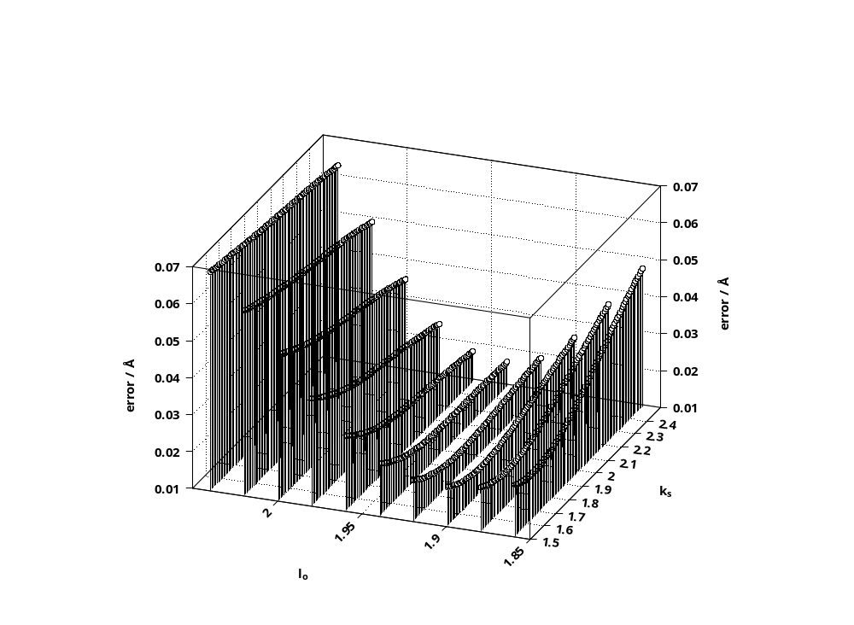

Fig. S1 Error response surface for the modelling of four-coordinate Cu(II) porphyrins as a function of the strain-free bond length, l_{o} (Å), and the bond stretching force constant, k_{s}. The global minimum falls in a valley that is shallow in the k_{s} direction. This means that, whereas the value of l_{o} is quite tightly defined, a fairly wide range in k_{s} values still produces an error response close to the minimum value.

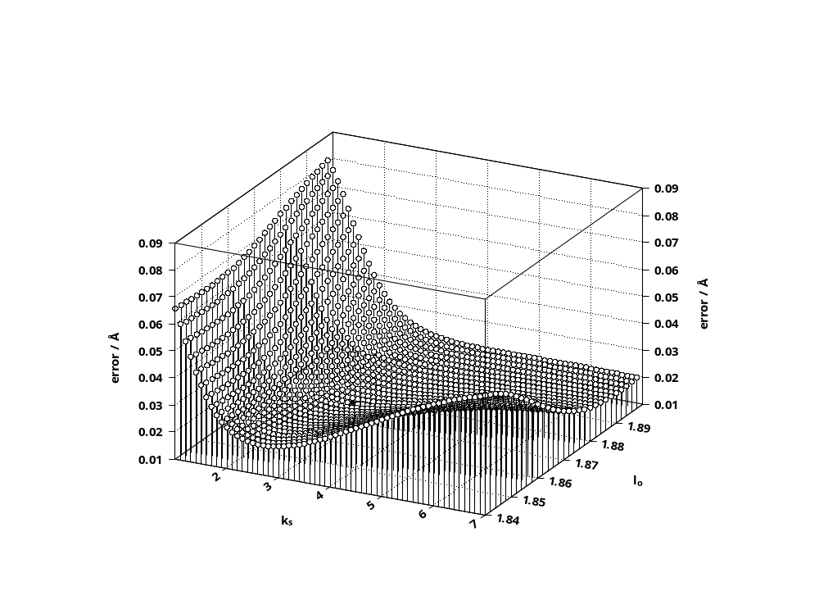

Fig. S2 Error response surface for the modelling of four-coordinate Ni(II) porphyrins as a function of the strain-free bond length, l_{o} (Å), and the bond stretching force constant, k_{s} (mdyn Å⁻¹). The error response surface seen was obtained from the trained ANN architecture (containing four neurons in the hidden layer) that predicted the global minimum to have an error of 0.0185 Å at k_{s} and l_{o} values of 3.0 mdyn Å⁻¹ and 1.868 Å, respectively. The global minimum is marked by a filled circle.

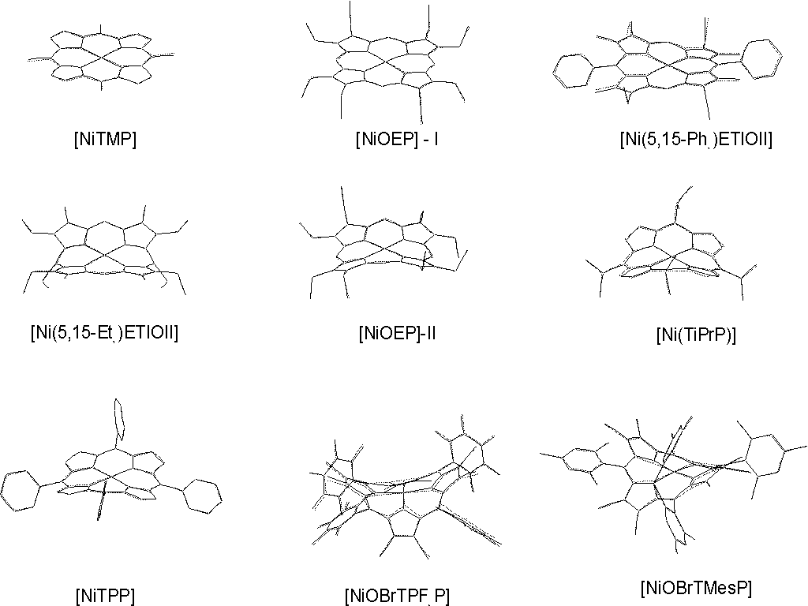

Fig. S3 A comparison of the crystal structures of nine Ni(II) 4-coordinate porphyrins (solid line) and the structures generated by molecular mechanics methods using the k_{s} and l_{o} values found by ANNs (dotted line).
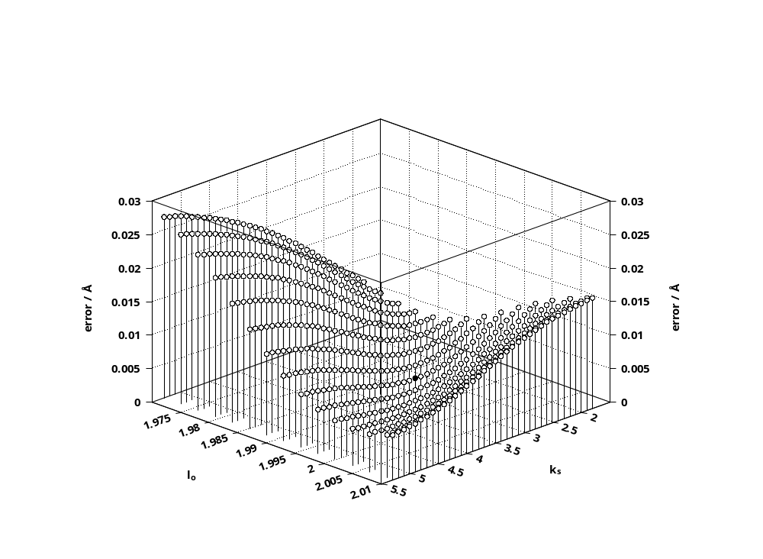

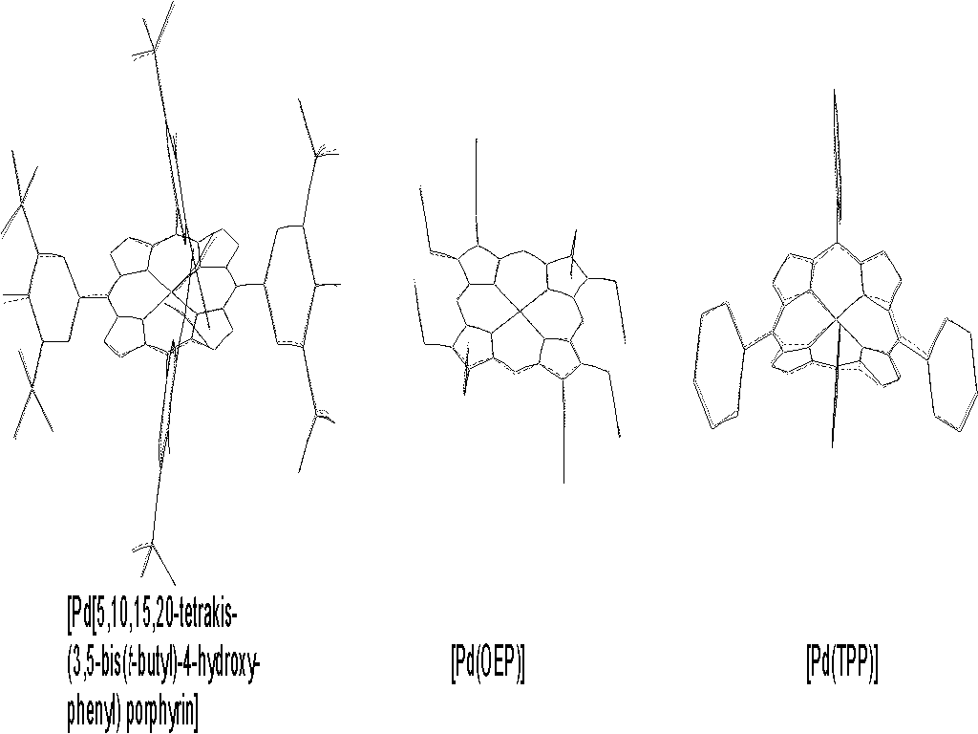
Fig. S4 The error response surface for the modelling of Pd(II) porphyrins generated by the trained ANN architecture with 7 neurons in the hidden layer. The global minimum is marked by a filled circle.

Fig. S5 A comparison of the crystal structures of three Pd(II) 4-coordinate porphyrins (solid line) and the structures generated by molecular mechanics methods using the k_{s} and l_{o} values found by ANNs (dotted line).

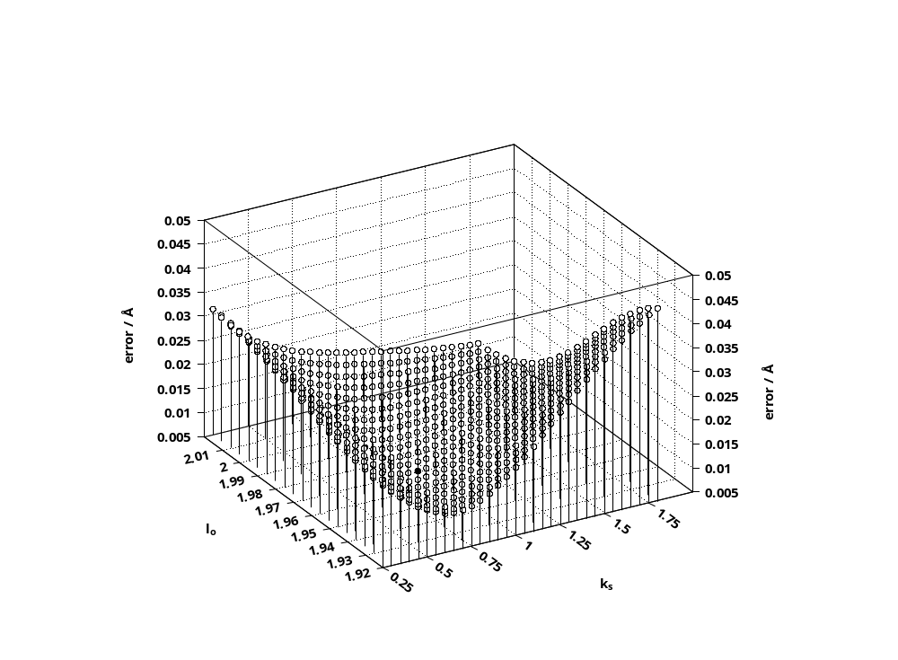

Fig. S6 The error response surface for the modelling of Zn(II) porphyrins generated by the trained ANN architecture with 9 neurons in the hidden layer. The global minimum is marked by the filled circle.

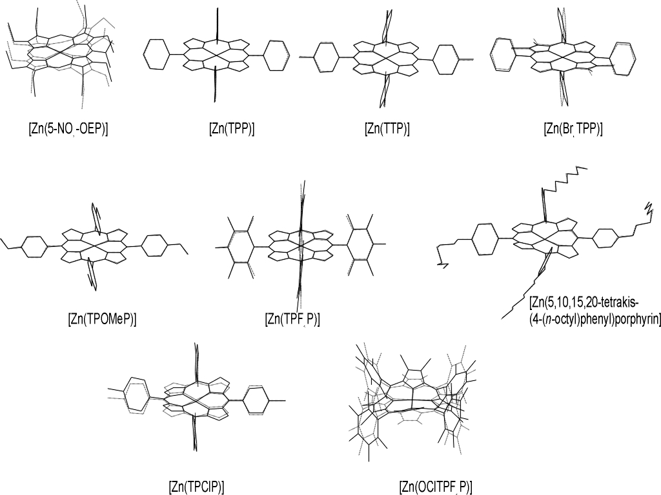

Fig. S7 A comparison of the crystal structures of nine Zn(II) 4-coordinate porphyrins (solid line) and the structures generated by molecular mechanics methods using the k_{s} and l_{o} values found by ANNs (dotted line).

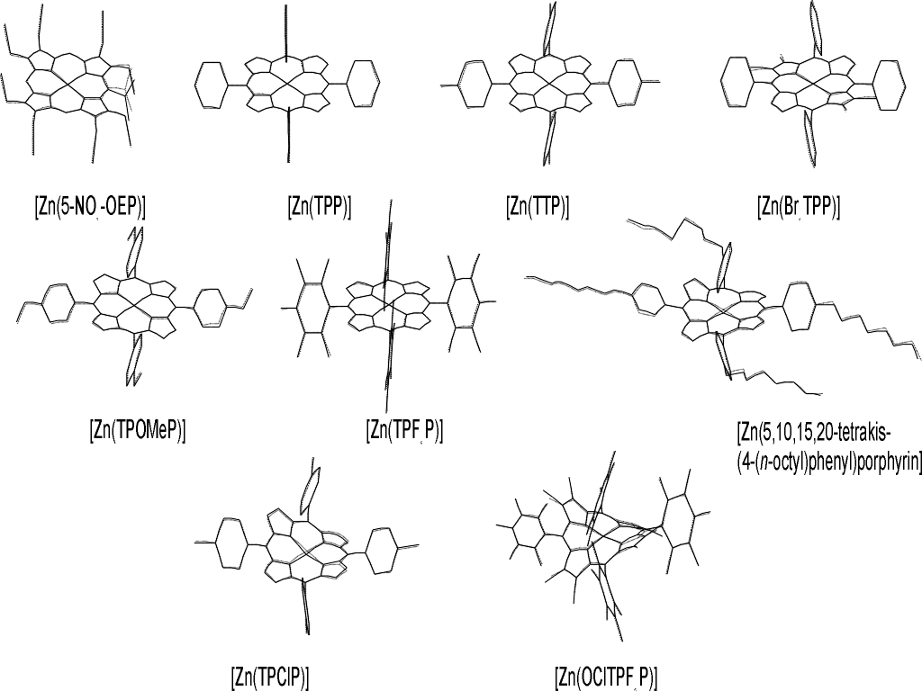

Fig. S7 A comparison of the crystal structures of nine Zn(II) 4-coordinate porphyrins (solid line) and the structures generated by molecular mechanics methods (dotted line), using the best possible values of k_{s} and l_{o} commensurate with the retaining of the modelled structures in the conformations observed crystallographically.

