On the Radiative Lifetime, Quantum Yield and Fluorescence Decay of Alq in Thin Films

V. V. N. Ravi Kishore, K. L. Narasimhan and N. Periasamy*
Departments of Chemical Sciences and Condensed Matter Physics & Materials Sciences
Tata Institute of Fundamental Research
Homi Bhabha Road, Colaba, Mumbai – 400 005, INDIA

* Author for Correspondence. Fax: 091 22 215 2110 Email: peri@tifr.res.in

------------------------------------------------------------------------------------------------------------

Supplementary Data

Elemental Analysis Data of Alq (Vacuum Sublimed sample)

Element | Experimental value (%) | Theoretical value(%)
Al | 6.0 | 5.88
C | 70.6 | 70.59
H | 3.3 | 3.92
N | 8.6 | 9.15

¹H NMR Spectrum of 8-Hydroxyquinoline (8-HQ) in CDCl₃
Solvent CHCl₃
A
F
B
C,D
E
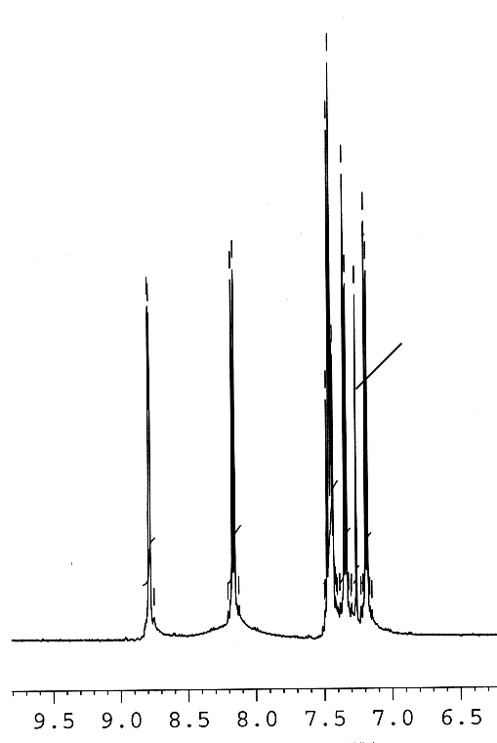

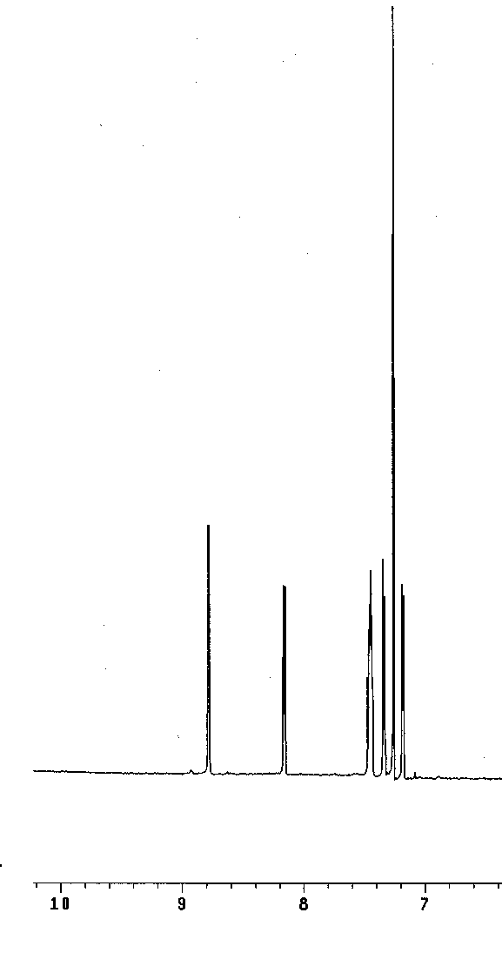
¹H NMR Spectrum of Tris(8-Hydroxyquinolinato) Aluminium (III) (Alq) in CDCl₃
Solvent CHCl₃

The above spectrum for Alq is similar that of 8-hydroxyquinoline given above. The protons of the ligand in Alq are similar to the protons in free 8-hydroxyquinoline.
1) The above spectrum for 8-Hydroxy quinoline is in agreement to the one given in the SDBS spectral database. http://www.aist.go.jp/RIODB/SDBS/sdbs/owa/sdbs_sea.cre_frame_sea
2) M. Alafandy et al, Inorganic Chimica Acta 255 (1997) 175-179.

The ¹H nmr spectra of 8-Hydroxyquinoline and Alq were recorded on Varian-600 MHz instrument using tetramethylsilane (TMS) as the internal standard and the chemical shifts are given in the δ(ppm) scale. The peak at δ=7.26 ppm corresponds to the solvent.
The authors thank National NMR Facility in Tata Institute of Fundamental Research for the spectra given above.
FT-IR Spectrum of Alq

FT-IR spectrum of Alq was recorded using Perkin Elmer FT-IR spectrometer (Model: Spectrum GX) in transmission mode geometry with nitrogen purging. The sample was deposited on porous silicon.

The above spectrum is in agreement with the spectrum reported in
1) M.Halls and R.Aroca, Can. J.Chem, 1998, 76, 1730.
2) X.M.Ding, L.M.Hung, C.S.Lee, S.T.Lee, Phy. Rev B, 1999, 60, No-19, 13 291.
3) A.D.Esposti, M.Brinkmann, G.Ruani, R.Zamboni, Synth. Metals 2002, 127, 247.

