Systems | T (K) | solvent | 18C6 | M^{n+} |  | X– |  | total
25 K⁺,Pic– | 305 K | CO₂ |  | 0 |  |  | -2 | -2
25 K⁺,Pic– | 305 K | wat |  | -113 |  |  | -126 | -239
 | 350 K | CO₂ |  | 0 |  |  | -2 | -2
 | 350 K | wat |  | -117 |  |  | -121 | -238
25 K⁺,PFO– | 305 K | CO₂ |  | 0 |  | -7 |  | -7
25 K⁺,PFO– | 305 K | wat |  | -106 |  | -92 |  | -198
 | 350 K | CO₂ |  | 0 |  | -6 |  | -6
 | 350 K | wat |  | -100 |  | -86 |  | -186
25 Sr²⁺,2Pic– | 305 K | CO₂ |  |  | 0 |  | -5 | -10
25 Sr²⁺,2Pic– | 305 K | wat |  |  | -240 |  | -67 | -374
 | 350 K | CO₂ |  |  | 0 |  | -4 | -8
 | 350 K | wat |  |  | -238 |  | -53 | -344
25 Sr²⁺,2PFO– | 305 K | CO₂ |  |  | -1 | -10 |  | -21
25 Sr²⁺,2PFO– | 305 K | wat |  |  | -286 | -51 |  | -388
 | 350 K | CO₂ |  |  | 0 | -11 |  | -22
 | 350 K | wat |  |  | -276 | -31 |  | -338
25 NEt₄⁺,PFO– | 305 K | CO₂ |  | -2 |  | -6 |  | -8
25 NEt₄⁺,PFO– | 305 K | wat |  | -13 |  | -87 |  | -100
 | 350 K | CO₂ |  | -2 |  | -6 |  | -8
 | 350 K | wat |  | -14 |  | -76 |  | -90
1 K⁺⊂18C6,Pic– | 350 K | CO₂ | -6 | -1 |  |  | -12 | -19
1 K⁺⊂18C6,Pic– | 350 K | wat | 15 | -192 |  |  | 8 | -169
1 K⁺⊂18C6,PFO– | 350 K | CO₂ | -12 | 0 |  | -10 |  | -22
1 K⁺⊂18C6,PFO– | 350 K | wat | -27 | -134 |  | -111 |  | -272
1 Sr²⁺⊂18C6,2Pic– | 350 K | CO₂ | -7 |  | -1 |  | -20 | -48
1 Sr²⁺⊂18C6,2Pic– | 350 K | wat | 2 |  | -59 |  | -43 | -143
1 Sr²⁺⊂18C6,2PFO– | 350 K | CO₂ | -8 |  | 0 | -23 |  | -54
1 Sr²⁺⊂18C6,2PFO– | 350 K | wat | -6 |  | -43 | -34 |  | -117
25 K⁺⊂18C6,Pic– | 305 K | CO₂ | -7 | 0 |  |  | -2 | -9
25 K⁺⊂18C6,Pic– | 305 K | wat | -9 | -79 |  |  | -120 | -208
 | 350 K | CO₂ | -9 | 0 |  |  | -2 | -11
 | 350 K | wat | -19 | -104 |  |  | -109 | -232
25 K⁺⊂18C6,PFO– | 305 K | CO₂ | -7 | 0 |  | -6 |  | -13
25 K⁺⊂18C6,PFO– | 305 K | wat | -4 | -52 |  | -85 |  | -141
 | 350 K | CO₂ | -8 | 0 |  | -5 |  | -13
 | 350 K | wat | -13 | -78 |  | -77 |  | -168
25 Sr²⁺⊂18C6,2Pic– | 305 K | CO₂ | -4 |  | 0 |  | -10 | -24
25 Sr²⁺⊂18C6,2Pic– | 305 K | wat | -1 |  | -21 |  | -46 | -114
 | 350 K | CO₂ | -4 |  | 0 |  | -11 | -26
 | 350 K | wat | 1 |  | -25 |  | -40 | -104
25 Sr²⁺⊂18C6,2PFO– | 305 K | CO₂ | -5 |  | 0 | -14 |  | -33
25 Sr²⁺⊂18C6,2PFO– | 305 K | wat | 1 |  | -32 | -23 |  | -77
 | 350 K | CO₂ | -6 |  | 0 | -16 |  | -38
 | 350 K | wat | 1 |  | -33 | -20 |  | -72

Table S1: Energy component analysis for the KX and KX₂ salts and the corresponding complexes with 18C6. Average interaction energies (kcal/mol) between one solute molecule and the water or CO₂ phases calculated with a 15 Å + RF cutoff.
Fluctuations are about 5 kcal/mol.

Systems | T (K) | N_{wat} | N_{CO2}
25 K⁺,Pic– | 305K | 0±0 | 33±3
25 K⁺,Pic– | 350K | 5±4 | 36±6
25 K⁺,PFO– | 305K | 0±0 | 28±2
25 K⁺,PFO– | 350K | 5±2 | 33±3
25 Sr²⁺,2Pic– | 305K | 1±1 | 27±2
25 Sr²⁺,2Pic– | 350K | 3±2 | 40±4
25 Sr²⁺,2PFO– | 305K | 1±1 | 24±3
25 Sr²⁺,2PFO– | 350K | 4±2 | 51±6
25 K⁺⊂18C6,Pic– | 305K | 2±1 | 16±2
25 K⁺⊂18C6,Pic– | 350K | 5±1 | 405±67
25 K⁺⊂18C6,PFO– | 305K | 17±3 | 19±2
25 K⁺⊂18C6,PFO– | 350K | 4±3 | 28±3
25 Sr²⁺⊂18C6,2Pic– | 305K | 1±1 | 18±3
25 Sr²⁺⊂18C6,2Pic– | 350K | 5±2 | 27±4
25 Sr²⁺⊂18C6,2PFO– | 305K | 6±1 | 313±28
25 Sr²⁺⊂18C6,2PFO– | 350K | 8±2 | 21±2
3 (Sr²⁺⊂18C6,2PFO–)  22 (18C6 NEt₄⁺ PFO–) | 350K | 12±6 | 41±4

Table S2: Solvent mixing in the simulated systems: number of water molecules (N_{wat}) in "bulk" CO₂ and of CO₂ molecules (N_{CO2}) in "bulk" water. "Bulk" is defined beyond 10 Å from the two interfaces.

Systems temp. (K) | (CF₃)– CF₂ – CF₂ – CF₂ – CF₂ – CF₂ – CF₂– (CO₂–)
25 K⁺, PFO– 305 K |  | 42 (57) | 87 (12) | 87 (12) | 51 (48) | 49 (50)
25 K⁺, PFO– 350 K |  | 11 (88) | 87 ( 9) | 75 (23) | 59 (38) | 4 (95)
25 Sr²⁺, 2 PFO– 305 K |  | 34 (65) | 84 (14) | 73 (25) | 76 (22) | 31 (68)
25 Sr²⁺, 2 PFO– 350 K |  | 29 (70) | 76 (22) | 68 (21) | 61 (36) | 15 (84)

Table S3: Percentage of trans / gauche (in parenthesis) C–C dihedrals of PFO– anions in the 25 K+PFO– and 25 Sr2+ (PFO–)₂ systems at 305 K and 350 K.

K⁺ | Pic– | 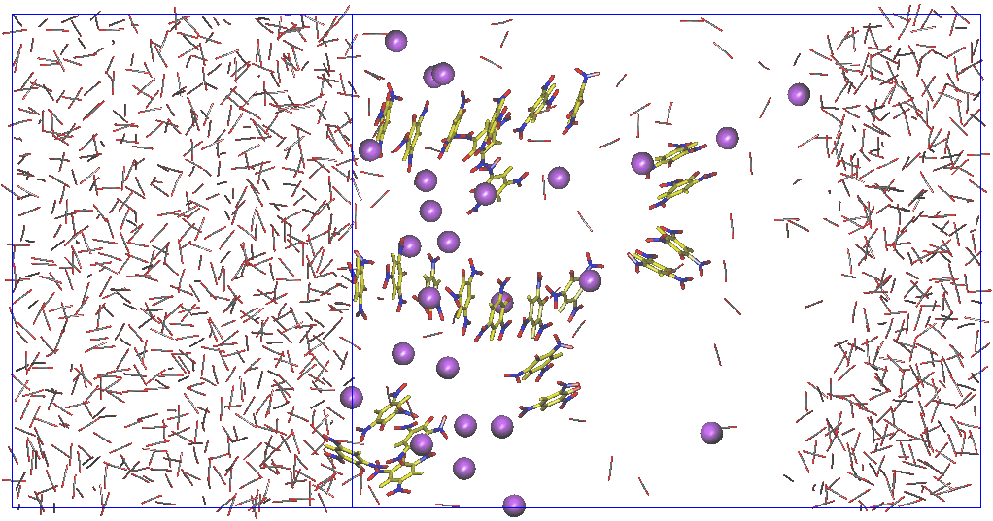 | 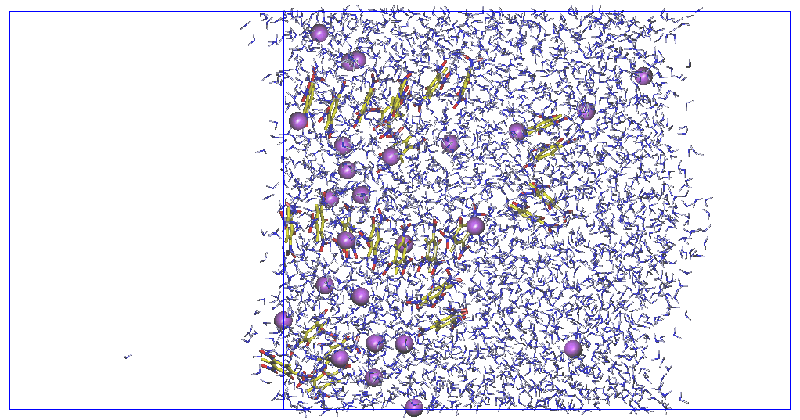 | 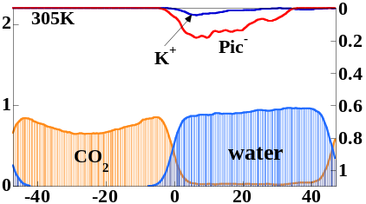
K⁺ | PFO– | 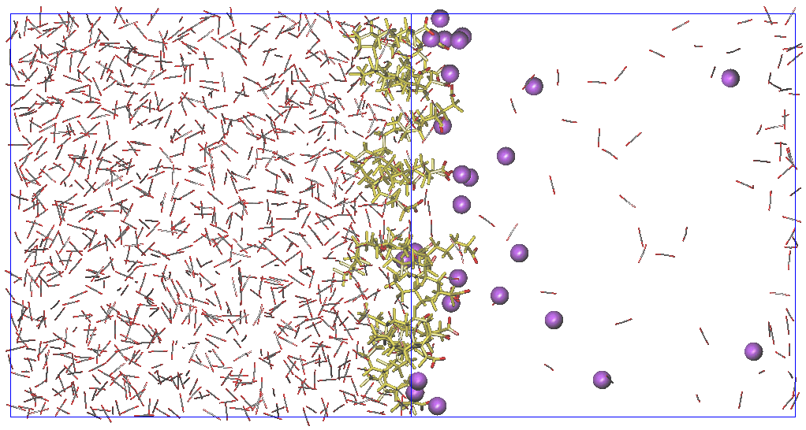 | 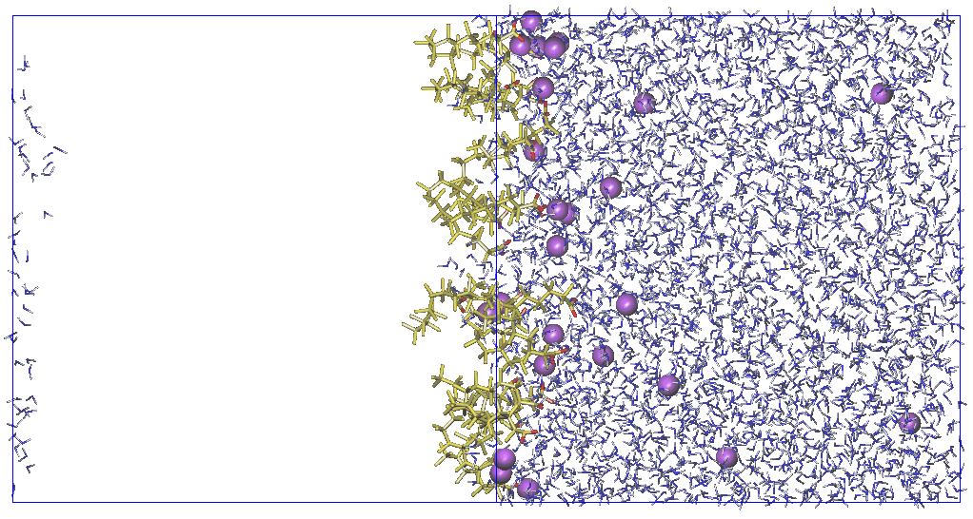 | 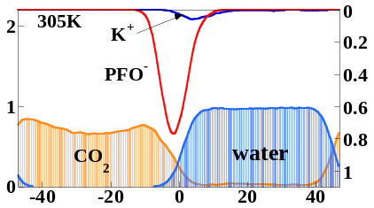
Sr²⁺ | Pic– | 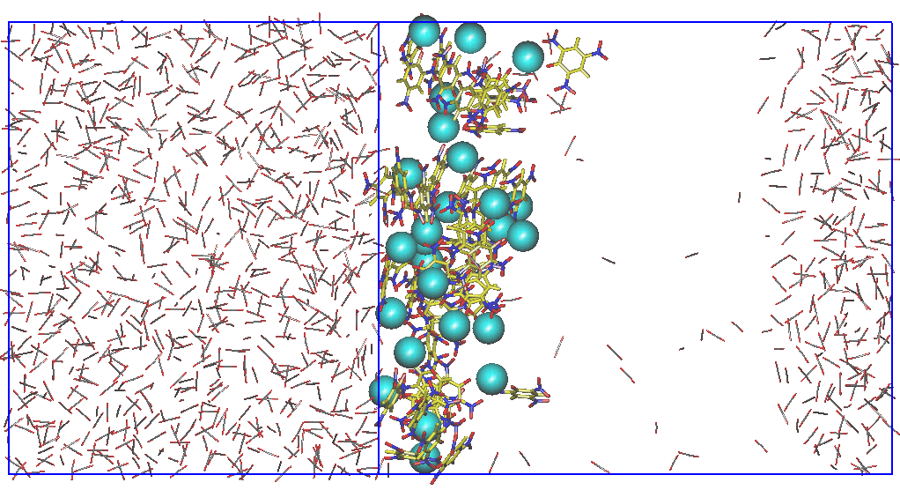 | 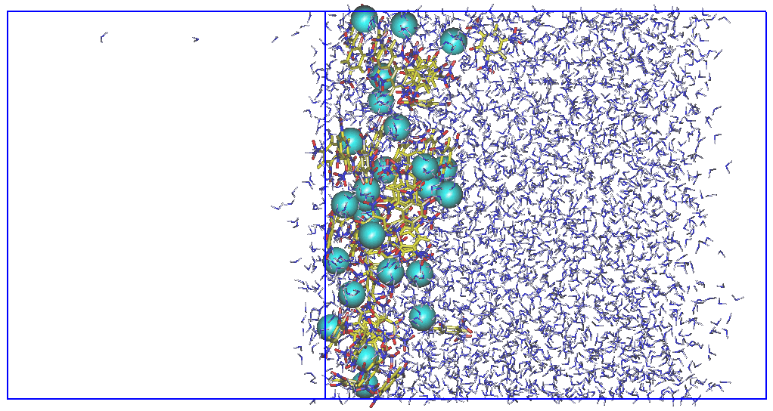 | 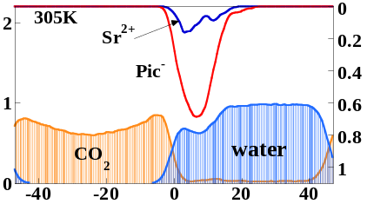
Sr²⁺ | PFO– | 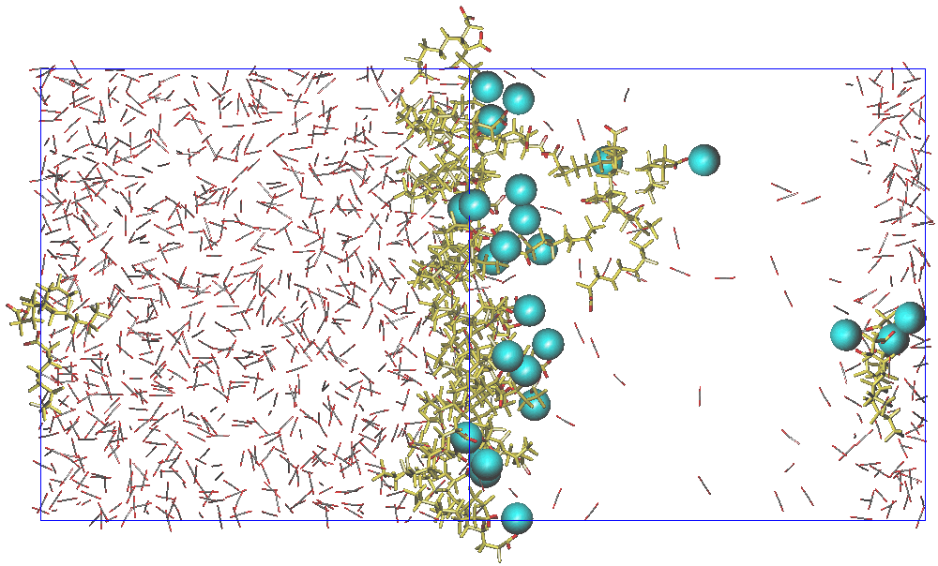 | 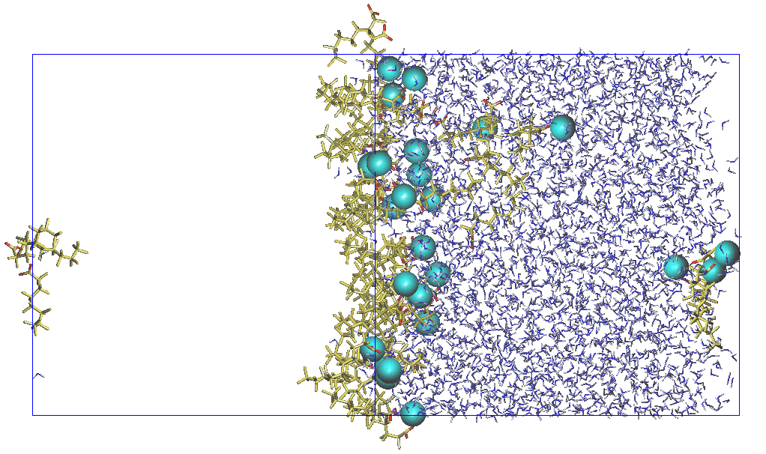 | 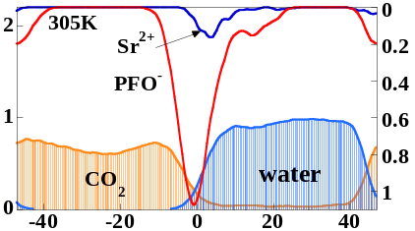
NEt₄⁺ | PFO– | 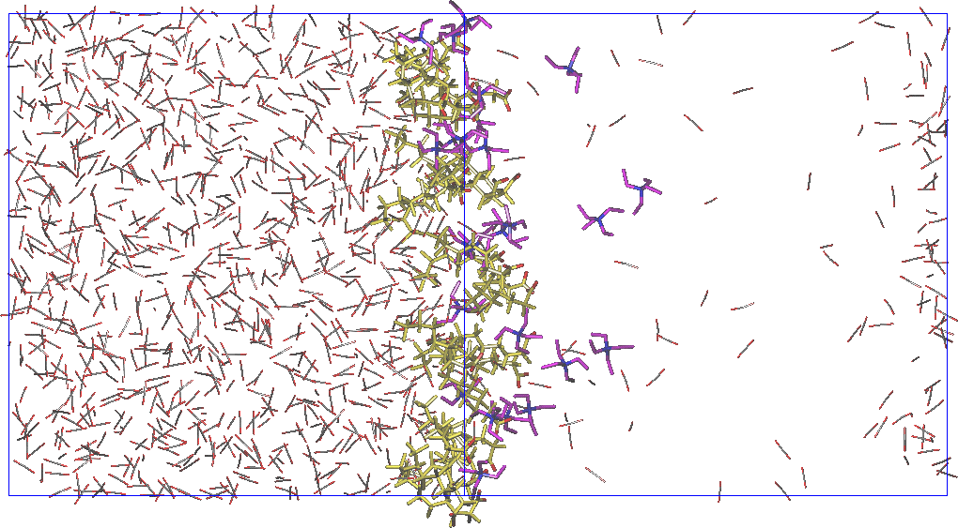 | 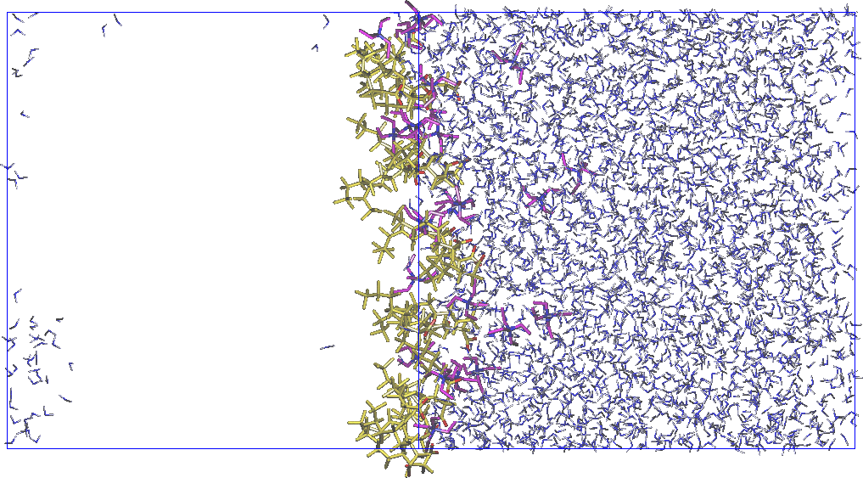 | 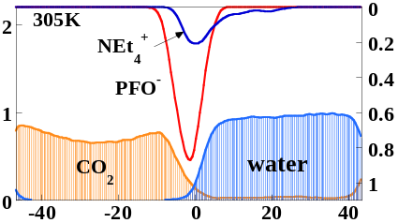

Figure S1: The 25 K⁺X–, 25 Sr²⁺(X–)₂ (X– = Pic– vs PFO–) and 25 NEt₄⁺, PFO– salts at the interface at 305 K. Left and middle : snapshots at the end of the simulation (1.2 ns), with water (left) and CO₂ (middle) not shown for clarity. Right : average density curves for the solvents and solutes (arbitrary units). Averages over the last 0.2 ns.

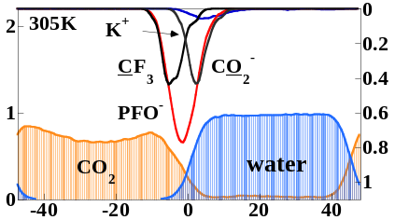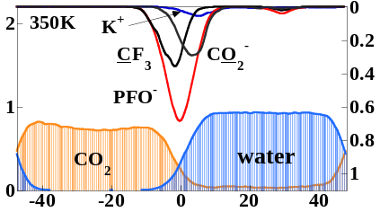

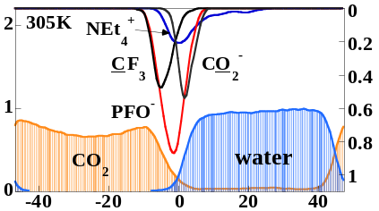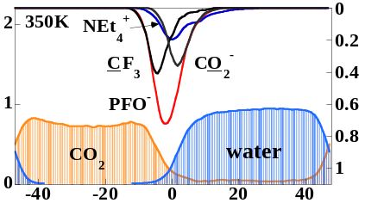

Figure S2: The K⁺PFO– and NEt₄⁺PFO– salts at the interface at 305 K and 350 K. Density profiles of the O(PFO–) and CF3(PFO–) atoms and of all atoms of the anions (red curve), of cations (blue) and of the solvents.

K⁺ | Pic– | 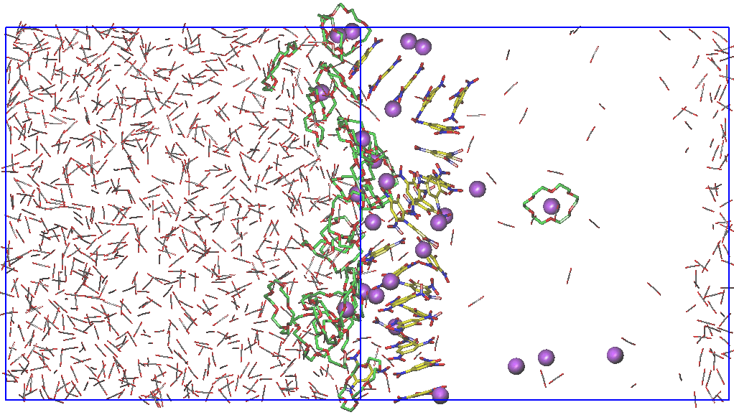 | 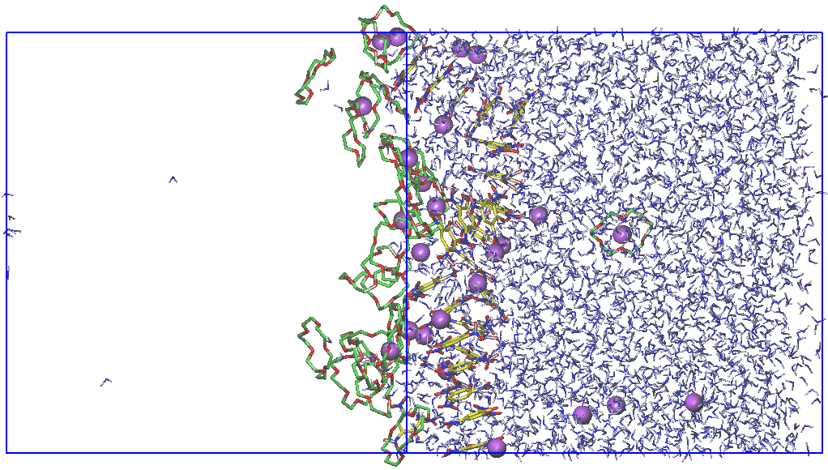 | 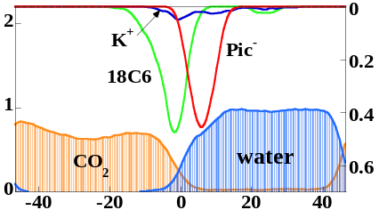
K⁺ | PFO– | 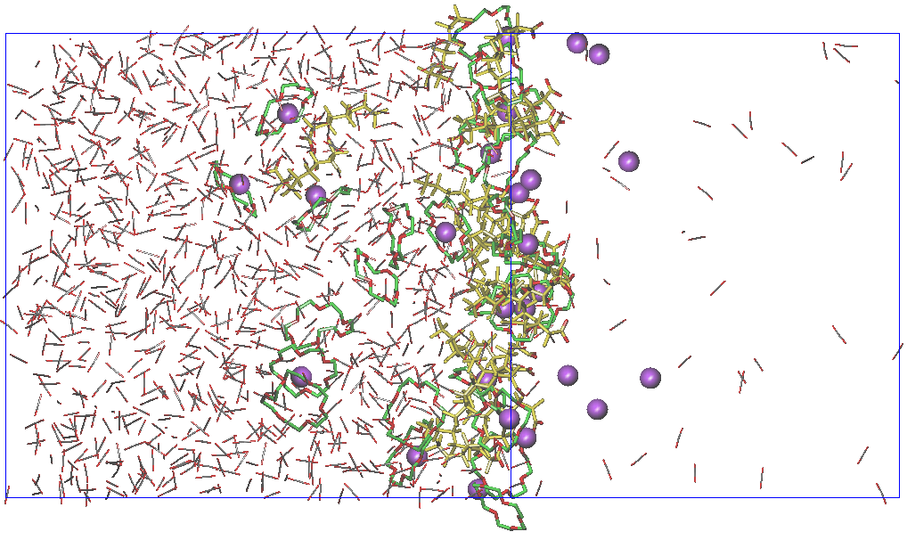 | 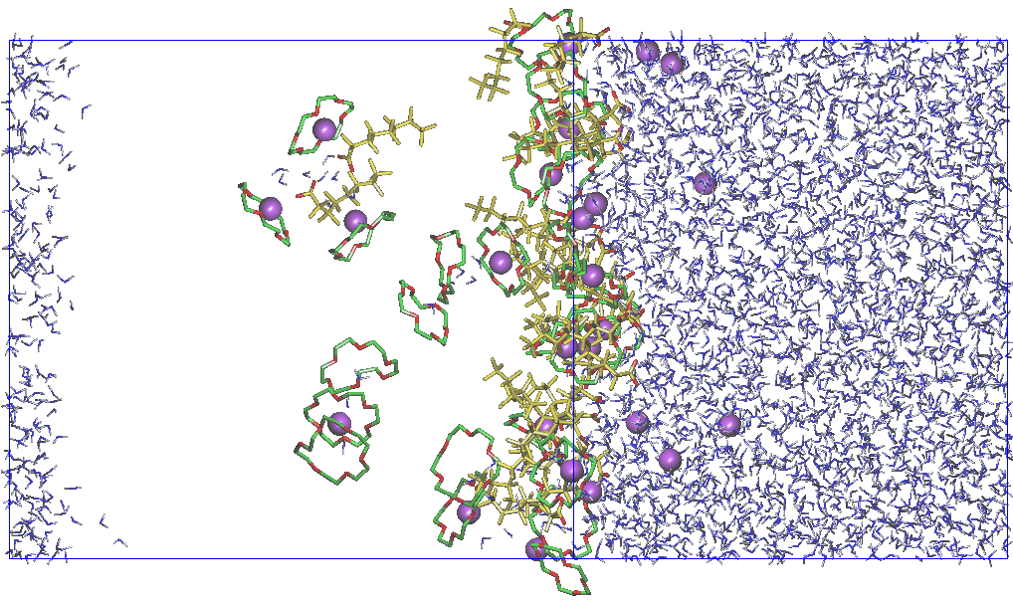 | 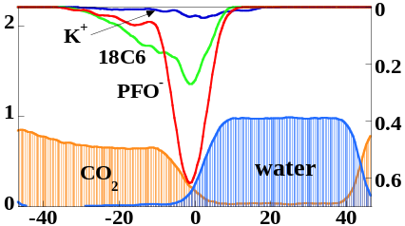
Sr²⁺ | Pic– | 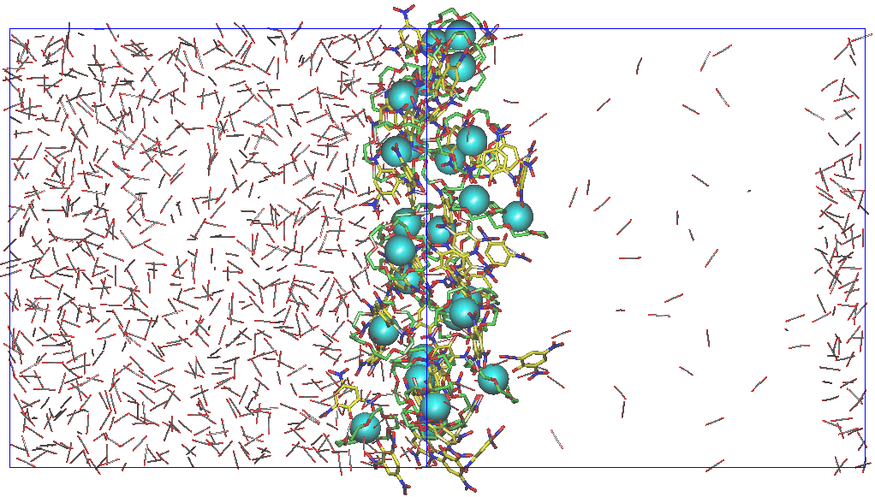 | 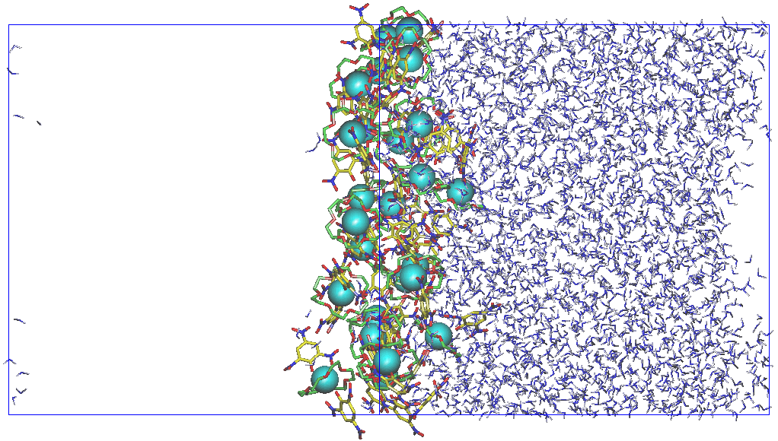 | 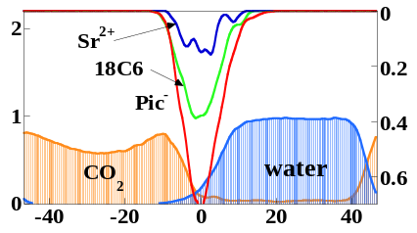
Sr²⁺ | PFO– | 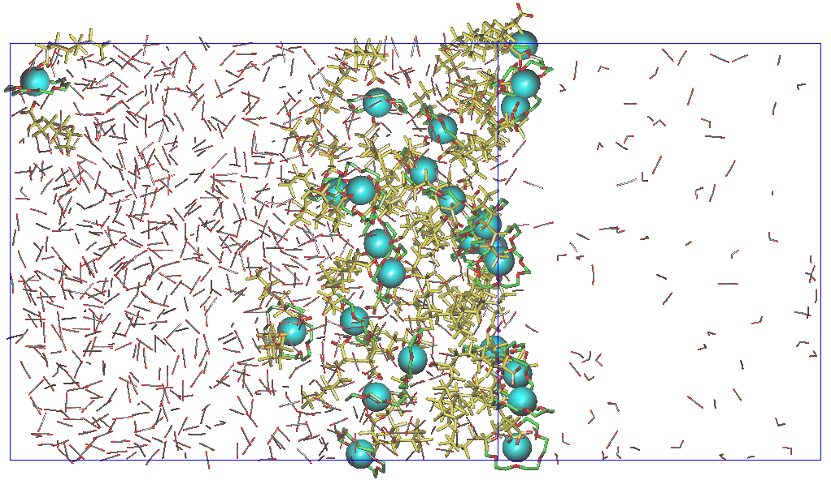 | 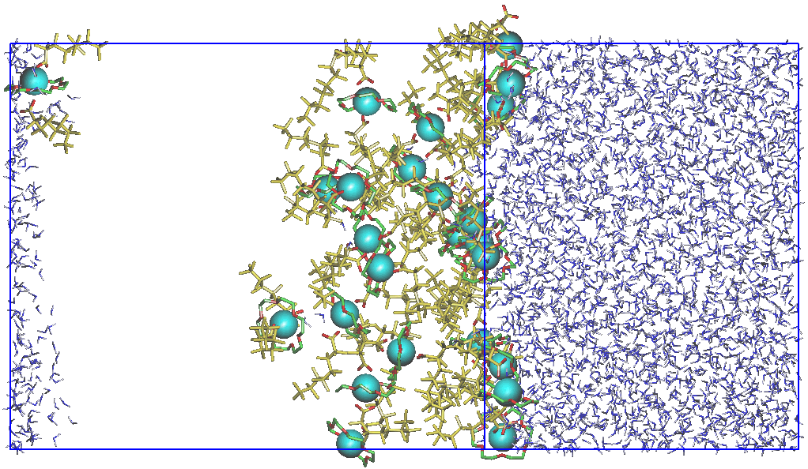 | 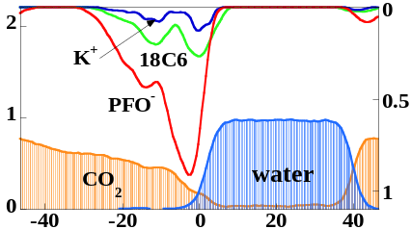

Figure S3: The 25 18C6,K⁺X– and 25 Sr²⁺⊂18C6,2X– complexes (with X– = Pic– vs PFO–) at the interface at 305 K. See Figure 4 for definitions.

