Supplementary Information for b304966c

Unusual calcination temperature dependent tetragonal-monoclinic transitions in rare earth-doped zirconia nanocrystals
Gang Xu, Ya-Wen Zhang, Bo Han, Mei-Jun Li, Can Li, and Chun-Hua Yan

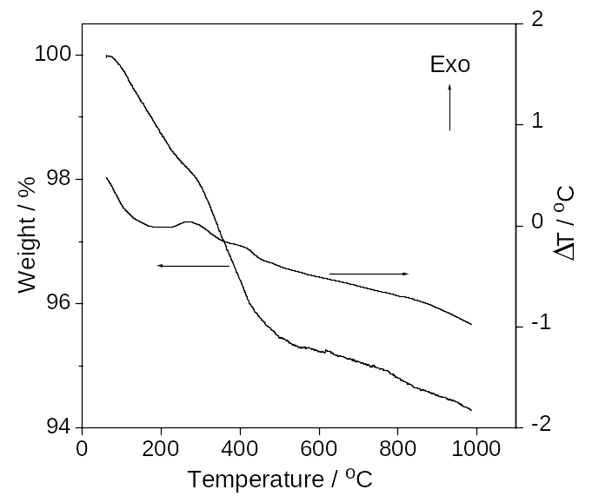
Figure 1S Combined TG-DTA run of the as-prepared 2ScSZ powders.

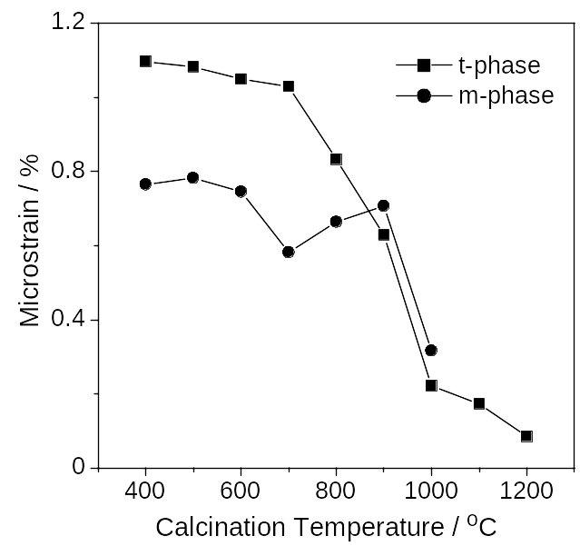
Figure 2S Microstrain of tetragonal phase and monoclinic phases versus calcination temperature for the as-calcined 2YSZ powders.

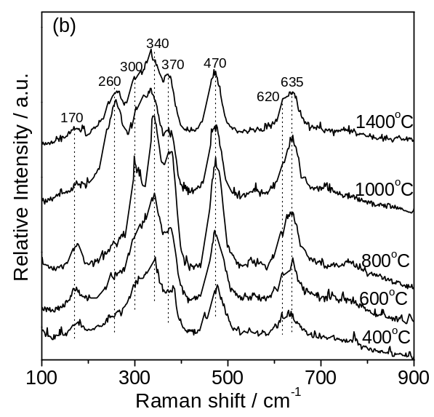
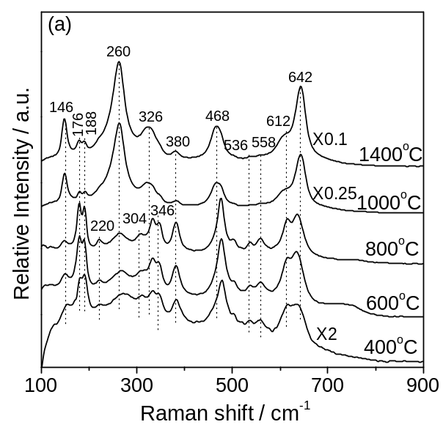
Figure 3S FT Raman (a) and UV Raman (b) spectra of the 2YSZ powders calcined over 400~1400 °C

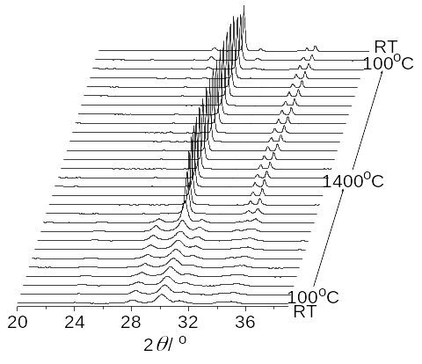
Figure 4S In situ HTXRD patterns of the as-prepared 2YSZ powders.
(111)_{m}
(111)_{t}
(111)_{m}

Tetragonal
Monoclinic
Calcination Temperature
400 °C
1400 °C
Figure 5S Schematic diagram of the t-m transitions characteristics for the 2YSZ powders versus calcination temperatures.

