Size dependent redox behavior of monolayer protected silver nanoparticles (2-7 nm) in aqueous medium

Nirmalya Kumar Chakiª, Jadab Sharmaª, A. B. Mandleª, I. S. Mullaª, Renu Pasricha^{b} and K. Vijayamohananª∗

Electronic Supporting Informations

Fig. 1S(a-e) shows corresponding superimposed voltammograms of particle a-e respectively at 10, 20, 50, 100, 200 and 500 mV/s scan rate (all are in 2nd scan) in 0.1 M aqueous KCl using a modified Pt as working electrode, Pt flag as counter and SCE as reference. The anodic peak of the couples are better resolved especially at higher scan rates and there is a slight dependence of scan rate on the peak potentials, perhaps due to the insulating nature of the DDT layer on the metal cluster surface.

Fig. 2S shows the cyclic voltammograms of particle c at 100 mV/s scan rate after 50 scans 0.1 M aqueous KCl using a modified Pt as working electrode, Pt flag as counter and SCE as reference, where both the peaks are sharpened enough, suggesting the destruction of monolayers during oxidative sweep of CV measurements.

3S shows superimposed voltammograms of particle b at 20, 50, 100, 200 and 500 mV/s scan rate in 0.1 N aqueous KNO₃ (a) and at 10, 20, 50, 75 and 100 mV/s in 0.1 N aqueous Na₂SO₄ using a modified Pt as working electrode, Pt flag as counter and SCE as reference (all are in 2nd scan). The peak nature and position is unaffected with the change of supporting electrolyte KCl to KNO₃ or Na₂SO₄

Nirmalya Kumar Chaki et. al.

Figure 1S

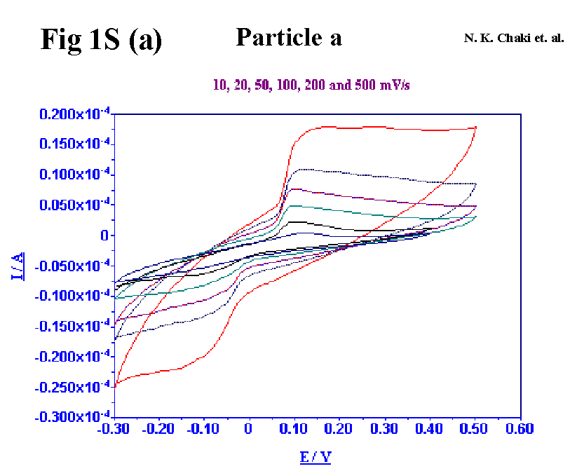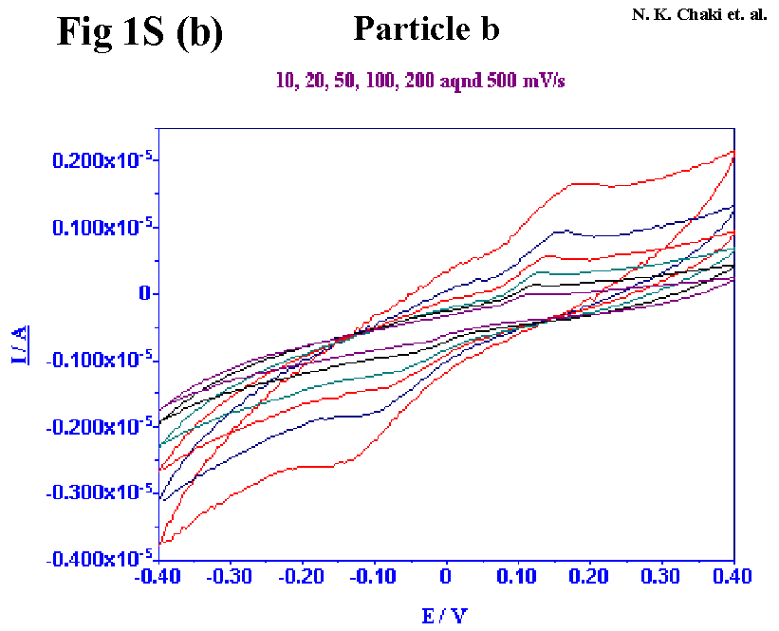

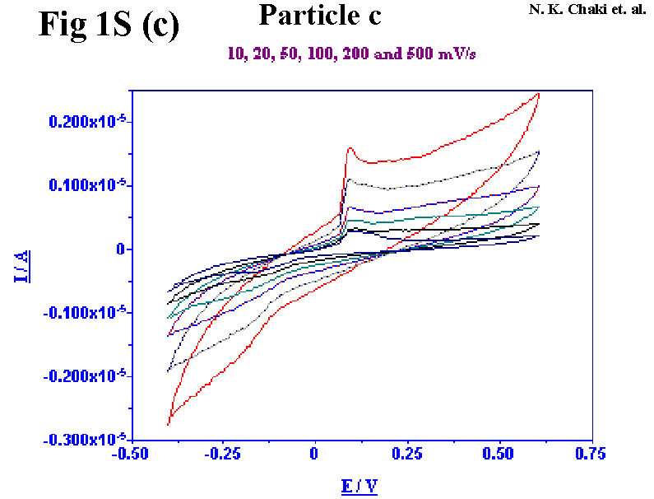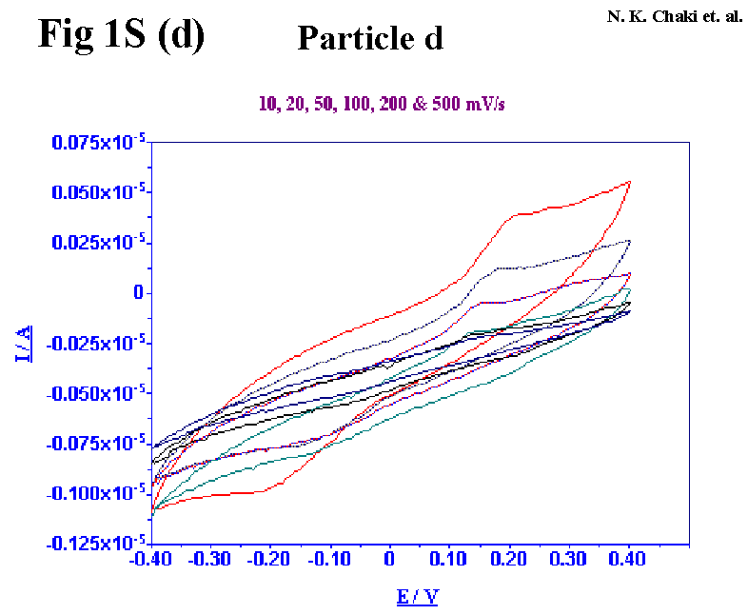

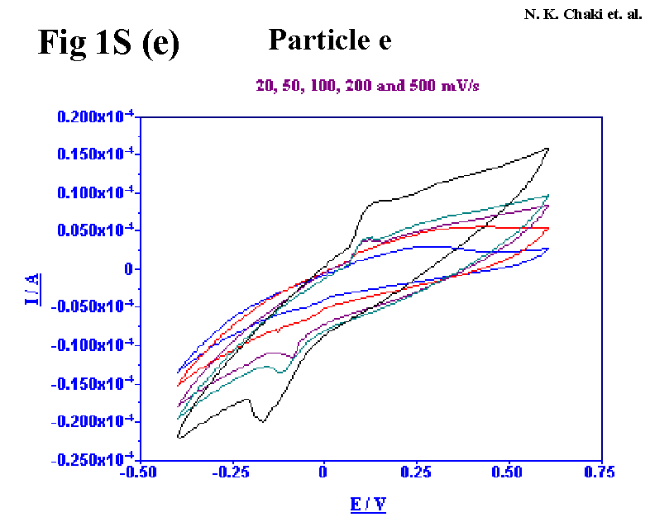

Nirmalya Kumar Chaki et. al.

Figure 2S

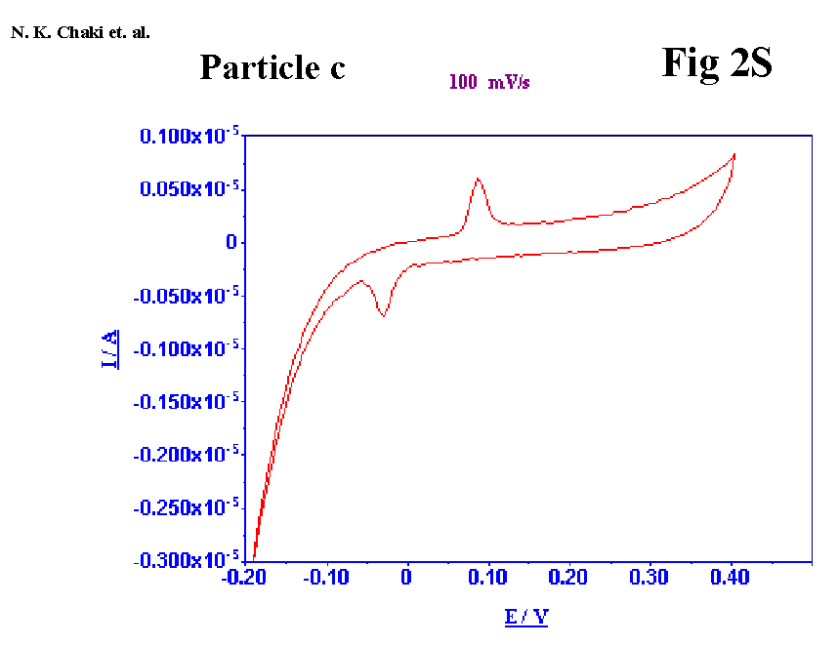

Nirmalya Kumar Chaki et. al.

Figure 3S

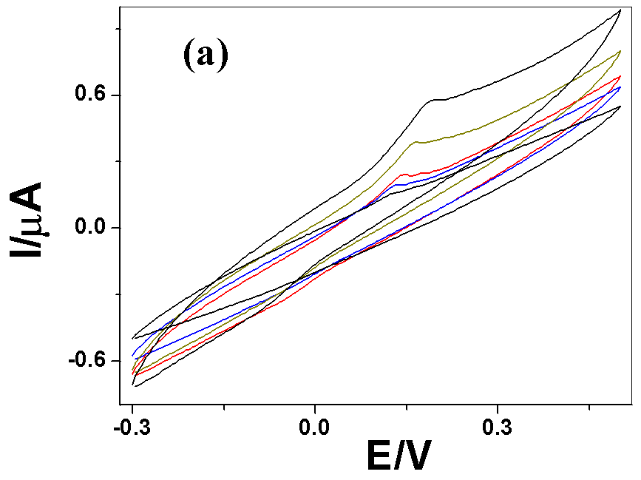

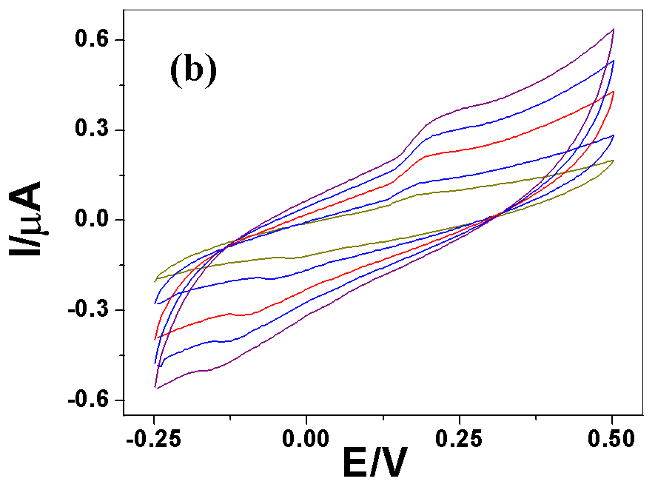

 Corresponding author

