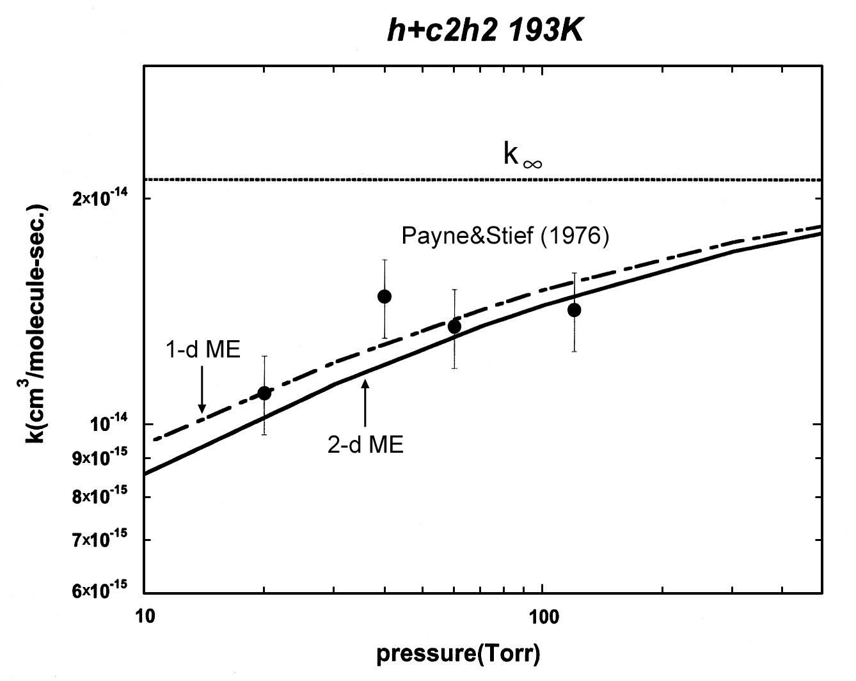

Fig. ESI.1: Comparison of the theoretical results with the experiments of Payne and Stief,⁸ T=193 K.

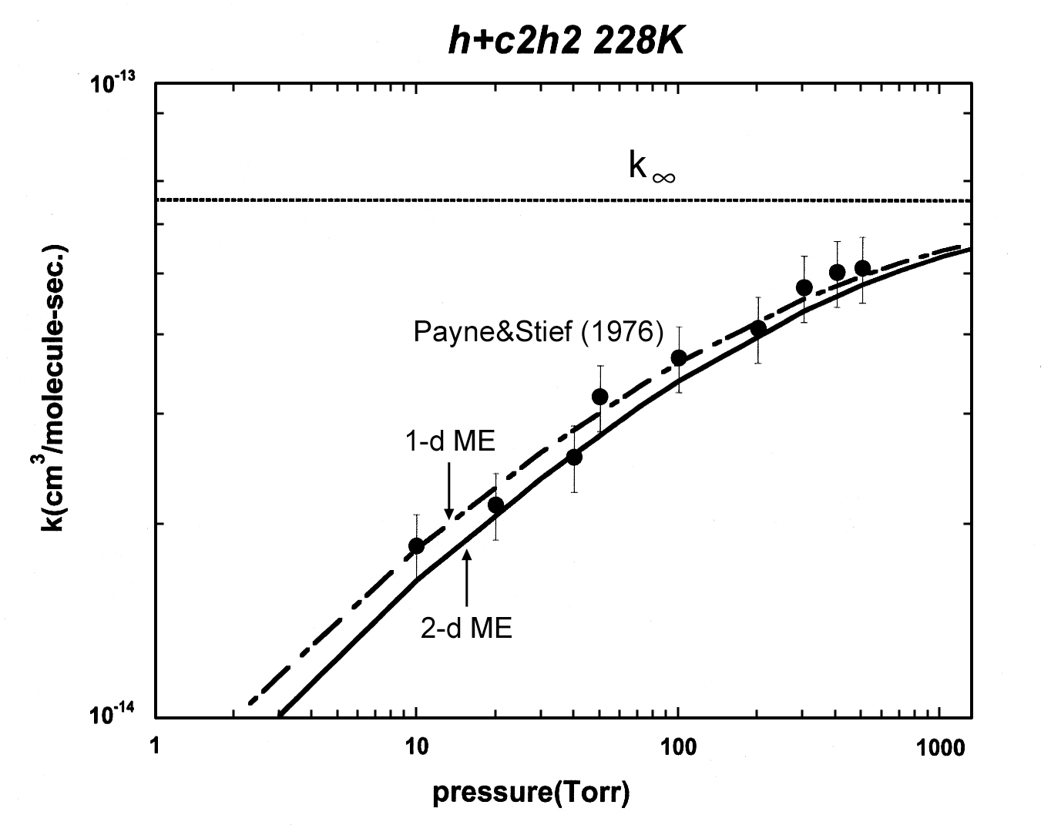

Fig. ESI.2: Comparison of the theoretical results with the experiments of Payne and Stief,⁸ T=228 K.

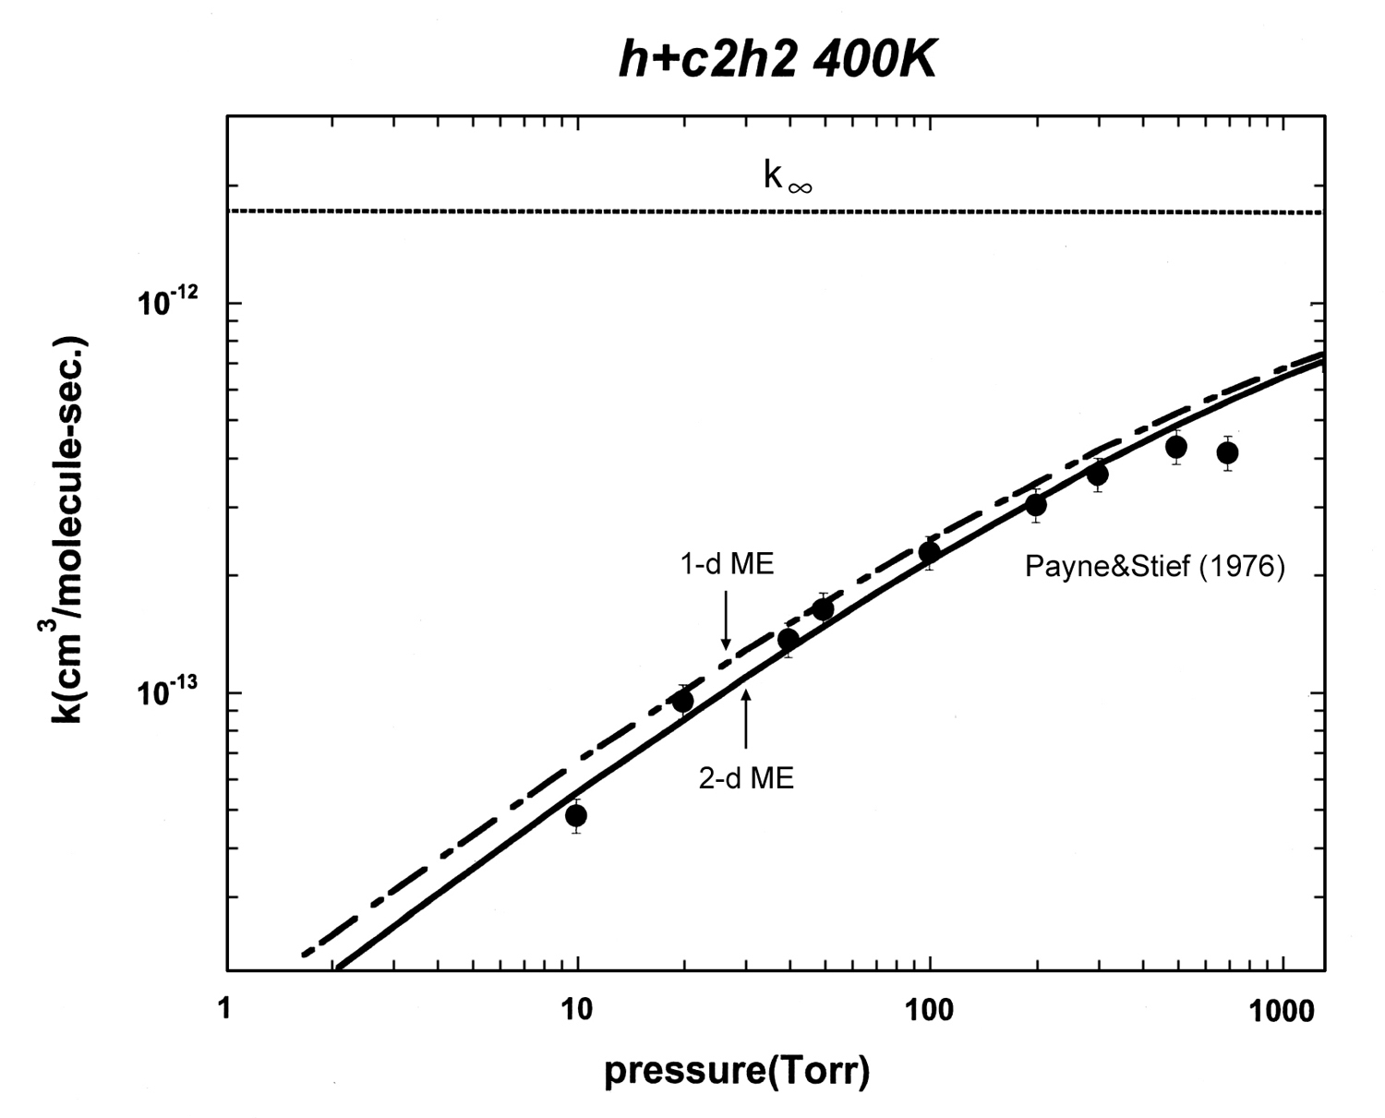

Fig. ESI.3:Comparison of the theoretical results with the experiments of Payne and Stief,⁸ T=400 K.

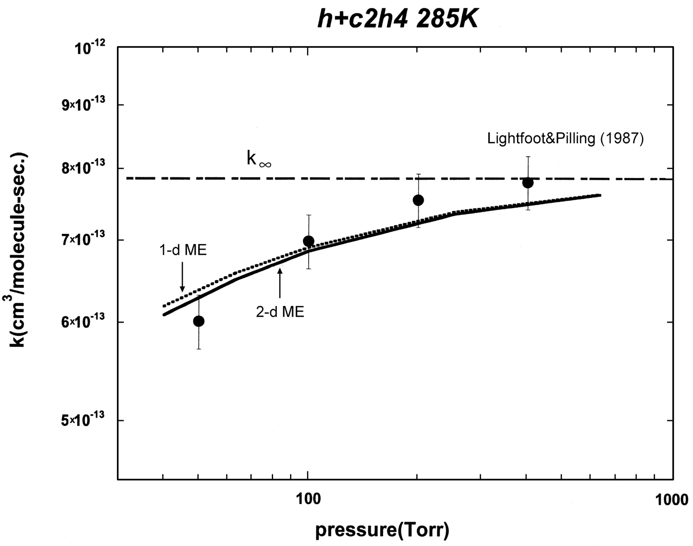

Fig. ESI.4:The rate coefficient for at T=285 K with helium as the bath gas.

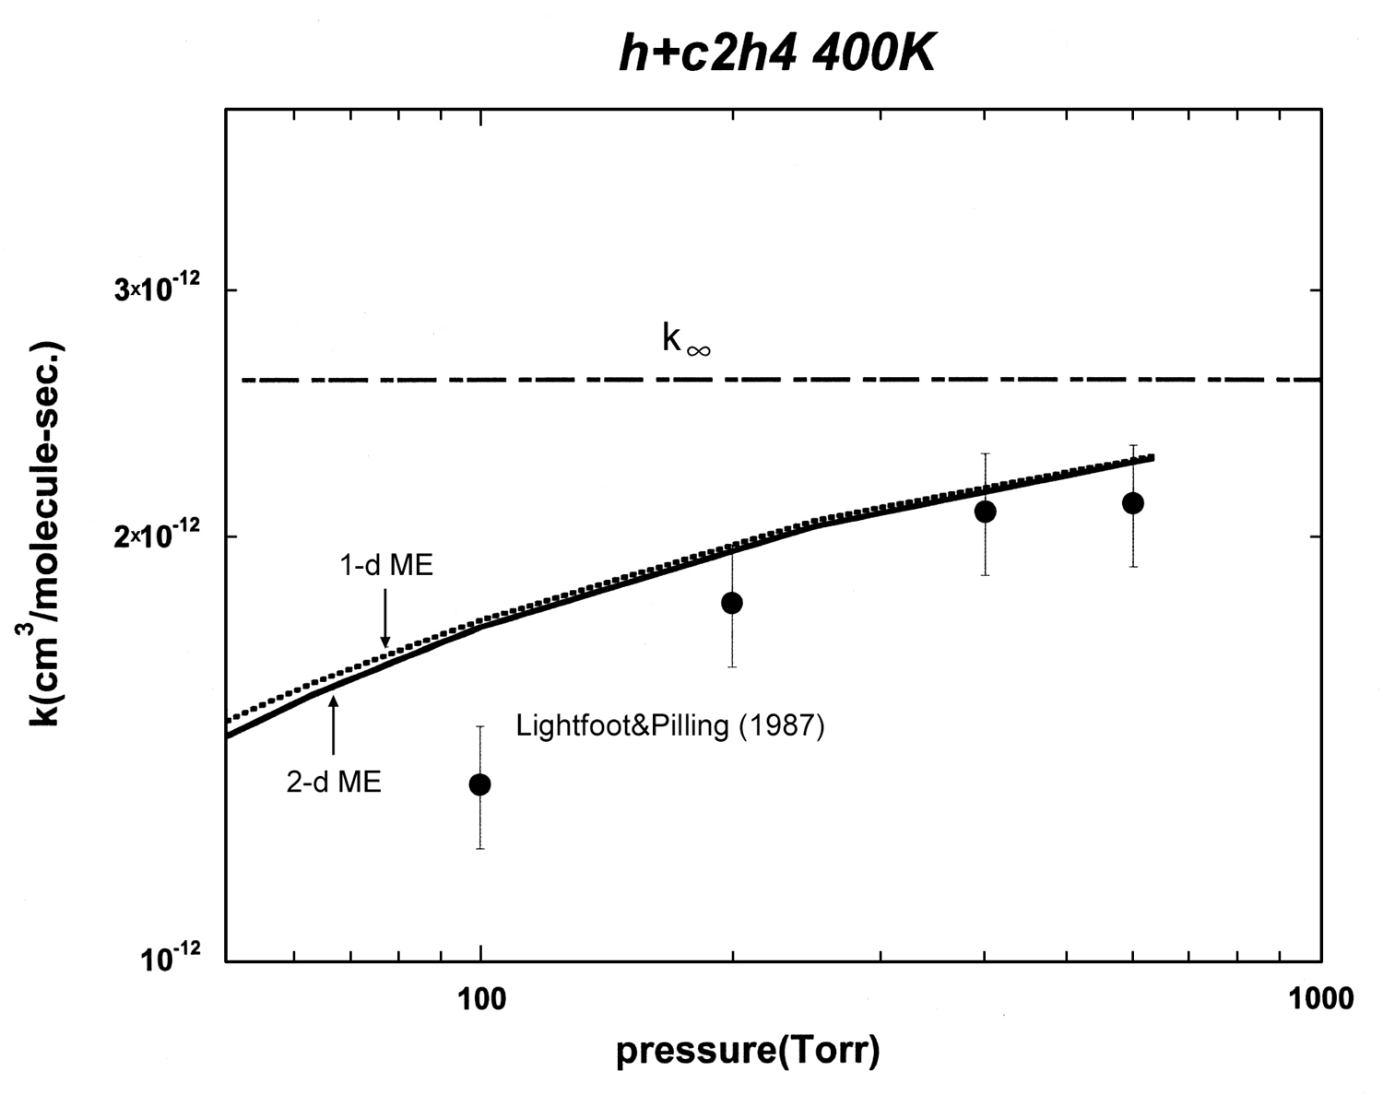

Fig. ESI.5:The rate coefficient for at T=400 K with helium as the bath gas.

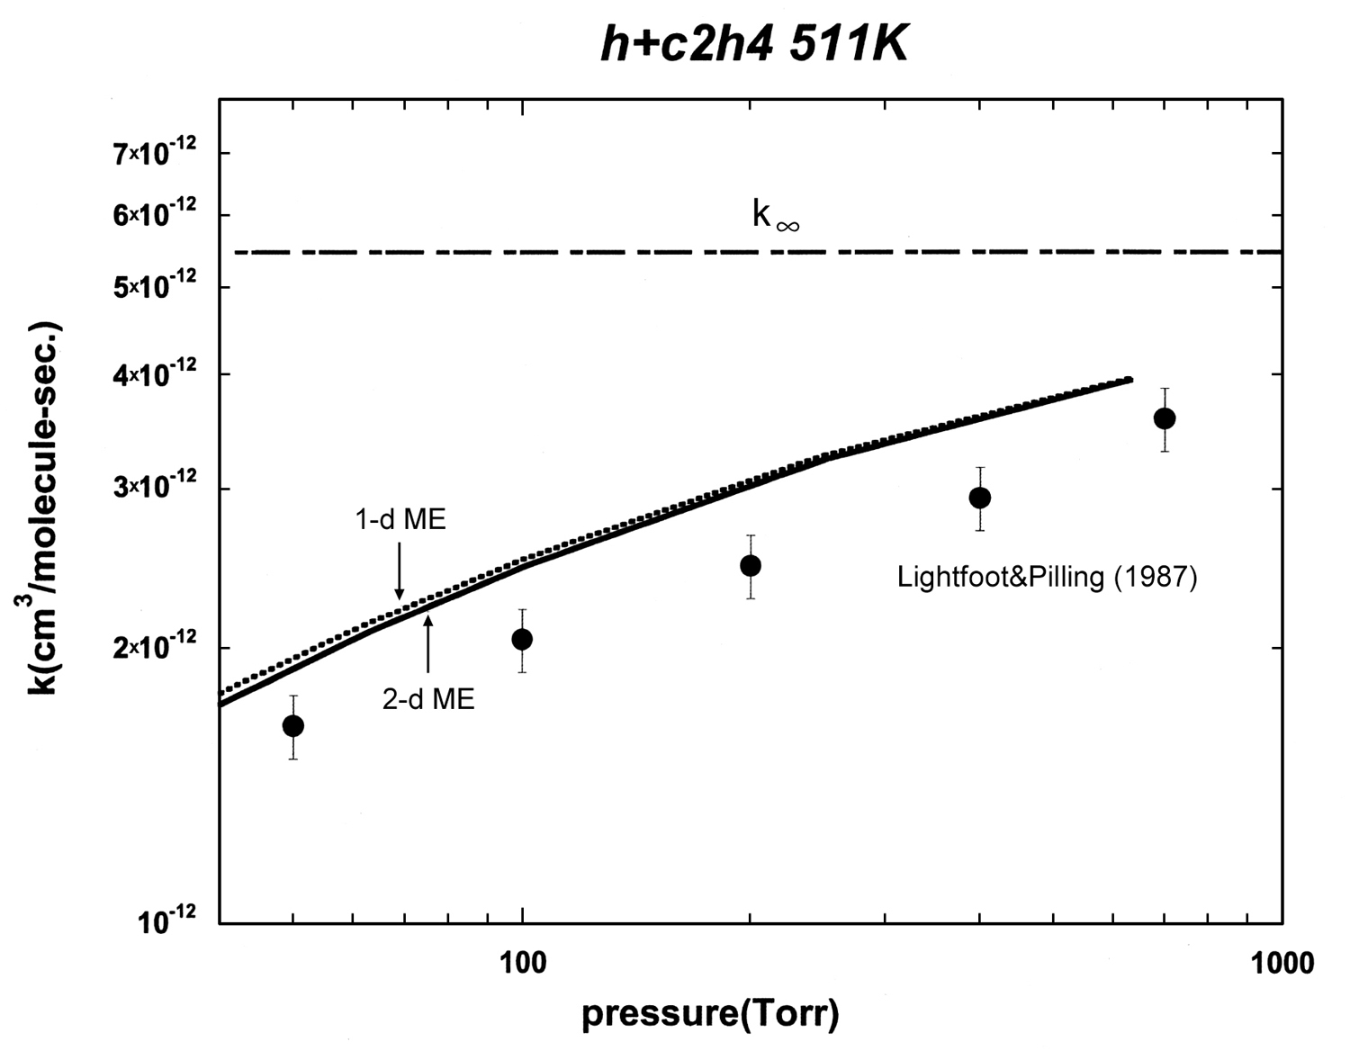

Fig. ESI.6:The rate coefficient for at T=511 K with helium as the bath gas.

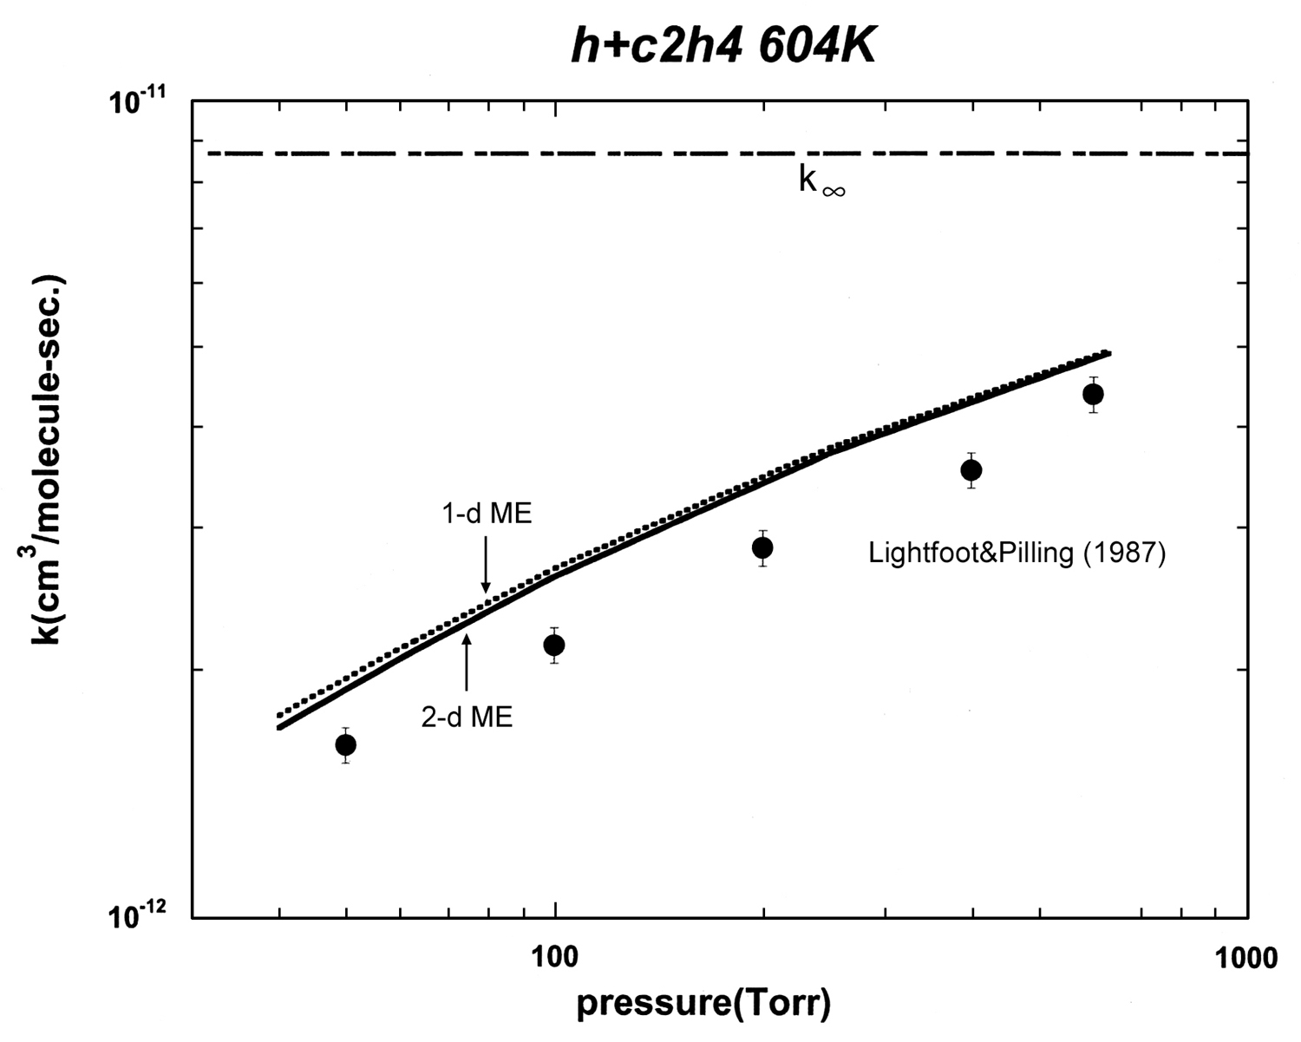

Fig. ESI.7:The rate coefficient for at T=604 K with helium as the bath gas.

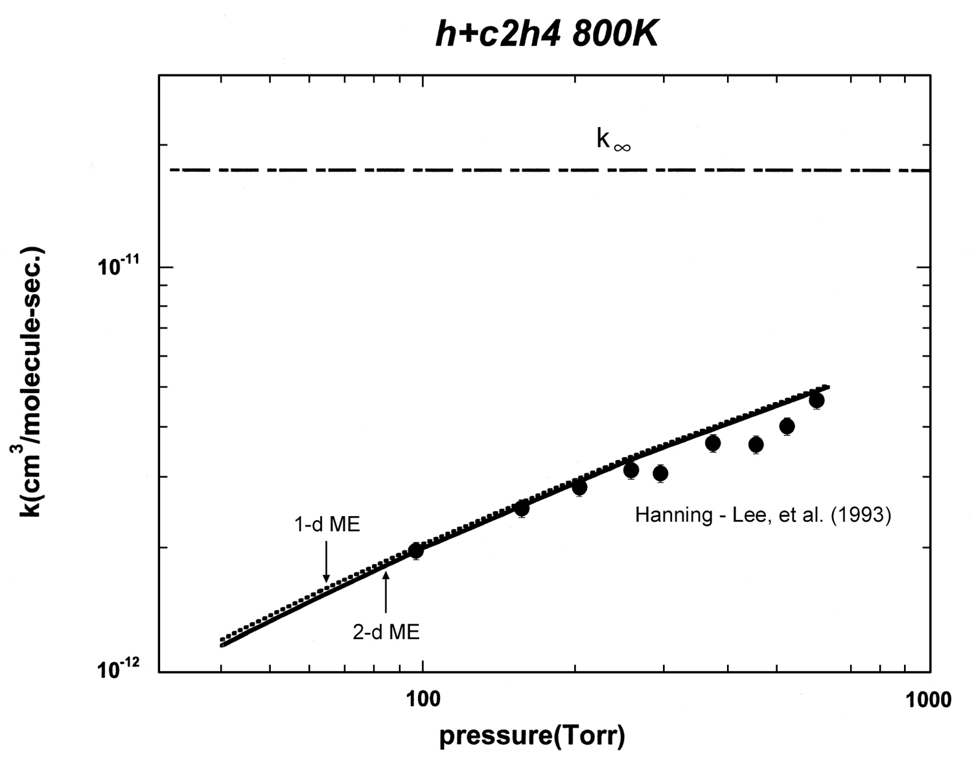

Fig. ESI.8:The rate coefficient for at T=800 K with helium as the bath gas.

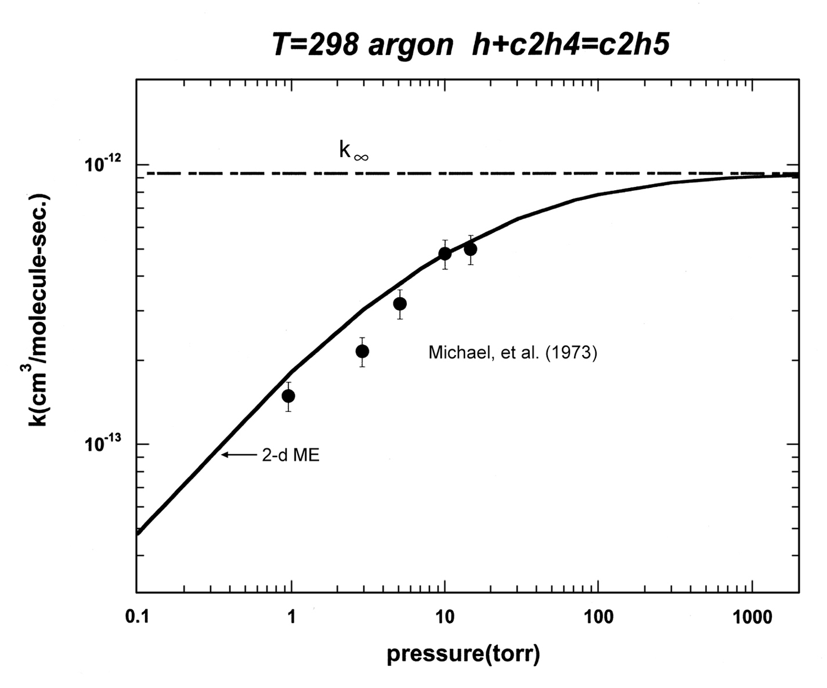

Fig. ESI.9:The rate coefficient for as a function of pressure at T=298 with argon as the diluent.

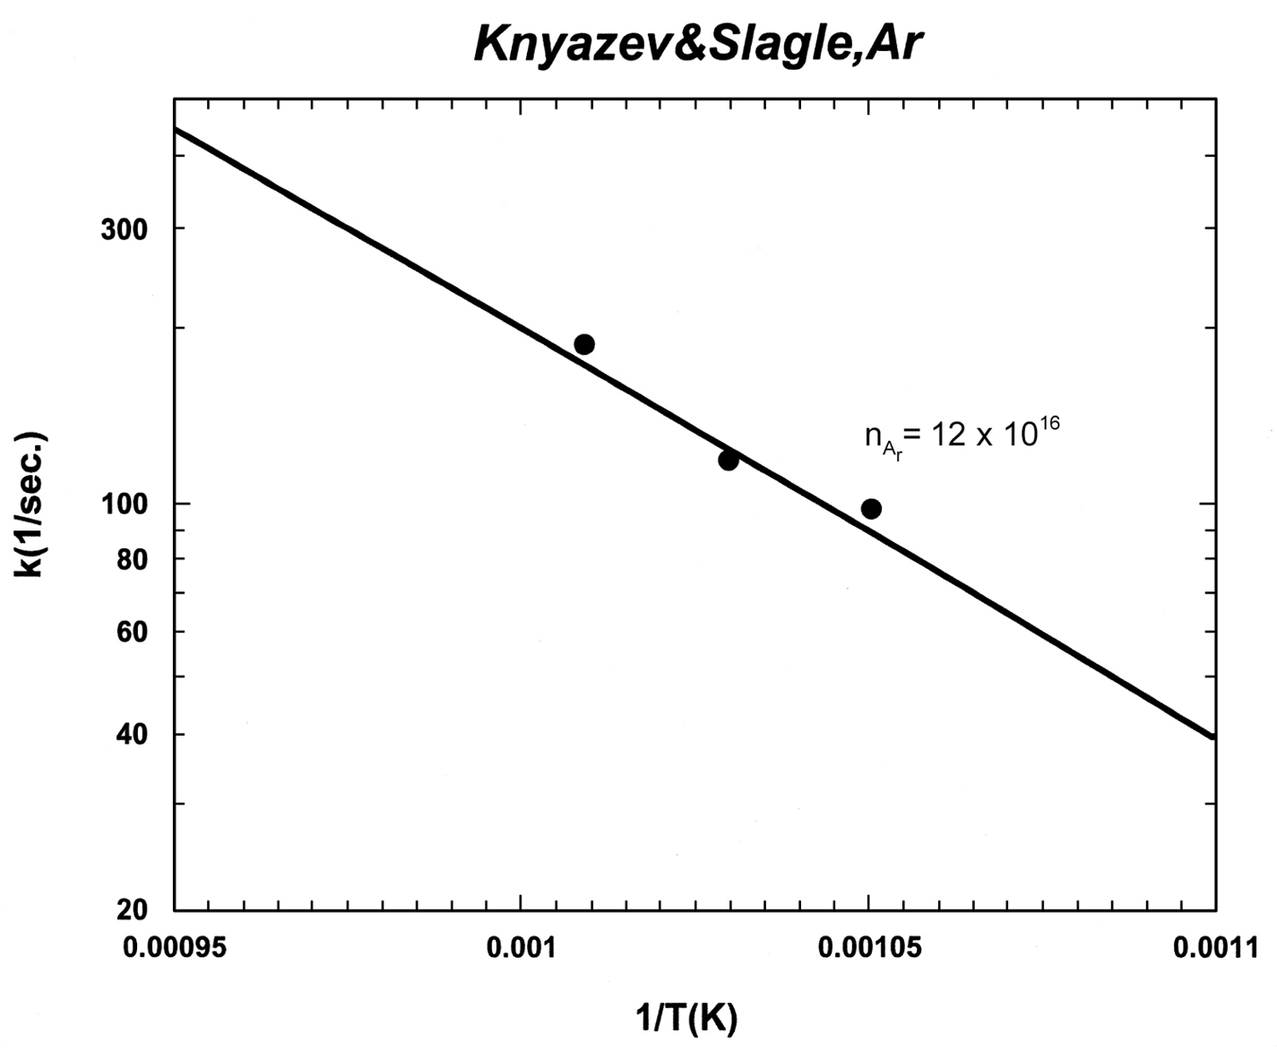

Fig. ESI.10:The rate coefficient for with argon as the diluent. The solid line is the theory and the circles are the experimental data of Knyazev and Slagle.²¹ The units of n_{Ar} are molecules/cm³.

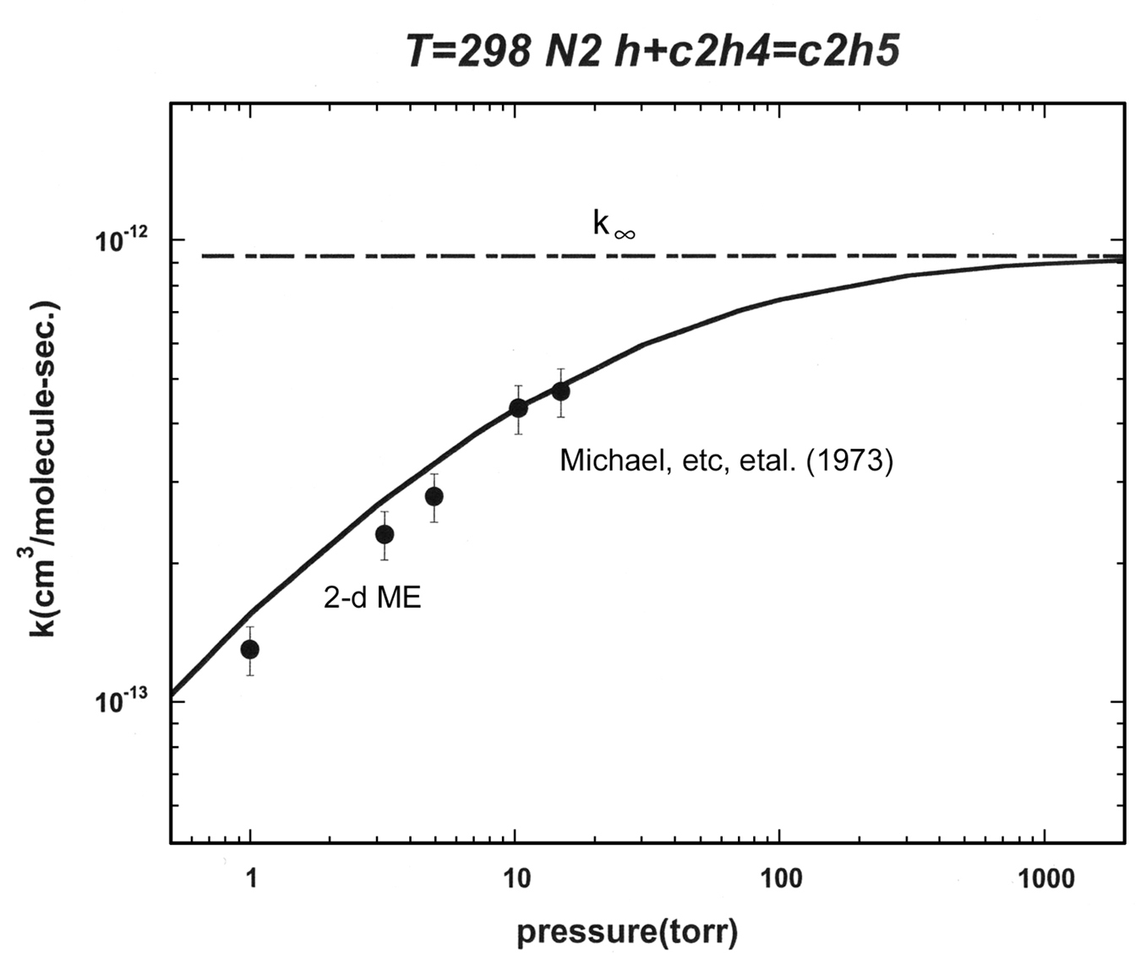

Fig. ESI.11:The rate coefficient for as a function of the pressure at T=298 K with N₂ as the bath gas.

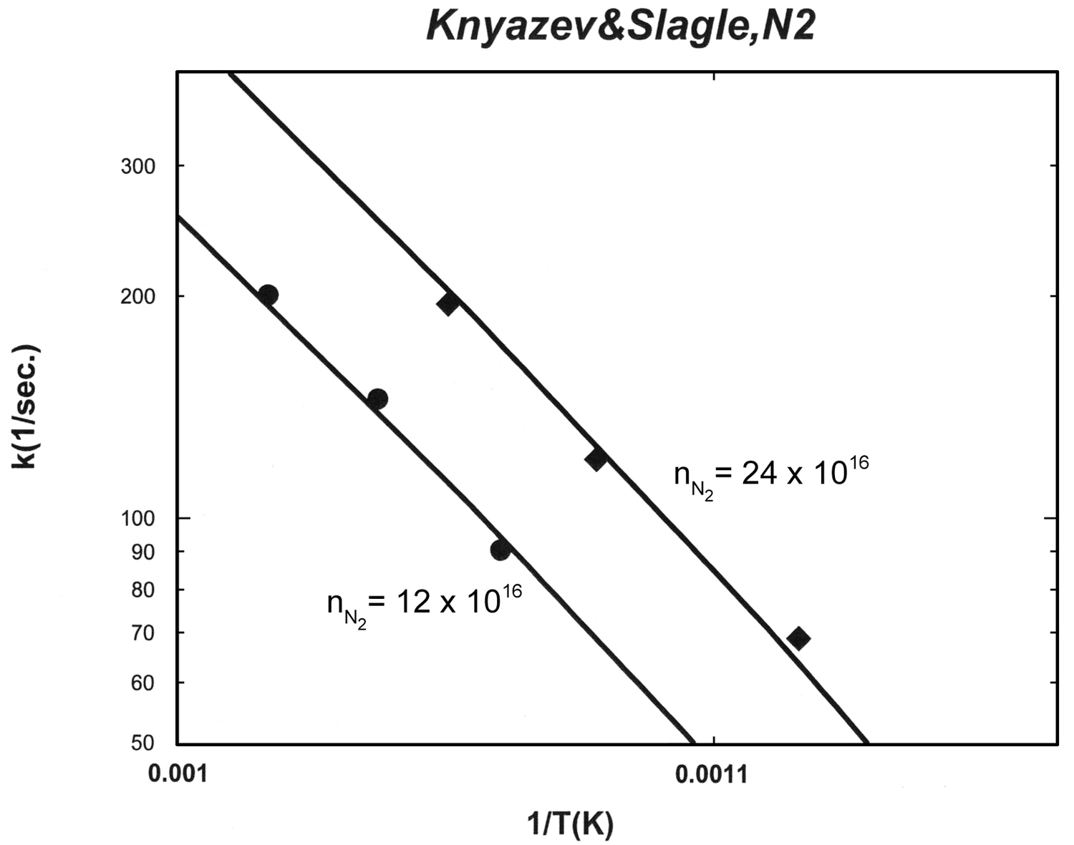

Fig. ESI.12:The dissociation rate coefficient for with N₂ as the bath gas. The solid line is the theory and the points are the experimental data of Knyazev and Slagle.²¹ The units of are molecules/cm³.

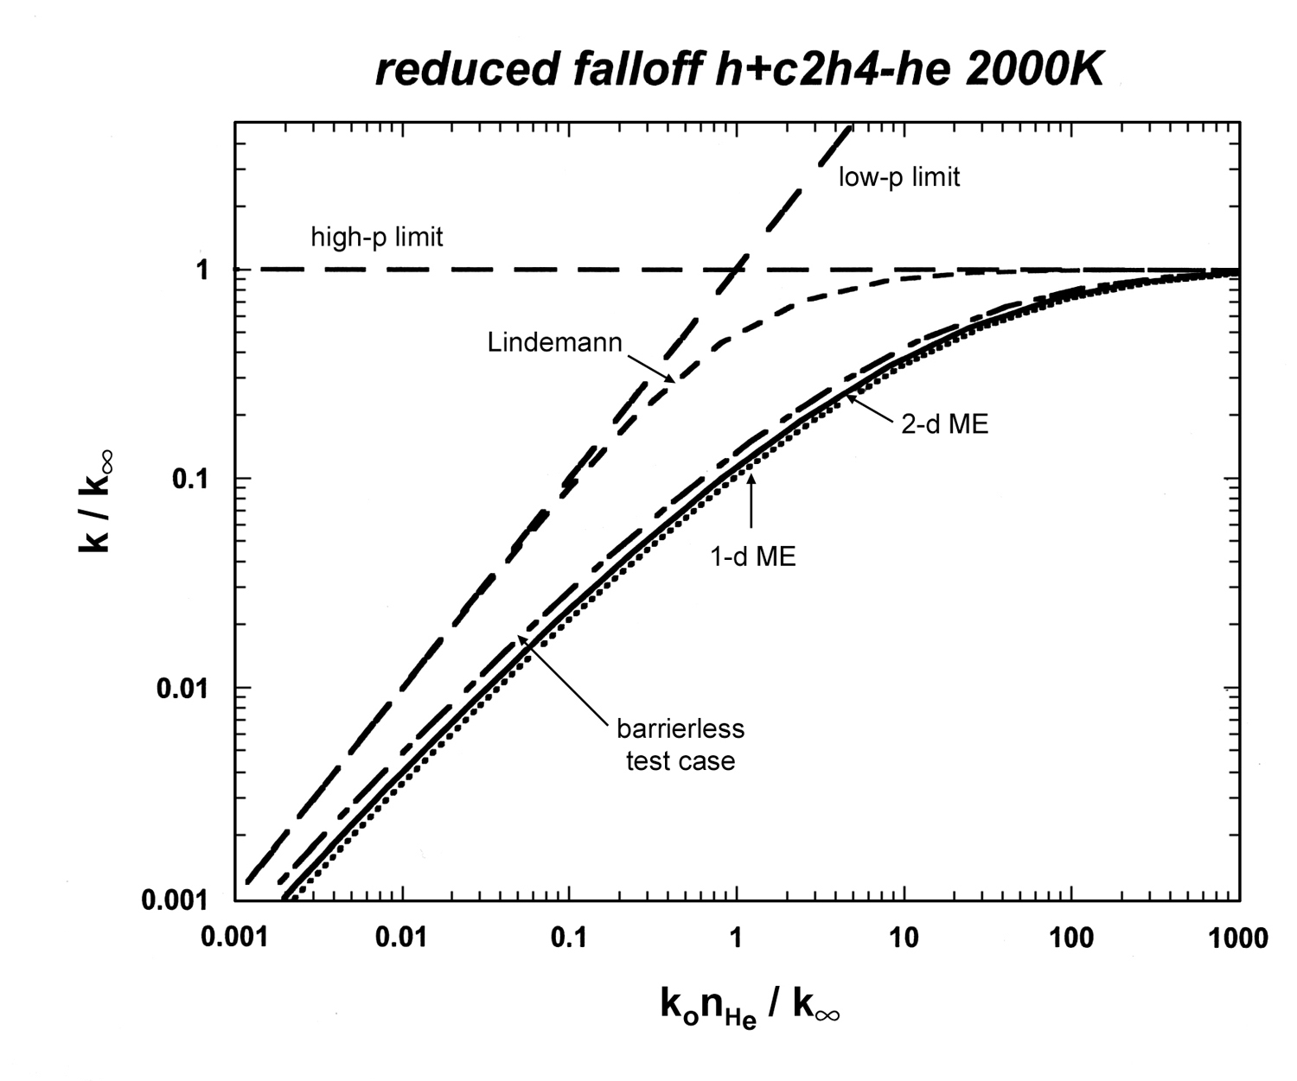

Fig. ESI.13:Reduced falloff curves for at T=2000 K.

