Supplement 1

Cyclic voltammograms of extended viologens 1 to 6 in the potential range from –0.7V to –2.5V against ferrocene/ferrocenium redox couple.

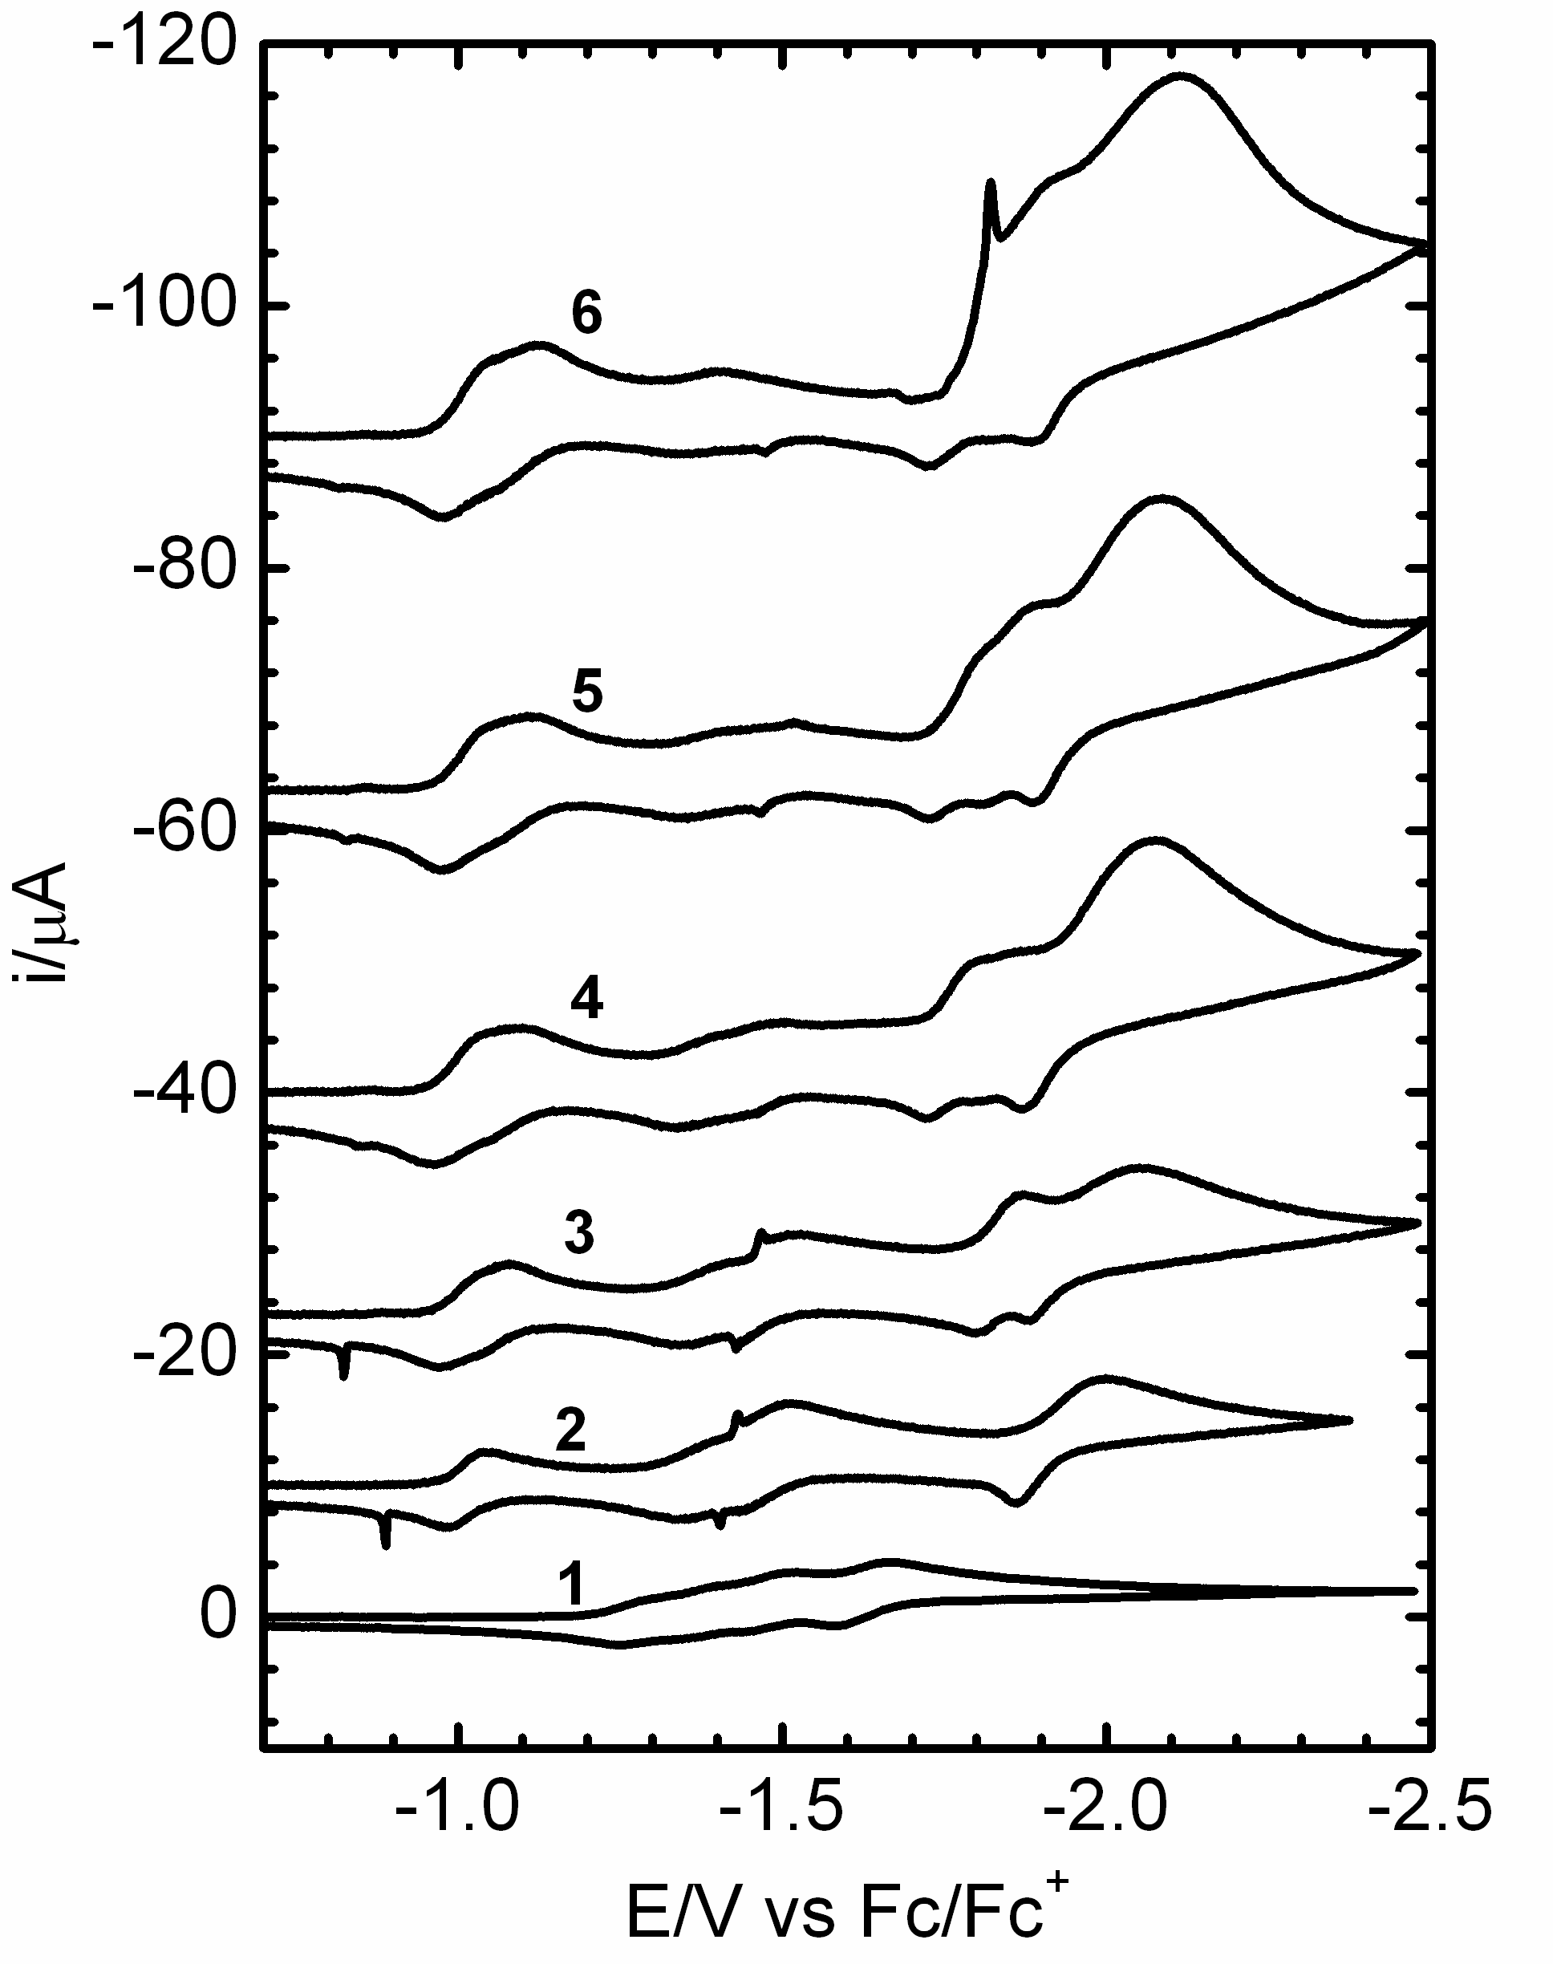

Figure S1 Cyclic voltammogram of 1×10^{–3} M extended viologen compound in DMSO, containing 0.1 M TBAPF₆ as the supporting electrolyte, obtained at scan rate 0.25 V/s on the hanging mercury drop electrode. Labels 1 to 6 indicate the compound used. Current–voltage curves are shifted vertically for better visualization. Originally, they have the same charging current value at the starting potential –0.7V against the Fc/Fc⁺ couple.

Supplement 2

Logarithmic analysis of the DC polarograms shown in Figure 1 of the main text.

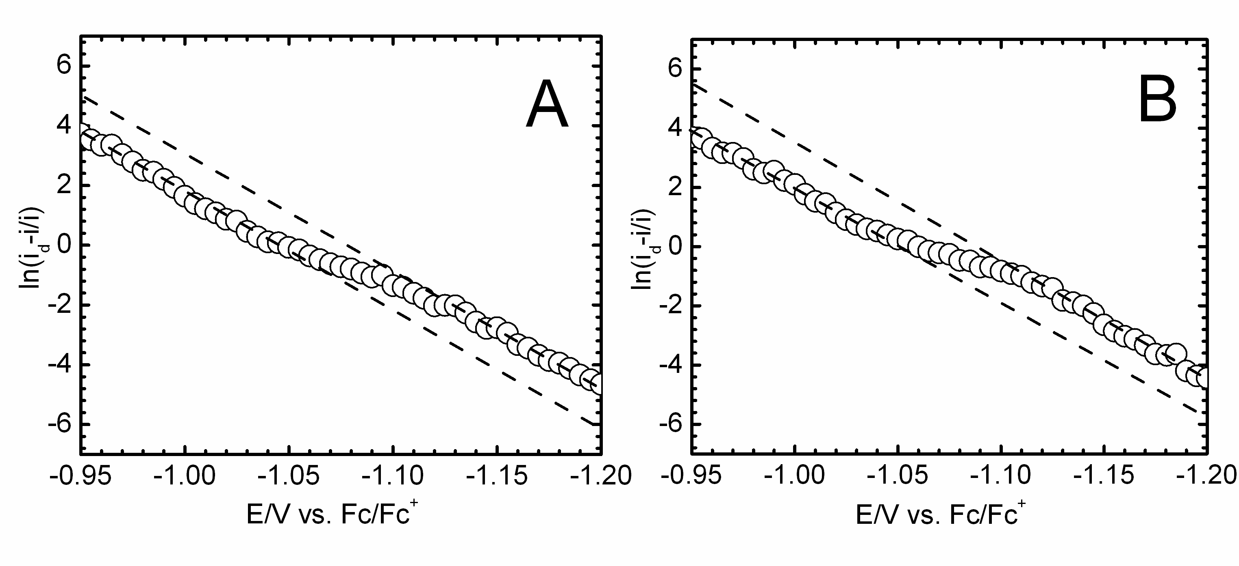

Figure S2 Log–plot analysis of the merged polarographic waves of 4 (A) and 6 (B) obtained from the DC polarograms shown in Figure 1A of the main text.

