Supplementary Material (ESI) for Phys. Chem. Chem. Phys.
This Journal is © The Owner Societies 2011

Supporting Information

MnO₂/TiN Heterogeneous Nanostructure Design for
Electrochemical Energy Storage

Stefanie A. Sherrill, Jonathon Duay, Zhe Gui, Parag Banerjee, Gary W. Rubloff, Sang Bok Lee
Department of Chemistry and Biochemistry, University of Maryland, College Park, Maryland 20742
Department of Materials Science and Engineering, University of Maryland, College Park, Maryland 20742
Graduate School of Nanoscience and Technology (WCU), Korea Advanced Institute of Science and Technology, Daejeon, Korea 305-701, Korea

Supplementary Material (ESI) for Phys. Chem. Chem. Phys.
This Journal is © the Owners Societies 2011

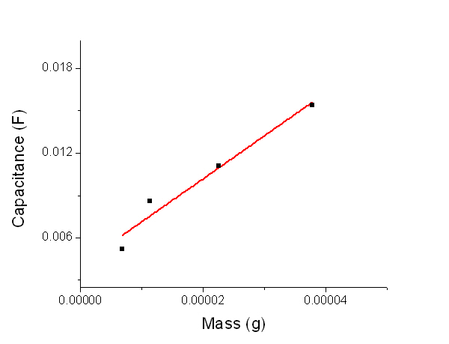
Figure S1 Linear fit of results from depositing various amounts of MnO₂ into the TiN nanotubes. We found that the capacitance results varied for given amount of MnO₂ deposited. This figure shows capacitance calculated versus mass deposited. The red curve is the linear fit to the given data points.

Supplementary Material (ESI) for Phys. Chem. Chem. Phys.
This Journal is © the Owners Societies 2011

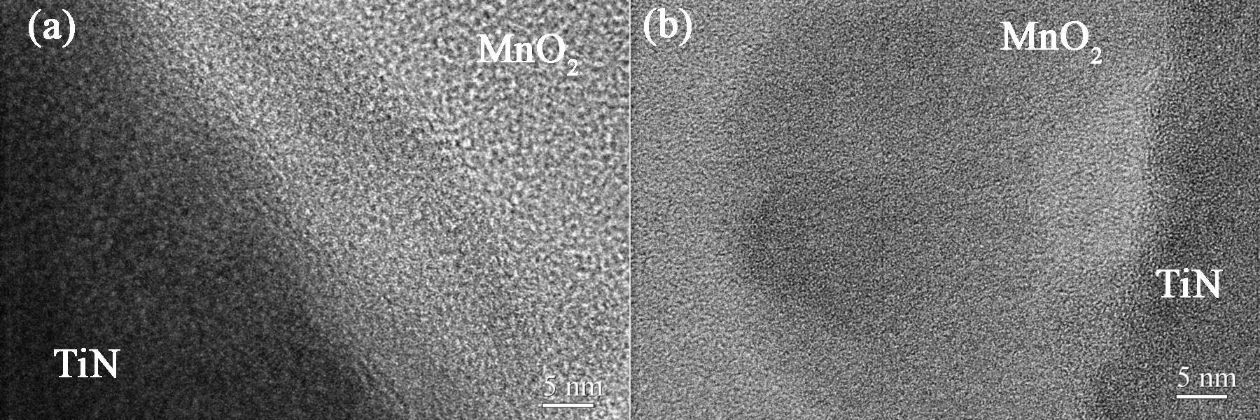

Figure S2 (a,b) High resolution transmission electron microscope (HR-TEM) images of the MnO₂/TiN nanotube nanostructure. The images show the amorphous material of both MnO₂ and TiN.

Supplementary Material (ESI) for Phys. Chem. Chem. Phys.
This Journal is © the Owners Societies 2011

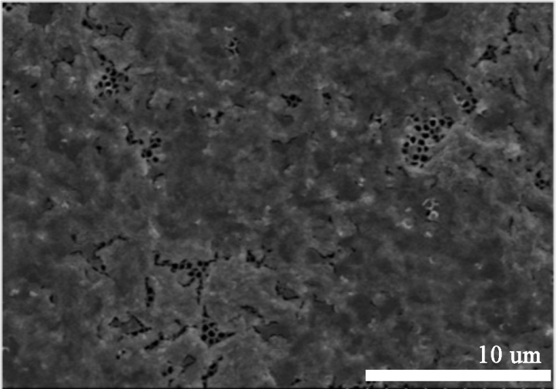

Figure S3 SEM top view of excessive MnO₂ deposited onto the TiN nanotubes. This figure illustrates with SEM the result that occurs when an excessive amount of MnO₂ is deposited onto the TiN nanotubes. We believe that when this results occurs, that the capacitance capabilities of the system are limited as the MnO₂ does not reach into the pores.

Supplementary Material (ESI) for Phys. Chem. Chem. Phys.
This Journal is © the Owners Societies 2011

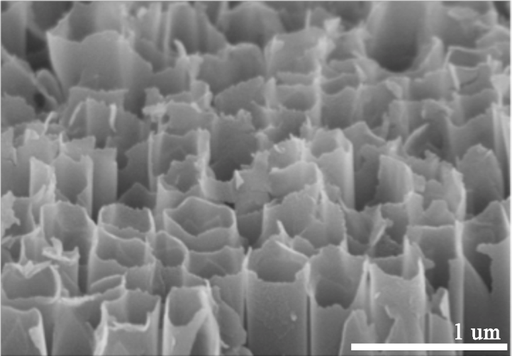

Figure S4: SEM top view of TiN nanotubes after GV cycling at 0.1 mA for 1000 cycles. illustrates the thin nature of the TiN nanotubes at the top. We believe that because the TiN nanotubes are only a few nanometers thick at the top and this contributes to the decrease in specific capacitance at greater current densities. The cracking at the top of the nanotubes leads to a breakdown in the structure at higher current densities. The SEM image provided shows the TiN nanotubes after GV cycling of 1000 cycles at 0.1 mA.

