Supplementary Information

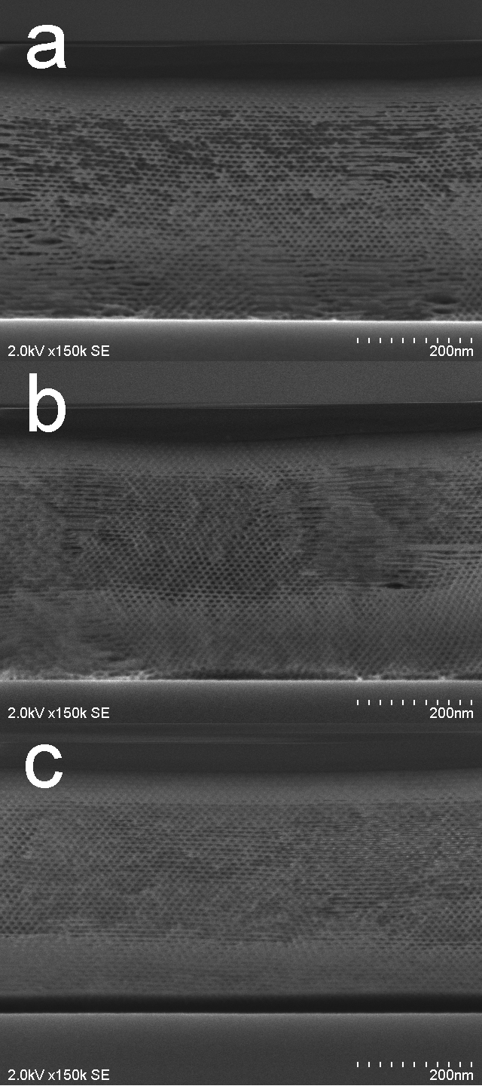

Figure S1. Cross-sectional SEM images of (a) AS-MSS, (b) Me₃SiOMe-MPS and (c) Me₃SiCl-MPS.
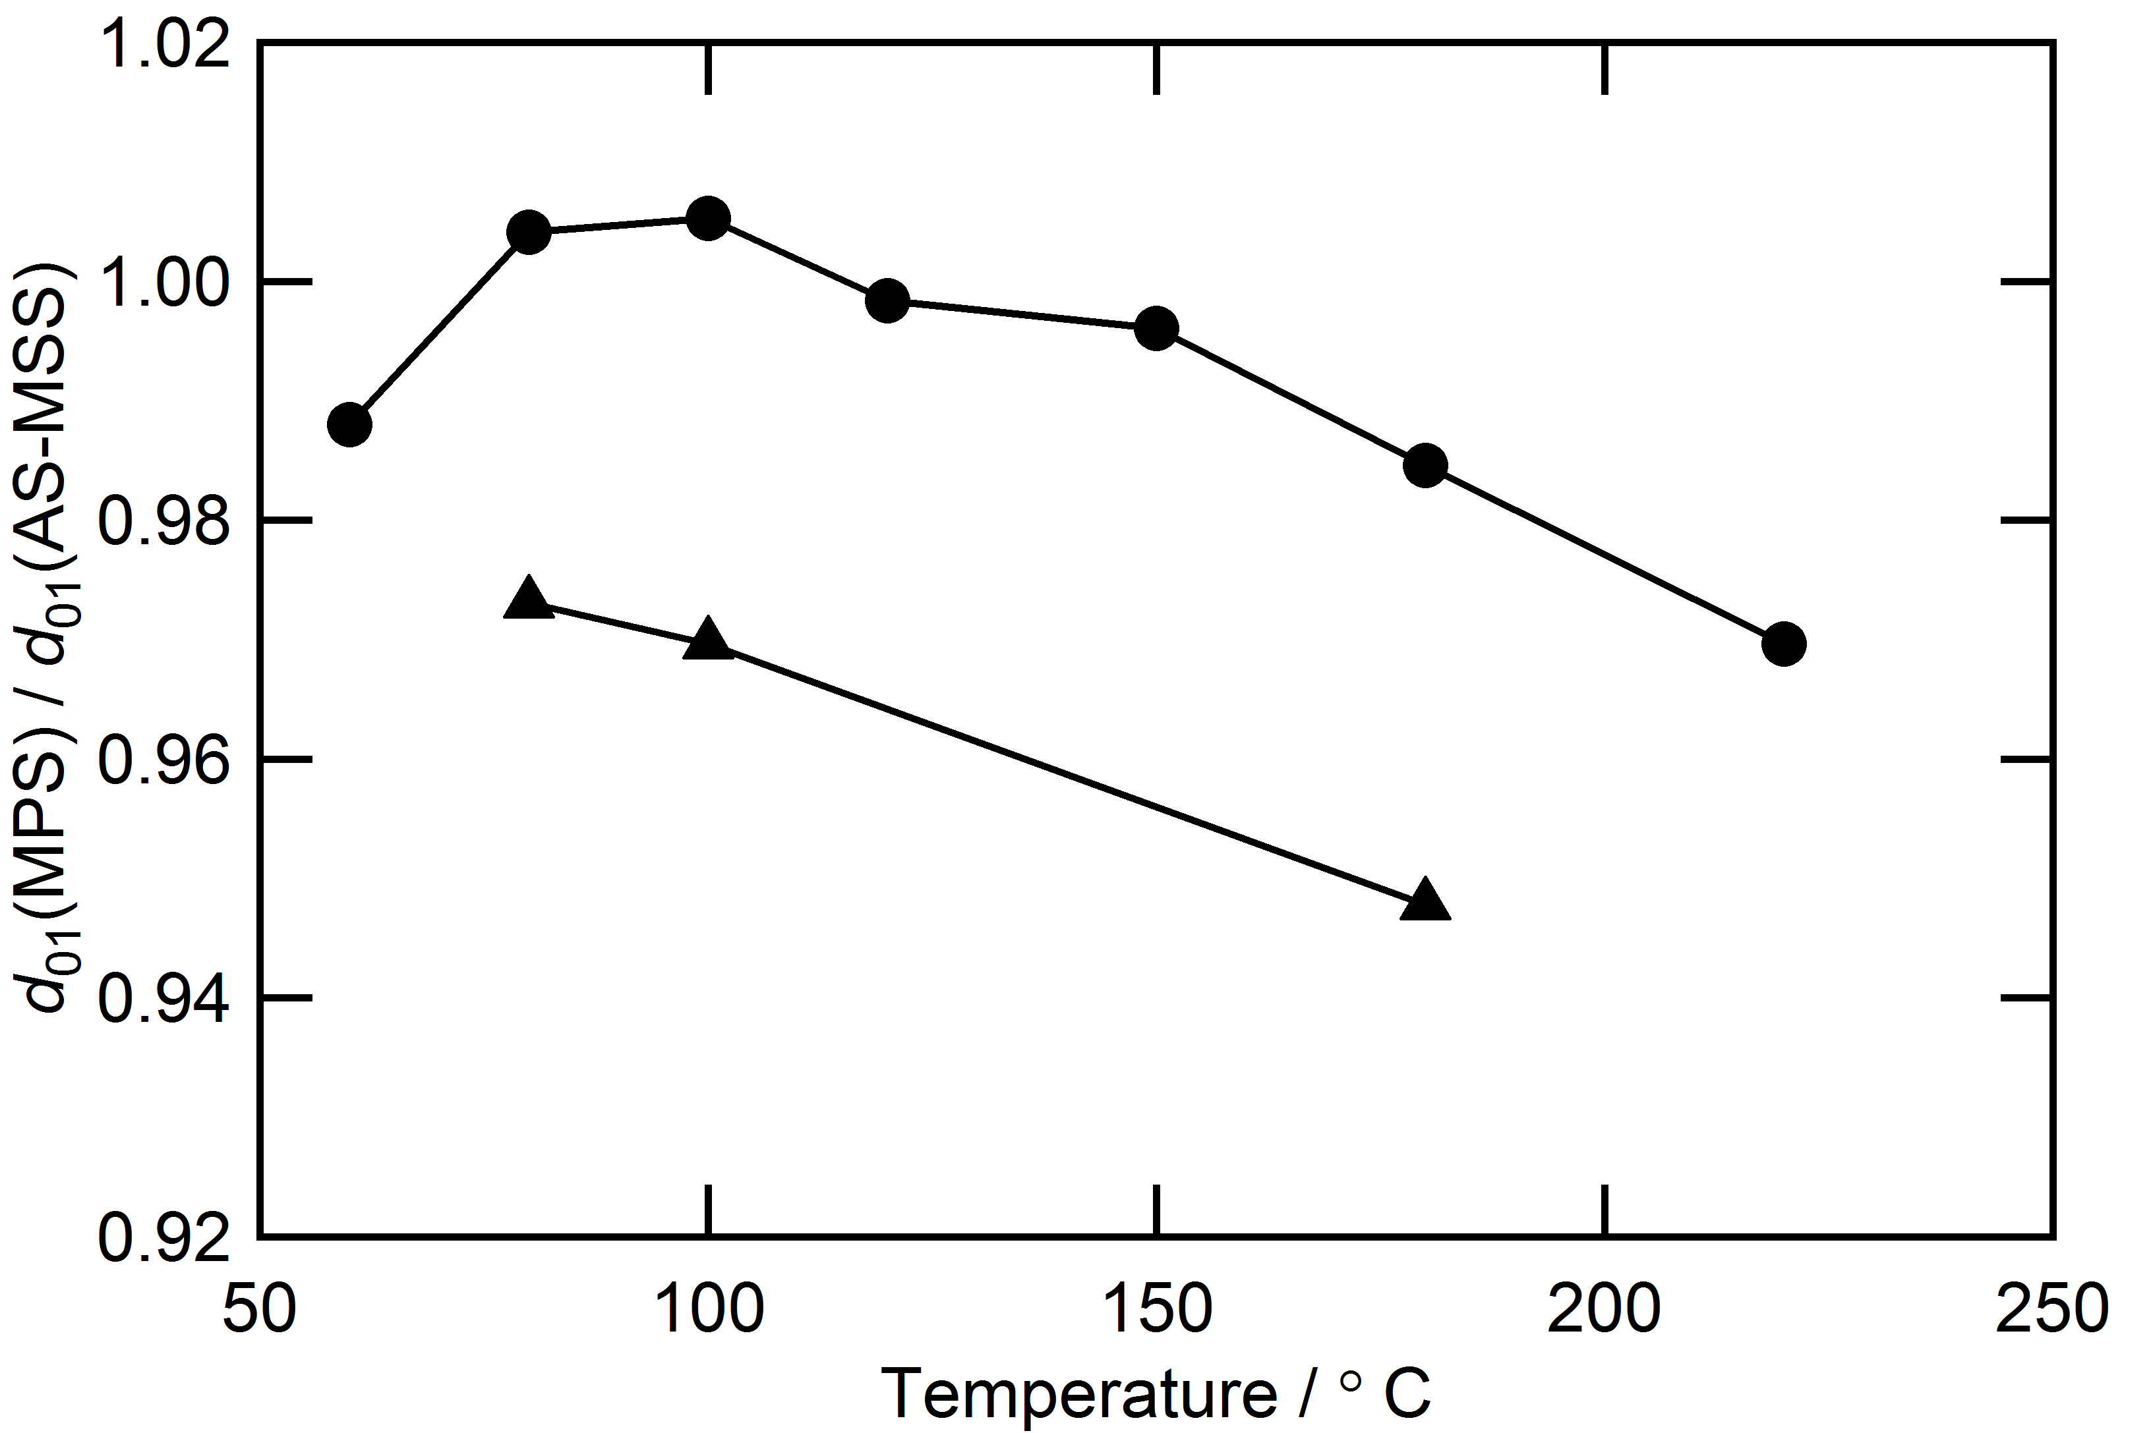
Figure S2. Effect of the treatment temperature on the normalized structural period of Me₃SiOMe-MPS (triangle) and Me₃SiCl-MPS (circle).

