Supporting Information

Polyureas from Diamines and Carbon Dioxide: Synthesis, Structures and Properties

Table of Contents

Fig. S1 CP/MAS ¹³C NMR spectra of the products
Fig. S2 FTIR spectra of the products
Fig. S3 The network structure of the PUas
Fig. S4 TGA curves of the PUas
Fig. S5 DTA curves of the PUas
Fig. S6 DSC curves of PUa3-PUa5
Table S1. DFT calculations

The peaks at 5-15 ppm and 240-270 ppm were caused by the side band.

The peaks at 5-25 ppm and 250-270 ppm were caused by the side band.

Fig. S1 CP/MAS ¹³C NMR spectra of the products

Fig. S2 FTIR spectra of the products

Fig. S3 The network structure of the PUas.

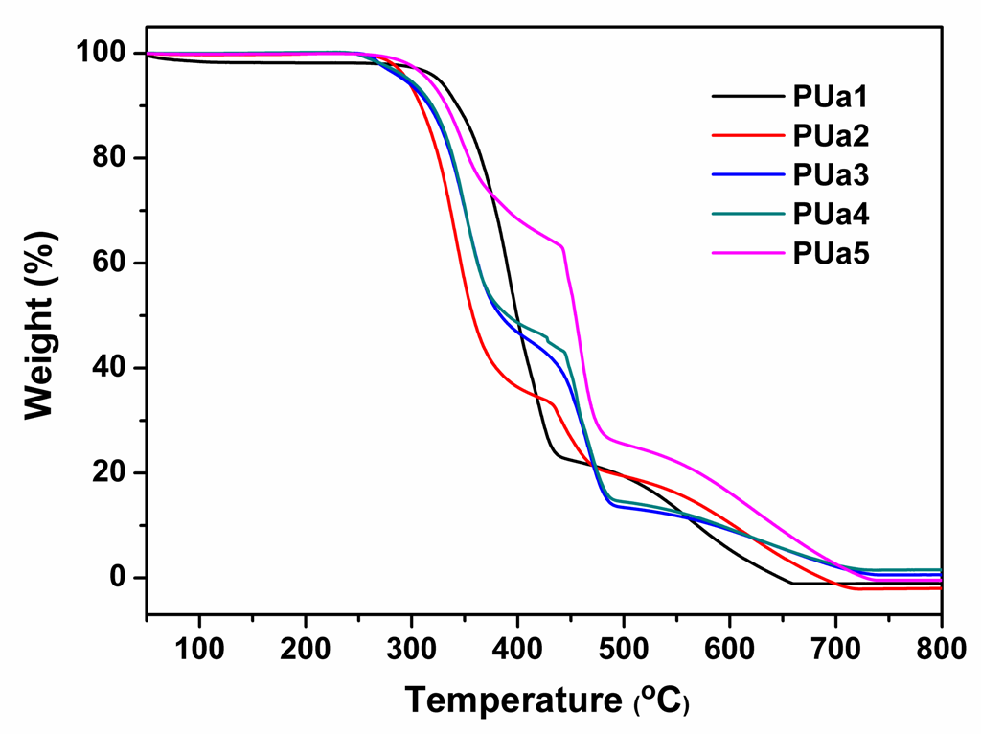
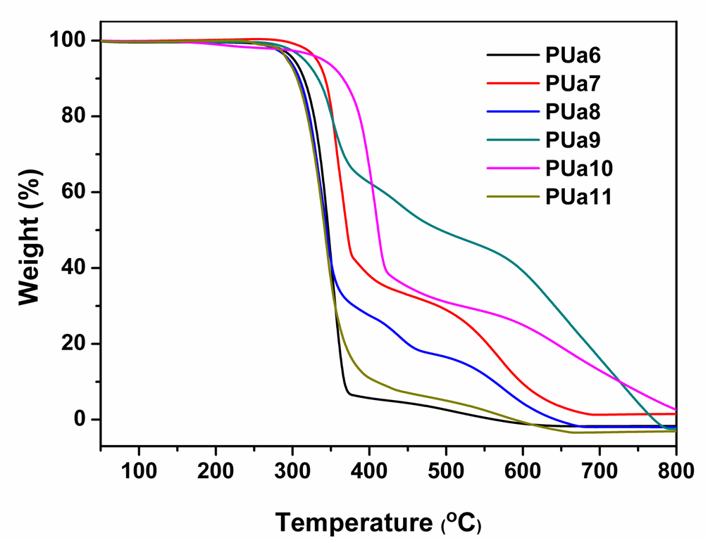

Fig. S4 TGA curves of the PUas.

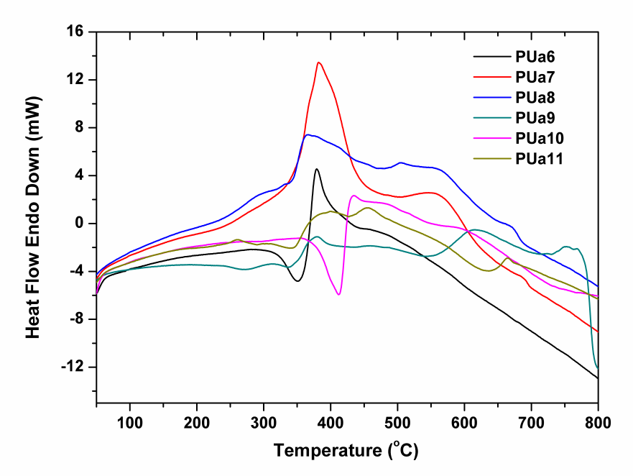
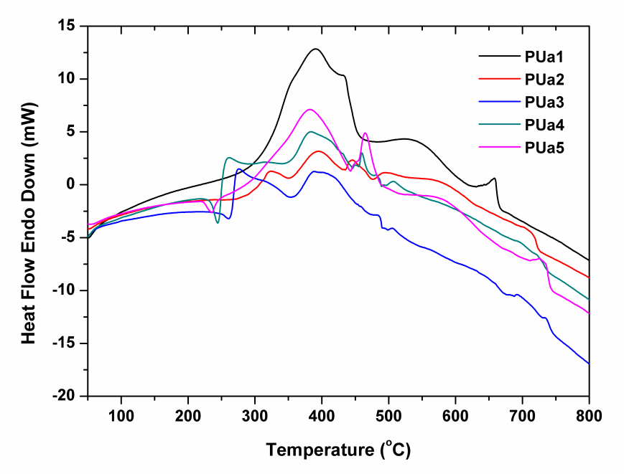

Fig. S5 DTA curves of the PUas.

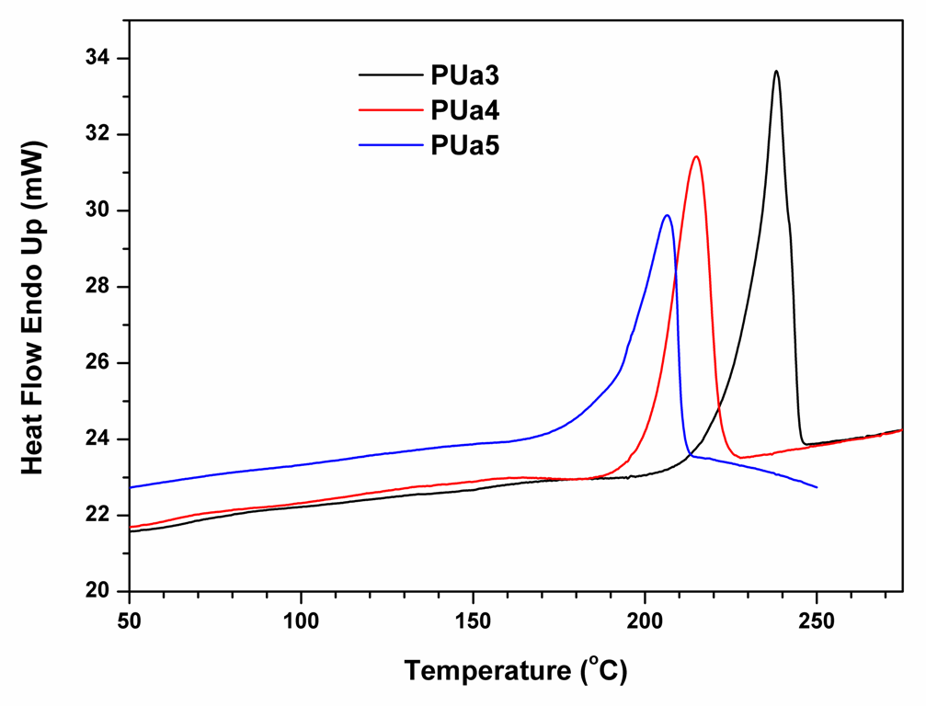

Fig. S6 The second heating runs of DSC curves of PUa3-PUa5.

Table S1. DFT calculations

Cartesian Coordinates of N, N’-dipropylurea calculated at the B3LYP/6-31G(d,p) levels of theory.

C -0.00000500 -0.00012800 0.00096500
O 0.00001700 -0.00006300 1.22776200
N 1.15941400 -0.00084400 -0.75732800
N -1.15950200 0.00085400 -0.75726000
H 1.07711700 -0.30200300 -1.71859200
H -1.07721500 0.30269500 -1.71832400
C 2.45845300 -0.19892600 -0.12788500
C 3.53950000 0.69561400 -0.74088700
H 2.76823600 -1.25392800 -0.19166300
H 2.32113400 0.02767400 0.93173100
C 4.90913000 0.47963800 -0.09076800
H 3.61089300 0.49885800 -1.81997000
H 3.23008000 1.74230200 -0.63789000
H 4.87688500 0.70183000 0.98144900
H 5.24514100 -0.55737300 -0.20342500
C -2.45834100 0.19952500 -0.12755300
C -3.54046800 -0.69223500 -0.74265500
H -2.76668800 1.25509000 -0.18911200
H -2.32153000 -0.02948500 0.93160700
C -4.90990600 -0.47588700 -0.09225800
H -3.61147000 -0.49301300 -1.82131600
H -3.23244900 -1.73955600 -0.64192200
H -4.87811300 -0.70051000 0.97946600
H -5.24453200 0.56181200 -0.20265300
H -5.67025000 -1.11954500 -0.54490500
H 5.66869300 1.12530200 -0.54186700

Cartesian Coordinates of the dimmer of N, N’-dipropylurea calculated at the B3LYP/6-31G(d,p) levels of theory.

C 0.34836300 0.20443900 -0.19922700
O 0.75091600 0.55875600 0.90989600
N 0.72122100 -0.97650800 -0.79531000
N -0.50911800 0.97870600 -0.96852700
H 0.41435200 -1.15397900 -1.74508500
H -0.95122000 0.51575300 -1.75516300
C 1.71652000 -1.83679700 -0.18450300
C 3.16395300 -1.49542200 -0.57033700
H 1.49116600 -2.87489300 -0.46063100
H 1.60172900 -1.75003400 0.89979300
C 4.18231300 -2.43192200 0.08549400
H 3.26607600 -1.53817400 -1.66352400
H 3.35842000 -0.45857000 -0.27357900
H 4.11935200 -2.37962300 1.17816000
H 4.01110800 -3.47540200 -0.20501800
C -1.20670300 2.09771300 -0.35394100
C -2.44414500 1.70089500 0.46458500
H -1.49134500 2.79959600 -1.14812000
H -0.48900000 2.60563700 0.29587100
C -3.14575900 2.91095800 1.08755600
H -3.14482200 1.15330200 -0.18030500
H -2.12388500 1.00586500 1.24857800
H -2.47342900 3.45238200 1.76249800
H -3.48188300 3.61784500 0.31942000
H -4.02431700 2.60965500 1.66678600
H 5.20701600 -2.17306200 -0.19971600
H -3.72590600 -4.39078700 -4.87255100
C -3.65973500 -4.10605800 -5.92823800
C -2.42720600 -3.23604300 -6.19042400
H -4.58412300 -3.57759400 -6.18719300
H -3.62717200 -5.02597200 -6.51935400
C -2.44696700 -1.94051600 -5.37309600
H -2.36993100 -2.99273900 -7.26061200
H -1.51232300 -3.79013200 -5.94964600
N -1.28696200 -1.09959200 -5.63770400
H -3.37372500 -1.38404400 -5.57676100
H -2.42988700 -2.15698600 -4.30297300
C -0.52263700 -0.56223500 -4.63065500
H -1.19929200 -0.70832300 -6.56427300
O -0.73081200 -0.82189100 -3.43653700
N 0.47251000 0.28553500 -5.04933600
H 0.74401600 0.23922900 -6.02191700
C 1.47301300 0.81851200 -4.12714900
C 2.08731400 2.10993000 -4.67023600
H 2.26557400 0.07859000 -3.93687800
H 0.97728200 1.00741100 -3.17251700
C 3.14959900 2.68276000 -3.72802600
H 2.53669100 1.91859900 -5.65581000
H 1.28762800 2.84311500 -4.82990200
H 2.72279500 2.91222500 -2.74631900
H 3.97024500 1.97344000 -3.57495200
H 3.57774400 3.60495100 -4.13189000

