Supplementary Information

Mechanistic investigations on dimethyl carbonate formation by oxidative carbonylation of methanol over CuY zeolite: An operando SSITKA/DRIFTS/MS study
Jana Engeldinger, Manfred Richter and Ursula Bentrup*

Experimental
For the SSITKA experiments with ¹⁶O₂/¹⁸O₂ and ¹²CO/¹³CO different gas dosing systems were used the detailed flow diagrams of which are shown in Fig. S1a, and S1b. The following gases and gas mixtures were used: 5 vol.% ¹²CO/He, 5 vol.% ¹⁶O₂/He, and 1 vol. % Ne/He (Air Liquide), ¹³CO (pure) and 5 vol.% ¹⁸O₂/He (Linde). MeOH was dosed using a saturator (14°C) with He (cf. Fig. S1a, b).
The general feed composition was 5.1 vol.% MeOH / 2.5 vol.% CO / 1.2 vol.% O₂ balanced with He. In the experiments with Ne as marker the mixture additionally contained 0.2 vol.% Ne. The switching from the normal to the isotopic labelled gas mixture was done by a four-way valve realizing a constant flow rate of 25 ml min⁻¹.

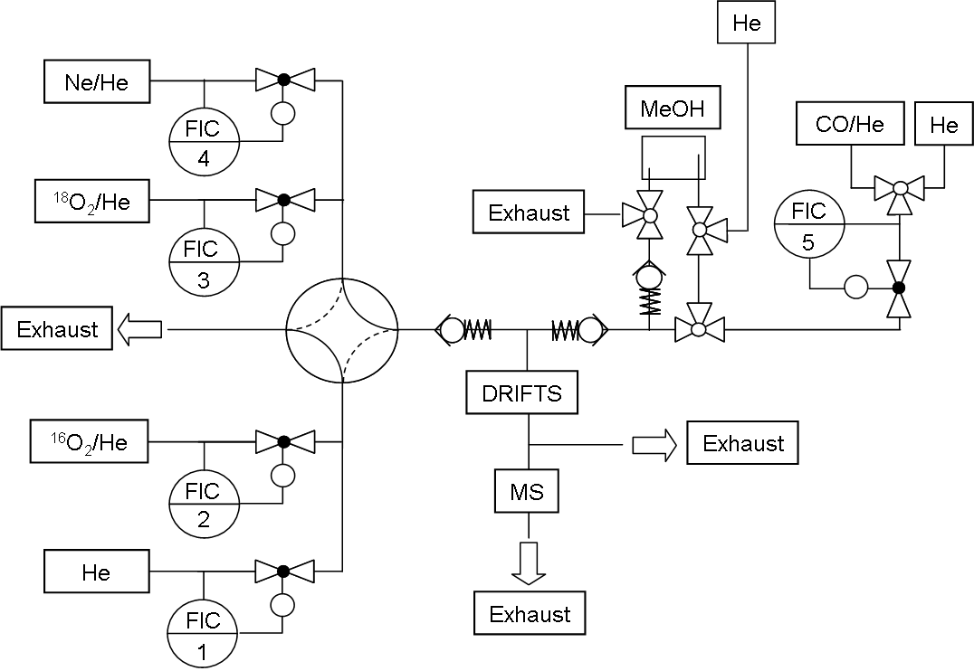
Fig. S1a Scheme of gas dosing system applied for SSITKA/DRIFTS/MS with ¹⁶O₂/¹⁸O₂.
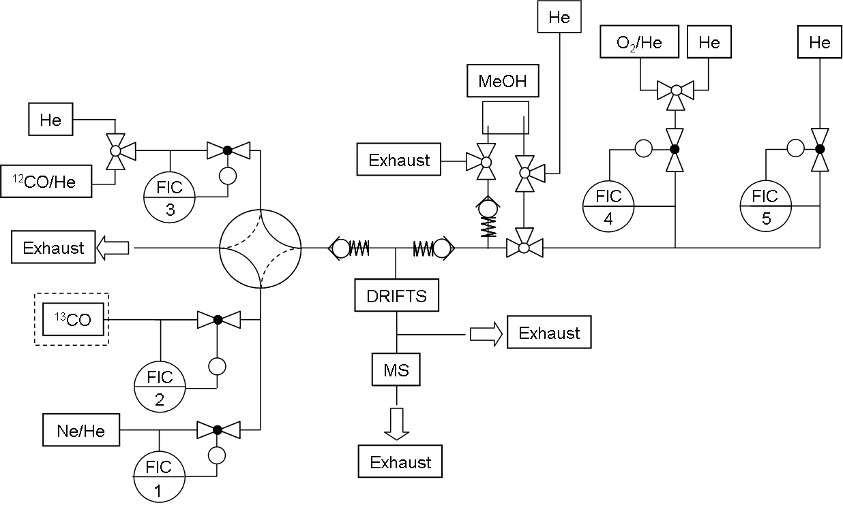
Fig. S1b Scheme of gas dosing system applied for SSITKA/DRIFTS/MS with ¹²CO / ¹³CO.

Interaction of the CuY catalyst with ¹⁶O₂/¹⁸O₂
It was checked if the oxygen of the zeolite lattice or the CuO_{x} agglomerates can be exchanged with gaseous oxygen at reaction temperature of 150°C. If ¹⁶O₂ is replaced by ¹⁸O₂ under steady state conditions a simultaneous increase of the MS signals of ¹⁸O₂ and the tracer Ne was observed 30 sec after switching whereas the MS signal intensity of ¹⁶O₂ decreases in parallel (Fig. S2). Because no ¹⁶O¹⁸O was detected an exchange between lattice oxygen of both the zeolite and oxidic Cu species with gas phase oxygen can be excluded.
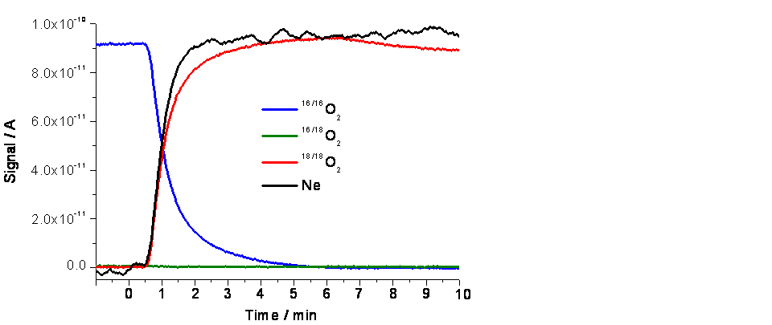
Fig. S2 MS signal intensities of ^{16/16}O₂, ^{16/18}O₂, ^{18/18}O₂ and the tracer Ne versus time; switching from ¹⁶O₂ to ¹⁸O₂ at time = 0.
Interaction of the CuY catalyst with ¹²CO/¹³CO
After switching from the ¹²CO/He to the ¹³CO/He gas mixture the DRIFT spectra shown in Fig. S3a were obtained. The bands at 2160/2144/2112 cm⁻¹ obtained after 30 min exposure to the ¹²CO/He feed are assigned to Cu(I)−¹²CO modes of Cu(I) carbonyls at different sites. After switching to ¹³CO/He a rapid intensity decrease of these bands is observed accompanied by the appearance of new ones at 2110/2097/2062 cm⁻¹. The analysis of the respective integral band intensities (cf. Fig. S3a) in dependence on time demonstrates the quick ¹²CO/¹³CO exchange (Fig. S3b).

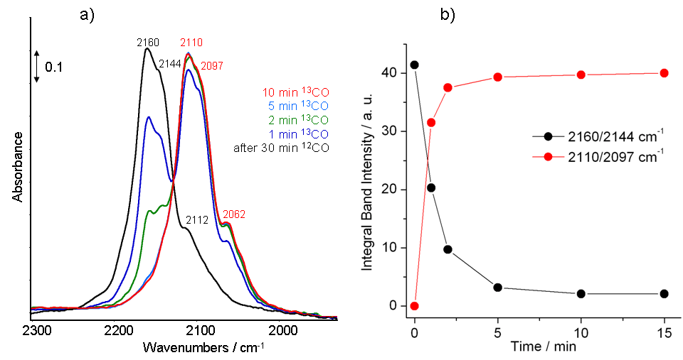

Fig. S3 a) DRIFT spectra of adsorbed CO on 13CuY at 150°C after 30 min exposure to 2.5 vol.% ¹²CO/He and subsequent switching to 2.5 vol.% ¹³CO/He; b) Integral intensities of the Cu(I)−¹²CO (2160/2144 cm⁻¹) and Cu(I)−¹³CO (2110/2097 cm⁻¹) bands versus time calculated from the measured DRIFT spectra.

Comparing the interaction of the CuY catalyst with MeOH/CO and MeOH/CO/O₂
Comparing the amounts of MF, DMC, and CO₂ formed during 120 min exposure the catalyst to 5.1 vol.% MeOH/2.5 vol.% ¹²CO/He and to 5.1 vol.% MeOH/2.5 vol.% ¹²CO/1.2 vol.% O₂/He at 150°C it is clearly seen that CO oxidation is preferred in the presence of oxygen (Fig. S4). The formation of DMC is lowered while the increased MF formation points to a higher extent of unselective MeOH oxidation. In the absence of oxygen (MeOH/CO/He feed) the MF formation proceeds by participation of lattice oxygen supplied by CuO_{x}. Because no additional oxygen is dosed the MF formation decreases with time.
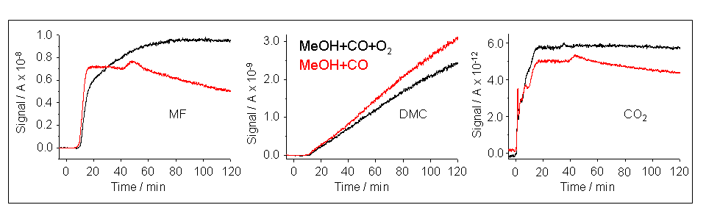

Fig. S4 MS signal intensities of MF, DMC, and CO₂ versus time measured during 120 min exposure the catalyst to a 5.1 vol.% MeOH/2.5 vol.% ¹²CO/He feed and to 5.1 vol.% MeOH/2.5 vol.% ¹²CO/1.2 vol.% O₂/He feed at 150°C, respectively.

