Supplementary date
Effects of Calcination Treatment on the Morphology and Crystallinity, and Photoelectric Properties of All-Solid-State Dye-Sensitized Solar Cells Assembled by TiO₂ Nanorod Arrays
Xianmiao Sunª, Qiong Sunª, Yang Liª, Lina Suiª, and Lifeng Dong^{a, b}*
ª College of Materials Science and Engineering, Qingdao University of Science and Technology, Qingdao, 266042 P.R. China
^{b} Department of Physics, Astronomy, and Materials Science, Missouri State University, Springfield, Missouri, 65897 USA
E-mail: donglifeng@qust.edu.cn

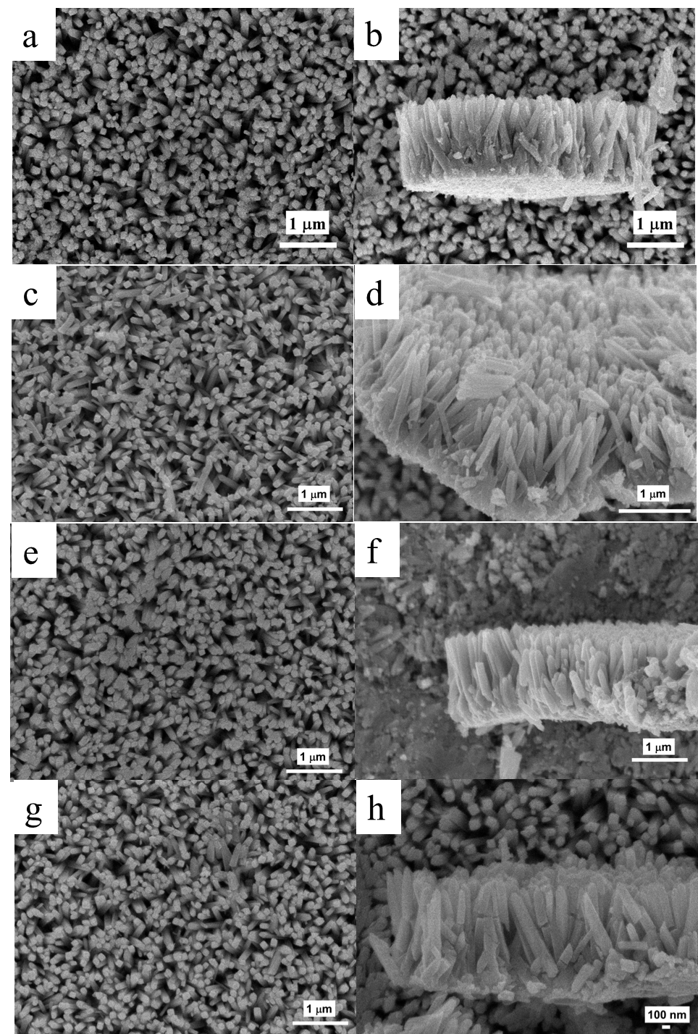
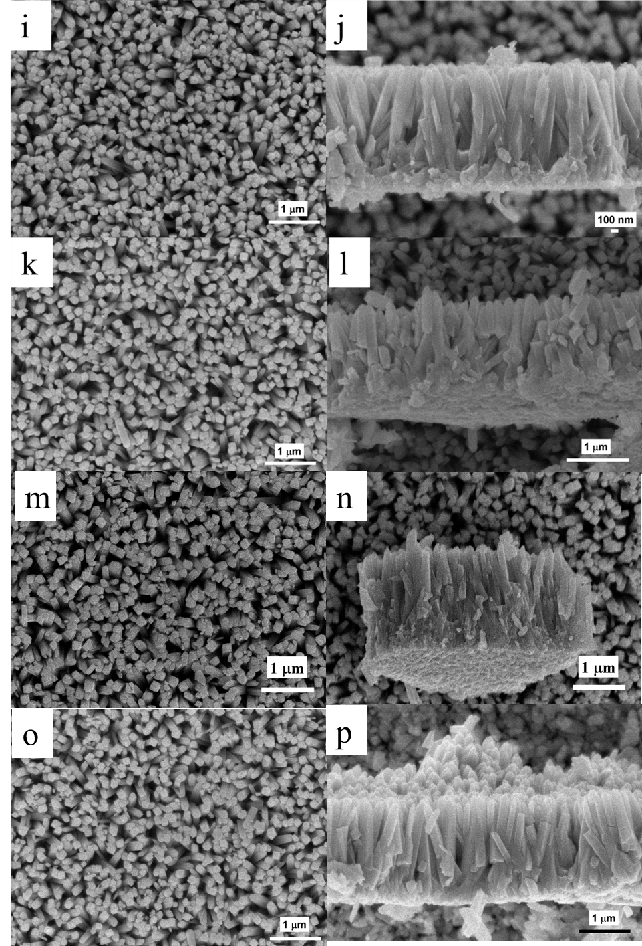
Figure S1. SEM images of TiO₂ nanorods without sintering (a & b) and sintered at different temperatures including 200 °C (c & d), 250 °C (e & f), 300 °C (g & h), 350 °C (i & j), 400 °C (k & l), 450 °C (m & n), and 500 °C (o & p).

