Table s1 Comparison of the structural parameters calculated by LDA and vdWs.
 | Without vdWs interaction | With vdWs interaction
Lattice parameter a (Å)  Lattice parameter c (Å) | 3.194  12.474 | 3.201  12.394
S-Mo bond length (Å)  Se-W bond length (Å) | 2.401  2.501 | 2.401  2.501
Bond angle θ (S1-Mo-S2)  Bond angle θ (Se1-W-Se2) | 79.645  85.014 | 79.358  84.729

Figure s1 Comparison of the band offset calculated by (a) LDA and (b) vdWs.

Figure s2 Comparison of the band structure calculated by (a) LDA and (b) vdWs.

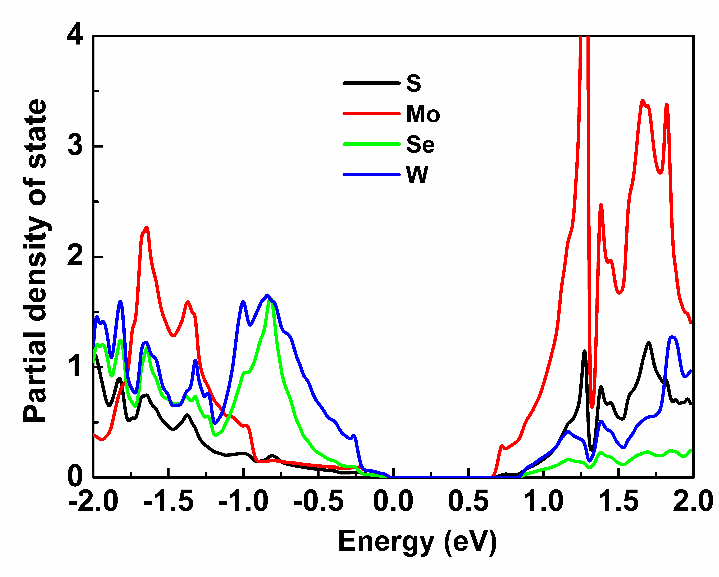
Figure s3 Partial density of state (PDOS) of MoS₂/WSe₂ superlattice (SL). Black, red, green and blue lines are the PDOS of S, Mo, Se, and W atoms, respectively.

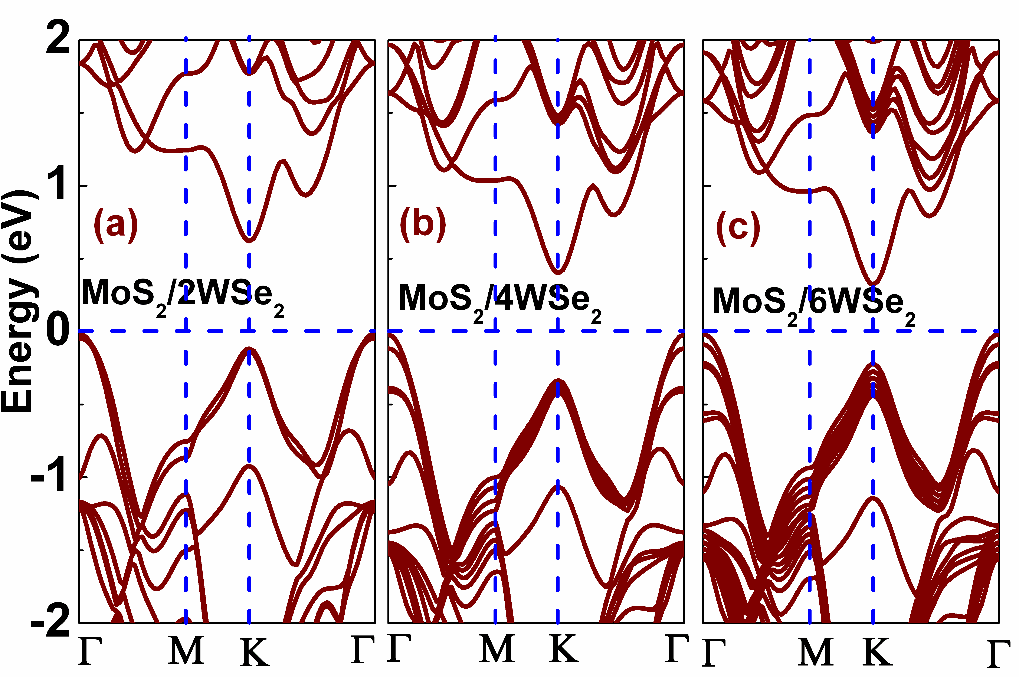
Figure s4 Band structures of (a) MoS₂/2WSe₂, (b) MoS₂/4WSe₂, and (c) MoS₂/6WSe₂ SLs. 2, 4 and 6 mean the number of the WSe₂ layers in these SLs, and MoS₂ is monolayer. The Fermi energy is set to 0 eV.

Figure s5 The band structure of the SLs whose in-plane lattice parameters was set to the value of the free standing MoS₂.

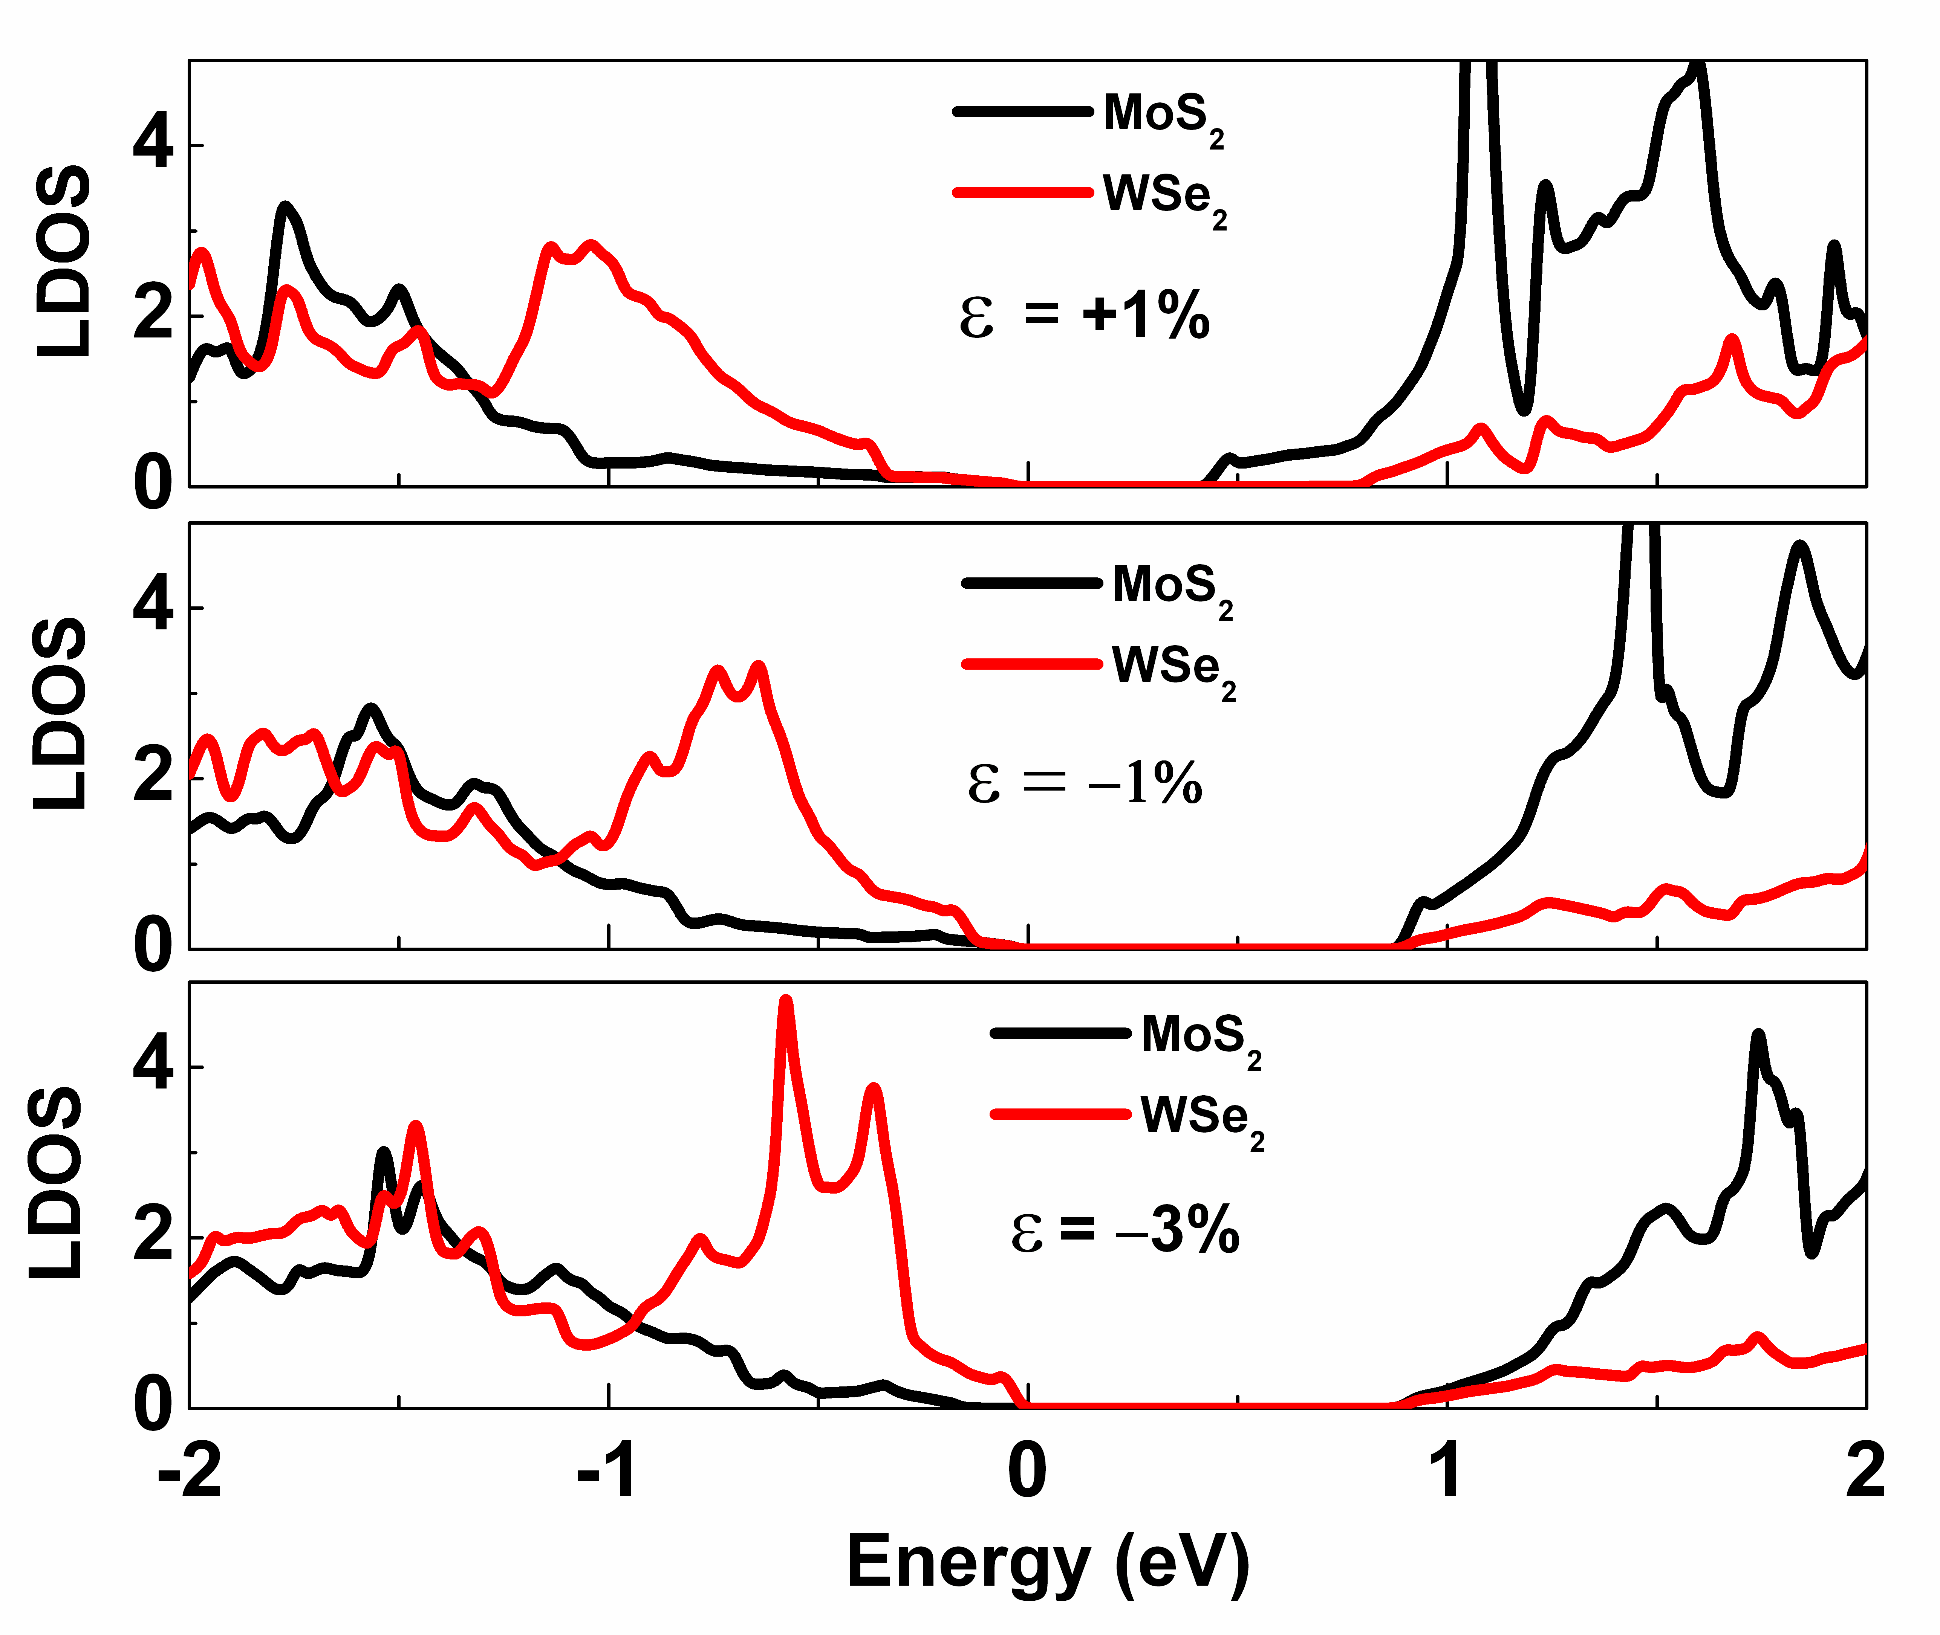
Figure s6 Local density of state (LDOS) of MoS₂/WSe₂ SLs under mechanical strains. Black and red lines correspond to the LDOS of MoS₂ and WSe₂ layers, respectively.

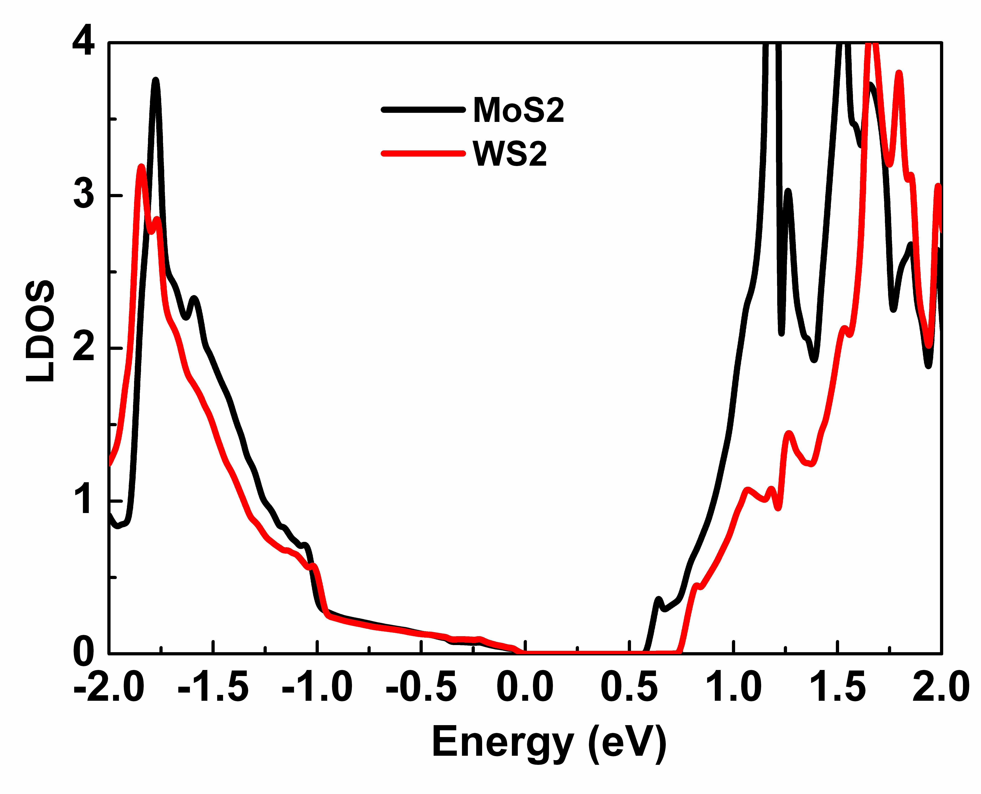
Figure s7 Local density of state (LDOS) of MoS₂/WSe₂ SL. Black and red lines correspond to the PDOS of MoS₂ and WSe₂ layers, respectively.

