Electronic Supplementary Information
Biocompatible and flexible graphene oxide/upconversion nanoparticle hybrid film for optical pH sensing†
Liang Yan,ª Ya-Nan Chang,ª Wenyan Yin,ª Xiaodong Liu,^{a,b} Debao Xiao,^{b} Gengmei Xing,ª Lina Zhao,*ª Zhanjun Gu*ª and Yuliang Zhao*ª
ª CAS Key Laboratory for Biomedical Effects of Nanomaterials and Nanosafety, Institute of High Energy Physics, Chinese Academy of Sciences, Beijing 100049, China. Fax: +86-10-88236786; E-mail: zjgu@ihep.ac.cn, linazhao@ihep.ac.cn, zhaoyuliang@ihep.ac.cn;
^{b} Hebei Key Laboratory of Applied Chemistry, School of Environmental and Chemical Engineering, Yanshan University, Qinhuangdao 066004, China.

Supporting Discussions
The strength of the interaction of GO nanosheets and PEI-NaYF₄:Yb,Er nanoparticles
Isothermal titration calorimetry (ITC) is a sensitive technique that measures the heat of reaction of two solutions when one is titrated against the other and thus has emerged as a powerful tool for studying the thermodynamic in biological systems. Until now, ITC has been employed with much success in studies related to protein-protein interactions, protein-DNA interactions, protein-lipid interactions, and so on.^{S1} Additively, ITC also has been used to study the interactions of biomolecules and nanocrystals such as gold nanocrystals.^{S2}
Owing to the huge π-conjugation system, as well as the large amounts of oxygen-containing functional groups located both on the plane and the edges, GO sheets readily “load from” or “load on” other materials to improve their properties or prepare nanocomposites with unique performance via hydrogen bond, π-π stack, or Van der Waals force.^{S3} ITC is used to study the intensity of the interaction of GO and PEI-NaYF₄:Yb,Er nanoparticles. In our experiment, in order to availably determine thermodynamic data, we first study the interaction between GO nanosheets and PEI polymer instead of PEI-NaYF₄:Yb,Er nanoparticles. The molarity of GO nanosheets is obtained by using the molecular weight of chemical formula. ITC responses recorded during titration of GO solution into PEI solutions with different pH values after correction for dilution effects are shown in Fig. S10. As can be seen, the hybridation processes are exothermic for all pH values. Strikingly, a much larger number of injections are needed to reach saturation for the pH 7.00, 8.00 and 9.00 compared to the case of pH 5.00, implying a higher loading of PEI for higher pH values. Furthermore, the signal at pH 12.00 is only slightly higher than that in the blank titration, indicating that few PEI is loaded onto the surface of GO. As shown in Fig. S11, the enthalpy change (ΔH ) was negative in all cases but appeared to be more negative for pH at 7.00~9.00. Our results indicate that ΔH of the hybridation process is pH dependent. From the viewpoint of chemistry that the binding enthalpy is the term that predominantly reflects the strength of the interactions due to long-range electrostatic interactions and short-range hydrogen bond formation,^{S4} we could infer that the strength of electrostatic interaction of GO nanosheets and PEI firstly increases in the pH 5.00-8.00, and then decreases in the pH 8.00-12.00, showing a pH-dependent manner. According to the ITC analysis, in the case of PEI polymer coated onto nanocrystals surfaces, the positively charged PEI tails also preferentially adsorbed on the negatively charged GO nanosheets via electrostatic interaction to minimize their disruptive effect during the mixing process (Fig. 1c). Considering that there were ten thousands of PEI coated on the surface of nanocrystals, the strength of the electrostatic interaction of GO nanosheets and PEI tails was also pH dependent.
We further established a model to understand this binding process (Scheme 1 and Fig. S9b). It is estimated that the pK_{as} of –COOH of GO and –NH₂ of PEI were similar to those of weak organic aliphatic acids (pK_{a}~4.00-5.00) and protonated organic ammonium salts (pK_{a}~9.00-11.00), respectively.^{S5} At pH 5.00, through –NH₂ of PEI is fully protonated (–NH₃⁺), only part of –COOH on the GO nanosheets is deprotonated (–COO⁻). It means that the conversion of –COO⁻ to –COOH in the acid dispersion is the main reason for the decrease of binding interaction. Thus, in this case, PEI-NaYF₄:Yb,Er nanoparticles do not tightly bind to GO nanosheets. On the other hand, at pH 12.00, –COOH of GO nanosheets is fully deprotonated, but almost no –NH₂ groups are protonated, resulting in that it is unfavorable to bind PEI-NaYF₄:Yb,Er nanoparticles on GO nanosheets. However, at pH 8.00, –NH₂ is protonated and –COOH is ionized. PEI-NaYF₄:Yb,Er nanoparticles can be tightly bound on GO nanosheets. In this case, multiple hydrogen bonds can be formed between these charged or polar groups of PEI tails and GO nanosheets. Indeed, as expected at pH 7.00-9.00, the hybrids were readily prepared and the degree of GO’s wrinkle was more significant than that at pH 5.00 and 12.00. The –NH₂ groups in PEI could not protonated, and so not be positively charged at high pH values. The high pH should not affect the negative charges of –COOH on the GO. As predicted, when the solution pH was increased to 12.00, a large number of GO failed to interact with PEI-coated NaYF₄:Yb,Er nanoparticles.
pH-dependent quenching effect
Having been demonstrated by ITC analysis, along with the increase of pH, the electrostatic interaction of GO and PEI increases firstly and then decreases. Thus, when pH is too low, the strength of electrostatic interaction is relatively weak, resulting in that the upconversion luminescence of PEI-NaYF₄:Yb,Er nanoparticles is not significantly quenched by GO nanosheets. When pH gets close to 8.00, –NH₂ is protonated (–NH₃⁺) and –COOH is ionized (–COO⁻), leading to the increase of interaction strength and effective binding contact interface between GO nanosheets and PEI-NaYF₄:Yb,Er nanoparticles, and then enhance the quenching efficiency. As expected, on increasing pH from 5.00 to 8.00, the intensity of upconversion luminescence gradually decreases, showing pH-dependent luminescence quenching effect. Similar electrostatic effects also have been reported by Ando and Bronshtein.^{S6}

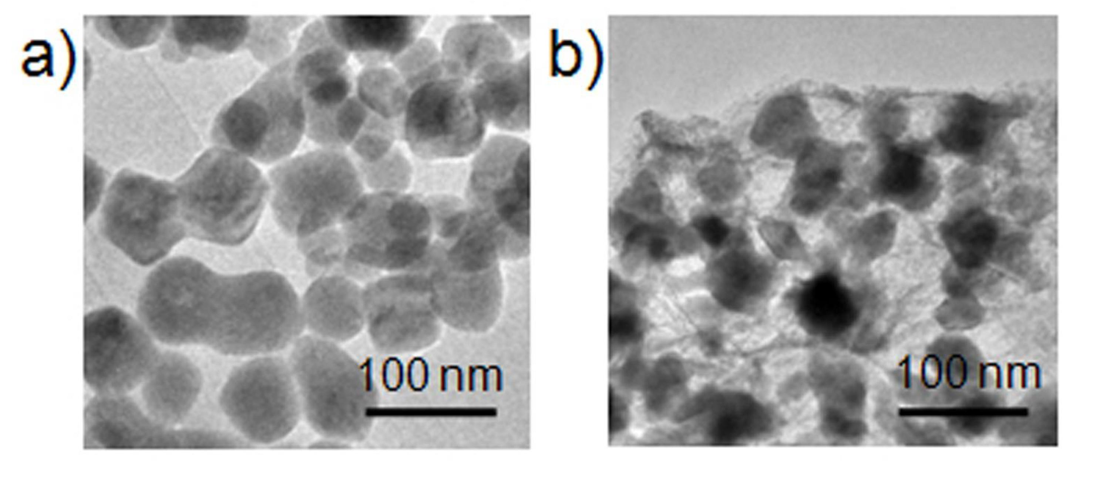
Fig. S1 TEM images of PEI-NaYF₄:Yb,Er nanoparticles and GO/PEI-NaYF₄:Yb,Er hybrid.
The TEM image reveals that not only there is no nanoparticle distribution without the presence of GO sheets, but these GO sheets are firmly attached to PEI-NaYF₄:Yb,Er nanoparticles, even after the ultrasonic dispersion of GO/PEI-NaYF₄:Yb,Er hybrids for TEM characterization.
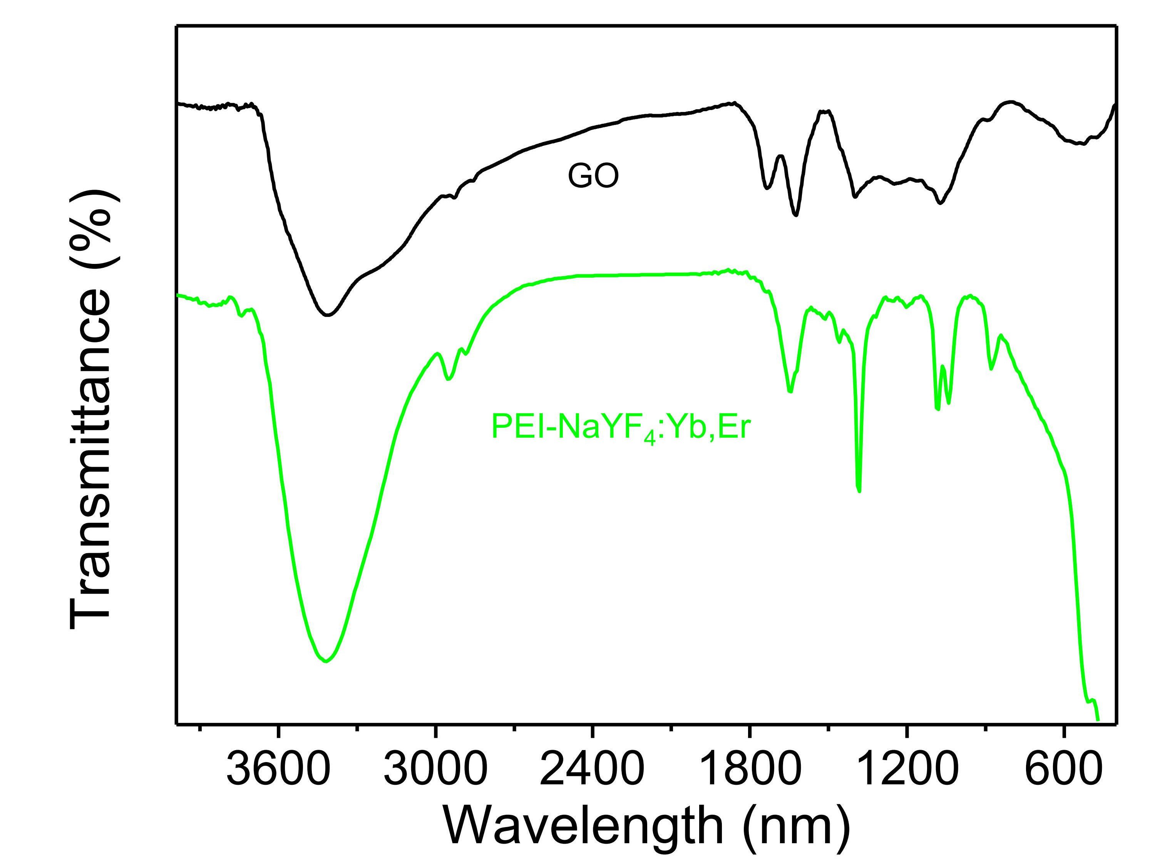
Fig. S2 FT-IR spectra of GO (black line) and PEI-NaYF₄:Yb,Er nanoparticles.
FT-IR spectrum of GO indicates the presence of C=O (1731 cm⁻¹), C-O (1064 cm⁻¹), C-O-C (1252 cm⁻¹), C-OH (1403 cm⁻¹).^{S7} The peak found at 1621 cm⁻¹ is a resonance peak that can be assigned to the C-C stretching and absorbed hydroxyl groups in the GO. These results indicate that there are many kinds of oxygen-containing functional groups on the GO, resulting in GO dispersing well in water.
In the FT-IR spectrum of PEI-NaYF₄:Yb,Er nanoparticles, the internal vibration of the amide bonds (1380-1630 cm⁻¹) and CH₂ stretching vibrations (2850-2960 cm⁻¹) could clearly be seen, which clearly indicates the presence of PEI.^{S8} Moreover, the absorption peak at about 1520 cm⁻¹, assigning to amine groups, suggests that there are still a number of free amine groups available on PEI-NaYF₄:Yb,Er nanoparticles. The free amine groups, which can be readily protonated, provide enough interaction sites to load with negative-charged GO nanosheets.
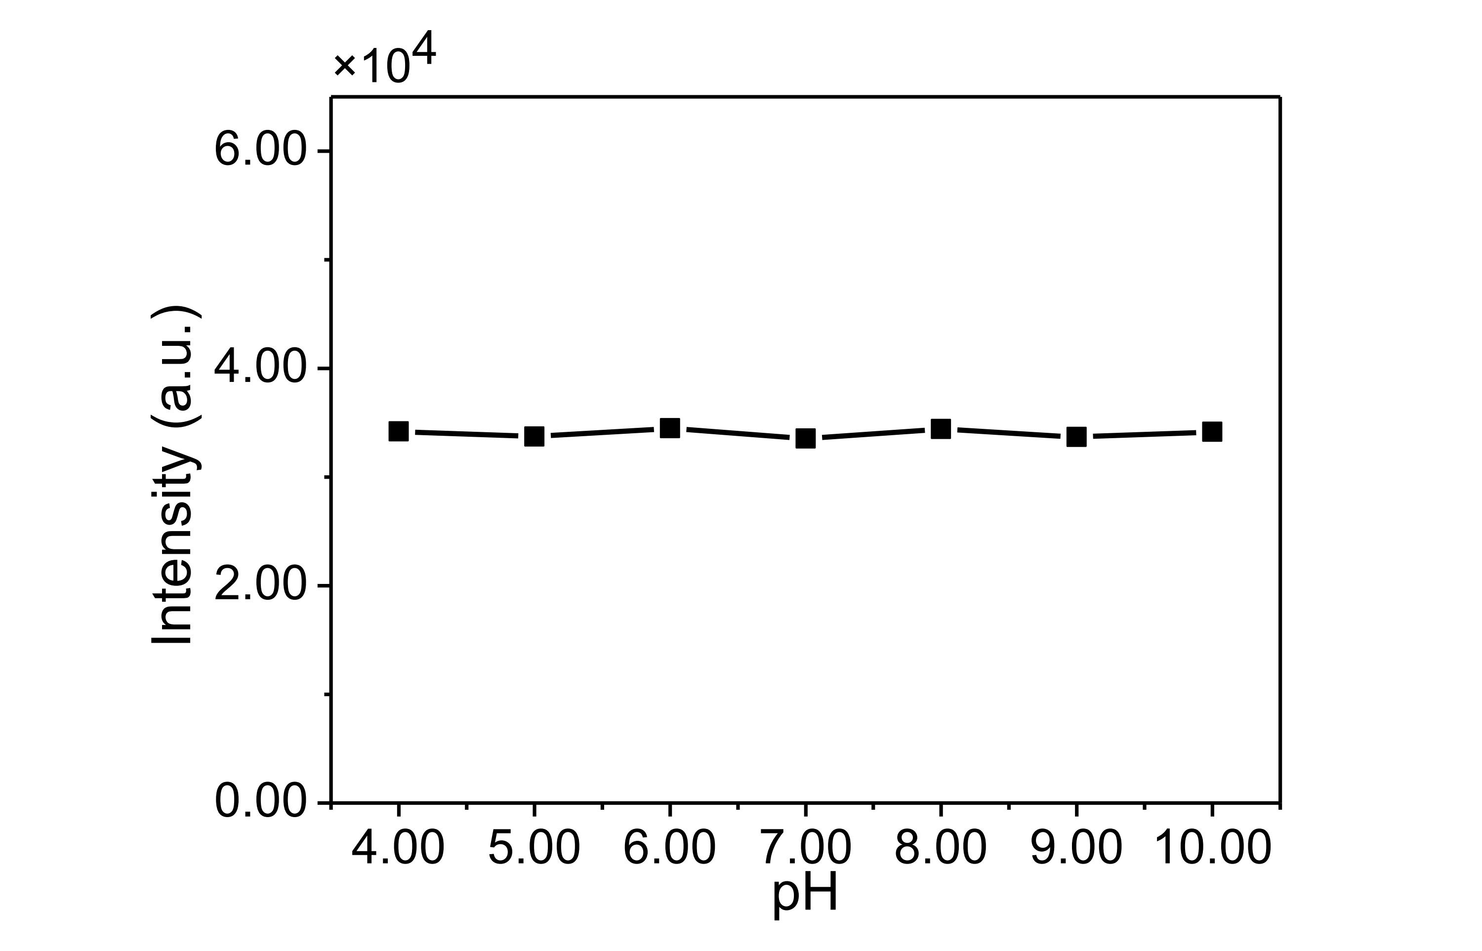
Fig. S3 Upconversion luminescence intensity of PEI-NaYF₄:Yb,Er nanoparticles in Britton-Robinson buffers with different pH values.
The result shows that the upconversion luminescence intensity of PEI-NaYF₄:Yb,Er nanoparticles is independent of pH in the range from 4.00 to 9.00.
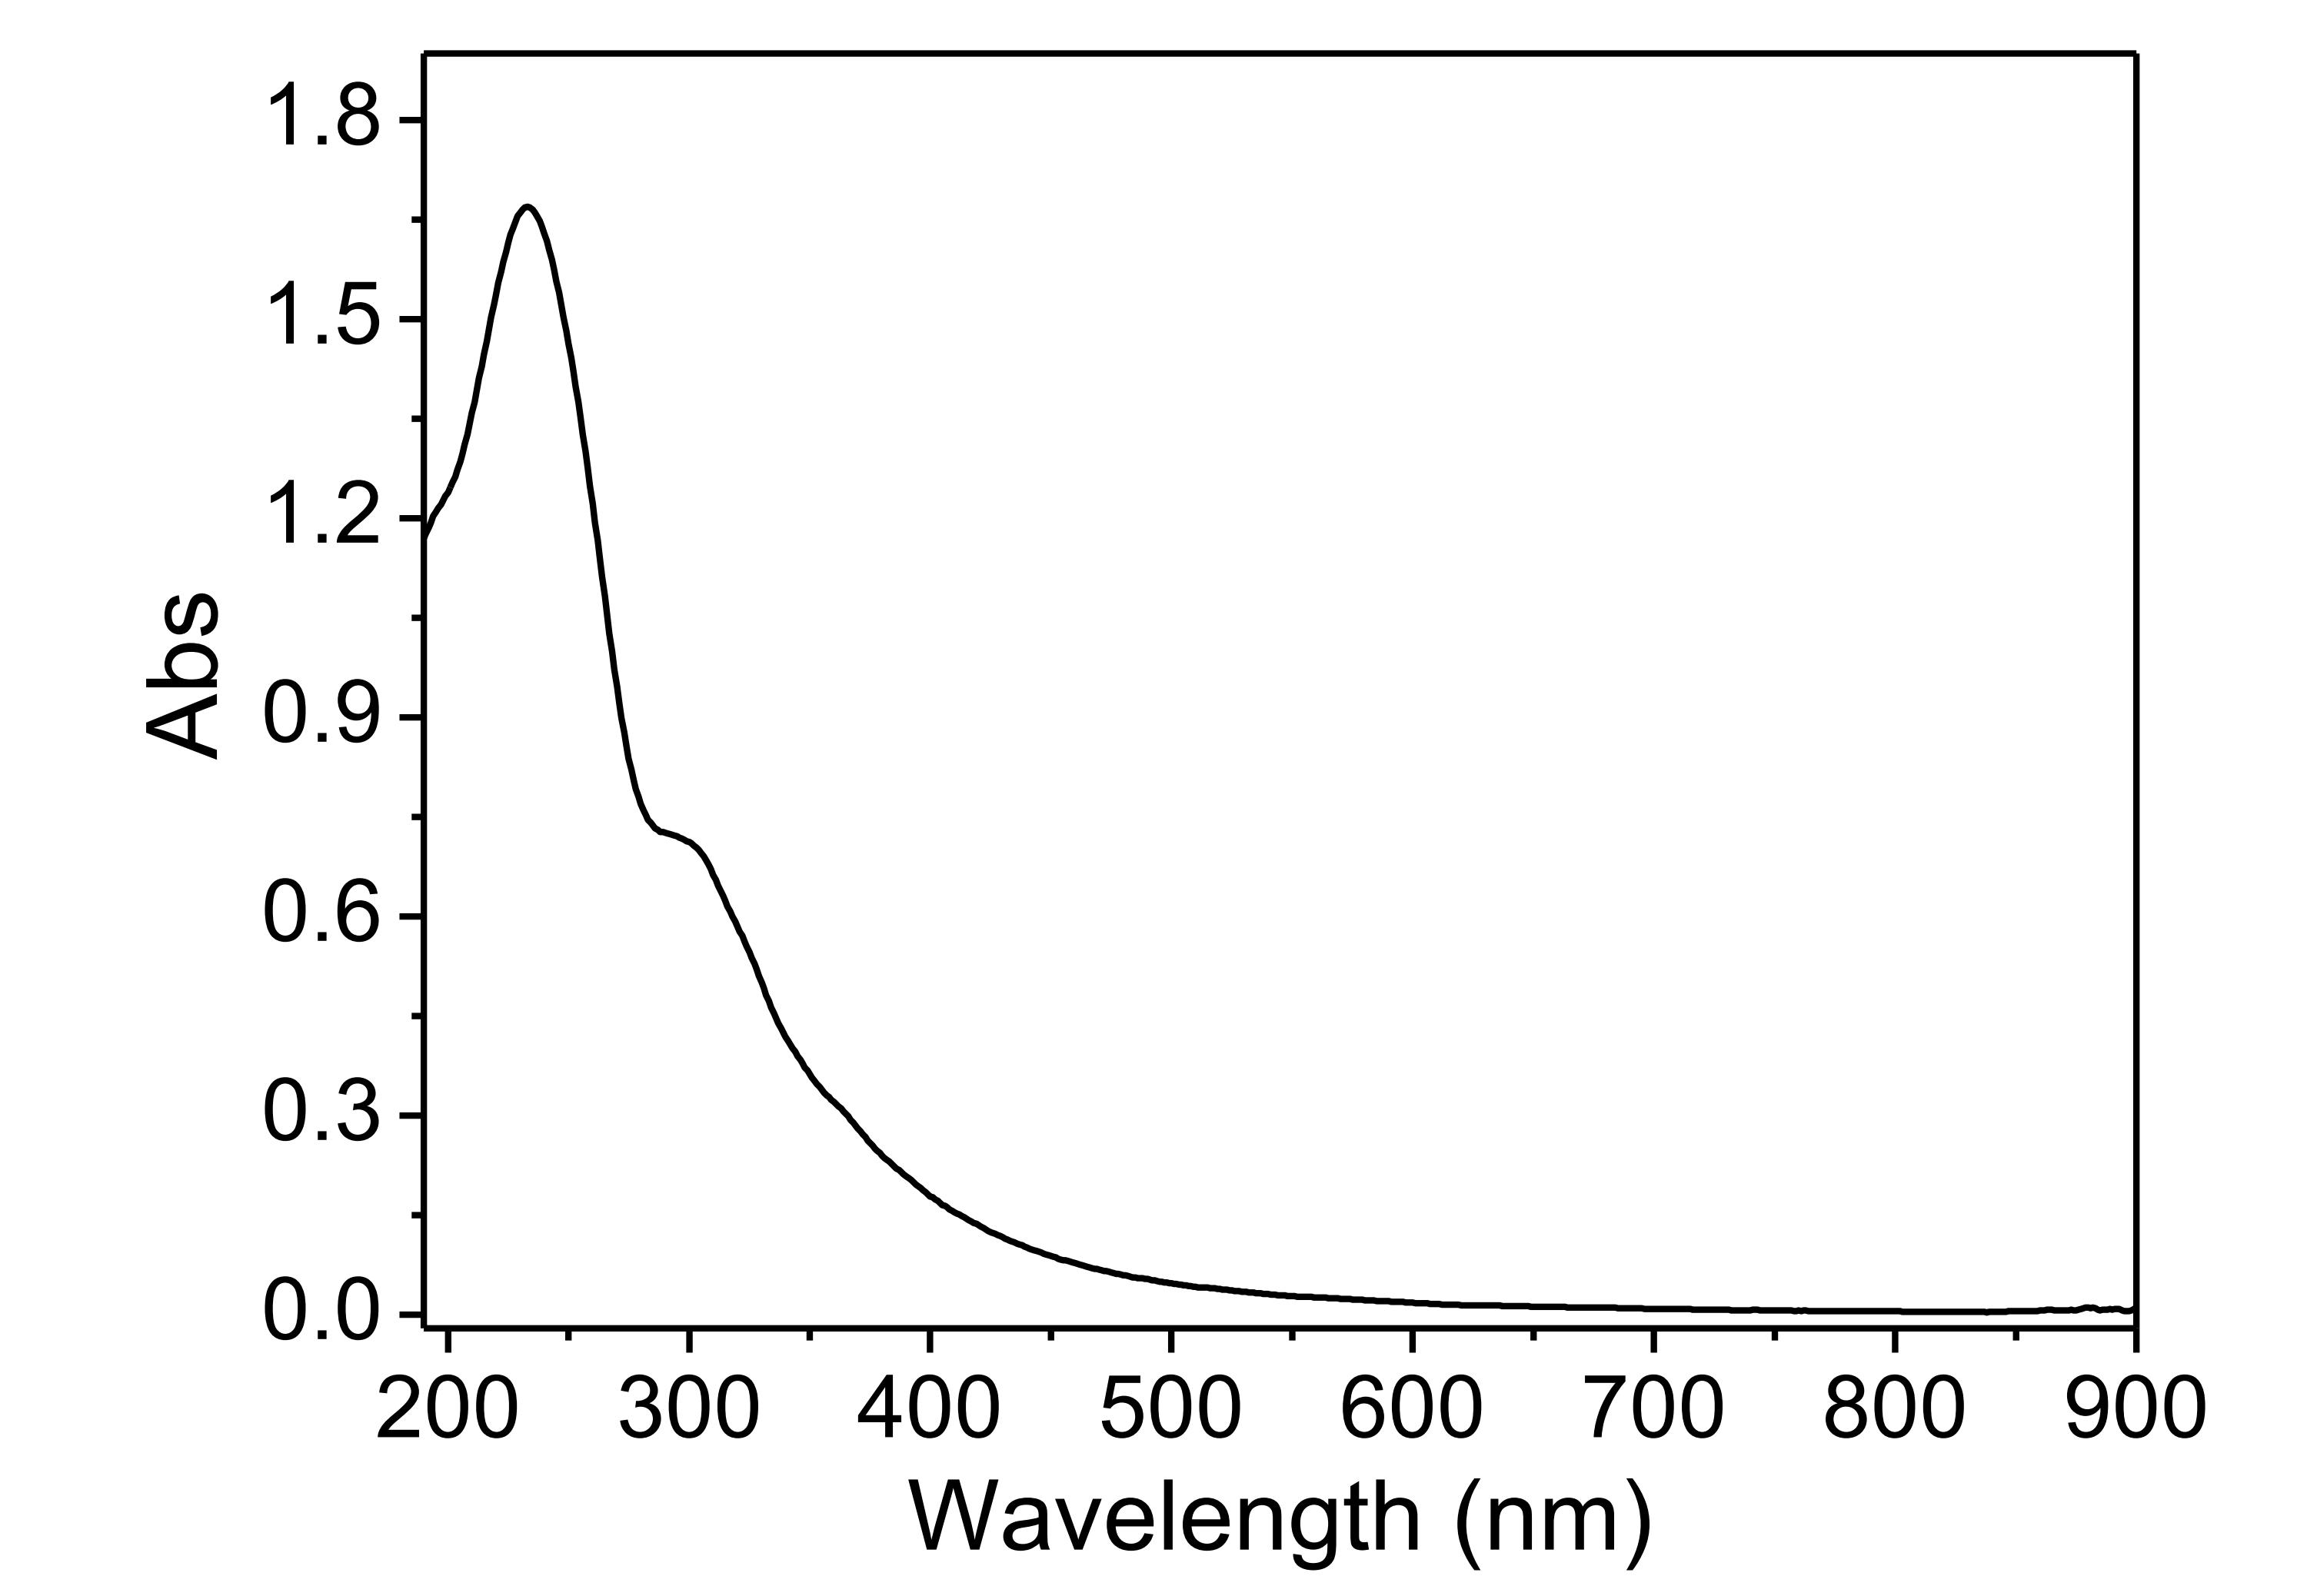
Fig. S4 UV-vis spectrum of GO.
This result indicates that graphene is heavily oxidized, then leading to the presence of various oxygen-containing functional groups, such as carboxyl, hydroxyl.
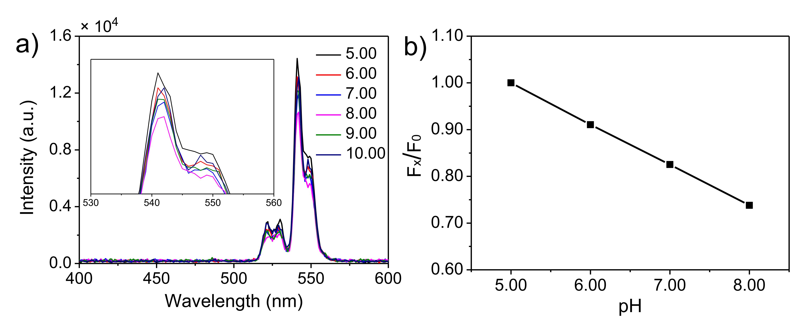
Fig. S5 (a) Upconversion luminescence spectra of GO/PEI-NaYF₄:Yb,Er hybrid as a function of pH upon diode laser excitation at 980 nm; (b) the upconversion luminescence intensity of the sensor film with F_{x}/F₀ plotted against the pH values.
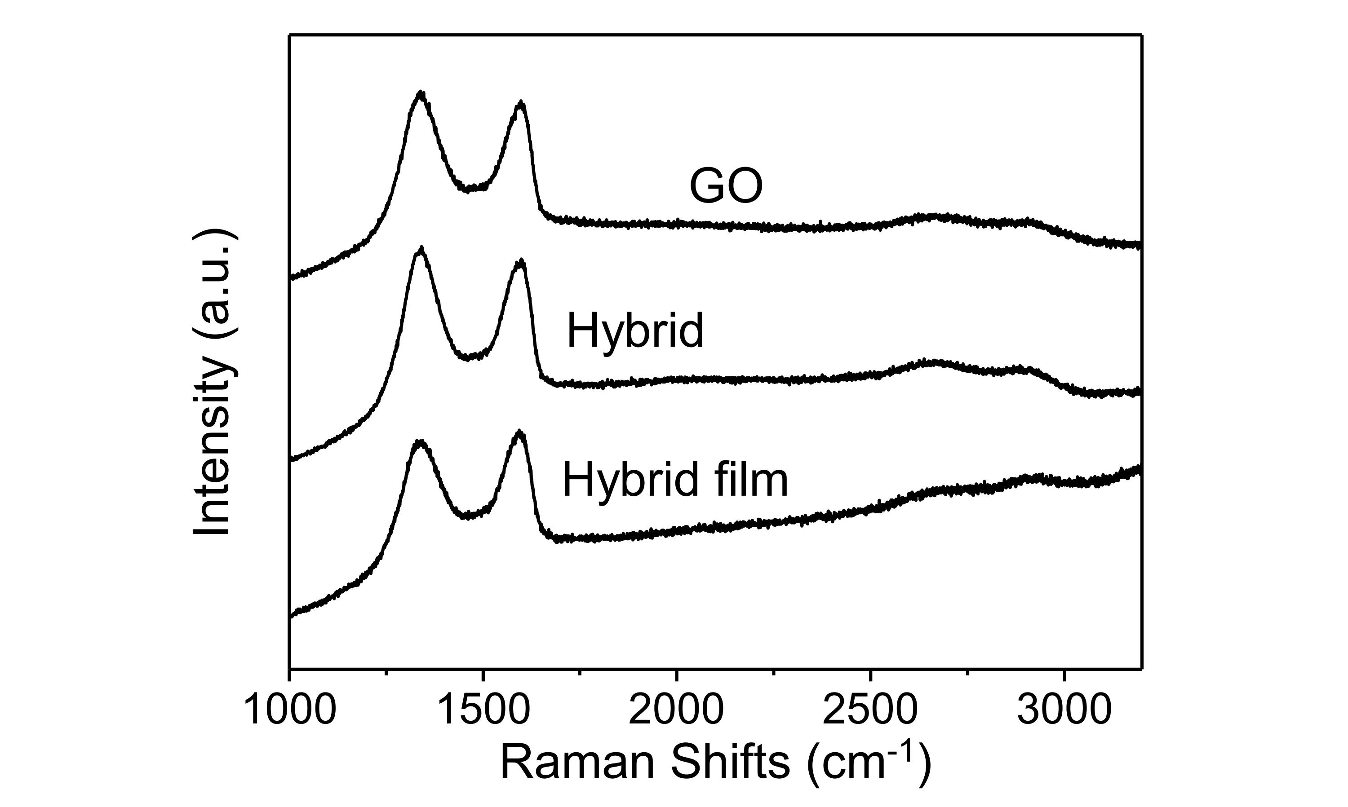
Fig. S6 Raman spectra of GO, GO/PEI-NaYF₄:Yb,Er hybrid, and hybrid film.
The Raman analysis indicates that the GO structures are kept intact during the hybridation process.
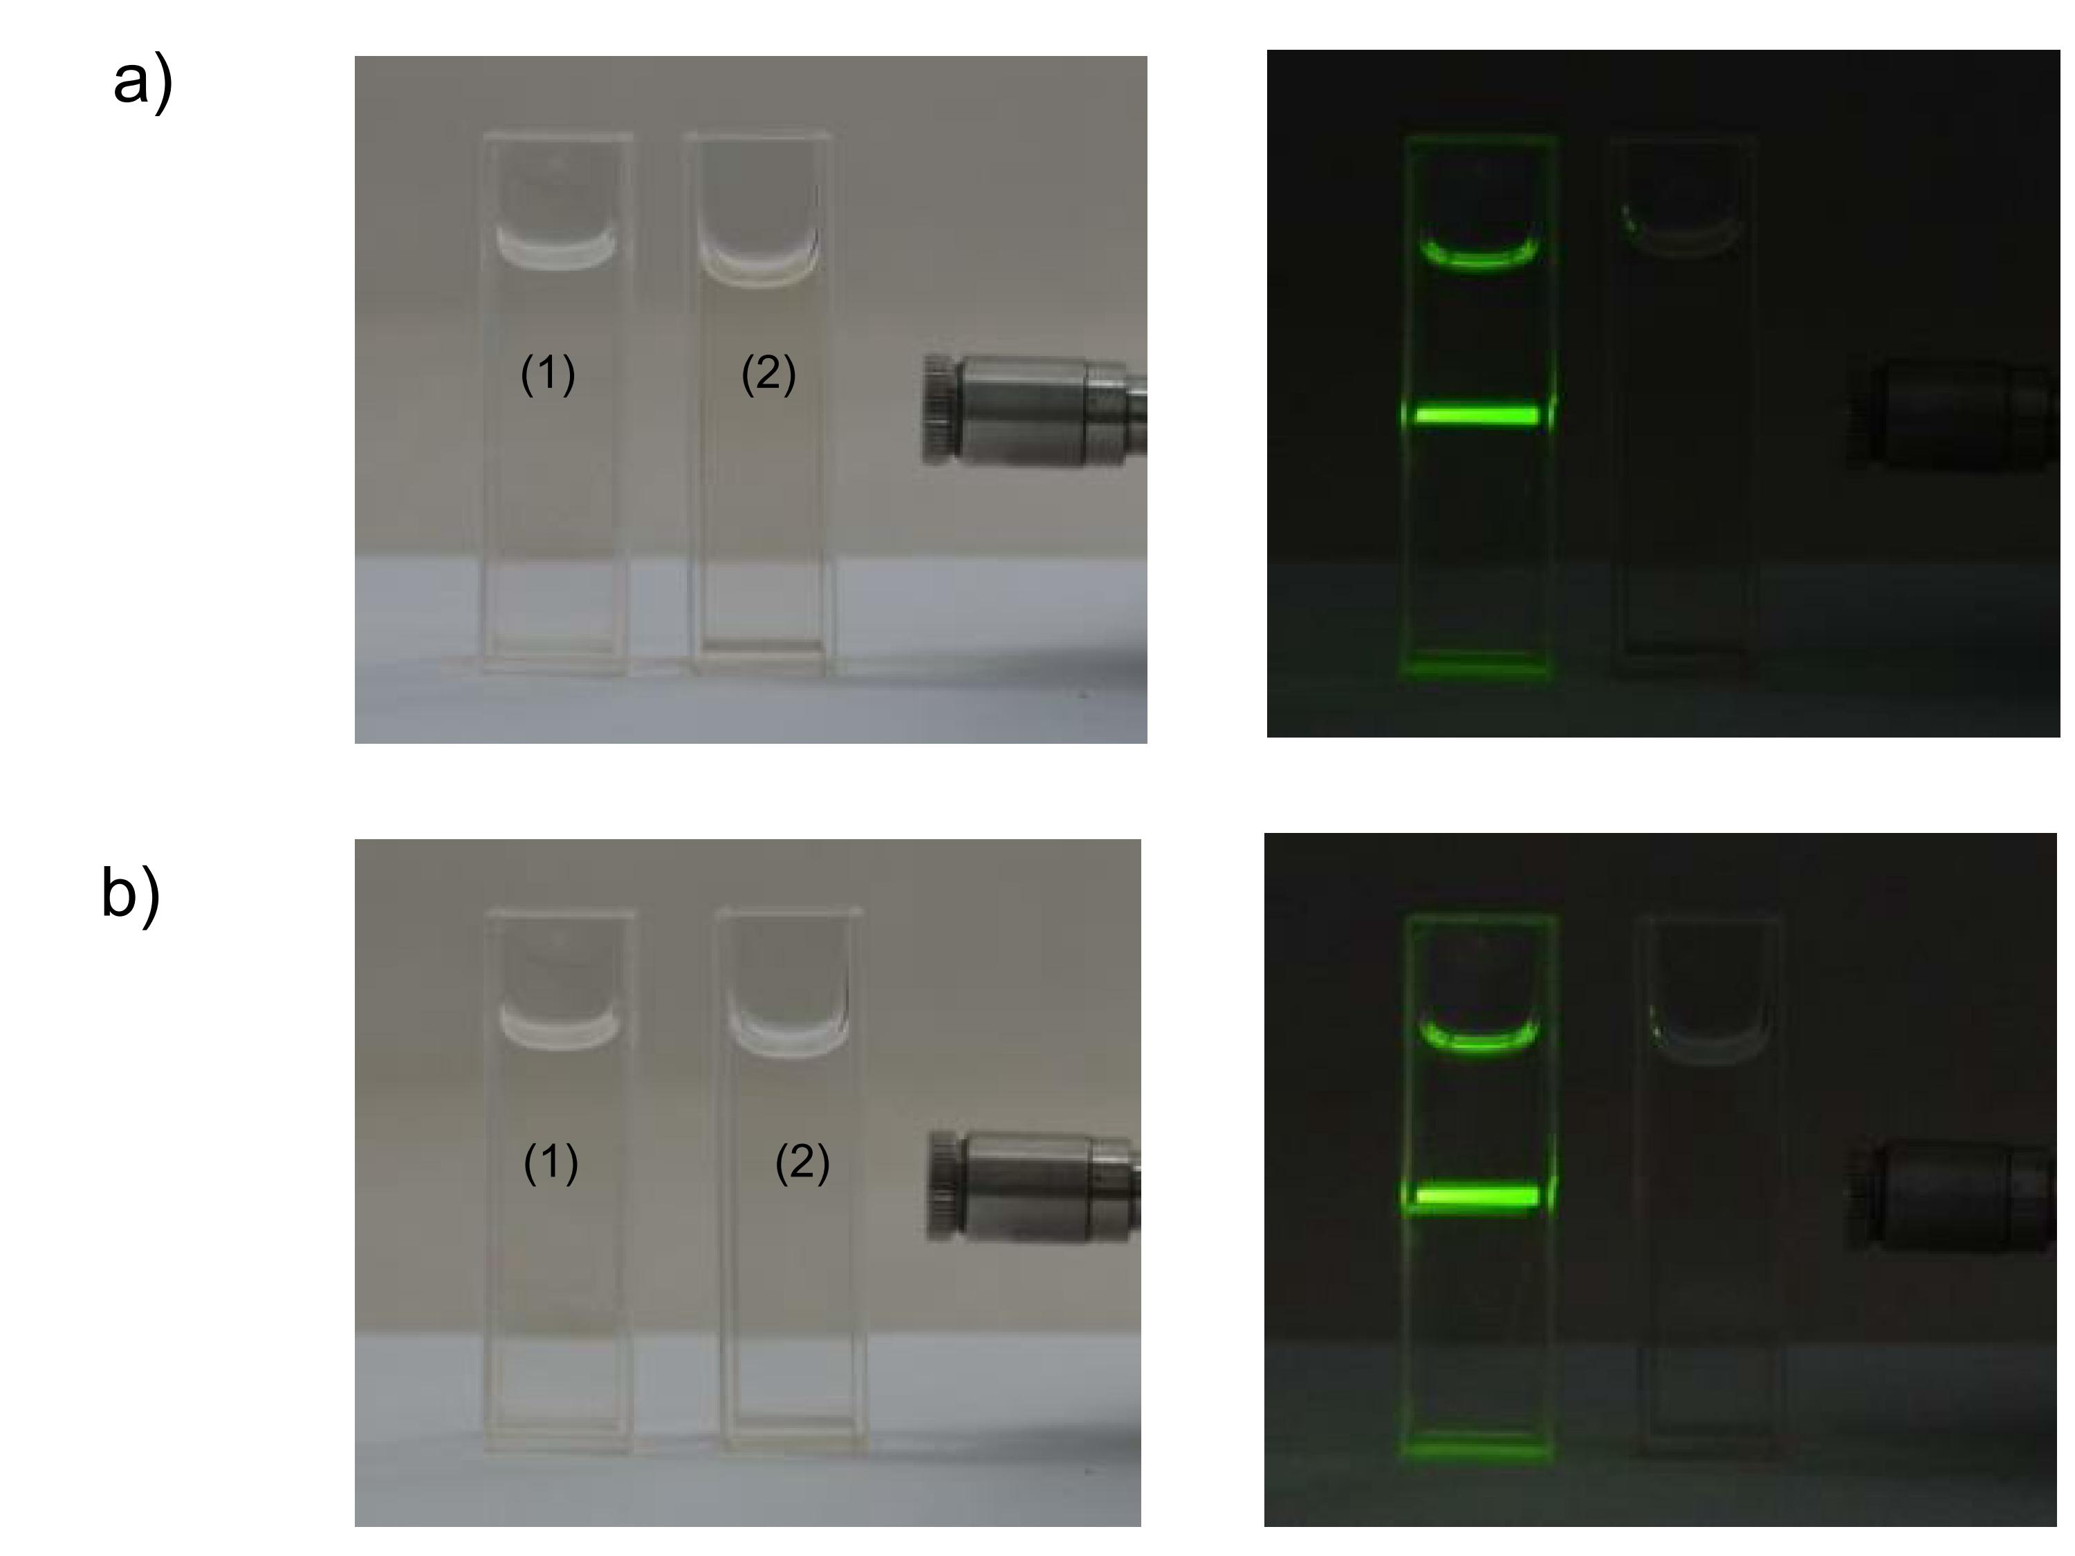
Fig. S7. Photographs of B-R buffer solutions with pH 6.00 (a) and 8.00 (b), respectively under daylight (left) and 980 nm (right) excitation.
The solutions of (1) and (2) are PEI-NaYF₄:Yb,Er suspension (as reference) and B-R buffer solutions after testing repetitive cycling experiment, respectively. This indicates that there are on PEI-NaYF₄:Yb,Er nanoparticles leaking from the sensor film.
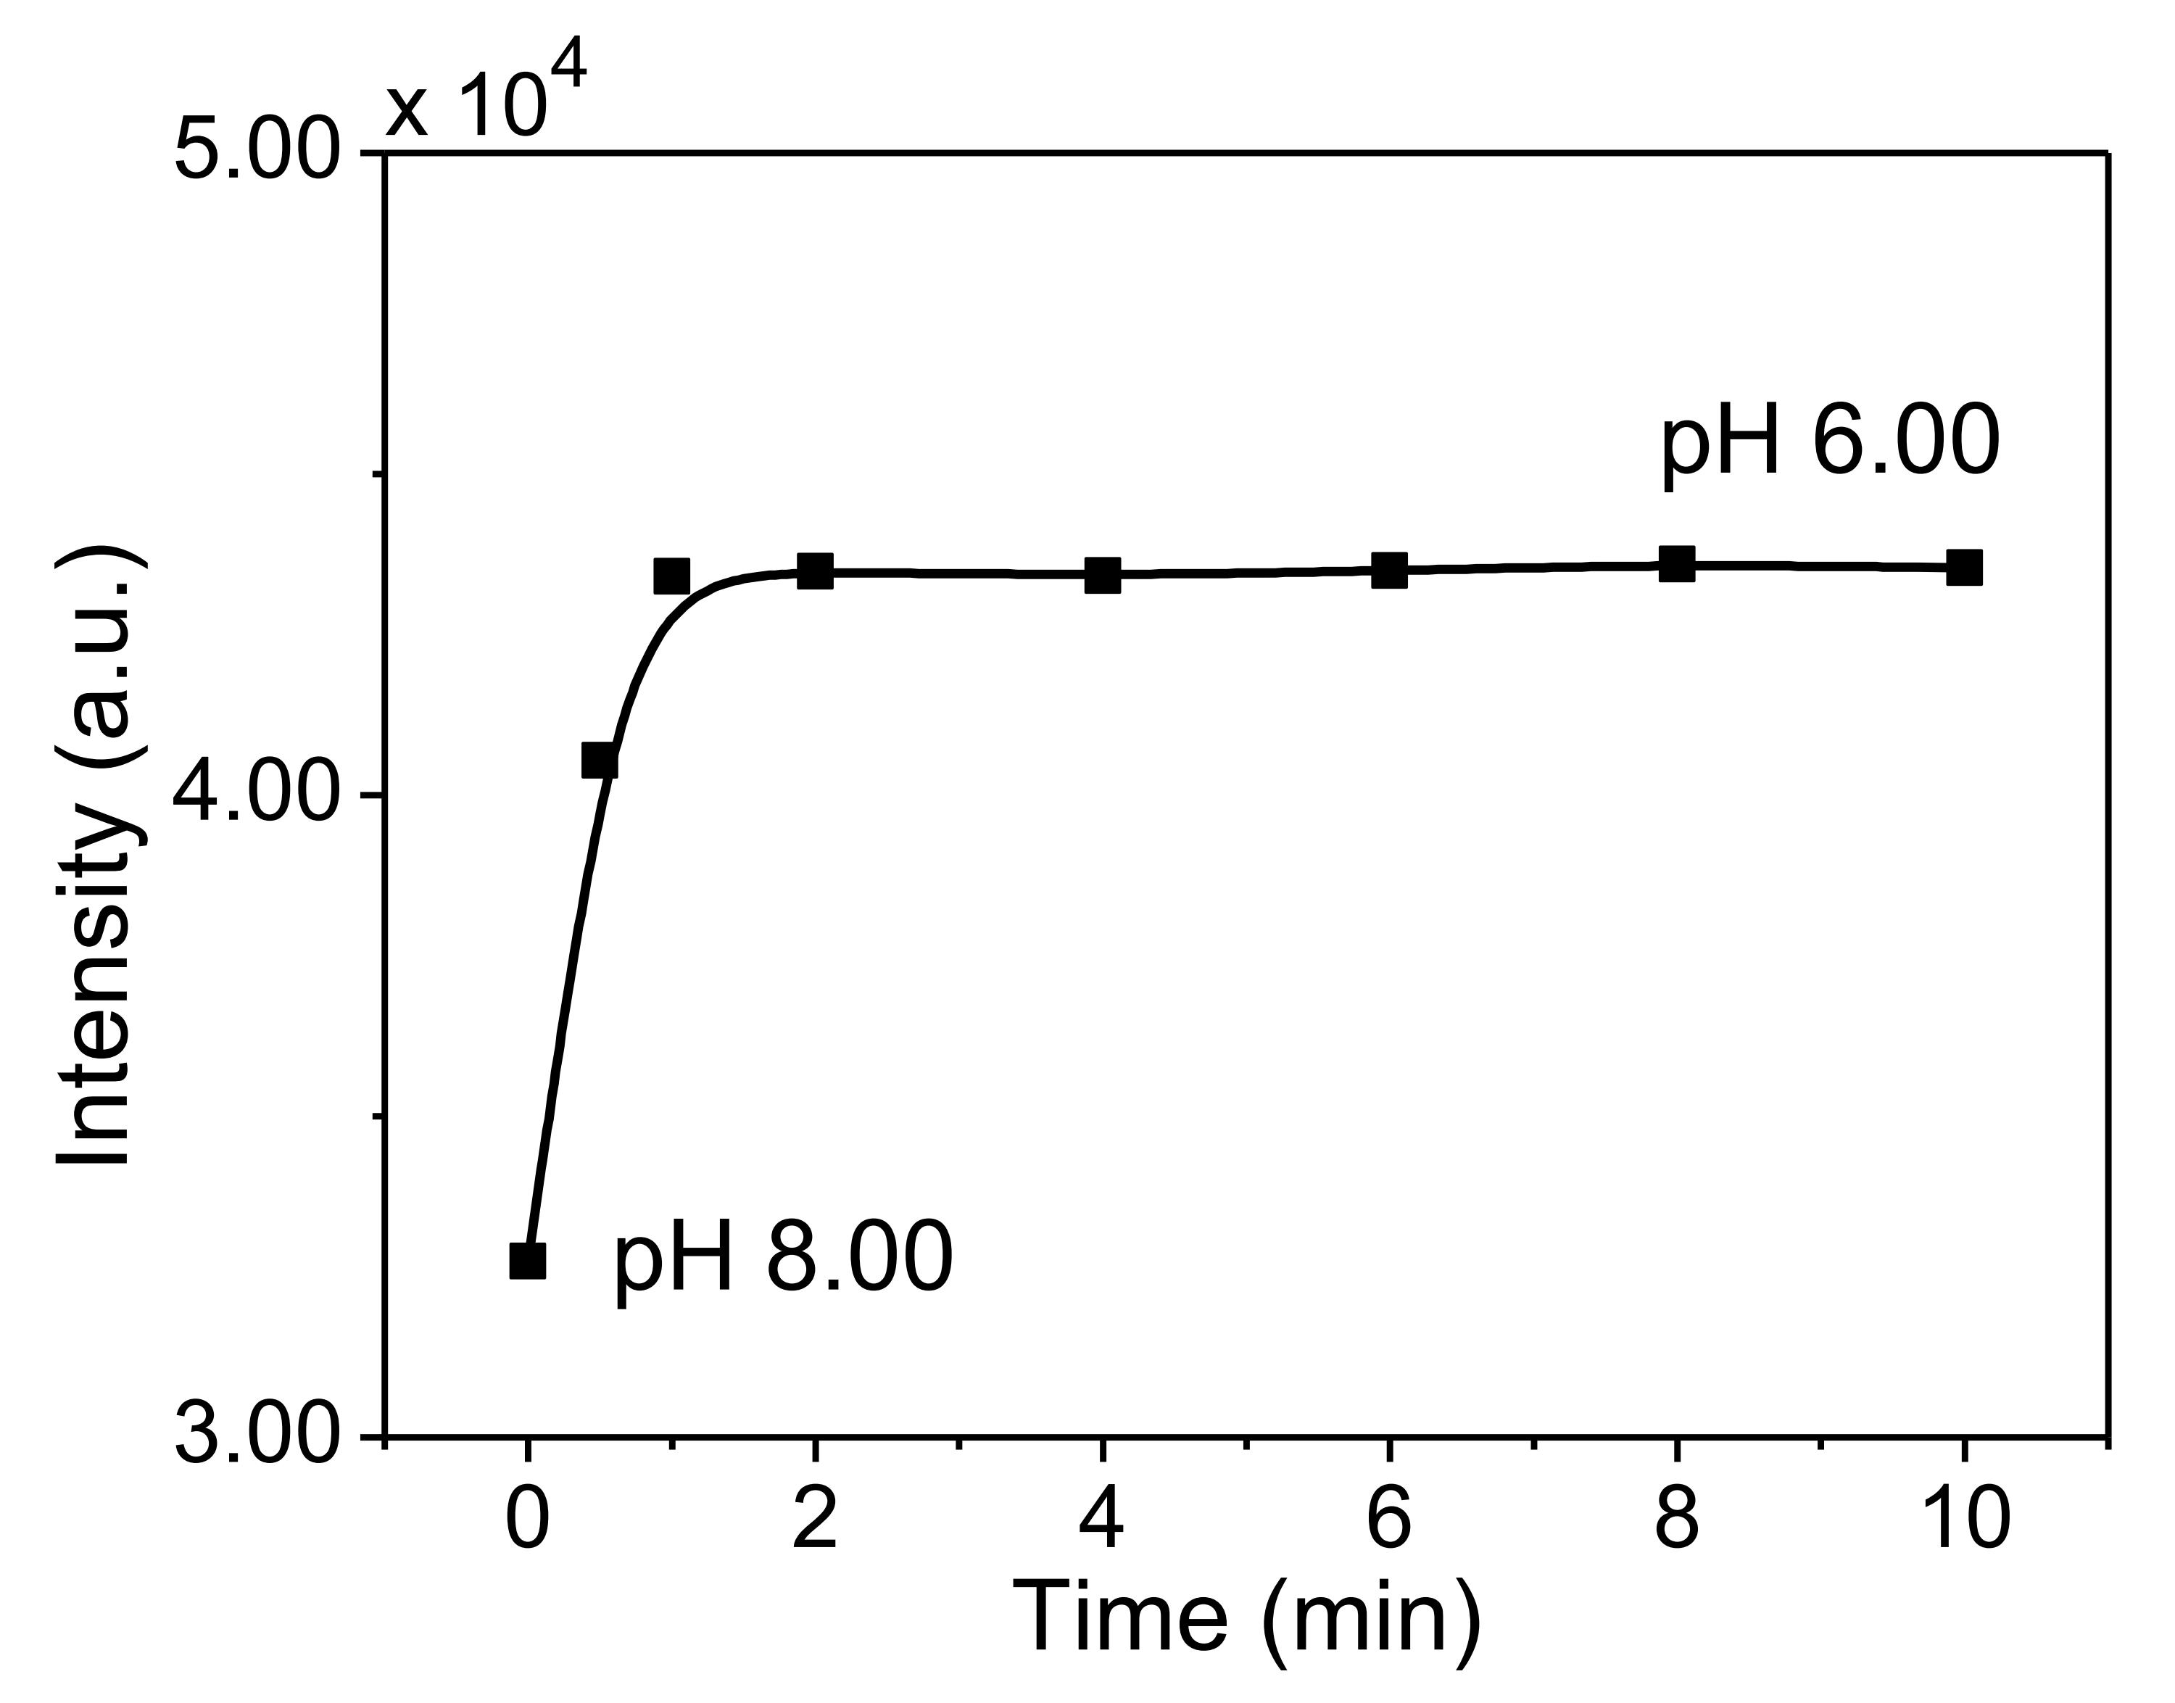
Fig. S8 Evaluation of upconversion luminescence intensity for sensor film between pH 6.00 and pH 8.00.
This result indicates that response occurs within less than 60 s. At the same time, the upconversion luminescence is rather stability in the B-R buffer solutions.
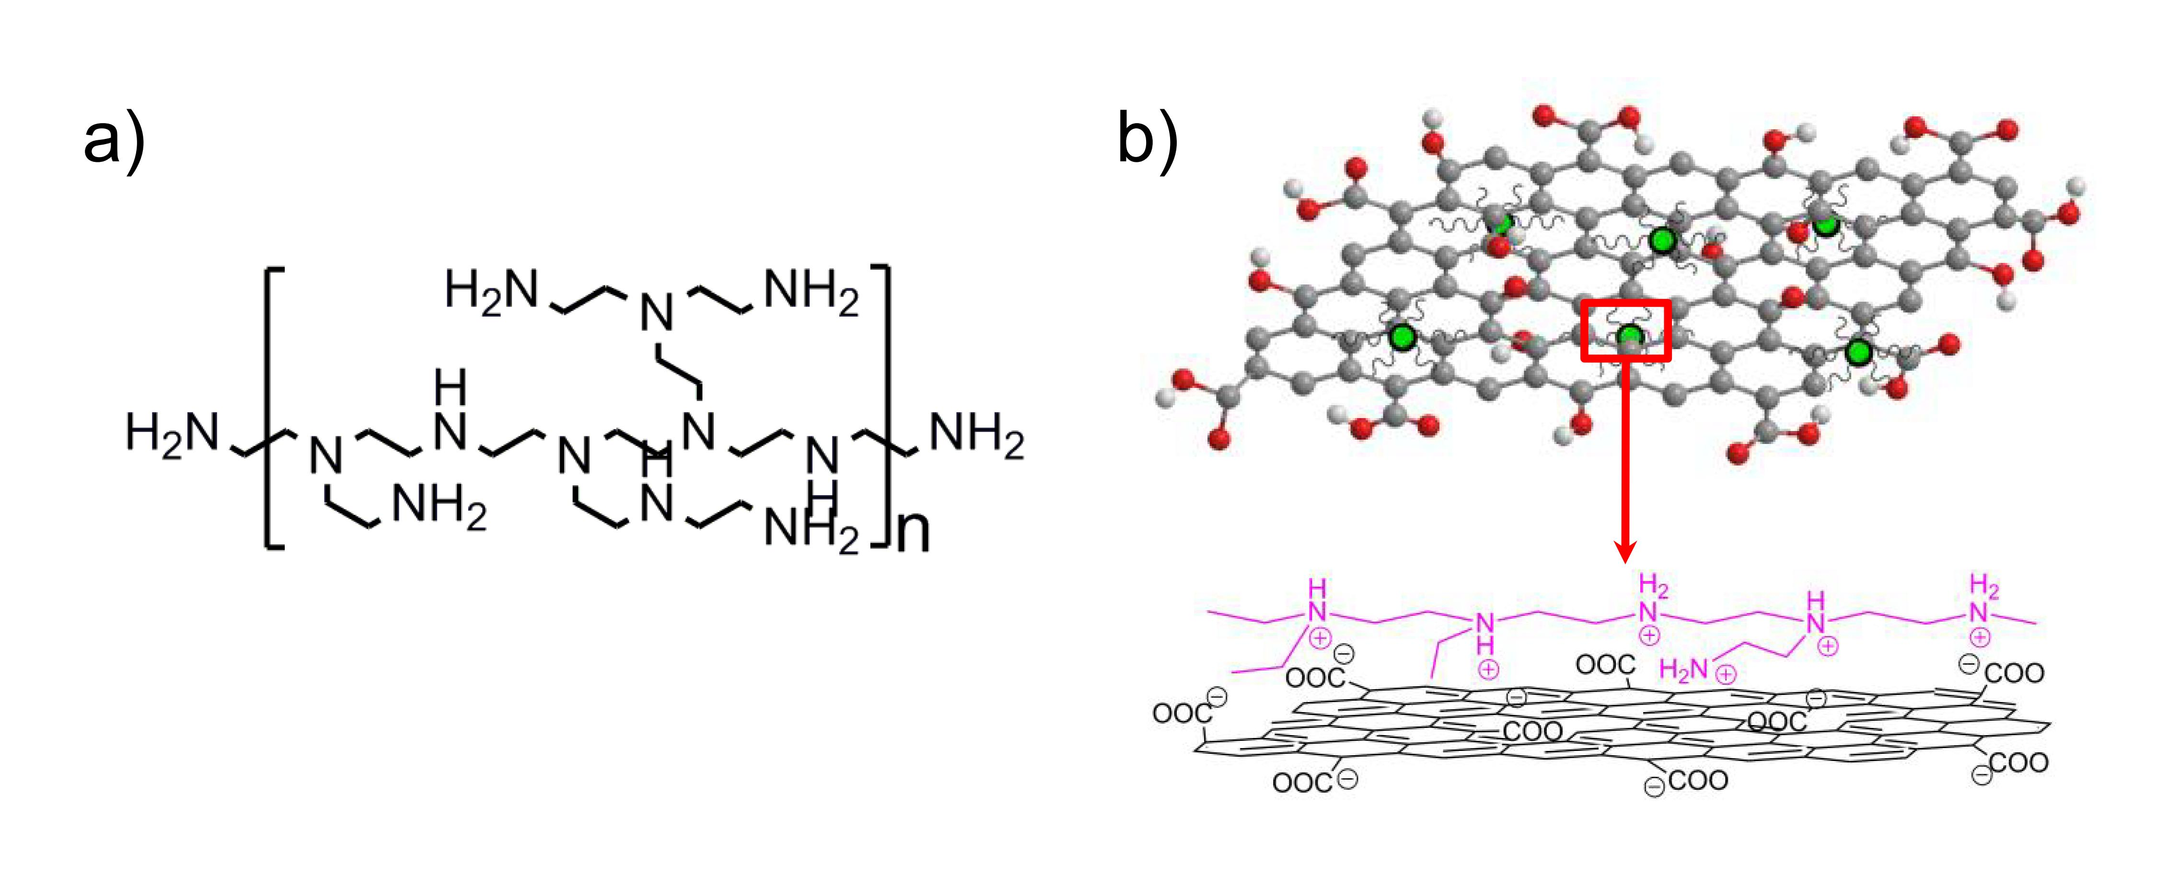
Fig. S9. (a) The structure of PEI polymer. (b) The model of the interaction of GO nanosheets and PEI-NaYF₄:Yb,Er nanoparticles.
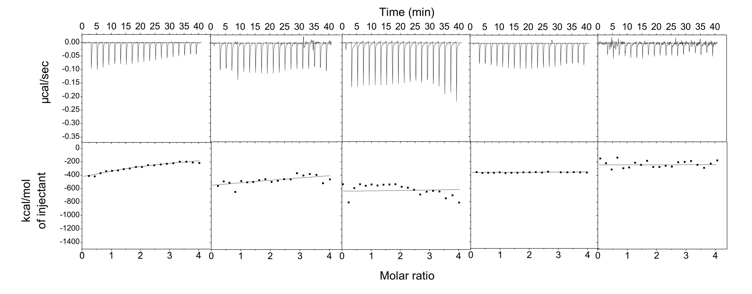
Fig. S10 ITC data for titration of GO into PEI aqueous with pH 5.00, 7.00, 8.00, 9.00 and 12.00.
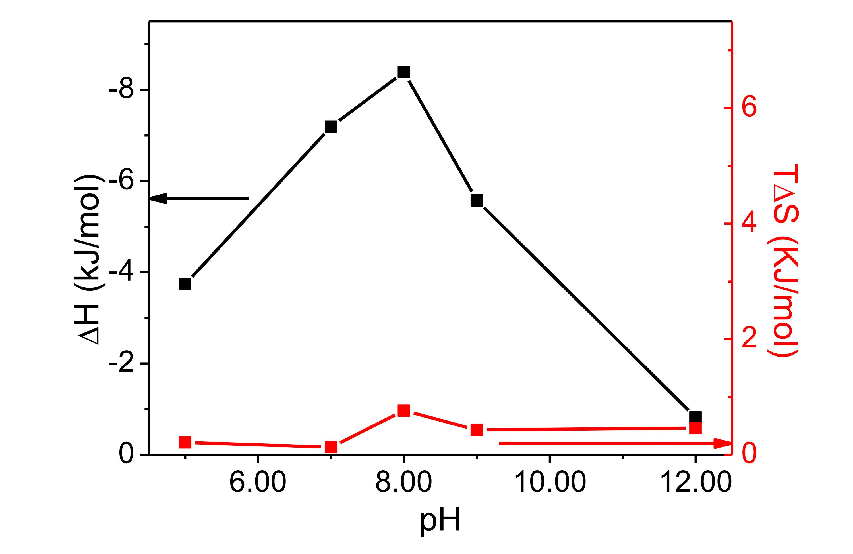
Fig. S11 ΔH (black) and TΔS (red) of hybridation process at various pH values when titrating GO aqueous into PEI solution.
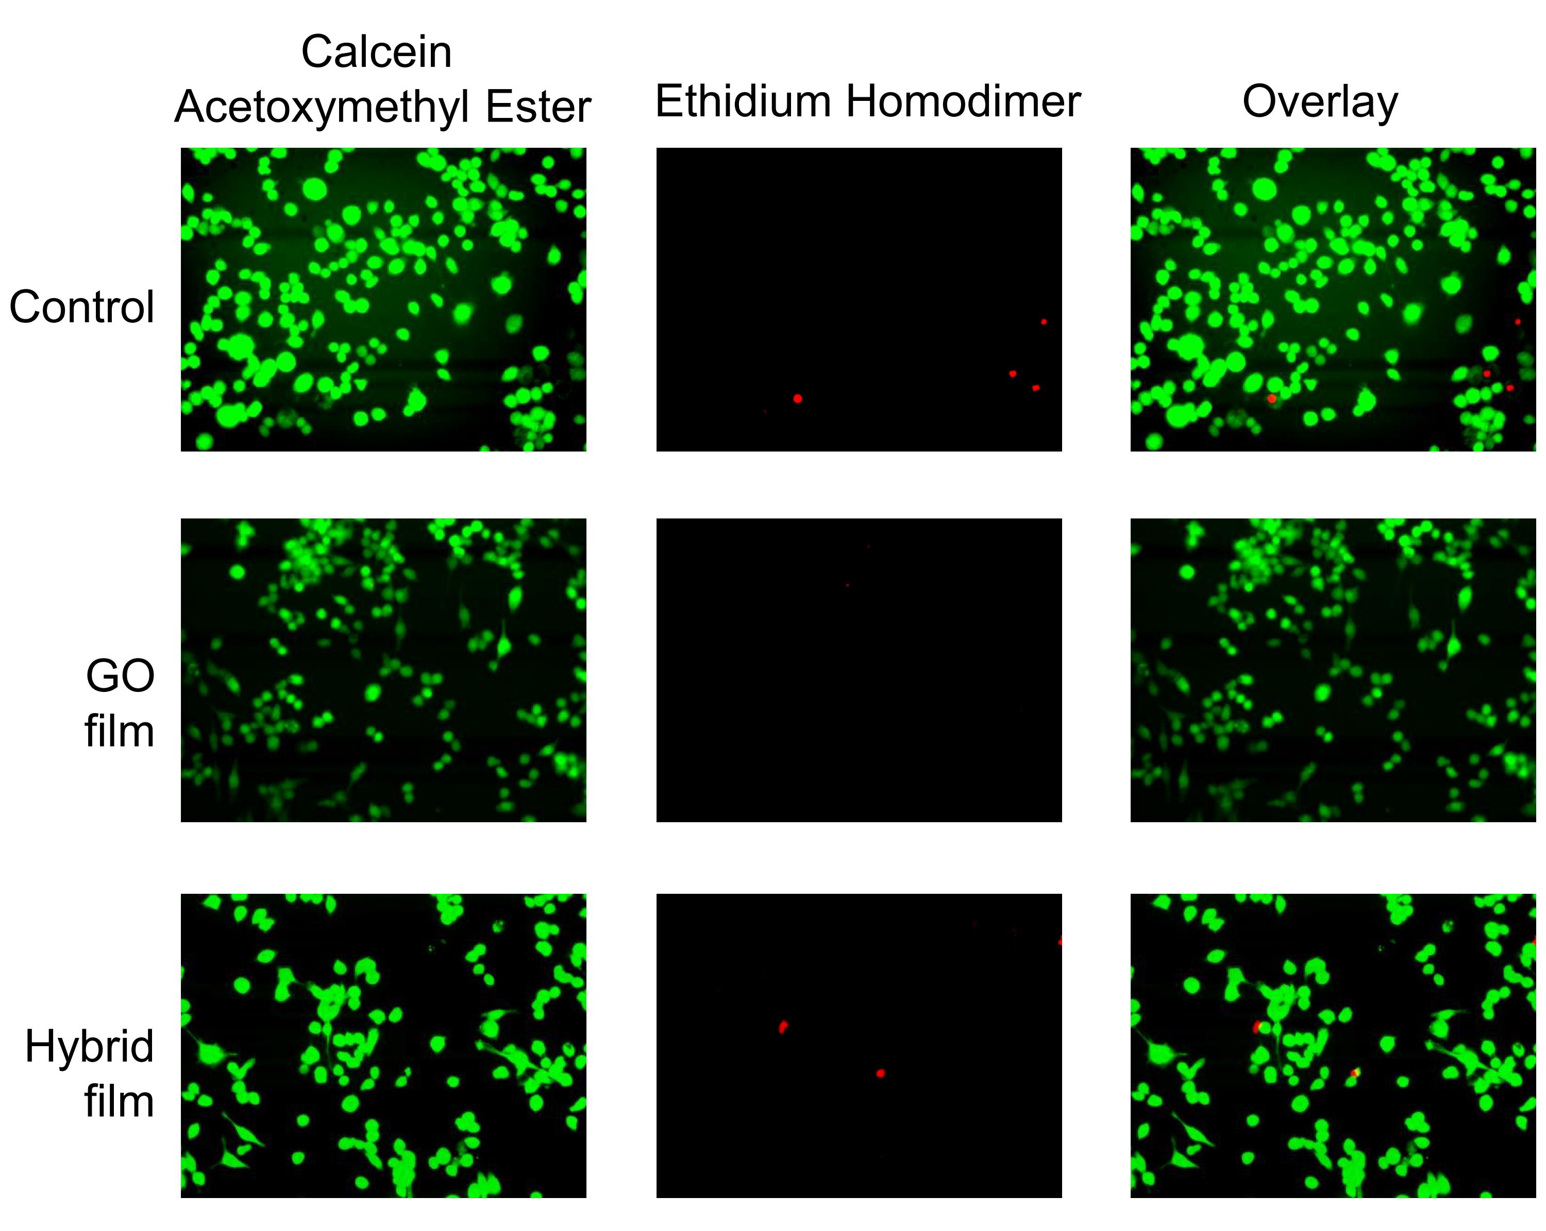
Fig. S12 Fluorescence microscopy images of Raw264.7 cells.
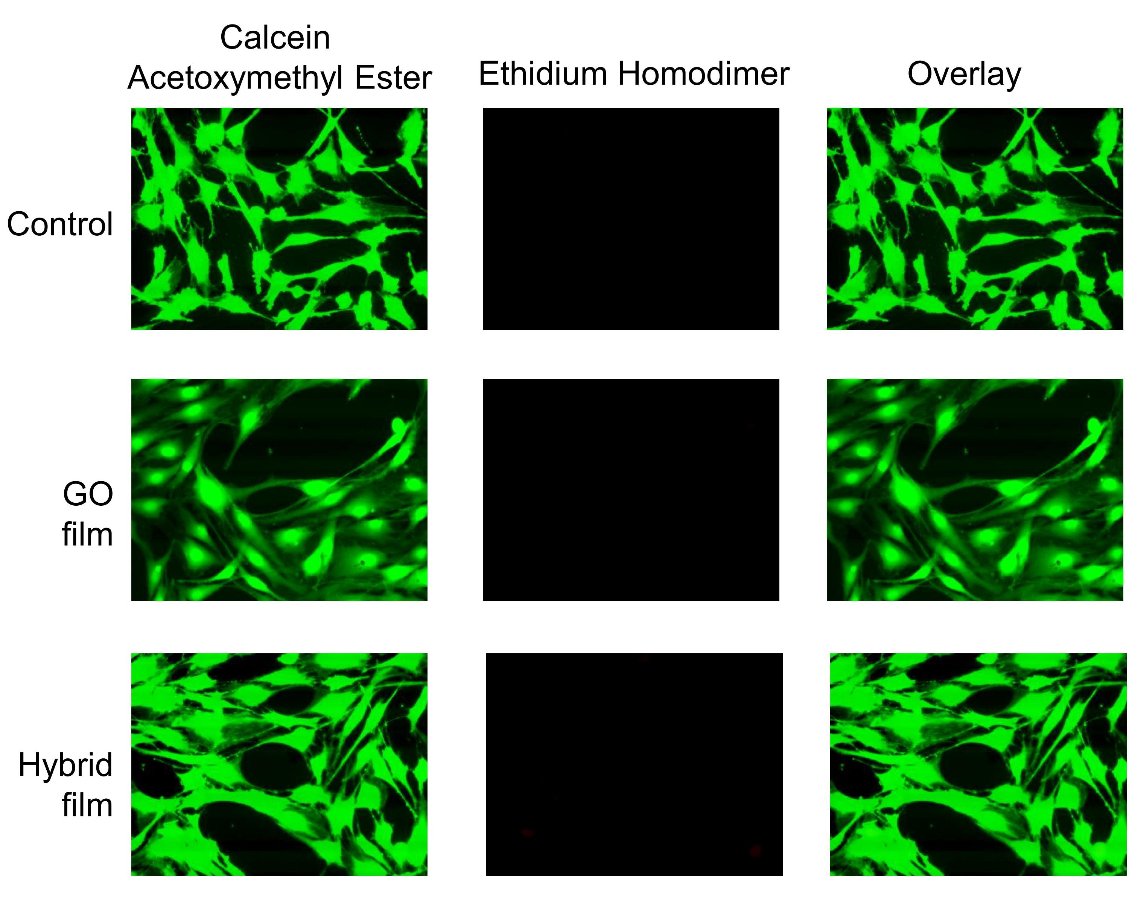
Fig. S13 Fluorescence microscopy images of MC3T3-T1 cells.
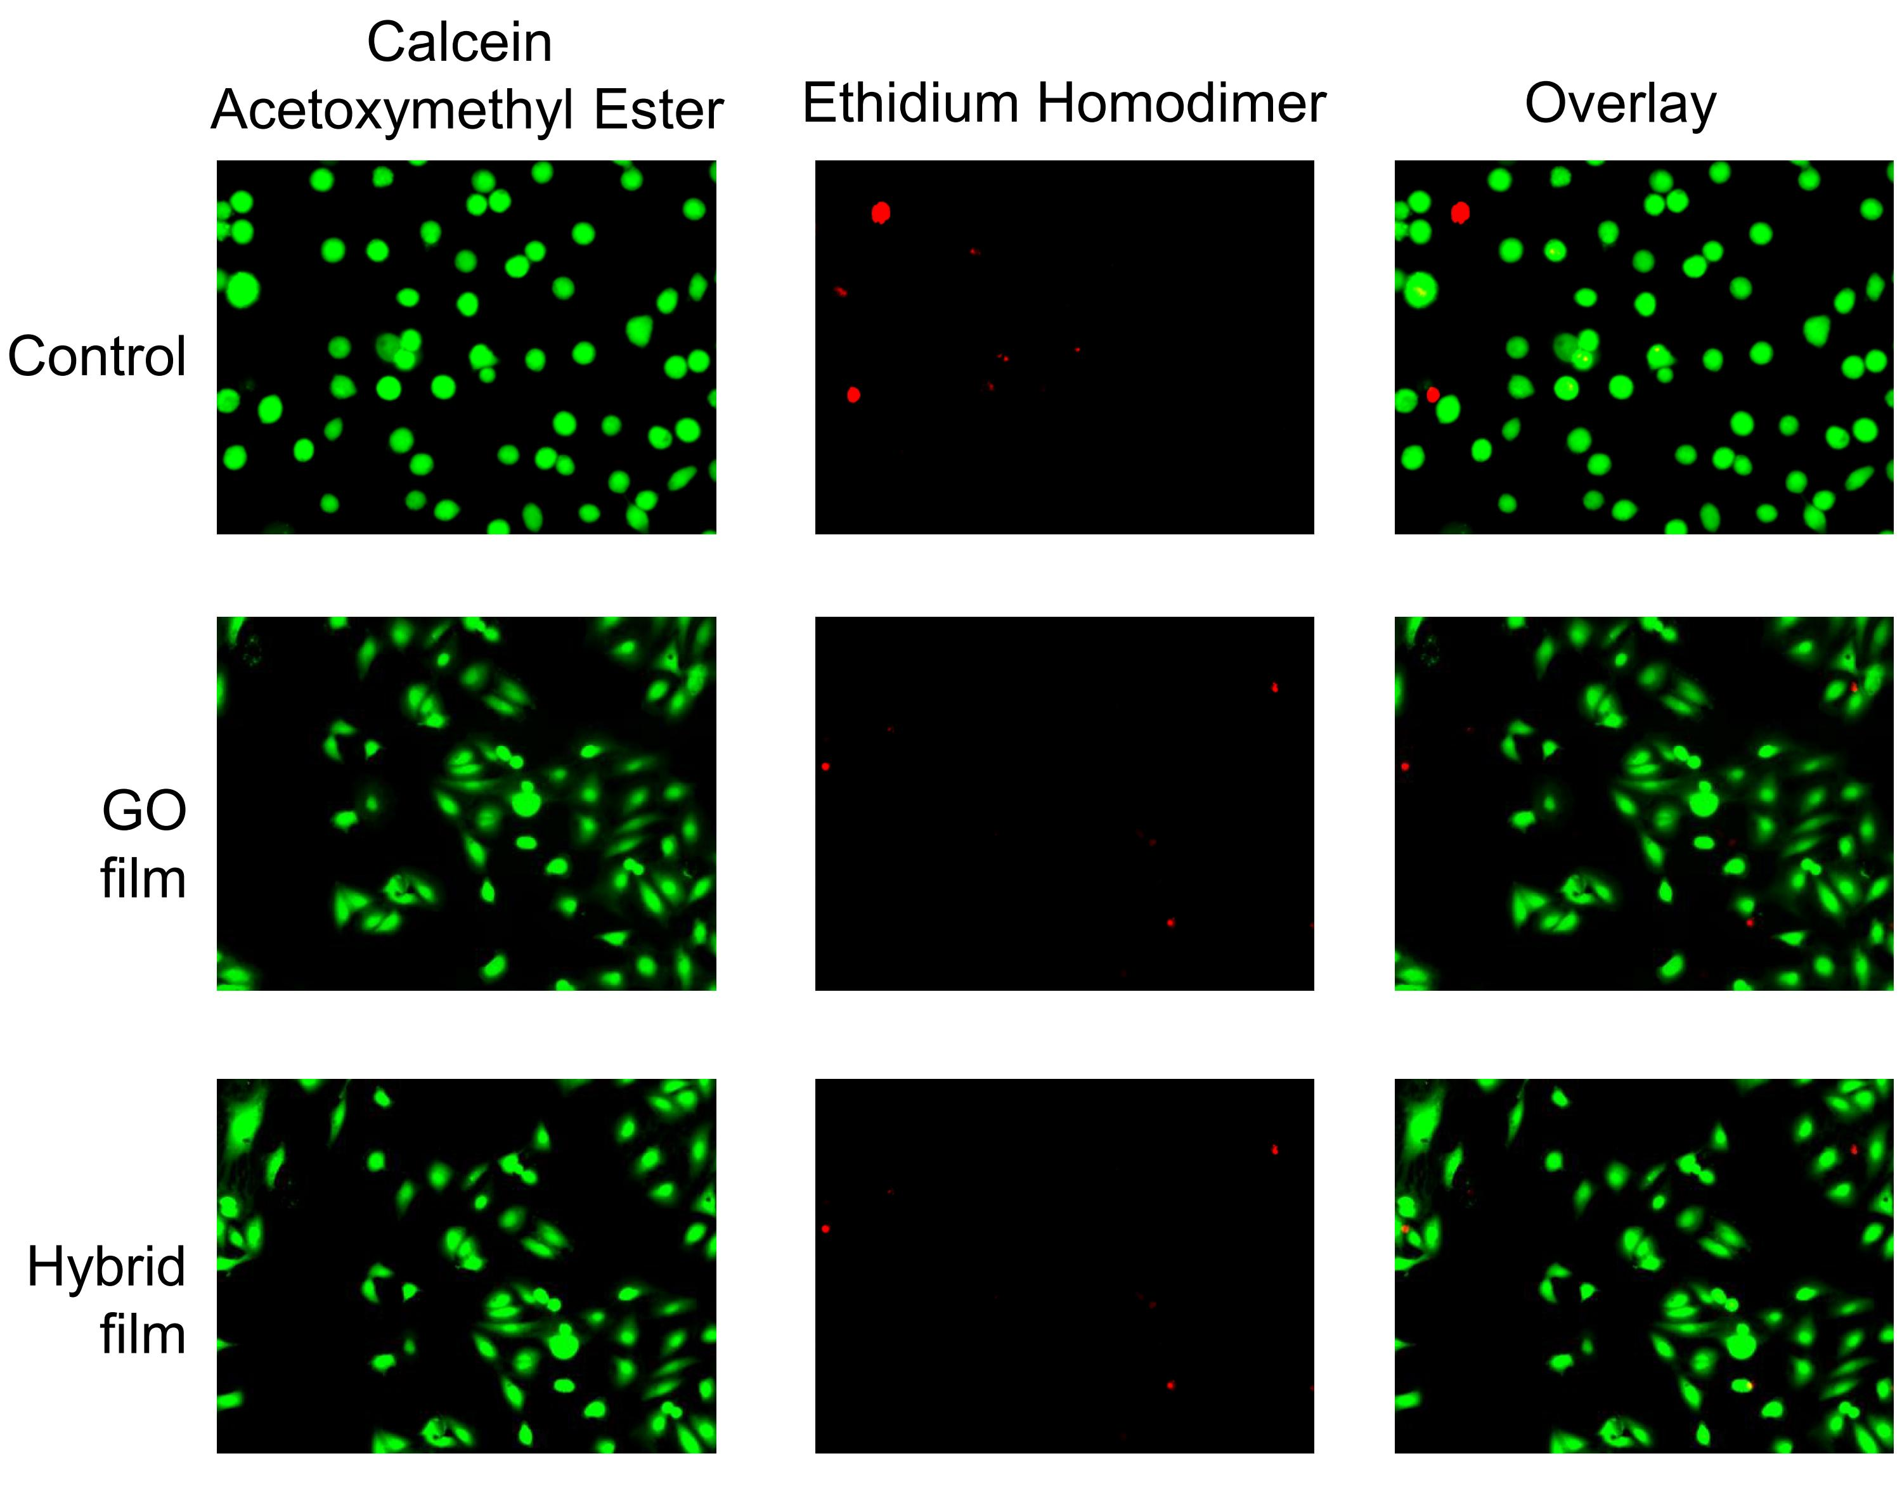
Fig. S14 Fluorescence microscopy images of MDA cells.

References
S1. (a) Y. Liang, Acta Biochim. Biophys. Sin., 2008. 40, 565-576; (b) G. Thompson, D. Owen, P. A. Chalk and P. N. Lowe, Biochemistry, 1998, 37, 7885-7891.
S2. A. Gourishankar, S. Shukla, K. N. Ganesh and M. Sastry, J. Am. Chem. Soc., 2004, 126, 13186-13187.
S3. L. Yan, Y. B. Zheng, F. Zhao, S. Li, X. Gao, B. Xu, P. S. Weiss and Y. Zhao, Chem. Soc. Rev., 2012, 41, 97-114.
S1. I. Luque and E. Freire, Proteins, 2002, 49, 181.
S2. Z. Wei, D. E. Barlow and P. E. Sheehan, Nano Lett., 2008, 8, 3141.
S3. (a) T. Ando and H. Asai, J. Biochem., 1980, 88, 255; (b) T. Ando, H. Fujisaki and H. Asai, J. Biochem., 1980, 88, 265; (c) I. Bronshtein, K. M. Smith and B. Ehrenberg, Photochemistry and Photobiology, 2005, 81, 446-451.
S4. L. Yan, Y.-N. Chang, L. Zhao, Z. Gu, X. Liu, G. Tian, L. Zhou, W. Ren, S. Jin, W. Yin, H. Chang, G. Xing, X. Gao and Y. Zhao, Carbon, 2013, 57, 120.
S5. W. Feng, K. C. Dev, L. Zhengquan, Z. Yong, F. Xianping and W. Minquan, Nanotechnology, 2006, 17, 5786.

