Supplementary Information
Kinetics of Carbon Monoxide Oxidation
with Sn_{0.95}M_{0.05}O_{2-δ} (M= Cu, Fe, Mn, Co) Catalysts.
Vijay M. Shinde, Giridhar Madras*
Department of Chemical Engineering, Indian Institute of Science, Bangalore-560 012, INDIA.

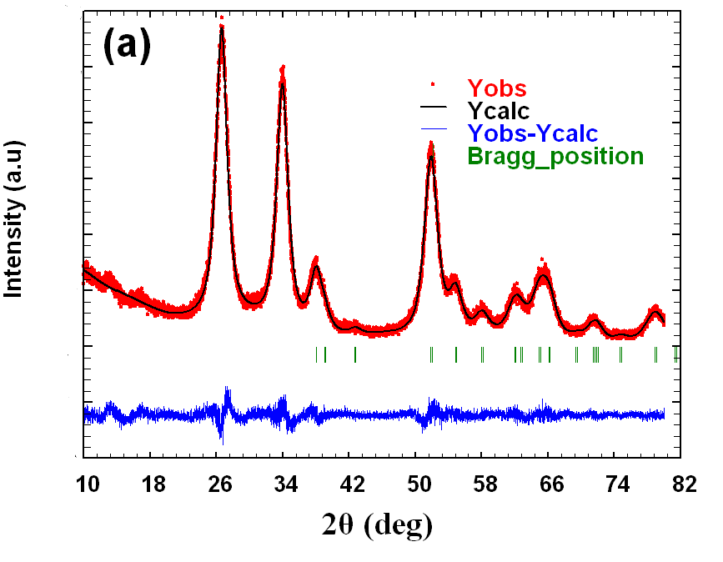

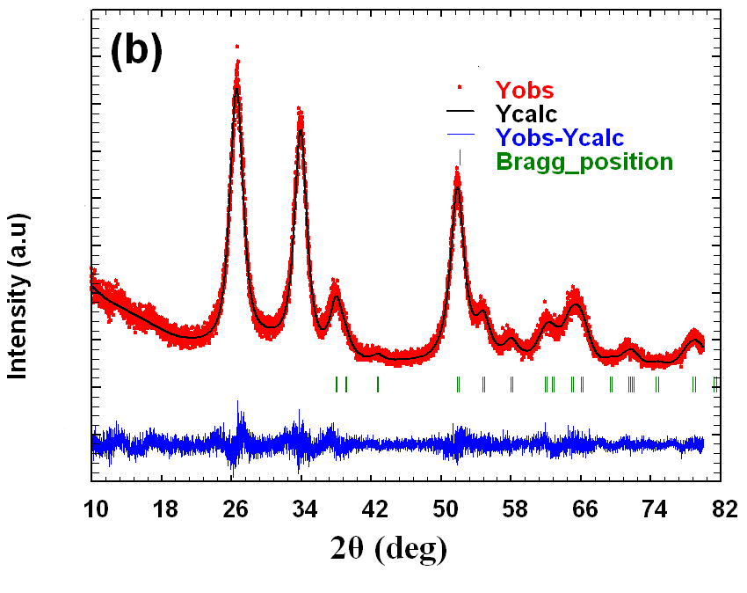

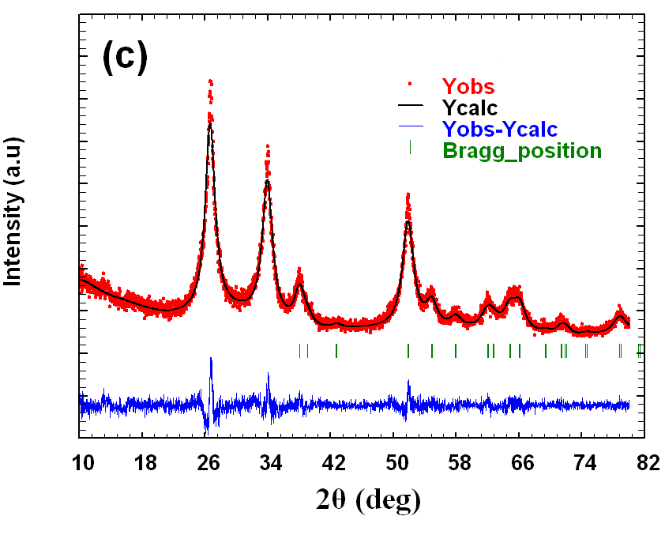

Fig. S1 Profile refinement of (a) Sn_{0.95}Fe_{0.05}O_{2-δ} (b) Sn_{0.95}Mn_{0.05}O_{2-δ} (c) Sn_{0.95}Co_{0.05}O_{2-δ.}
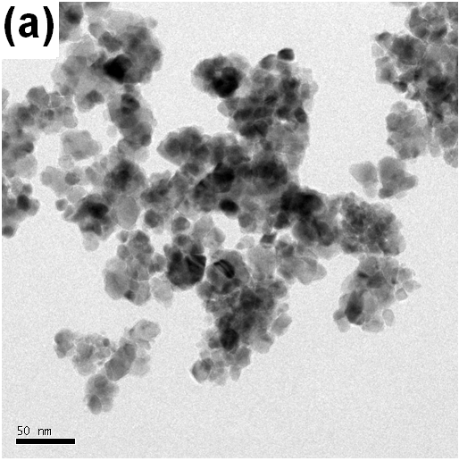
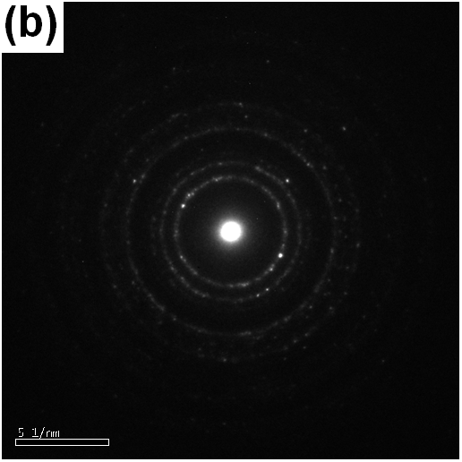
Fig. S2 (a) TEM image and (b) the electron diffraction pattern of SnO₂.

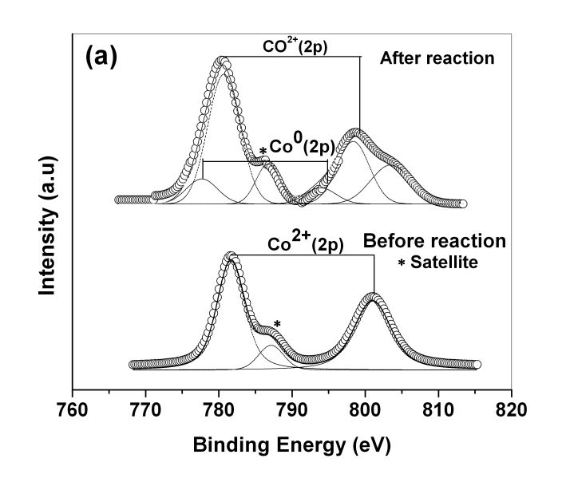
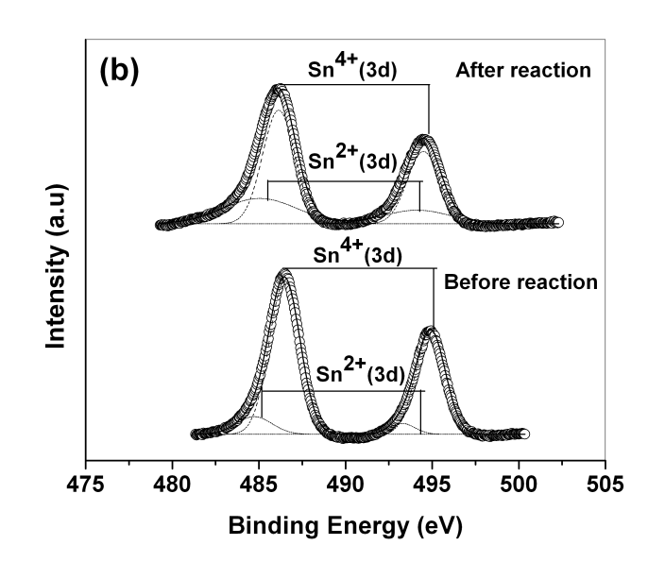
Fig. S3 Core level XPS of (a) Co 2p (b) Sn 3d in Sn_{0.95}Co_{0.05}O_{2-δ}

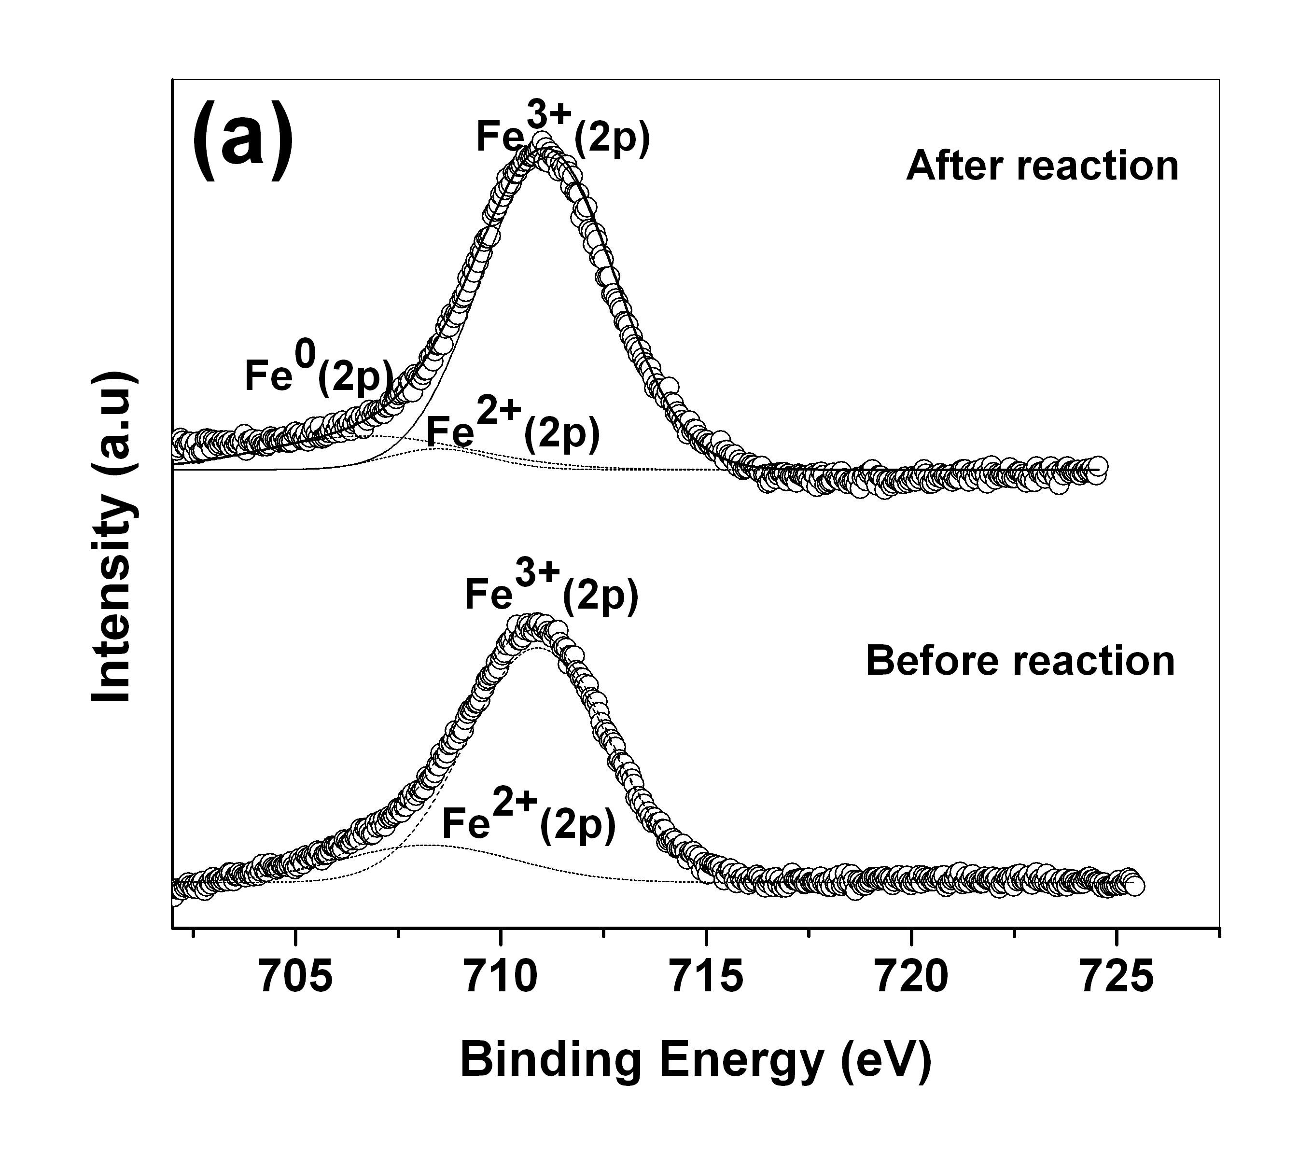

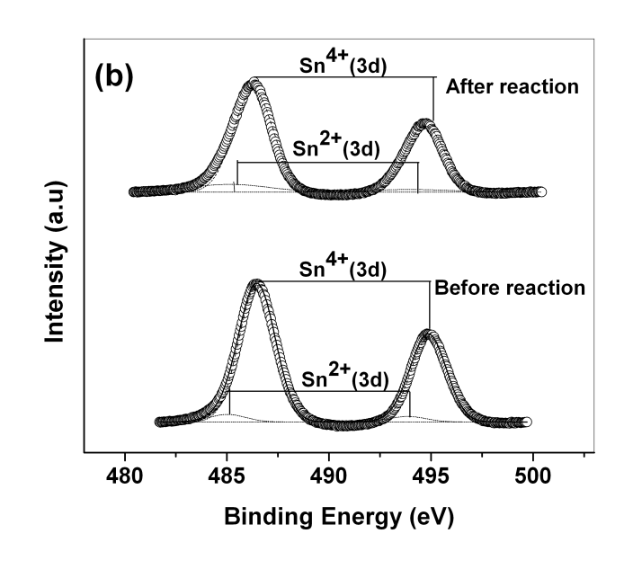
Fig. S4 Core level XPS of (a) Fe 2p (b) Sn 3d in Sn_{0.95}Fe_{0.05}O_{2-δ}

