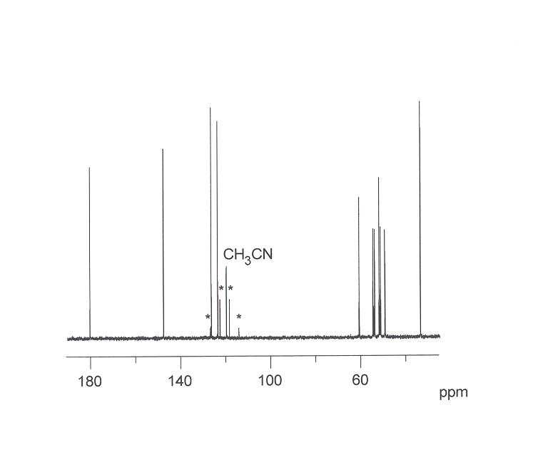
13C{1H} spectrum of the [LaL]+ cation at 278 K in D2O. * Signals due to the trifluoro-methansulfonate.
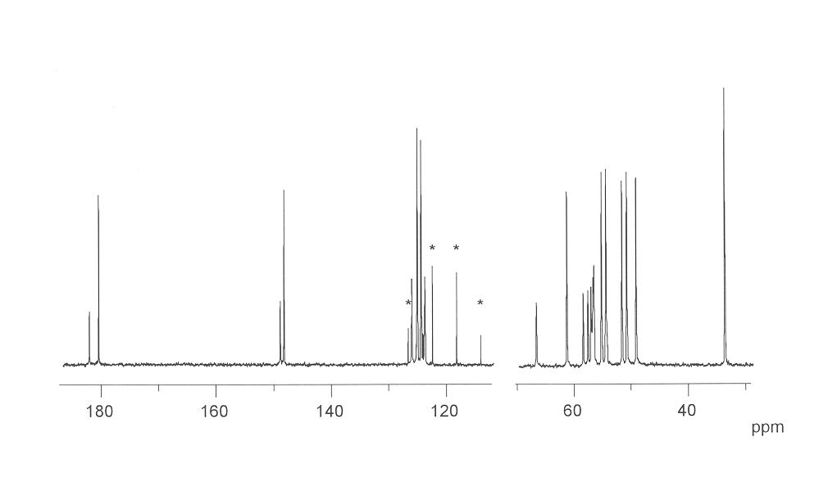
13C{1H} spectrum of the [LuL]+ cation at 272 K in D2O. * Signals due to the trifluoromethansulfonate.
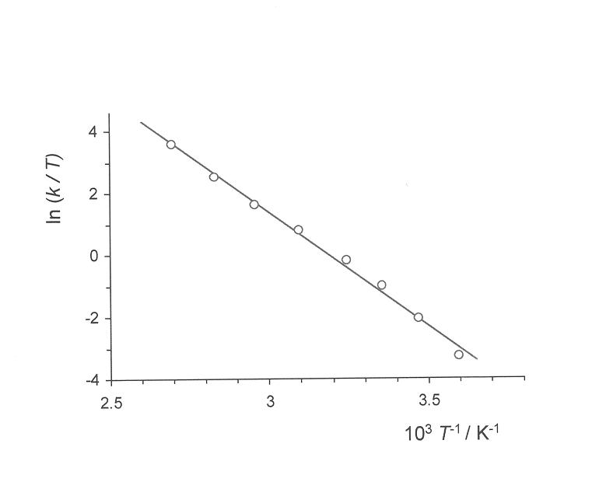
Eyring plot for the ring inversion of the [LaL]+ cation in D2O.

