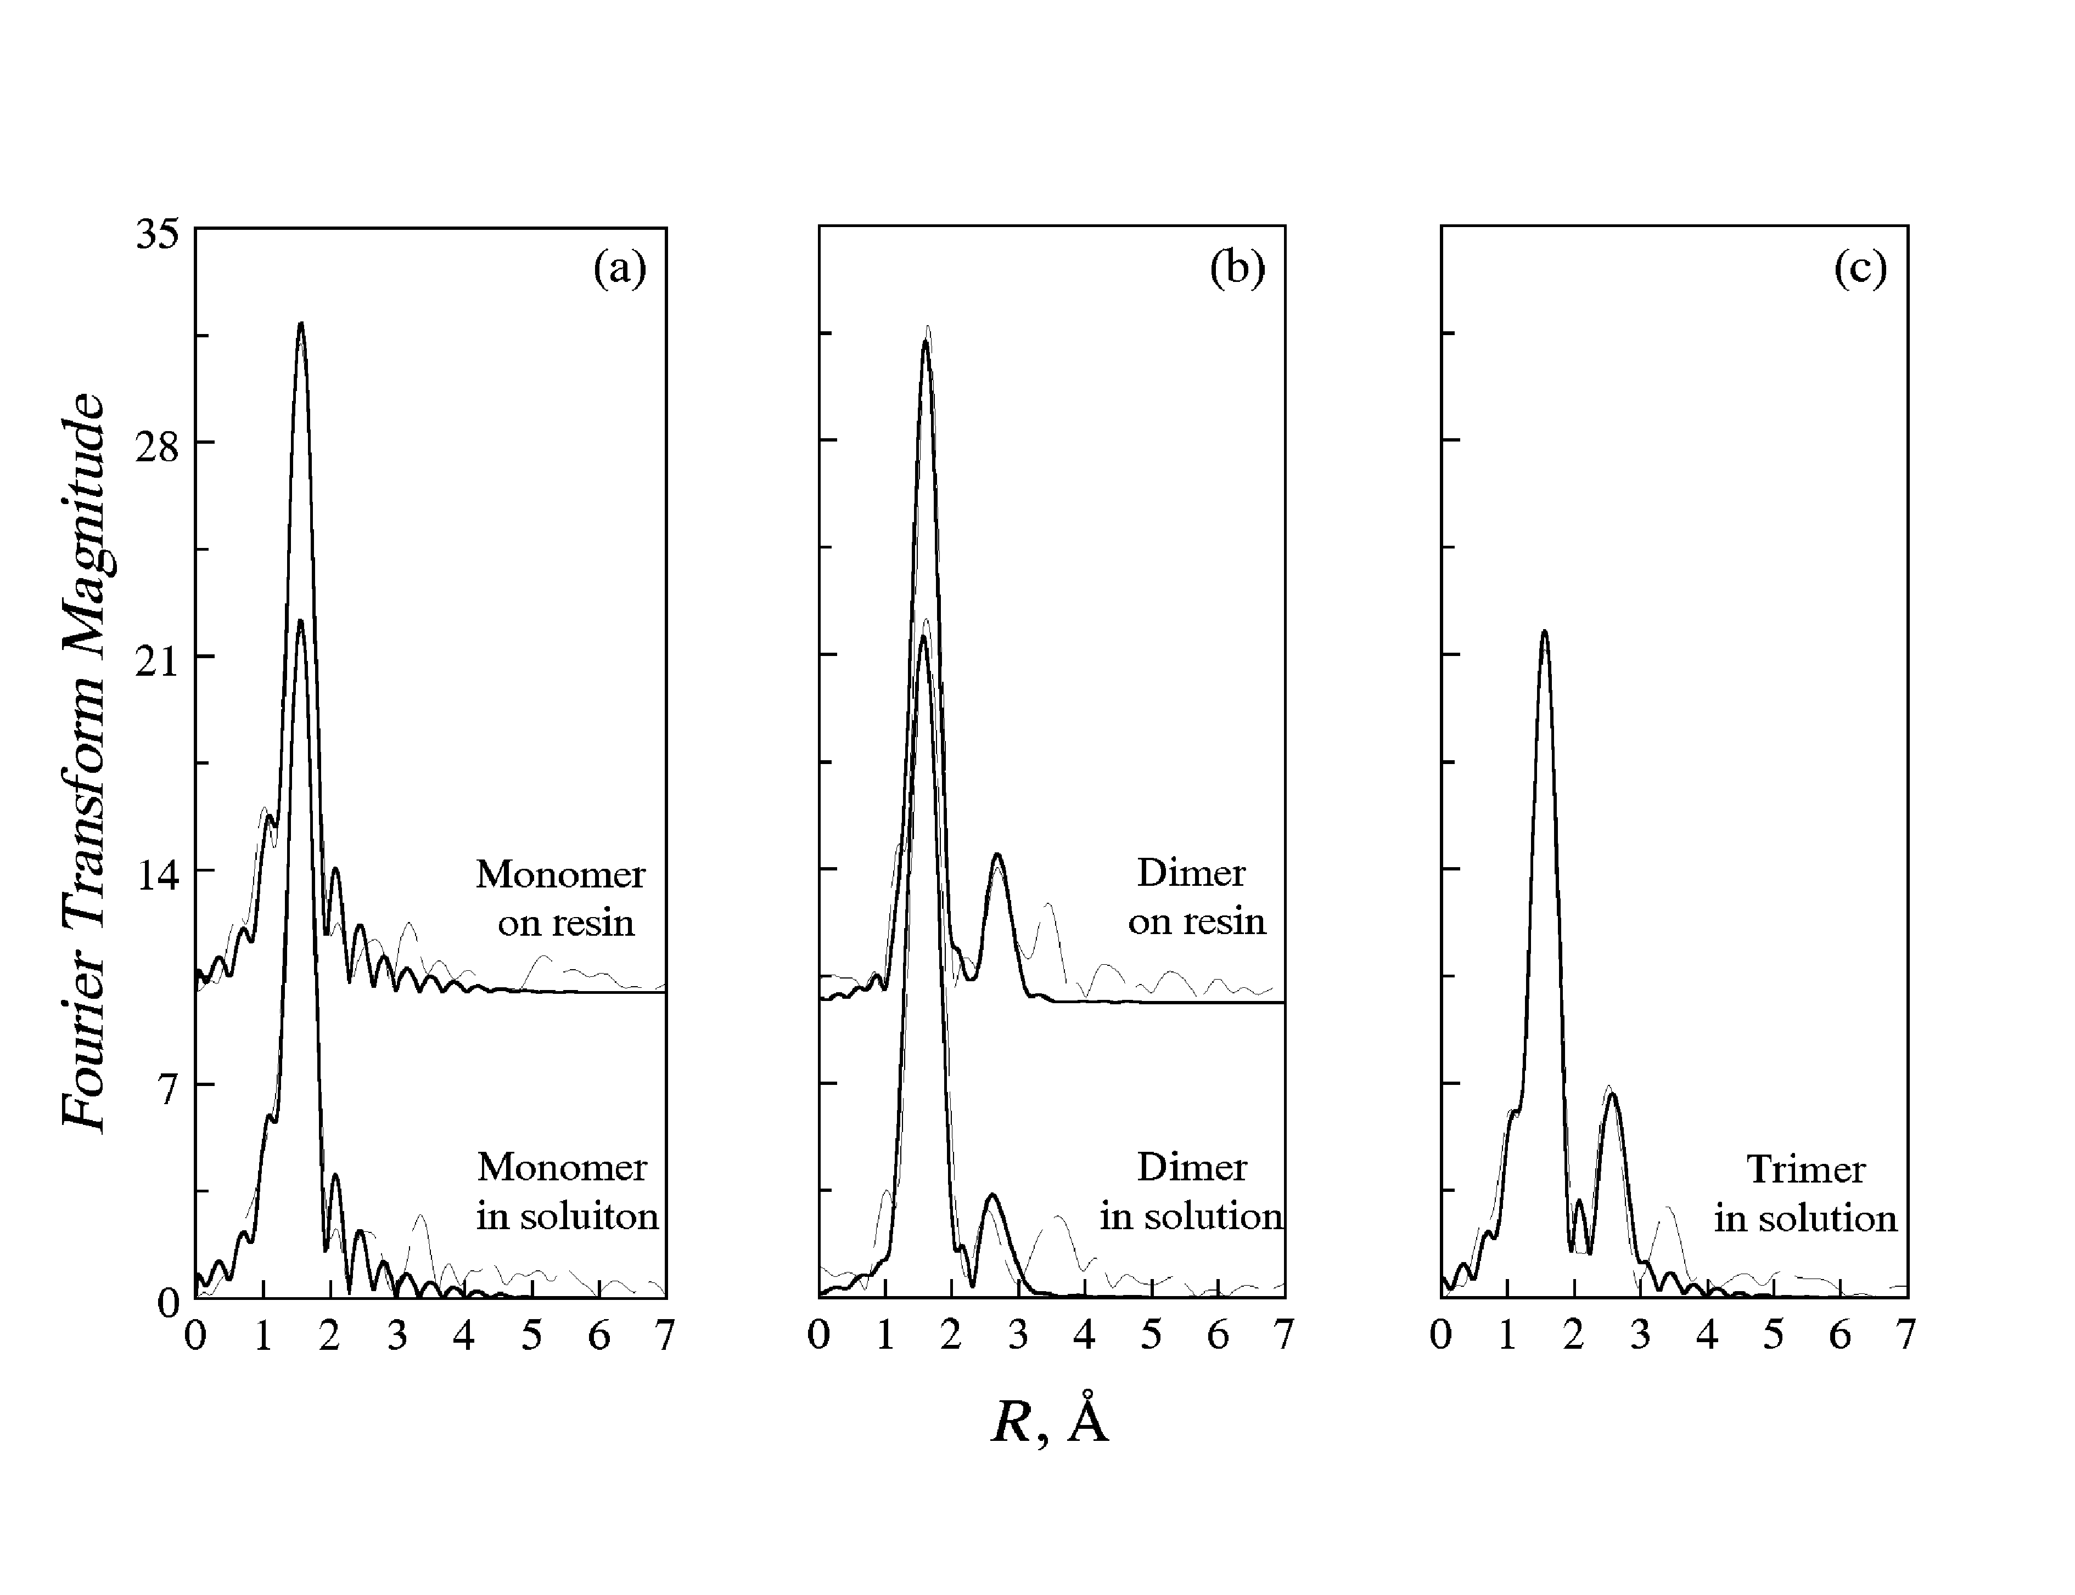

Fig. S1 The Fourier transforms of the EXAFS spectra of separated chromium(III) oligomers in solution and on resin. The phase shift is not corrected. Dashed line: experimental; solid line: fit. The fitting parameters and results are listed in Table 2. All the solutions were filtered with the Gelman 0.2 μm nylon filter.

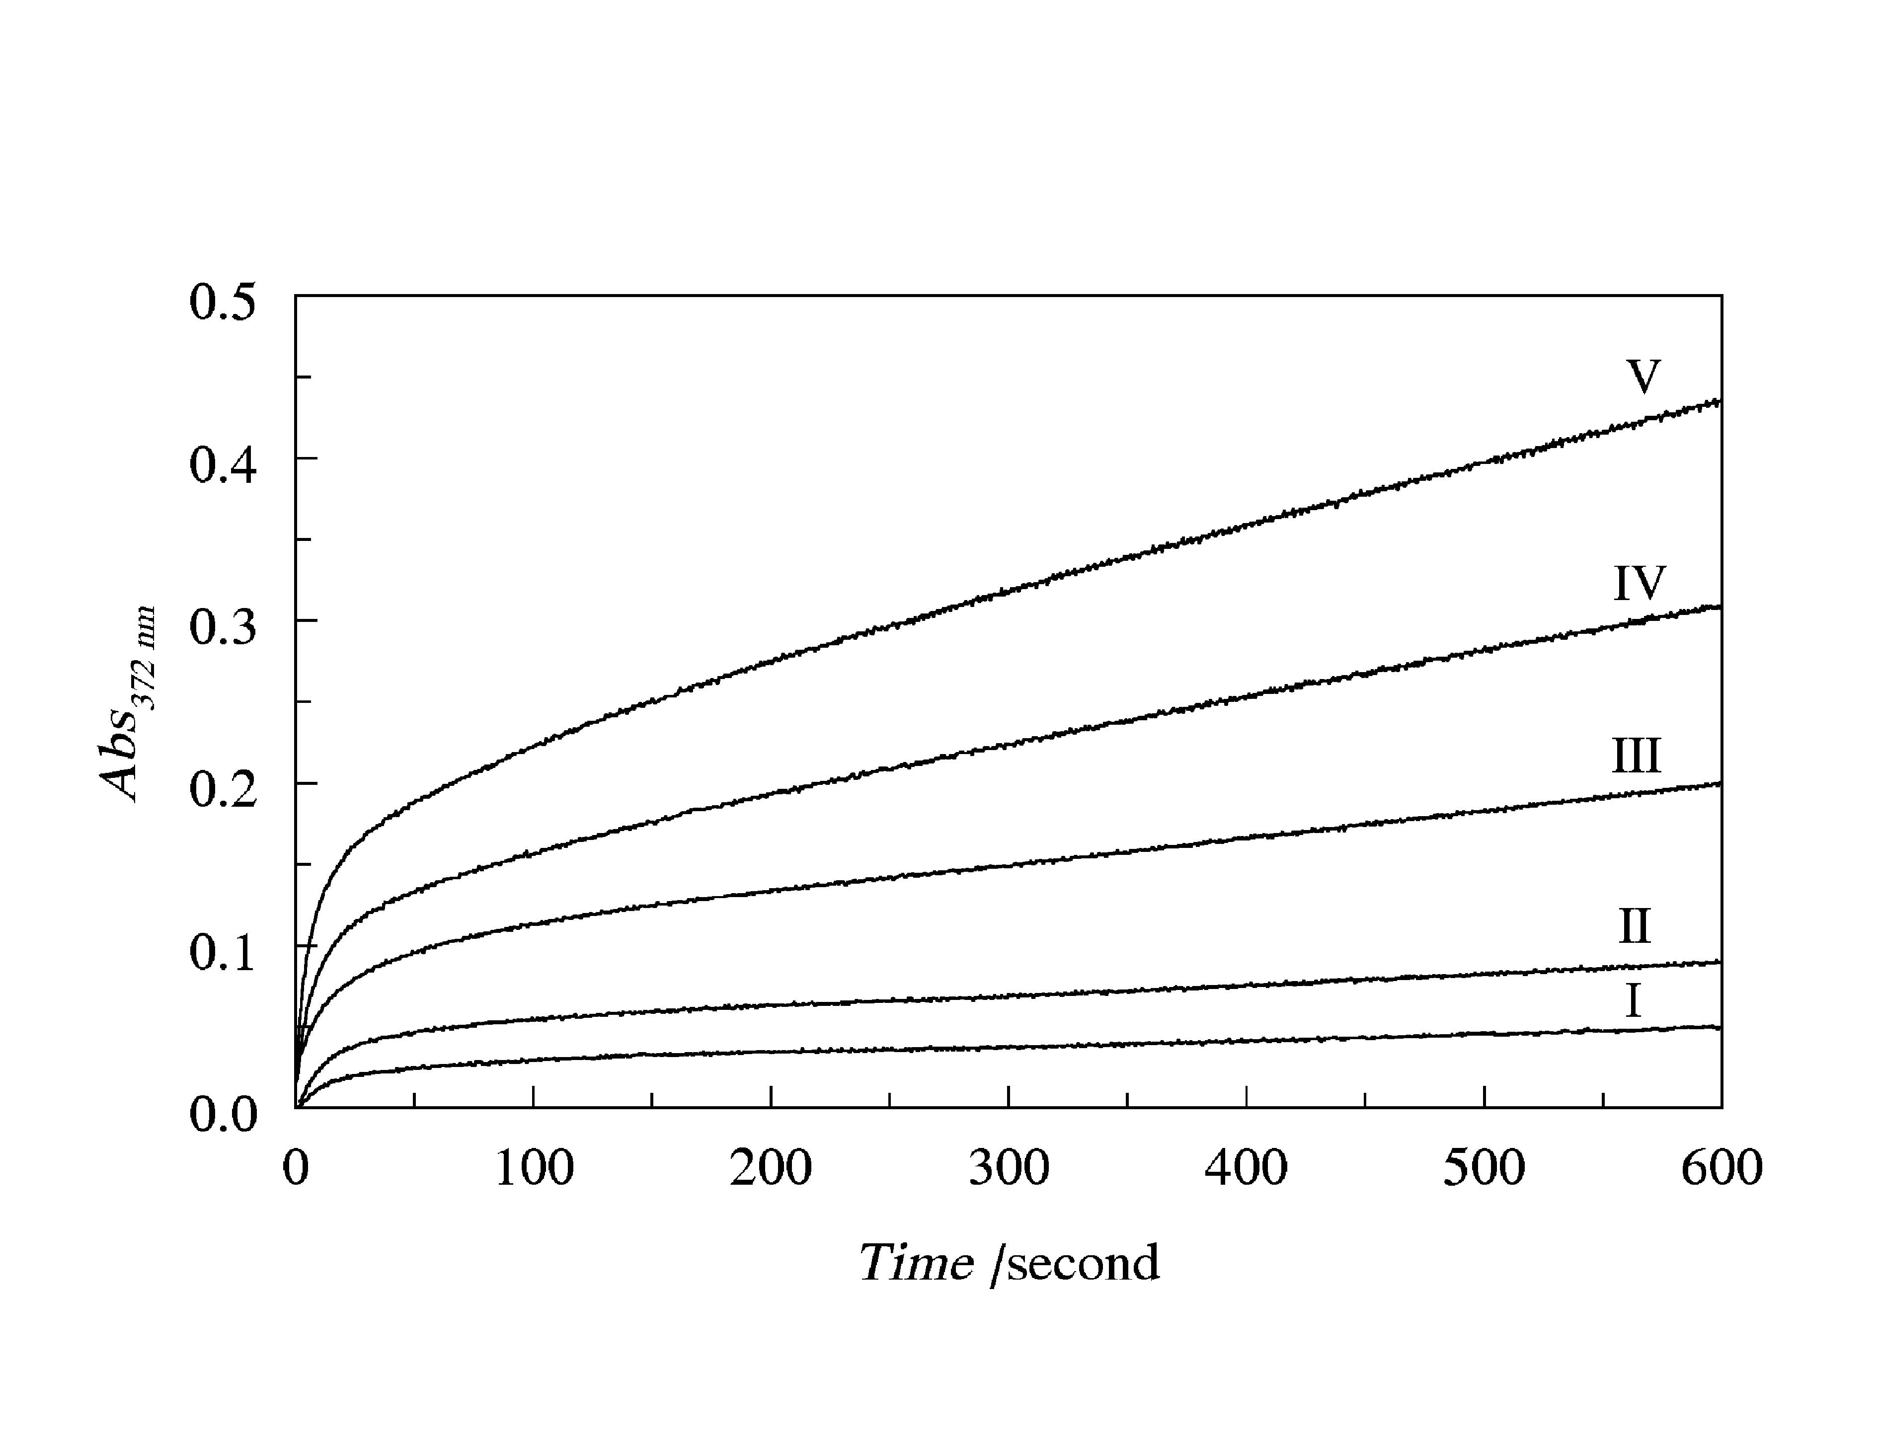
Fig. S2 The absorbance at 372 nm as a function of time, observed by stopped-flow spectroscopy. C_{NaOH} = 2.0 × 10⁻¹ mol dm⁻³, C_{H2O2} = 1.03 × 10⁻³ mol dm⁻³, 20 mm pathlength. C_{Cr(III),0} (mol dm⁻³) = 1.18 × 10⁻⁵ (I), 2.36 × 10⁻⁵ (II), 3.77 × 10⁻⁵ (III), 7.04 × 10⁻⁵ (IV), 1.18 × 10⁻⁴ (V).

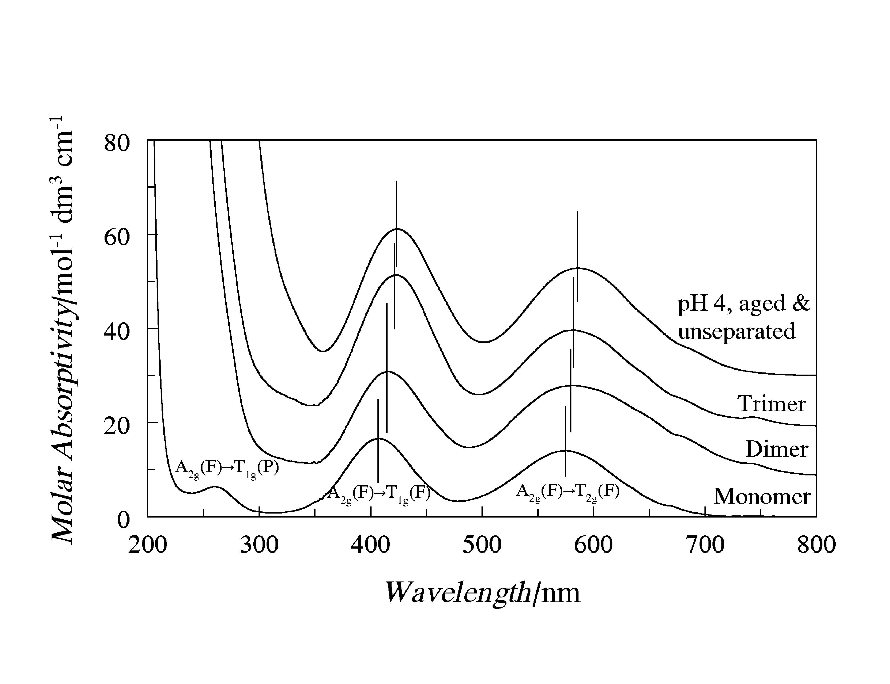
Fig. S3 UV/Vis absorption spectra of chromium(III) monomer, dimer, trimer and unseparated solutions. All the solutions were filtered with the Gelman 0.2 μm nylon filter. The spectra are shifted with respect to the y-coordinate for better viewing.

