Electronic Supporting Information
Paper Ref.: B107021P
Clathrochelate monoribbed-functionalized iron(II) α-dioximates: the pathways of the synthesis, structural and electrochemical features
Yan Z. Voloshin,^{*,a} Valery E. Zavodnik,ª Oleg A. Varzatskii,^{b} Vitaly K. Belsky,ª Aleksei V. Palchik,^{b} Nataly G. Strizhakova,^{b} Ivan I. Vorontsov,^{c}
and Mikhail Yu. Antipin ^{c}
ª Karpov Institute of Physical Chemistry, 10 Vorontsovo Pole, 103064 Moscow, Russia.
E-mail: voloshin@cc.nifhi.ac.ru
^{b} Vernadskii Institute of General and Inorganic Chemistry, 252142 Kiev, Ukraine
^{c} Nesmeyanov Institute of Organoelement Compounds, 117813 Moscow, Russia

NMR and IR Data
FeBd₂(Cl2Gm)(BF)₂ (6). ¹H NMR (CDCl₃): δ (ppm) 7.30-7.40 (m, 20H, Ph). ¹³C{¹H} NMR (CDCl₃): δ (ppm) 128.0 (s, Ph), 128.7 (s, ClC=N), 130.4 (s, Ph), 130.8 (s, Ph), 157.5 (s, PhC=N). IR (cm⁻¹,KBr) 1540 ν(ClC=N), 1559 ν(PhC=N), 915, 928, 948, 1067 ν(N–O), 1217 ν(B–O)+ν(B–F).
FeBd₂((n-C₄H₉NH)2Gm)(BF)₂ (7). ¹H NMR (CDCl₃): δ (ppm) 0.97 (m, 6H, CH₃), 1.43 (m, 4H, CH₂), 1.59 (m, 4H, CH₂), 3.42 (m, 4H, NCH₂), 5.63 (m, 2H, NH), 7.27-7.40 (m, 20H, Ph). ¹³C{¹H} NMR (CDCl₃): δ (ppm) 13.8 (s, CH₃), 19.4 (s, CH₂), 33.5 (s, CH₂), 44.8 (s, NCH₂), 127.8 (s, Ph), 129.5 (s, Ph), 130.5 (s, Ph), 150.6 (s, NC=N), 156.9 (s, PhC=N). IR (cm⁻¹, KBr): 1582 ν(C=N), 912, 924, 943, 965, 1057 ν(N–O), 1194 ν(B–O)+ν(B–F).
FeBd₂((aza18-C-6)ClGm)(BF)₂ (8). ¹H NMR (CDCl₃): δ (ppm) 3.65 (m, 4H, NCH₂), 3.81 (m, 20H, OCH₂), 7.28-7.33 (m, 20H, Ph). ¹³C{¹H} NMR (CDCl₃): δ (ppm) 40.4 (s, NCH₂), 70.1 (s, OCH₂), 70.5 (two s, OCH₂), 71.1 (two s, OCH₂), 127.8 (two s, Ph), 129.0 (two s, Ph), 129.8 (two s, Ph), 130.6 (two s, Ph), 132.4 (s, ClC=N), 151.7 (s, NC=N), 156.6 (s, PhC=N), 157.5 (s, PhC=N). ¹¹B NMR (CDCl₃): δ (ppm, rel. to NaB(C₆H₅)₄) 7.4 (two d, J₁₁B₋₁₉F=15Hz). IR (cm⁻¹, KBr): 1550 ν(ClC=N), 1584 ν(PhC=N)+ν(NC=N), 910sh, 932, 950sh, 1062 ν(N–O), 1212 ν(B–O)+ν(B–F).
FeBd₂(((C₂H₅)₂N)ClGm)(BF)₂ (9). ¹H NMR (CDCl₃): δ (ppm) 1.21 (t, 3H, CH₃), 3.51 (quartet, 2H, NCH₂), 7.27-7.37 (m, 20H, Ph). ¹³C{¹H} NMR (CDCl₃): δ (ppm) 13.8 (s, CH₃), 44.7 (s, NCH₂), 127.9 (two s, Ph), 129.1 (two s, Ph), 129.5 (s, ClC=N), 130.0 (two s, Ph), 130.7 (two s, Ph), 151.0 (s, NC=N), 156.9 (s, PhC=N), 157.6 (s, PhC=N). ¹¹B NMR (CDl₃): δ (ppm, rel. to NaB(C₆H₅)₄) 7.3 (two d, J₁₁B₋₁₉F=15Hz). IR (cm⁻¹, KBr): 1555 ν(ClC=N), 1590 ν(PhC=N)+ν(NC=N), 915sh, 933, 950sh ν(N–O), 1205 ν(B–O).
FeBd₂(((C₂H₅)₂N)(NH(CH₂)₅NH₂)Gm)(BF)₂ (10). ¹H NMR (CDCl₃): δ (ppm) 1.07 (t, 3H, CH₃), 1.16 (m, 2H, CH₂), 1.52 (m, 4H, CH₂), 2.86 (m, 2H, NCH₂(cadaverine)), 3.32 (quartet, 2H, NCH₂(DEA)), 3.59 (m, 2H, NCH₂(cadaverine)), 5.82 (m, 1H, NH), 6.22 (m, 2H, NH₂), 7.24-7.33 (m, 20H, Ph). ¹³C{¹H} NMR (CDCl₃): δ (ppm) 13.6 (s, CH₃), 22.9 (s, CH₂), 26.1 (s, CH₂), 30.3 (s, CH₂), 40.7 (s, NCH₂(cadaverine)), 43.4 (s, NCH₂(cadaverine)), 45.0 (s, NCH₂(DEA)), 127.8 (s, Ph), 128.0 (s, Ph), 129.5 (s, Ph), 129.6 (s, Ph), 129.8 (two s, Ph), 130.7 (two s, Ph), 149.4 (s, NC=N(cadaverine)), 149.9 (s, NC=N(DEA)), 156.7 (s, PhC=N), 156.8 (s, PhC=N). IR (cm⁻¹, KBr): 1585 ν(PhC=N)+ν(NC=N), 905sh, 913, 945sh, 1068 ν(N–O), 1192 ν(B–O)+ν(B–F).
(FeBd₂(((C₂H₅)₂N)Gm)(BF)₂)₂(NH(CH₂)₅NH) (11). ¹H NMR (CDCl₃): δ (ppm) 1.13 (t, 6H, CH₂), 1.29 (m, 6H, CH₂), 3.35 (m, 4H, NCH₂(cadaverine)), 3.50 (quartet, 4H, NCH₂(DEA)), 5.55 (m, 2H, NH), 7.27-7.38 (m, 40H, Ph). ¹³C{¹H} NMR (CDCl₃): δ (ppm) 13.7 (s, CH₃), 22.6 (s, CH₂), 31.5 (s, CH₂), 44.6 (s, NCH₂(DEA)), 44.9 (s, NCH₂(cadaverine)), 127.8 (s, Ph), 127.9 (s, Ph), 129.1 (s, Ph), 129.5 (s, Ph), 129.9 (two s, Ph), 130.7 (two s, Ph), 149.2 (s, NC=N(cadaverine)), 151.0 (s, NC=N(DEA)), 156.5 (s, PhC=N), 156.8 (s, PhC=N). IR (cm⁻¹, KBr): 1585 ν(C=N), 910sh, 925, 940sh,
1060 ν(N–O), 1205 ν(B–O).
FeBd₂(CwGm)(BF)₂ (12). ¹H NMR (CDCl₃): δ (ppm) 3.84 (m, 4H, OCH₂), 4.16 (m, 4H, OCH₂), 6.88 (m, 4H, OPh), 7.27-7.37 (m, 24H, Ph+OPh). ¹³C{¹H} NMR (CDCl₃): δ (ppm) 67.3 (s, OCH₂), 70.3 (s, OCH₂), 114.0 (s, Ph), 119.5 (s, Ph), 120.8 (s, Ph), 125.9 (s, Ph), 136.3 (s, OC=N), 143.6 (s, OPh), 148.7 (s, OPh), 156.5 (s, PhC=N). ¹¹B NMR (CDCl₃): δ (ppm, rel. to NaB(C₆H₅)₄) 7.1 (d, J₁₁B₋₁₉F=15Hz). IR (cm⁻¹, KBr): 1582, 1611 ν(PhC=N)+ν(OC=N), 930, 1013, 1060 ν(N–O), 1206 ν(B–O)+ν(B–F).
FeBd₂((CH₃S)2Gm)₂(BF)₂ (13). ¹H NMR (CDCl₃): δ (ppm) 2.71 (s, 6H, SCH₃), 7.19-7.25 (m, 20H, Ph). ¹³C{¹H} NMR (CDCl₃): δ (ppm) 17.7 (s, SCH₃), 127.9 (s, Ph), 129.1 (s, Ph), 130.1 (s, Ph), 130.8 (s, Ph), 149.4 (s, SC=N), 156.7 (s, PhC=N). ¹¹B NMR (CDCl₃): δ (ppm, rel. to NaB(C₆H₅)₄) 7.3 (d, J₁₁B₋₁₉F=17Hz). IR (cm⁻¹, KBr): 1541 ν(SC=N), 1573 ν(PhC=N), 912, 928, 940, 1060 ν(N–O), 1203 ν(B–O)+ν(B–F).
FeBd₂((OctS)2Gm)(BF)₂ (14). ¹H NMR (CDCl₃): δ (ppm) 0.90 (m, 6H, CH₃), 1.27-1.63 (m, 24H, CH₂), 3.41 (m, 4H, SCH₂), 7.30-7.35 (m, 20H, Ph). ¹³C{¹H} NMR (CDCl₃): δ (ppm) 14.0 (s, CH₃), 22.5 (s, CH₂), 28.4 (s, CH₂), 29.0 (s, CH₂), 29.4 (s, CH₂), 29.9 (s, CH₂), 31.7 (s, CH₂), 34.5 (s, SCH₂), 127.8 (s, Ph), 129.0 (s, Ph), 129.9 (s, Ph), 130.7 (s, Ph), 149.0 (s, SC=N), 156.5 (s, PhC=N). IR (cm⁻¹, KBr): 1543 ν(SC=N), 1583 ν(PhC=N), 923-948m, 1064 ν(N–O),
1212 ν(B–O)+ν(B–F).

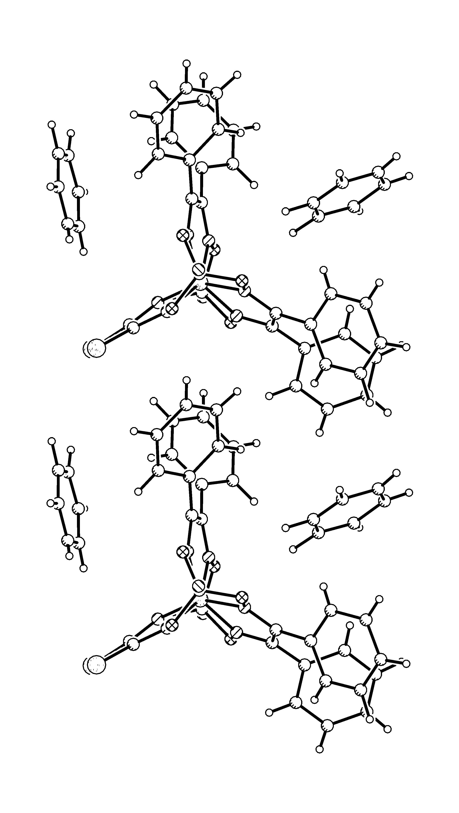
View of the molecular packing fragment along a axis in 6.

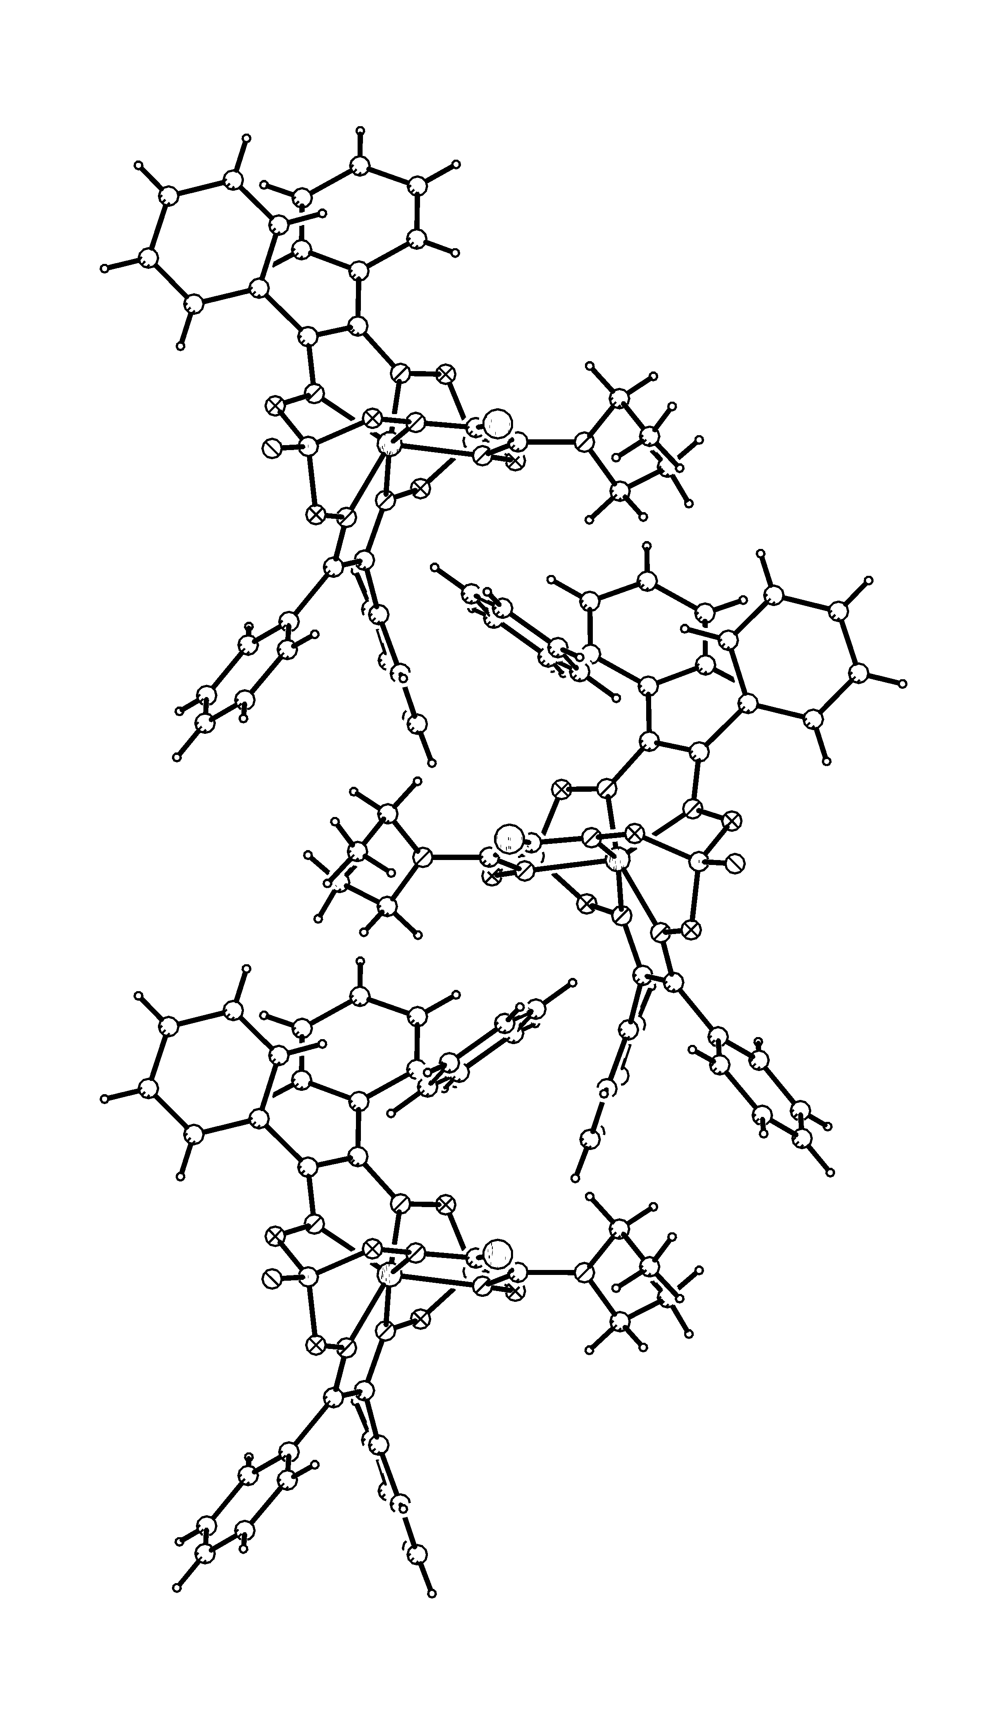
View of the molecular packing fragment of the structure 9 down the b axis with the a axis vertical.

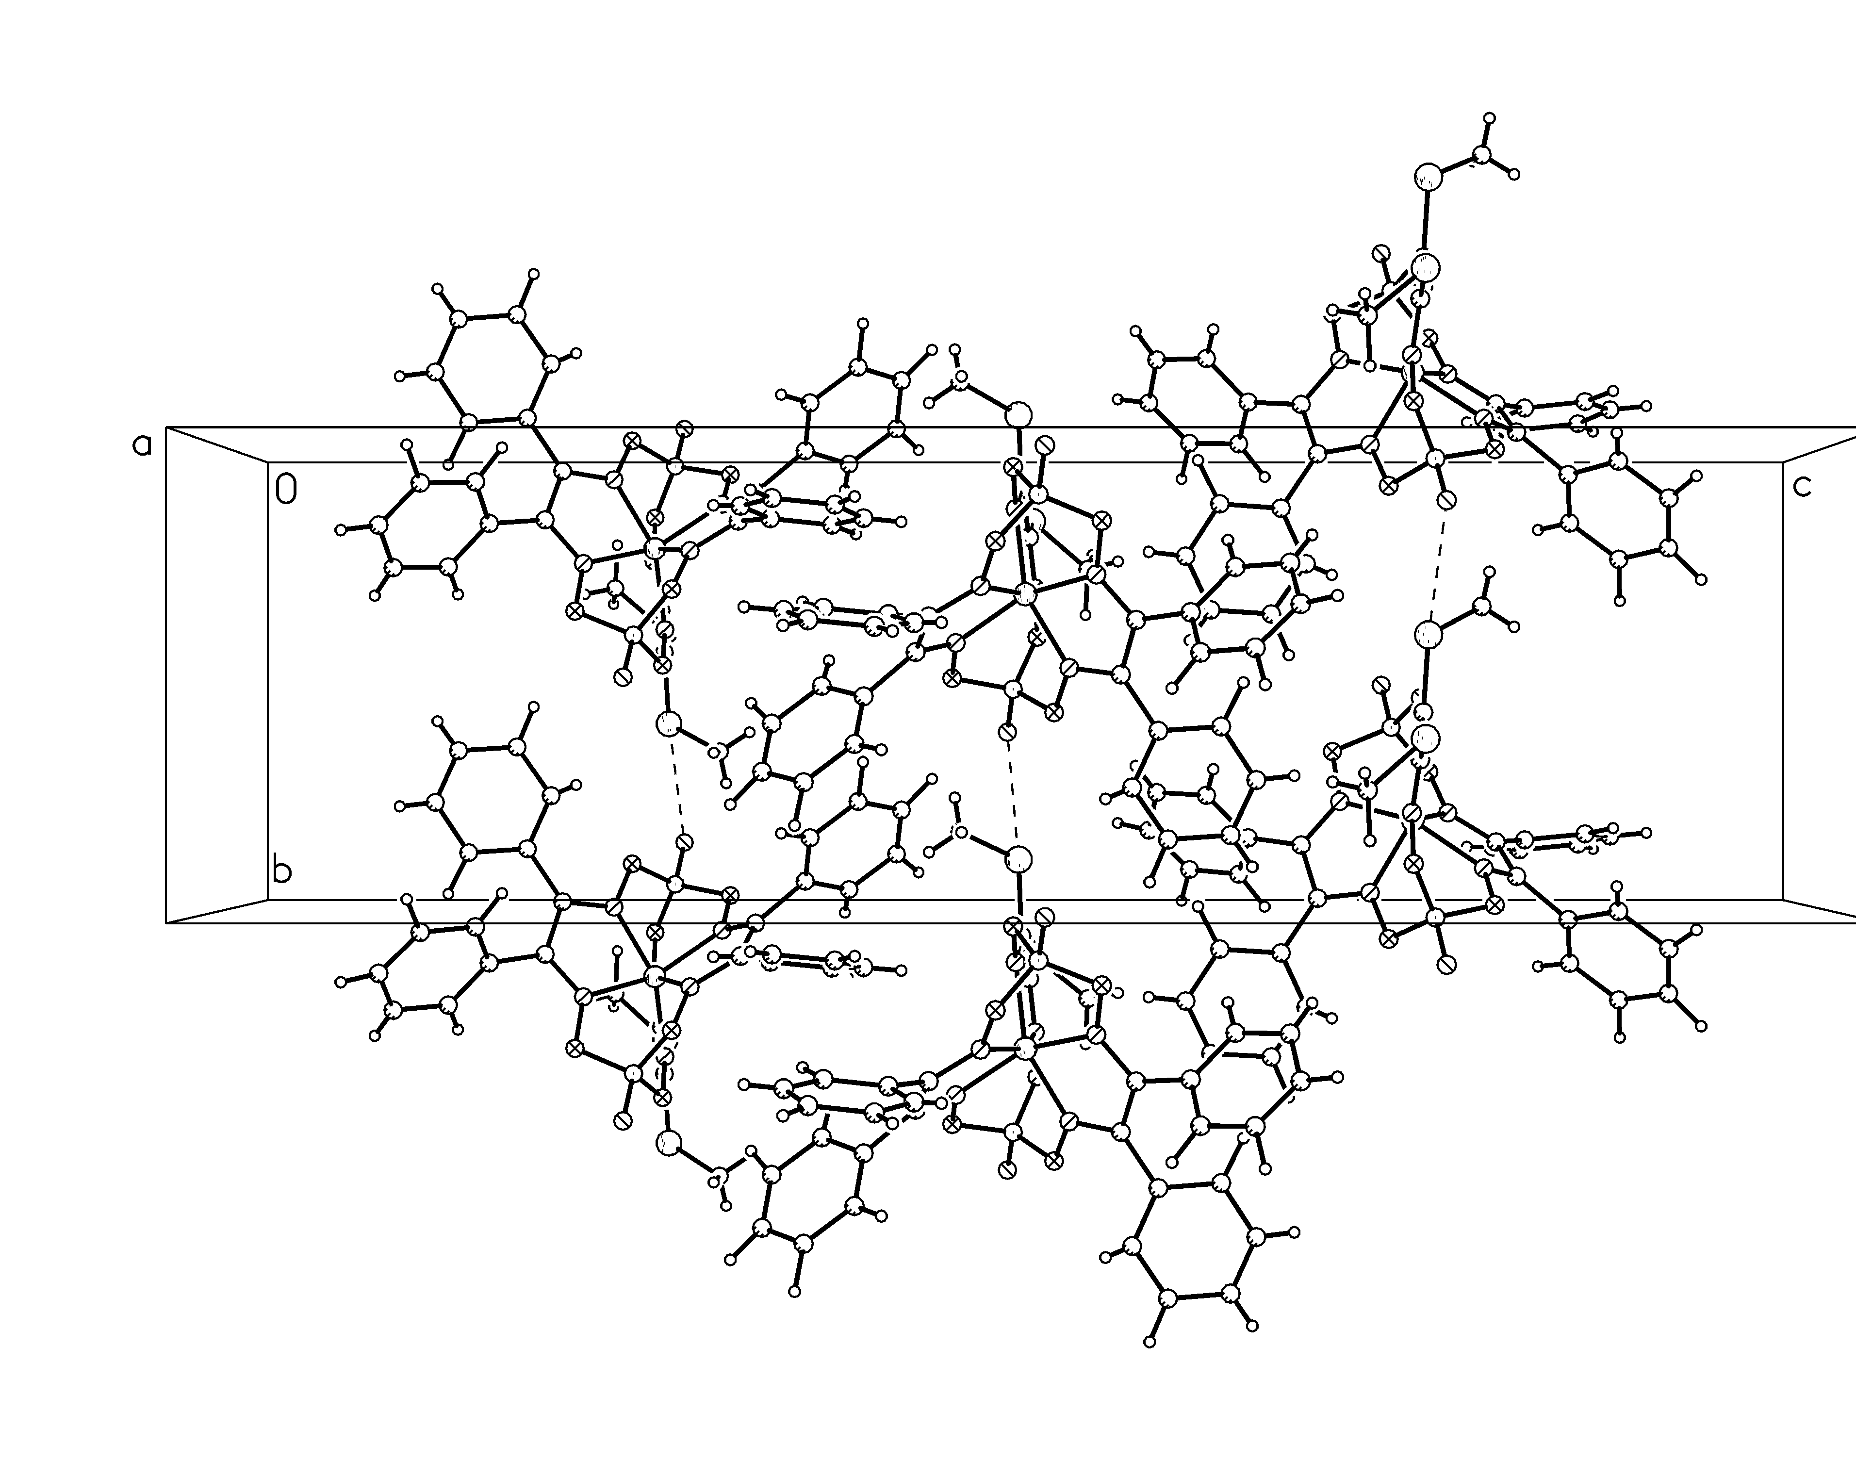
Perspective view of the molecular packing fragment of the structure 13 along the a axis.

