Supplementary Information

————————————————————————————
Aromatic C−F Activation at Ni in the Presence of a Carbon Chlorine Bond: The Nickel Mediated Synthesis of new Pyrimidines
—————————————————————————————————————
Marianna I. Sladek, Thomas Braun*, Beate Neumann and Hans-Georg Stammler
Fakultät für Chemie, Universität Bielefeld, Postfach 100131, D-33501 Bielefeld, Germany,
E-mail: thomas.braun@uni-bielefeld.de

Received November 2001

Preparation and analytical data for 1:
A suspension of [Ni(COD)2] (306 mg, 1.10 mmol) in hexane (6 mL) was treated with PEt₃ (350 μl, 2.40 mmol). The solution was stirred for 15 min at room temperature until the colour changed from red-purple to yellow. After adding 5-chloro-2,4,6-trifluoropyrimidine (137 μl, 1.32 mmol) the solution was stirred for 2 h and the volatiles were removed under vacuum. The orange residue was suspended in hexane (10 mL) and filtered. The filtrate was concentrated to about 2 mL in vacuo. Yellow crystals of 1 were obtained at –20 °C overnight. Yield 98 mg (20%) (Found: C, 40.84; H, 6.53; N, 5.99%. C₁₆H₃₀ClF₃N₂NiP₂ requires: C, 41.46; H, 6.52; N, 6.04%). ³¹P NMR (202.5 MHz, C₆D₆, 300K): δ 15.83 (s). ¹⁹F NMR (470.4 MHz, C₆D₆, 300K): δ −37.77 (s, br, 2 F), −55.72 (s, br, 1 F).

Preparation and analytical data for 2:
Compound 2 was prepared in an analogous procedure as described for 1 starting from [Ni(COD)2] (110 mg, 0.40 mmol), PCy₃ (286 mg, 1.02 mmol) and 5-chloro-2,4,6-trifluoropyrimidine (50 μl, 0.48 mmol). Yield 107 mg (34%) (Found: C, 60.50; H, 8.35; N, 3.59%. C₄₀H₆₆ClF₃N₂NiP₂ requires: C, 60.97; H, 8.44; N, 3.55%). ³¹P NMR (202.5 MHz, C₆D₆, 300K): δ 19.65 (d, J_{PF} 39 Hz). ¹⁹F NMR (470.4 MHz, C₆D₆, 300K): δ −49.86 (s, 1 F), −73.67 (s, 1F), −377.56 (t, J_{PF} 40 Hz, 1F).

Preparation and analytical data for 3:
Heating a sample of 2 (90 mg, 0.11 mmol) together with NaCl (20 mg, 0.32 mmol) in thf (3 mL) at 343 K for 3 d led to complex 3. After removing the solvent under vacuum, the orange solid was recrystallised from hexane at 0 °C. Yield: 45 mg (50%) (Found: C, 59.92; H, 8.70; N, 3.10%. C₄₀H₆₆Cl₂F₂N₂NiP₂ requires: C, 59.72; H, 8.27; N, 3.48%). ³¹P NMR (202.4 MHz, C₆D₆, 300K): δ 15.67 (s). ¹⁹F NMR (470.4 MHz, C₆D₆, 300K): δ −48.91 (s, 1 F), −73.77 (s, 1 F).

Crystal data for 1: C₁₆H₃₀ClF₃N₂NiP₂, M = 463.52, triclinic, space group , a = 11.8700(1), b = 13.3690(1), c = 14.1440(2) Å, α = 97.9150(5)°, β = 96.7310(5)°, γ = 90.4950(4)°, U = 2207.11(4) Å³, T = 100 K, μ(Mo-Kα) = 1.172 mm⁻¹, Z = 4, D_{c} = 1.395 g cm⁻³, 89302 reflexions measured, 12851 unique (R_{int} = 0.033). Final R₁, wR₂ values on all data 0.0395, 0.0710. R₁, wR₂ values on [I_{o} > 2σ(I_{o}), 10758 reflexions] data 0.0289, 0.0670.

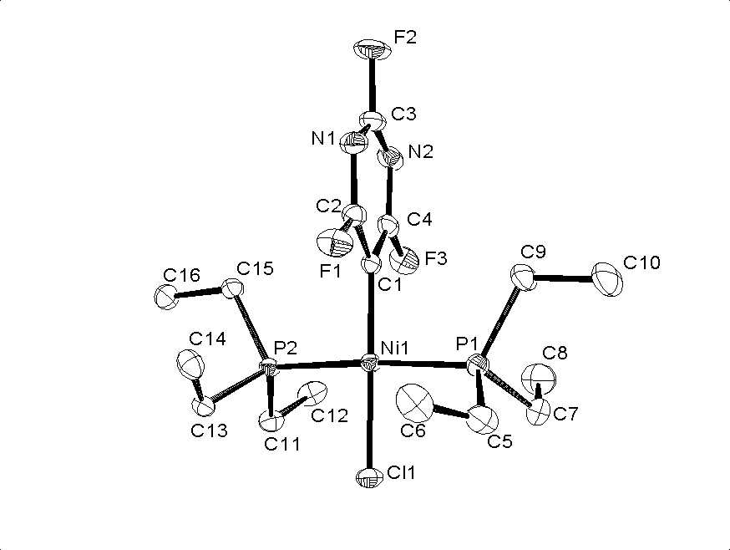
Fig. An ORTEP diagram of 1. Ellipsoids are drawn at the 50% probability level. Selected bond lengths (Å) and angles (°):Ni(1)–Cl(1) 2.1983(4), Ni(1)–C(1) 1.8849(13), C(1)-C(4) 1.3817(19), N(2)-C(4) 1.3290(18), N(2)-C(3) 1.310(2), N(1)-C(3) 1.310(2), N(1)-C(2) 1.3253(18), C(1)-C(2) 1.3876(19), F(1)-C(2) 1.3483(17), F(2)-C(3) 1.3439(17), F(3)-C(4) 1.3449(19), C(1)-Ni(1)-Cl(1) 178.30(4), P(1)-Ni(1)-P(2) 176.378(15).

