Supplementary Material (ESI) for Dalton Transactions
This journal is © The Royal Society of Chemistry 2002
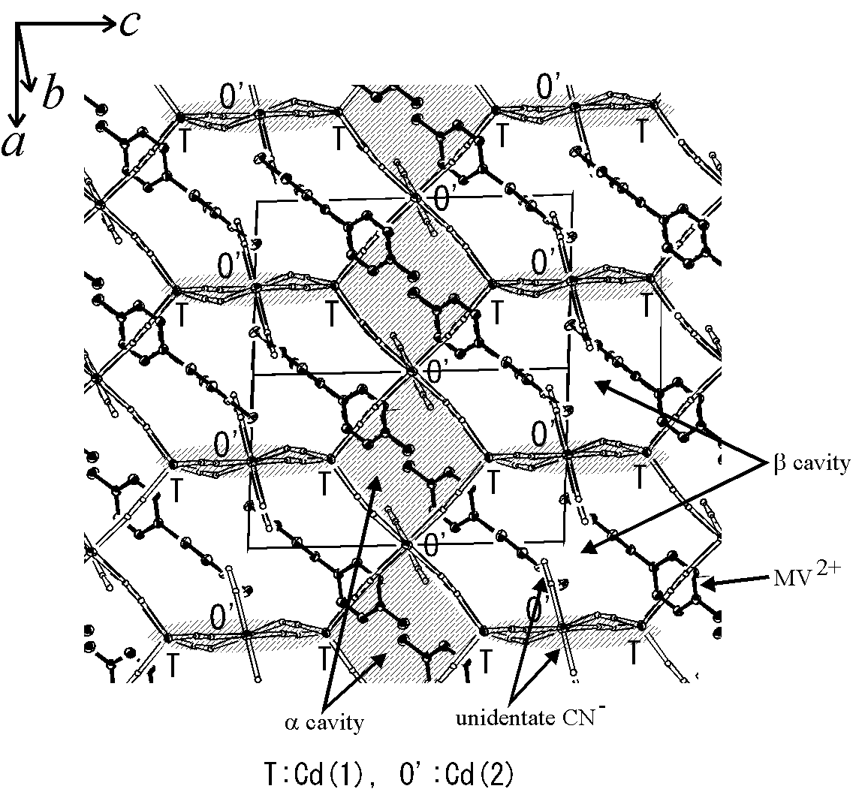
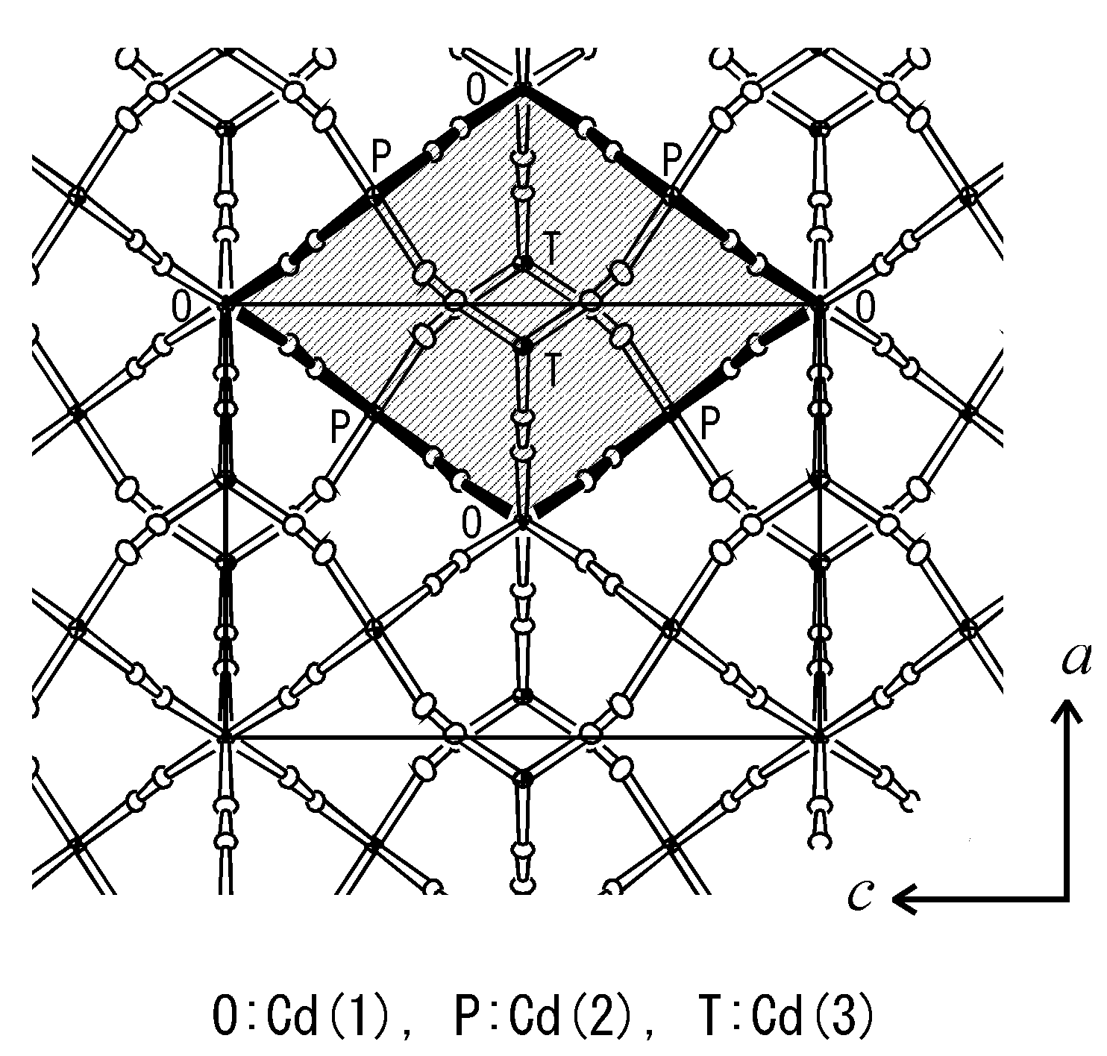
Crystal structure of the toluene clathrate III-2.
Crystal structure in the range of b = +0.35 to b = +0.65. The thick bonds indicate a cage-like cavity. The arrangement of the cage-like cavities is shown.
Crystal structure of the Cd complex V-1.
A projective view along the [$\bar{1}$,1,0] direction shows the 3-D network structure of V-1 constructed by the linkage of (-O’-T-O’-T-) quadrangles(hatched areas).

