Supplementary Material (ESI) for Dalton Transactions
This journal is © The Royal Society of Chemistry 2002
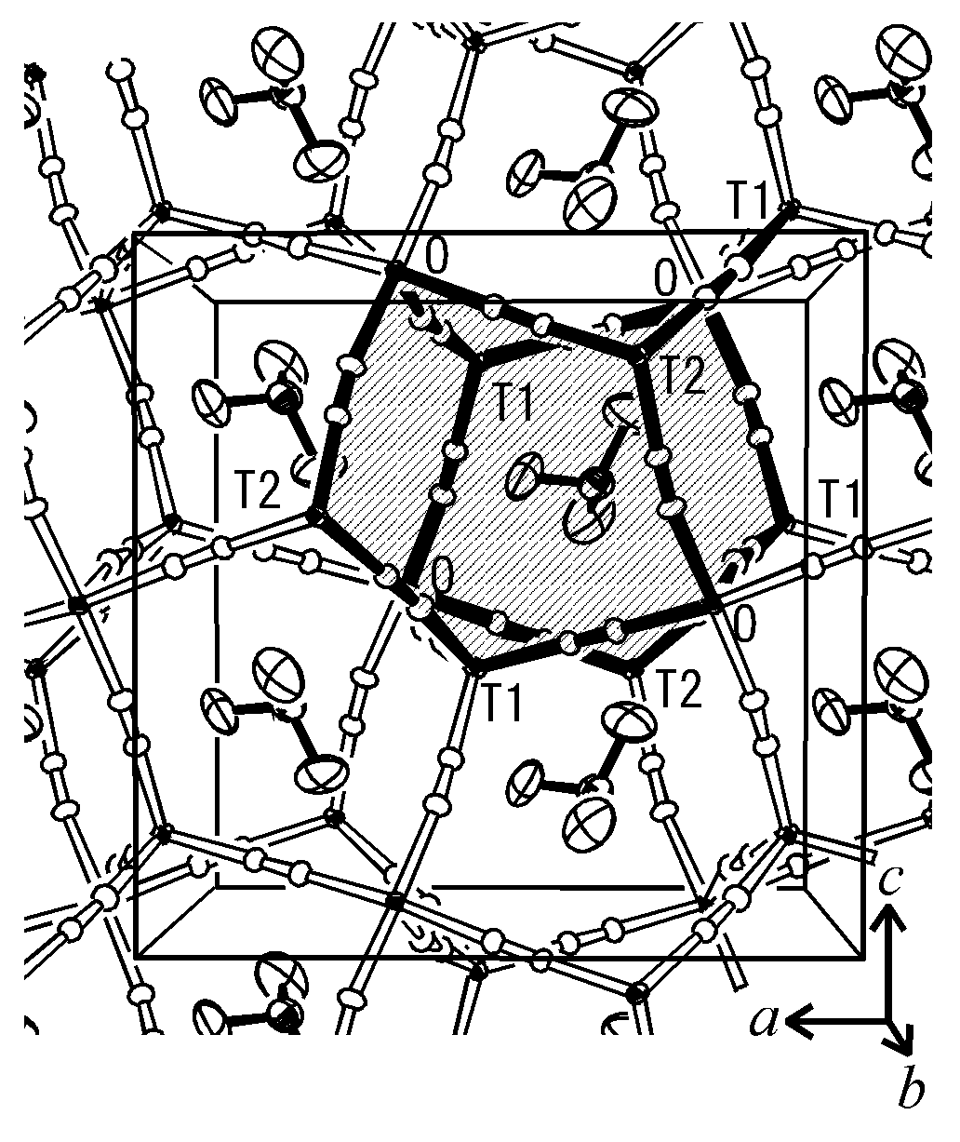
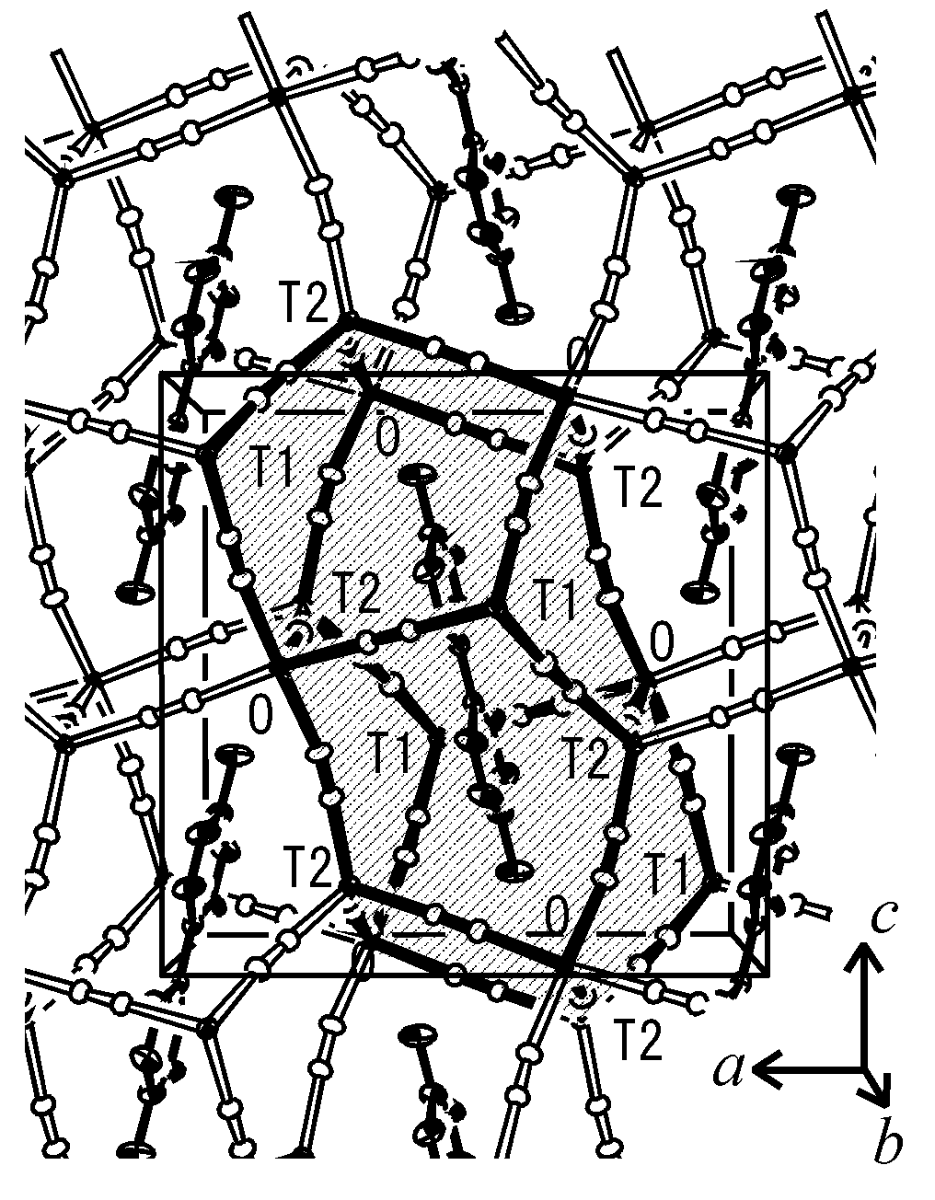
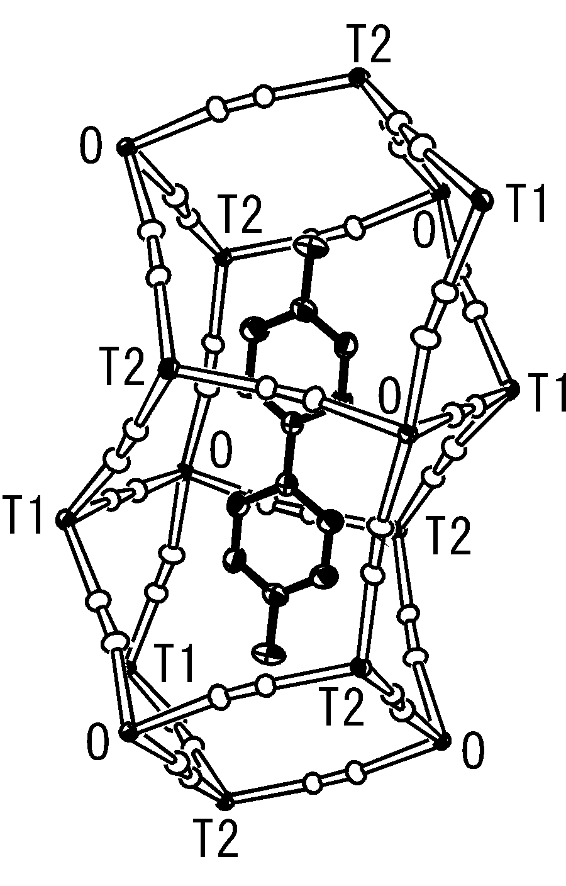
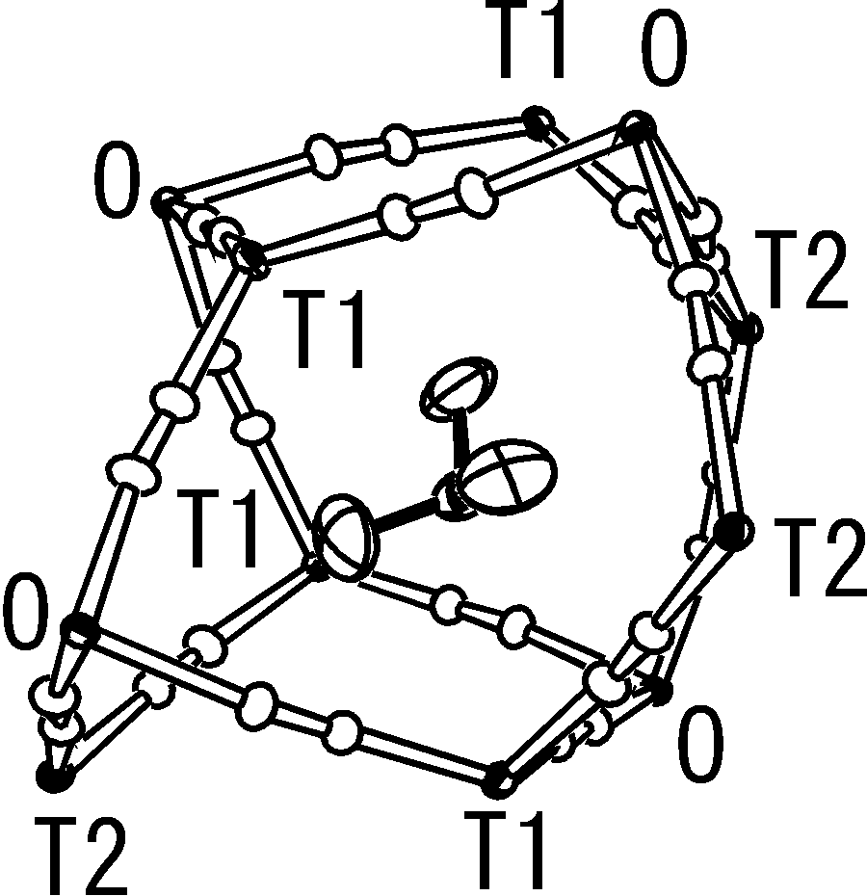
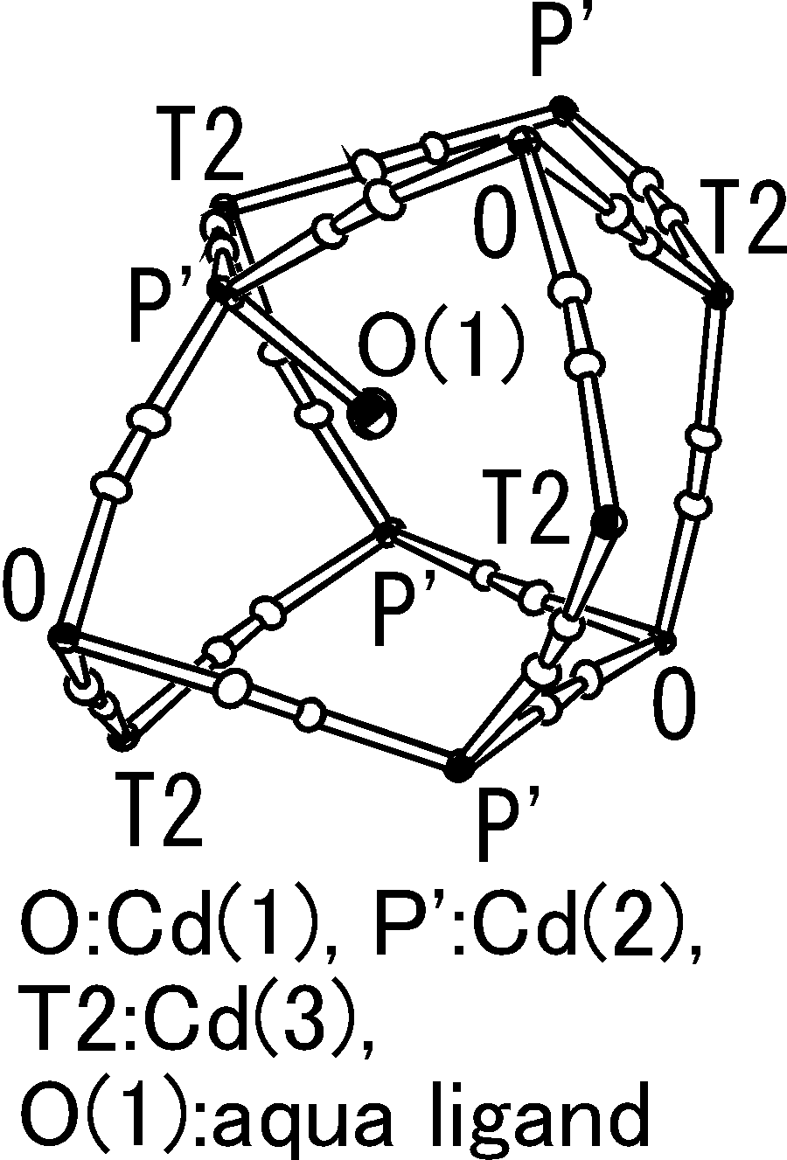
Crystal structure of the chloroform clathrate IIa-1.
Crystal structure in the range of b = +0.3 to b = +0.7 viewed along the b axis. The 2-D arrangement of IIA cavities in the monolayer is shown.
IIA cage-like cavity and MV²⁺.
Crystal structure in the range of b = 0 to b = +0.5. The 2-D arrangement of IIB cavities in the monolayer is shown.
IIB cage-like cavity and a guest chloroform molecule.
IIB cage-like cavity of the diethyl ether clathrate IIb-1. It is similar to the IIB cavity of IIa-1 except an aqua ligand coordinating to P’.

