Supplementary Material (ESI) for Dalton Transactions
This journal is © The Royal Society of Chemistry 2002
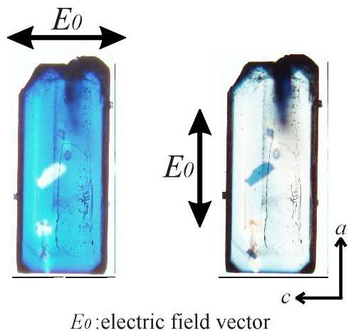
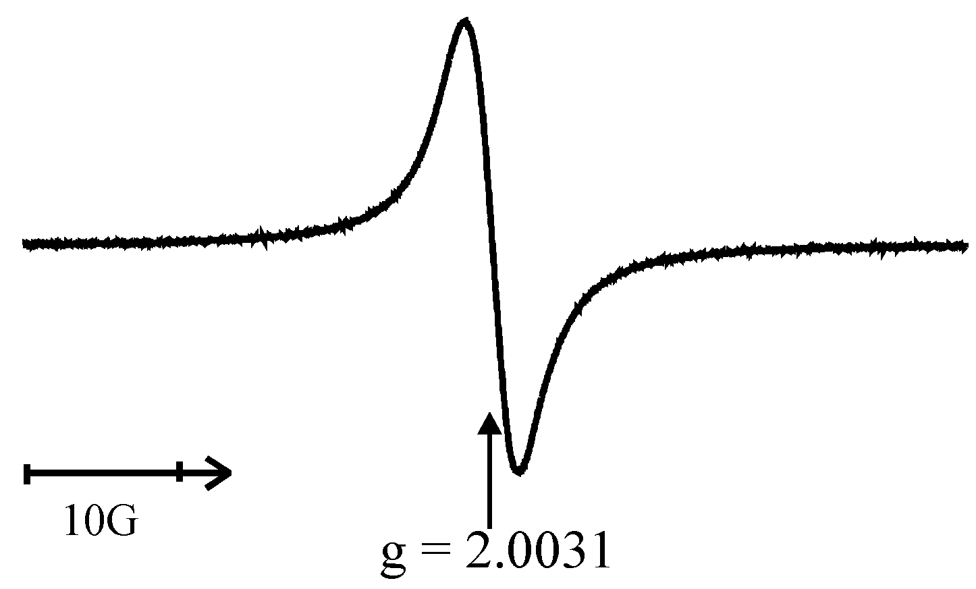
ESR spectrum of the diethyl ether clathrate IIb-1 powdered sample after UV irradiation measured at room temperature. g = 2.0031 and ΔH_{p-p} = 4.3 G.
Dichroism of the diethyl ether clathrate IIb-1 single crystal irradiated by UV light. See text and Fig. 9.

