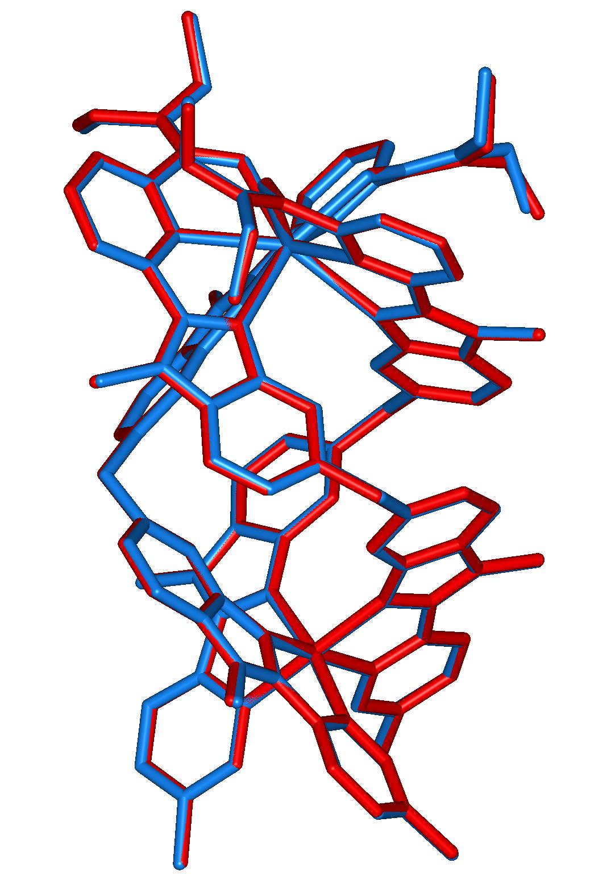
Figure S2 View of the molecular structure 7 (red) superimposed with the molecular structure of 8 (blue) in the same orientation.

