O-benzylated-calix[4]arenes as ancillary ligands in organolanthanide chemistry

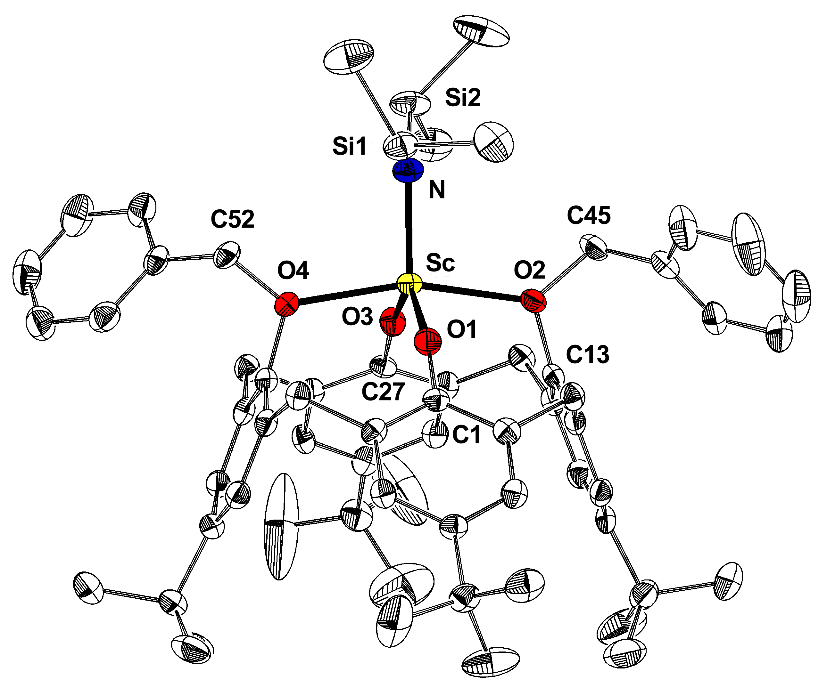
Frank Estler, Eberhardt Herdtweck and Reiner Anwander*

Anorganisch-chemisches Institut der Technischen Universität München, Lichtenbergstraße 4,
D-85747 Garching, Germany. Fax: +49 (0) 289-13473; e-mail: reiner.anwander@ch.tum.de

Supplementary Information
Experimental Section

General Considerations. All air- and moisture-sensitive compounds were manipulated with the rigorous exclusion of oxygen and moisture in flame-dried (180 °C) Schlenk-type glassware using standard high-vacuum technique or an argon-filled glovebox (MBraun) with O2/H2O < 1ppm. The solvents were predried, distilled from Na/K alloy and stored in a glovebox. Deuterated solvents were obtained from Deutero GmbH and degassed and dried over Na/K alloy. The lanthanide silylamide precursors Ln[N(SiHMe₂)₂]₃(THF)_{x} (Ln = Sc 2a, Lu 2b) were synthesized according to the literature (ref. 1). NMR spectra were recorded either on a Bruker DPX-400 (FT, 400 MHz 1H; 100 MHz 13C) or on a JEOL JNM-GX-270 (FT, 270.16 MHz 1H; 67.93 MHz 13C) spectrometer. 1H and 13C shifts are referenced to internal solvent resonances and reported relative to TMS. IR spectra were recorded on a Perkin-Elmer 1650-FTIR spectrometer as Nujol mulls. Elemental analyses were performed in the microanalytical laboratory of the institute.

Synthesis of 3a. In a glove box, 360.0 mg (0.44 mmol) of 1a and 224.0 mg (0.44 mmol) of 2a were dissolved in 10 mL of n-hexane. The solution was stirred for 24 h at room temperature. The resulting solid was separated and washed with 10 mL of n-hexane, then dissolved in a minimum amount of toluene and kept at –30 °C over night affording 380.0 mg (0.38 mmol, 86 %) of 3a as colorless crystals. ¹H NMR (d₆-benzene, 23 °C, 400.1 MHz): δ 7.1 – 6.7 (m, 18H, Ar-H), 5.79 (sp, 2H, Si-H), 5.64 (s, 4H, OCH₂Ph), 4.30 (d, 4H, CH₂), 2.93 (d, 4H, CH₂), 1.41 (s, 18H, C(CH₃)₃), 0.77 (d, 12H, SiH(CH₃)₂), 0.71 (s, 18H, C(CH₃)₃). ¹³C NMR (d₆-benzene, 23 °C, 100.6 MHz): δ 157.4, 148.5, 145.8, 139.6, 137.5, 133.6, 131.7, 128.9, 128.2, 126.4, 125.3, 124.0 (Ar-C), 81.8 (OCH₂Ph), 33.8 (CH₂), 33.4 (C(CH₃)₃) 31.9 (C(CH₃)₃), 30,3 (C(CH₃)₃), 21.0 (C(CH₃)₃), 3.3 (SiH(CH₃)₂). IR (Nujol mull) ν = 2083 cm⁻¹ s (Si-H). Found: C, 78.6; H, 8.9, N, 1.4. C₆₂H₈₀NO₄Si₂Sc requires C, 78.4; H, 8.6, N, 1.2 %.

Synthesis of 3b. According to the procedure for 3a, 449.2 mg (0.40 mmol, 90 %) of 3b were obtained from 366.4 mg (0.44 mmol) of 1a and 316.5 mg (0.44 mmol) of 2b as a white powder. ¹H NMR (d₆-benzene, 23 °C, 400.1 MHz): δ 7.3 – 6.7 (m, 18H, Ar-H), 5.71 (sp, 2H, Si-H), 5.44 (s, 4H, OCH₂Ph), 4.19 (d, 4H, CH₂), 2.93 (d, 4H, CH₂), 1.42 (s, 18H, C(CH₃)₃), 0.75 (s, 18H, C(CH₃)₃), 0.71 (d, 12H, SiH(CH₃)₂). ¹³C NMR (d₆-benzene, 23 °C, 100.6 MHz): δ 158.3, 148.8, 146.0, 138.7, 134.3, 133.5, 131.7, 129.8, 129.2, 127.0, 125.6, 124.2 (Ar-C), 82.2 (OCH₂Ph), 34.1 (CH₂), 33.8 (C(CH₃)₃) 32.3 (C(CH₃)₃), 30,7 (C(CH₃)₃), 21.4 (C(CH₃)₃), 3.7 (SiH(CH₃)₂). IR (nujol mull) ν = 2052 cm⁻¹ s (Si-H). Found: C, 66.4; H, 7.6 N, 1.37. C₆₂H₈₀NO₄Si₂Lu requires C, 65.6; H, 7.1, N, 1.23 %.

Synthesis of 4. In a glove box, 207.9 mg (0.34 mmol) of 1b and 246.2.0 mg (0.34 mmol) of 2b were dissolved in 15 mL of toluene. The solution was stirred for 24 h at room temperature. Then, the volatiles were removed under reduced pressure. The resulting white powder was dissolved in a minimum amount of toluene and kept at –30 °C over night yielding 278.5 mg (0.31 mmol, 90 %) of 4 as colorless crystals. ¹H NMR (d₆-benzene, 23 °C, 400.1 MHz): δ 7.3 – 7.0 (m, 10H, OCH₂Ph-H), 6.81 (dd, 2H, Ar-H), 6.65 (d, 4H, Ar-H), 6.18 (dd, 2H, Ar-H), 5.74 (sp, 2H, Si-H), 5.49 (s, 4H, OCH₂Ph), 4.19 (d, 4H, CH₂), 2.93 (d, 4H, CH₂), 0.75 (d, 12H, SiH(CH₃)₂). ¹³C NMR (d₆-benzene, 23 °C, 100.6 MHz): δ 160.7, 148.1, 137.8, 136.9, 134.5, 131.6, 130.7, 129.9, 129.3, 127.0, 125.6, 116.6 (Ar-C), 82.5 (OCH₂Ph), 32.8 (CH₂), 3.6 (SiH(CH₃)₂). IR (nujol mull) ν = 2053 cm⁻¹ s (Si-H). Found: C, 61.4; H, 5.6, N, 1.4. C₄₆H₄₈NO₄Si₂Lu requires C, 60.7; H, 5.3, N, 1.5 %.

Additional references.
1 R. Anwander, O. Runte, J. Eppinger, G. Gerstberger, E. Herdtweck, M. Spiegler, J. Chem. Soc., Dalton Trans. 1998, 847.

