SUPPLEMENTARY MATERIAL

INDEX

Table 1
Thermodynamic parameters for Ac-TLEGTKKGHKLHLDY-NH₂ protonation, at 298.2 K and I = 0.1 mol · dm⁻³ (KNO₃).

Table 2
Thermodynamic parameters of Cu(II)/Ac-TLEGTKKGHKLHLDY-NH₂ binary-complex formation, at 298.2 K and I = 0.1 mol · dm⁻³ (KNO₃).

Table 3
¹H-NMR chemical shifts (ppm) measured for Ac-TLEGTKKGHKLHLDY-NH₂ 2.2 ∙ 10⁻³ mol dm⁻³, in D₂O/H₂O at pH 5.6 and T = 298.2 K.

Table 4
¹³C-NMR chemical shifts (ppm) measured for Ac-TLEGTKKGHKLHLDY-NH₂ 3.8∙ 10⁻³ mol dm⁻³ in D₂O at pH 10.4 and T = 298.2 K.

Fig. 1
¹H-NMR spectrum of Ac-TLEGTKKGHKLHLDY-NH₂ 2.2 ∙ 10⁻³ mol dm⁻³ in D₂O/H₂O at pH 5.6 before (A trace) and after the addition of Cu(II) 8.8 ∙ 10⁻⁶ mol dm⁻³ (B trace).

Fig. 2
¹H-NMR spectrum of Ac-TLEGTKKGHKLHLDY-NH₂ 2.2 ∙ 10⁻³ mol dm⁻³ in D₂O/H₂O at pH 5.6 before (A trace) and after the addition of Cu(II) 8.8 ∙ 10⁻⁶ mol dm⁻³ (B trace): expanded low field region.

Fig. 3
Temperature dependence of the R_{1p} values measured for selected protons of Ac-TLEGTKKGHKLHLDY-NH₂ 2.2 ∙ 10⁻³ mol dm⁻³ in D₂O/H₂O at pH 5.6 after the addition of Cu(II) 8.8 ∙ 10⁻⁶ mol dm⁻³.

Fig. 4
Structure hypothesis for the Cu(II)/Ac-TLEGTKKGHKLHLDY-NH₂ complex at pH 10.4.

Table 1
Thermodynamic parameters for Ac-TLEGTKKGHKLHLDY-NH₂ protonation, at 298.2 K and I = 0.1 mol · dm⁻³ (KNO₃).

Species | −ΔG°  (kJ · mol⁻¹) | −ΔH°  (kJ · mol⁻¹) | ΔS°  ( J · mol⁻¹ · K⁻¹)
HL | 63.8 (1) | 50 (8) | 46 (26)
H₂L | 123.1 (2) | 100 (4) | 79 (14)
H₃L | 180.7 (2) | 142 (6) | 131 (19)
H₄L | 234.3 (2) | 168 (5) | 221 (18)
H₅L | 272.3 (2) | 201 (5) | 239 (18)
H₆L | 305.7 (2) | 212 (5) | 314 (18)
H₇L | 329.5 (2) | 211 (5) | 398 (18)
H₈L | 348.9 (2) | 209 (6) | 470 (19)

Table 2
Thermodynamic parameters of Cu(II)/Ac-TLEGTKKGHKLHLDY-NH₂ binary-complex formation, at 298.2 K and I = 0.1 mol · dm⁻³ (KNO₃).

Species | −ΔG°  (kJ · mol⁻¹) | −ΔH°  (kJ · mol⁻¹) | ΔS°  ( J · mol⁻¹ · K⁻¹)
CuH₅L | 296.9 (3) | 208 (4) | 300 (13)
CuH₄L | 268.9 (3) | 199 (2) | 233 (6)
CuH₃L | 229.0 (5) | 212 (3) | 57 (12)
CuH₂L | 189.3 (2) | 156 (2) | 110 (8)
CuHL | 139.7 (3) | 119 (3) | 70 (10)
CuL | 84.3 (3) | 67 (5) | 56 (16)
CuH₋₁L | 26.3 (4) | 46 (7) | -68 (24)
CuH₋₂L | -34.9 (5) | -17 (11) | -61 (38)
CuH₋₃L | -99.5 (6) | -56 (19) | -145 (63)

Table 3
¹H-NMR chemical shifts (ppm) measured for Ac-TLEGTKKGHKLHLDY-NH₂
2.2 ∙ 10⁻³ mol dm⁻³, in D₂O/H₂O at pH 5.6 and T = 298.2 K

 | HN | Hα | Hβ | Hγ | Others
¹Thr | 8.20 | 4.30 | 4.23 | 1.27
²Leu | 8.44 | 4.39 | 1.68 | 1.65 | δCH₃ 0.93-0.88
³Glu | 8.47 | 4.25 | 2.29 – 1.99
⁴Gly | 8.44 | 3.97
⁵Thr | 8.03 | 4.32 | 4.26
⁶Lys | 8.28 | 4.30 | 1.79 – 1.74 | 1.38 | δCH₂ 1.68 εCH₂ 3.00
⁷Lys | 8.26 | 4.27 | 1.82 – 1.71 | 1.44 | δCH₂ 1.68 εCH₂ 3.00
⁸Gly | 8.40 | 3.93
⁹His | 8.24 | 4.65 | 3.19 – 3.10 |  | H₂ 8.23 H₄ 7.10
¹⁰Lys | 8.37 | 4.29 | 1.69 | 1.39 | δCH₂ 1.68 εCH₂ 3.00
¹¹Leu | 8.34 | 4.27 | 1.59 | 1.54 | δCH₃ 0.91-0.85
¹²His | 8.42 | 4.63₅ | 3.16 |  | H₂ 8.36 H₄ 7.17
¹³Leu | 8.19 | 4.31 | 1.58 | 1.47 | δCH₃ 0.88-0.83
¹⁴Asp | 8.31 | 4.57 | 2.65 – 2.53
¹⁵Tyr | 8.08 | 4.53₅ | 3.12 – 2.92₅ |  | H_{2,6} 7.16 H_{3,5} 6.83

Table 4
¹³C-NMR chemical shifts (ppm) measured for Ac-TLEGTKKGHKLHLDY-NH₂
3.8∙ 10⁻³ mol dm⁻³ in D₂O at pH 10.4 and T = 298.2 K

 | CO | Cα | Cβ | Cγ | Others
¹Thr | 174.88 | 62.27 | 69.93 | 21.73
²Leu | 175.18 | 55.18 | 42.34 | 27.01 | δCH₃ 25.05-23.70
³Glu | 177.73 | 57.19 | 30.35 | 36.43 | COOH 184.12
⁴Gly | 173.99 | 45.57
⁵Thr | 174.69 | 62.11 | 69.94
⁶Lys | 176.74 | 55.38 |  | 25.08 | Cδ 30.76 Cε 42.41
⁷Lys | 176.70 | 55.42 | 33.26 | 25.08 | Cδ 30.78 Cε 42.41
⁸Gly | 173.92 | 45.38
⁹His | 175.66 | 56.55 | 31.30 |  | C₂ 138.87 C₄ 119.93
¹⁰Lys | 176.31 | 56.38 | 33.10 | 25.12 | Cδ 30.62 Cε 42.39
¹¹Leu | 177.50 | 56.73 | 42.53 | 27.17 | δCH₃ 25.00-23.62
¹²His | 175.46 | 56.55 | 31.72 |  | C₂ 138.90 C₄ 119.93
¹³Leu | 177.00 | 56.67 | 42.58 | 27.17 | δCH₃ 24.96-23.52
¹⁴Asp | 175.93 | 54.31 | 41.32 |  | COOH 180.38
¹⁵Tyr | 178.86 | 57.95 | 38.80 |  | C₁ 128.18 C_{2,6} 133.29  C_{3,5} 119.93 C₄ 162.01

Fig. 1 - ¹H-NMR spectrum of Ac-TLEGTKKGHKLHLDY-NH₂ 2.2 ∙ 10⁻³ mol dm⁻³ in D₂O/H₂O at pH 5.6 before (A trace) and after the addition of Cu(II) 8.8 ∙ 10⁻⁶ mol dm⁻³ (B trace).

Fig. 2 - ¹H-NMR spectrum of Ac-TLEGTKKGHKLHLDY-NH₂ 2.2 ∙ 10⁻³ mol dm⁻³ in D₂O/H₂O at pH 5.6 before (A trace) and after the addition of Cu(II) 8.8 ∙ 10⁻⁶ mol dm⁻³ (B trace): expanded low field region.

Fig. 3 - Temperature dependence of the R_{1p} values measured for selected protons of Ac-TLEGTKKGHKLHLDY-NH₂ 2.2 ∙ 10⁻³ mol dm⁻³ in D₂O/H₂O at pH 5.6 after the addition of Cu(II) 8.8 ∙ 10⁻⁶ mol dm⁻³.

Fig. 4 - Structure hypothesis for the Cu(II)/Ac-TLEGTKKGHKLHLDY-NH₂ complex at pH 10.4.
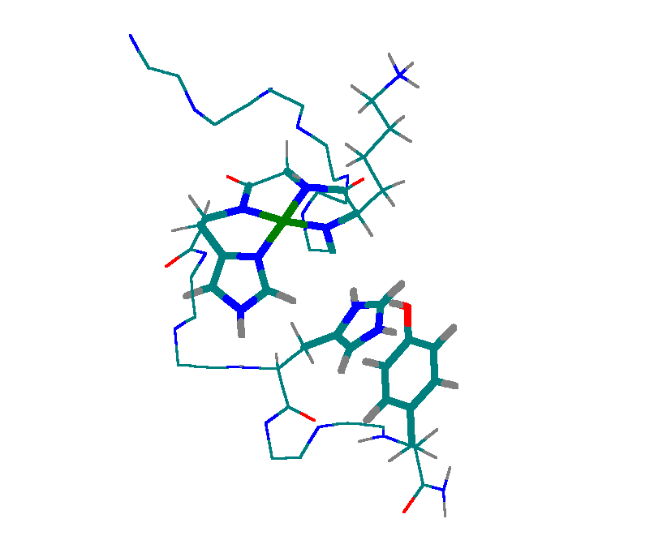
⁷Lys
⁸Gly
⁹His
¹²His
¹⁵Tyr
C-terminal
N-terminal

