Synthesis of mono- and di-potassium salts and methoxy adducts of sulfur-bridged biphenols by selective deprotonation
Polly L. Arnold,* Jonathan J. Hall, Louise S. Natrajan, Alexander J. Blake, and Claire Wilson
School of Chemistry, The University of Nottingham, University Park, Nottingham NG7 2RD, UK. Fax: 0115 951 3563; Tel: 0115 951 3437; E-mail: Polly.Arnold@Nottingham.ac.uk

Supplementary Data
Experimental

General procedures
All manipulations were carried out under a dry, oxygen-free dinitrogen atmosphere using standard Schlenk techniques or in a Mbraun Unilab glove box. The solvents used (toluene, thf, hexane, pentane) were degassed and purified by passage through activated alumina towers prior to use. Benzene-d₆ was refluxed over potassium, and vacuum transferred prior to use. The compounds 1, Li₂L^{S} (9), and 2 were prepared by literature methods. All other reagents were procured from Aldrich and used without further purification. Elemental analyses were determined by Mr Stephen Boyer at London University.

¹H and ¹³C NMR spectra were recorded on Bruker AMX300 spectrometer, referenced internally to residual solvent proton resonance, and externally to TMS. IR spectra were run as nujol mulls (KBr disc) on a Nicolet Avatar 360 instrument. Melting points were obtained in sealed glass capillaries under dinitrogen and are reported uncorrected. Mass spectra (EI and FAB) were run by Mr Tony Hollingworth on a VG autospec instrument, Dr Ali Abdul-Sada on a Kratos MS80RF instrument, and the EPSRC mass spectrometry facility at Swansea.

Preparations
[1,1’-S(2-KO)(2’-HO)(C₆H₂Bu^{t}-3-Me-5)₂(Et₂O)] 3.
To a stirred suspension of KH in diethyl ether (0.335 g, 8.4 mmol, 30 ml) was added a solution of H₂L^{S} (3.0 g, 8.4 mmol, 30 ml) dropwise over 15 mins at –30ºC. Upon addition a pale yellow precipitate formed, and the suspension was allowed to warm to room temperature with stirring over 12 h. The precipitated yellow solid was recrystallised from diethyl ether to yield 3 (3.20 g, 82 %). Large colourless crystals were obtained from a solution of 3 in diethyl ether upon cooling to –30 ºC. M.p. 246-9°C ºC (dec). Addition of one drop of distilled water regenerated the ¹H NMR spectrum of 1. Repetition of the reaction between 1 and KH in thf yields the same complex, but up to 20 % of the crude mixture is the doubly deprotonated salt, [1,1’-S(2’-KOC₆H₂Bu^{t}-3-Me-5)₂(thf)_{0.5}] contaminant.
NMR/C₆D₆ δ_{H}: δ 14.9 (s, fwhm 50 Hz, 1H, OH), 7.65 (s, 2H, aryl H), 2.19, (s, 6H, methyl CH₃), 1.46 (s, 18H, C(CH₃)₃), 3.24 (q, 4H, (CH₃CH₂)₂O), 1.13 (t, 6H, (CH₃CH₂)₂O). δ_{C}:163.4, 138.4, 128.4, 125.7 (aryl CH), 35.3, 29.8 (C(CH₃)₃), 20.6, 15.3 (CH₃).IR (nujol mull) ν(cm⁻¹): 3426.5 (br, OH). ESMS (MeOH solution) 413 [M-Bu^{t}]⁺, 381 [M-Et₂O-Me]⁺. Anal. Calc. for C₂₂H₂₉O₂SK.Et₂O: C 66.34, H 8.35. Found: C 66.28, H 8.29. Flame Photometry. Calc. for C₂₂H₂₉O₂SK.Et₂O: K 8.31. Found: K 8.50

[1,1’-S(2-KOC₆H₂Bu^{t}-3-Me-5)₂(thf)₂] 4.
To a stirred suspension of KH (0.224 g, 5.58 mmol, 10 ml) in thf was added a thf solution of H₂L^{S} (0.50 g, 1.39 mmol, 10 ml) dropwise at –30ºC over 15 min. Upon addition a yellow precipitate formed. The suspension was allowed to warm to room temperature with stirring over 12 h, by which time only a colourless precipitate was visible in a colourless solution. Filtration, followed by evaporation of volatiles from the filtrate under reduced pressure afforded a microcrystalline solid which was washed with cold thf (10 ml) to yield 4 (0.510 g, 63 %) as a colourless powder. M.p. 251-256 ºC (dec). Addition of one drop of distilled water regenerated the ¹H NMR spectrum of H₂L^{S}. NMR/C₆D₆ δ_{H}: 7.47, 7.00 (s, 2H, aryl H), 1.96 (s, 6H, CH₃), 1.62 (s, 18H, C(CH₃)₃). HRMS (ES) Calc.(found) [M.2thf]⁺: 435.1162 (435.1143). Anal. Calc. for C₂₂H₂₈O₂SK₂: C 60.78, H 6.41. Found: C 60.51, H 6.69. Flame Photometry. Calc. for C₂₂H₂₈O₂SK₂.(thf)₂: 13.51. Found: 13.78. ,

[1,1’-S(2-KO)(2’-HO)(C₁₀H₄Bu^{t}₂-3,6)₂] 5.
To a stirred solution of H₂L^{SN} in thf (2.0 g 3.69 mmol, 25 ml) was added a slurry of KH in thf (0.295 mmol, 15ml) dropwise at -78˚C over 30 minutes. The suspension was allowed to warm to room temperature over 12 hours under a slow argon sweep. The resultant yellow solution was filtered and volatiles removed under reduced pressure. The pale yellow solid was washed with three aliquots of diethyl ether (10ml) to yield analytically pure 5 in 58 % yield (1.25 g). The complex may be isolated as either the bis(diethylether) adduct, or solvent free depending on the extent of drying (10⁻³ mbar, 50 °C, 16 h). Single crystals suitable for X-ray analysis were grown by slow cooling of a saturated diethylether solution of 5 to –30 ˚C. M.p 262-265 °C (dec).

NMR/C₆D₆ δ_{H}: 14.2 (s, fwhm 561 Hz, 1H, OH), 1.31 (s, 9H, 6-Bu^{t}), 1. 58(s, 9H, 3-Bu^{t}), 7.76 (s, 2H, 4-H, 5-H), 7.73 (s, 1H, 7-H), 9.40 (d, 1H, 8-H, ³J_{HH} 8.73 Hz). δ_{C}: 162.92, 144.34, 140.26, 134.76, 114.69 (quaternary C), 125.26, 124.34 (CH), 31.50, 30.21 (Bu^{t}). IR (nujol mull) ν(cm⁻¹): 3338.39 (br, OH), 1261.03 (s), 1093.39 (s), 1019.69 (s), 799.90 (s). FAB-MS: m/z 580 (37) [M]⁺ HRMS (ES) Calc.(found) [MH]⁺: 619.2414 (619.2413).Anal. Calcd for C₃₆H₄₅O₂SK: C 74.48, H 7.76 Found: C 74.64 H 7.89.

[1,1’-S(2-KOC₁₀H₄Bu^{t}₂-3,6)₂(thf)₂] 6.
a) To a stirred slurry of KH in thf (0.59 g, 14.76 mmol, 25 ml), was added a solution of 2 in thf (2.0 g 3.69 mmol, 35 ml) dropwise at –78 °C over 1 h. The suspension was allowed to warm to room temperature over 12 h under a slow argon sweep, during which time the solution slowly changed from colourless to bright yellow. The solution was decanted off unreacted KH, and all volatiles removed under reduced pressure. The crude solid was then washed with hexane (3 x 10 ml) to yield colourless 6.2thf in 89 % yield (2.27 g). M.p. 274 –278 °C (dec). The complex may also be isolated thf-free after prolonged drying (10⁻³ mbar, 50 °C, 16 h).
NMR/C₆D₆ δ_{H}: 1.29 ( br s, 9H, 6-Bu^{t}), 1. 47(br s, 9H, 3-Bu^{t}), 7.65 (br, 4H, 4-H, 5-H, 7-H, 8-H), 3.52 (br m, 2H, thf), 1.39 (br m, 2H, thf). IR (nujol mull) ν(cm⁻¹): 1430.60 (m), 1338.59 (m), 1261.38 (m), 1214.60 (m), 903.07 (w), 818.13 (w). FAB-MS: m/z 619 [M]⁺. Anal. Calcd for C₃₆H₄₄O₂SK₂: C 69.85, H 7.16 Found: C 67.87 H 7.69. HRMS (ES) Calc.(found) [MH]⁺ 618.2336 (619.2345).

b) Reaction of 5 and KH
To solution of 5.Et₂O (0.306 mmol, 10 ml) was added a suspension of KH in toluene (0.46 mmol, 10 ml) dropwise at –78 °C over 45 minutes. The solution was allowed to warm to room temperature over 12 h. The resultant bright yellow solution was decanted from any excess KH, and volatiles removed under reduced pressure to afford a solid which was washed with cold diethyl ether (3 x 5ml) and dried in vacuo, yielding pure 6 in 80 % yield (0.15g).

Reaction of 3 and methyl iodide, synthesis of 7

To a stirred solution of 3 (0.100 g, 0.21 mmol, 10 ml) in thf was added methyl iodide (26 μL, 0.43 mmol) at room temperature; the solution immediately changed from colourless to orange, and a colourless precipitate formed. Filtration, followed by removal of volatiles from the filtrate under reduced pressure afforded a bright yellow solid characterised as 7 (0.073 g, 92%).
NMR/C₆D₆ δ_{H}: 7.41, 7.31 (1H, s, aryl H), 7.02, 6.86 (1H, s, aryl H), 3.75 (3H, s, OCH₃), 1.98, 1.87 (3H, s, CH₃), 1.56, 1.43 (9H, s, C(CH₃)₃). M.p. 83-5 °C.

Reaction of 4 and methyl iodide, synthesis of 8

To a stirred colourless solution of 4 (0.100g, 0.17 mmol) in thf was added methyl iodide (15 μL, 0.34 mmol) at room temperature. The solution immediately turned orange and a colourless precipitate formed over 24 h. Filtration, followed by removal of volatiles from the filtrate under reduced pressure afforded a yellow solid characterised as 8 (0.058 g, 87%).

¹H NMR (benzene-d₆) δ 7.35, 6.94 (2H, s, aryl H), 3.8 (6H, s, OCH₃), 2.02 (6H, s, CH₃), 1.36 (18H, s, C(CH₃)₃) M.p. 101-3 °C (105-6 °C reported).

X-Ray Crystallography
X-ray data were collected on a Bruker SMART1000 CCD area detector diffractometer using ω scans using Mo-K_{α} (λ=0.71073 Å) radiation. Structure solution and refinement was carried out using the SHELX suite of programs.

Crystal data for complex 3. C₅₂H₇₈O₆S₂K₂, M = 941.46, monoclinic, a = 12.065(2), b = 17.968(3), c = 12.609(3) Å, α = 90, β = 99.857(4), γ = 90°, U = 2693.1(9) Å³, T = 150(2) K, space group = P21/c, Z = 2, D_{c} = 1.161 g cm⁻³, μ(Mo-Kα) = 0.297 mm⁻¹, 6310 unique reflections (R_{int} 0.0579) used in all calculations. Final R₁ [4477 F  4σ(F)] = 0.0405 and wR(all F²) was 0.0952. H atoms were placed geometrically.

Crystal data for complex 5. C₅₀H₈₀KO_{5.5}S, M = 840.30, monoclinic, a = 12.9794(15), b = 23.913(3), c = 17.896(2) Å, V = 5216.5(11) Å³, T = 150(2) K, space group = P2₁/c (No. 14), Z = 4, D_{c} = 1.070 g cm⁻³, μ(Mo-Kα) = 0.717 mm⁻¹, 12542 unique reflections (R_{int} 0.047) used in all calculations. Final R₁ [5471 F  4σ(F)] = 0.124 and wR(all F²) was 0.328. All fully occupied non-hydrogen atoms were refined anisotropically. Severe positional disorder in the diethyl ether solvent molecules was identified and modelled. The minor components were refined isotropically. 3.5 molecules of Et2O included in asymmetric unit. 3 coordinated to K, one ordered, 2 show disorder. O3 modelled with C33 anc C34 common to both components and C31, C32 and O3 over 2 sites with occupancies 0.6:0.4. Minor component refined with common Uiso. O4 modelled with 3 components O4' and C atoms with occupancy 0.4. C41 and C42 common to 2 remaining components (occupancy 0.6) and remaining atoms split over 2 sites with occupancies 0.45:0.15, all modelled with common Uiso. O6, 0.5 Et2O non-coordated, O6 and C63 modelled over 2 sites with cocupancies 0.3:0.2, again with common Uiso. H atoms were placed geometrically and refined using a riding model. Hydrogens omitted from disordered Et2O. OH not located, assumed to be O1 as longer (>10 sigma difference K-O(1) than K-O(2)).

Packing diagrams for 3 (above) and 5 (below).
3: Fig S1 and S2
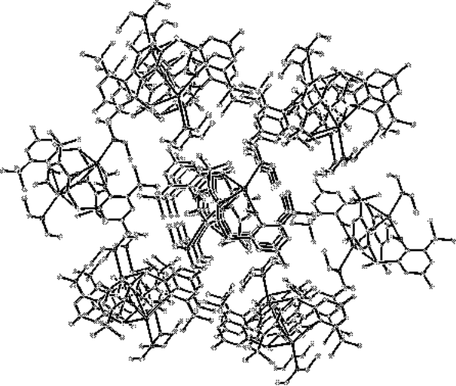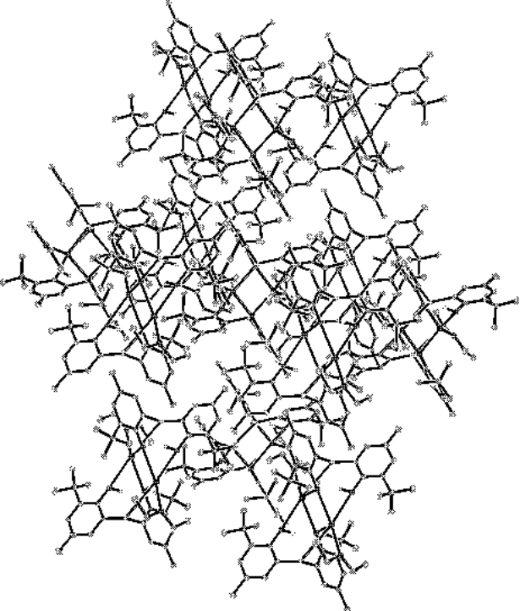

5: Fig S3 and S4
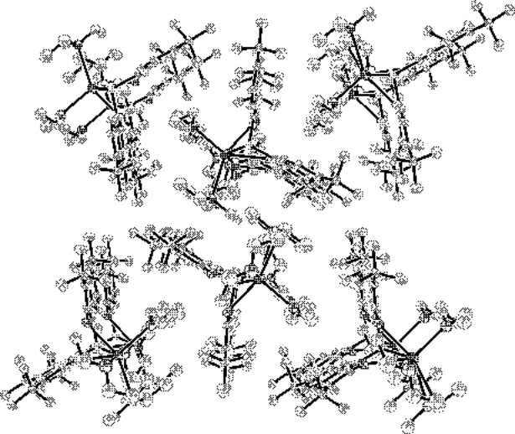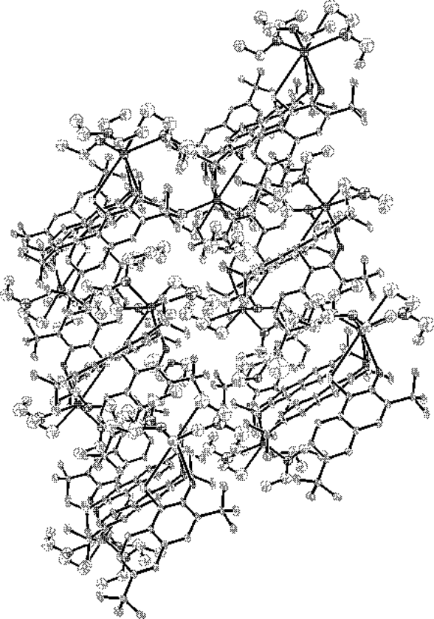

L. Jirackova and J. Pospisil, 1974, 39, 2792. F. Amor, S. Fokken, T. Kleinhenn, T. P. Spaniol, and J. Okuda, J. Organomet. Chem., 2001, 621, 3 (modification). Arnold, P. L.; Natrajan, L. S.; Hall, J. J.; Bird, S. J.; Wilson, C. J. Organomet. Chem. 2002, 647 205.
Bruker (1997). SHELXTL 5.10. Bruker AXS Inc., Madison, Wisconsin, USA. G. M. Sheldrick Acta Cryst A46 (1990). 467. G. M. Sheldrick (1997) SHELXL97, University of Goettingen, Germany.

