INFRA-RED SPECTRA

Solid IR spectrum (KBr disc) of 1

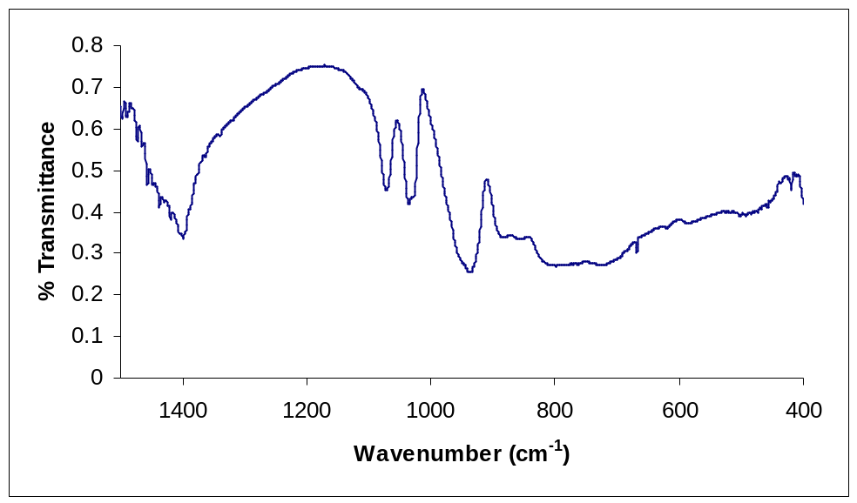

Solid IR spectrum (KBr disc) of 2

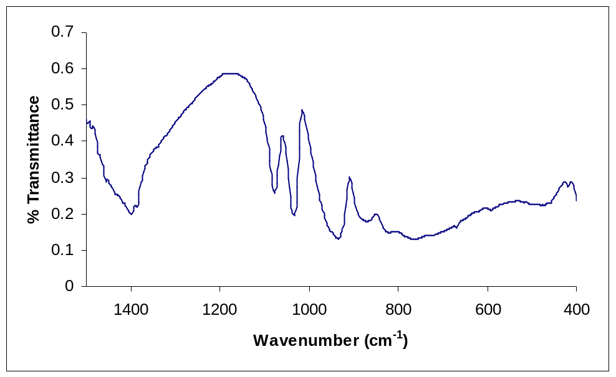

Solid IR spectrum of 3

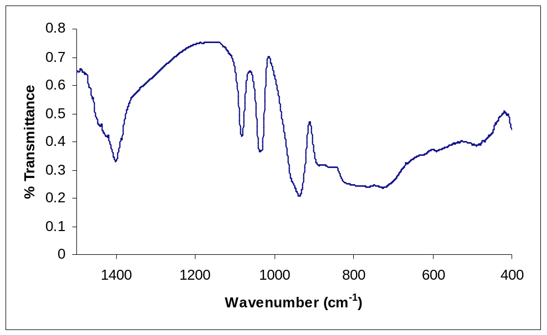

Solid IR spectrum (KBr disc) of 4

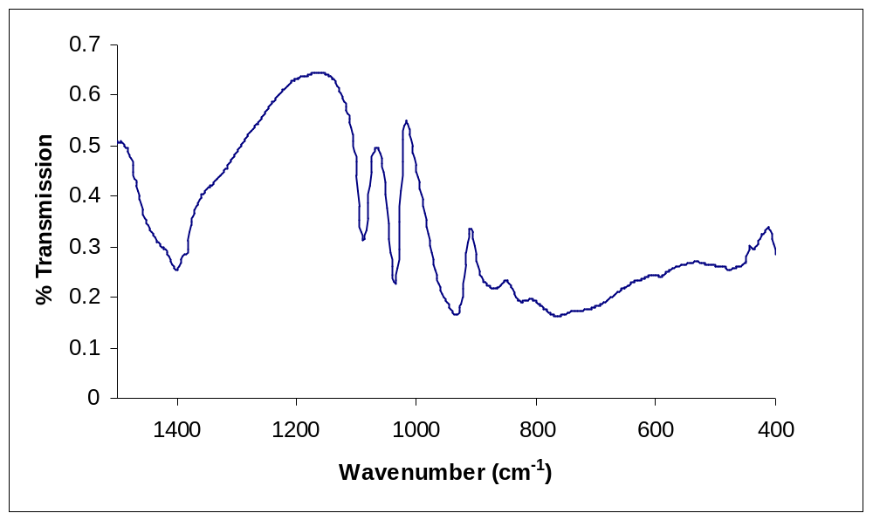

Aqueous IR spectrum (ATR) of 1

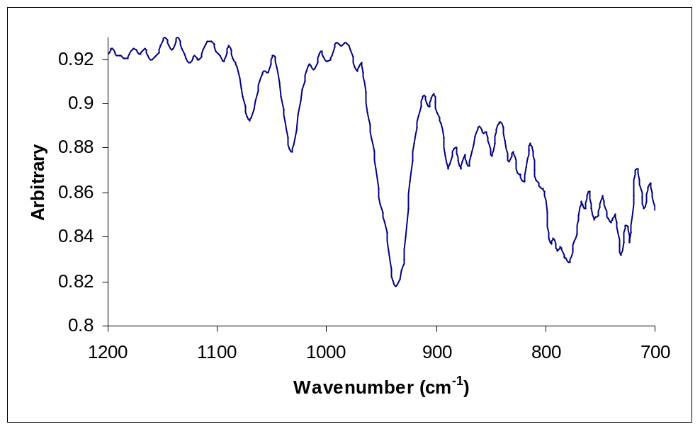

Aqueous IR spectrum (ATR) of 2

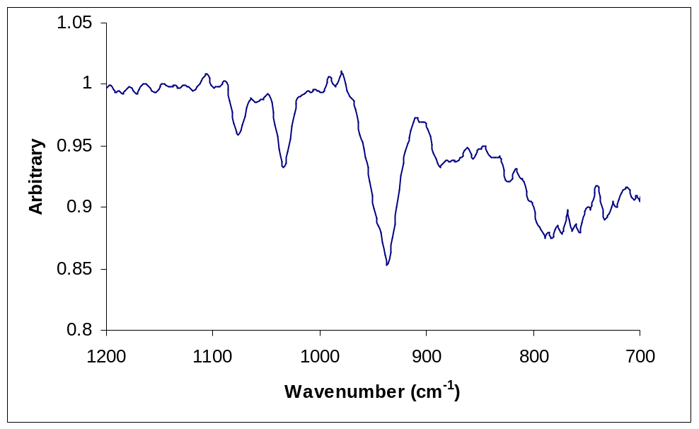

Aqueous IR spectrum (ATR) of 3

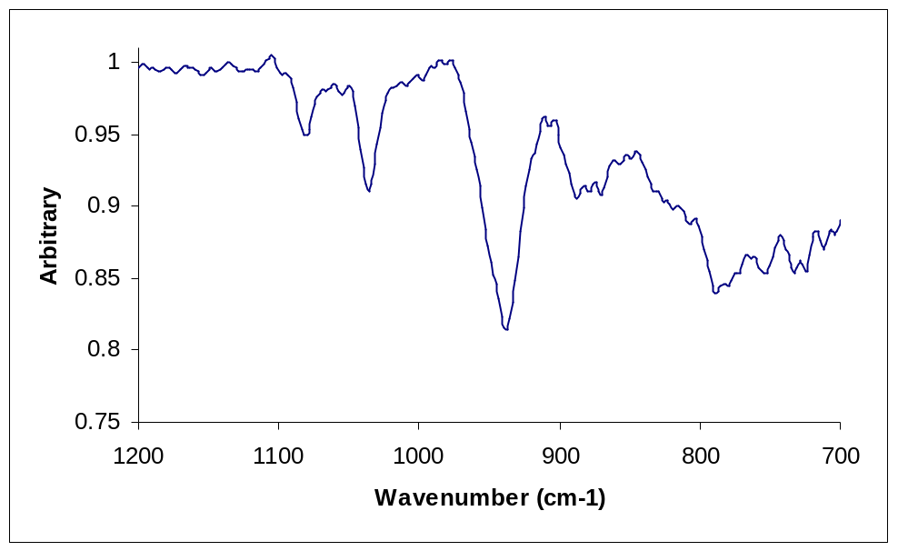

Aqueous IR spectrum (ATR) of 4

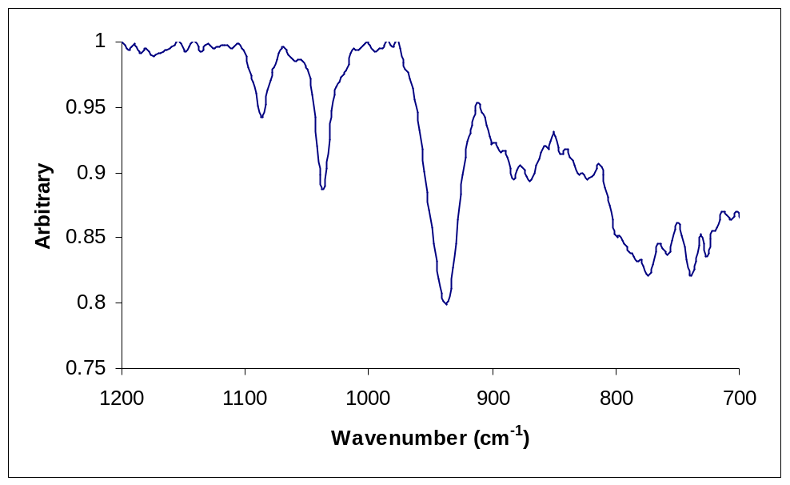

SELECTED UV/VIS/NIR SPECTRA

Aqueous solution UV/vis/nIR spectrum of 1 (diluted by a factor of 1000) showing the O➔Mo charge transfer transition of the polyoxometalate. There are no f-f transitions because Ce(III) has a 4f⁰ electronic configuration.

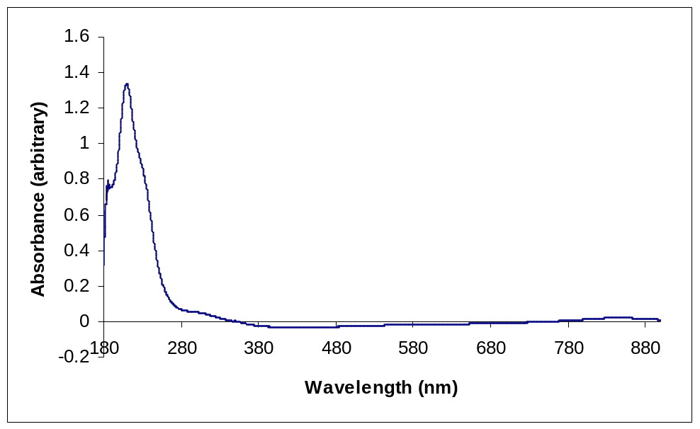

Aqueous solution UV/vis/nIR spectrum of 2

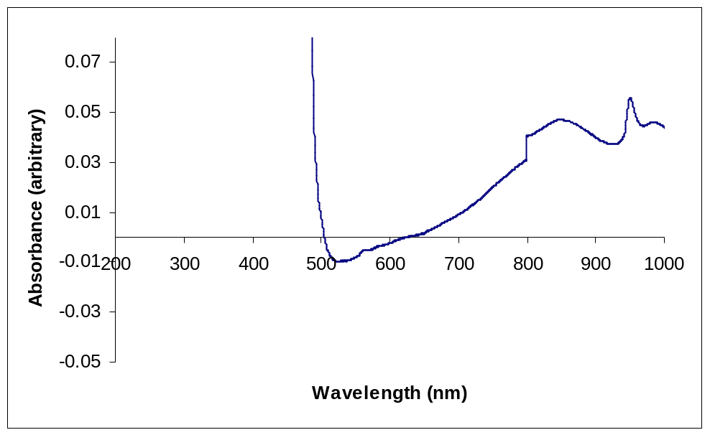

Aqueous solution UV/vis/nIR spectrum of 3

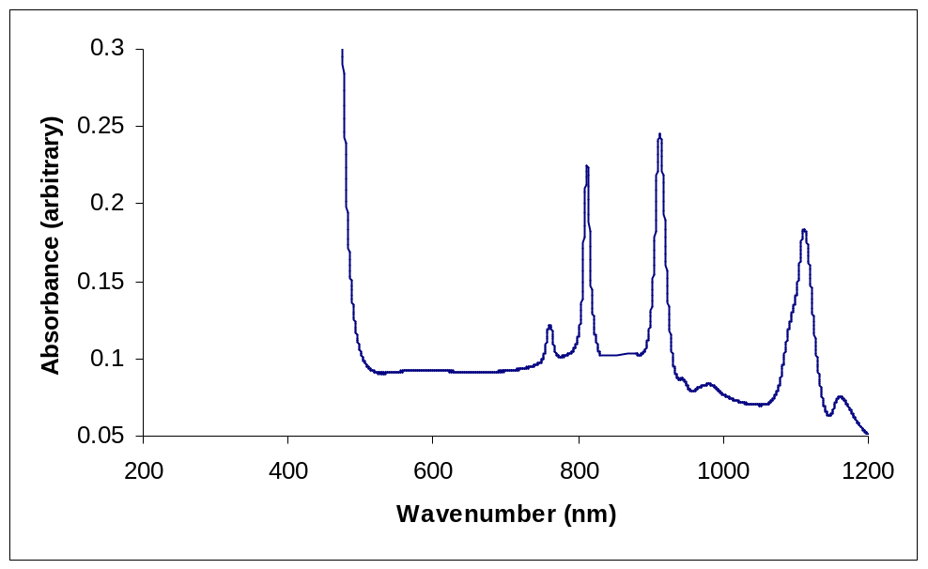

Aqueous solution UV/vis/nIR spectrum of 4 is not included here as there are no characteristic f-f transitions because Lu(III) has a 4f¹⁴ full shell electronic configuration.

Diffuse reflectance solid state UV/vis/nIR spectrum of 3

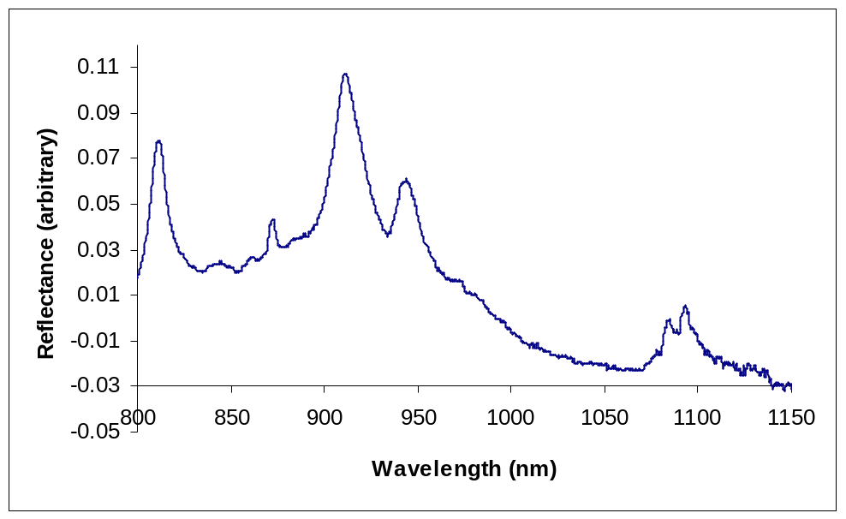

Solid state UV/vis/nIR spectrum of 3 showing the charge transfer band of the polyoxometalate.

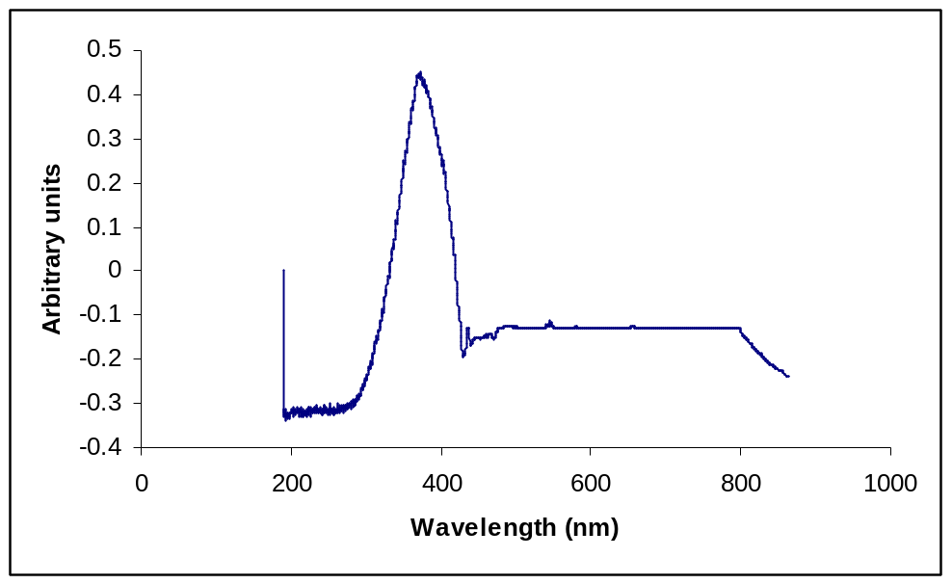

Only a charge transfer band was observed in the solid state UV/vis/nIR spectra of 1, 2, and 4.

RAMAN SPECTRA

Solid Raman spectrum of 1.

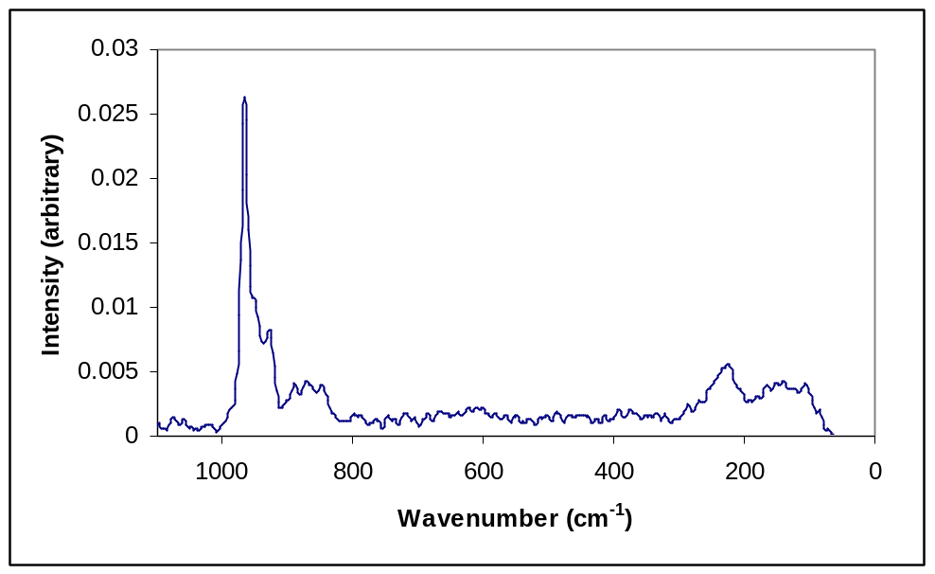

Solid Raman spectrum of 2.

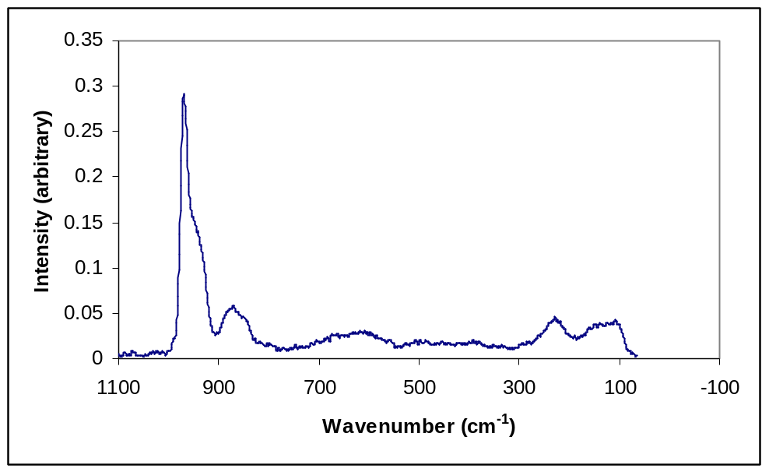

Solid Raman spectrum of 3.

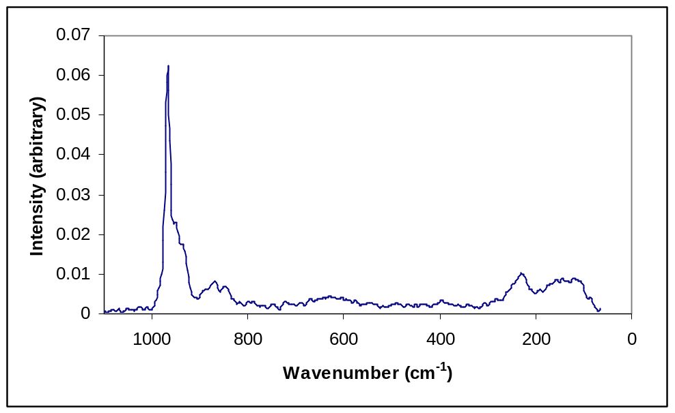

Solid Raman spectrum of 4.

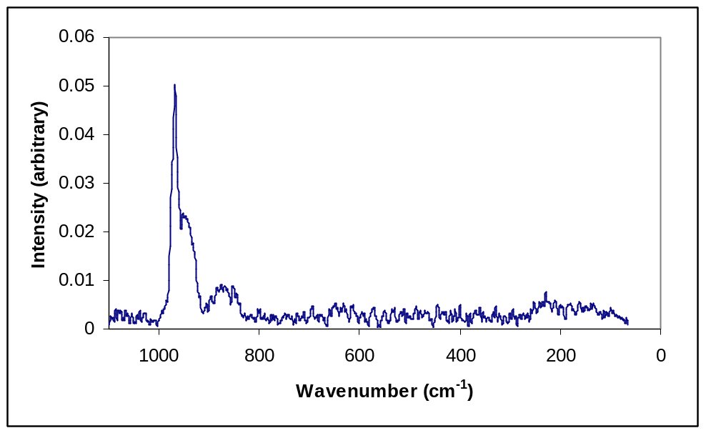

Aqueous solution Raman spectrum of 1.

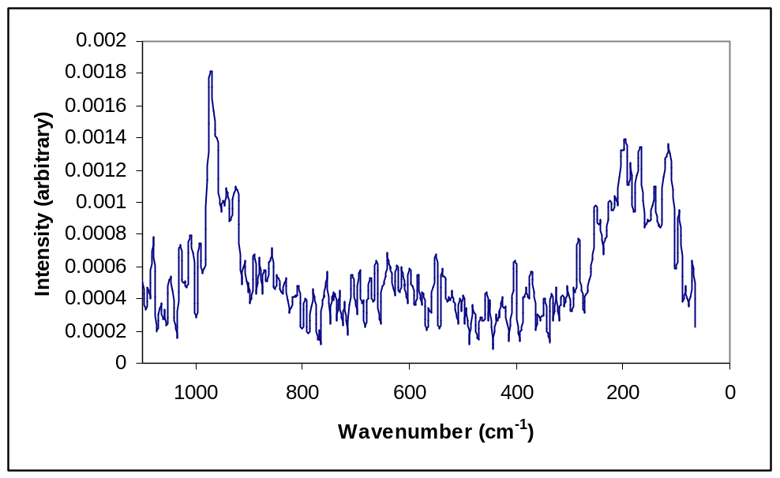

Aqueous solution Raman spectrum of 2.

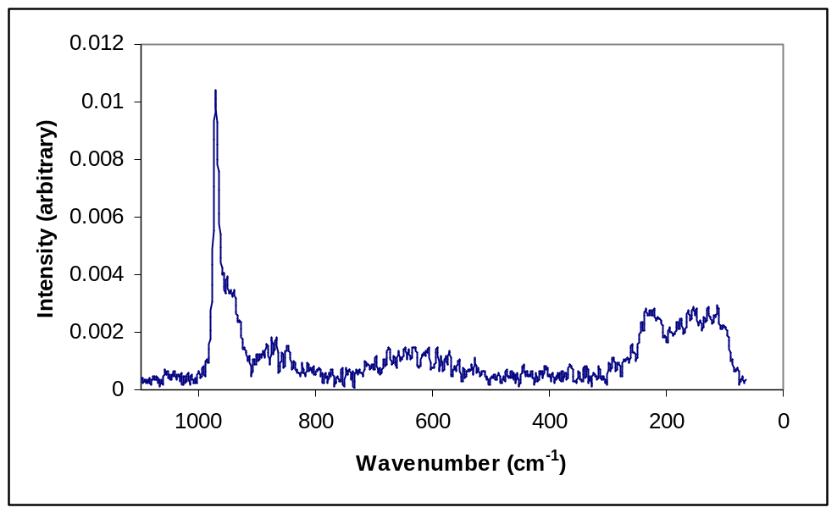

Aqueous solution Raman spectrum of 3.

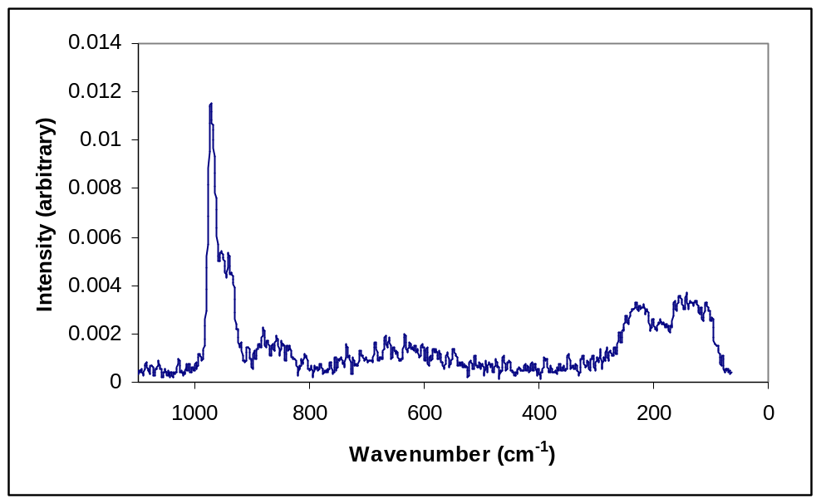

Aqueous solution Raman spectrum of 4.

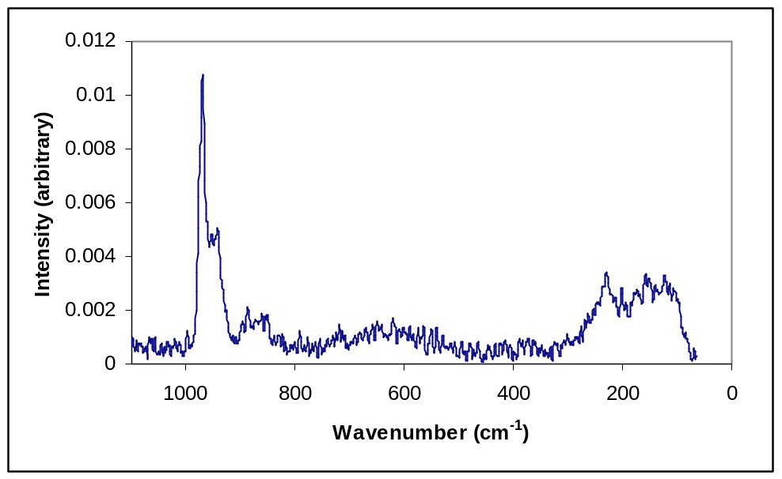

TGA’s

TGA curve of 1.

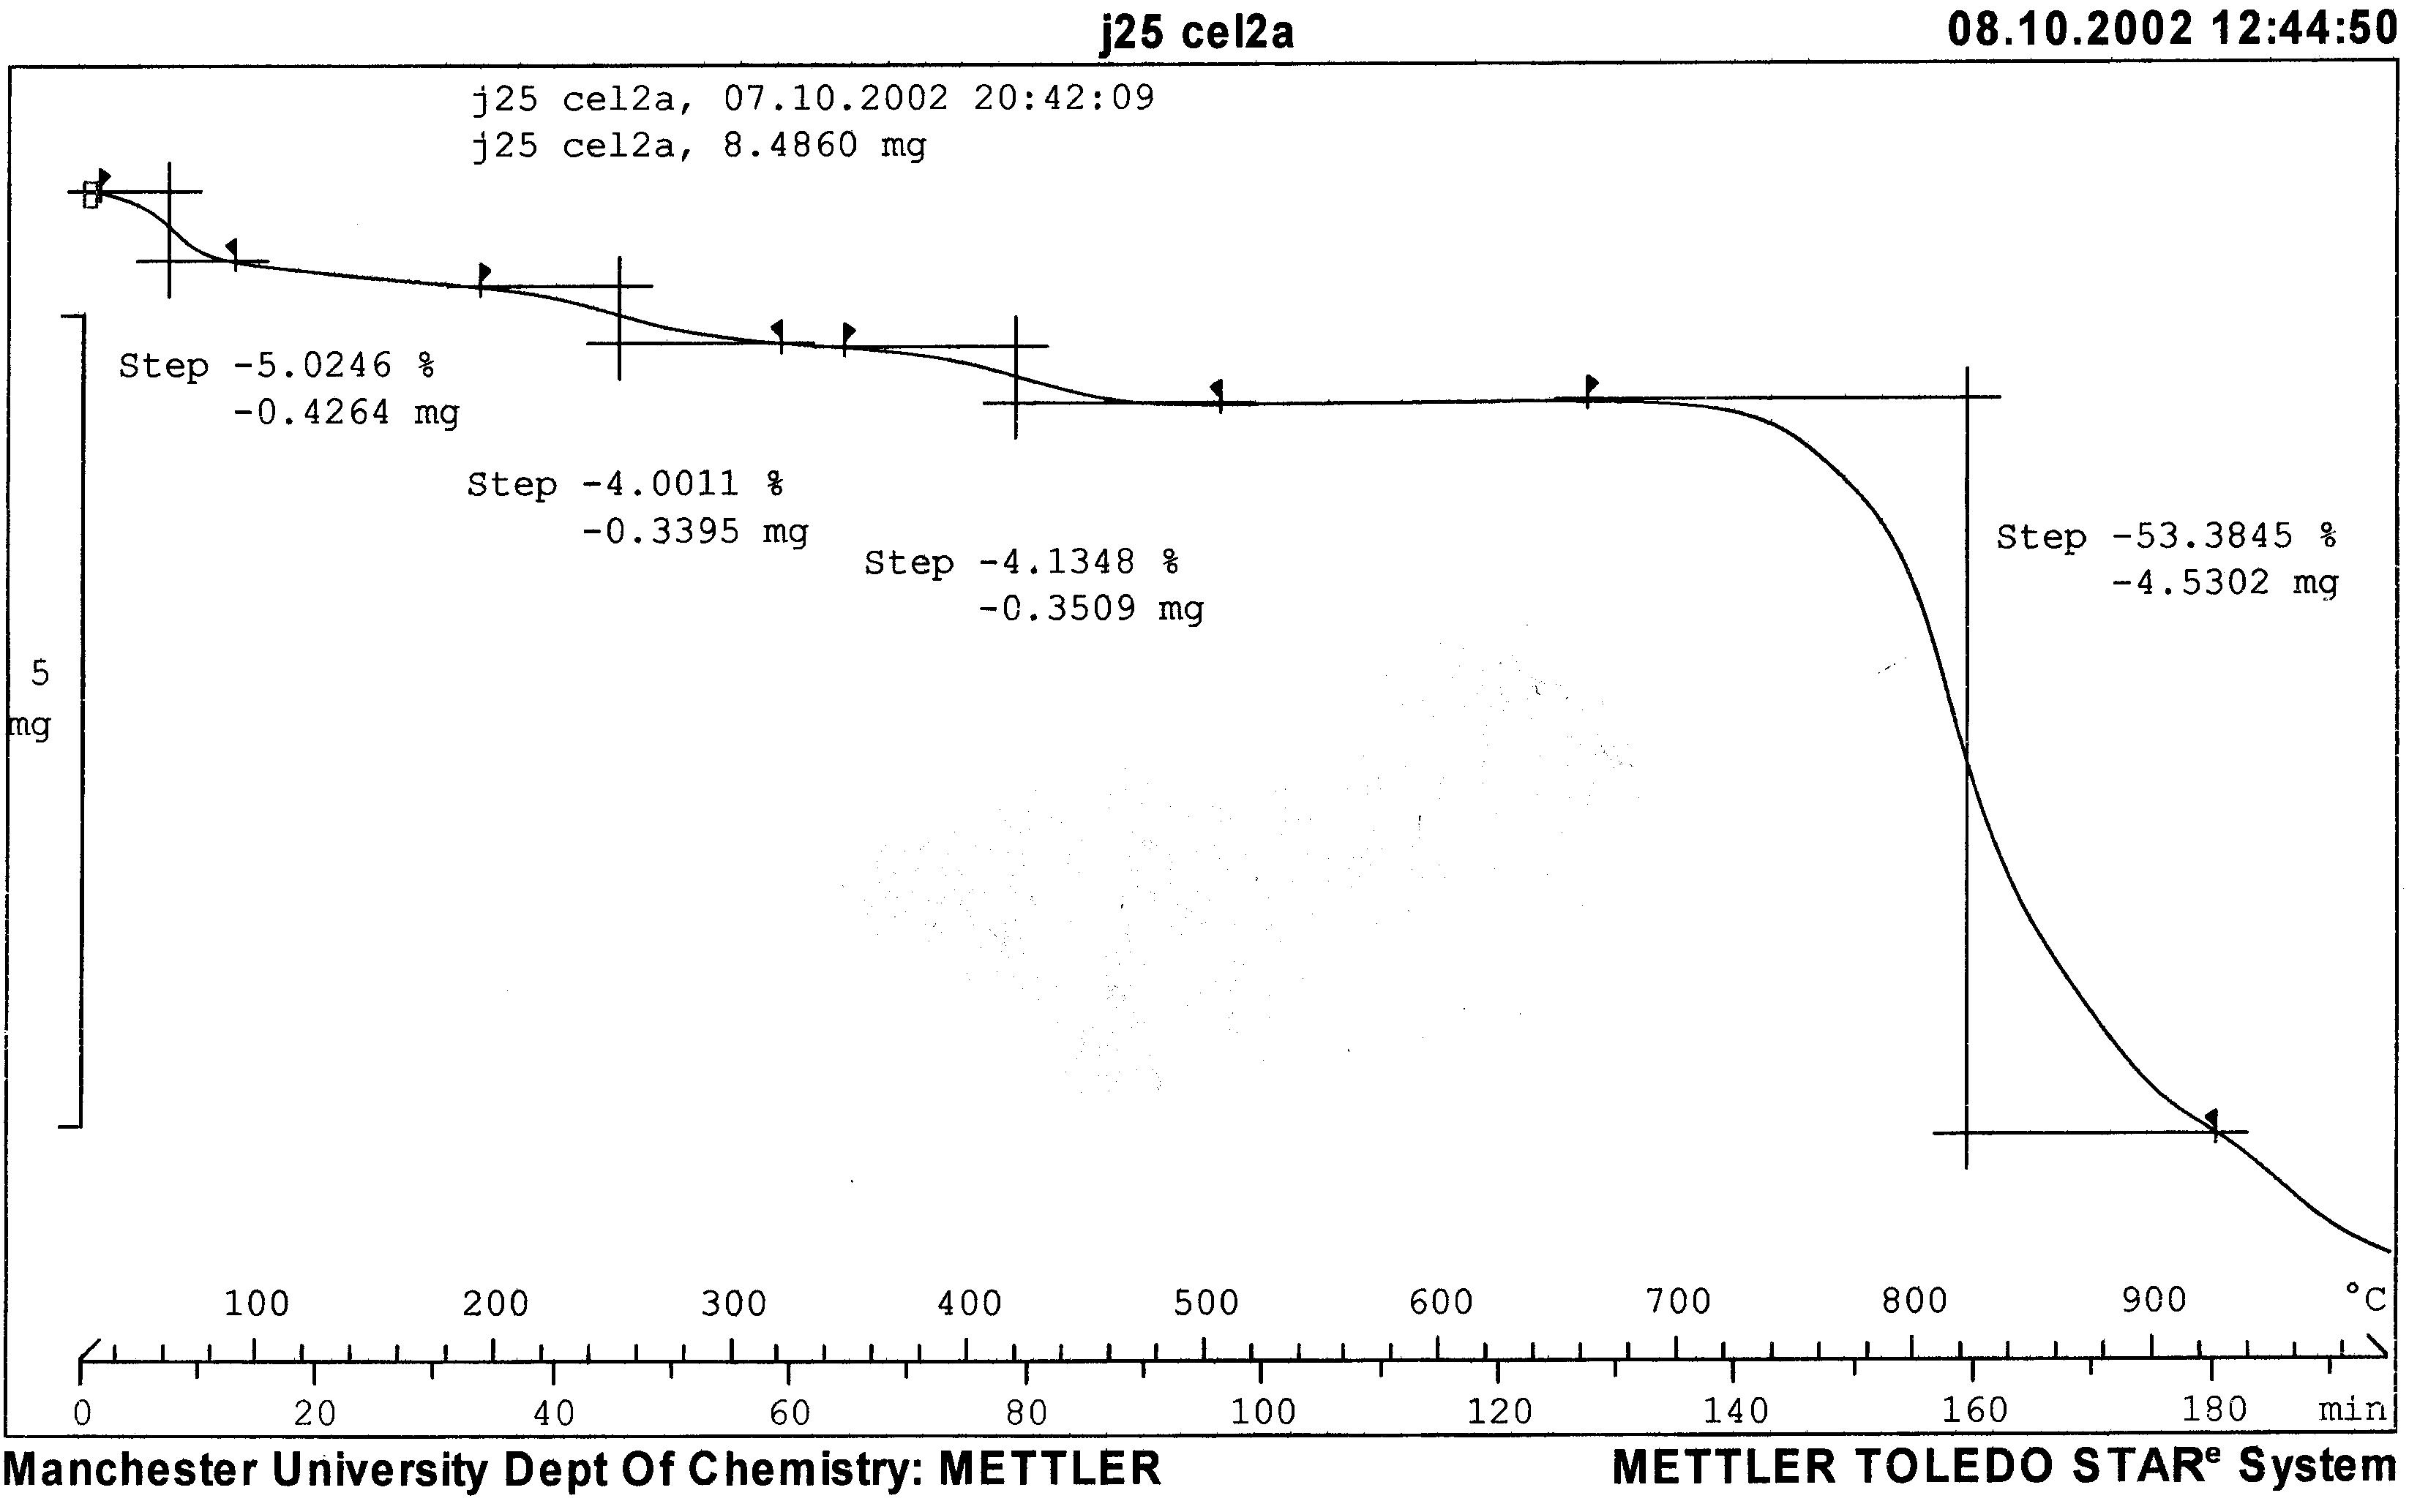

TGA curve of 2.

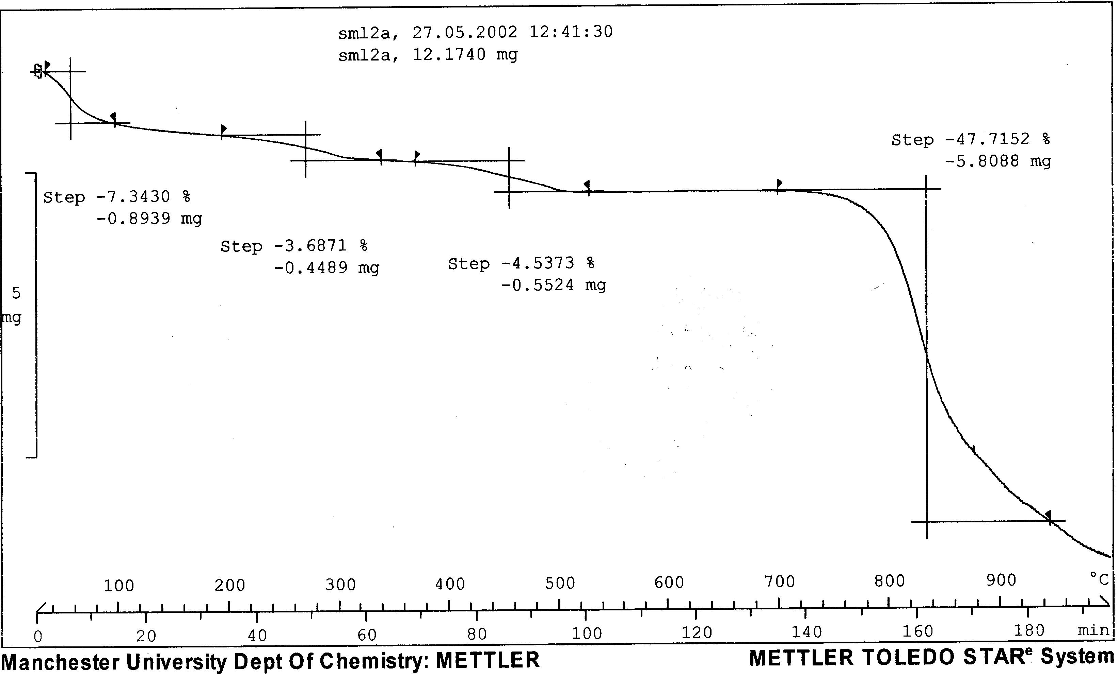

TGA curve of 3.

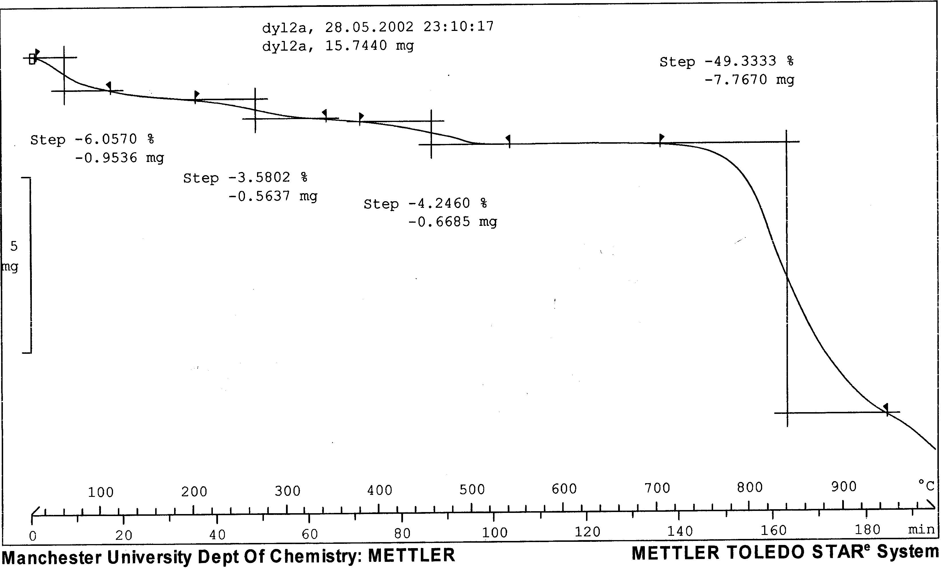

TGA curve of 4



