Supplementary Material

Synthesis and coordination chemistry of neutral phospha(III)guanidines. Formation of 1-aza-3-phospha-4-metallacyclobut-1-ene rings at group 6 metals
Joanna Grundy, Martyn P. Coles* and Peter B. Hitchcock

The Chemistry Department, University of Sussex, Falmer, Brighton BN1 9QJ. U.K.
Fax: 01273 677196; Tel: 01273 877339; email: m.p.coles@sussex.ac.uk

Contents:

p 2 Figure 1 ORTEP representation of 3a
p 3 Table 1 Bond lengths [Å] and angles [°] for 3a
p 6 Figure 2 ORTEP representation of Mo(CO)₄(pip)₂
p 7 Table 2 Crystal structure and refinement data for Mo(CO)₄(pip)₂
p 8 Table 3 Bond lengths [Å] and angles [°] for Mo(CO)₄(pip)₂
Figure 1

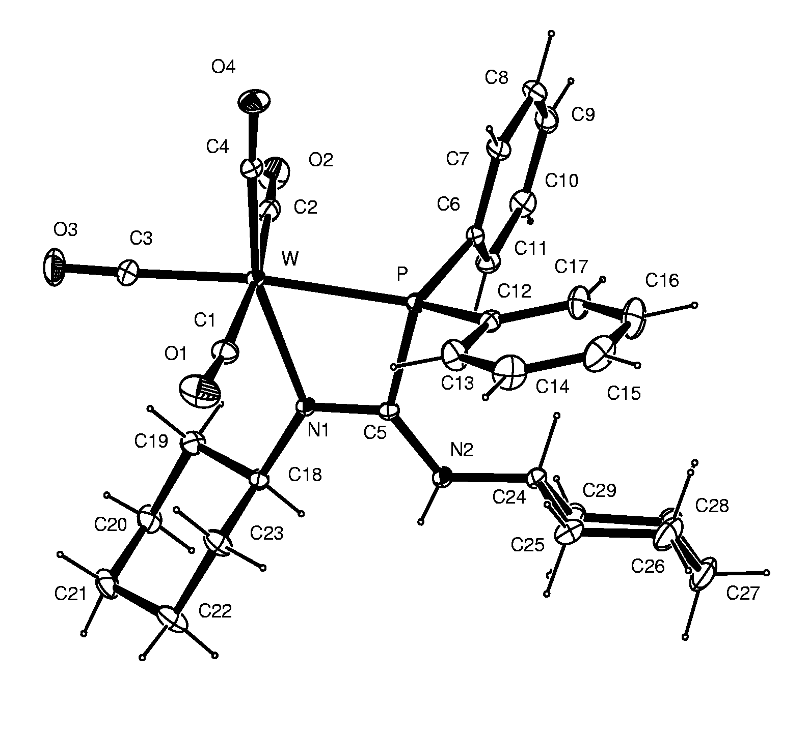
Table 1 Bond lengths [Å] and angles [°] for 3a
_____________________________________________________
W-C(4) 1.936(3)
W-C(3) 1.990(3)
W-C(1) 2.027(3)
W-C(2) 2.049(3)
W-N(1) 2.299(2)
W-P 2.4913(6)
P-C(6) 1.810(2)
P-C(12) 1.821(2)
P-C(5) 1.853(2)
O(1)-C(1) 1.139(4)
O(2)-C(2) 1.135(3)
O(3)-C(3) 1.143(3)
O(4)-C(4) 1.179(3)
N(1)-C(5) 1.301(3)
N(1)-C(18) 1.474(3)
N(2)-C(5) 1.343(3)
N(2)-C(24) 1.463(3)
C(6)-C(11) 1.393(3)
C(6)-C(7) 1.400(3)
C(7)-C(8) 1.377(4)
C(8)-C(9) 1.379(4)
C(9)-C(10) 1.382(4)
C(10)-C(11) 1.386(4)
C(12)-C(17) 1.383(4)
C(12)-C(13) 1.387(4)
C(13)-C(14) 1.388(4)
C(14)-C(15) 1.370(5)
C(15)-C(16) 1.374(5)
C(16)-C(17) 1.386(4)
C(18)-C(19) 1.514(3)
C(18)-C(23) 1.519(3)
C(19)-C(20) 1.532(4)
C(20)-C(21) 1.520(4)
C(21)-C(22) 1.526(4)
C(22)-C(23) 1.531(4)
C(24)-C(25) 1.526(4)
C(24)-C(29) 1.530(4)
C(25)-C(26) 1.521(5)
C(26)-C(27) 1.521(5)
C(27)-C(28) 1.513(5)
C(28)-C(29) 1.524(4)

C(4)-W-C(3) 90.57(11)
C(4)-W-C(1) 89.46(10)
C(3)-W-C(1) 85.03(12)
C(4)-W-C(2) 93.14(10)
C(3)-W-C(2) 87.55(11)
C(1)-W-C(2) 172.16(11)
C(4)-W-N(1) 161.42(9)
C(3)-W-N(1) 107.89(10)
C(1)-W-N(1) 90.11(8)
C(2)-W-N(1) 89.77(8)
C(4)-W-P 98.90(8)
C(3)-W-P 169.77(9)
C(1)-W-P 98.82(9)
C(2)-W-P 88.09(8)
N(1)-W-P 62.84(5)
C(6)-P-C(12) 105.85(11)
C(6)-P-C(5) 107.52(10)
C(12)-P-C(5) 110.80(10)
C(6)-P-W 116.13(7)
C(12)-P-W 128.00(8)
C(5)-P-W 85.04(7)
C(5)-N(1)-C(18) 120.75(19)
C(5)-N(1)-W 108.17(15)
C(18)-N(1)-W 130.86(15)
C(5)-N(2)-C(24) 127.1(2)
O(1)-C(1)-W 173.8(3)
O(2)-C(2)-W 178.0(3)
O(3)-C(3)-W 177.8(3)
O(4)-C(4)-W 175.6(2)
N(1)-C(5)-N(2) 128.2(2)
N(1)-C(5)-P 103.61(16)
N(2)-C(5)-P 128.22(18)
C(11)-C(6)-C(7) 118.8(2)
C(11)-C(6)-P 123.36(18)
C(7)-C(6)-P 117.33(18)
C(8)-C(7)-C(6) 120.6(3)
C(7)-C(8)-C(9) 120.1(3)
C(8)-C(9)-C(10) 120.1(3)
C(9)-C(10)-C(11) 120.3(3)
C(10)-C(11)-C(6) 120.1(2)
C(17)-C(12)-C(13) 119.1(2)
C(17)-C(12)-P 123.1(2)
C(13)-C(12)-P 117.8(2)
C(12)-C(13)-C(14) 120.4(3)
C(15)-C(14)-C(13) 120.0(3)
C(14)-C(15)-C(16) 120.2(3)
C(15)-C(16)-C(17) 120.2(3)
C(12)-C(17)-C(16) 120.2(3)
N(1)-C(18)-C(19) 111.20(19)
N(1)-C(18)-C(23) 110.76(19)
C(19)-C(18)-C(23) 111.0(2)
C(18)-C(19)-C(20) 110.0(2)
C(21)-C(20)-C(19) 111.2(2)
C(20)-C(21)-C(22) 110.7(2)
C(21)-C(22)-C(23) 112.0(2)
C(18)-C(23)-C(22) 110.3(2)
N(2)-C(24)-C(25) 112.4(2)
N(2)-C(24)-C(29) 109.2(2)
C(25)-C(24)-C(29) 110.3(2)
C(26)-C(25)-C(24) 111.1(3)
C(25)-C(26)-C(27) 110.9(3)
C(28)-C(27)-C(26) 110.7(3)
C(27)-C(28)-C(29) 112.1(3)
C(28)-C(29)-C(24) 111.9(2)
Figure 2

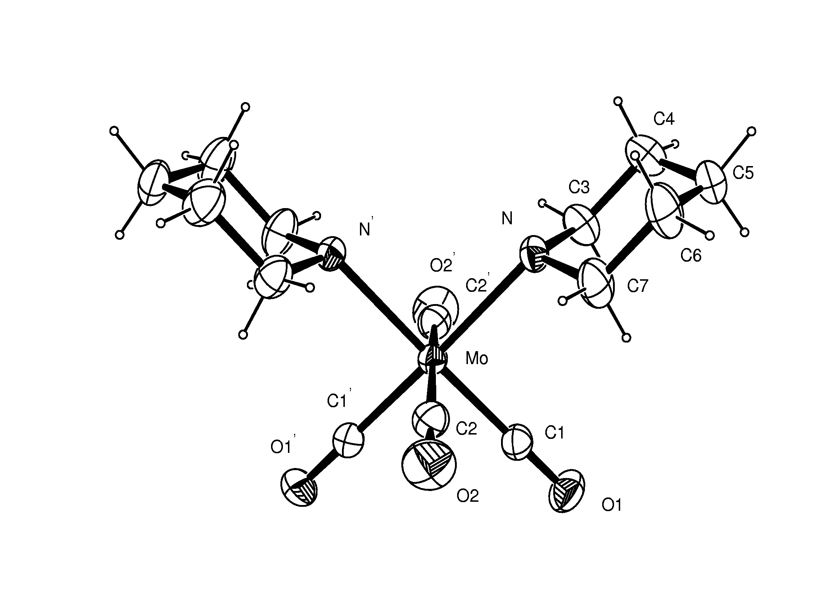
Table 2

Empirical formula C14 H20 Mo N2 O4
Formula weight 376.26
Temperature 223(2) K
Wavelength 0.71073 Å
Crystal system Tetragonal
Space group P4₃2₁2 (No.96)
Unit cell dimensions a = 12.0134(3) Å α= 90°.
b = 12.0134(3) Å β= 90°.
c = 11.2821(3) Å γ = 90°.
Volume 1628.25(7) Å3
Z 4
Density (calculated) 1.54 Mg/m3
Absorption coefficient 0.82 mm-1
F(000) 768
Crystal size 0.1 x 0.1 x 0.1 mm3
Theta range for data collection 3.79 to 28.68°.
Index ranges -11<=h<=16, -15<=k<=15, -14<=l<=14
Reflections collected 9080
Independent reflections 2002 [R(int) = 0.039]
Reflections with I>2sigma(I) 1883
Completeness to theta = 28.68° 95.6 %
Tmax. and Tmin. 0.950 and 0.900
Refinement method Full-matrix least-squares on F2
Data / restraints / parameters 2002 / 0 / 96
Goodness-of-fit on F2 1.047
Final R indices [I>2sigma(I)] R1 = 0.025, wR2 = 0.057
R indices (all data) R1 = 0.029, wR2 = 0.058
Absolute structure parameter 0.00(5)
Largest diff. peak and hole 0.43 and -0.41 e.Å-3
Table 3
_____________________________________________________
Mo-C(1) 1.945(3)
Mo-C(2) 2.035(2)
Mo-N 2.345(2)
O(1)-C(1) 1.168(3)
O(2)-C(2) 1.143(3)
N-C(7) 1.484(3)
N-C(3) 1.486(3)
C(3)-C(4) 1.523(4)
C(4)-C(5) 1.510(4)
C(5)-C(6) 1.515(4)
C(6)-C(7) 1.517(4)

C(1)-Mo-C(1)’ 89.76(14)
C(1)-Mo-C(2) 86.55(10)
C(1)-Mo-C(2)’ 87.38(10)
C(2)-Mo-C(2)’ 171.42(14)
C(1)-Mo-N’ 177.87(9)
C(2)-Mo-N’ 92.59(8)
C(1)-Mo-N 92.14(8)
C(2)-Mo-N 93.69(8)
C(2)’-Mo-N 92.59(8)
N’-Mo-N 85.97(10)
C(7)-N-C(3) 109.3(2)
C(7)-N-Mo 112.46(14)
C(3)-N-Mo 114.02(14)
O(1)-C(1)-Mo 179.5(2)
O(2)-C(2)-Mo 173.6(2)
N-C(3)-C(4) 113.1(2)
C(5)-C(4)-C(3) 111.8(2)
C(4)-C(5)-C(6) 109.3(2)
C(5)-C(6)-C(7) 111.3(2)
N-C(7)-C(6) 113.4(2)
_____________________________________________________________
Symmetry transformations used to generate equivalent atoms: ‘ y,x,-z+2

