Figure Captions

Fig. S1 Electrospray mass spectrum of [{(bpy)₂Ru^{II}}₃(L)](ClO₄)₃, [1](ClO₄)₃ : (a) shows the measured spectrum and (b) shows an expansion of the isotopic distribution pattern of the metal ions.

Fig. S2 Emission spectra of (a) [{(bpy)₂Ru^{II}}₃(L)](ClO₄)₃ ,[1](ClO₄)₃ and (b) [{(phen)₂Ru^{II}}₃(L)](ClO₄)₃ , [2](ClO₄)₃ in 1:4 MeOH/EtOH at 77 K.

Fig. S3 Experimental layout for nonlinear absorption and z-scan measurement.

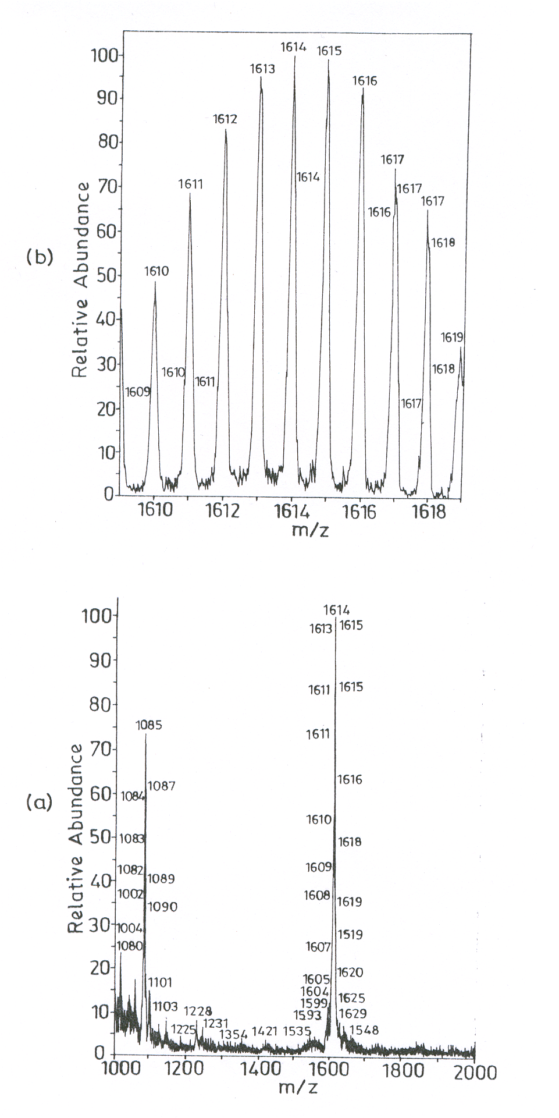
Fig. S1

Fig.S2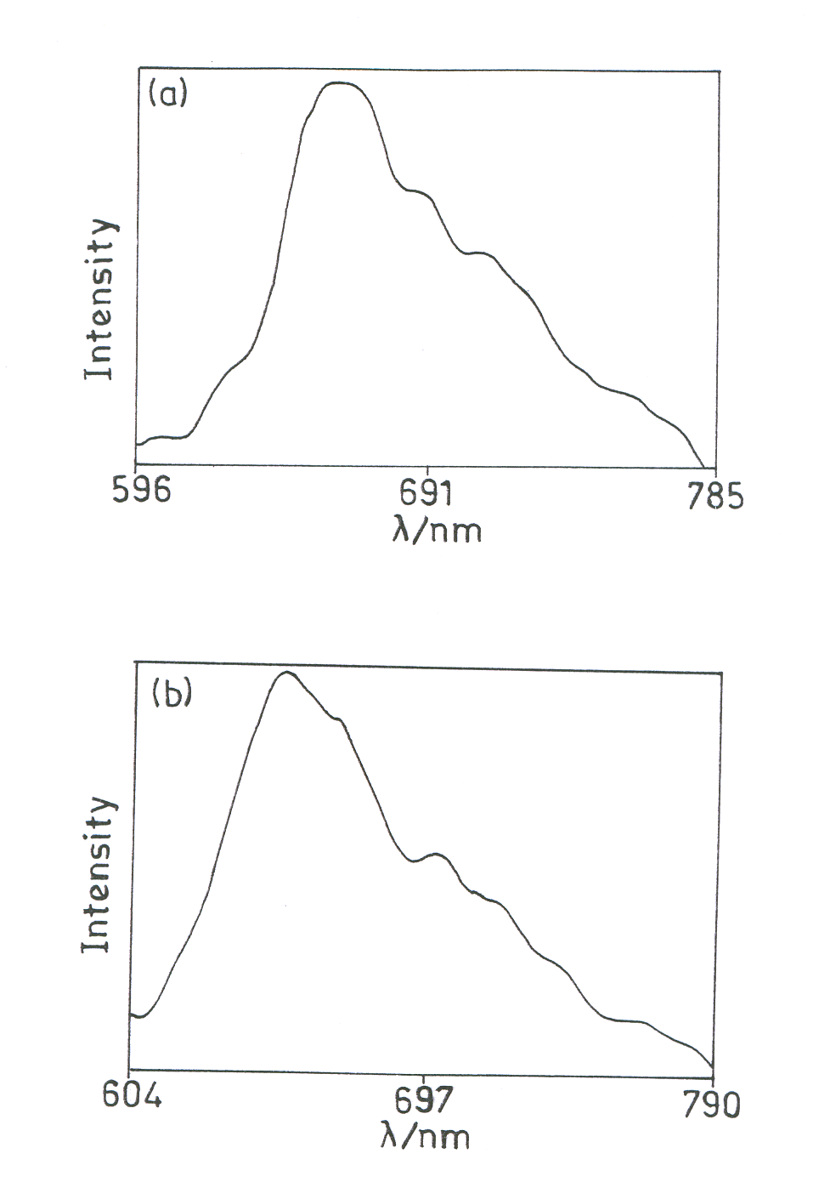

Attenuator

Sample
+z
Nd:Yag
Laser
-z
Computer

SHG
Oscilloscope
PD1
PD2

Fig. S3

