A novel extended covalent tripod for assembling triple-helical nine-co-ordinated lanthanide(III) podates: the rational design of a single conformer.
________________________________________________________________________________
Sylvain Koeller, Gérald Bernardinelli and Claude Piguet*

Supporting Information

Table S1 Molecular peaks of complexes and adduct ions of L13 with Ln(ClO4)3 observed by ESI-MS.
Metal | Cation | m/z a | Metal | Cation | m/z a
La(ClO4)3 | [La(L13)]3+ | 434.7 | Tb(ClO4)3 | [Tb(L13)]3+ | 441.4
 | [La(L13)(ClO4)]2+ | 701.4 |  | [Tb(L13)(ClO4)]2+ | 711.3
 | [La(L13)(ClO4)2]+ | 1503.4 |  | [Tb(L13)(ClO4)2]+ | 1521.3
Nd(ClO4)3 | [Nd(L13)]3+ | 436.3 | Lu(ClO4)3 | [Lu(L13)]3+ | 446.7
 | [Nd(L13)(ClO4)]2+ | 703.8 |  | [Lu(L13)(ClO4)]2+ | 719.2
 | [Nd(L13)(ClO4)2]+ | 1508.3 |  | [Lu(L13)(ClO4)2]+ | 1539.2
Eu(ClO4)3 | [Eu(L13)]3+ | 439.3 | Y(ClO4)3 | [Y(L13)]3+ | 418.0
 | [Eu(L13)(ClO4)]2+ | 708.3 |  | [Y(L13)(ClO4)]2+ | 676.3
 | [Eu(L13)(ClO4)2]+ | 1515.2 |  | [Y(L13)(ClO4)2]+ | 1451.3
Gd(ClO4)3 | [Gd(L13)]3+ | 441.0
 | [Gd(L13)(ClO4)]2+ | 710.8
 | [Gd(L13)(ClO4)2]+ | 1522.3
a m/z values given for the maximum of the peak.
Table S2 Elemental analyses for the complexes [Ln(L13)](ClO4)3·xH2O (Ln = La, x = 3: 12; Ln = Nd, x = 0.5: 13; Ln = Eu, x = 1: 14; Ln = Gd, x = 1: 15; Ln = Tb, x = 4: 16; Ln = Lu, x = 5: 17; Ln = Y, x = 3: 18). Calculated values are given in parentheses.
Compound | % C | % H | % N
[La(L13)](ClO4)3.3H2O (12) | 49.4 (49.30) | 5.4 (5.48) | 10.2 (10.15)
[Nd(L13)](ClO4)3.0.5H2O (13) | 50.6 (50.51) | 5.3 (5.30) | 10.5 (10.39)
[Eu(L13)](ClO4)3.H2O (14) | 49.8 (50.55) | 5.3 (5.24) | 10.5 (10.40)
[Gd(L13)](ClO4)3.H2O (15) | 50.0 (50.38) | 5.3 (5.22) | 10.5 (10.36)
[Tb(L13)](ClO4)3.4H2O (16) | 48.3 (48.19) | 5.5 (5.47) | 9.7 (9.92)
[Lu(L13)](ClO4)3.5H2O (17) | 47.2 (47.24) | 5.2 (5.48) | 9.7 (9.72)
[Y(L13)](ClO4)3.3H2O (18) | 50.5 (50.83) | 5.5 (5.65) | 10.5 (10.46)

Table S3 Selected structural dataa for the lanthanide co-ordination sphere in [Eu(L13)](ClO4)3 (19). Values for [La(L12)](ClO₄)₃ are given between parentheses.15
___________________________________________________________
Angles  /degreesa
R1-Eu-R2 180 (180)
Angles i /degreesa
R1-Eu-N1 53 (53)
R2-Eu-O2 48 (49)
Angles i /degrees (intraligand)a
proj(N1)-Eu-proj(N3)b 52 (51)
proj(N3)-Eu-proj(O2) 58 (55)
proj(N1)-Eu-proj(O2) 110 (105)
Angles i /degrees (interligand)a
proj(N1)-Eu-proj(N3’) 68 (69)
proj(N1)-Eu-proj(N3’) 172 (171)
proj(N1)-Eu-proj(O2’) 10 (15)
proj(N1)-Eu-proj(O2") 130 (135)
proj(N3)-Eu-proj(O2’) 62 (65)
___________________________________________________________
a For the definition of , i and i, see the associated scheme. The error in the angles is typically 1°. b Proj[Oi] and Proj[Ni] are the projection of Oi and respectively Ni along the R1-R2 direction onto a perpendicular plane passing through the lanthanide atom. R1 = Eu-N1 + Eu-N1’ + Eu-N1’’ and R2 = Eu-O2 + Eu-O2’ + Eu-O2’’.
Table S4 Paramagnetic 1H NMR shifts in ppm for the aromatic protons H5-H10 and for the diastereotopic protons of the tripods H2-H4 in the complexes [Ln(L12)]3+ and [Ln(L13)]3+ (Ln = Nd, Eu) in CD3CN at 298 K.a
Compound | H2 | H3 | H4 | H5 | H6 | H7 | H8 | H9 | H10
[Nd(L12)]3+ b | -0.83/-0.83 | -0.58/-0.58 | -0.74/-0.55 | -4.17 | -0.45 | 0.53 | 2.21 | 1.09 | 1.04
[Nd(L12)]3+ c | -0.83/-0.83 | -0.83/-0.83 | -0.86/-0.56 | -3.91 | -0.50 | 0.52 | 2.37 | 1.20 | 1.09
[Nd(L13)]3+ | -1.21/-0.98 | -1.62/-1.14 | -0.97/-0.56 | -4.15 | -0.51 | 0.51 | 2.45 | 1.21 | 1.10
[Eu(L12)]3+ b | 0.89/0.89 | 1.37/1.37 | 0.65/0.97 | 3.76 | 0.56 | -1.14 | -3.50 | -1.61 | -1.89
[Eu(L12)]3+ c | 0.89/0.89 | 1.12/1.12 | 0.71/1.20 | 4.02 | 0.57 | -1.14 | -3.68 | -1.70 | -1.95
[Eu(L13)]3+ | 1.23/0.96 | 1.53/1.41 | 1.25/0.74 | 4.08 | 0.61 | -1.15 | -3.75 | -1.73 | -1.96
The paramagnetic shift of a nucleus i ($δ_{i}^{\text{para}}$) in the podate [Ln(L13)]3+ is calculated according to $δ_{i}^{\text{para}}=δ_{i}^{\text{exp}}([\text{Ln}(\text{L13})]^{3+})−δ_{i}^{\text{dia}}([\text{La}(\text{L13})]^{3+})$.
b Obtained for the major conformer in ref. 15. c Obtained for the minor conformer in ref. 15.

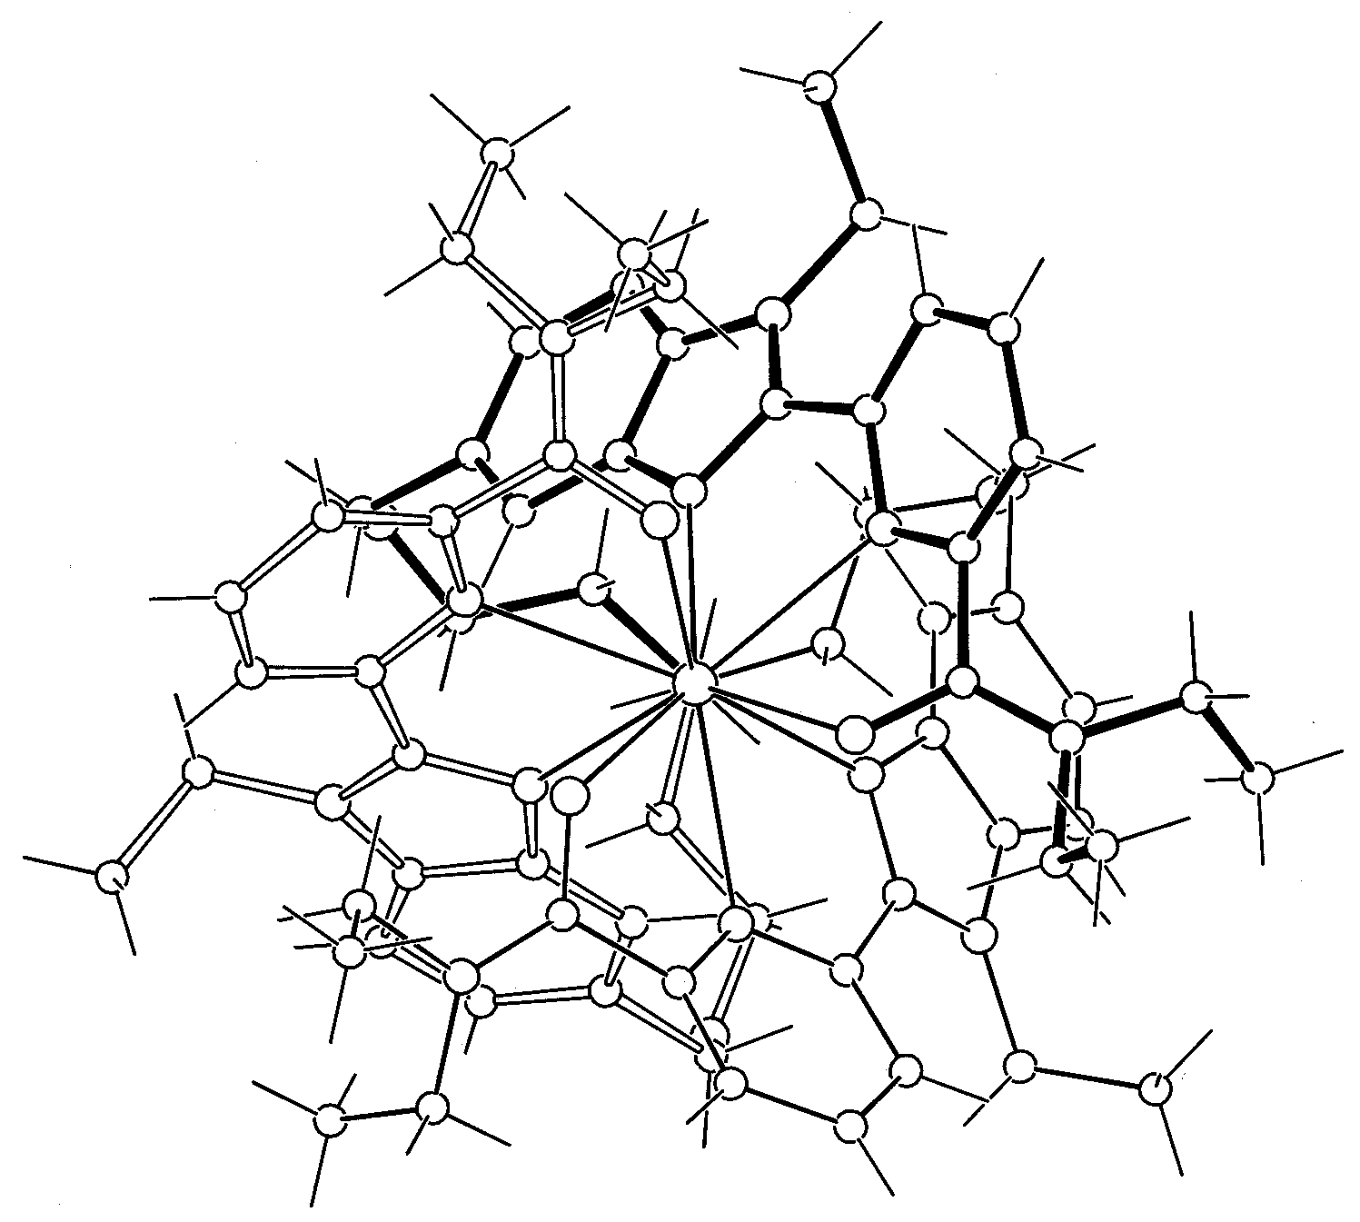
Figure S1 Perspective view of the complex [Eu(L13)]3+ along the 3-fold axis.
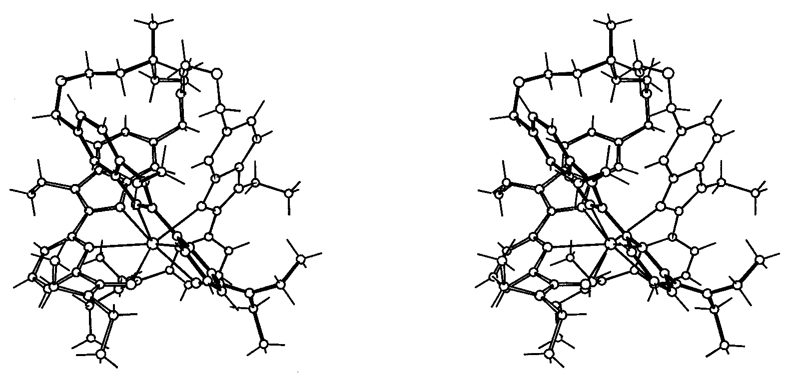
Figure S2 Stereoview of the complex [Eu(L13)]3+ perpendicular to the 3-fold axis.

