SUPPLEMENTARY DATA

X-Ray Crystallography Data for

Synthesis, Structural Studies and Photochemistry of Cobalt(III) Complexes of Anthracenylcyclam Macrocycles.

Alison M. Funston, Kenneth P. Ghiggino, Martin J. Grannas, W. David McFadyen, and Peter A. Tregloan.

Tables
Table 1. Selected bond lengths (Å) and angles (º) for 8. Symmetry transformations used to generate equivalent atoms: ‘ x,y,-z.

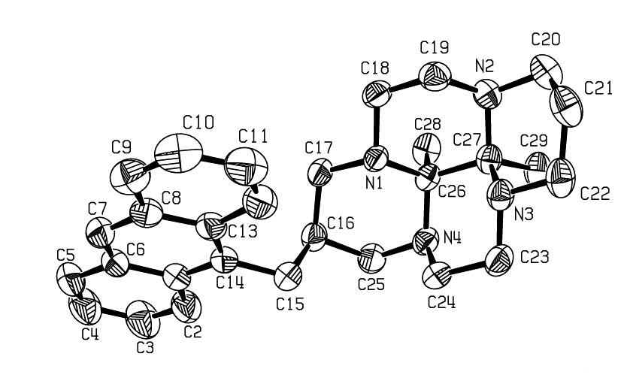

Bond Length (Å) |  | Bond Angle (º)
N(1)-C(18) | 1.4566(15) |  | C(18)-N(1)-C(17) | 108.67(9)
N(1)-C(17) | 1.4674(15) |  | C(18)-N(1)-C(26) | 111.93(9)
N(1)-C(26) | 1.4879(14) |  | C(17)-N(1)-C(26) | 112.37(9)
N(2)-C(19) | 1.471(2) |  | C(19)-N(2)-C(27) | 112.67(9)
N(2)-C(27) | 1.471(2) |  | C(19)-N(2)-C(20) | 110.45(11)
N(2)-C(20) | 1.473(2) |  | C(27)-N(2)-C(20) | 111.31(10)
N(3)-C(23) | 1.452(2) |  | C(23)-N(3)-C(22) | 110.22(10)
N(3)-C(22) | 1.469(2) |  | C(23)-N(3)-C(27) | 111.50(10)
N(3)-C(27) | 1.4843(15) |  | C(22)-N(3)-C(27) | 113.31(10)
N(4)-C(24) | 1.463(2) |  | C(24)-N(4)-C(25) | 111.95(11)
N(4)-C(25) | 1.471(2) |  | C(24)-N(4)-C(26) | 113.01(10)
N(4)-C(26) | 1.472(2) |  | C(25)-N(4)-C(26) | 111.40(9)
C(1)-C(14) | 1.415(2) |  | N(4)-C(26)-N(1) | 108.11(9)
C(16)-C(17) | 1.523(2) |  | N(4)-C(26)-C(28) | 109.30(10)
C(16)-C(25) | 1.546(2) |  | N(1)-C(26)-C(28) | 111.95(9)
C(18)-C(19) | 1.498(2) |  | N(4)-C(26)-C(27) | 109.15(9)
C(20)-C(21) | 1.519(2) |  | N(1)-C(26)-C(27) | 110.78(9)
C(21)-C(22) | 1.517(2) |  | C(28)-C(26)-C(27) | 107.50(10)
C(23)-C(24) | 1.501(2) |  | N(2)-C(27)-N(3) | 109.11(10)
C(26)-C(28) | 1.543(2) |  | N(2)-C(27)-C(29) | 108.95(10)
C(26)-C(27) | 1.581(2) |  | N(3)-C(27)-C(29) | 111.64(10)
C(27)-C(29) | 1.547(2) |  | N(2)-C(27)-C(26) | 108.63(9)
 |  |  | N(3)-C(27)-C(26) | 110.27(9)
 |  |  | C(29)-C(27)-C(26) | 108.18(10)

Table 2. Selected bond lengths (Å) and angles (º) for the complex [Co(2)Cl₂]Cl·0.5CH₃OH. Symmetry transformations used to generate equivalent atoms: ‘ x,y,-z.

Bond Length (Å) |  | Bond Angle (º)
Co-N(4) | 1.904(3) |  | N(4)-Co-N(8) | 92.97(12)
Co-N(8) | 1.920(3) |  | N(4)-Co-N(1) | 86.83(12)
Co-N(1) | 1.959(3) |  | N(8)-Co-N(1) | 176.58(12)
Co-N(11) | 1.966(3) |  | N(4)-Co-N(11) | 176.97(13)
Co-Cl(1) | 2.246(2) |  | N(8)-Co-N(11) | 85.89(12)
Co-Cl(2) | 2.264(2) |  | N(1)-Co-N(11) | 94.14(12)
N(4)-C(5) | 1.280(4) |  | N(4)-Co-Cl(1) | 91.13(10)
C(5)-O(5) | 1.319(4) |  | N(8)-Co-Cl(1) | 92.63(10)
C(5)-C(6) | 1.521(5) |  | N(1)-Co-Cl(1) | 90.78(10)
C(6)-C(7) | 1.512(5) |  | N(11)-Co-Cl(1) | 91.72(10)
C(6)-C(15) | 1.557(5) |  | N(4)-Co-Cl(2) | 88.55(10)
C(7)-N(8) | 1.276(4) |  | N(8)-Co-Cl(2) | 88.19(10)
C(7)-O(7) | 1.320(4) |  | N(1)-Co-Cl(2) | 88.39(10)
 |  |  | N(11)-Co-Cl(2) | 88.61(10)
 |  |  | Cl(1)-Co-Cl(2) | 179.13(4)
 |  |  | C(5)-N(4)-C(3) | 119.0(3)
 |  |  | C(5)-N(4)-Co | 129.0(2)
 |  |  | C(3)-N(4)-Co | 111.7(2)
 |  |  | N(4)-C(5)-O(5) | 118.1(3)
 |  |  | N(4)-C(5)-C(6) | 124.5(3)
 |  |  | O(5)-C(5)-C(6) | 117.2(3)
 |  |  | C(7)-C(6)-C(5) | 115.4(3)
 |  |  | C(7)-C(6)-C(15) | 110.2(3)
 |  |  | C(5)-C(6)-C(15) | 108.0(3)
 |  |  | N(8)-C(7)-O(7) | 117.8(3)
 |  |  | N(8)-C(7)-C(6) | 124.2(3)
 |  |  | O(7)-C(7)-C(6) | 117.9(3)
 |  |  | C(7)-N(8)-C(9) | 118.7(3)
 |  |  | C(7)-N(8)-Co | 128.4(2)
 |  |  | C(9)-N(8)-Co | 112.0(2)
 |  |  | C(16)-C(15)-C(6) | 115.8(3)
 |  |  | C(17)-C(16)-C(29) | 119.4(3)
 |  |  | C(17)-C(16)-C(15) | 120.4(3)
 |  |  | C(29)-C(16)-C(15) | 120.2(3)

Table 3. Selected bond lengths (Å) and angles (º) for the complex [Co(3)Cl₂]Cl·4H₂O. Symmetry transformations used to generate equivalent atoms: ‘ x,y,-z.

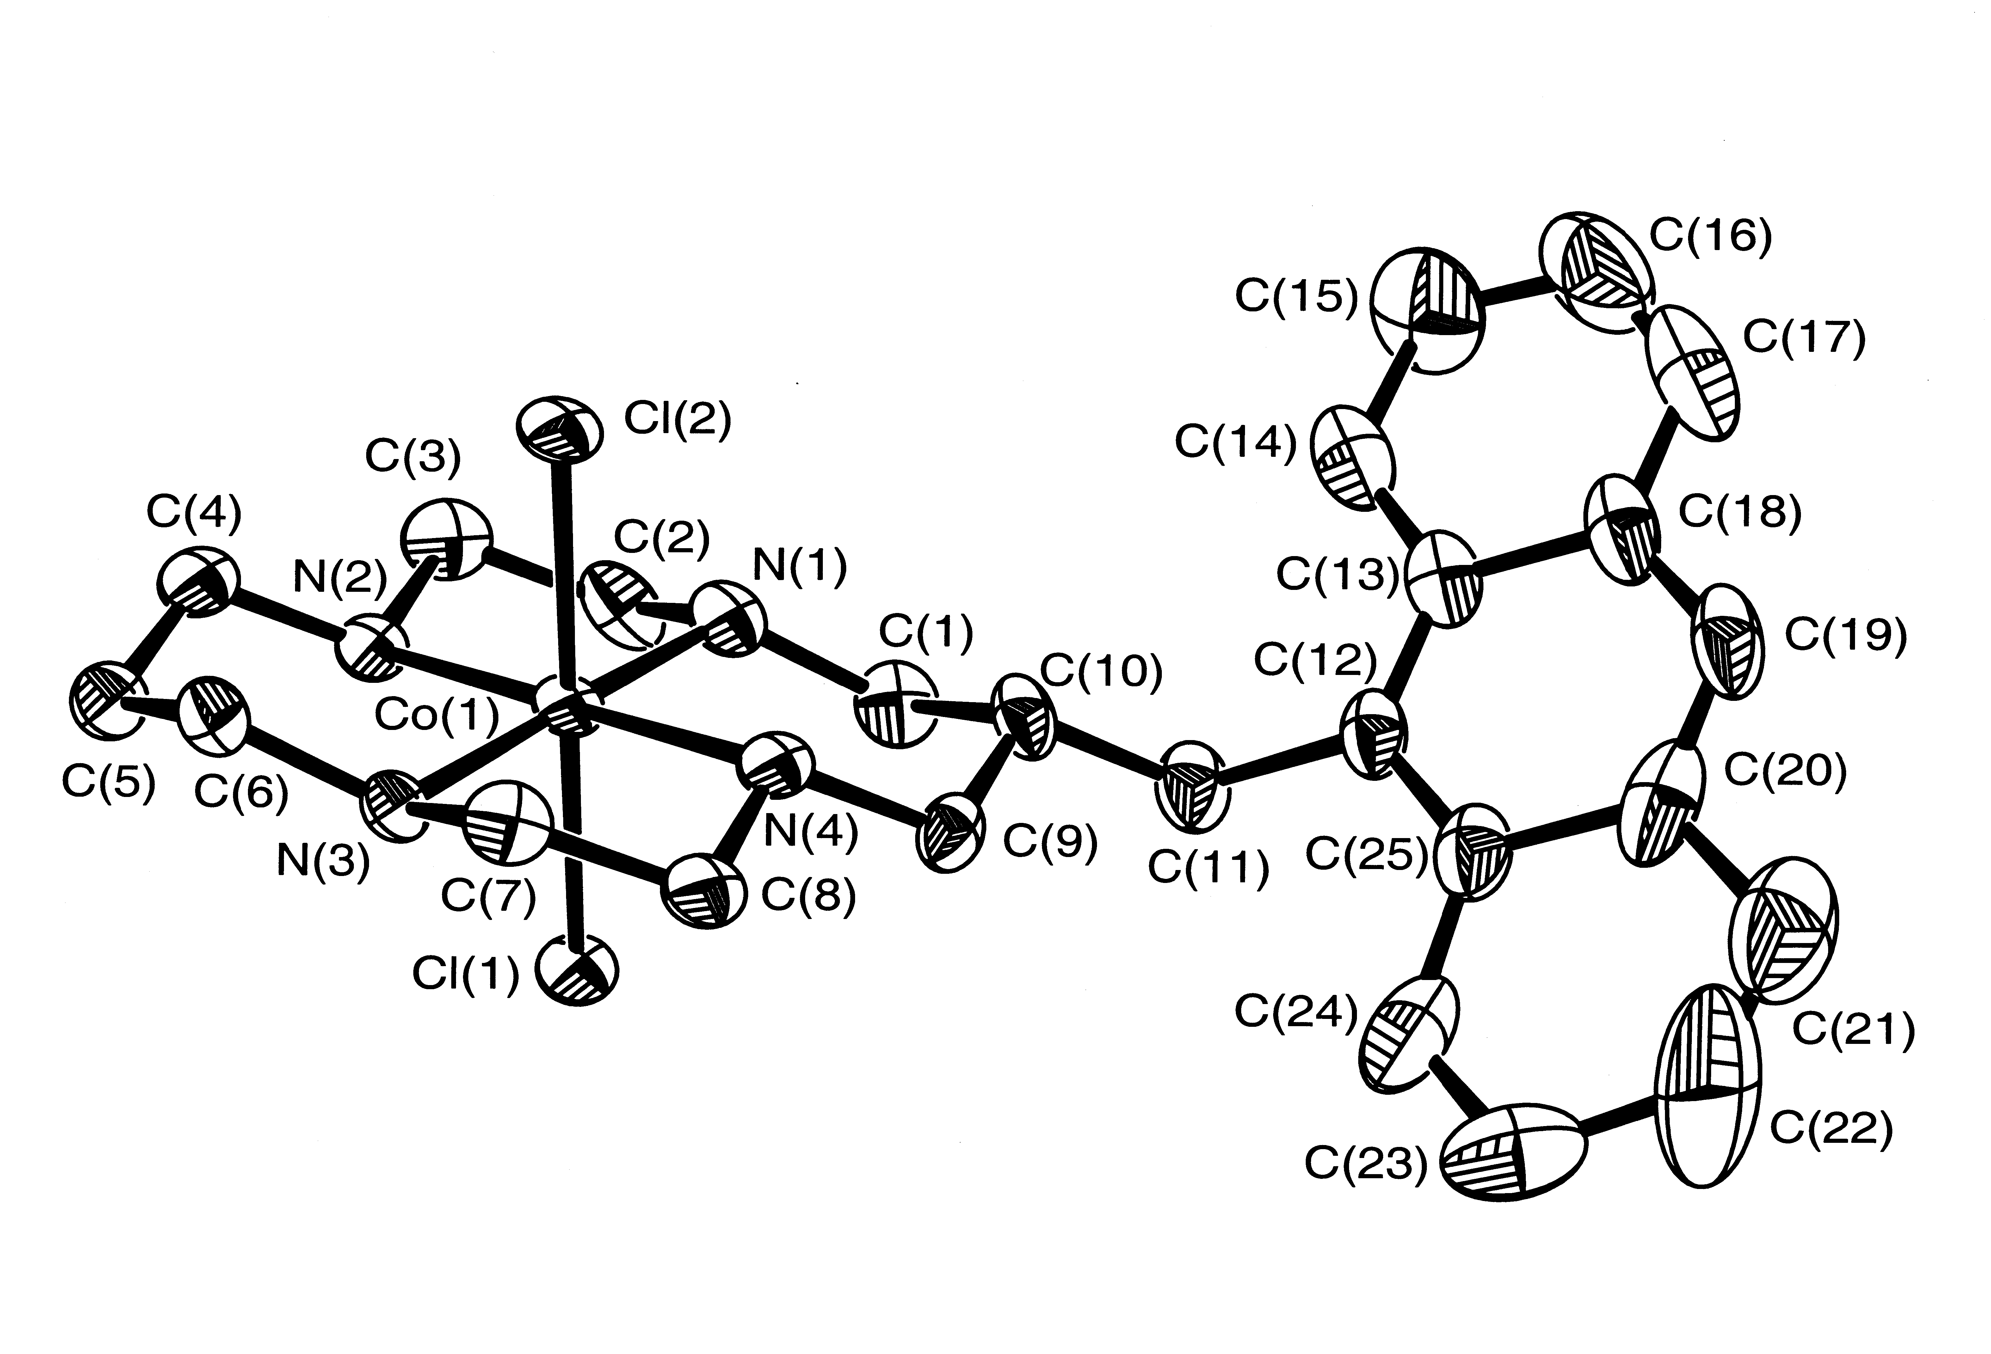

Bond Length (Å) |  | Bond Angle (º)
Co(1)-N(4) | 1.955(9) |  | N(4)-Co(1)-N(1) | 93.3(4)
Co(1)-N(1) | 1.959(8) |  | N(4)-Co(1)-N(3) | 87.1(4)
Co(1)-N(3) | 1.972(8) |  | N(1)-Co(1)-N(3) | 178.4(5)
Co(1)-N(2) | 1.976(10) |  | N(4)-Co(1)-N(2) | 179.3(5)
Co(1)-Cl(2) | 2.254(3) |  | N(1)-Co(1)-N(2) | 86.0(4)
Co(1)-Cl(1) | 2.257(3) |  | N(3)-Co(1)-N(2) | 93.6(4)
N(1)-C(1) | 1.486(13) |  | N(4)-Co(1)-Cl(2) | 88.1(3)
N(4)-C(9) | 1.483(12) |  | N(1)-Co(1)-Cl(2) | 89.4(3)
C(1)-C(10) | 1.52(2) |  | N(3)-Co(1)-Cl(2) | 92.2(3)
C(9)-C(10) | 1.517(14) |  | N(2)-Co(1)-Cl(2) | 91.8(3)
C(10)-C(11) | 1.515(15) |  | N(4)-Co(1)-Cl(1) | 91.6(3)
C(11)-C(12) | 1.57(2) |  | N(1)-Co(1)-Cl(1) | 90.7(3)
 |  |  | N(3)-Co(1)-Cl(1) | 87.7(3)
 |  |  | N(2)-Co(1)-Cl(1) | 88.4(3)
 |  |  | Cl(2)-Co(1)-Cl(1) | 179.75(15)
 |  |  | C(1)-N(1)-Co(1) | 119.1(6)
 |  |  | C(9)-N(4)-Co(1) | 120.9(7)
 |  |  | N(1)-C(1)-C(10) | 114.3(10)
 |  |  | N(4)-C(9)-C(10) | 114.2(8)
 |  |  | C(9)-C(10)-C(11) | 111.9(10)
 |  |  | C(9)-C(10)-C(1) | 111.9(9)
 |  |  | C(11)-C(10)-C(1) | 106.1(9)
 |  |  | C(10)-C(11)-C(12) | 116.2(10)

Table 4. Selected bond lengths (Å) and angles (º) for the complex [Co(12)Cl₂]. Symmetry transformations used to generate equivalent atoms: ‘ x,y,-z.
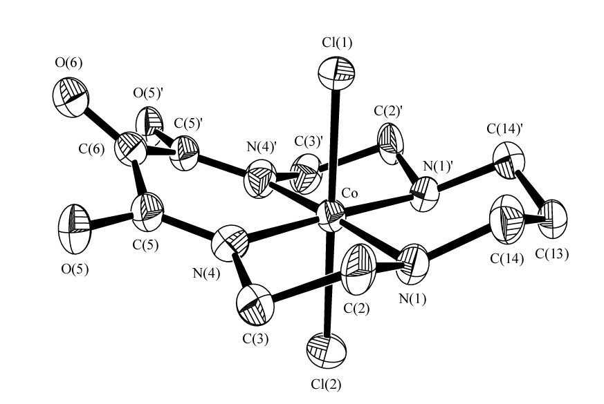

[Co(12)Cl₂]
Bond Length (Å) |  | Bond Angle (º)
Co-N(4) | 1.907(8) |  | N(4)-Co-N(4)’ | 93.8(4)
Co-N(4)’ | 1.907(8) |  | N(4)-Co-N(1) | 85.6(3)
Co-N(1) | 1.970(7) |  | N(4)’-Co-N(1) | 177.5(3)
Co-N(1)’ | 1.970(7) |  | N(4)-Co-N(1)’ | 177.5(3)
Co-Cl(2) | 2.234(3) |  | N(4)’-Co-N(1)’ | 85.6(3)
Co-Cl(3) | 2.262(3) |  | N(1)-Co-N(1)’ | 94.9(4)
N(1)-C(2) | 1.460(13) |  | N(4)-Co-Cl(2) | 90.1(2)
N(1)-C(14) | 1.479(11) |  | N(4)’-Co-Cl(2) | 90.1(2)
C(2)-C(3) | 1.531(12) |  | N(1)-Co-Cl(2) | 92.4(2)
C(3)-N(4) | 1.472(12) |  | N(1)’-Co-Cl(2) | 92.4(2)
N(4)-C(5) | 1.281(10) |  | N(4)-Co-Cl(3) | 90.1(2)
C(5)-O(5) | 1.293(10) |  | N(4)’-Co-Cl(3) | 90.1(2)
C(5)-C(6) | 1.518(10) |  | N(1)-Co-Cl(3) | 87.4(2)
C(6)-O(6) | 1.188(14) |  | N(1)’-Co-Cl(3) | 87.4(2)
C(6)-C(5)’ | 1.518(10) |  | Cl(2)-Co-Cl(3) | 179.80(13)
C(13)-C(14) | 1.516(11) |  | C(2)-N(1)-C(14) | 111.0(7)
C(13)-C(14)’ | 1.516(11) |  | C(2)-N(1)-Co | 108.1(5)
 |  |  | C(14)-N(1)-Co | 118.7(6)
 |  |  | N(1)-C(2)-C(3) | 107.7(8)
 |  |  | N(4)-C(3)-C(2) | 105.0(7)
 |  |  | C(5)-N(4)-C(3) | 119.0(8)
 |  |  | C(5)-N(4)-Co | 128.2(7)
 |  |  | C(3)-N(4)-Co | 112.4(5)
 |  |  | N(4)-C(5)-O(5) | 124.5(8)
 |  |  | N(4)-C(5)-C(6) | 118.7(9)
 |  |  | O(5)-C(5)-C(6) | 116.7(7)
 |  |  | O(6)-C(6)-C(5) | 118.7(5)
 |  |  | O(6)-C(6)-C(5)’ | 118.7(5)
 |  |  | C(5)-C(6)-C(5)’ | 122.6(10)
 |  |  | C(14)-C(13)-C(14)’ | 115.4(10)
 |  |  | N(1)-C(14)-C(13) | 110.4(8)

