SUPPORTING INFORMATION

Fig. S1 Electrospray mass spectra of (a) [1](ClO₄)₂ and (b) [2]ClO₄

Fig. S2 Far-IR spectra of (a) [1](ClO₄)₂ and (b) [2]ClO₄ on polyethylene discs

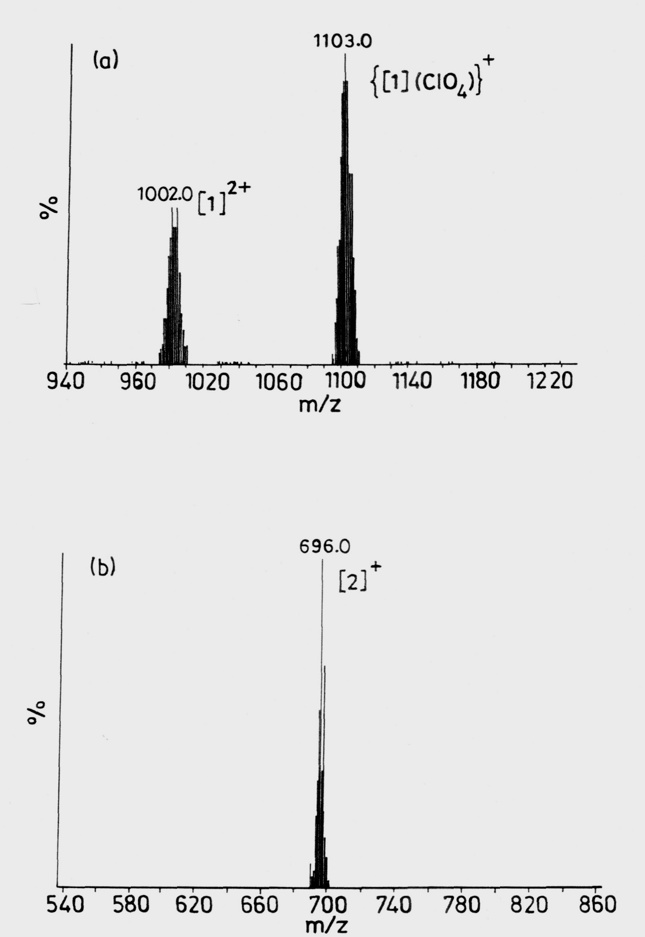

Fig. S1
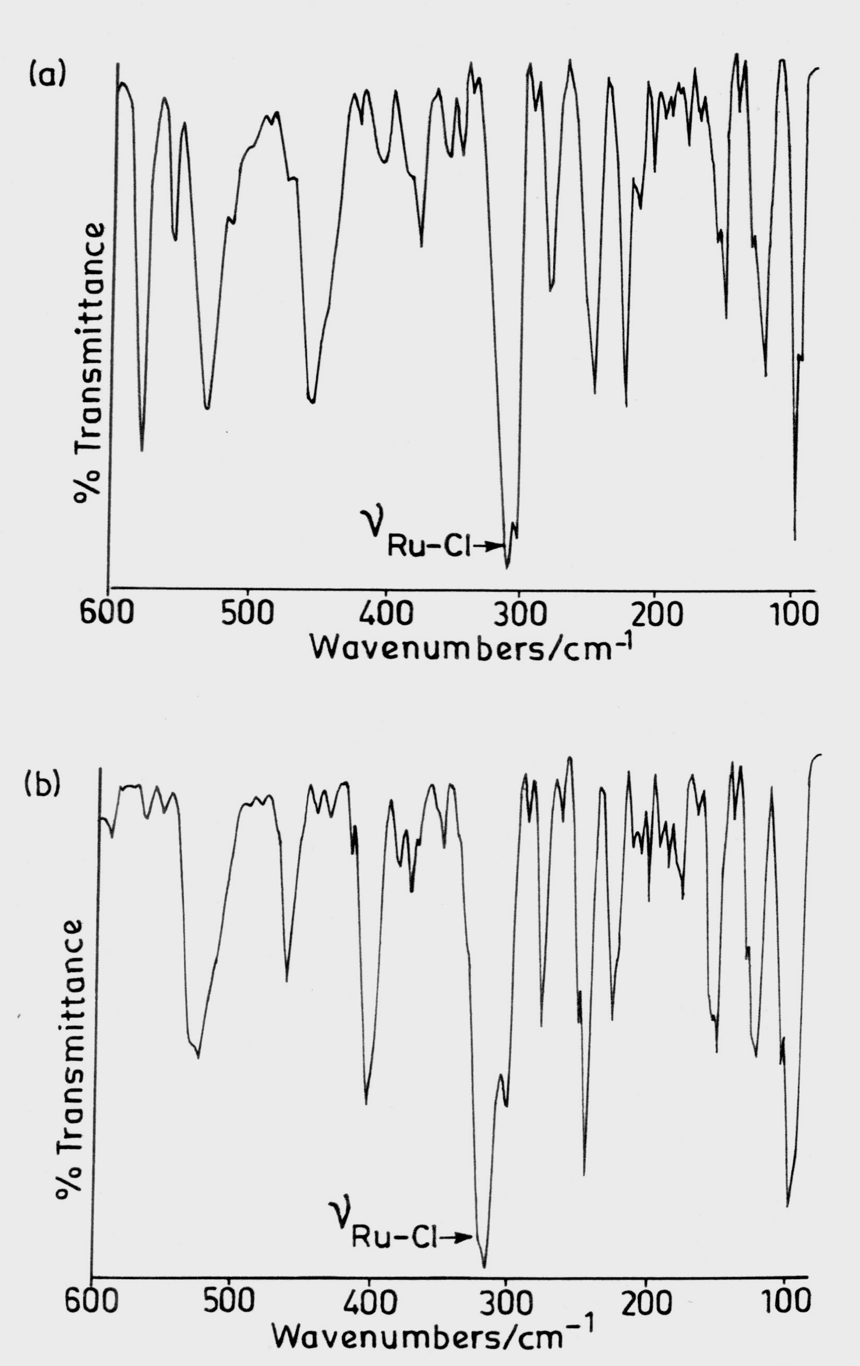

Fig. S2

