Synthesis.
K₄H₃[SiW₁₁O₃₉Mn(H₂PO₄)] (SiW₁₁Mn-PO₄ for short). The preparation procedure was similar to that for SiW₁₁Co-PO₄, except that MnSO₄ was used. The product was yellow precipitate (3.5g, 1.1 mmol). Yellow rhombus crystalline was harvested by re-crystallization in a solution containing quarter volume of acetonitrile.

K₅H₂[SiW₁₁O₃₉Ni(H₂PO₄)] (SiW₁₁Ni-PO₄ for short). The preparation procedure was similar to that for SiW₁₁Co-PO₄. The difference was in that green oil rather than precipitate deposited upon additions of KCl and water/acetone solution. The oil was isolated by decanting solution and solidified by addition of a solution of water/ethanol to get green powder (2.9g, 0.9 mmol). The powder was purified through repeating the steps of dissolution and extraction, using distillation water and ethanol alternatively.

K₃H₃[SiW₁₁O₃₉Cr(H₂PO₄)] (SiW₁₁Cr-PO₄ for short). The preparation procedure was similar to that for SiW₁₁Co-PO₄. During addition of SiW₁₁ the formation of a bean-green precipitate should be avoided as the precipitate might be a [Cr(AMP)]⁺ salt of monosubstituted tungtosilicate (deduced from its IR spectrum). KCl(1g), then a little amount of ethanol, was added into the filtrate. Green needle crystals (1g, 0.3mmol) were harvested from the solution after several days’ standing.

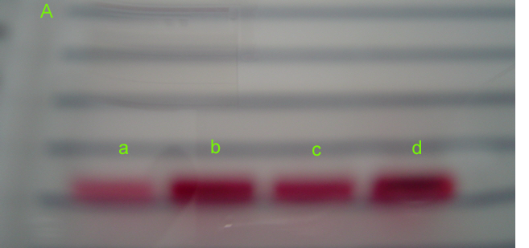
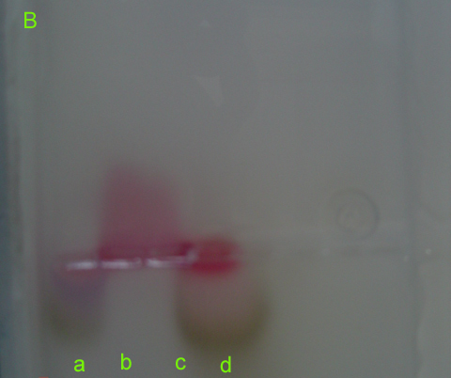
S.Fig.1 Photos of electrophoresis for solutions of (a) Co₃(PO₄)₂ (a little amount of diluted H₃PO₄ was added to dissolve it), (b) SiW₁₁Co-PO₄, (c) SiW₁₁Co, and (d) Co(NO₃)₂: A, before electrophoresis; B, after 10 min′s electrophoresis.

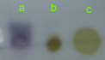
S.Fig.2 TLC photo taken after 40min′s immersing for thin-layer plate of Al₂O₃: (a) Co₃(PO₄)₂; (b) SiW₁₁Co; (c) SiW₁₁Co-PO₄.

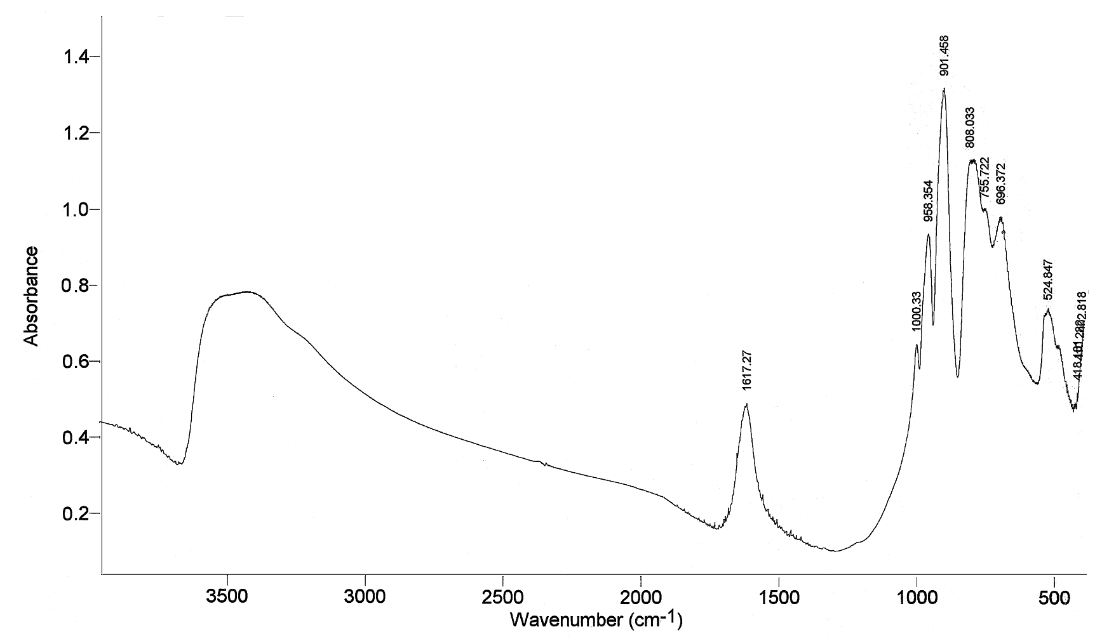
S.Fig. 3 A typical IR spectrum of [SiW₁₁O₃₉M(H₂PO₄)]^{n-}, here M=Co^{II}

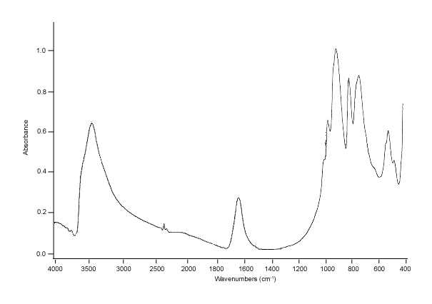
S. Fig.4 IR spectrum of [SiW₁₁O₃₉]⁸⁻

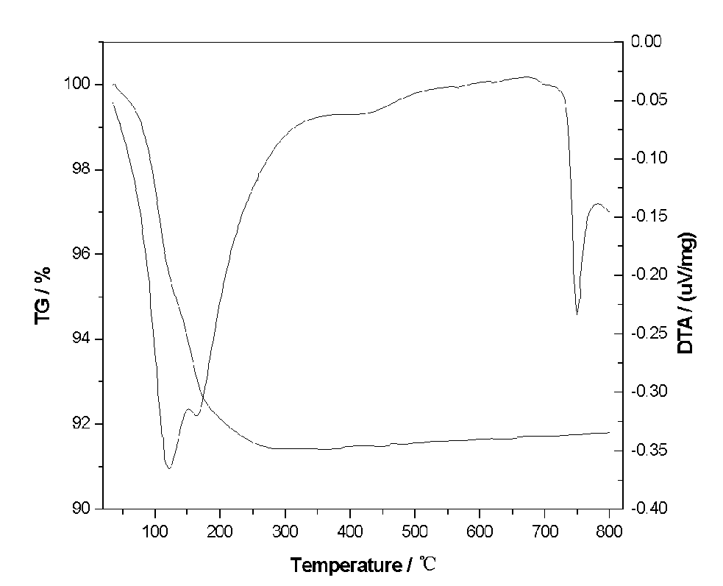
S.Fig.5 TG-DTA curves of SiW₁₁-Co-PO₄.

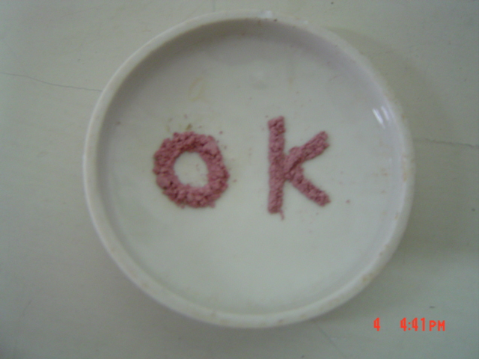
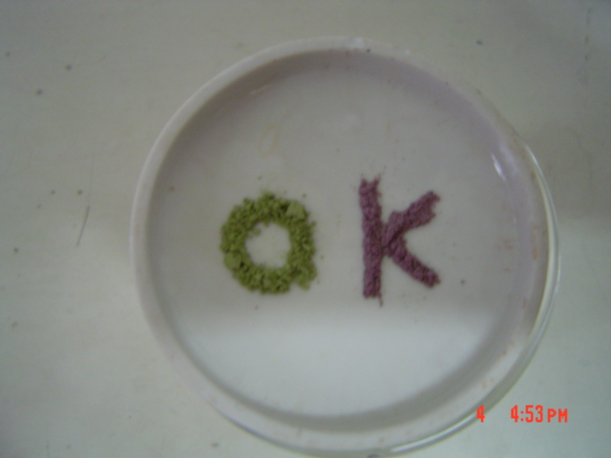
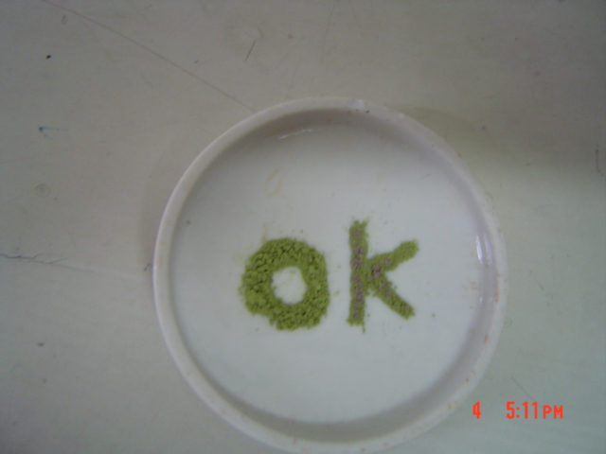
a
b
S. Fig. 6 The photos for SiW₁₁Co (letter “O”) and SiW₁₁Co-PO₄ (letter “K”): before heating (a), after calcination at 520℃ for 30 min (b) and after calcination at 600℃ (c). Green powders are decomposed compounds.
c

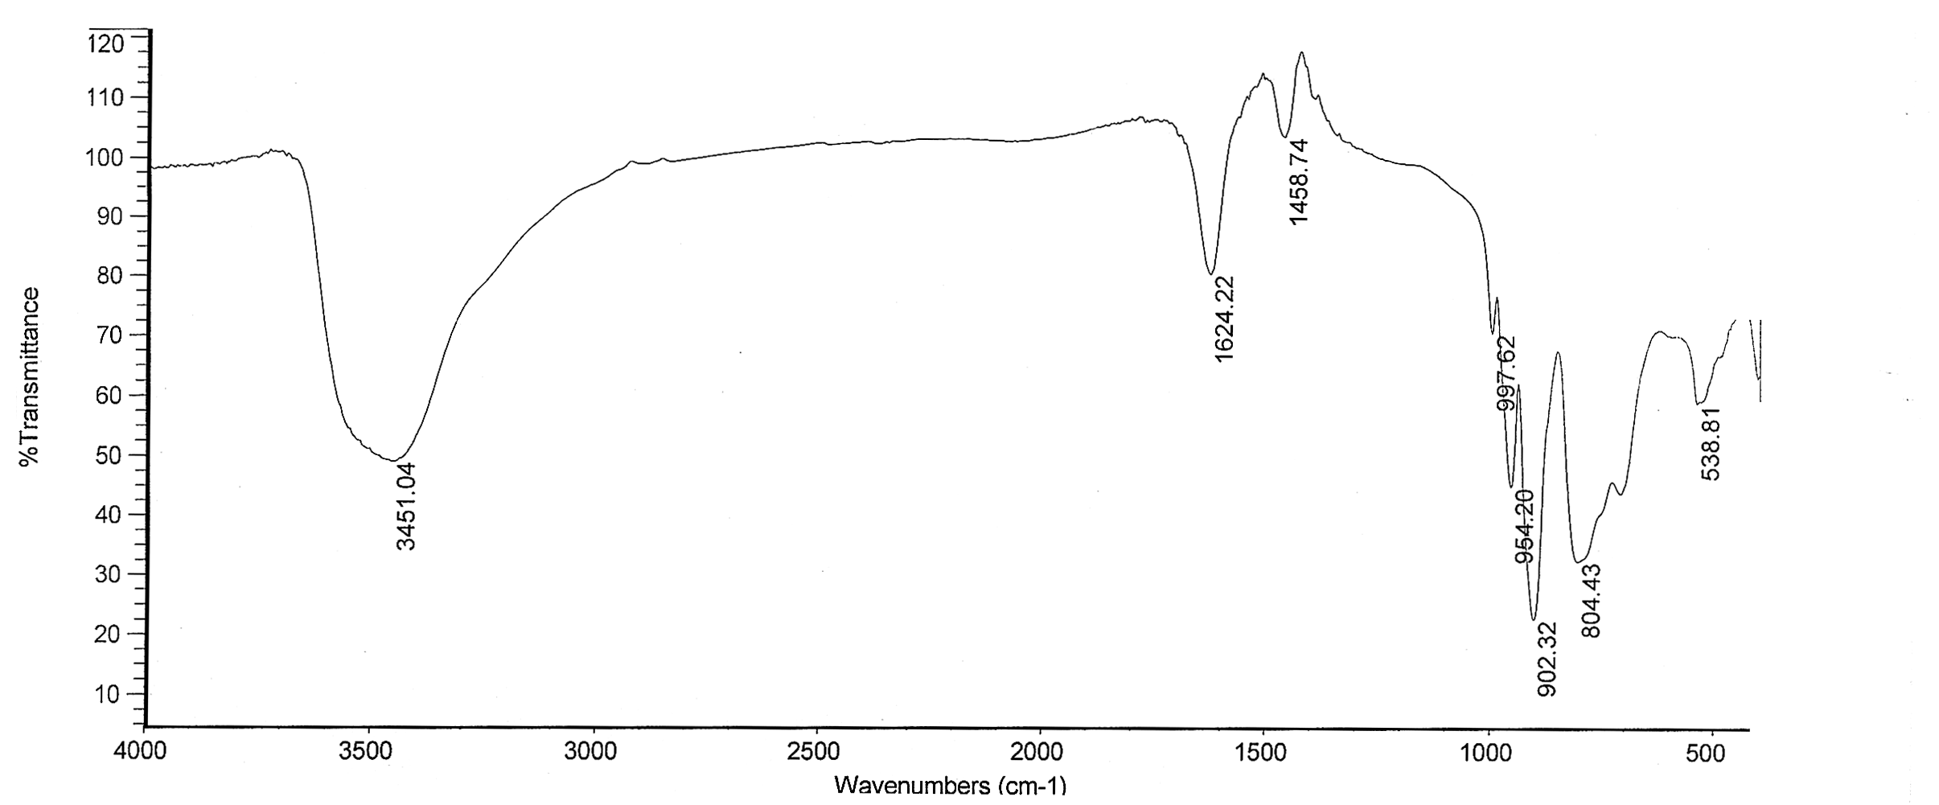
S.Fig.7 IR spectrum of [SiW₁₁O₃₉Co^{II} (H₂PO₄)]^{n-} after calcinations at ca.520℃ for 30 min.

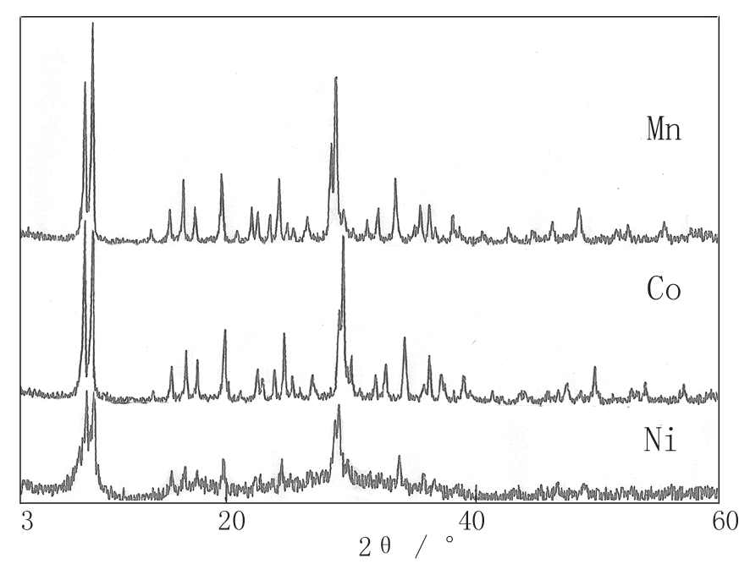
Fig 8 X-ray powder diffraction patterns for SiW₁₁M-PO₄ (M = Co^{II}, Mn^{II} or Ni^{II})

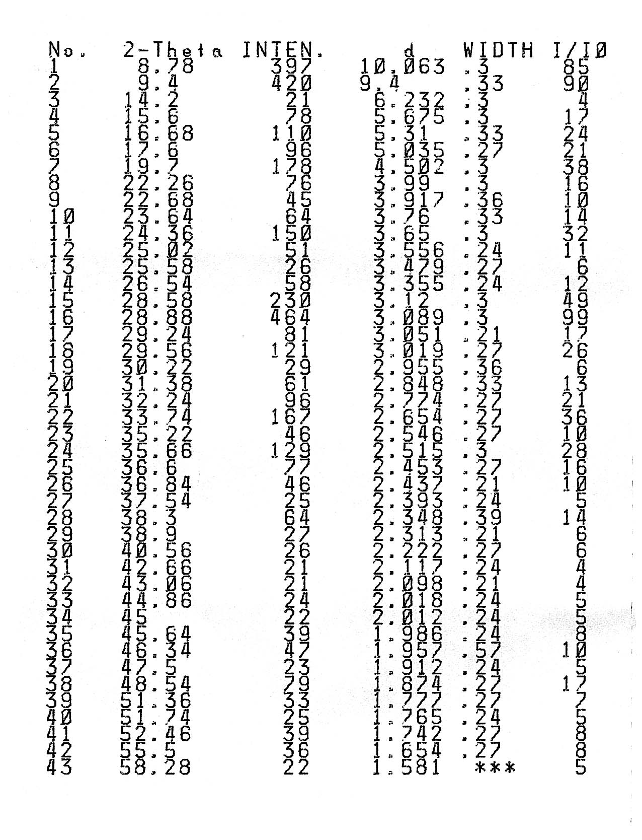
S.Table 1 Data of X-ray powder diffraction for α-K₄H₃[SiW₁₁O₃₉Co(H₂PO₄ )]·15H₂O

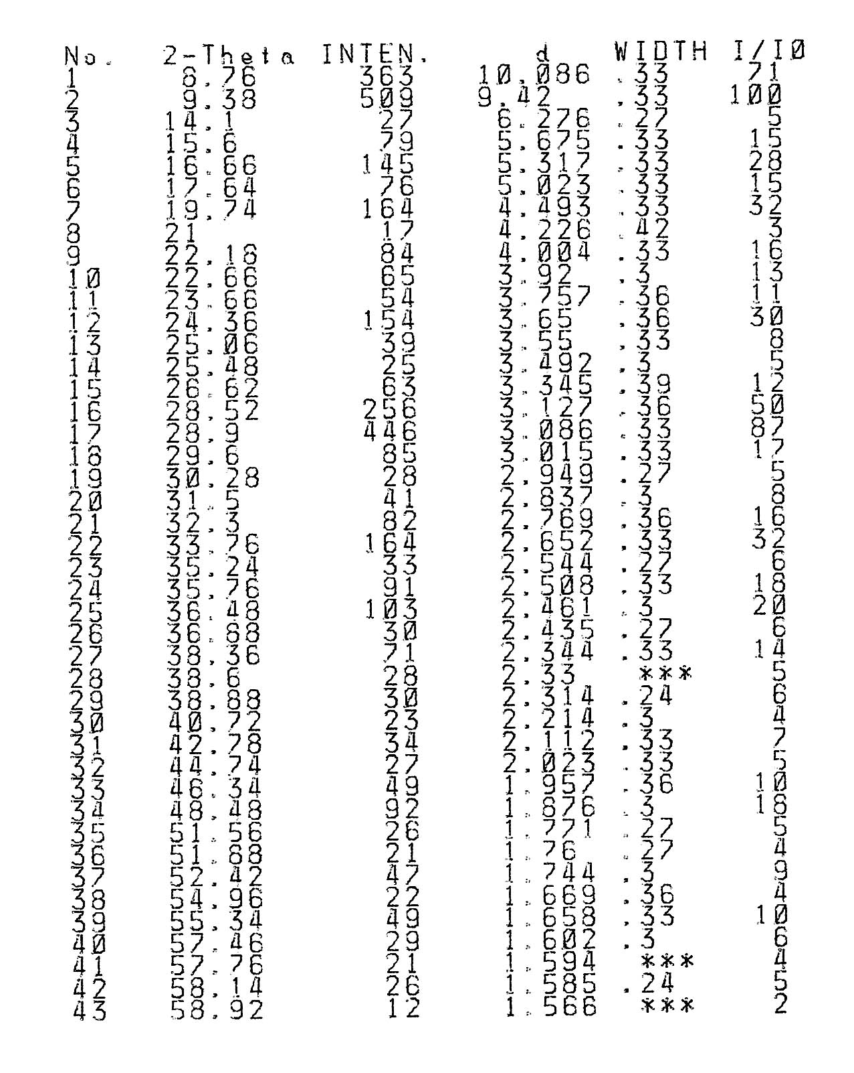
S.Table 2 Data of X-ray powder diffraction for α-K₄H₃[SiW₁₁O₃₉Mn (H₂PO₄)]·11H₂O

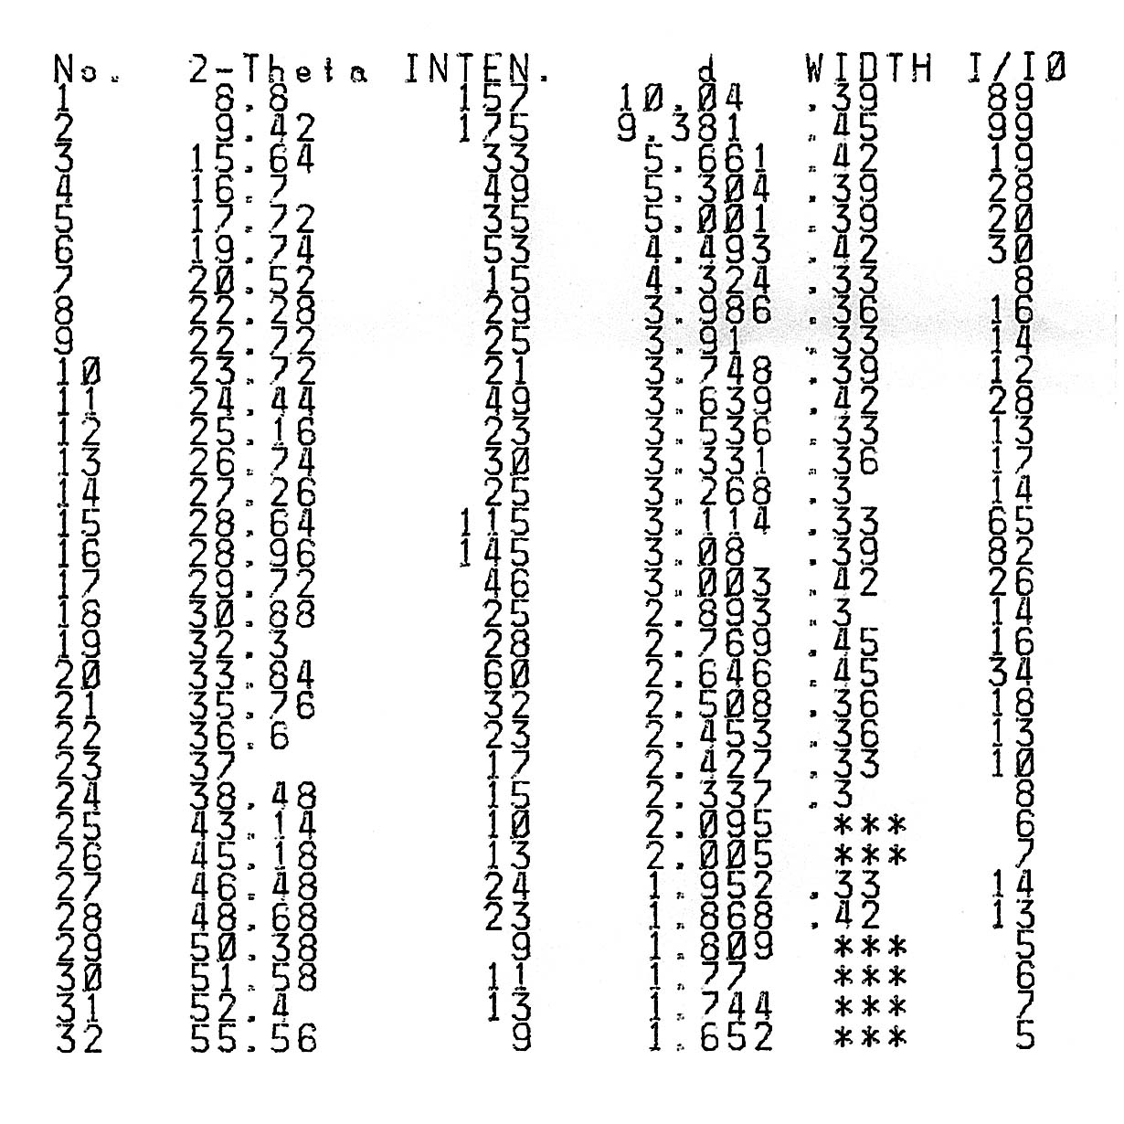
S.Table 3 Data of X-ray powder diffraction for α-K₅H₂[SiW₁₁O₃₉Ni(H₂PO₄)]·8H₂O

